**About Shakespeare**

* **Introduction**

William Shakespeare was an English poet, playwright and actor, widely regarded as the greatest writer in the English language and the world's pre-eminent dramatist. He is often called England's national poet and the "Bard of Avon". His extant works, including collaborations, consist of approximately 39 plays, 154 sonnets, two long narrative poems and a few other verses, some of uncertain authorship.

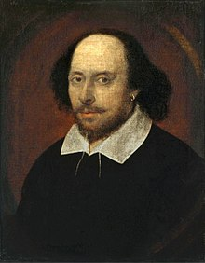

* **Famous Works**
* *The Sonnets*
* *The Comedy of Errors*
* *As You Like It*
* *Romeo and Juliet*
* *Macbeth*
* *Hamlet*
* *Othello*