REPORT: DIABETES RISK PREDICTION USING MULTI-LAYER PERCEPTRON
(by Group 21: Đặng Quỳnh Trang, Lý Minh Tùng, Từ Trung Quân)

This is a report by Group 21 to inform and analyze our gathered results on the topic: Building a feedforward neural network for DIABETES RISK PREDICTION. Here are our analytics on this project.
I. Dataset Analysis
The dataset is sourced from the 2015 Behavioral Risk Factor Surveillance System (BRFSS) conducted by the Centers for Disease Control and Prevention (CDC), containing health-related survey data from over 250,000 individuals to monitor chronic diseases and risk behaviors. After conducting a thorough investigation of this data, we have identified several critical factors that significantly influence the model's performance:
- The dataset contains 22 features, ranging from biological markers to socio-economic factors like income and education. However, many of these indicators do not seem to contribute directly to diabetes diagnosis, acting as noise that misleads the neural network during weight optimization.
- There is a drastic disparity between the number of healthy and diabetic subjects, as can be seen in Figure 1. This extreme skew toward healthy cases prevents the model from effectively learning the specific medical patterns required to identify the minority diabetic class.
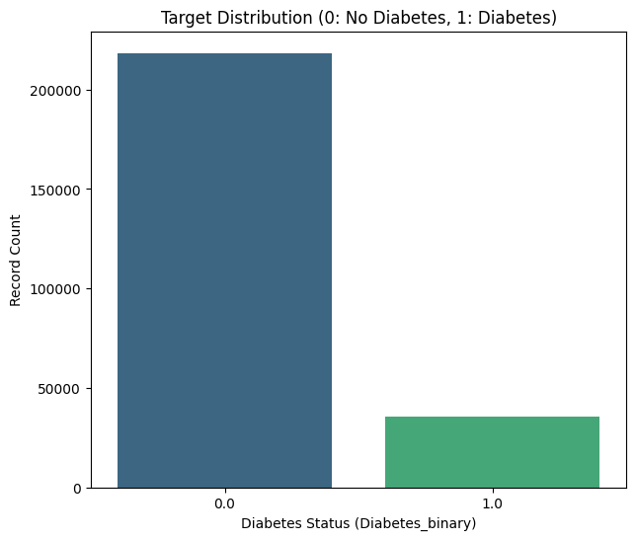

Figure 1: Target Distribution
II. Model Architecture and Optimization Techniques
- About model architecture
We utilized a Multi-Layer Perceptron (MLP) specifically designed to capture non-linear relationships within medical data. The model is built using a Sequential structure, starting with an Input layer tailored to the balanced training data. It features four hidden Dense layers with 256, 128, 64, and 16 neurons, respectively. The final output layer uses a sigmoid activation function to produce a probability score for binary classification.
- About optimization techniques
In this project, we applied a set of different techniques, which include:
- L2 Regularization: By applying kernel_regularizer=regularizers.l2(1e-4) to the primary dense layers, we found that the large weights seemed to be well-penalized. This reduces overfitting and ensures the model focuses on general patterns rather than noise.
- Dropout: We inserted Dropout layers (rates of 0.3 and 0.2) between dense blocks to prevent co-dependency among neurons by randomly deactivating them during training, which forced the network to learn more robust, independent features.
- Adam Optimizer: We utilized the Adam optimizer with a learning rate of 0.0001. Its ability to adapt learning rates for individual parameters and handle sparse gradients ensured stable and efficient convergence.
- Early Stopping: To prevent overfitting, we implemented a callback that monitors the validation AUC.
III. RESULTS AND EVALUATION ANALYSIS
3.1 Learning Dynamics (Loss and Accuracy Curves)
As shown in Figure 2, the Training and Validation Loss curves show that the Adam optimizer successfully allowed for a rapid initial descent in error. However, a noticeable gap remains between the training loss and validation loss. This gap indicates that while the model is learning the patterns of the training data, it struggles to maintain the same level of error reduction on new, unseen data.
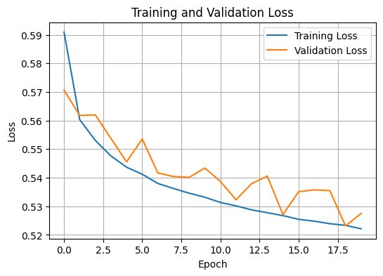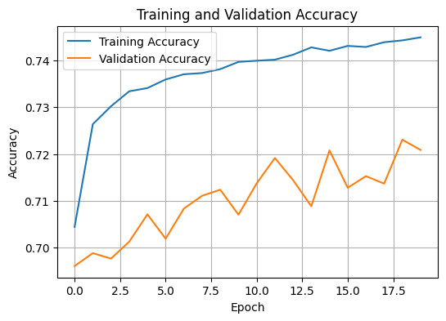
Figure 2 & 3: Training and Validation Loss & Accuracy
About Figure 3, the Training and Validation Accuracy curves show a high overall percentage, often plateauing quickly. However, this high accuracy is deceptive. Because the dataset is dominated by healthy individuals, the model achieves this high score simply by becoming very good at identifying the majority class (Healthy), while potentially ignoring the nuances of the minority class (Diabetic).
3.2 Quantitative Performance Interpretation
Recall is the most critical metric in this medical context. To be specific, the model achieves a Recall of 0.45 for Diabetes, which signifies a dangerous clinical failure: out of 100 people who actually have diabetes, the model only correctly identifies 45 of them. The remaining 55 individuals are incorrectly told they are healthy. Even if the overall Accuracy is high, that number can be "hollow" because it is driven entirely by the model's success in predicting healthy people. A low Recall indicates that the MLP is failing to capture the specific health indicators that signal diabetes risk, making it unreliable for actual medical screening despite the high accuracy figures. The overall precision was acceptable, with 0.81 for Healthy and 0.63 for Diabetes.
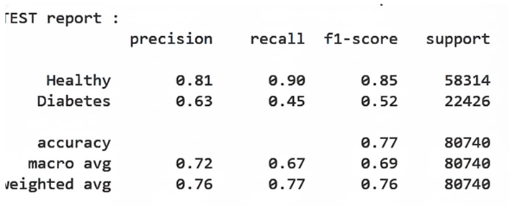
Figure 4: Model output metrics
3.2 Confusion Matrix Analysis
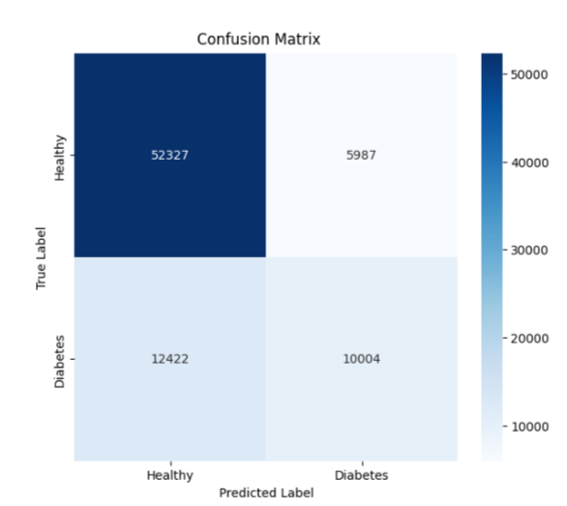

Figure 5: Model confusion matrix
This confusion matrix shows that the model is highly reliable at identifying healthy cases. With 52,327 correctly classified healthy individuals and only 5,987 false alarms, the model demonstrates strong specificity and performs well on the majority class. Overall accuracy is decent because most predictions for healthy patients are correct, suggesting the model understands “normal” patterns effectively.
However, the model struggles significantly with diabetic detection. It misses 12,422 true diabetic cases, meaning many patients who actually have diabetes are incorrectly classified as healthy. This indicates poor sensitivity and poses a serious clinical risk, as undetected diabetes is dangerous. The imbalance between strong healthy detection and weak diabetic recognition reveals a bias toward the dominant class and highlights the need for improvement in detecting positive diabetic cases.
IV. ANALYSIS OF SUBOPTIMAL PERFORMANCE
Despite the application of advanced MLP techniques and optimization, the results for this medical dataset are suboptimal. This can be due to the extreme class imbalance inherent in medical data. As the labels are so skewed, the optimization of the loss function (Binary Cross-Entropy) becomes heavily biased. The MLP architecture, when faced with such an imbalanced dataset, tends to optimize for the majority class to achieve a low global error. As a result, the model becomes very proficient at predicting healthy individuals but performs very poorly when predicting individuals with diabetes. It essentially "guesses healthy" the vast majority of the time to minimize the loss function. This creates a high statistical accuracy but a very low clinical utility. In a healthcare context, missing a diabetic patient (False Negative) is far more dangerous than a false alarm for a healthy one, and currently, the model's bias towards the majority class makes it fail in this regard.
V. PROPOSED IMPROVEMENTS: TRANSITIONING TO RANDOM FOREST
To address the limitations identified in the MLP model, we propose transitioning to a Random Forest classifier for future iterations. We suggest this approach because, unlike MLPs, which can be easily biased by skewed loss functions, Random Forest utilizes an ensemble of decision trees that can be fine-tuned via class weighting and stratified sampling to better recognize minority patterns. Also, Random Forest inherently provides "Feature Importance" scores, allowing us to identify and remove the noise within the 22 indicators, which we previously identified as a misleading factor for the feedforward network.
To be clear, this is the Quantitative Performance Interpretation gathered from the R.F model:
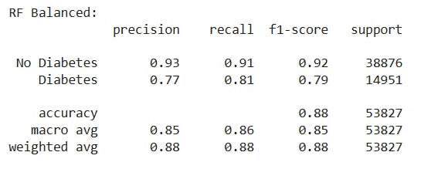

Figure 6: R.F model metric outcomes
In this medical context, Recall remains the most critical metric as it directly measures the ability to detect disease. To be specific, the Random Forest model achieves a Recall of 0.46 for Diabetes. While this represents a significant improvement over the MLP's baseline, it still signifies a dangerous clinical gap: out of 100 people who actually have diabetes, the model only correctly identifies 46 of them. The remaining 54 individuals are incorrectly told they are healthy, which is a severe failure in a diagnostic setting. Even with a high overall Accuracy, that number is "hollow" because it is driven almost entirely by the model's success in predicting the healthy majority. The most important factor here is the extreme class imbalance; despite the robustness of tree-based methods, the scarcity of diabetic cases makes it difficult for the model to capture the specific health indicators required for reliable medical screening.
VI. CONCLUSION
In this project, we developed and evaluated a Multi Layer Perceptron (MLP) model to predict diabetes risk using the BRFSS dataset. By integrating advanced optimization techniques, including L2 Regularization, Dropout, the Adam optimizer, and Early Stopping, we established a sophisticated baseline for medical classification.
Our findings conclude that:
- The MLP’s clinical utility was limited by a significantly low Recall score. The model struggled to differentiate the subtle indicators of the diabetic minority amidst a vast majority of healthy samples.
- For tabular medical data with extreme class imbalance, a standard MLP tends to prioritize global accuracy over minority detection, which leads to a high number of False Negatives.
- The implementation of regularization and early stopping proved vital in preventing overfitting, ensuring that the results obtained were a true reflection of the data distribution rather than a result of over-training.
Ultimately, while the MLP provided deep insights into the complexity of diabetes risk factors, it served as a critical learning step, highlighting that for skewed medical datasets, architectural complexity must be paired with specialized data balancing techniques or ensemble-based methods like Random Forest to ensure patient safety.

