Defining Classes Lab Answers (Dog Grooming)

Class Diagram

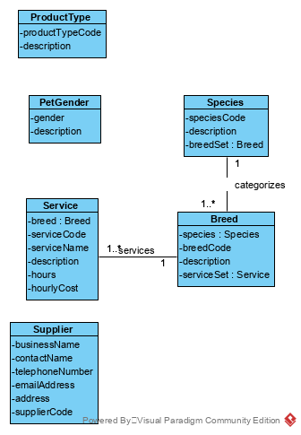

1. Must be able to query product types to retrieve a list of product types

|  |  |  |  |
| --- | --- | --- | --- |
| Use Case Name | Create a product type | | |
| Triggering Event | A new type of product on the market | | |
| Brief Description | Allows the Owner to create a product type | | |
| Actors | Owner | | |
| Related Use Cases |  | | |
| Preconditions | Owner has opened the Main Menu. | | |
| Post Conditions | Product type is added and available to query | | |
| Flow of activities | Actor | | System |
|  |  | Requests to add a new product type | Displays a list of product types and prompts for product type and product type description. |
|  |  | Enters product type and description | Verifies that product type and description have been entered.  Prompts for confirmation |
|  |  | Confirms entry | Saves the product type and returns to the main menu |
| Exception Conditions | * Owner chooses to cancel adding the product type | | |

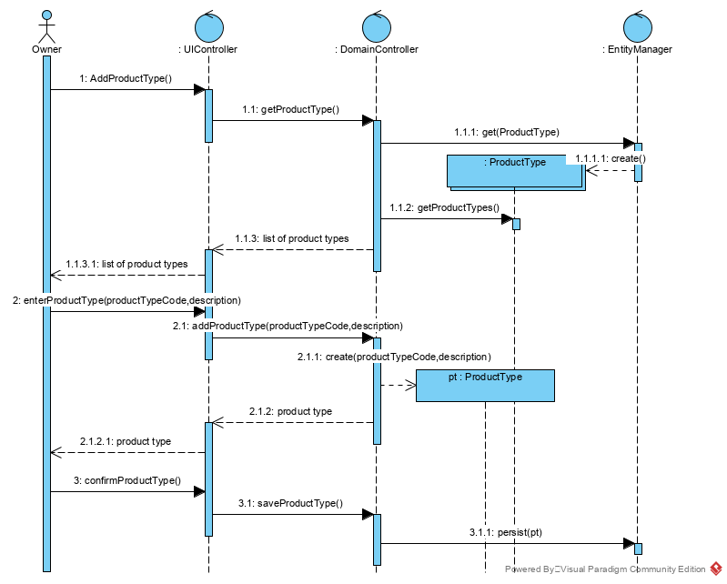

|  |  |  |  |
| --- | --- | --- | --- |
| Use Case Name | Change a Product Type description | | |
| Triggering Event | Request to change a product type description | | |
| Brief Description | Allows the Owner to change a product type’s description | | |
| Actors | Owner | | |
| Related Use Cases |  | | |
| Preconditions | Owner has opened the Main Menu. | | |
| Post Conditions | Product type description is updated | | |
| Flow of activities | Actor | | System |
|  | 1. | Requests to query a product type | Displays a list of product types and prompts for product type. |
|  | 2. | Selects a product type | Retrieves the product type description and prompts for updates |
|  | 3. | Updates description and requests to save | Verifies that description was entered.  Saves the data |
| Exception Conditions | * Owner chooses to cancel updating the product type description | | |

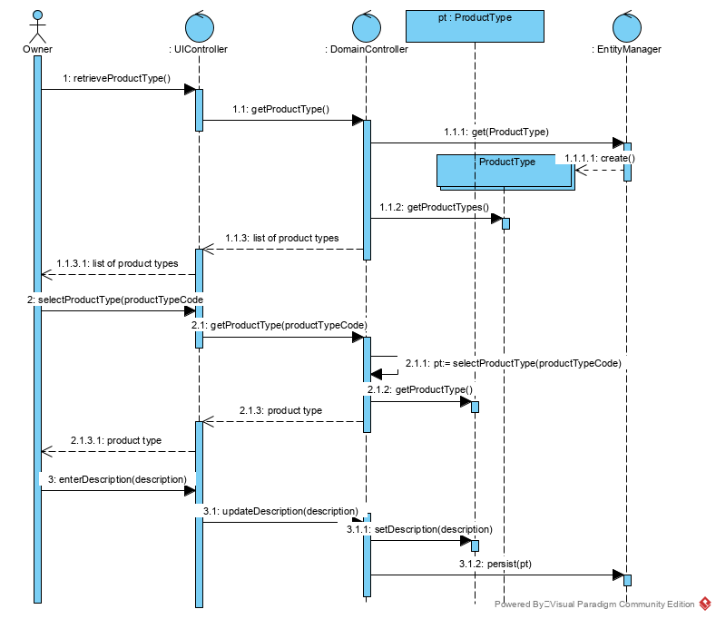

|  |  |  |  |
| --- | --- | --- | --- |
| Use Case Name | Query all product types and their descriptions | | |
| Triggering Event | Request for product types | | |
| Brief Description | Allows the Owner to retrieve all product types and their descriptions. | | |
| Actors | Owner | | |
| Related Use Cases |  | | |
| Preconditions | Owner has opened the Main Menu. | | |
| Post Conditions | All product types and their descriptions are retrieved. | | |
| Flow of activities | Actor | | System |
|  | 1. | Requests to query all product type | Displays a list of product types  Prompts to cancel |
|  | 3. | Chooses to cancel | returns to the main menu |
| Exception Conditions | * Owner chooses to cancel retrieving the product type | | |

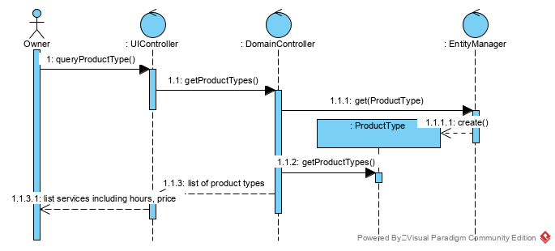

User Story

I have added surcharges for my services based on the gender of the pet. For example, cleaning the sanitary areas of pets differ between male and females, or even between female and spayed females. Male pets can be more aggressive than neutered males or females. For that reason, I would like to classify pets by gender.

Most of my client’s pets fall into the genders:

Female

Female – spayed

Male

Male – neutered

I’m thinking of expanding into large animals, so for horses, I would have to add Gelding and Rig.

For that reason, Pet Gender has to have some flexibility!

Acceptance Criteria:

1. Must be able to query pet genders to retrieve a list of pet genders

|  |  |  |  |
| --- | --- | --- | --- |
| Use Case Name | Create a pet gender | | |
| Triggering Event | A new type pet gender | | |
| Brief Description | Allows the Owner to create a pet gender | | |
| Actors | Owner | | |
| Related Use Cases |  | | |
| Preconditions | Owner has opened the Main Menu. | | |
| Post Conditions | Pet gender is added and available to query | | |
| Flow of activities | Actor | | System |
|  | 1. | Requests to add a new pet gender | Displays a list of pet gender and prompts for pet gender and pet gender description. |
|  |  | Enters pet gender and description | Verifies that pet gender and description have been entered.  Prompts for confirmation |
|  |  | Confirms entry | Saves the pet gender and returns to the main menu |
| Exception Conditions | * Owner chooses to cancel adding the pet gender | | |

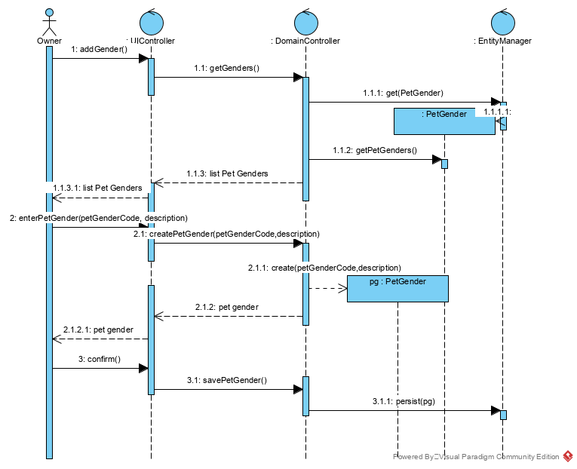

|  |  |  |  |
| --- | --- | --- | --- |
| Use Case Name | Change a pet gender description | | |
| Triggering Event | Request to change a pet gender description | | |
| Brief Description | Allows the Owner to change a pet gender’s description | | |
| Actors | Owner | | |
| Related Use Cases |  | | |
| Preconditions | Owner has opened the Main Menu. | | |
| Post Conditions | Pet gender description is updated | | |
| Flow of activities | Actor | | System |
|  | 1. | Requests to query a pet gender | Displays a list of pet genders and prompts for pet gender |
|  | 2. | Selects a pet gender | Retrieves the pet gender description and prompts for updates |
|  | 3. | Updates description and requests to save | Verifies that description was entered.  Saves the data |
| Exception Conditions | * Owner chooses to cancel updating the pet gender description | | |

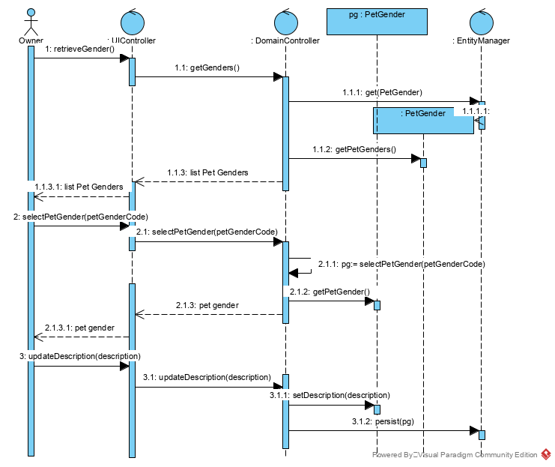

|  |  |  |  |
| --- | --- | --- | --- |
| Use Case Name | Query all pet genders and their descriptions | | |
| Triggering Event | Request for pet genders | | |
| Brief Description | Allows the Owner to retrieve all pet genders and their descriptions. | | |
| Actors | Owner | | |
| Related Use Cases |  | | |
| Preconditions | Owner has opened the Main Menu. | | |
| Post Conditions | All pet genders and their descriptions are retrieved. | | |
| Flow of activities | Actor | | System |
|  | 1. | Requests to query all pet genders | Displays a list of pet genders  Prompts to cancel |
|  | 2. | Chooses to cancel | returns to the main menu |
| Exception Conditions | * Owner chooses to cancel query pet genders | | |

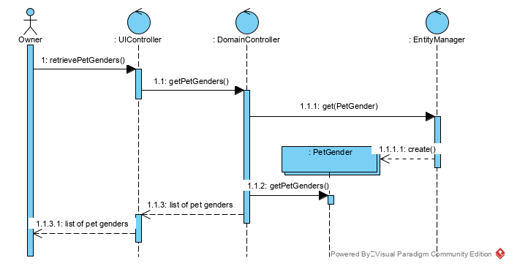

User Story

I charge for my services based on species and breed. For example, I groom both cats and dogs. To bath and brush a cat is more work than bathing and brushing a small dog. Cats won’t sit on command! Different breeds of a species require a different about of work. For example, a groom of a beagle entails a bath and brush whereas a groom of a poodle entails a bath, brush and hair cut. I would like to categorize by clients pets by species and then breed.

Acceptance Criteria:

1. Must be able to query breeds by species.

Use Case Descriptions

|  |  |  |  |
| --- | --- | --- | --- |
| Use Case Name | Create a species and add breeds | | |
| Triggering Event | A new species. | | |
| Brief Description | Allows the Owner to record species and breed information | | |
| Actors | Owner | | |
| Related Use Cases |  | | |
| Preconditions | Owner has opened the Main Menu. | | |
| Post Conditions | Species and breeds added and available for query | | |
| Flow of activities | Actor | | System |
|  | 1. | Requests to add a new species | Display a list of species and prompts for species and description |
|  |  | Enters species and description | Verifies that species and description have been entered  Prompts to add breed and breed description  Prompts to save |
|  |  | Enters breed and description | Verifies that breed and breed description have been entered  Display a list of breeds for the species  Prompts to add breed and breed description  Prompts to save |
|  |  | Until all breeds have been entered | Saves data |
| Exception Conditions | * Owner chooses to abort adding the species | | |

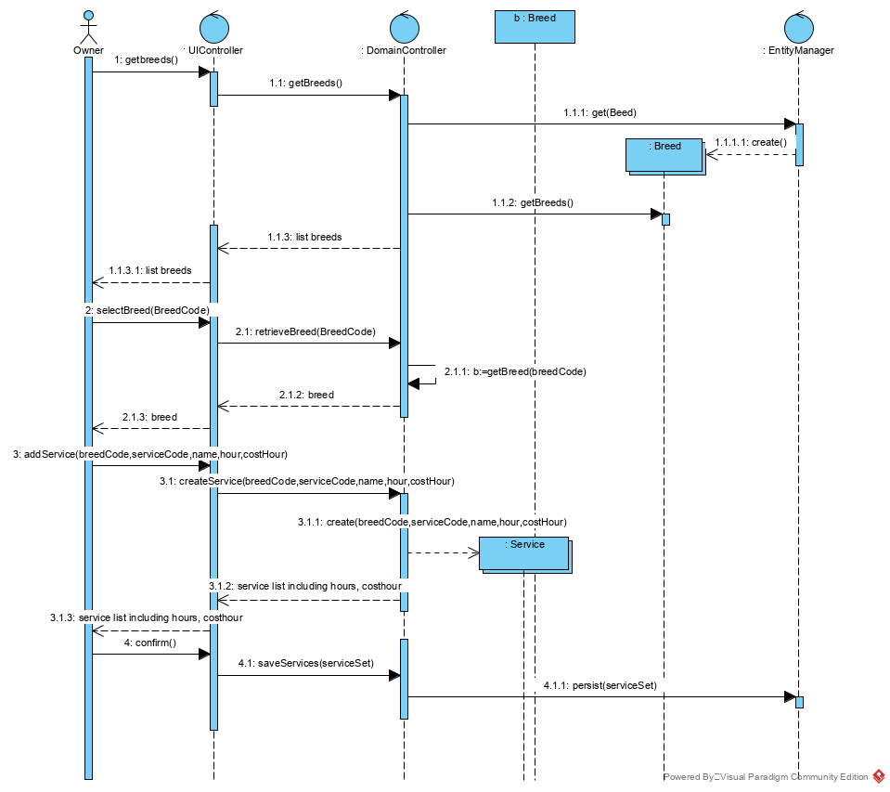

|  |  |  |  |
| --- | --- | --- | --- |
| Use Case Name | Add breeds to species | | |
| Triggering Event | A new breed. | | |
| Brief Description | Allows the Owner to record species and breed information | | |
| Actors | Owner | | |
| Related Use Cases |  | | |
| Preconditions | Owner has opened the Main Menu. | | |
| Post Conditions | Species and breeds added and available for query | | |
| Flow of activities | Actor | | System |
|  | 1. | Requests to change a species | Display a list of species and prompts for species and description |
|  |  | selects species and description | Displays a list of breeds for the species.  Prompts to add breed and breed description  Prompts to save |
|  |  | Enters breed and description | Verifies that breed and breed description have been entered  Prompts to add breed and breed description  Prompts to save |
|  |  | Until all breeds have been entered | Saves data |
| Exception Conditions | * Owner chooses to abort adding the breed | | |

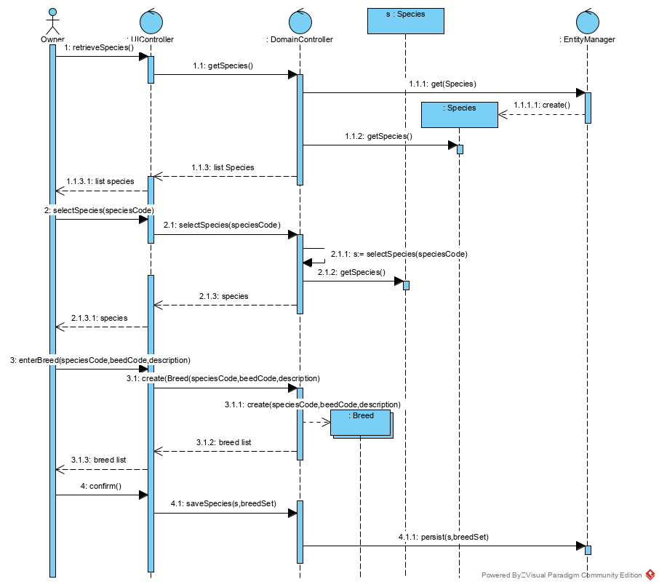

|  |  |  |  |
| --- | --- | --- | --- |
| Use Case Name | Query all species and breeds | | |
| Triggering Event | Request for species and breed information | | |
| Brief Description | Allows the Owner to retrieve all species and breed information | | |
| Actors | Owner | | |
| Related Use Cases |  | | |
| Preconditions | Owner has opened the Main Menu. | | |
| Post Conditions | All pet species and breeds are retrieved | | |
| Flow of activities | Actor | | System |
|  | 1. | Requests to query all species | Displays a list of species  For each species, displays a list of breeds |
|  | 2. | Chooses to cancel | returns to the main menu |
| Exception Conditions | * Owner chooses to cancel retrieve species and breeds. | | |

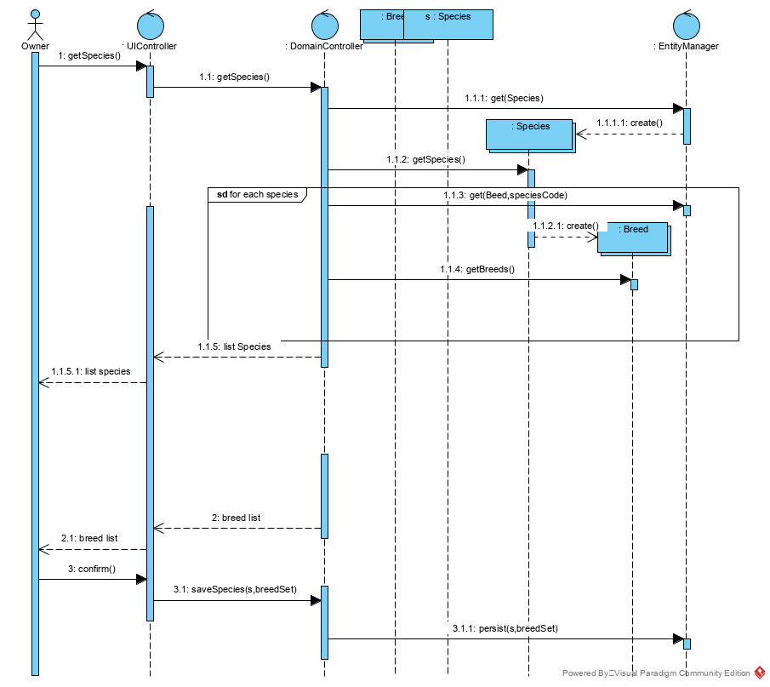

User Story

I charge for my services based on species and breed. I would like to record the service name, a description of the service, the minimum number of hours that the service takes and a cost per hour. My costs change depending on how much water and electricity that I have to use for a service.

Acceptance Criteria:

1. Must be able to query services by breeds.

Use Case Descriptions

|  |  |  |  |
| --- | --- | --- | --- |
| Use Case Name | Create a service for a breed. | | |
| Triggering Event | A new breed. | | |
| Brief Description | Allows the Owner to record service information for a breed | | |
| Actors | Owner | | |
| Related Use Cases |  | | |
| Preconditions | Owner has opened the Main Menu. | | |
| Post Conditions | Service added and available for query | | |
| Flow of activities | Actor | | System |
|  | 1. | Requests to add a new service | Display a list of breeds sorted by species. Prompts for breed selection |
|  | 2. | Selects a breed | Display a list of services for the breed.  Prompts to add service code, name, description, hours, and cost/hour  Prompts to save |
|  |  | Enters service code, name, description, hour and cost/hour | Verifies that service code, name, description, hour and cost/hour have been entered.  Displays a list of services for the breed.  Prompts to save |
|  |  | Until all services have been entered | Saves data |
| Exception Conditions | * Owner chooses to cancel adding the service | | |

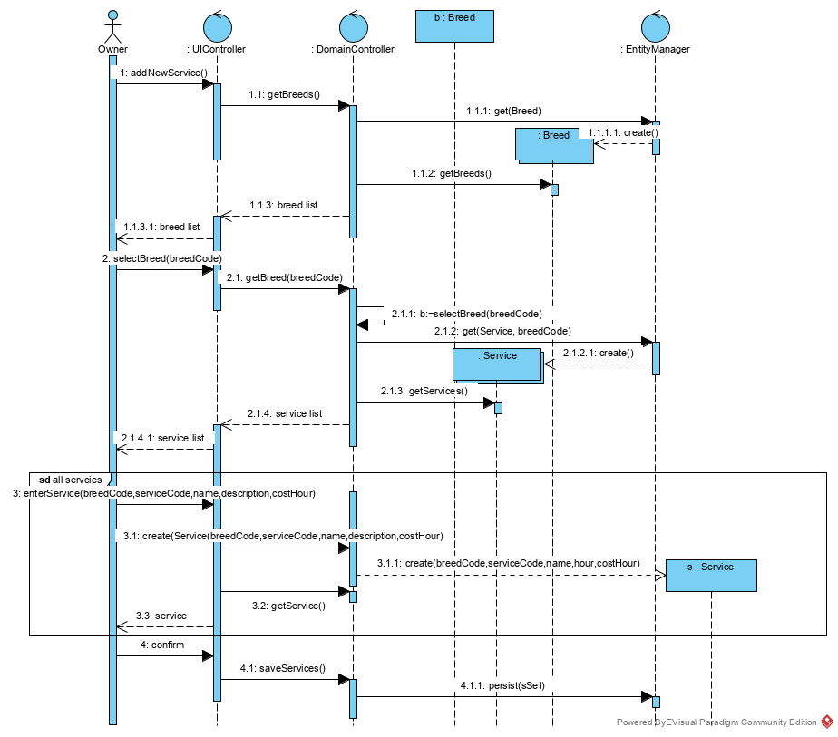

|  |  |  |  |
| --- | --- | --- | --- |
| Use Case Name | Query all services for a breed | | |
| Triggering Event | Request for service information for a breed | | |
| Brief Description | Allows the Owner to retrieve all services for a breed | | |
| Actors | Owner | | |
| Related Use Cases |  | | |
| Preconditions | Owner has opened the Main Menu. | | |
| Post Conditions | All services for a breed are retrieved. | | |
| Flow of activities | Actor | | System |
|  | 1. | Requests to query services for a breed | Display a list of breeds sorted by species. Prompts for breed selection |
|  | 2. | Selects a breed | Displays a list of services for the breed. |
| Exception Conditions | * Owner chooses to cancel retrieve services. | | |

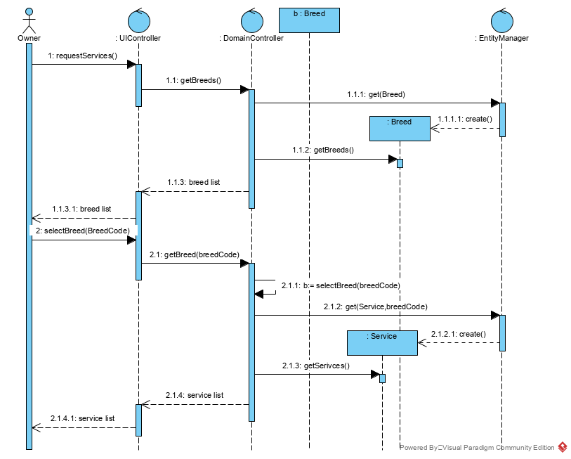

1. A supplier has the following information:
   1. Business Name
   2. Contact Name
   3. Telephone number
   4. Email address
   5. Address
   6. Identifier

Using the examples, try writing a User Story and a scenario for Create Supplier. Create a class diagram and sequence diagram to support your work

|  |  |  |  |
| --- | --- | --- | --- |
| Use Case Name | Create a Supplier | | |
| Triggering Event | A new supplier to the business | | |
| Brief Description | Allows the Owner to create a supplier | | |
| Actors | Owner | | |
| Related Use Cases |  | | |
| Preconditions | Owner has opened the Main Menu. | | |
| Post Conditions | Supplier is added and available to query | | |
| Flow of activities | Actor | | System |
|  |  | Requests to add a new supplier | Displays a list of suppliers and prompts for new supplier details including business name, contact name, telephone number, email address and address |
|  |  | Enters business name, contact name, telephone number, email address and address. Requests to add supplier | Verifies that information was entered. Generate a unique supplier code. Displays information and prompts for confirmation. |
|  |  | Confirms entry | Saves the supplier and returns to the main menu |
| Exception Conditions | * Owner chooses to cancel adding the supplier | | |

