University of Information Technology – VNU-HCM
Faculty of Computer Engineering
CSBU102 – Computer System
LAB 02
Accessing Main Memory: Words, Arrays, Bytes and Strings
Full name | Trang Như Thịnh | Student ID | 26560060
Class | ATBC2026 | Practice date | 11/11/2026
Self-assessed score |  | GitHub link | https://github.com/trangthinh-lang/Lab02_26560060

1. LAB OVERVIEW
Purpose. In LAB 1 every value lived in one of the 32 registers. Real programs use far more data than that, such as a list of scores or a line of text, and keep it in main memory (RAM); a processor can calculate only on registers. In this session you will learn how a program finds data in memory, brings it into a register and writes a result back, for whole words (arrays) and for single bytes (characters). Every new idea is explained first and then practised.
Situation: a lecturer’s score sheet
A lecturer keeps the scores of a class and the students’ names in a small program. Even five scores and one name are too much to keep in registers, so the program stores them in main memory and moves one value at a time into a register to read, change or add it. All names and scores are fictitious.

After this session, you can:
- explain address, word and the alignment rule, and declare data with .word, .byte and .asciiz;
- read and write words with lw and sw (base register + offset) and compute the address of array element i as base + 4 × i, also when i is held in a register;
- read and write bytes with lb, lbu and sb, and explain sign extension and byte order from your own observations;
- change data in memory: swap two elements, update an element, edit characters of a string;
- predict, observe and explain what a short program does with memory, including what happens when it goes wrong.
Table 1. Structure of the session
Part | Content | Score
0 | Getting started: the memory panes of MARS | –
1 | Experiment 1 – Words and addresses | 30
2 | Experiment 2 – Arrays: reading and writing elements | 30
3 | Experiment 3 – Bytes, characters and strings | 25
4 | Wrap-up and submission | 15
 | Total | 100
Ext | Extension – A 3 × 3 board in memory (optional) | +10

Working conventions
• A yellow cell is where you write an answer or a value (your text appears in red). A dashed frame is where you paste a screenshot. Listings are in grey frames; a line that starts with # >>> marks a place where you write code.
• Questions are labelled Understand, Apply, Analyze or Evaluate. Many activities follow PREDICT → OBSERVE → EXPLAIN: write down what you expect, run the program and record what happens, then explain any difference. A wrong prediction is never penalised; the explanation earns the marks.
• Save every program you submit as Lab02_<StudentID>_<Part>.asm, for example Lab02_22520001_TN2.asm (parts TN1 to TN3 and EXT), and start it with a comment block with your name, student ID and a one-line purpose.

PART 0. GETTING STARTED: THE MEMORY PANES OF MARS
You already know how to assemble, run and step through a program. This time you also use the Data Segment, the MARS pane that shows main memory (Table 2).
Table 2. Skills checklist
☐ | Skill | Hint
☐ | Check the settings | Settings: tick Permit extended (pseudo) instructions and Initialize Program Counter to global ‘main’.
☐ | Read the Data Segment | Each row starts with an address; the columns Value (+0), Value (+4), … show the words that follow. Tick Hexadecimal Values / Addresses or ASCII to change the display.
☐ | Find the address of a label | Settings → Show Labels Window (symbol table).
☐ | Set a breakpoint | Tick the Bkpt box of an instruction in the Text Segment; Go stops just before it.
Step 0 – Quick check. Type Listing 0, assemble and run it (it prints one number read from memory). Then find the label x in the Labels window and the number 7 in the Data Segment.
Listing 0
# Listing 0 - quick check
.data
x: .word 7
msg: .asciiz "Value read from memory: "
nl: .asciiz "\n"

.text
.globl main
main:
li $v0, 4
la $a0, msg
syscall
la $t0, x
lw $a0, 0($t0)
li $v0, 1
syscall
li $v0, 4
la $a0, nl
syscall
li $v0, 10
syscall
Text in the Run I/O pane:
Value read from memory: 7

EXPERIMENT 1. WORDS AND ADDRESSES (30 points)
Situation
Before the program can add two scores it must find them. A processor sees not a list of named scores but a very long row of numbered storage cells. This experiment shows how a program names a cell, brings its contents into a register and writes a result back.

Background: main memory, addresses and words
Main memory is a long row of bytes (8 bits). Every byte has its own number, its address. A MIPS register holds one word of 4 bytes, which occupies four consecutive addresses; the address of a word is the address of its first byte and must be a multiple of 4 (the alignment rule). In MARS, declared data begins at 0x10010000 (Figure 1).
The processor calculates only with registers, so a program loads a value into a register and stores a result back: lw $t0, 8($s0) copies the word at address $s0 + 8 into $t0, and sw $t0, 8($s0) copies $t0 into that word. The constant 8 is the offset (in bytes), $s0 is the base register, and base + offset is the effective address. A label names an address, and la $s0, scores copies the address of scores into $s0. Table 3 lists the directives that place data in memory.
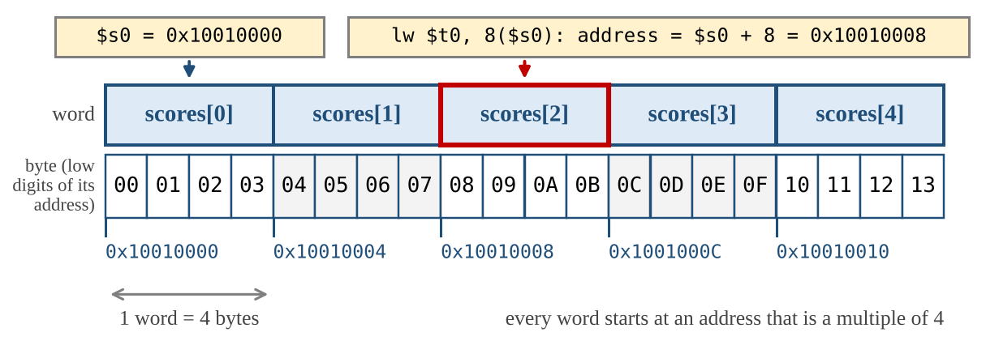
Figure 1. An array of five words in memory and the effective address of lw $t0, 8($s0)
Table 3. Data declarations
Directive | Example | What is placed in memory
.word | a: .word 40, 55, 70 | Consecutive 32-bit words (an array); the label is the address of the first one.
.byte | b: .byte 65 | One byte with the value 65.
.asciiz | s: .asciiz "Hi" | One byte per character, then one extra byte of value 0 that marks the end of the string.

Step 1.1 – Variables in memory (10 points)
In LAB 1, a = b + c was a single add on registers. Now the variables live in memory. Type Listing 1, assemble it, PREDICT the values in Table 4, then run it (decimal display) and OBSERVE. Also read the addresses in Table 5 (pc and $sp from the Registers pane right after assembling).
Listing 1
# Listing 1 - varA = varB + varC, with all three variables in memory
.data
varB: .word 25
varC: .word 17
varA: .word 0

.text
.globl main
main:
la $t0, varB # $t0 = address of varB
lw $t1, 0($t0) # $t1 = varB
lw $t2, 4($t0) # $t2 = varC
add $t3, $t1, $t2 # $t3 = varB + varC
sw $t3, 8($t0) # varA = $t3
li $v0, 10
syscall
Table 4. Predict and observe Listing 1
Item | PREDICT (decimal) | OBSERVE (decimal)
$t3 | 42 | 42
Word at label varA in the Data Segment | 42 | 42
Table 5. Addresses in the program
Item | Address (hex)
pc before the program runs | 0x00400000
Label varB / varC / varA | 0x10010000/ 0x10010004/ 0x10010008
$sp before the program runs | 0x7fffeffc
Question 1.1 (Understand) Why do the addresses of varB, varC and varA differ by that number of bytes? The instructions, the declared data and the stack are kept in three different regions: which address belongs to which region, and which region has the highest addresses?
The addresses of varB, varC, and varA differ by 4 bytes because each variable is declared with .word (32 bits = 4 bytes). In MIPS, memory is byte-addressed, so consecutive 32-bit words are placed 4 bytes apart.
Instructions (.text) reside in the Text Segment starting at 0x00400000 (pc).
Declared data (.data) resides in the Data Segment starting at 0x10010000 (varB, varC, varA).
Function call frames and local variables reside in the Stack Segment starting at 0x7fffeffc ($sp).
The Stack Segment has the highest addresses (0x7fffeffc > 0x10010000 > 0x00400000).

Step 1.2 – Base plus offset (10 points)
Type Listing 2 (an array of five scores). For each instruction in Table 6, work out the effective address and PREDICT the value that ends up in the destination register; run the program and record the observed value. Row (4) is an addi: its result is an address (hexadecimal).
Listing 2
# Listing 2 - addresses and offsets
.data
scores: .word 40, 55, 70, 85, 100

.text
.globl main
main:
la $s0, scores # $s0 = address of scores[0]
lw $t0, 0($s0) # (1)
lw $t1, 4($s0) # (2)
lw $t2, 16($s0) # (3)
addi $s1, $s0, 8 # (4) $s1 = $s0 + 8
lw $t3, 0($s1) # (5)
lw $t4, -4($s1) # (6)
li $v0, 10
syscall
Table 6. Effective addresses and loaded values
# | Instruction | Effective address (hex) | PREDICT value | OBSERVE value
(1) | lw $t0, 0($s0) | 0x10010000 | 40 | 40
(2) | lw $t1, 4($s0) | 0x10010004 | 55 | 55
(3) | lw $t2, 16($s0) | 0x10010010 | 100 | 100
(4) | addi $s1, $s0, 8 | – | 0x10010008 | 0x10010008
(5) | lw $t3, 0($s1) | 0x10010008 | 70 | 70
(6) | lw $t4, -4($s1) | 0x10010004 | 55 | 55
Question 1.2 (Apply) Write the formula for the address of element i of an array of words in terms of the address of element 0, and use it for scores[3]. Why does 4 appear in the formula, and not 1?
Formula: $\text{Address of element }i=\text{base}+4×i$ (where $\text{base}$ is the address of element 0).
For scores[3]: $\text{Address}=0\text{x}10010000+4×3=0\text{x}10010000+12=0\text{x}1001000\text{C}$.
Because MIPS uses byte addressing. A word comprises 4 bytes, so each consecutive array element begins 4 bytes after the previous one.

Step 1.3 – Break it on purpose (10 points)
For each change in Table 7, PREDICT what will happen, change instruction (2) of Listing 2 (one change at a time), run the program and OBSERVE. In (a), also note the message that MARS shows. Restore the program afterwards.
Table 7. Controlled experiments
Change | PREDICT | OBSERVE
(a) lw $t1, 2($s0) | Runtime error/exception due to unaligned word access (0x10010002 is not a multiple of 4). | Runtime exception at 0x00400008: fetch address not aligned on word boundary 0x10010002.
(b) lw $t1, 20($s0) | Program executes without error, loading whatever 32-bit word lies immediately after the array. | Program executes normally; $t1 receives 0 (or value stored in memory at 0x10010014).
Question 1.3 (Analyze) Explain (a) and (b). Which one does the processor detect, and which does it not? What does this say about who is responsible for keeping an access inside an array?
The processor hardware detects (a) because attempting to fetch a 4-byte word from address 0x10010002 violates the MIPS hardware alignment rule (address must be divisible by 4). The processor does not detect (b) because 0x10010014 is properly aligned to a 4-byte boundary.
This demonstrates that the programmer (or compiler) is strictly responsible for array bounds checking, whereas the processor hardware enforces memory alignment rules.

EXPERIMENT 2. ARRAYS: READING AND WRITING ELEMENTS (30 points)
Situation
The lecturer finds a mistake in the score sheet. Two scores must be exchanged, one score must be corrected, and the total of the five scores must be recalculated. All of this happens in memory, element by element.

Background: the address of element i
The elements of an array are words stored one after another, so element i is at base + 4 × i (Experiment 1). When the index is a constant, you write 4 × i yourself as the offset of lw or sw. When the index is held in a register, the program must compute the address: sll $t1, $s1, 2 shifts $s1 left by two bits, which multiplies it by 4, and add $t1, $t1, $s0 adds the base address. Then lw or sw uses 0($t1).

Step 2.1 – Swap two scores (10 points)
Complete Listing 3 so that it exchanges scores[0] and scores[4] in memory, using only lw and sw. After the run, the Data Segment must show 100, 55, 70, 85, 40 (decimal).
Listing 3
# Listing 3 - swap two scores in memory
.data
scores: .word 40, 55, 70, 85, 100

.text
.globl main
main:
la $s0, scores # $s0 = address of scores[0]
# >>> load scores[0] into $t0
# >>> load scores[4] into $t1
# >>> store $t1 into scores[0]
# >>> store $t0 into scores[4]
li $v0, 10
syscall
Screenshot of the Data Segment after the run:
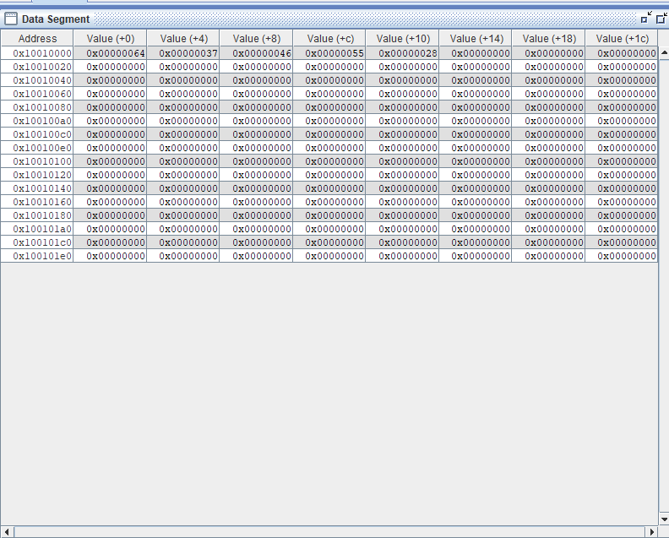Paste screenshot here
Question 2.1 (Analyze) Why did you need two registers? Could one temporary register be enough? Explain.
Two temporary registers are required because copying a value directly into memory location scores[0] before reading its original content would overwrite and permanently destroy scores[0]

Step 2.2 – The index in a register (10 points)
Listing 4 computes the address of scores[i] from the index i in $s1 and prints the element. Type it and run it with i = 3 to see how it works. Then, for each variant in Table 8, PREDICT the result (for (a) to (c): $t1 in hexadecimal and $t2; for (d): what happens), change the program, run it and OBSERVE. Restore the original program after each variant.
Listing 4
# Listing 4 - the index of the element is held in a register
# Register plan: $s0 = address of scores[0] $s1 = i
.data
scores: .word 40, 55, 70, 85, 100
msg: .asciiz "scores[i] = "
nl: .asciiz "\n"

.text
.globl main
main:
la $s0, scores # $s0 = address of scores[0]
addi $s1, $zero, 3 # i = 3
sll $t1, $s1, 2 # $t1 = 4 * i
add $t1, $t1, $s0 # $t1 = address of scores[i]
lw $t2, 0($t1) # $t2 = scores[i]
li $v0, 4
la $a0, msg
syscall
li $v0, 1
add $a0, $t2, $zero
syscall
li $v0, 4
la $a0, nl
syscall
li $v0, 10
syscall
Table 8. Variants of Listing 4
Variant | PREDICT | OBSERVE
(a) i = 0 | $t1 = 0x10010000, $t2 = 40. Prints scores[i] = 40. | $t1 = 0x10010000, $t2 = 40. Output: scores[i] = 40.
(b) i = 2 | $t1 = 0x10010008, $t2 = 70. Prints scores[i] = 70. | $t1 = 0x10010008, $t2 = 70. Output: scores[i] = 70.
(c) i = 4 | $t1 = 0x10010010, $t2 = 100. Prints scores[i] = 100. | $t1 = 0x10010010, $t2 = 100. Output: scores[i] = 100.
(d) i = 3 and sll $t1, $s1, 1 | $t1 = 0x10010006. | Runtime exception at 0x00400010: fetch address not aligned on word boundary 0x10010006.
Question 2.2 (Analyze) Why does the shift amount have to be 2? Explain what happened in (d) and which part of the computer detected the problem.
The shift amount must be 2 because shifting left by 2 bits multiplies an integer by $2^{2}=4$, which converts the element index $i$ into a 4-byte word offset.
Shifting by 1 bit multiplied $i=3$ by $2^{1}=2$, yielding byte offset 6. Adding 6 to 0x10010000 produced address 0x10010006. The CPU execution unit detected that 0x10010006 is not divisible by 4, throwing an unaligned memory access hardware exception.

Step 2.3 – Your own data (10 points)
Let D be the last digit of your student ID. In Table 9, find the index k and the new score V. Write a program, starting from Listing 4, that (1) puts k in $s1 and V in a register and stores V into scores[k] with sw, using the address computation of Step 2.2; (2) adds up the five scores in $s3, loading each one with lw and a constant offset; (3) prints Total: followed by the total and a new line. First run it without step (1): the total of the original scores is 350. Then PREDICT the total for your own data by hand, run the program and complete Table 10.
Table 9. Personal data (D = last digit of the student ID)
D | k | V | D | k | V
0 | 0 | 15 | 5 | 0 | 62
1 | 1 | 28 | 6 | 1 | 77
2 | 2 | 33 | 7 | 2 | 84
3 | 3 | 46 | 8 | 3 | 91
4 | 4 | 59 | 9 | 4 | 98
Table 10. Results for your own data
My D | Result | Total | scores[k] in the Data Segment
0 | PREDICT | 325 | 0
0 | OBSERVE | 325 | 0

EXPERIMENT 3. BYTES, CHARACTERS AND STRINGS (25 points)
Situation
The score sheet also contains students’ names. Text is stored one character per byte, so the program must read and write single bytes, not only whole words.

Background: characters, bytes and byte order
A character is stored as a small number, its ASCII code (Table 18): A is 65 (0x41), a is 97 (0x61), the digit 0 is 48. A string declared with .asciiz is a sequence of codes followed by a byte of value 0. Three instructions work on single bytes (Table 11); a byte address can be any number.
A word occupies four consecutive bytes, so a computer must decide which byte of the number goes to the lowest address. In little-endian order the least significant byte comes first; in big-endian order the most significant byte comes first. Both are used in real computers, and the lecture slides show both. Step 3.2 shows which one MARS uses.
Table 11. Instructions that move single bytes
Instruction | Example | Meaning
lb | lb $t0, 1($s0) | Load the byte at address $s0 + 1; the upper 24 bits are filled with copies of the byte’s top bit (sign extension).
lbu | lbu $t0, 1($s0) | Load the byte at address $s0 + 1; the upper 24 bits are filled with zeros.
sb | sb $t0, 1($s0) | Store the lowest 8 bits of $t0 in the byte at address $s0 + 1.

Step 3.1 – The bytes of a string (6 points)
Type Listing 5 and assemble it; tick ASCII in the Data Segment. Using Table 18, PREDICT the hexadecimal code of each byte of "Hi!"; then run and complete Table 12 and the answer below it.
Listing 5
# Listing 5 - the bytes of a string
.data
word1: .asciiz "Hi!"

.text
.globl main
main:
la $s0, word1 # $s0 = address of the first byte
lb $t0, 0($s0)
lb $t1, 1($s0)
lb $t2, 2($s0)
lb $t3, 3($s0)
li $v0, 11 # service 11: print one character
add $a0, $t1, $zero # the byte that was loaded into $t1
syscall
li $v0, 10
syscall
Table 12. The bytes of word1
Offset | Address (hex) | PREDICT byte (hex) | OBSERVE byte (hex) | Character
0 | 0x10010000 | 0x48 | 0x48 | ‘H’
1 | 0x10010001 | 0x69 | 0x69 | ‘i’
2 | 0x10010002 | 0x21 | 0x21 | ‘!’
3 | 0x10010003 | 0x00 | 0x00 | ‘\0’
PREDICT – character printed in the Run I/O pane:
i
Question 3.1 (Understand) How many bytes does "Hi!" occupy, and why one more than the number of visible characters? What is the address of the last byte?
Hi!" occupies 4 bytes in memory.
It requires 3 bytes for the visible characters 'H', 'i', '!' plus 1 additional byte for the terminating null byte (0x00) appended automatically by .asciiz.
0x10010003.

Step 3.2 – Which byte comes first? (6 points)
Listing 6 stores the word 0x41424344 and reads its four bytes one by one. Decide which byte order you expect MARS to use and PREDICT the four bytes; then run it and complete Table 13.
Listing 6
# Listing 6 - one word, four bytes
.data
w: .word 0x41424344

.text
.globl main
main:
la $s0, w
lb $t0, 0($s0) # byte at offset 0
lb $t1, 1($s0) # byte at offset 1
lb $t2, 2($s0) # byte at offset 2
lb $t3, 3($s0) # byte at offset 3
lw $t4, 0($s0) # the whole word
li $v0, 10
syscall
Table 13. Reading the bytes of one word
Item | PREDICT (hex) | OBSERVE (hex)
Byte at offset 0 ($t0) | 0x44 | 0x44
Byte at offset 1 ($t1) | 0x43 | 0x43
Byte at offset 2 ($t2) | 0x42 | 0x42
Byte at offset 3 ($t3) | 0x41 | 0x41
Whole word ($t4) | 0x41424344 | 0x41424344
Question 3.2 (Analyze) Which byte of 0x41424344 is at the lowest address in MARS, and which byte order is that? Does it match your prediction? Why does $t4 still hold 0x41424344, and why does a program that uses only lw and sw never notice the byte order?
0x44 (the least significant byte) is placed at the lowest address (0x10010000).
When loading a word (lw), the hardware automatically reassembles the byte sequence so that lower memory addresses correspond to lower byte positions inside the register.
Why lw/sw programs notice no difference: lw and sw move entire 32-bit registers to and from memory symmetrically, insulating word-level data operations from internal byte layout.

Step 3.3 – Signed and unsigned bytes (6 points)
Listing 7 stores one byte of value 0xF0 and loads it twice. PREDICT $t0 and $t1 in hexadecimal and decimal, run it, and complete Table 14.
Listing 7
# Listing 7 - lb and lbu
.data
b1: .byte 0xF0

.text
.globl main
main:
la $s0, b1
lb $t0, 0($s0)
lbu $t1, 0($s0)
li $v0, 10
syscall
Table 14. lb and lbu compared
Instruction | PREDICT (hex) | PREDICT (dec) | OBSERVE (hex) | OBSERVE (dec)
lb $t0, 0($s0) | 0xfffffff0 | -16 | 0xfffffff0 | -16
lbu $t1, 0($s0) | 0x000000f0 | 240 | 0x000000f0 | 240
Question 3.3 (Analyze) Explain the difference in terms of sign extension (compare LAB 1, Question 2.4). Which instruction would you use to read the brightness of a pixel stored as a number from 0 to 255, and why?
lb performs sign extension by replicating bit 7 (the sign bit, which is 1 for 0xF0) across all top 24 bits of the register, preserving signed 2's complement numbers. lbu performs zero extension, clearing all upper 24 bits to 0.
Use lbu because pixel intensity values are unsigned quantities from 0 to 255. Using lb would incorrectly turn brightness levels $≥128$ into negative integers.

Step 3.4 – Capital letters by hand (7 points)
A capital letter has a code 32 below the matching lower-case letter (Table 18). Complete Listing 8 so that it changes the letters at offsets 0, 7 and 11 of str1 into capital letters: for each one, load the byte with lb, subtract 32 and store it back with sb. The program must print Nguyen Van An. Then change .asciiz to .ascii in the declaration of str1, PREDICT the output, run it and OBSERVE (Table 15). Restore .asciiz afterwards.
Listing 8
# Listing 8 - capital letters at chosen positions of a string
# Register plan: $s0 = address of the first byte of str1
.data
str1: .asciiz "nguyen van an"
tag: .asciiz " [end]"
nl: .asciiz "\n"

.text
.globl main
main:
la $s0, str1 # $s0 = address of str1
# >>> make the byte at offset 0 a capital letter
# >>> make the byte at offset 7 a capital letter
# >>> make the byte at offset 11 a capital letter
li $v0, 4 # service 4: print the string that starts at $a0
add $a0, $s0, $zero
syscall
li $v0, 4
la $a0, nl
syscall
li $v0, 10
syscall
Screenshot of the Run I/O pane (with .asciiz):
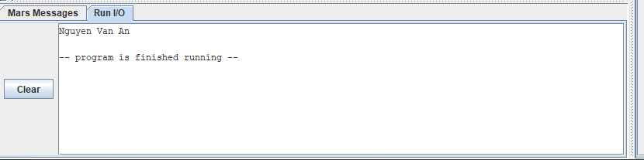Paste screenshot here
Table 15. A string without the terminating zero
Change | PREDICT | OBSERVE
.ascii instead of .asciiz | Nguyen Van An [end] | Nguyen Van An [end]
Question 3.4 (Analyze) Explain the output you observed with .ascii. Where did the extra text come from, and how does the print service know where a string ends?
When changing to .ascii, no terminating null byte (0x00) is inserted after "nguyen van an". System call 4 continues reading contiguous bytes in memory until it finds a 0x00. It prints through str1 directly into the adjacent memory location holding tag (" [end]"), finally stopping at the null byte of tag.

EXTENSION. A 3 × 3 BOARD IN MEMORY (optional – up to 10 bonus points)
A game board with 3 rows and 3 columns is stored in memory as nine words, row by row: board: .word 0, 0, 0, 0, 0, 0, 0, 0, 0. The cell in row r and column c (both counted from 0) is word number 3 × r + c, so its address is board + 4 × (3 × r + c). Write a program that keeps r in $s1 and c in $s2, computes this address with sll and add (3 × r is r + 2 × r), and stores the value 1 (mark X) into the cell (1, 2) and the value 2 (mark O) into the cell (2, 0). After the run, the Data Segment must show 1 and 2 in two of the nine words and 0 in all the others.
Question E.1 (Analyze) Which two words of board changed, at which addresses, and why does the formula give these words?
Cell (1, 2) holds value 1.
Cell (2, 0) holds value 2.
Row-major order maps a 2D grid into contiguous 1D memory. Multiplying row $r$ by 3 skips full preceding rows of 3 elements each, and adding column $c$ steps to the specific cell within that row. Multiplying by 4 scales the 1D index to byte addresses.

PART 4. WRAP-UP AND SUBMISSION (15 points)
Question 4.1 (Understand) Explain why varA = varB + varC needs two loads and one store in addition to the add when the variables are in memory. Use the terms register, main memory, load and store. (5 points)
Two load (lw) instructions copy the values of varB and varC from main memory into registers.
The add instruction calculates their sum inside a register.
One store (sw) instruction copies the result from the register back into main memory at varA.

Question 4.2 (Apply) Write the MIPS instructions for scores[3] = scores[1] + scores[2]. Assume $s0 holds the address of scores[0] and use only $t registers. (5 points)
lw $t0, 4($s0)
lw $t1, 8(4s0)
add $t2, $t0, $t1
sw $t2, 12($s0)

Question 4.3 (Evaluate) lw and sw need an address that is a multiple of 4, but lb and sb accept any address. Explain why, and name one task from this LAB where a byte instruction is the right choice and one where a word instruction is. (5 points)
lw and sw access 32-bit (4-byte) words, which hardware rules dictate must start at addresses divisible by 4. In contrast, lb and sb operate on single bytes (8 bits), which is the base addressable unit of memory; therefore, every byte address is inherently aligned.
Reading or updating character strings.
Loading and storing 32-bit integer elements in an array to calculate class totals

Table 16. Submission checklist
☐ | Item
☐ | The files Lab02_<StudentID>_TN1.asm to _TN3.asm (and _EXT.asm if you did the extension) are saved with the correct names, begin with a comment block and assemble without errors.
☐ | Every # >>> marker is replaced by your own code and the register plan is documented in comments.
☐ | This document is complete: all yellow cells are filled and every dashed frame contains a screenshot.
☐ | The .asm files are pushed to your GitHub repository, the link is written on the first page, and everything is submitted as announced by your instructor.

APPENDIX. REFERENCE
Table 17. Instructions and system calls used in this LAB
Instruction | Example | Meaning
lw / sw | lw $t0, 8($s0) | $t0 = word at address $s0 + 8 / word at that address = $t0 (address a multiple of 4)
lb / lbu | lb $t0, 1($s0) | $t0 = byte at address $s0 + 1, sign-extended / filled with zeros
sb | sb $t0, 1($s0) | byte at address $s0 + 1 = lowest 8 bits of $t0
la, li | la $s0, label | pseudo-instructions: $s0 = address of label; li $t0, 7: $t0 = 7
add, addi | addi $t0, $t1, 20 | $t0 = $t1 + 20 (add uses two registers)
sll | sll $t1, $s1, 2 | $t1 = $s1 shifted left by 2 bits (4 × $s1)
syscall | $v0 = 1, 4, 10 | print integer ($a0); print string ($a0 = address); exit
Table 18. ASCII codes used in this LAB
Character | Decimal | Hexadecimal | Remark
end of string | 0 | 0x00 | terminator of .asciiz
space; ! | 32; 33 | 0x20; 0x21
digits 0 to 9 | 48 – 57 | 0x30 – 0x39 | consecutive
capital letters A to Z | 65 – 90 | 0x41 – 0x5A | consecutive
lower-case letters a to z | 97 – 122 | 0x61 – 0x7A | consecutive

