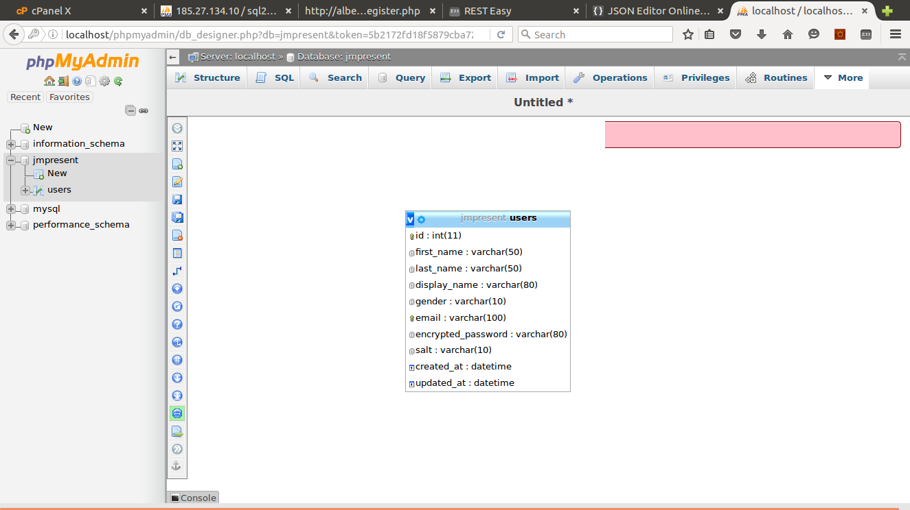
Database structure
- Register User
Request:

Url | http://host/api/register.php
Method | POST
Note

Parameter | Presence | Data Type | Remarks
first_name | Required | String
last_name | Required | String
display_name | Required | String
gender | Required | String
email | Required | String | Unique (check email existed or not)
password | Required | String

Response:

Parameter | Presence | Data Type | Remarks
statusCode | Required | int | 1000  9000  9100  9200
statusMsg | Required | String | “Success”  “Unknown error occurred in registration!”  “User already existed with email: ”  "Required parameters (first_name, last_name, display_name, gender, email or password) is missing!"
result | Required | Object

Example:

Request | http://host/api/register.php?first_name=abc&last_name=xyz&display_name=ghyabc&gender=male&email=useremail@mail.com&password=123456
Response | {  "statusCode": 1000,  "statusMsg": "Success",  "result": {  "firstName": "abc",  "lastName": "xyz",  "displayName": "ghyabc",  "gender": "male",  "email": "useremail@mail.com",  "createdTime": "2016-04-29 14:56:15",  "updatedTime": null  }  }

- Login

Request:

Url | http://host/api/login.php
Method | POST
Note

Parameter | Presence | Data Type | Remarks
email | Required | String | Unique (check email existed or not)
password | Required | String

Response:

Parameter | Presence | Data Type | Remarks
statusCode | Required | int | 1000  9200  9300
statusMsg | Required | String | “Success”  “Required parameters email or password is missing!”  “Login credentials are wrong. Please try again!”
result | Required | Object

Example:

Request | http://host/api/login.php?email=useremail@mail.com&password=123456
Response | {  "statusCode": 1000,  "statusMsg": "Success",  "result": {  "firstName": "abc",  "lastName": "xyz",  "displayName": "ghyabc",  "gender": "male",  "email": "useremail@mail.com",  "createdTime": "2016-04-29 14:56:15",  "updatedTime": null  }  }

- Get User

Request:

Url | http://host/api/get_user_details.php
Method | GET
Note

Parameter | Presence | Data Type | Remarks
email | Required | String | Unique (check email existed or not)

Response:

Parameter | Presence | Data Type | Remarks
statusCode | Required | int | 1000  9200  9400
statusMsg | Required | String | “Success”  “Required parameters email is missing!”  “Email is not exist!”
result | Required | Object

Example:

Request | http://host/api/get_user_details.php?email=useremail@mail.com
Response | {  "statusCode": 1000,  "statusMsg": "Success",  "result": {  "firstName": "abc",  "lastName": "xyz",  "displayName": "ghyabc",  "gender": "male",  "email": "useremail@mail.com",  "createdTime": "2016-04-29 14:56:15",  "updatedTime": null  }  }

- Get All Users

Request:

Url | http://host/api/get_all_user_details.php
Method | GET
Note

Parameter | Presence | Data Type | Remarks

Response:

Parameter | Presence | Data Type | Remarks
statusCode | Required | int | 1000  9500
statusMsg | Required | String | “Success”  “No user found!”
result | Required | Object

Example:

Request | http://host/api/get_all_user_details.php
Response | {  "statusCode": 1000,  "statusMsg": "Success",  "result": {  "firstName": "abc",  "lastName": "xyz",  "displayName": "ghyabc",  "gender": "male",  "email": "useremail@mail.com",  "createdTime": "2016-04-29 14:56:15",  "updatedTime": null  }  }

- Update User

Request:

Url | http://host/api/update_user.php
Method | POST
Note

Parameter | Presence | Data Type | Remarks
first_name | Required | String | If first_name is null or empty will get old value of user
last_name | Required | String | If last_name is null or empty will get old value of user
display_name | Required | String | If display_name is null or empty will get old value of user
gender | Required | String | If gender is null or empty will get old value of user
email | Required | String | Email to check user existed or not (not to update email)

Response:

Parameter | Presence | Data Type | Remarks
statusCode | Required | int | 1000  9000  9200  9400
statusMsg | Required | String | “Success”  “Unknown error occurred in update!”  “Required parameters (first_name, last_name, display_name, gender, email) is missing!”  "Email is not exist!"
result | Required | Object

Example:

Request | http://host/api/update_user.php?first_name=abc&last_name=&display_name=&gender=male&email=useremail@mail.com
Response | {  "statusCode": 1000,  "statusMsg": "Success",  "result": {  "firstName": "abc",  "lastName": "xyz",  "displayName": "ghyabc",  "gender": "male",  "email": "useremail@mail.com",  "createdTime": "2016-04-29 14:56:15",  "updatedTime": “2016-04-30 17:23:11”  }  }

- Delete User

Request:

Url | http://host/api/delete_user.php
Method | POST
Note

Parameter | Presence | Data Type | Remarks
email | Required | String | Check user existed or not

Response:

Parameter | Presence | Data Type | Remarks
statusCode | Required | int | 1000  9000  9200  9400
statusMsg | Required | String | “Success”  “Unknown error occurred in delete!”  “Required parameters email is missing!”  “Email is not exist!”
result | Required | Object

Example:

Request | http://host/api/delete_user.php?email=useremail@mail.com
Response | {  "statusCode": 1000,  "statusMsg": "Success",  "result": null  }

- Delete All Users

Request:

Url | http://host/api/delete_all_user.php
Method | POST
Note

Parameter | Presence | Data Type | Remarks
delete | Required | int | delete = 1 if delete all users  delete !=1 do nothing

Response:

Parameter | Presence | Data Type | Remarks
statusCode | Required | int | 1000  9200  9400  9600
statusMsg | Required | String | “Success”  “Required parameters (delete) is missing!”  “Delete all user fail!”  “Unknown error occurred in delete!”
result | Required | Object

Example:

Request | http://host/api/delete_all_user.php?delete=1
Response | {  "statusCode": 1000,  "statusMsg": "Success",  "result": null  }

