Data Exploration

# 1. Customers distribution

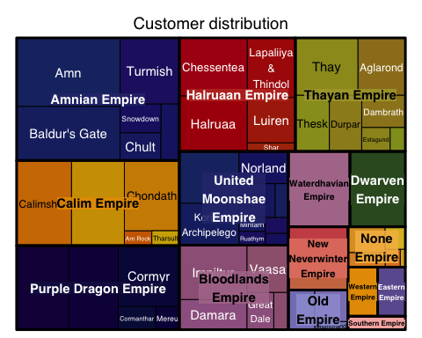

* Number of key account and territory distribution of them

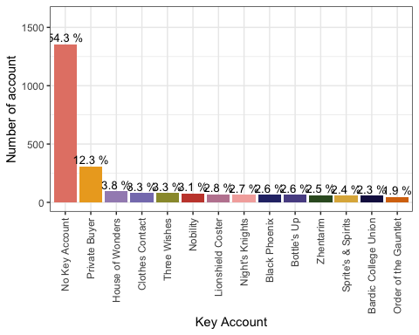

# 2. Product distribution

Product dataset - Number of products per type, contributions of each type in the whole product range

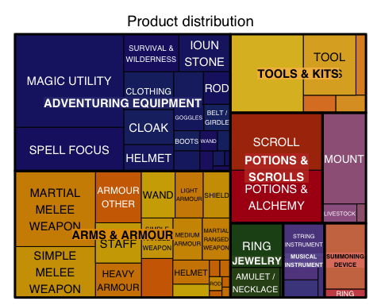

# 3. Order distribution

* Time-serie: Number of order per month and year
* Time-serie: cart price per month and year

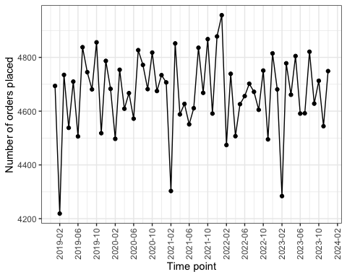

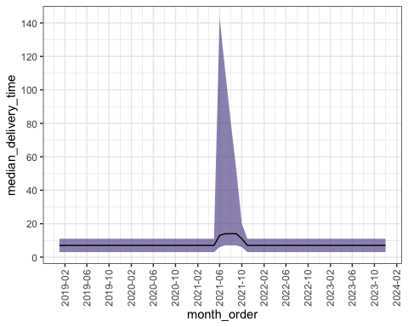

* Customer that ordered the most (in terms of cart price)

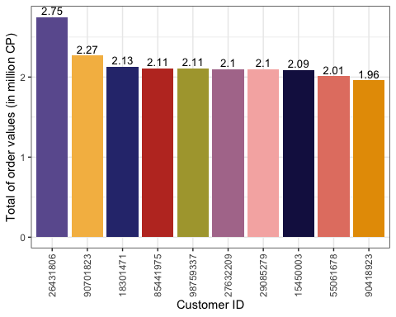

* Territory that ordered the most (in terms of cart price)

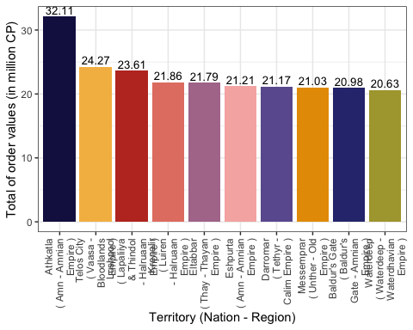

* Products that were sold the most

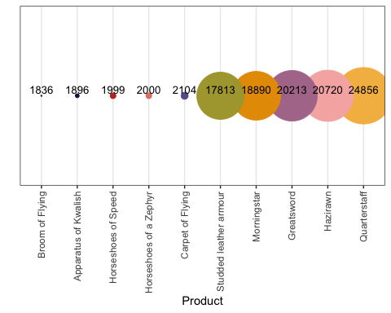

* Products that were sold the most, per month and year

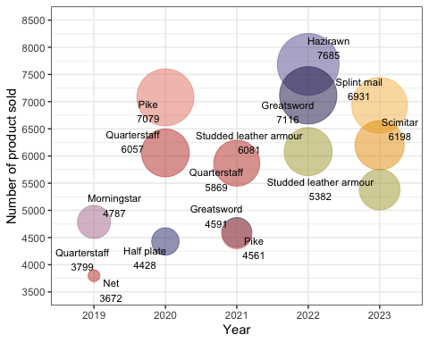

Products that brought the most revenue per year

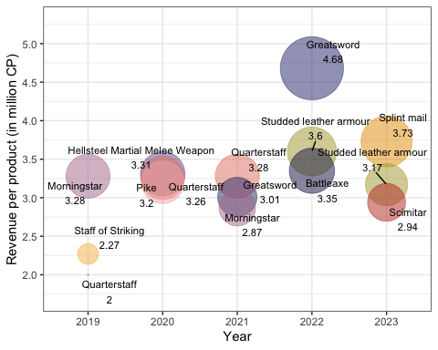

* Products that were sold the most to key account customers, per year and month