D.E.A.D Dataset - Data Exploration

|  |  |
| --- | --- |
| **Feature explored** | **Data type** |
| Region | Categorical |
| Nation | Categorical |
| Number of orders | Numerical |
| Delivery time | Numerical |
| Number of products sold | Numerical |
| Amount of revenue per product | Numerical |

The regions with the most customers are Amnian Empire (439 customers) (Fig 1). The product type with largest number of product are adventuring equipment (670 products) (Figure 2). There is seasonal trend in the number of monthly order, with the trough in February and the peak around (Fig 3). The delivery time is mostly stable over time with median of 7 days (Fig 4). The product that was sold the most was Quarterstall (24855 products sold), and Broom of Flying was sold the least (Fig 5). Product “Greatsword” brought the most yearly revenue (4.68 million CP, in 2022) (Fig 6).

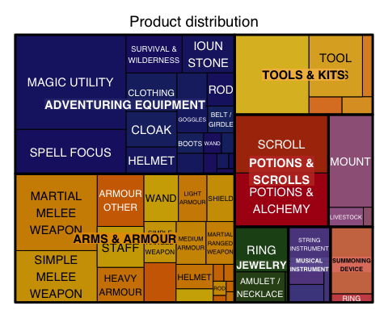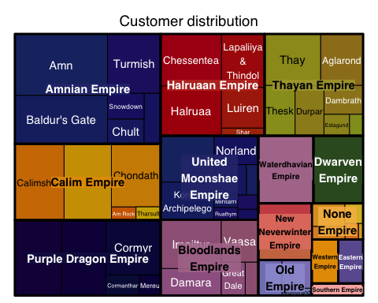

Figure 1. Distribution of customers per Nation and Region Figure 2. Distribution of D.E.A.D products

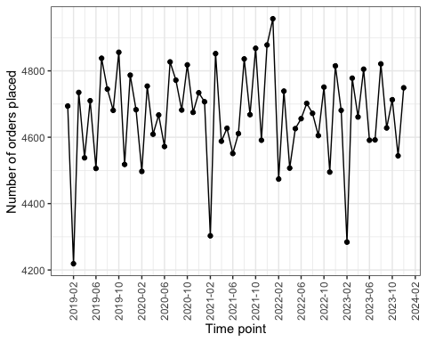

*Figure 3. Total number of orders over time*

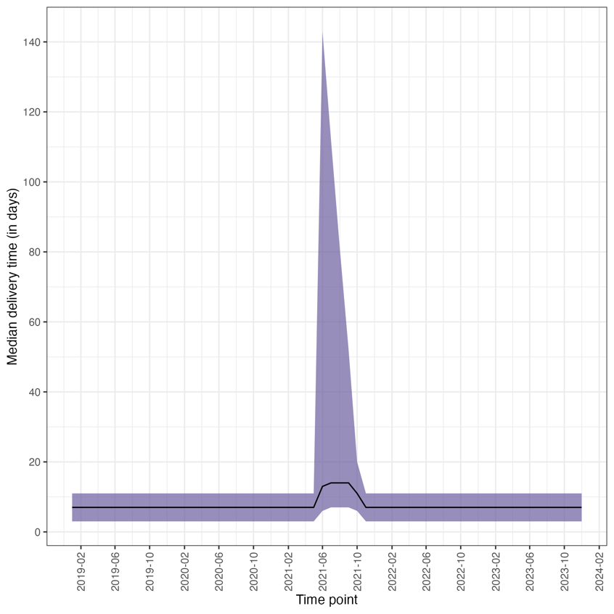

Figure 4. Delivery time over time. Black line indicates median number of days, purple ribbons indicate interquartile range

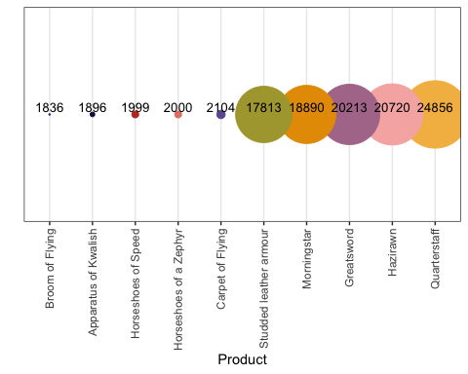

Figure 5. Top 5 most sold and least sold products

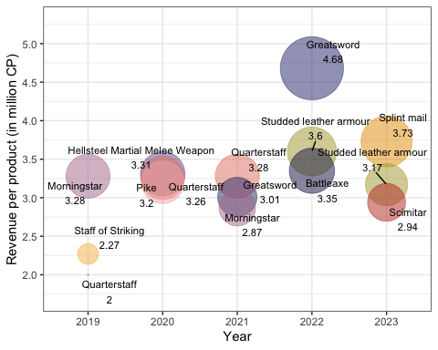

Figure 6. Top 3 products that brought highest revenue per year