Assignment : #5

Description : Your App Status

Class : CPW 253 Spring 2023

Instructor : Ken Meerdink

Student : Tung Kim

Project : Simple Calculator

This quarter is my first time working with Android Studio and Kotlin, which are new to me. My plan is to create an app called Simple Calculator with three or more features.

The main goal is to learn Kotlin and become proficient in using Android Studio.

The first two features I will include are Fragments and a Tabbed Interface. I will determine additional features as the project progresses.

My app will consist of three (or more) tabs/fragments:

1. Calculator: This allows users to perform simple calculations. They can use the result of one equation for the next calculation without having to click the Clear button and start over. Users can also correct any mistaken operator clicks.
2. History: Here, all calculations will be stored and can be cleared as needed.
3. Feedback: This section is where users can provide feedback, suggestions, and recommendations to help me improve the app. 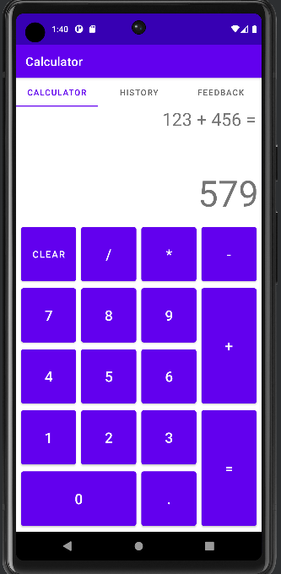Users’ input is greatly appreciated!

