I.Ve giao dien login:

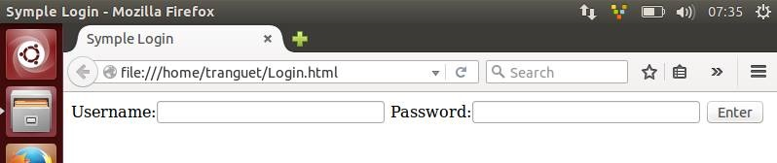

II.Huong dan su dung login:

1.Vao duong dan localhost/Login

2.Nhap username va password

3.Neu nhap dung thi chuyen toi trang helloworld,neu sau thi quay lai trang login

III.Huong dan cai dat Cyclon-1.1 tren ubuntu:

+ Tai file cyclone-1.1.tar.gz ve tu https://pypi.python.org/pypi/cyclone

+ Yeu cau may da cai dat Python,Twisted(co san trong ubuntu).

+ Mo terminal len vao duong dan chua file cyclone-1.1.tar.gz, sau dó chay dong lenh:

tar zxvf cyclone-1.1.tar.gz // giai nen

cd cyclone-1.1 sudo python setup.py install // chay file cài dat

Hoàn thành cài dat.

Tai lieu: <http://cyclone.io/documentation/>