Hello Fresh Regression Modeling
Trang Vu
2026-02-22

R Markdown
This is an R Markdown document of Hello fresh Regression Modeling
### Read in Data ###
PATH = "//Users/janessavu/Desktop/Chang_Trine_University/BA6933/Hello Fresh Project"
FILE_NAME = "HF_scrubbed.csv"
INFILE = paste(PATH,FILE_NAME, sep="/")
df = read.csv(INFILE)
### Summary of the Data ###
df$customer_id = NULL
str(df)
## 'data.frame': 5500 obs. of 34 variables:
## $ age : int 27 61 75 28 43 77 53 63 43 27 ...
## $ dependents : int 2 0 2 1 1 0 0 3 0 0 ...
## $ tenure_months : int 47 29 13 24 22 33 26 21 18 5 ...
## $ city : chr "San Diego" "San Francisco" "Austin" "Los Angeles" ...
## $ state : chr "CA" "CA" "TX" "CA" ...
## $ cook_days_per_week : int 2 3 5 1 2 6 7 6 2 7 ...
## $ recipes_per_week : int 5 2 6 6 2 5 3 2 4 6 ...
## $ latest_discount_used_pct : num 0.77 0.82 0.09 0.61 0.16 0.62 0.13 0.15 0.13 0.34 ...
## $ skips_last_3_months : int 0 5 4 4 2 1 0 4 2 4 ...
## $ delivery_issues_last_3mo : int 0 1 0 0 0 1 0 2 1 0 ...
## $ app_logins_per_month : int 10 7 44 13 22 3 3 22 0 22 ...
## $ recipe_rating : int 2 3 5 4 4 5 3 3 3 1 ...
## $ customer_service_rating : int 1 2 1 2 1 4 4 5 4 1 ...
## $ price_per_recipe : num 12.23 12.66 8.76 12.99 10.87 ...
## $ monthly_charges : num 245 101 210 312 87 ...
## $ total_charges : num 11496 2937 2733 7482 1913 ...
## $ churn : int 1 1 0 0 0 0 0 0 0 1 ...
## $ IMP_income : num 50737 277523 205022 86036 228287 ...
## $ M_income : int 0 0 0 0 0 0 0 0 0 0 ...
## $ FLAG_married : int 0 0 0 1 0 0 0 1 0 0 ...
## $ FLAG_uses_other_meal_kits: int 0 0 0 0 1 0 0 0 1 1 ...
## $ FLAG_Male : int 1 0 1 1 1 0 1 1 1 0 ...
## $ FLAG_meat_veggie : int 0 0 1 0 1 0 1 0 0 1 ...
## $ FLAG_pescatarian : int 0 1 0 1 0 1 0 0 0 0 ...
## $ FLAG_veggie : int 1 0 0 0 0 0 0 1 1 0 ...
## $ FLAG_low_cal : int 1 0 0 0 0 1 0 0 0 0 ...
## $ FLAG_low_sugar : int 0 1 0 0 0 0 0 0 0 1 ...
## $ FLAG_low_salt : int 0 0 1 0 0 0 0 0 0 0 ...
## $ FLAG_plant_based : int 0 0 0 1 1 0 0 0 1 0 ...
## $ FLAG_low_carb : int 0 0 0 0 0 0 0 1 0 0 ...
## $ FLAG_high_prt : int 0 0 0 0 0 0 1 0 0 0 ...
## $ FLAG_classic : int 0 0 0 0 0 0 1 0 0 1 ...
## $ FLAG_premium : int 1 1 0 1 0 0 0 0 0 0 ...
## $ FLAG_quickneasy : int 0 0 1 0 1 1 0 1 1 0 ...
summary(df)
## age dependents tenure_months city
## Min. :18.00 Min. :0.000 Min. : 1.00 Length:5500
## 1st Qu.:32.00 1st Qu.:0.000 1st Qu.:15.00 Class :character
## Median :47.00 Median :1.000 Median :30.00 Mode :character
## Mean :47.22 Mean :1.007 Mean :29.53
## 3rd Qu.:62.00 3rd Qu.:2.000 3rd Qu.:44.00
## Max. :77.00 Max. :7.000 Max. :59.00
## state cook_days_per_week recipes_per_week
## Length:5500 Min. :1.000 Min. :1.00
## Class :character 1st Qu.:2.000 1st Qu.:3.00
## Mode :character Median :4.000 Median :4.00
## Mean :4.043 Mean :3.98
## 3rd Qu.:6.000 3rd Qu.:5.00
## Max. :7.000 Max. :7.00
## latest_discount_used_pct skips_last_3_months delivery_issues_last_3mo
## Min. :0.0000 Min. :0.000 Min. :0.000
## 1st Qu.:0.1300 1st Qu.:1.000 1st Qu.:0.000
## Median :0.4200 Median :3.000 Median :1.000
## Mean :0.4374 Mean :2.504 Mean :1.455
## 3rd Qu.:0.7200 3rd Qu.:4.000 3rd Qu.:2.000
## Max. :1.0000 Max. :5.000 Max. :3.000
## app_logins_per_month recipe_rating customer_service_rating price_per_recipe
## Min. : 0.00 Min. :0.000 Min. :0.000 Min. : 7.08
## 1st Qu.: 8.75 1st Qu.:2.000 1st Qu.:2.000 1st Qu.: 9.94
## Median :20.00 Median :3.000 Median :3.000 Median :10.92
## Mean :20.68 Mean :3.149 Mean :3.028 Mean :11.15
## 3rd Qu.:33.00 3rd Qu.:4.000 3rd Qu.:4.000 3rd Qu.:12.32
## Max. :44.00 Max. :5.000 Max. :5.000 Max. :16.15
## monthly_charges total_charges churn IMP_income
## Min. : 31.64 Min. : 40.92 Min. :0.0000 Min. : 50060
## 1st Qu.:117.12 1st Qu.: 2165.04 1st Qu.:0.0000 1st Qu.:125247
## Median :172.80 Median : 4408.92 Median :0.0000 Median :176464
## Mean :177.69 Mean : 5253.87 Mean :0.1631 Mean :175569
## 3rd Qu.:228.96 3rd Qu.: 7604.64 3rd Qu.:0.0000 3rd Qu.:224338
## Max. :428.68 Max. :20928.48 Max. :1.0000 Max. :299981
## M_income FLAG_married FLAG_uses_other_meal_kits FLAG_Male
## Min. :0.0000 Min. :0.0000 Min. :0.0000 Min. :0.0000
## 1st Qu.:0.0000 1st Qu.:0.0000 1st Qu.:0.0000 1st Qu.:0.0000
## Median :0.0000 Median :0.0000 Median :0.0000 Median :0.0000
## Mean :0.1638 Mean :0.3478 Mean :0.3545 Mean :0.4007
## 3rd Qu.:0.0000 3rd Qu.:1.0000 3rd Qu.:1.0000 3rd Qu.:1.0000
## Max. :1.0000 Max. :1.0000 Max. :1.0000 Max. :1.0000
## FLAG_meat_veggie FLAG_pescatarian FLAG_veggie FLAG_low_cal
## Min. :0.0000 Min. :0.0000 Min. :0.0000 Min. :0.000
## 1st Qu.:0.0000 1st Qu.:0.0000 1st Qu.:0.0000 1st Qu.:0.000
## Median :0.0000 Median :0.0000 Median :0.0000 Median :0.000
## Mean :0.3429 Mean :0.3298 Mean :0.3273 Mean :0.102
## 3rd Qu.:1.0000 3rd Qu.:1.0000 3rd Qu.:1.0000 3rd Qu.:0.000
## Max. :1.0000 Max. :1.0000 Max. :1.0000 Max. :1.000
## FLAG_low_sugar FLAG_low_salt FLAG_plant_based FLAG_low_carb
## Min. :0.00000 Min. :0.00000 Min. :0.0000 Min. :0.0000
## 1st Qu.:0.00000 1st Qu.:0.00000 1st Qu.:0.0000 1st Qu.:0.0000
## Median :0.00000 Median :0.00000 Median :0.0000 Median :0.0000
## Mean :0.09764 Mean :0.09655 Mean :0.3233 Mean :0.1889
## 3rd Qu.:0.00000 3rd Qu.:0.00000 3rd Qu.:1.0000 3rd Qu.:0.0000
## Max. :1.00000 Max. :1.00000 Max. :1.0000 Max. :1.0000
## FLAG_high_prt FLAG_classic FLAG_premium FLAG_quickneasy
## Min. :0.0000 Min. :0.0000 Min. :0.0000 Min. :0.0000
## 1st Qu.:0.0000 1st Qu.:0.0000 1st Qu.:0.0000 1st Qu.:0.0000
## Median :0.0000 Median :0.0000 Median :0.0000 Median :0.0000
## Mean :0.1916 Mean :0.2804 Mean :0.2864 Mean :0.4333
## 3rd Qu.:0.0000 3rd Qu.:1.0000 3rd Qu.:1.0000 3rd Qu.:1.0000
## Max. :1.0000 Max. :1.0000 Max. :1.0000 Max. :1.0000
head(df)
## age dependents tenure_months city state cook_days_per_week
## 1 27 2 47 San Diego CA 2
## 2 61 0 29 San Francisco CA 3
## 3 75 2 13 Austin TX 5
## 4 28 1 24 Los Angeles CA 1
## 5 43 1 22 Brooklyn NY 2
## 6 77 0 33 Dallas TX 6
## recipes_per_week latest_discount_used_pct skips_last_3_months
## 1 5 0.77 0
## 2 2 0.82 5
## 3 6 0.09 4
## 4 6 0.61 4
## 5 2 0.16 2
## 6 5 0.62 1
## delivery_issues_last_3mo app_logins_per_month recipe_rating
## 1 0 10 2
## 2 1 7 3
## 3 0 44 5
## 4 0 13 4
## 5 0 22 4
## 6 1 3 5
## customer_service_rating price_per_recipe monthly_charges total_charges churn
## 1 1 12.23 244.60 11496.20 1
## 2 2 12.66 101.28 2937.12 1
## 3 1 8.76 210.24 2733.12 0
## 4 2 12.99 311.76 7482.24 0
## 5 1 10.87 86.96 1913.12 0
## 6 4 10.00 200.00 6600.00 0
## IMP_income M_income FLAG_married FLAG_uses_other_meal_kits FLAG_Male
## 1 50737 0 0 0 1
## 2 277523 0 0 0 0
## 3 205022 0 0 0 1
## 4 86036 0 1 0 1
## 5 228287 0 0 1 1
## 6 213355 0 0 0 0
## FLAG_meat_veggie FLAG_pescatarian FLAG_veggie FLAG_low_cal FLAG_low_sugar
## 1 0 0 1 1 0
## 2 0 1 0 0 1
## 3 1 0 0 0 0
## 4 0 1 0 0 0
## 5 1 0 0 0 0
## 6 0 1 0 1 0
## FLAG_low_salt FLAG_plant_based FLAG_low_carb FLAG_high_prt FLAG_classic
## 1 0 0 0 0 0
## 2 0 0 0 0 0
## 3 1 0 0 0 0
## 4 0 1 0 0 0
## 5 0 1 0 0 0
## 6 0 0 0 0 0
## FLAG_premium FLAG_quickneasy
## 1 1 0
## 2 1 0
## 3 0 1
## 4 1 0
## 5 0 1
## 6 0 1
### Load Necessary Library ###
library(MASS)
library(rpart)
library(rpart.plot)
library(ROCR)
### Simple Linear Regression ###
dfa = df
dfa$churn = NULL
dfa$total_charges = NULL
# Develop Regression Model of Monthly Charges vs Recipe Per Week
simp_model = lm(monthly_charges ~ recipes_per_week, data = dfa)
summary(simp_model)
##
## Call:
## lm(formula = monthly_charges ~ recipes_per_week, data = dfa)
##
## Residuals:
## Min 1Q Median 3Q Max
## -86.715 -17.154 -3.007 16.113 115.018
##
## Coefficients:
## Estimate Std. Error t value Pr(>|t|)
## (Intercept) -1.5269 1.0673 -1.431 0.153
## recipes_per_week 45.0269 0.2517 178.869 <2e-16 ***
## ---
## Signif. codes: 0 '***' 0.001 '**' 0.01 '*' 0.05 '.' 0.1 ' ' 1
##
## Residual standard error: 27.27 on 5498 degrees of freedom
## Multiple R-squared: 0.8534, Adjusted R-squared: 0.8533
## F-statistic: 3.199e+04 on 1 and 5498 DF, p-value: < 2.2e-16
# Prediction
p = predict(simp_model, dfa)
RMSE_simp = sqrt(mean((dfa$monthly_charges - p)^2))
print(RMSE_simp)
## [1] 27.26211
# Plot the Model and Errors
r = df$monthly_charges - p #Calculate the errors
plot(df$monthly_charges,p)
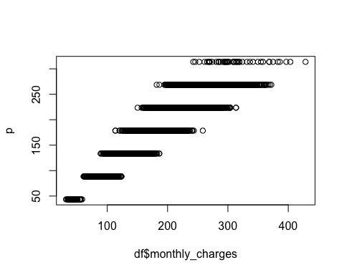
plot(df$monthly_charges,r)
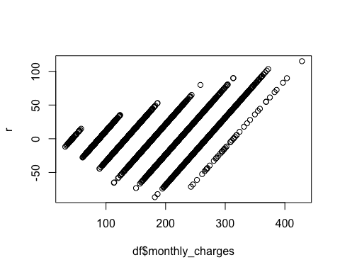
### Multiple Linear Regression ###
# Develop Multiple Regression Model of Monthly Charges
multi_model = lm(monthly_charges ~., data = dfa)
summary(multi_model)
##
## Call:
## lm(formula = monthly_charges ~ ., data = dfa)
##
## Residuals:
## Min 1Q Median 3Q Max
## -40.441 -4.698 -0.152 4.751 47.806
##
## Coefficients: (13 not defined because of singularities)
## Estimate Std. Error t value Pr(>|t|)
## (Intercept) -1.804e+02 1.881e+00 -95.905 < 2e-16 ***
## age -4.674e-05 7.272e-03 -0.006 0.994872
## dependents 4.224e-01 1.260e-01 3.354 0.000803 ***
## tenure_months 1.758e-03 7.303e-03 0.241 0.809779
## cityAustin -3.267e-01 8.587e-01 -0.381 0.703566
## cityBoston 5.372e-01 8.803e-01 0.610 0.541716
## cityBrooklyn 3.608e-01 7.574e-01 0.476 0.633814
## cityBuffalo -2.683e-01 8.558e-01 -0.314 0.753853
## cityCambridge 8.111e-02 8.790e-01 0.092 0.926483
## cityCharlotte -3.546e-01 8.630e-01 -0.411 0.681156
## cityChicago 1.435e-01 8.666e-01 0.166 0.868476
## cityDallas 2.591e-01 8.486e-01 0.305 0.760135
## cityDenver 8.058e-01 8.568e-01 0.941 0.346973
## cityEvanston 7.024e-01 8.757e-01 0.802 0.422518
## cityHouston 7.171e-02 8.820e-01 0.081 0.935207
## cityLos Angeles 4.714e-01 8.856e-01 0.532 0.594548
## cityMiami -4.462e-01 9.142e-01 -0.488 0.625557
## cityNew York 6.237e-01 8.965e-01 0.696 0.486670
## cityOakland 5.897e-01 8.846e-01 0.667 0.505040
## cityOrlando 8.636e-01 8.576e-01 1.007 0.313969
## cityPortland 4.858e-01 8.964e-01 0.542 0.587837
## cityRochester -8.578e-03 8.672e-01 -0.010 0.992109
## citySan Diego 6.085e-01 8.630e-01 0.705 0.480737
## citySan Francisco -1.057e+00 8.803e-01 -1.200 0.230112
## citySeattle -3.552e-01 8.805e-01 -0.403 0.686659
## stateCO NA NA NA NA
## stateFL NA NA NA NA
## stateGA NA NA NA NA
## stateIL NA NA NA NA
## stateMA NA NA NA NA
## stateNC NA NA NA NA
## stateNY NA NA NA NA
## stateOR NA NA NA NA
## stateTX NA NA NA NA
## stateWA NA NA NA NA
## cook_days_per_week 4.605e-02 6.215e-02 0.741 0.458754
## recipes_per_week 4.463e+01 8.635e-02 516.922 < 2e-16 ***
## latest_discount_used_pct 6.793e-01 4.039e-01 1.682 0.092679 .
## skips_last_3_months -3.109e-02 7.413e-02 -0.419 0.674970
## delivery_issues_last_3mo -2.329e-02 1.125e-01 -0.207 0.835968
## app_logins_per_month 3.204e-03 9.353e-03 0.343 0.731963
## recipe_rating 2.462e-01 9.274e-02 2.655 0.007952 **
## customer_service_rating -4.532e-02 9.735e-02 -0.466 0.641569
## price_per_recipe 1.602e+01 1.522e-01 105.306 < 2e-16 ***
## IMP_income -5.091e-07 1.937e-06 -0.263 0.792679
## M_income -4.441e-01 3.412e-01 -1.302 0.193131
## FLAG_married 1.294e-01 2.649e-01 0.488 0.625280
## FLAG_uses_other_meal_kits 1.295e-02 2.636e-01 0.049 0.960838
## FLAG_Male -1.110e-01 2.578e-01 -0.431 0.666712
## FLAG_meat_veggie -3.313e-01 3.202e-01 -1.035 0.300920
## FLAG_pescatarian -3.193e-01 3.326e-01 -0.960 0.337212
## FLAG_veggie NA NA NA NA
## FLAG_low_cal 1.418e+00 4.935e-01 2.874 0.004070 **
## FLAG_low_sugar 1.927e-01 5.014e-01 0.384 0.700681
## FLAG_low_salt 3.881e-01 5.027e-01 0.772 0.440157
## FLAG_plant_based 3.700e-01 3.668e-01 1.009 0.313124
## FLAG_low_carb 5.812e-01 4.134e-01 1.406 0.159845
## FLAG_high_prt NA NA NA NA
## FLAG_classic -5.291e-02 3.532e-01 -0.150 0.880925
## FLAG_premium -1.861e-02 5.708e-01 -0.033 0.973994
## FLAG_quickneasy NA NA NA NA
## ---
## Signif. codes: 0 '***' 0.001 '**' 0.01 '*' 0.05 '.' 0.1 ' ' 1
##
## Residual standard error: 9.321 on 5452 degrees of freedom
## Multiple R-squared: 0.983, Adjusted R-squared: 0.9829
## F-statistic: 6711 on 47 and 5452 DF, p-value: < 2.2e-16
# Prediction
p1 = predict(multi_model, dfa)
RMSE_multi = sqrt(mean((dfa$monthly_charges - p1)^2))
print(RMSE_multi)
## [1] 9.279841
# Plot the Model and Errors
r1 = df$monthly_charges - p1 # Calculate errors
plot(df$monthly_charges,p1)
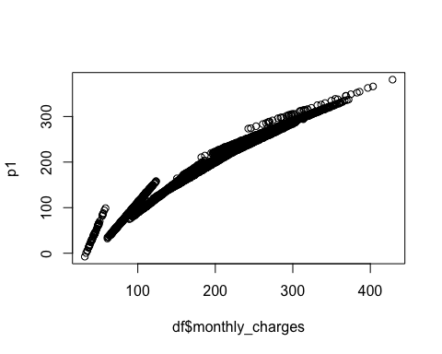
plot(df$monthly_charges,r1)
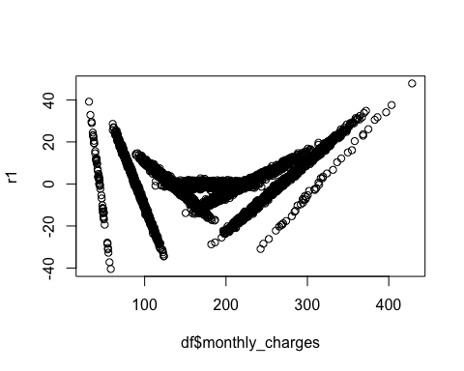
### Logistic Regression ###
dfb = df
dfb$monthly_charges = NULL
dfb$total_charges = NULL
# Develop Losgic Regression Model of Churn
log_model = glm(churn ~., family = "binomial", data = dfb)
summary(log_model)
##
## Call:
## glm(formula = churn ~ ., family = "binomial", data = dfb)
##
## Coefficients: (13 not defined because of singularities)
## Estimate Std. Error z value Pr(>|z|)
## (Intercept) 1.277e+00 5.818e-01 2.195 0.02817 *
## age -3.375e-03 2.263e-03 -1.491 0.13584
## dependents -7.993e-02 4.032e-02 -1.982 0.04743 *
## tenure_months -4.162e-02 2.476e-03 -16.808 < 2e-16 ***
## cityAustin -8.498e-02 2.575e-01 -0.330 0.74138
## cityBoston -2.102e-01 2.697e-01 -0.779 0.43578
## cityBrooklyn -1.853e-01 2.288e-01 -0.810 0.41812
## cityBuffalo -3.603e-01 2.665e-01 -1.352 0.17635
## cityCambridge -8.559e-02 2.633e-01 -0.325 0.74511
## cityCharlotte -4.664e-01 2.728e-01 -1.710 0.08728 .
## cityChicago 4.957e-02 2.554e-01 0.194 0.84613
## cityDallas -1.055e-01 2.548e-01 -0.414 0.67895
## cityDenver -1.262e-01 2.629e-01 -0.480 0.63110
## cityEvanston -4.514e-02 2.613e-01 -0.173 0.86287
## cityHouston -3.169e-01 2.760e-01 -1.148 0.25092
## cityLos Angeles -3.367e-01 2.742e-01 -1.228 0.21942
## cityMiami -4.929e-01 2.941e-01 -1.676 0.09376 .
## cityNew York -1.452e-01 2.743e-01 -0.529 0.59664
## cityOakland -1.564e-01 2.649e-01 -0.590 0.55492
## cityOrlando -2.442e-01 2.653e-01 -0.920 0.35739
## cityPortland -4.256e-01 2.828e-01 -1.505 0.13233
## cityRochester 3.768e-02 2.578e-01 0.146 0.88383
## citySan Diego -3.939e-01 2.668e-01 -1.476 0.13985
## citySan Francisco -1.887e-02 2.626e-01 -0.072 0.94271
## citySeattle 5.860e-02 2.612e-01 0.224 0.82246
## stateCO NA NA NA NA
## stateFL NA NA NA NA
## stateGA NA NA NA NA
## stateIL NA NA NA NA
## stateMA NA NA NA NA
## stateNC NA NA NA NA
## stateNY NA NA NA NA
## stateOR NA NA NA NA
## stateTX NA NA NA NA
## stateWA NA NA NA NA
## cook_days_per_week 4.308e-03 1.944e-02 0.222 0.82461
## recipes_per_week 3.136e-02 2.680e-02 1.170 0.24207
## latest_discount_used_pct 3.090e-01 1.248e-01 2.476 0.01328 *
## skips_last_3_months 1.358e-01 2.313e-02 5.870 4.35e-09 ***
## delivery_issues_last_3mo 2.705e-01 3.537e-02 7.648 2.04e-14 ***
## app_logins_per_month -7.996e-03 2.934e-03 -2.726 0.00641 **
## recipe_rating -2.975e-01 2.808e-02 -10.595 < 2e-16 ***
## customer_service_rating -2.726e-01 3.041e-02 -8.965 < 2e-16 ***
## price_per_recipe -6.786e-02 4.746e-02 -1.430 0.15282
## IMP_income 1.366e-07 6.014e-07 0.227 0.82031
## M_income 7.364e-02 1.043e-01 0.706 0.48021
## FLAG_married 2.282e-02 8.206e-02 0.278 0.78094
## FLAG_uses_other_meal_kits -1.844e-01 8.291e-02 -2.224 0.02616 *
## FLAG_Male -1.078e-01 8.058e-02 -1.337 0.18108
## FLAG_meat_veggie 2.535e-02 9.914e-02 0.256 0.79822
## FLAG_pescatarian 4.725e-02 1.027e-01 0.460 0.64547
## FLAG_veggie NA NA NA NA
## FLAG_low_cal -1.070e-01 1.579e-01 -0.678 0.49799
## FLAG_low_sugar 2.073e-01 1.539e-01 1.347 0.17786
## FLAG_low_salt 7.894e-02 1.574e-01 0.502 0.61595
## FLAG_plant_based 1.468e-01 1.152e-01 1.275 0.20248
## FLAG_low_carb 7.222e-02 1.304e-01 0.554 0.57971
## FLAG_high_prt NA NA NA NA
## FLAG_classic -1.046e-02 1.106e-01 -0.095 0.92467
## FLAG_premium 2.178e-01 1.773e-01 1.229 0.21909
## FLAG_quickneasy NA NA NA NA
## ---
## Signif. codes: 0 '***' 0.001 '**' 0.01 '*' 0.05 '.' 0.1 ' ' 1
##
## (Dispersion parameter for binomial family taken to be 1)
##
## Null deviance: 4892.4 on 5499 degrees of freedom
## Residual deviance: 4252.9 on 5452 degrees of freedom
## AIC: 4348.9
##
## Number of Fisher Scoring iterations: 5
# Predict Model
p_log = predict(log_model, dfb, type = "response")
p_log2 = prediction(p_log, dfb$churn)
p_log3 = performance(p_log2,"tpr","fpr")
# Plot the ROC Curve and Calculate AUC
plot(p_log3, col="blue")
abline(0,1, lty=2)
legend("bottomright",c("LOGISTIC REGRESSION"),col=c("blue"),bty="y",lty=1)
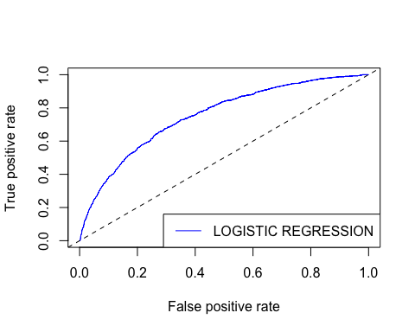
auc = performance(p_log2, "auc")@y.values
print(auc)
## [[1]]
## [1] 0.7529688
### Confusion Matrix ###
# Convert probabilities to class (Threshold = 0.5)
pred_class_log = ifelse(p_log > 0.5, 1, 0)
# Create the Table
conf_matrix_log = table(Predicted = pred_class_log, Actual = dfb$churn)
print("Confusion Matrix (Logistic Regression):")
## [1] "Confusion Matrix (Logistic Regression):"
print(conf_matrix_log)
## Actual
## Predicted 0 1
## 0 4535 811
## 1 68 86
# Calculate Accuracy
accuracy_log = sum(diag(conf_matrix_log)) / sum(conf_matrix_log)
print(paste("Logistic Model Accuracy:", round(accuracy_log, 4)))
## [1] "Logistic Model Accuracy: 0.8402"

