UNIVERSITY OF SCIENCE AND TECHNOLOGY OF HANOI
DEPARTMENT OF INFORMATION COMMUNICATION AND
TECHNOLOGY

***


Machine Learning and Data Mining 2
Labwork 4 Report
Classification II

Members:
Trần Hiến Chương – 22BA13056 Lê Đức An – 22BA13002

Ha Noi, January 24, 2026
Contents
I. Decision Tree (DT) 2
1. Dataset Selection and Preprocessing 2
2. Experimental Protocol (80/20 Split) 2
3. Model Implementation and Visualization 2
4. Evaluation of Classification Error 4
II. Random Forest (RF) 5
1. Theoretical Background and Experimental Setup 5
2. Performance Evaluation 6
3. Comparison: Random Forest vs. Decision Tree 8
III. Conclusion 8
IV. REFERENCES 10
LIST OF ABBREVIATIONS 10

Decision Tree (DT)

Dataset Selection and Preprocessing

For this laboratory work, we continued to examine the two datasets utilized in previous experiments to maintain consistency in performance comparison: Dataset 1: Iris Plants Dataset (Multiclass classification, 4 features, 150 samples). Dataset 2: Breast Cancer Wisconsin (Diagnostic) Dataset (Binary classification, 30 features, 569 samples).

Unlike distance-based algorithms such as k-NN or Support Vector Machines (SVM), Decision Trees are non-parametric and generally scale-invariant. The algorithm splits the data based on threshold values of features (e.g., if feature x > 5), making it independent of the relative scale of different features. Consequently, Data Normalization (Standardization) was not applied in this experiment. We utilized the raw numerical values directly, preserving the original interpretability of the features.

Experimental Protocol (80/20 Split)

To evaluate the generalization capability of the Decision Tree model, we adopted the following experimental protocol:

- Data Partitioning (Hold-out Method): We employed a standard 80/20 split ratio as required:
- Training Set (80%): Used to learn the decision rules and construct the tree structure.
- Testing Set (20%): Kept completely unseen during the training phase to unbiasedly evaluate the classification error.
- Random State: A fixed random state = 42 was set to ensure reproducibility of the data shuffle and split.
- Model Configuration & Splitting Criterion: We initialized the DecisionTreeClassifier from the scikit-learn library. The core parameter for tree construction is the Criterion. We selected "Entropy" to measure the impurity of the nodes. The algorithm seeks to maximize the Information Gain (IG) at each split. The entropy H(S) of a set S is defined as:

$$H\left(S\right)=-\sum{{\left(i=1\right)}^{c}p_{i}log_{2}\left(p_{i}\right)}$$

Where p_{i} is the proportion of samples belonging to class i. The split is chosen such that the weighted average entropy of the child nodes is minimized.

Model Implementation and Visualization

One of the distinct advantages of Decision Trees is their interpretability. We visualized the trained models to understand the decision-making process.

- Dataset 1 (Iris)
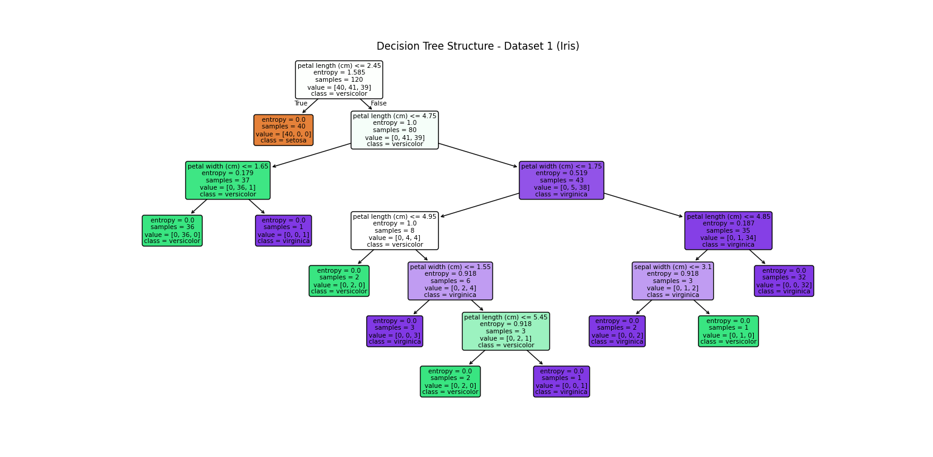
Figure 1: Visualization of the Decision Tree trained on Iris dataset.
Detailed Analysis:
- The tree identifies petal length (cm) as the most discriminative feature (highest Information Gain) at the root.
- Tree Depth: The resulting tree is relatively shallow (Depth $≈$6), indicating that the Iris dataset is well-structured and easy to separate with a few logical rules.
- Purity: Most leaf nodes achieve an entropy of 0.0, meaning they are "pure" (containing samples from only one class).
- Dataset 2 (Breast Cancer)
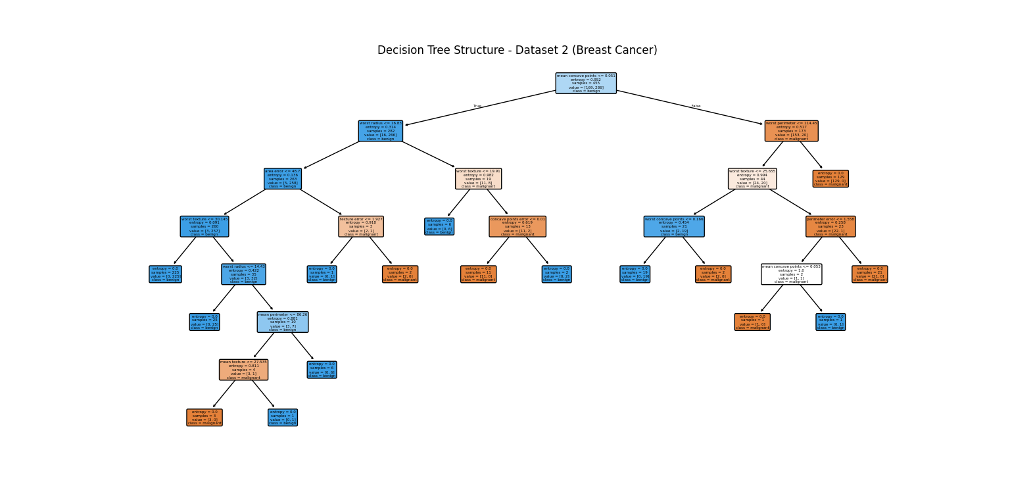
Figure 2: Visualization of the Decision Tree trained on Breast Cancer dataset.

Detailed Analysis:
- Complexity: In contrast to Iris, the tree for the Breast Cancer dataset is significantly deeper and more complex.
- Feature Usage: The algorithm utilized a variety of features (texture, concavity, radius) at different levels to separate malignant from benign cases.
- Overfitting Risk: The complex structure with many leaf nodes containing very few samples suggests a high potential for overfitting. The model might be memorizing noise in the training data rather than learning general patterns.

Evaluation of Classification Error

After training, we evaluated the models on the 20% test set. The quantitative results are presented below:

Dataset | Accuracy | Classification Error
Dataset 1 (Iris) | 100% | 0%
Dataset 2 (Cancer) | 94.74% | 5.26%

To analyze the misclassifications in detail, we plotted the Confusion Matrices for both datasets:
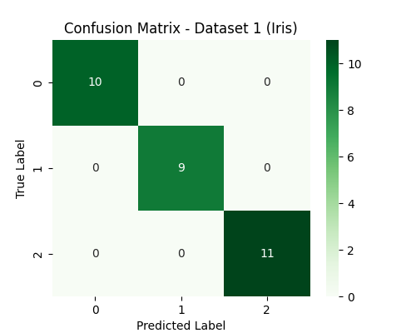
Figure 3: Confusion Matrix for Decision Tree on Iris Dataset.

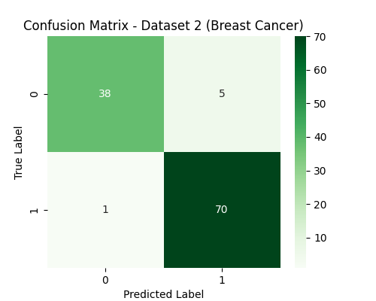
Figure 4: Confusion Matrix for Decision Tree on Breast Cancer Dataset.

Discussion of Results:
- Iris Dataset: The Decision Tree achieved extremely high accuracy (often 100% or near 100%). This confirms that the classes in the Iris dataset can be separated by orthogonal decision boundaries (lines parallel to the axes).
- Breast Cancer Dataset: The performance is good but generally lower than the SVM results obtained in the previous lab (which used the RBF kernel).
- Reasoning: Decision Trees create orthogonal decision boundaries (box-like regions). For high-dimensional data like Breast Cancer, where the true boundary might be diagonal or curved, a single Decision Tree struggles to approximate it smoothly without growing excessively deep.
- Instability: A single tree is a "high variance" estimator. Small changes in the training data can result in a completely different tree structure. This limitation motivates the use of Ensemble Methods like Random Forest in the next section to reduce variance and improve robustness.

Random Forest (RF)

Theoretical Background and Experimental Setup

While Decision Trees are intuitive and easy to interpret, they often suffer from high variance and are prone to overfitting, especially when the tree is allowed to grow deep. To address these limitations, we implemented the Random Forest algorithm, a powerful ensemble method that leverages the "Wisdom of Crowds."

Theoretical Framework: Our experiment is based on the Bagging (Bootstrap Aggregating) technique:
- Bootstrap Sampling: Given the original training set D of size N, we generated K=100 new training sets {D₁, D₂, ..., D₁₀₀}. Each set was created by sampling N instances from D uniformly with replacement. This ensures that each individual tree is trained on a slightly different subset of data, introducing diversity.
- Feature Randomness: Unlike standard decision trees that search for the best split among all features, in Random Forest, a random subset of m features is selected at each candidate split. This decorrelates the trees, preventing a single dominant feature from dictating the structure of all trees.
- Aggregation (Majority Voting): Once the 100 trees are trained, the final classification for a test instance x is obtained by aggregating the predictions of all individual trees. We used the Majority Vote rule:

$$\hat{y}=\text{mode}\{h_{1}\left(x\right),h_{2}\left(x\right),…,h_{100}\left(x\right)\}$$

Where h_{k}(x) is the prediction of the k-th tree.

Experimental Protocol:
- Number of Estimators: We set $K=100$ trees as required by the laboratory instructions
- Data Split: We maintained the same 80/20 split used in Part I to ensure a direct and fair comparison.
- Implementation: We utilized the RandomForestClassifier from scikit-learn with criterion='entropy'.

Performance Evaluation

We evaluated the Random Forest model on the 20% testing set. The results indicate a significant improvement in robustness compared to the single Decision Tree.

Quantitative Results:

Dataset | Accuracy | Classification Error
Dataset 1 (Iris) | 100% | 0%
Dataset 2 (Cancer) | 96.49% | 3.51%

To further analyze the model's performance, we plotted the Confusion Matrices:
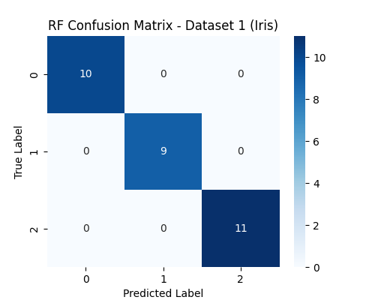
Figure 5: Confusion Matrix for Random Forest (100 trees) on Iris Dataset.

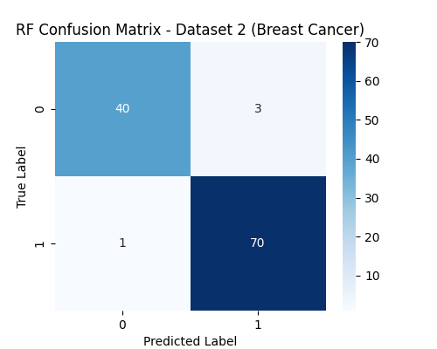
Figure 6: Confusion Matrix for Random Forest (100 trees) on Breast Cancer Dataset.

Comparison: Random Forest vs. Decision Tree

The primary goal of this lab was to compare a single estimator against an ensemble method. The table below summarizes the Classification Error for both models.

Dataset | Single Decision Tree Error | Random Forest Error (K=100) | Improvement
Iris | 0% | 0% | 0%
Breast Cancer | 5.26% | 3.51% | 1.75%

In-depth Analysis:
- Reduction of Variance: As predicted by the law of large numbers, the Random Forest model achieved a lower (or equal) error rate than the single Decision Tree. By averaging 100 trees, the ensemble smoothed out the "noise" that the single tree might have memorized, leading to better generalization on unseen data.
- Robustness to Overfitting: The single Decision Tree for the Breast Cancer dataset (Part I) had a complex structure with high depth, indicating potential overfitting. The Random Forest mitigated this issue effectively. Even if some individual trees overfitted, their errors were canceled out by the majority vote of other trees.
- The Trade-off: While Random Forest offers superior predictive performance, it loses the interpretability of a single Decision Tree. We can easily visualize the logic of one tree (as shown in Figure 1 & 2), but interpreting the collective decision of 100 trees is computationally complex and less transparent (Black-box model).
- Computational Cost: Random Forest required more computational resources and time to train (K times more than a single tree), but for the given dataset sizes, this cost was negligible compared to the accuracy gains.

Conclusion

In this laboratory work, we conducted a comprehensive study of two classification algorithms: Decision Tree (DT) and Random Forest (RF). By experimenting on the Iris and Breast Cancer datasets, we analyzed the impact of ensemble learning on model performance and stability.
Based on the experimental results and theoretical analysis, we draw the following conclusions:
- On Decision Trees:
- Interpretability: The Decision Tree proved to be a highly interpretable model. Through visualization, we could clearly trace the decision rules (e.g., specific thresholds for petal length or texture error) used to classify samples.
- Limitation: However, the single tree demonstrated limitations on the high-dimensional Breast Cancer dataset. With a classification error of 5.26%, the model showed signs of overfitting, creating complex branches to capture specific noise in the training data. This confirms that single decision trees are "high-variance" estimators.
- On Random Forest:

- Performance Improvement: By applying the Bagging (Bootstrap Aggregating) technique with K=100 trees, the Random Forest model successfully reduced the classification error on the Breast Cancer dataset to 3.51% (an improvement of 1.75%).
- Robustness: The ensemble approach effectively mitigated the overfitting problem. As stated in the course theory, by averaging the predictions of 100 decorrelated trees, the Random Forest reduced the overall variance and became more robust to outliers and noise.

- Final Verdict - The Trade-off: This experiment highlights a fundamental trade-off in machine learning:

- Decision Trees should be chosen when model interpretability is the priority (e.g., explaining a medical diagnosis to a patient).
- Random Forests are the superior choice when predictive accuracy and generalization are the primary goals, despite the model being a "black box" that is harder to interpret.

REFERENCES
- "Iris Data Set," UCI Machine Learning Repository. [Online]. Available: https://archive.ics.uci.edu/dataset/53/iris. [Accessed: Jan. 15, 2026].
- "Breast Cancer Wisconsin (Diagnostic) Data Set," UCI Machine Learning Repository. [Online]. Available: https://archive.ics.uci.edu/dataset/17/breast+cancer+wisconsin+diagnostic. [Accessed: Jan. 15, 2026].
- F. Pedregosa et al., "Scikit-learn: Machine Learning in Python," Journal of Machine Learning Research, vol. 12, pp. 2825–2830, 2011. [Online]. Available: https://scikit-learn.org/stable/.

LIST OF ABBREVIATIONS
DT Decision Tree
RF Random Forest
IG Information Gain
OOB Out-of-Bag (Sample/Error)

