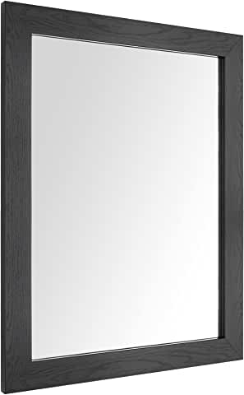

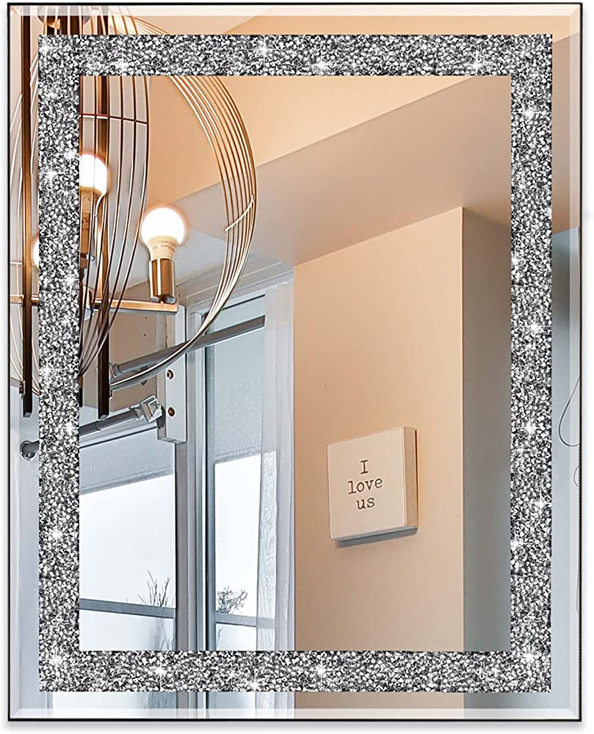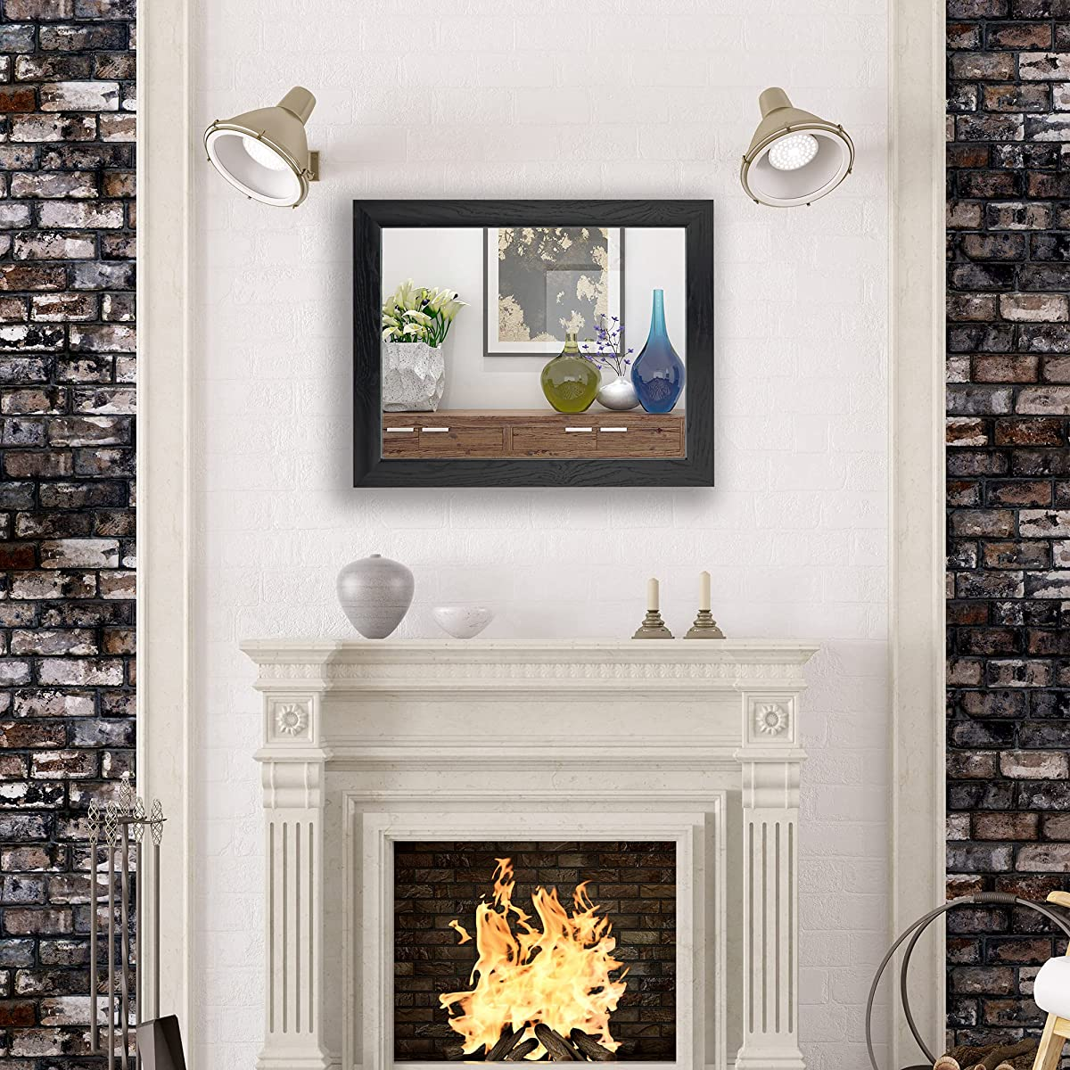

Ruomeng Rectangular Wall Mirror

~~$123~~

**$100**

Buy

We accept:

Living Room | - | Bedroom

**Material**

Glass | - | Polystyrene | - | Acrylic bordered

**Description**

1.5cm thick and 4cm wide frame+3mm no-distortion HD float silver glass to deliver clear reflection+high quality explosion-proof membrane for safety. We use commercial level material to provide a perfect wall mounted mirror to customer