- Setup source ,config and run project with port 88
Setup .env file:
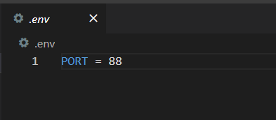
• http://localhost:88/wellcome
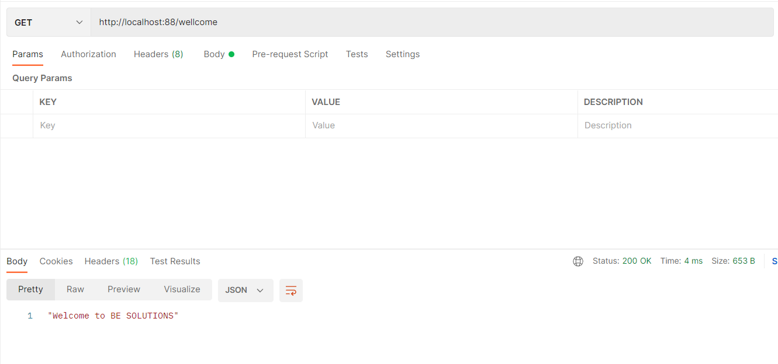
- Implement API Post Method: using Next
• Setup route : http://localhost:88/data/sortarray
- Create file arrayRouter.js
- Setup route:
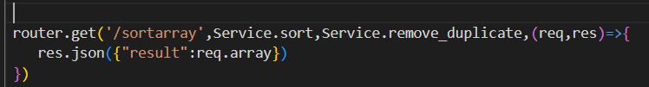
- 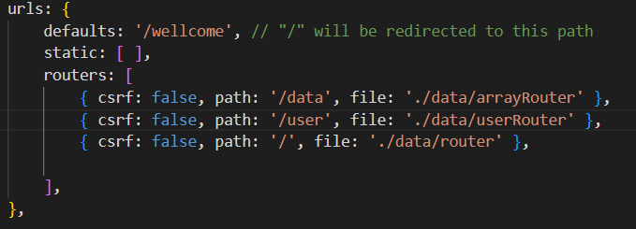
• Input : [1,4,2,7,2,6,5]
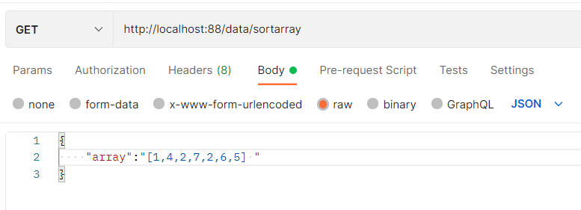
• Output : [1,2,4,5,6,7]
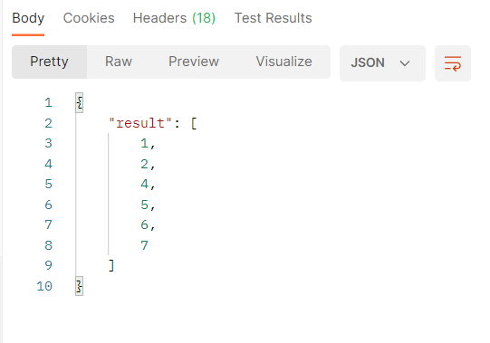
• Implement with 2 functions :
• Sort function: use Bubblesort
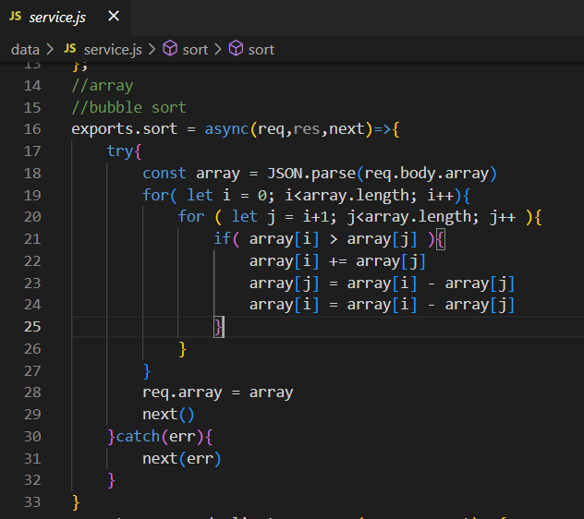
• Remove duplicate function
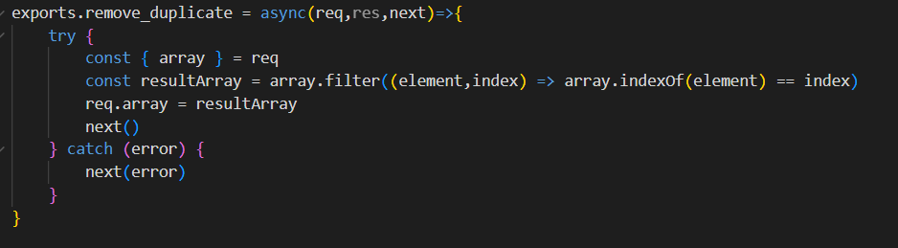
- Implement API get Method: get user info
• Setup route : http://localhost:88/user/{id}
- Create file userRouter.js
- Setup route:
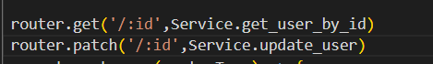
• Get user info by id from Users
- Import User
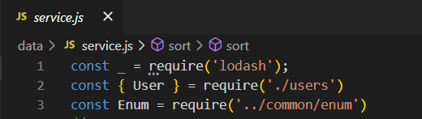
- Get user by id
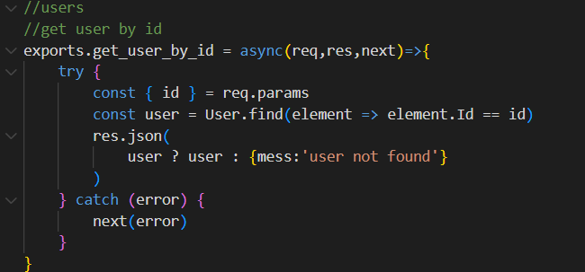
- Test:
+ input: 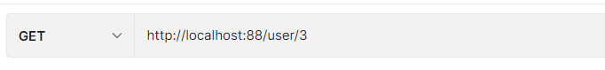
+ output:
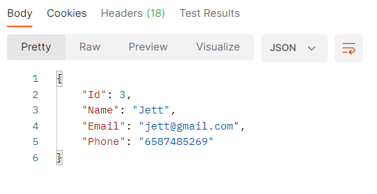
- Implement API put method: update user info
• Setup route : http://localhost:88/user/{id}
• Update user info in list and return
• Update Name, Email, Phone.
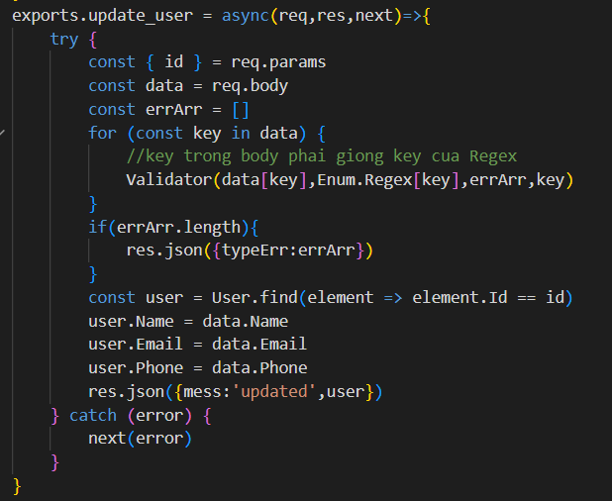
• Validate Email
• Validate phone with format : 65[0-9]{8}
• Sample: 659859623
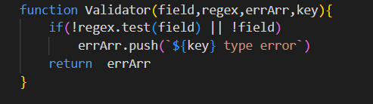
Test:
- Success:
+ input:
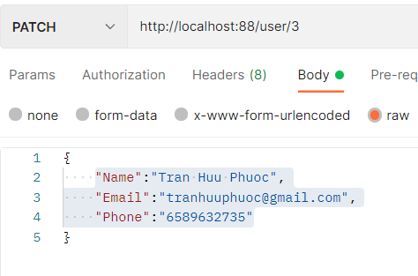
+ output:
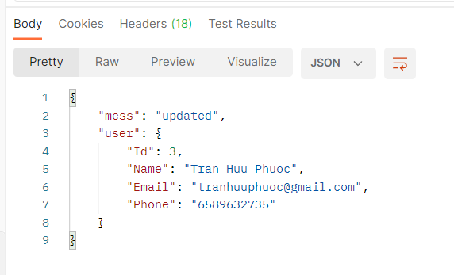

- Failed:
+ input:
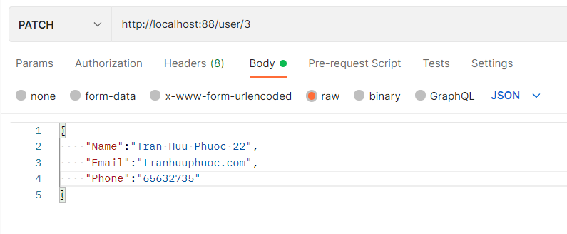
+ output:
