CHƯƠNG 3. XÂY DỤNG HỆ THỐNG
CẤU HÌNH

1. APACHE CASSANDRA

- Kiểm tra hoạt động của các node : nodetool status

- Kết nối vào csdl : cqlsh 192.168.1.100 9042

- Hiển thị thông tin về cụm (cluster) Cassandra : describe cluster

- CREATE KEYSPACE QLSalary WITH replication = {'class': 'SimpleStrategy', 'replication_factor':3};

- DESCRIBE keyspaces;

-CREATE TABLE tbsalary (id int, Age int, Gender text, EducationLevel text, JobTitle text, YearofExperience text, Salary float, Country text, Race text, PRIMARY KEY (id) );

- COPY tbsalary (id,Age,Gender,EducationLevel,JobTitle,YearofExperience,Salary,Country,Race) FROM '/home/huypro/Jupyter-nb/4-Salary_Data_Based_country_and_race.csv
' WITH HEADER = true;

-cqlsh:qlsalary> SELECT COUNT(*) FROM tbsalary;

- Import dữ liệu vào cassandra :

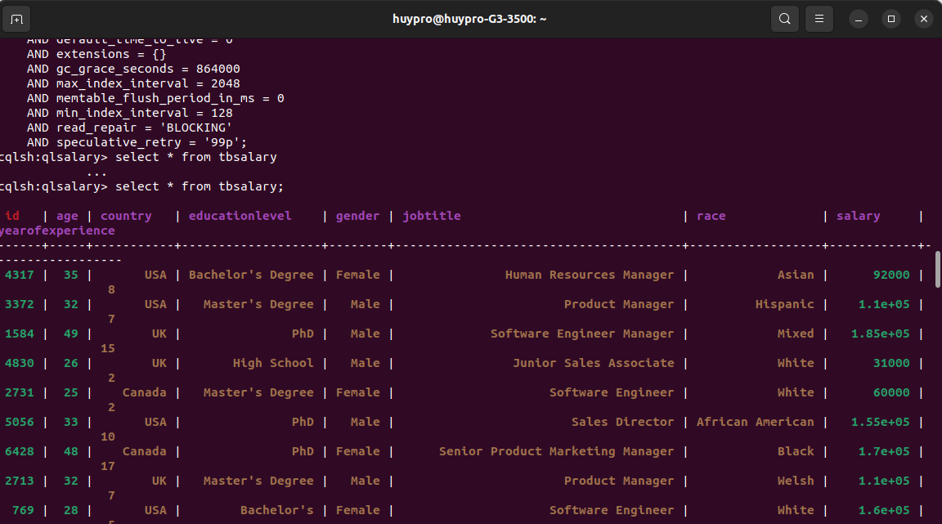

Kiểm tra số lượng cột trong một bảng:
SELECT COUNT(*) FROM tbsalary;
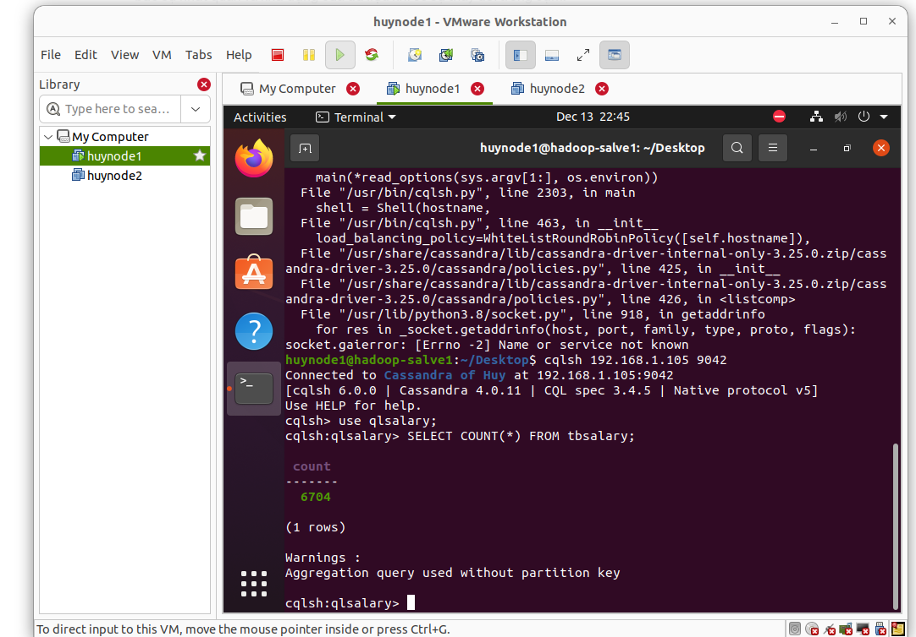
DESCRIBE TABLE qlsalary.tbsalary;

- Compile file : sbt update
- sbt compile
- sbt run
- sbt asembly

2. APACHE HADOOP
-Khởi động hdfs :

hdfs namenode -format
start-dfs.sh
start-yarn.sh

- Tạo thư mục trên HDFS :

hdfs dfs -mkdir /datalake

cấp quyền :
chmod 600 /home/hadoopuser/.ssh/id_rsa
chmod 700 /home/hadoopuser/.ssh

chmod 0700 /home/[your-username]
chmod 0700 /home/your_home/.ssh
chmod 0600 /home/[username]/.ssh/authorized_keys

Tạo thư mục :
hadoop fs -mkdir /datacsv
hadoop fs -mkdir /datalake
hadoop fs -mkdir /datawarehouse
hadoop fs -put 4-Salary_Data_Based_country_and_race.csv /datacsv
hdfs dfs -rm -r /datacsv

hdfs dfs -chmod g+wrx /datawarehouse
hdfs dfs -chmod g+w /datawarehouse
hadoop fs -chmod 777 /datalake
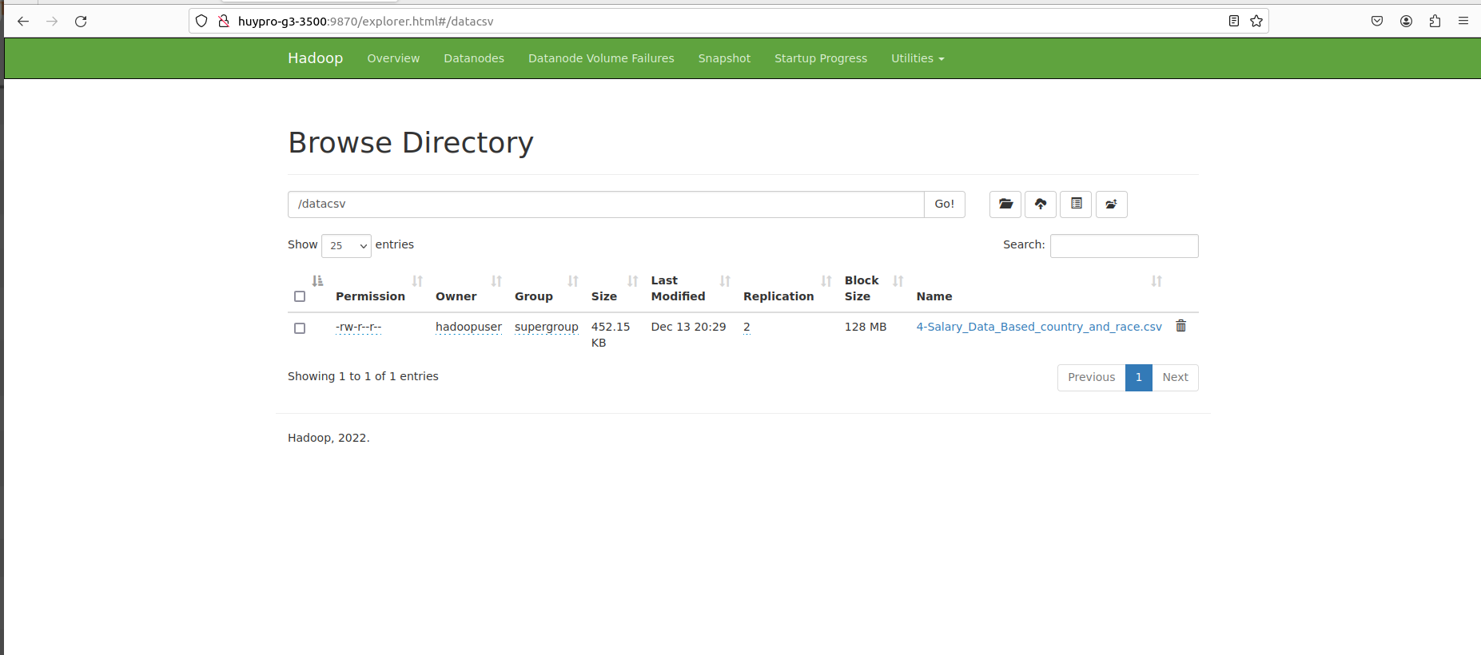

hdfs dfsadmin -report
hadoop dfs -du -h /
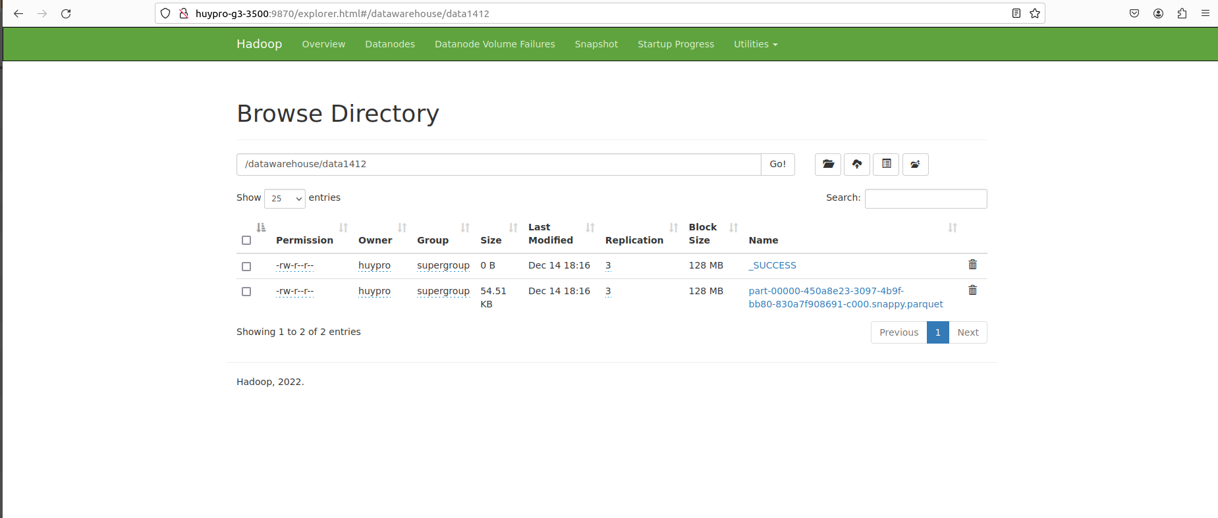
3. APACHE SPARK
- Tạo 1 dự án mới : sbt new scala/hello-world.g8
mkdir my-spark-cassandra-project
cd my-spark-cassandra-project

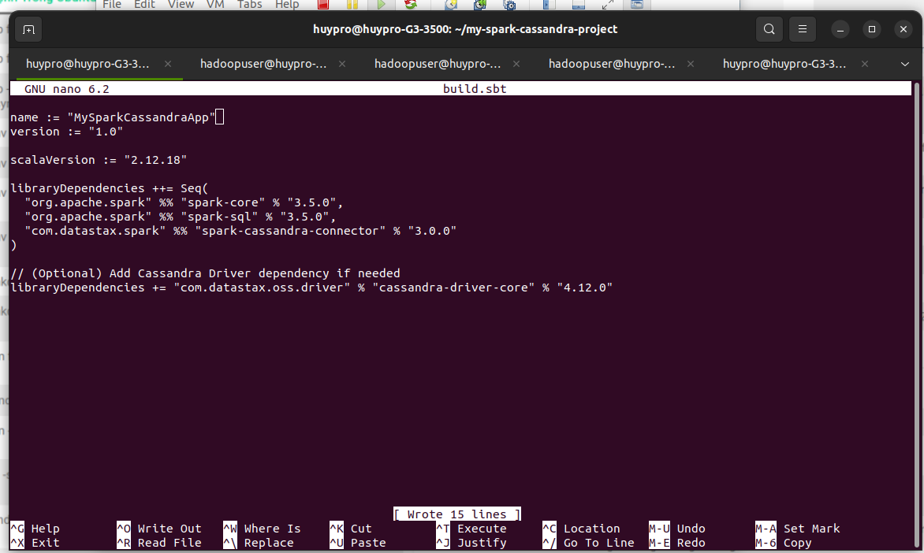
nano build.sbt
mkdir -p src/main/scala
nano App.scala
run sbt

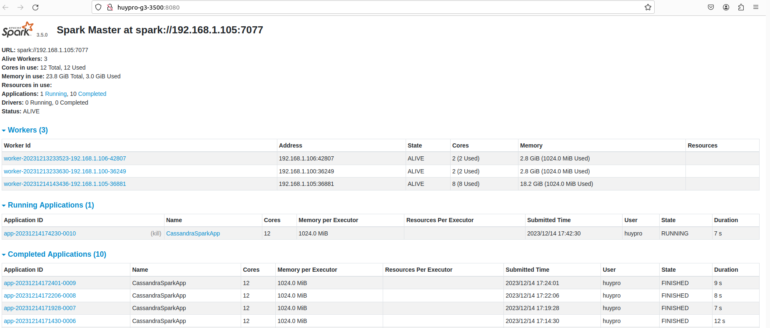

cd spark-3.1.1-bin-hadoop2.7/bin ./spark-class org.apache.spark.deploy.master.Master
Cài đặt worker:

cd spark-3.1.1-bin-hadoop2.7/bin ./spark-class org.apache.spark.deploy.worker.Worker spark://192.168.1.105:7077

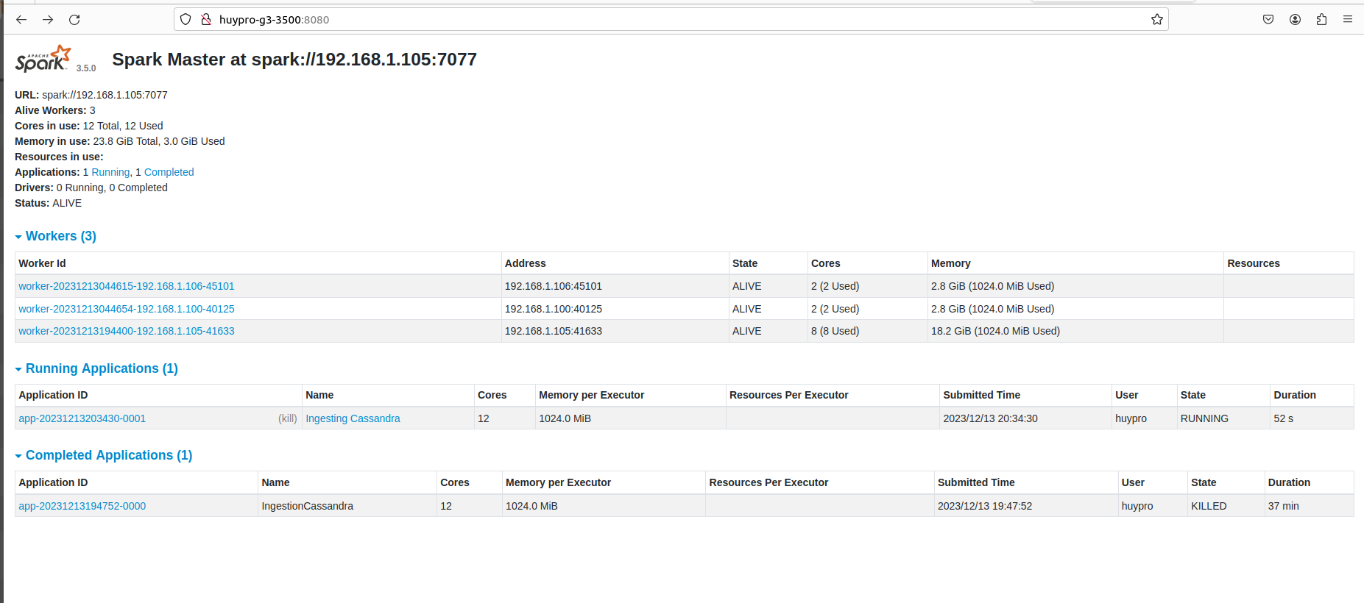

4.APACHE SUPPERSET

python3 -m venv venv
source venv/bin/activate
export FLASK_APP=superset
openssl rand -base64 42
export SUPERSET_SECRET_KEY=
superset db upgrade
superset run -h 0.0.0.0 -p 8088 --with-threads --reload --debugger

- connect mysql :
sudo apt-get install pkg-config
pip install mysqlclient
pip install cx_Oracle
pip install snowflake-sqlalchemy
pip install pymssql
pip install pyhive
pip install sqlalchemy-redshift

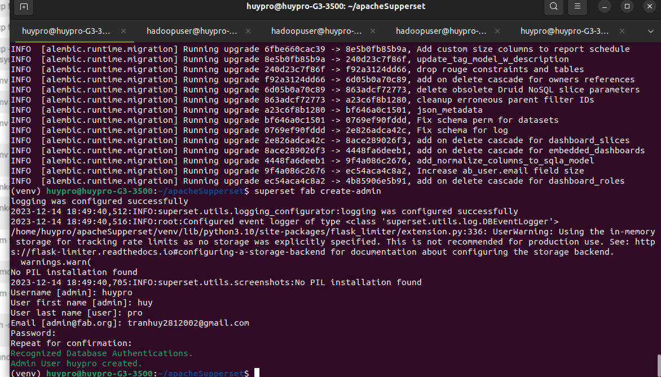
hive://hive@192.168.1.105:1000/qlsalary1
pip install 'pyhive[hive]'
pip install thrift
pip install 'pyhive[hive_pure_sasl]'
pip install 'pyhive[presto]'
pip install 'pyhive[trino]'
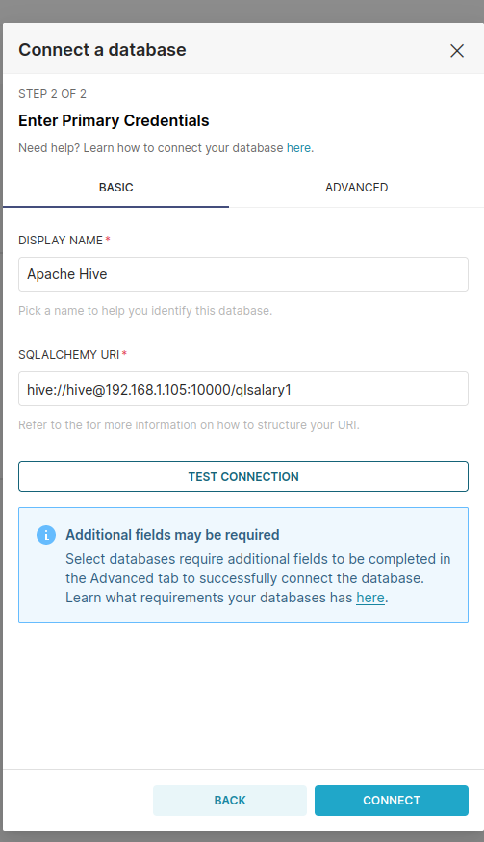
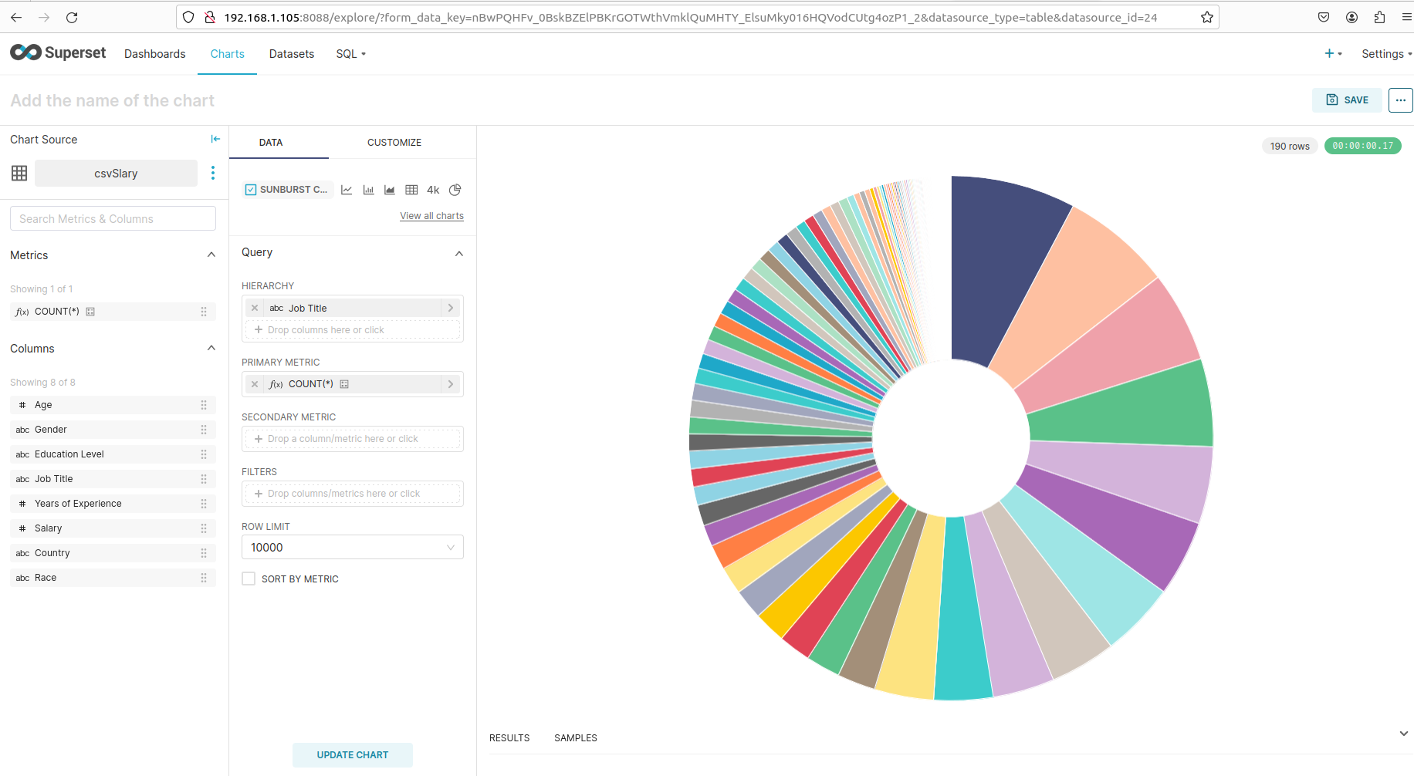
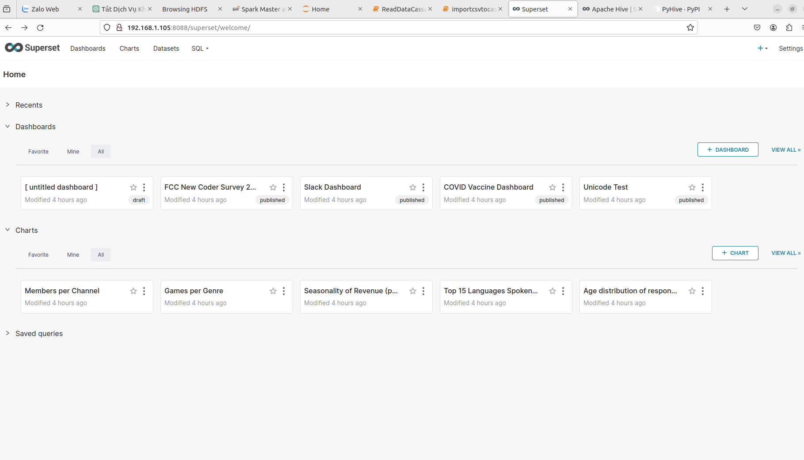
thong ke :
5.APACHE HIVE

rm -rf metastore_db
$HIVE_HOME/bin/schematool -dbType derby -initSchema

khởi chạy hiveserver2:
$HIVE_HOME/bin/hive --service hiveserver2
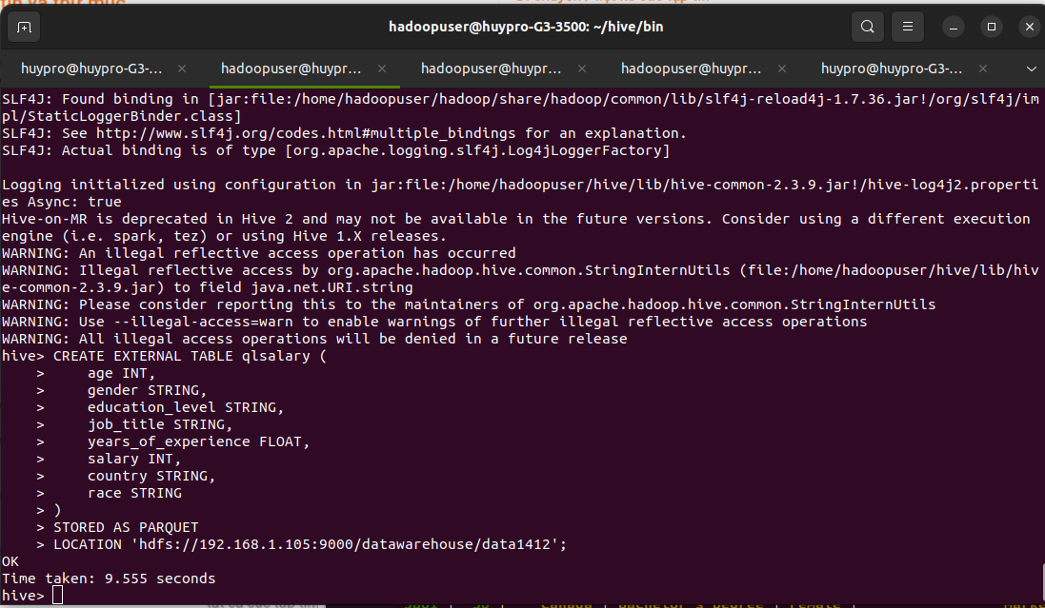
DỮ LIỆU TRONG HIVE :

CREATE EXTERNAL TABLE tbsalary (
age INT,
gender STRING,
educationlevel STRING,
job_title STRING,
yearsofexperience DOUBLE,
salary INT,
country STRING,
race STRING
)
STORED AS PARQUET
LOCATION 'hdfs://192.168.1.105:9000/datawarehouse/data1412';

SELECT * FROM qlsalary LIMIT 10;
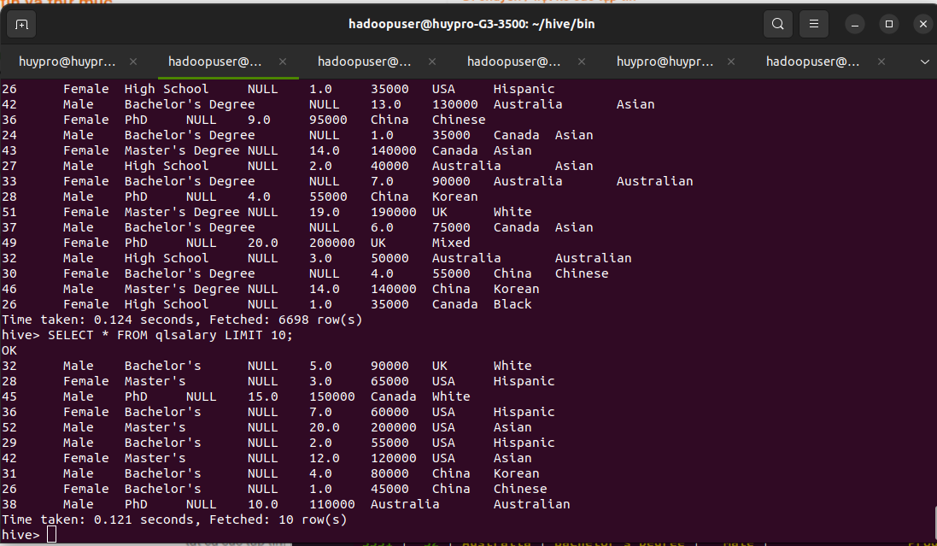
tạo bảng tạm : CREATE TABLE temporary_table
AS
SELECT *
FROM qlsalary;
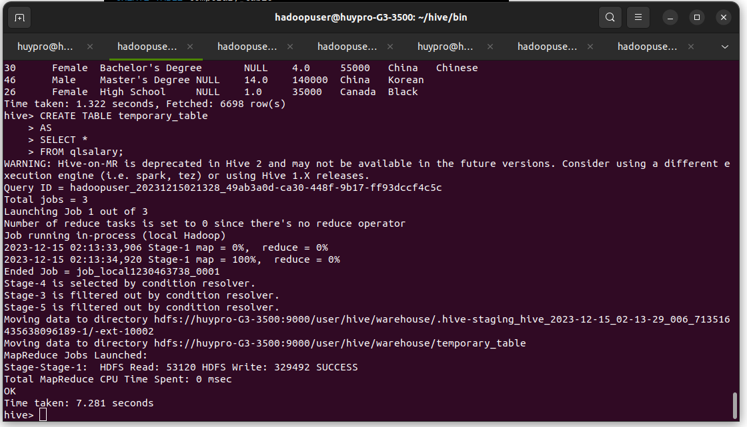
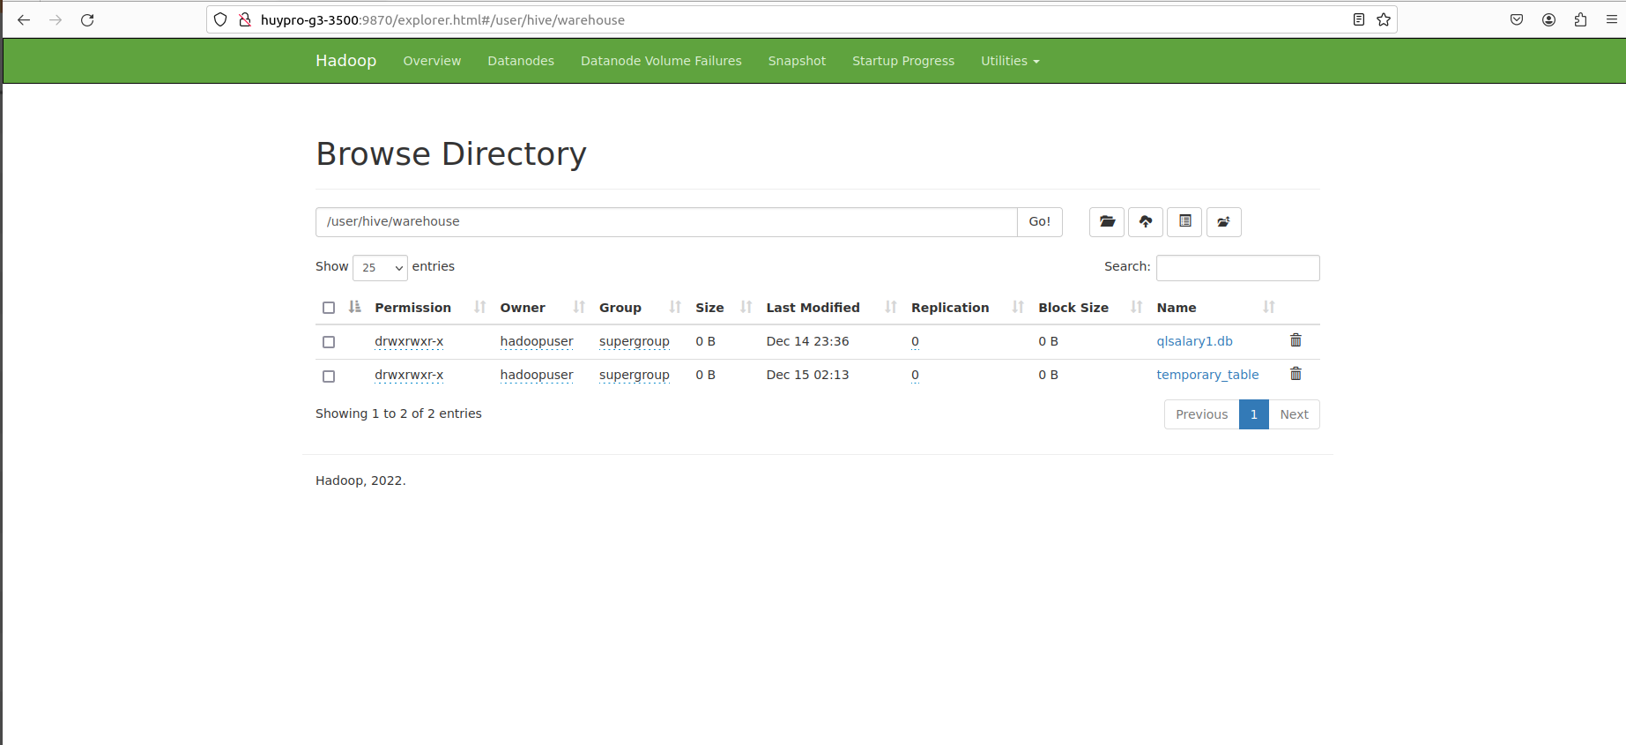
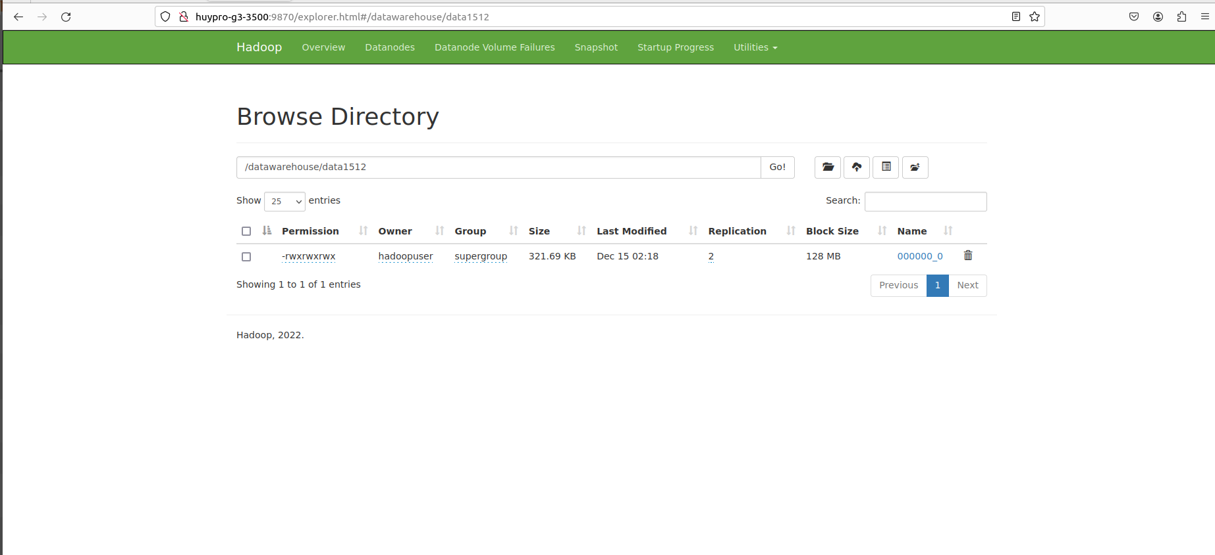
đẩy dữ liệu từ hive lên hdfs :
INSERT OVERWRITE DIRECTORY '/datawarehouse/data1512'
> SELECT *
> FROM temporary_table;

TÀI LIỆU THAM KHẢO
https://superset.apache.org/docs/intro/
https://en.wikipedia.org/wiki/Apache_Superset
https://hive.apache.org/
https://en.wikipedia.org/wiki/Apache_Hive

