# POSTMAN - Create a mock server, mock response

To create a mock server and then some mock response from the server, you need to:

* Create a mock server
* Add a request that has a link to the server

## Create a mock server

Create a collection first and then create a mock server or you create a mock server based on an existing collection:

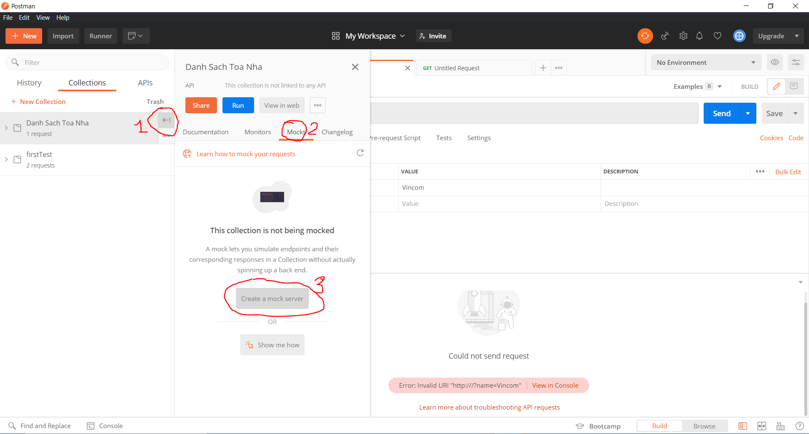

At the last step, note the URL for the mock server, which is needed in the next step.

## Add a request-response example

When you add a request, add it to a collection

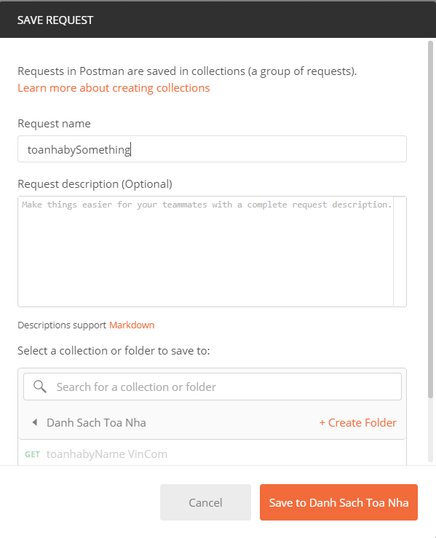

The newly added request has only Query Parameter, but not yet the Response like this:

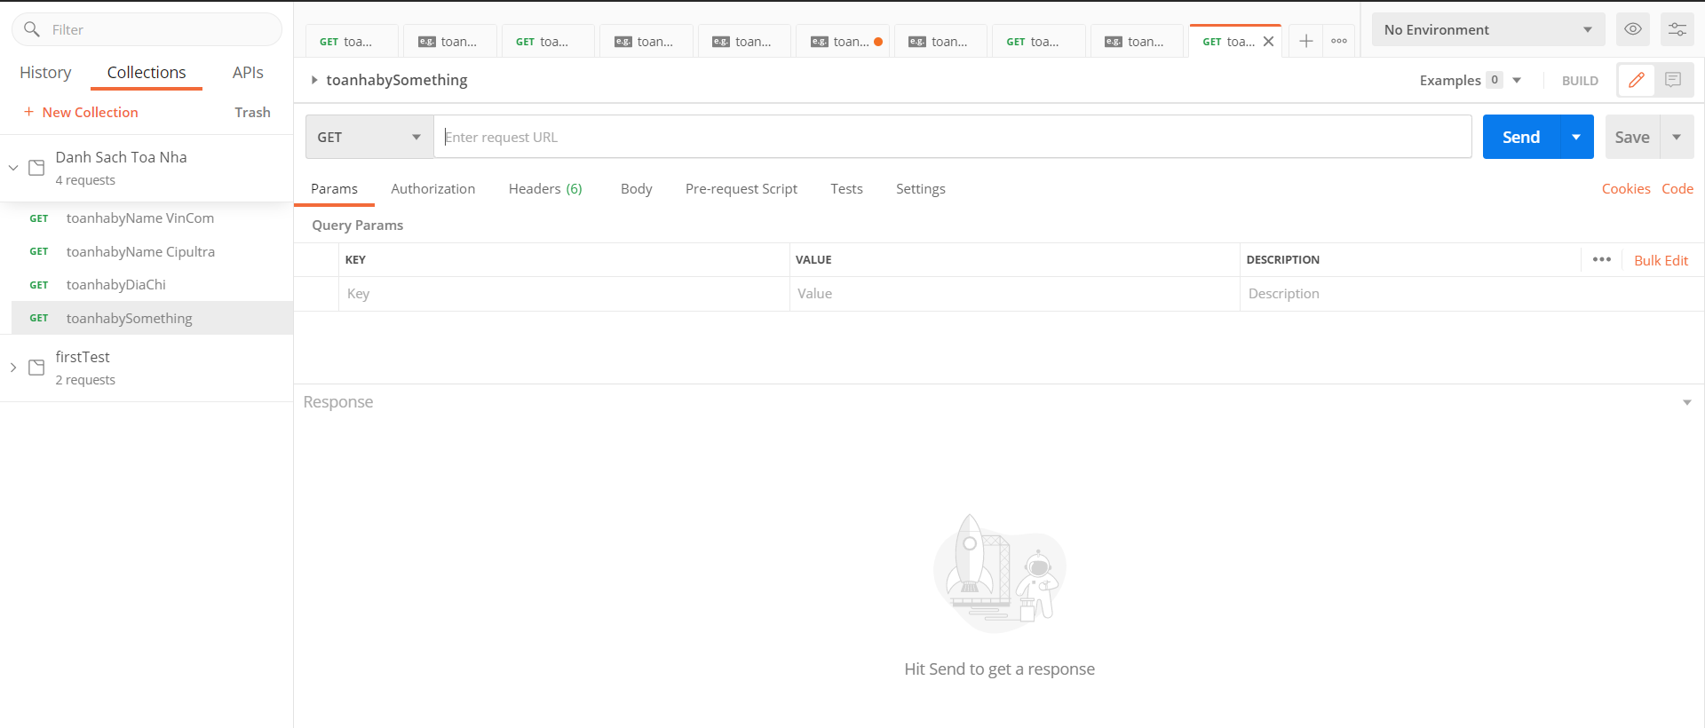or 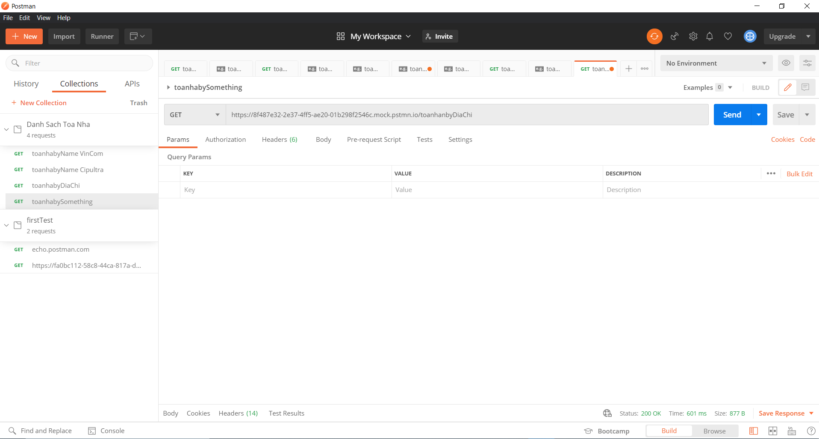

To open the Response part,

* Step 1: add the address that you created in the “Mock Server” stage
* Step 2: Hit SEND and then “Save Response”/”Save as example”

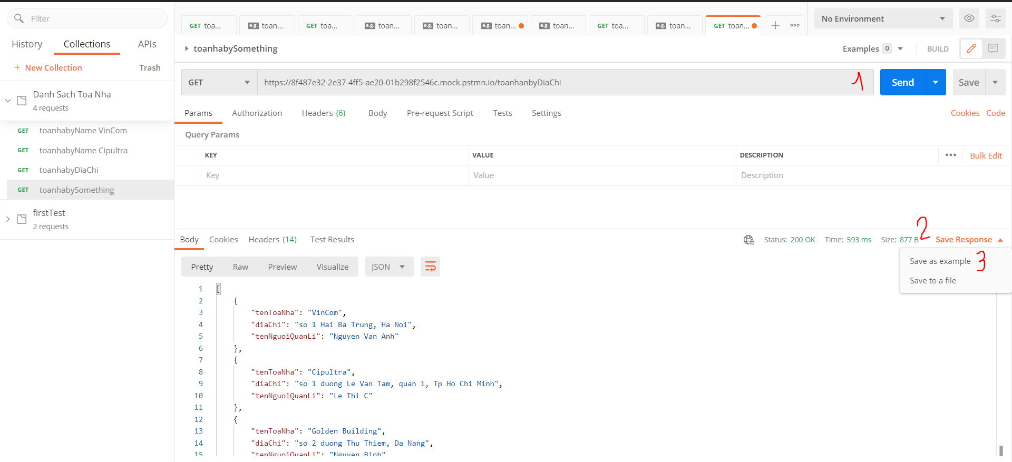

If the step above is right then the Example Response as below should appear

