SUPER QUICK START CHEAT SHEET
Audio EQ Cookbook HP15c CE software pac
Pepin Torres, P.E. pepin[dot]torres[at]gmail[dot]com

Pre-requisites

Calculator in 15.2 mode (this program is huge, can’t be run in default mode.)

Registers
R9 : Sampling frequency in Hz
R.0 : Center/Cutoff frequency in Hz
R.1 : Q. If necessary, it can be calculated as a function of bandwidth via GSB B
R.2 : A. Can be calculated as function of Gain in dB and S via GSB A. If not needed, set to 1.0.

Run Main Biquad Coefficients Generation Program

GSB C

Ruturn Frequency Response at arbitrary frequency f_{x} in Hz (Program C must be run first)

GSB D (place f_{x} in x-register, desired filter type index (1-9) in y-register)
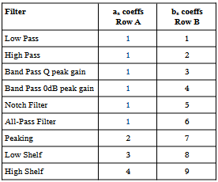
Memory Layout (after execution)
Matrix A [4 3] a_{n} coeffs
Matrix B [9 3] b_{n} coeffs
Matrix C [3 2] z^{-n} at f_{x}
Matrix D [4 2] Σ b_{n}z^{-n}
Matrix E [9 2] Σ a_{n}z^{-n}
See user’s guide for definition of the output matrices and filter type indexing.
C, D and E are temporary and can be deallocated after to save space

Register states after execution of Prog C and D

Registers Description
R9 Sampling Frequency Fs
R.0 Center/cutoff frequency f₀
R.1 Quality Factor Q
R.2 Gain in linear form A
R.3 sin(ω₀)
R.4 cos(ω₀)
R.5 α
R.6 A-1
R.7 A+1
R.8 2·√A·α
R.9 Bandwidth
R6 f_{x}/F_{s}
R7 Desired filter type row index for matrix A
R8 Desired filter type row index for matrix B

