Audio EQ Cookbook HP15c CE software pac
Pepin Torres, P.E. pepin[dot]torres[at]gmail[dot]com

Introduction:

This software pac calculates all the filters coefficients and related parameters as defined in the classic document Cookbook formulae for audio equalizer biquad filter coefficients.

Who is this for?

This software pac is for any audio enthusiants, audio engineers, or software engineers that need to generate the coefficients for any of the 9 different filters in the cookbook (when there is no computer in sight). Furthermore, this pac also calculates the complex frequency response of any of the 9 filters at any arbitrary frequency f_{x}. One use-case would be to generate the coefficients of a filter with center frequency f₀ and calculate the complex response for a set of frequencies f_{x} (think of being able to plot the response by sampling at different f_{x} frequencies). Another use-case would be to run this program for a set of filters with different center frequencies f₀ and evaluate each filter at a fixed f_{x} to understand the gain/phase contributions of each filter at f_{x} (think of an EQ with multiple bands that overlap f_{x}).

Main Programs:

Program C – Calculate all filter coefficients

Registers required before running: R9, R.0, R.1, R.2
where:
R9 = Fs (sampling frequency in Hz)
R.0 = f₀ (center frequency in Hz)
R.1 = Q (set manually, or run Prog A or Prog B to do so automatically, Q>0)
R.2 = A (see Prog A, A>0)
where f₀ is the center frequency of the filter (or cutoff frequency for shelf filters)

Registers modified: R.3, R.4, R.5, R.6, R.7, R.8, R.9

This program will use the parameters in R9, R.0, R.1, and R.2 to calculate all the coeffcients for the 9 digital filters defined in the Cookbook. Given the repetition of the a_{n} coeffcients for the Low-Pass, High-Pass, Band-Pass Q peak, Band-Pass 0dB peak, Notch, and All-Pass filters, the a0, a1, and a2 calculation is performed and stored only once.

The output is placed into two matrices, the A matrix containing all the a_{n} coeffcients of size [4-by-3] and the B matrix containing all the b_{n} coeffcients of size [9-by-3].

Example:

R9 = 48KHz = 48,000.0
R.0 = f₀ = 1KHz = 1,000.0
R.1 = Q = 2.8627260504
R.2 = A = 1.0

Key Strokes | Display | Description
GSB C | 0.000001330 | Stack has no useful data. All results are in Matrix A and Matrix B

Matrices after running Prog C:

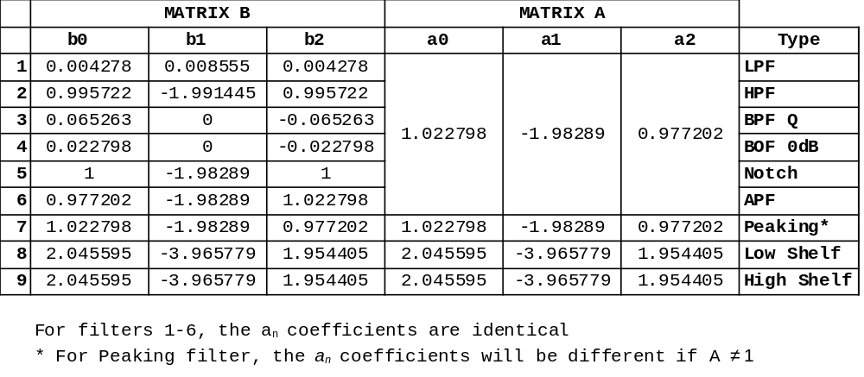Register states after running:

R9 | F_{s}
R.0 | f₀
R.1 | Q
R.2 | A
R.3 | sin(ω₀)
R.4 | cos(ω₀)
R.5 | α
R.6 | A-1
R.7 | A+1
R.8 | 2√Aα
R.9 | BW
Program D – Calculate filter response H(ω_{x}) at arbitrary frequecy f_{x}

Given Matrices A and B as calculated for center frequency f₀ at sampling rate F_{s}, program D will calculate the frequency response of the filter at frequency f_{x} returned as a complex number on the x-register.

Registers needed: All the registers and matrices from running Program C.
Registers modified: R6, R7, R8

For this you need to look up the row index in matrix B corresponding to the filter you want to use. The following table provides this:

Filter | Coeffiecients Location  Row Matrix A | Coeffiecients Location Row Matrix B
Low Pass | 1 | 1
High Pass | 1 | 2
Band Pass Q peak gain | 1 | 3
Band Pass 0dB peak gain | 1 | 4
Notch Filter | 1 | 5
All-Pass Filter | 1 | 6
Peaking | 2 | 7
Low Shelf | 3 | 8
High Shelf | 4 | 9

Example:

Get frequency response for the Bandpass Filter 0dB peak gain (with center frequency f₀ = 1KHz and F_{s}=48KHz) evaluated at f_{x} = 840Hz:

t-regsiter | -
z-register | -
y-register | 4
x-register | 840

Key Strokes | Display | Description
4 | 4 | Row 4 of Matrix B
ENTER | 4.0000
840 | 840 | f_{x}, Frequency of interest
GSB D | 0.4971 | Real of H(ω_{x})
f (i) | 0.4999 | Imag of H(ω_{x})
Note: Calculator will go into Complex Mode after this program

Running program D results in 3 more matrices being created C, D and E:

Matrix C [3x2] contains the real and imaginary parts of z=e^{j2πfx/Fs} , z⁻¹, and z⁻².
Matrix D [4x2] contains the real and imaginary parts of Σ a_{n}z^{-n} where n={0,1,2}
Matrix E [9x2] contains the real and imaginary parts of Σ b_{n}z^{-n} where n={0,1,2}

 | Powers of z for frequency fx = 840.0000
 | z^0 = (1.00000000,0.00000000)
 | z^-1 = (0.99396096,-0.10973431)
 | z^-2 = (0.97591676,-0.21814324)
 | Intermediate complex vectors.
 | E = sum(bn * zx^-n) D = sum(an * zx^-n)
LPF | E(1) 0.016956 + -0.001872j D(1) 0.005551 + 0.004421j
HPF | E(2) -0.011954 + 0.001320j D(2) 0.005551 + 0.004421j
BPF Q | E(3) 0.001572 + 0.014237j D(3) 0.005551 + 0.004421j
BPF 0dB | E(4) 0.000549 + 0.004973j D(4) 0.005551 + 0.004421j
NOTCH | E(5) 0.005002 + -0.000552j D(5) 0.005551 + 0.004421j
ALL-PASS | E(6) 0.004453 + -0.005525j D(6) 0.005551 + 0.004421j
PEAKING | E(7) 0.005551 + 0.004421j D(7) 0.005551 + 0.004421j
LOW SHELF | E(8) 0.011102 + 0.008842j D(8) 0.011102 + 0.008842j
HIGH SHELF | E(9) 0.011102 + 0.008842j D(9) 0.011102 + 0.008842j
 | Frequency response evaluated at fx = 840.0000 [ H(x) = E(wx)/D(wx) ]
LPF | H(2*pi*840Hz) = 1.70469312 + -1.69492177j
HPF | H(2*pi*840Hz) = -1.20181890 + 1.19493003j
BPF Q | H(2*pi*840Hz) = 1.42313489 + 1.43133938j
BPF 0dB | H(2*pi*840Hz) = 0.49712577 + 0.49999174j
NOTCH | H(2*pi*840Hz) = 0.50287423 + -0.49999174j
ALL-PASS | H(2*pi*840Hz) = 0.00574846 + -0.99998348j
PEAKING | H(2*pi*840Hz) = 1.00000000 + 0.00000000j
LOW SHELF | H(2*pi*840Hz) = 1.00000000 + 0.00000000j
HIGH SHELF | H(2*pi*840Hz) = 1.00000000 + 0.00000000j

The complex-valued H(ω_{x}) in the x-register comes from:

H(f_{x}) = (Σ b_{n}·z^{-n}) / (Σ a_{n}·z^{-n})
= (E[idxB,1]+jE[idxB,2])/(D[idxA,1]+jD[idxA,2])

Plot of BPF filter with center frequency f₀ and transfer function evaluaed at f_{x}

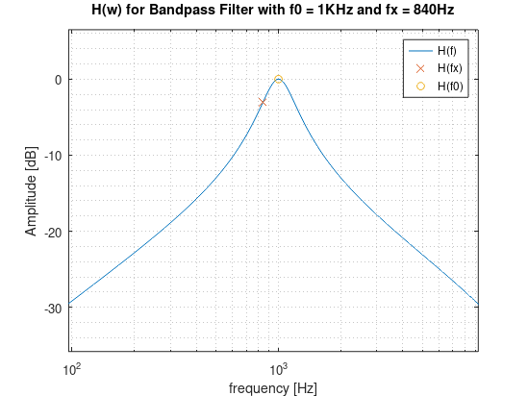
Auxilliary Programs:

Program A – Calculate A

Registers modified: R.1, R.2

This program is used to calculate the A = 10^{dBgain/40} parameter when designing Peaking, Low-Shelf and High-Shelf filters. Put the gain in dB in x-register and press GSB A. The A value will be placed in the x-register as well as stored in register R.2 automatically. If not interested in those filters, put 0.0 in the x-register then press GSB A to populate R.2 (or manually store 1.0 in R.2).

Note: R.2 > 0.0 is required by the main Program C.

Example: dBGain = 3dB

Key Strokes | Display | Description
3 | 3 | Gain in dB
GSB A | 1.1885 | A is also stored in R.2

After running:
Q is in R.1
A is in R.2

Program B – Calculate Bandwidth given Q

Registers required before running: R9, R.0
where:
R9 = Fs (sampling frequency in Hz)
R.0 = ω₀ = 2πf₀/F_{s} (angular frequency in rad)

This program is used to calculate the filter bandwidth (in multiples of an octave) given Q, f₀ , F_{s} and Q. It also calculate ω₀ which is used extensively in Program C.

Example:
Filter center frequency: f₀ = 1KHz
Sampling frequency: F_{s} = 48KHz
Quality Factor: Q = 2.862726050

Key Strokes | Display | Description
0.5 | 0.5 | Bandwidth (in multiples of an octave)
GSB B | 1.0

After running:
Q is stored in R.1
A is stored in R.2
Bandwidth is stored in R.9 (for reference only)

Extra Mini Programs:
These are two very short programs in the .mem file (but not in the listing file) that convert filter gain to and from dB.

Program 0 – Calculate Linear → dB

This program will take the absolute value of the x-register and do 20log10(abs(x-reg))

Program 1 – Calculate dB → Linear

This program will take the absolute value of the x-register and do 10^(x-reg / 20)
Technical Notes:

Given how much program memory this code needs (528 bytes) and the size of the matrices A thru E (568 bytes), the provided image can only be run in 15.2 mode and the author strongly recommends keeping the allocation to the default amount of 19 memory registers. The programs will not run in default 15 mode and allocating more than 19 registers might cause unexpected behavior up to and including freezing (requiring a hard reset.)

Supporting Docs:

audio_eq_cookbook.xlsx – This sheet has the full program listing and the state of the stack for every instruction. It also provides a worked out example for a given set of parameters so users can verify all calculations are correct.

audio_eq_cookbook.m – This Matlab/Octave script calculates all the parameters and is meant to be a way to validate the calculator output. It will plot the filter response and place markers on f₀ and f_{x}.
function [C,Hx,Hsweep] = sanity_check(Fs,f0,BW,A,fx)

