LAB 4 REPORT: Java Servlets & MVC Pattern
NAME: Trần Khánh Bình
ID: ITCSIU24015

5. EXERCISES
Exercise 1: Complete Basic CRUD (Basic - 90 minutes)
Objective: Implement complete CRUD operations with proper validation.
Requirements:
1. Search Functionality (30 minutes)
– Add search bar to student-list.jsp
– Search by student code OR full name
– Create searchStudents(String keyword) method in DAO
– Update controller to handle search action
– Display “No results found” if search returns empty
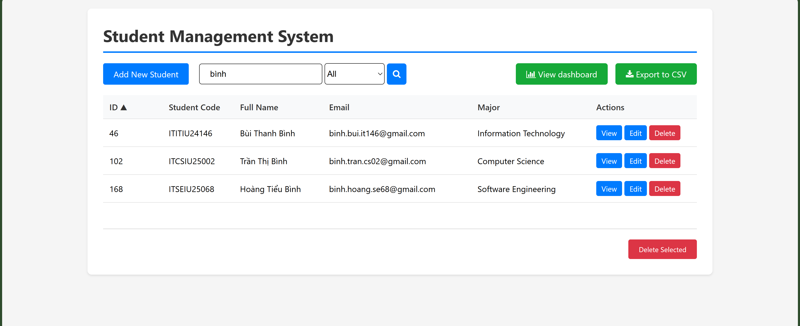
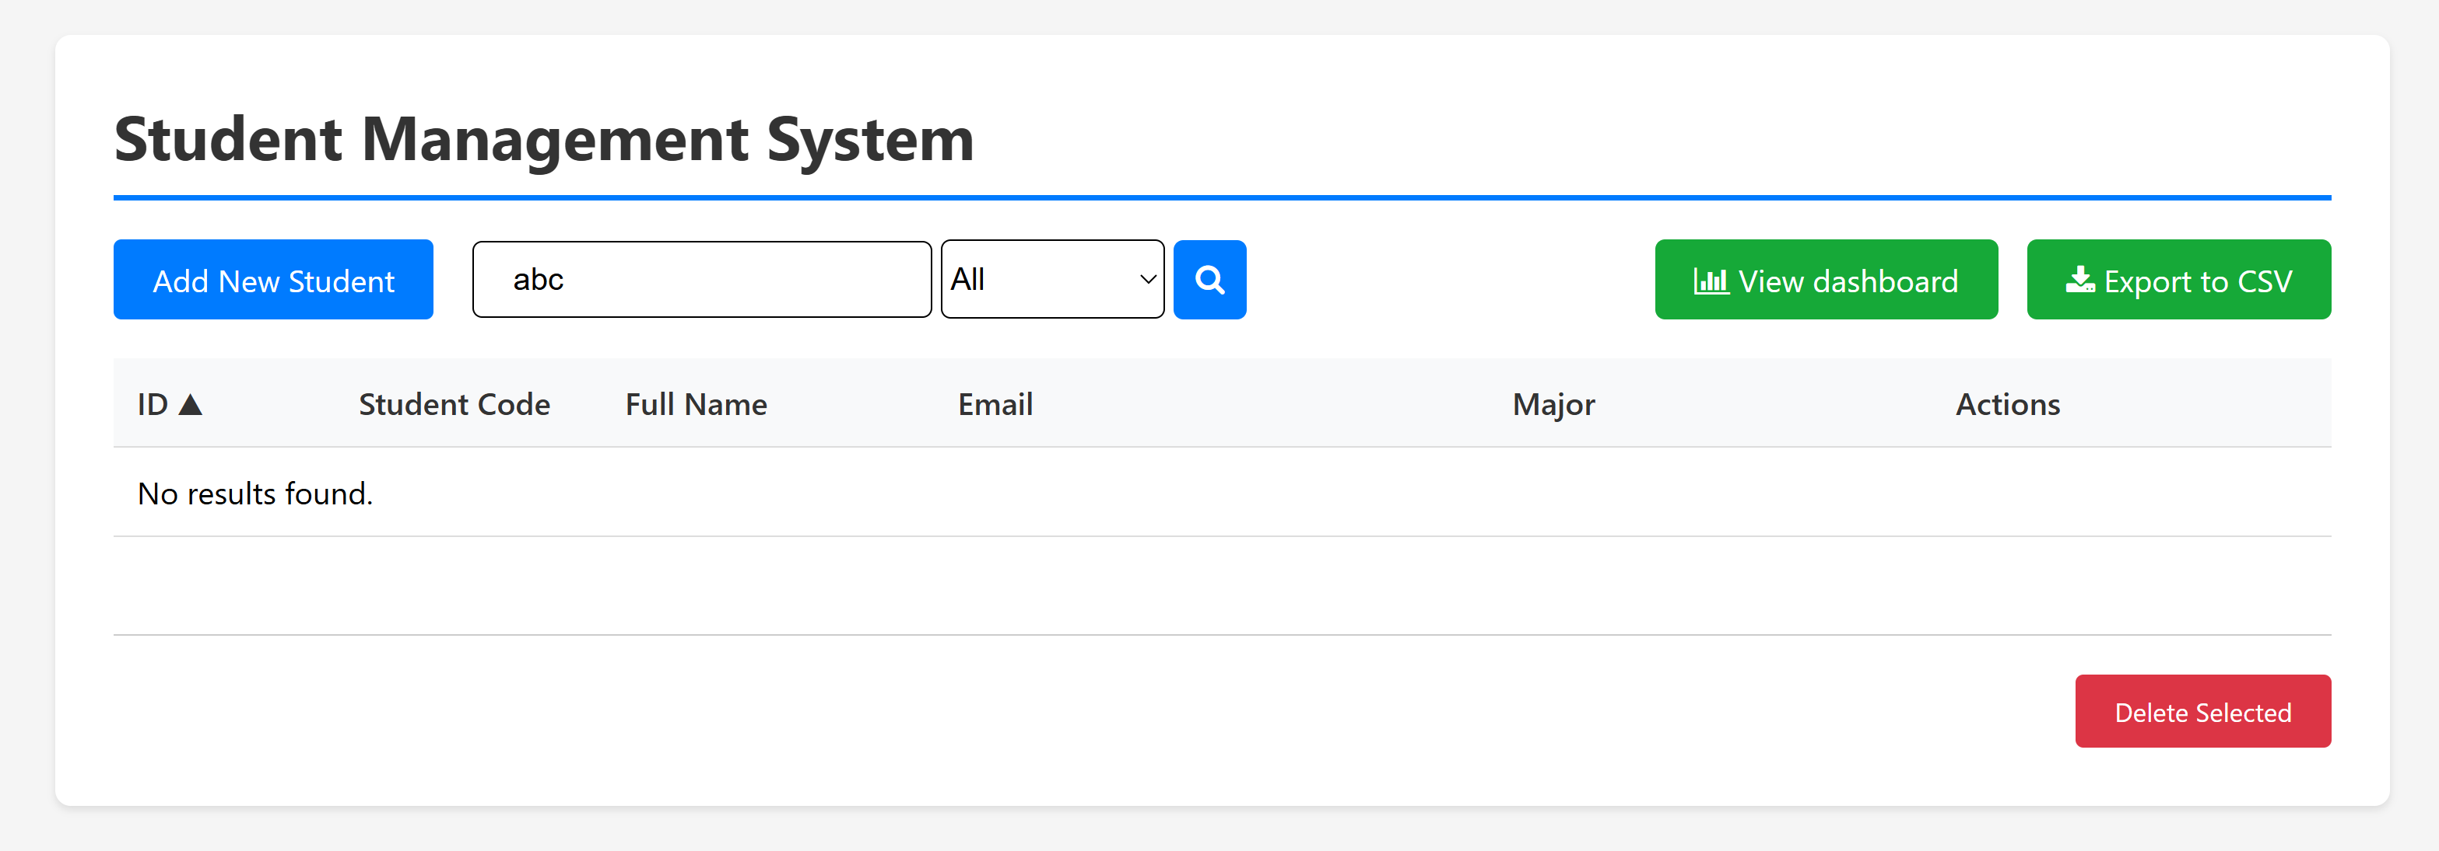
2. Server-Side Validation (30 minutes)
– Validate student code format: [A-Z]{2,6}IU\d{5} (e.g., ITITIU21001)
– Validate email format
– Check for duplicate student code before insert
– Check for duplicate email before insert
– Display validation errors on form (use request attributes)
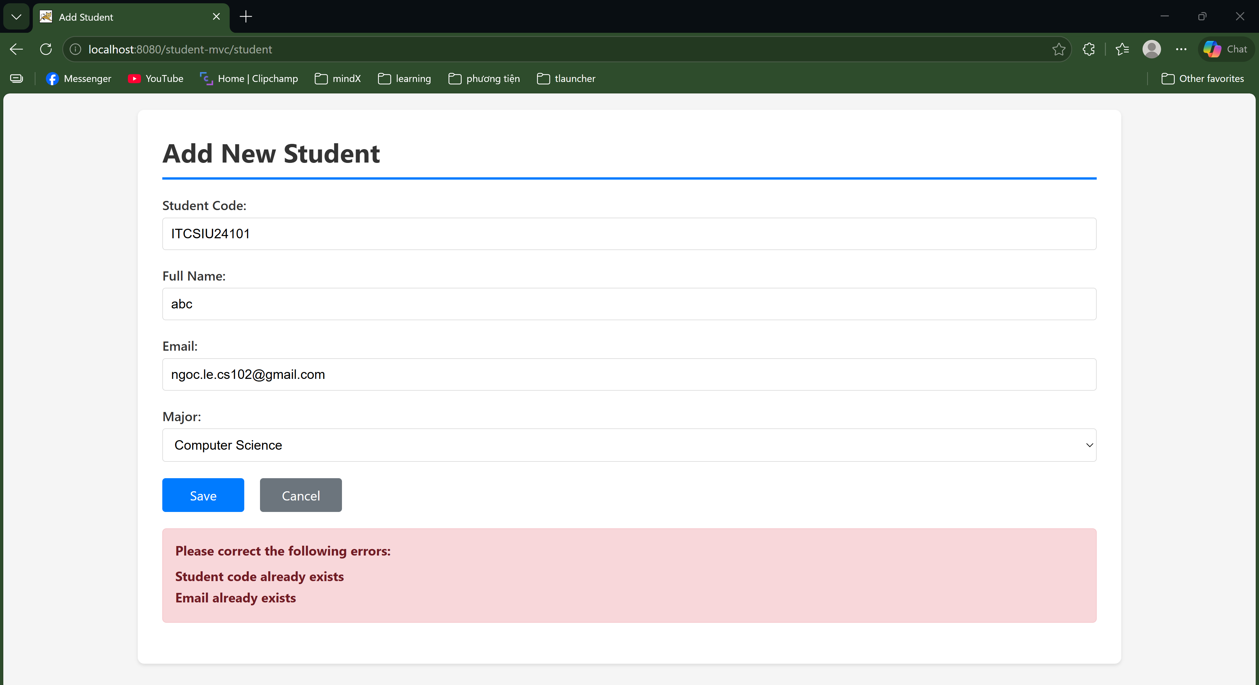
3. Improve Delete Confirmation (30 minutes)
– Instead of JavaScript confirm(), create a separate confirmation page
– GET /student?action=confirmDelete&id=X shows confirmation page
– Confirmation page displays student details
– POST /student?action=delete actually deletes
– Use PRG (Post-Redirect-Get) pattern
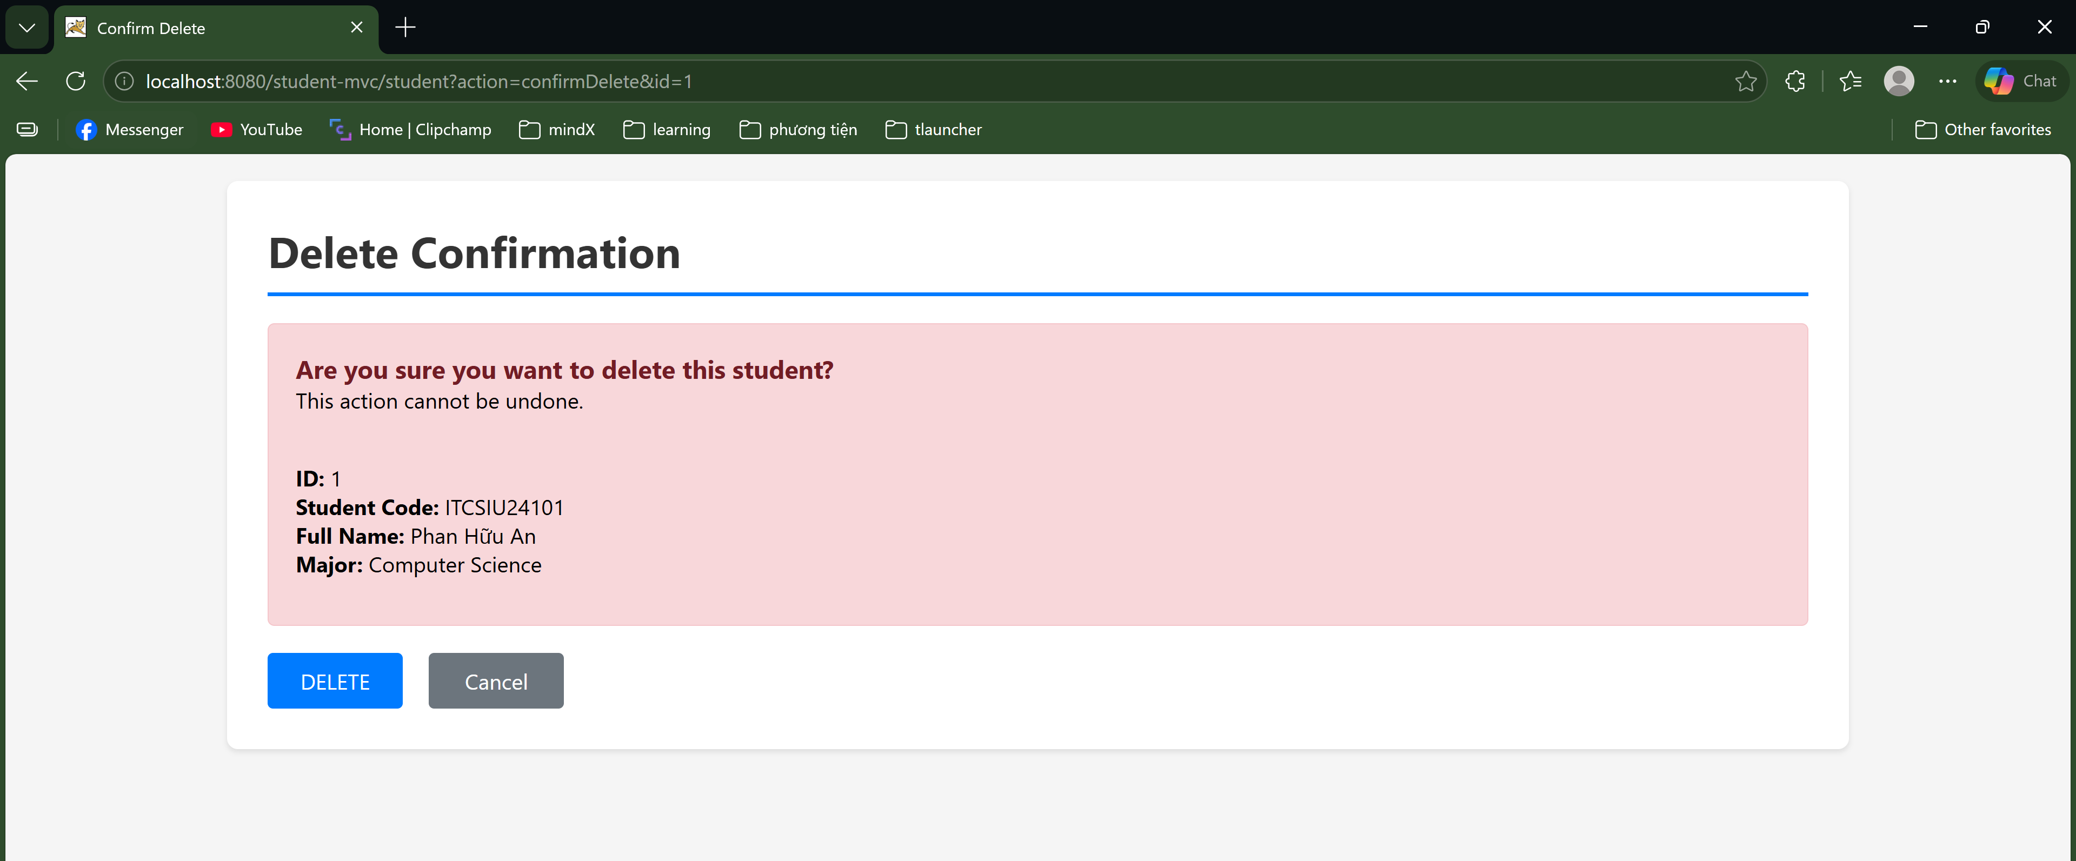
What to Submit:
- Updated StudentDAO.java with search method
- Updated StudentController.java with validation
- Updated JSP files with search UI and error display
- Screenshot showing search working
- Screenshot showing validation errors
What to Explain:
- Why validate on server-side even if client-side validation exists?
Client-side validation only improves user experience. Users can easily bypass HTML/JS controls, so server-side validation acts as the final security wall to protect the database from invalid or harmful inputs.
- What is PRG pattern and why use it for delete confirmation?
PRG (Post/Redirect/Get) pattern means after processing a POST request, the server redirects the user to a GET page. This prevents duplicate form submissions (like deleting the same record twice) if the user accidentally refreshes the page.
- How does prepared statement prevent SQL injection in your search?
Prepared statements pre-compile the SQL query structure before inserting user inputs. This forces the database to treat inputs strictly as plain text values, preventing them from being executed as SQL commands.
Exercise 2: Pagination and Sorting (Intermediate - 120 minutes)
Objective: Add pagination and sorting to student list.
Requirements:
1. Pagination (60 minutes)
– Display 5 students per page
– Add page navigation: Previous | 1 2 3 | Next
– Implement getStudents(int page, int pageSize) in DAO
– Use LIMIT and OFFSET in SQL
– Show “Page X of Y” information
– Handle edge cases (page < 1, page > maxPage)
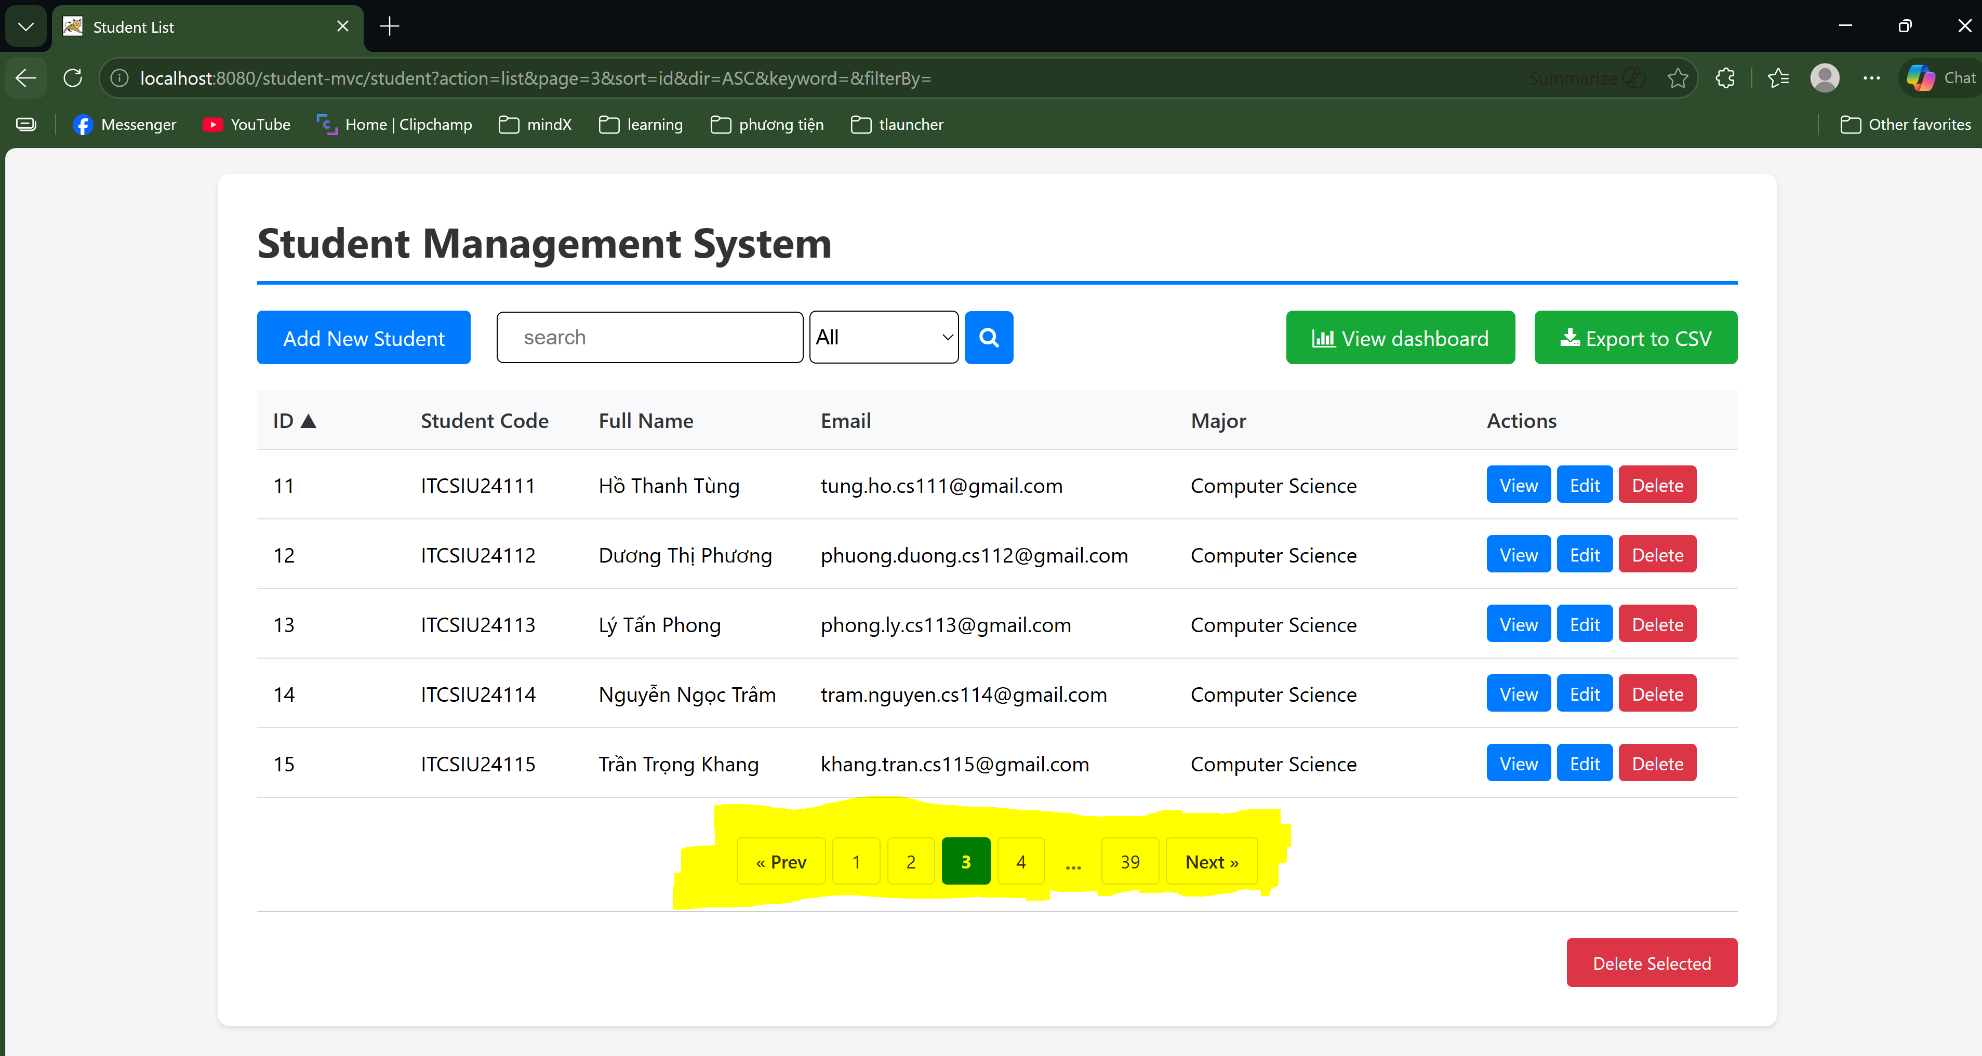
2. Sorting (40 minutes)
– Add sortable column headers (Student Code, Name, Email, Major)
– Clicking header sorts by that column
– Clicking again reverses sort order (ASC ↔ DESC)
– Visual indicator (▲▼) shows current sort column and direction
– Preserve sort when navigating pages
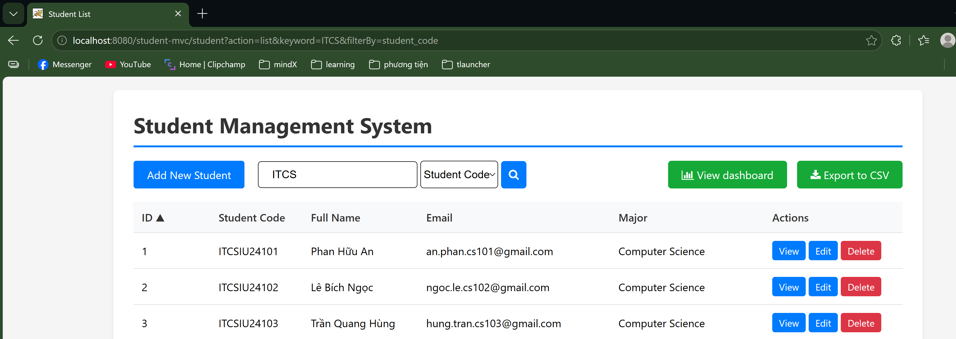
3. Combine Search + Pagination + Sort (20 minutes)
– Search results should be paginated
– Can sort search results
– Preserve all query parameters (search, page, sort, order) in links
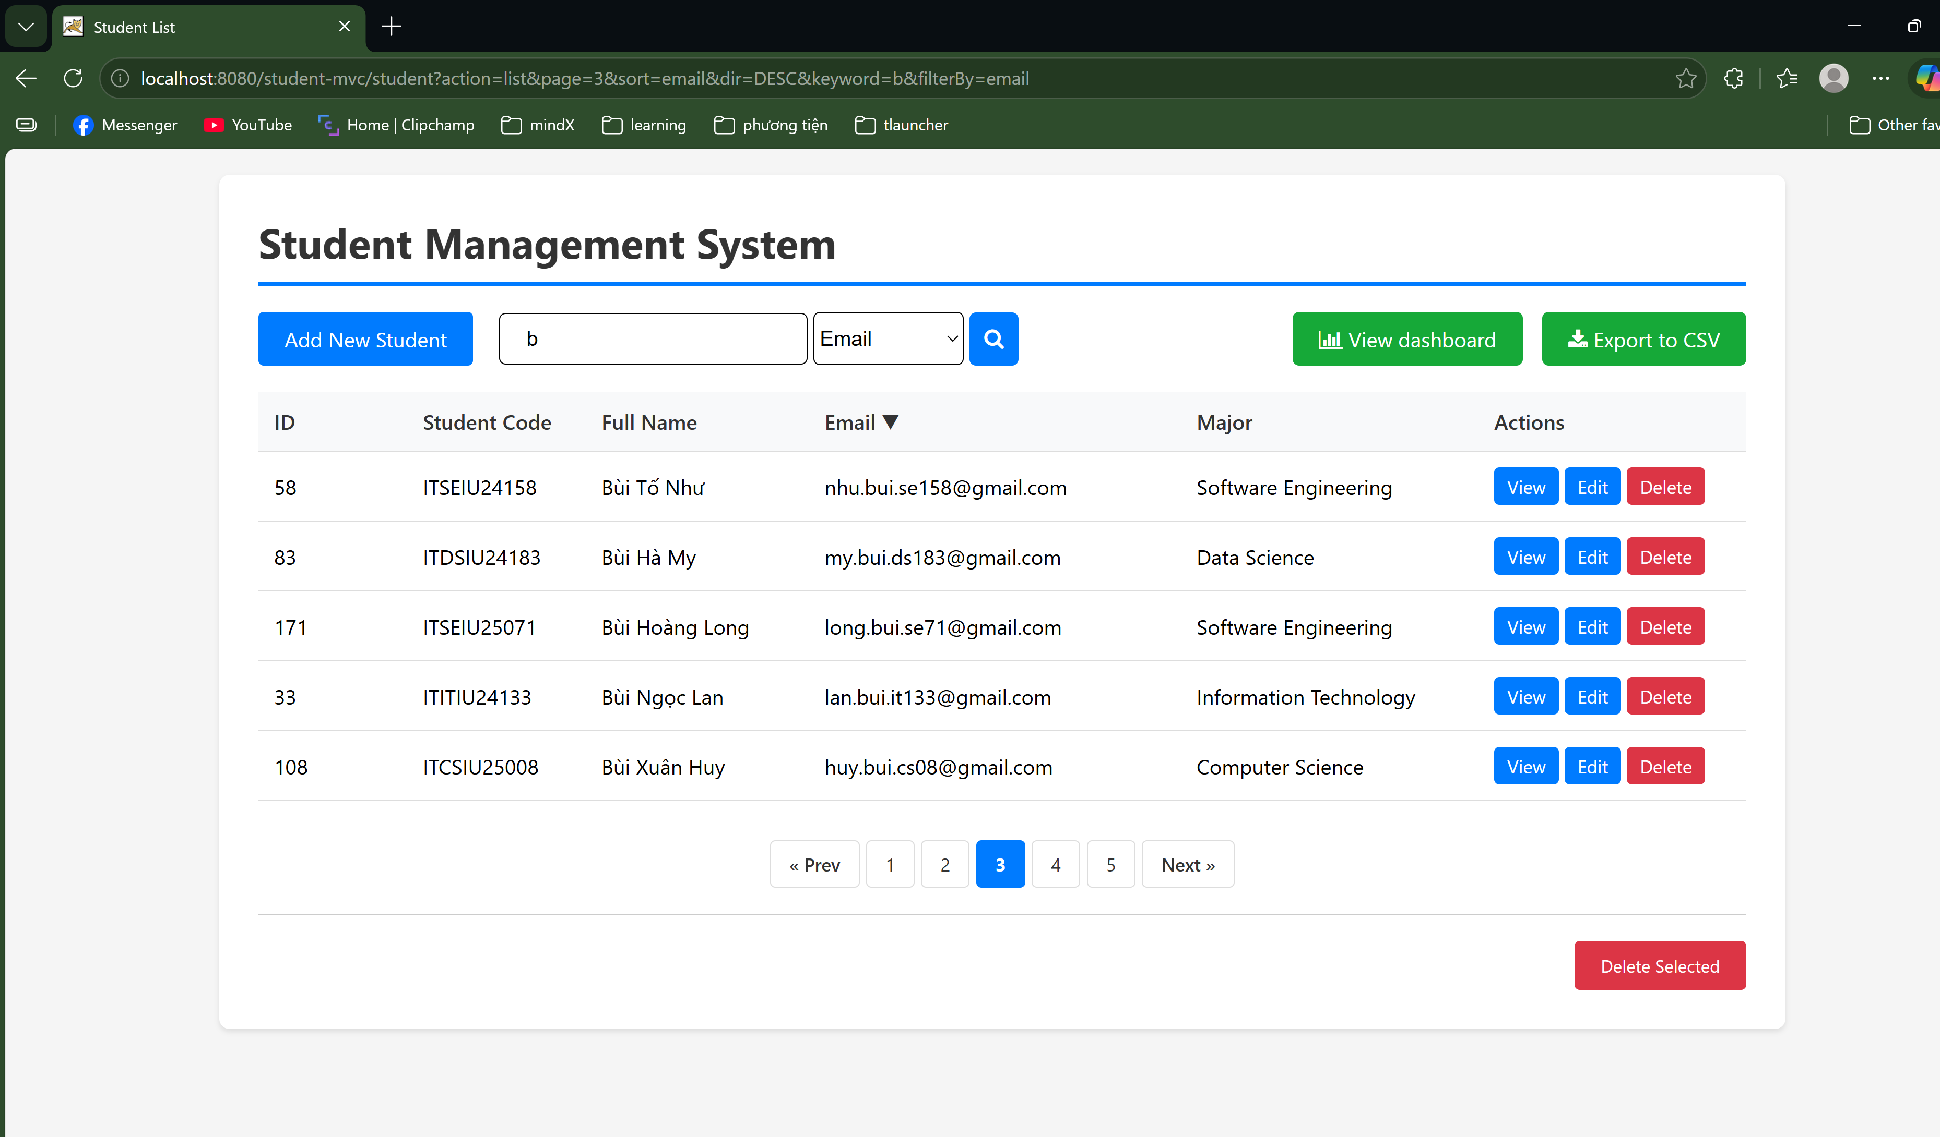
Technical Challenges:
- SQL query must support WHERE, ORDER BY, LIMIT, OFFSET dynamically
- URL parameters management: /student?action=list&search=nguyen&sort=name&order=asc&page=2
- Generating page links with all current parameters
What to Submit:
- Updated DAO with pagination and sorting
- Updated Controller handling all parameters
- Updated JSP with pagination UI and sortable headers
- Screenshot showing pagination working
- Screenshot showing sorting working
What to Explain:
- Why is LIMIT/OFFSET better than loading all records and paginating in Java?
Loading everything into Java consumes too much server RAM and slows down the application. LIMIT/OFFSET shifts the heavy lifting to the database, retrieving only the exact rows needed for the current page.
- How do you prevent SQL injection when sort column comes from user input?
Prepared statements cannot secure column names. Instead, I validate the input by checking it against a hardcoded list of allowed column names (whitelist approach) before appending it to the SQL query.
- What happens if user manually enters page=-1 or page=999 in URL?
My backend code catches negative or invalid pages and resets them to page 1. For pages exceeding the total count (like 999), the database simply returns an empty result, showing a blank table.
Exercise 3: Export and Advanced Features (Advanced - 150 minutes)
Objective: Add export, statistics, and improve user experience.
Requirements:
1. Export to CSV (50 minutes)
– Add “Export to CSV” button on student list
– GET /student?action=export&format=csv
– Set proper HTTP headers for file download
– Include all students (not just current page)
– File format: student_code,full_name,email,major
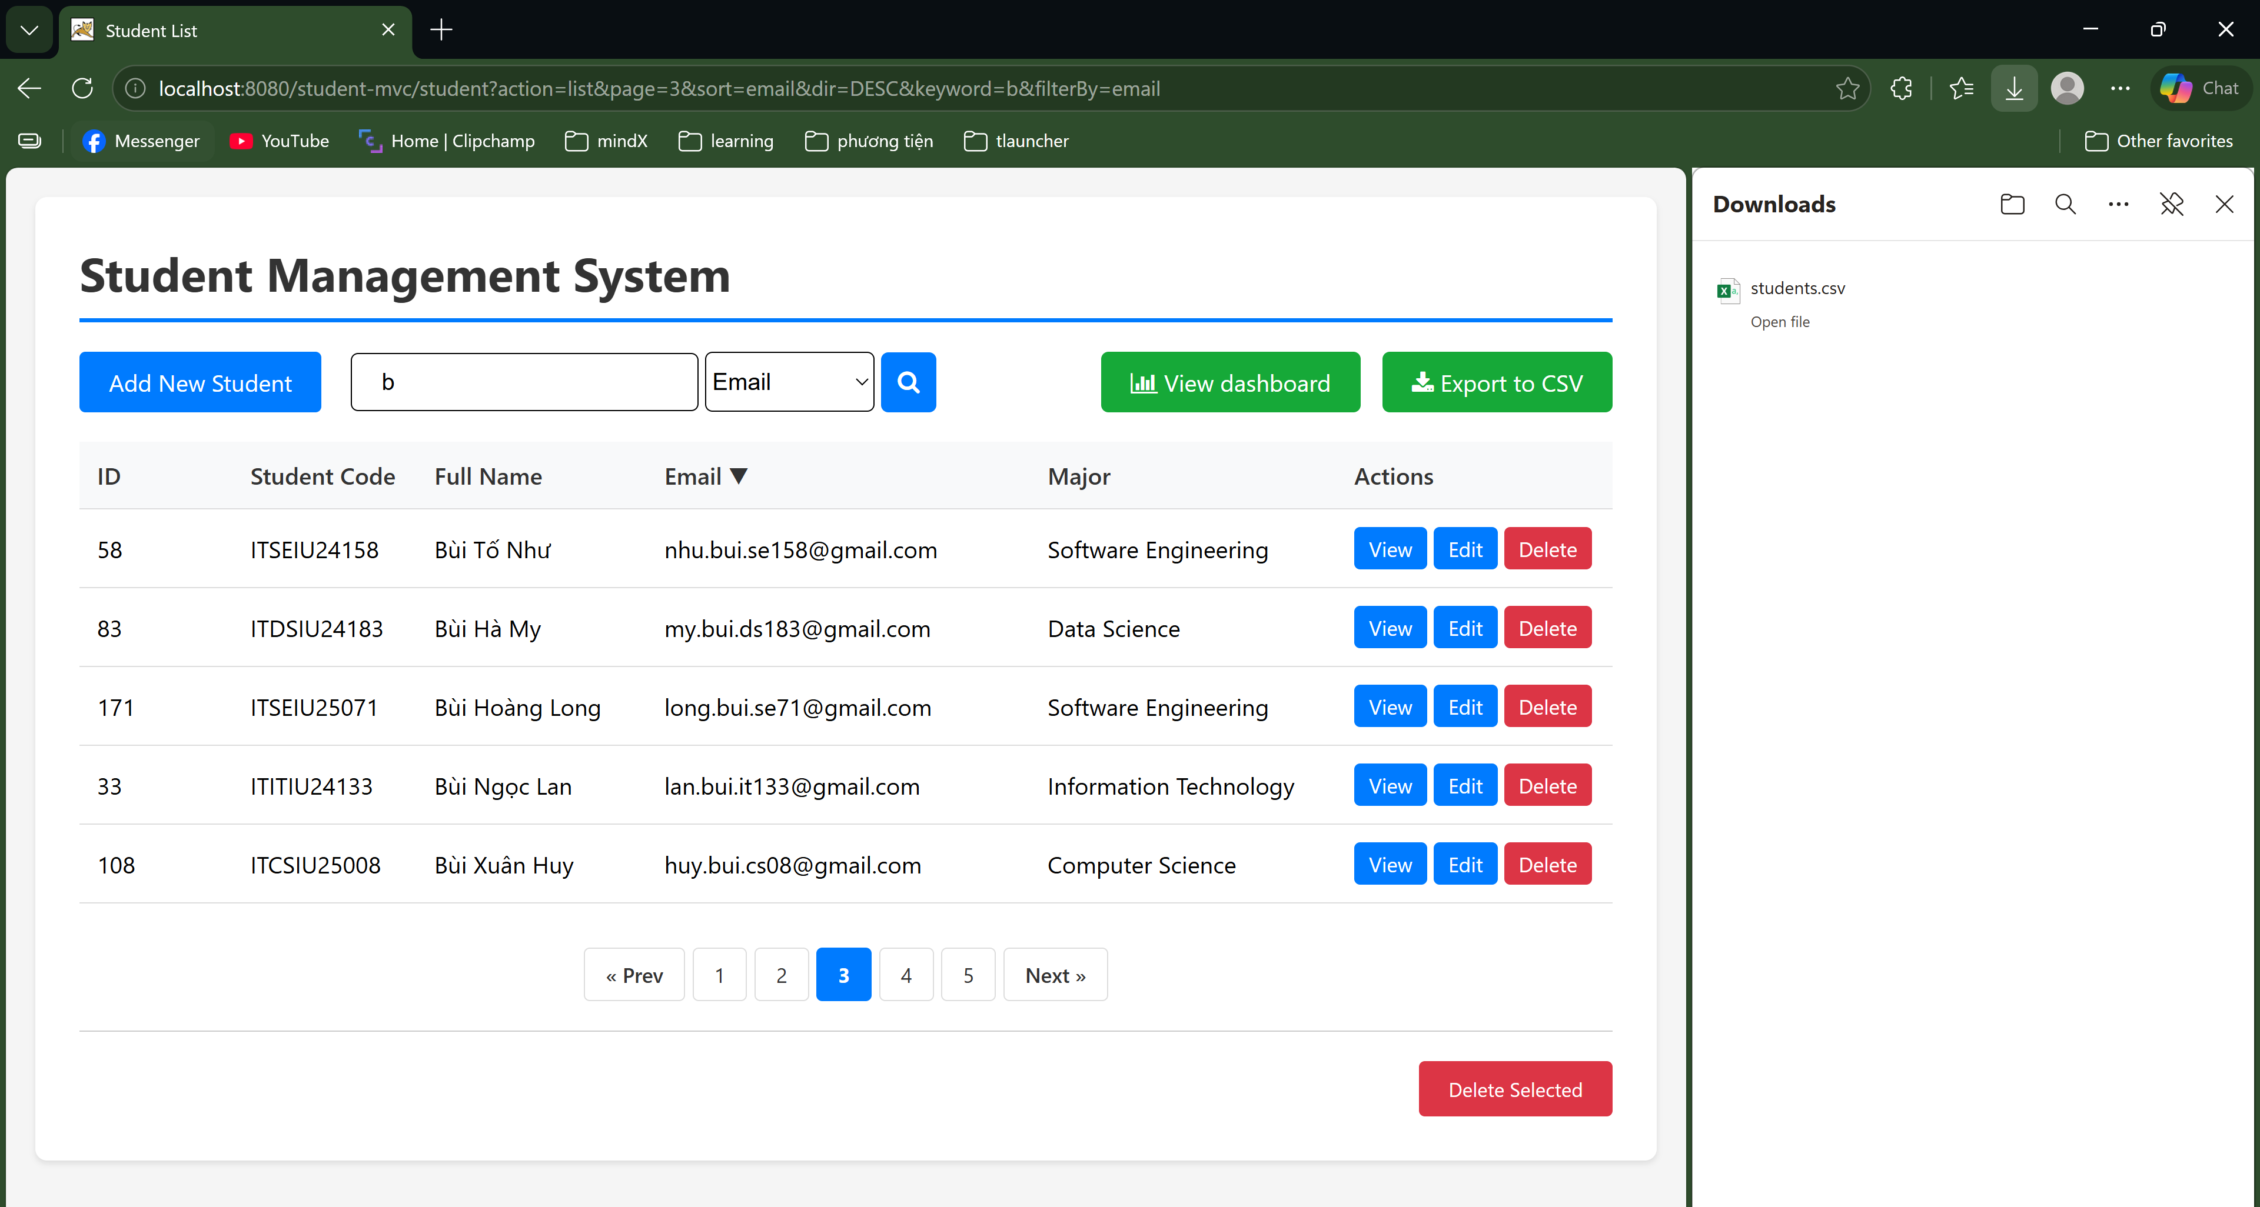

2. Statistics Dashboard (50 minutes)
– Create /student?action=dashboard page
– Show total students count
– Show count by major (pie chart or bar chart using Chart.js)
– Show growth trend (students added per month - last 6 months)
– Implement statistics queries in DAO
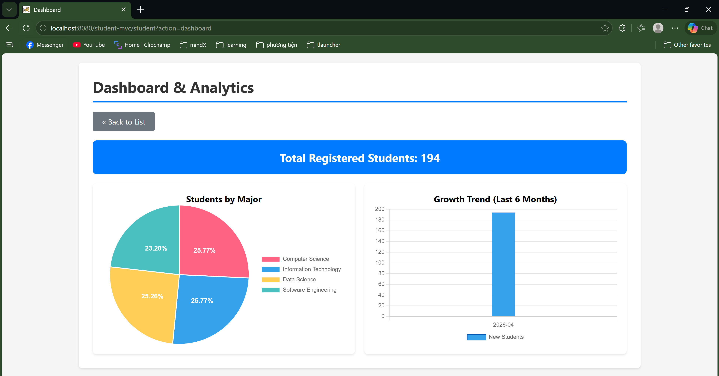
3. Bulk Operations (50 minutes)
– Add checkboxes to student list
– “Select All” checkbox
– Bulk delete selected students
– Confirmation page shows list of students to delete
– Use transaction to delete all or none
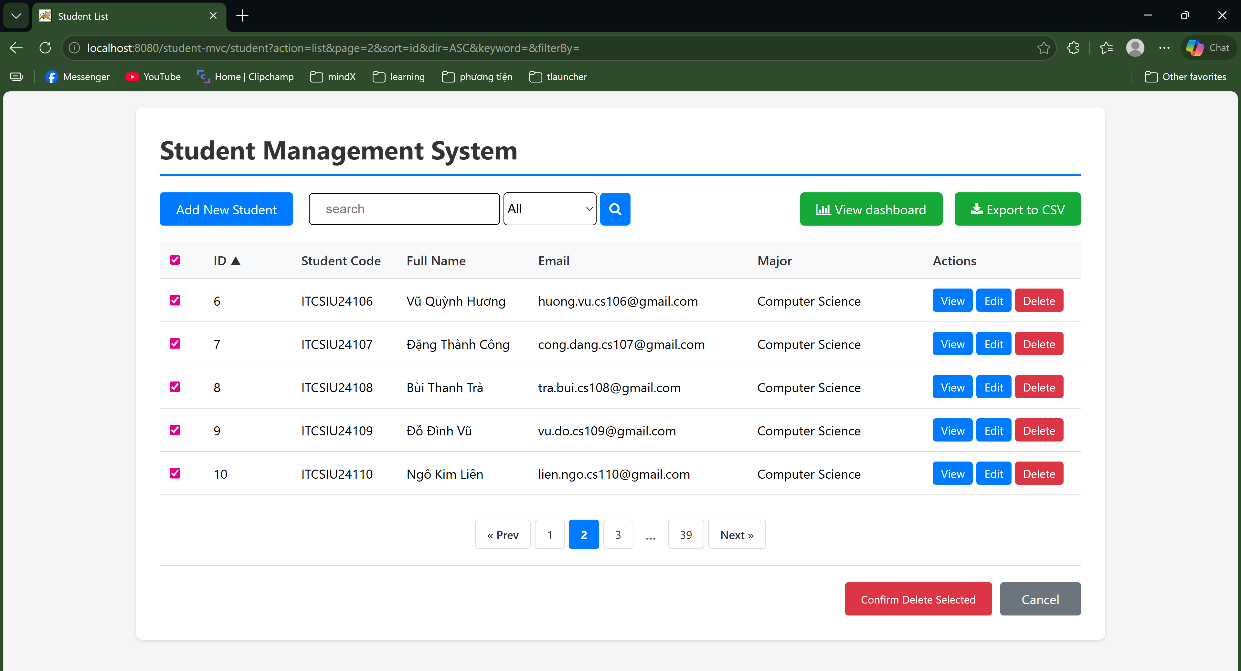
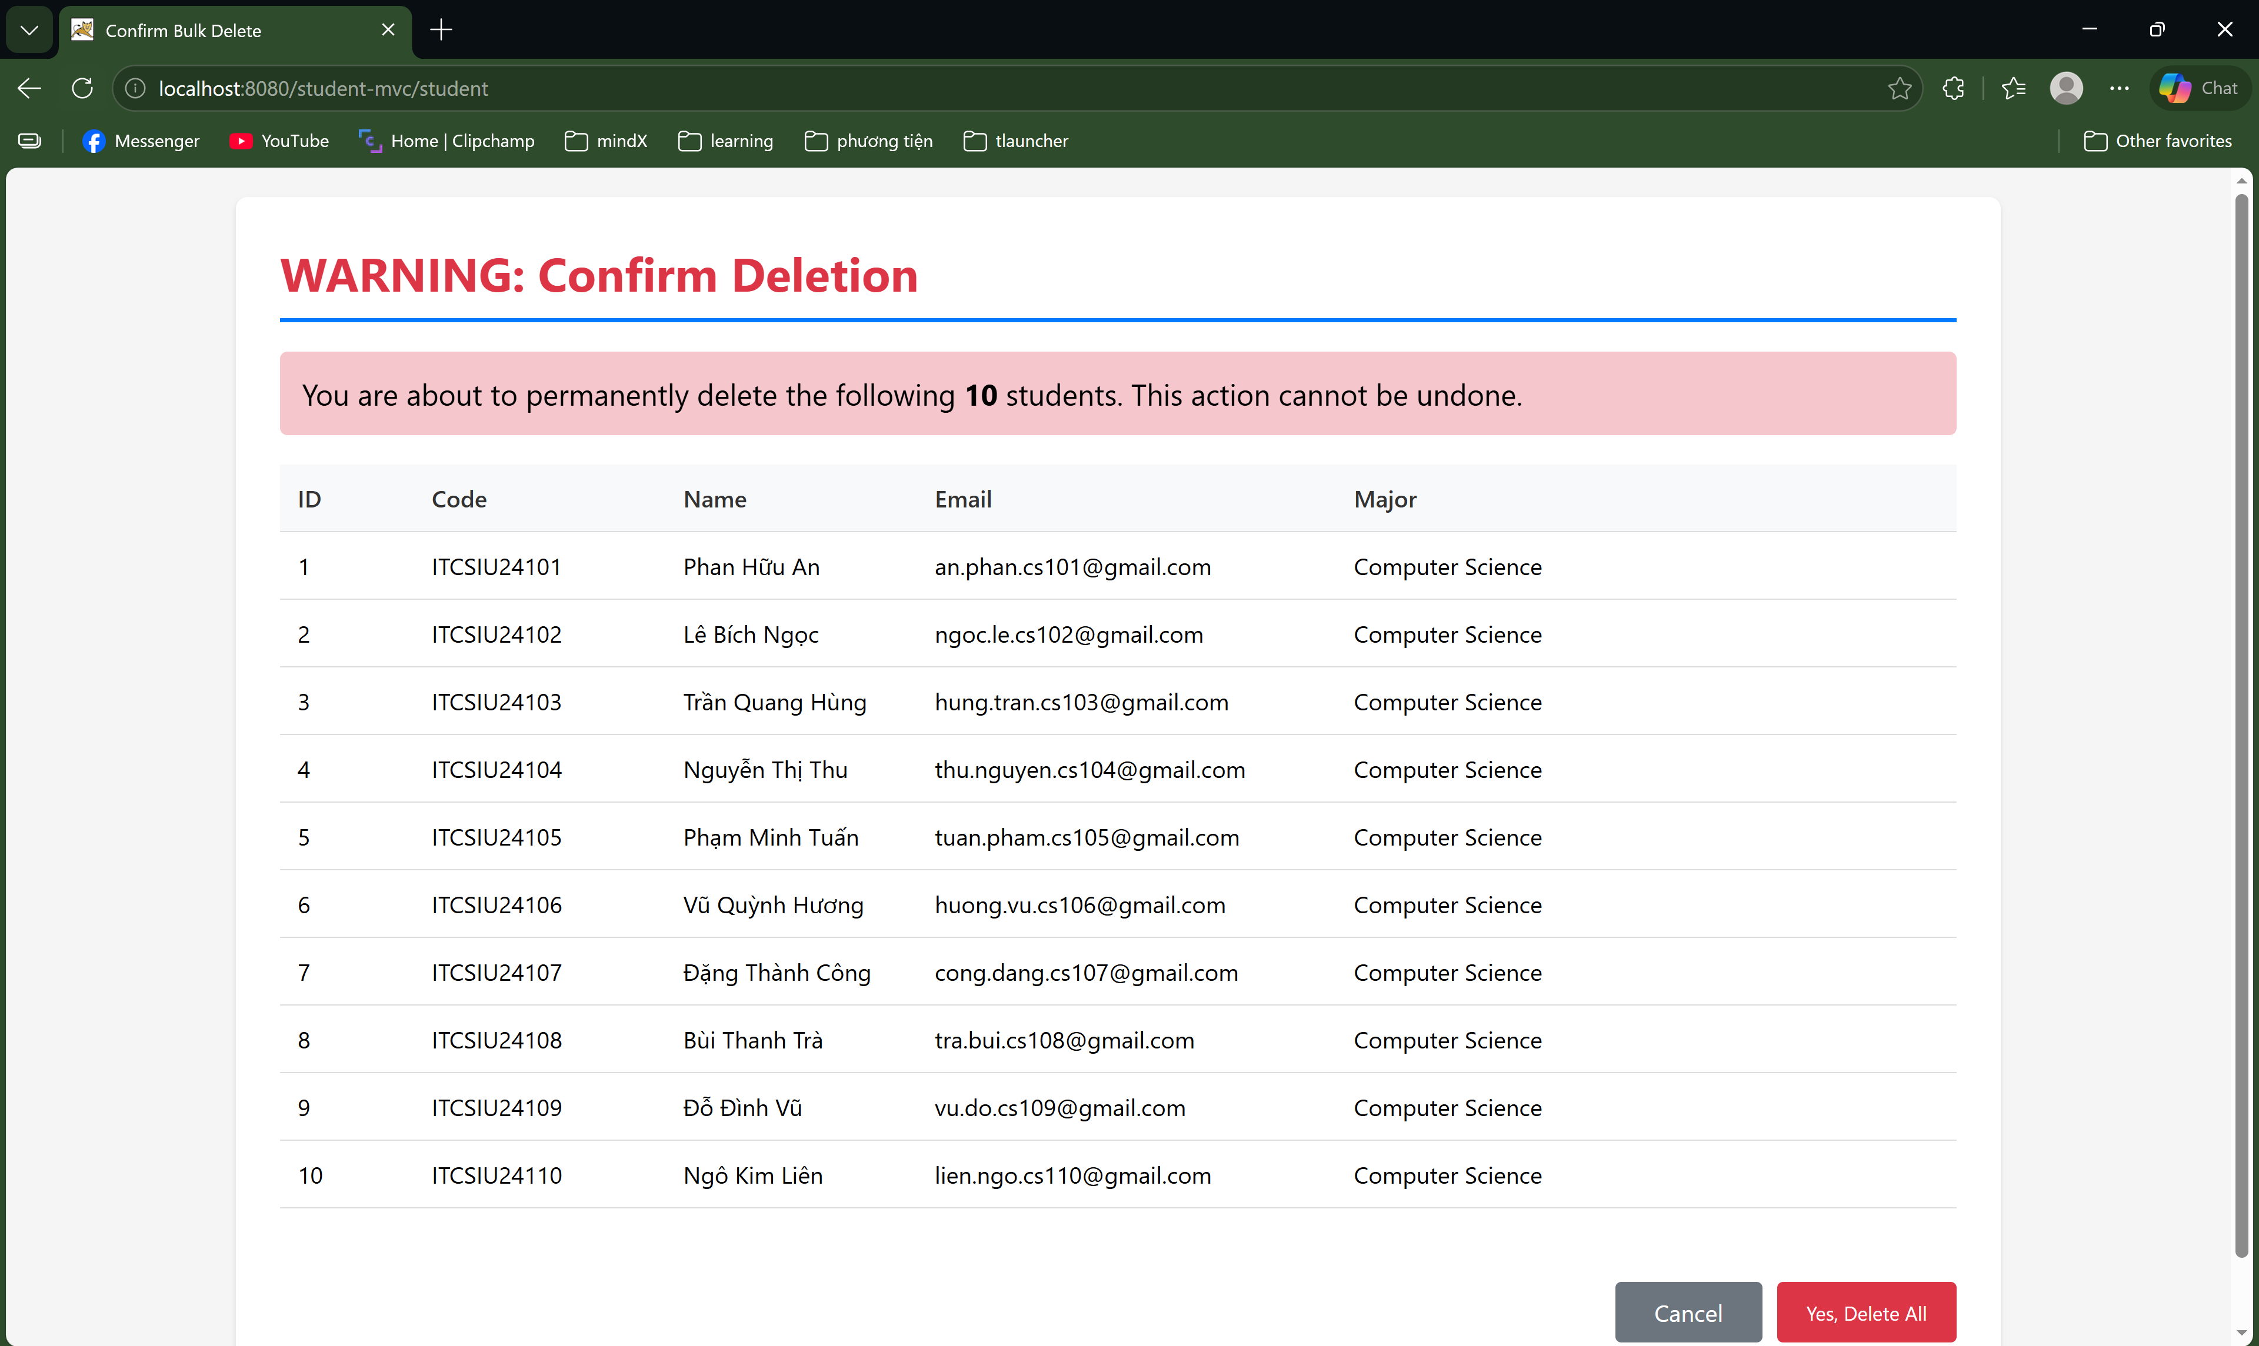
Advanced Technical Challenges:
- CSV generation with proper escaping (commas in names, quotes)
- SQL aggregation queries (GROUP BY, COUNT)
- Multiple checkboxes handling in servlet
- Transaction management in JDBC
What to Submit:
- Export feature working
- Dashboard with statistics
- Bulk delete feature
- Screenshots of all features
- DAO code showing transaction handling
What to Explain:
- Why use transactions for bulk delete?
If an error occurs halfway through deleting a batch of students, the database rolls back all changes, preventing partial deletions and keeping data consistent.
- What headers are needed for CSV download?
We need Content-Type: text/csv to tell the browser the file format, and Content-Disposition: attachment; filename="file.csv" to force the browser to download the file instead of displaying it.
- How would you handle exporting 100,000 students? (memory implications)
Loading 100,000 records into a Java List at once will cause a memory crash. Instead, I would stream the data, fetching and writing it to the CSV file row-by-row to save memory.
- Security: What if attacker submits id=1&id=2&id=3… for ALL student IDs to delete entire
database?
I would limit the maximum number of IDs allowed in a single bulk request (e.g., max 50 at a time). Additionally, critical actions like this should be protected by proper admin authorization checks.

PART 8 :
Question 1: MVC Architecture Trade-offs
• Short-term vs Long-term
- Short-term (JSP-only): faster to build, less structure.
- Long-term: hard to maintain, messy code, difficult debugging, poor scalability.
• Example where MVC prevents bugs
- Mixing SQL + UI in JSP can cause:
  - duplicate queries
  - inconsistent data handling
- MVC separates:
  - Servlet (control flow)
  - DAO (data access)
→ prevents logic duplication and data inconsistency.
• When JSP-only is acceptable
- Very small apps
- Prototypes or demos
- No long-term maintenance required

Question 2: Servlet Thread Safety
• What happens with 100 users?
- requestCount++ is not thread-safe
→ race condition → incorrect counts
• Why dangerous?
- Shared instance variable across threads
- Leads to inconsistent or corrupted data
• Fix
- Use:
  - AtomicInteger
  - or local variables
  - or synchronization
• Are all instance variables bad? - No
- Safe if:
  - stateless (e.g., DAO without shared mutable data)
  - or thread-safe

Question 3: Forward vs Redirect
• When to use
- forward():
  - same request
  - pass data via request
  - internal navigation
- sendRedirect():
  - new request
  - after POST
  - avoid duplicate submission
• PRG (Post-Redirect-Get)
- Flow: POST → Redirect → GET
- Prevents:
  - duplicate form submission
  - page refresh issues
• Pass message with redirect
- Use:
  - session attribute
  - or query parameter
Example:
response.sendRedirect("list?success=true");

Question 4: SQL Injection Prevention
• Exploit for Version A
Input:
' OR '1'='1
Query becomes:
SELECT * FROM students WHERE name = '' OR '1'='1'
→ returns all records

• How PreparedStatement prevents it
- Treats input as data, not SQL code
- Escapes special characters
- No query structure modification

• Does it prevent all injection? - No
Example:
String column = request.getParameter("sort");
String sql = "SELECT * FROM students ORDER BY " + column;
→ vulnerable (dynamic SQL part)
✔ Fix
- Use whitelist:
if (!allowedColumns.contains(column)) column = "name";

Question 5: Pagination Performance
- Faster approach: Approach B. Database engines are optimized for data retrieval, and it significantly reduces network bandwidth and Java server memory consumption.
- At 1,000,000 students: Approach A will cause an OutOfMemoryError and crash the server. Approach B remains stable because it still only fetches a small chunk (e.g., 10 rows) at a time.
- Disadvantages of Approach B: It requires executing an extra COUNT(*) query to calculate the total number of pages OFFSET performance degrades on large page.
Question 6: Session vs Request Scope
- PRG Pattern compatibility: Option 2. Option 1 fails because the request scope is destroyed the moment the server redirects to a new URL.
- Problem with unremoved session message: It causes a "ghost message" issue where the success alert keeps reappearing on different pages or after reloading, confusing the user.
- Flash message implementation: Set the message in the session, display it once in the JSP using JSTL/EL, and immediately remove it using:
<c:remove var="message" scope="session"/>
Or:
session.removeAttribute().
Question 7: Server-Side vs Client-Side Rendering
- Advantages: SSR is SEO-friendly and works even on low-end devices. CSR provides a smoother, desktop-app-like user experience without screen flickering.
- Speed comparison: SSR is faster for the initial page load. CSR is much faster for subsequent interactions because it only transfers lightweight JSON data instead of whole HTML documents.
- When to choose: Use SSR for content-heavy, SEO-critical websites (blogs, landing pages). Use CSR for highly interactive web applications (dashboards, management systems).
- How to combine: Serve the initial HTML shell and essential data via SSR for quick viewing, then use CSR (Fetch API/JavaScript) to dynamically update specific parts like charts or tables later.
Question 8: DAO Pattern Benefits
- Changing Database: With DAO, you only update the SQL syntax inside one DAO class. Without it, you have to hunt down and rewrite SQL strings scattered across dozens of Servlets.
- Mobile App integration: The DAO encapsulates data access, allowing you to easily reuse the exact same DAO methods inside a new REST API layer for the mobile app to consume.
- Unit testing: Without DAO, servlets are tightly coupled to the database, making testing slow and fragile. DAO allows you to use Mock objects to simulate database responses instantly.
- Cost of using DAO: It adds structural overhead—more boilerplate code, extra interfaces, and an increased number of files to manage for a simple feature.

