Part 4:
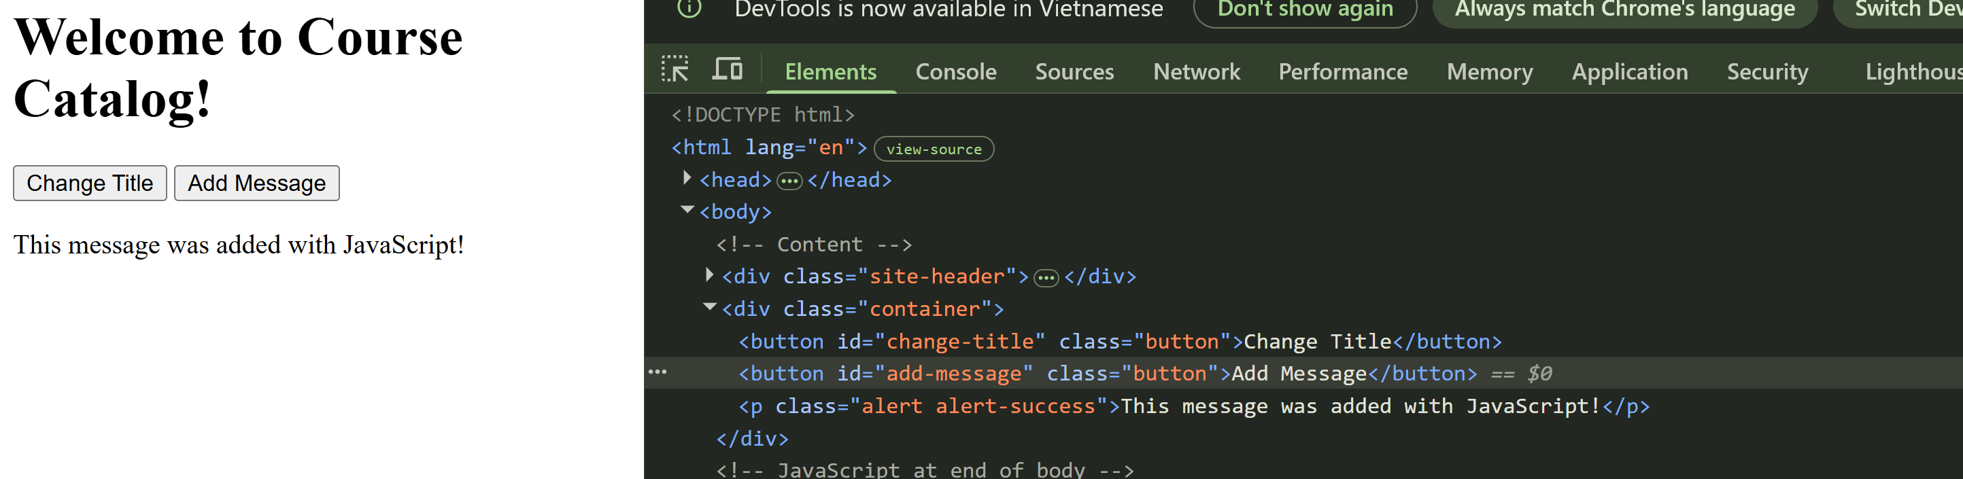

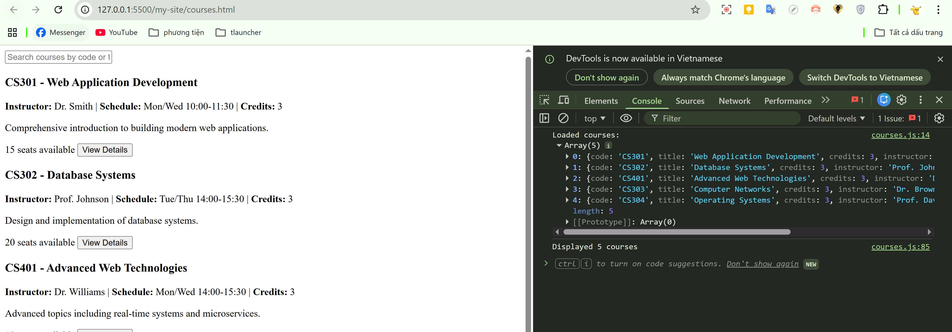
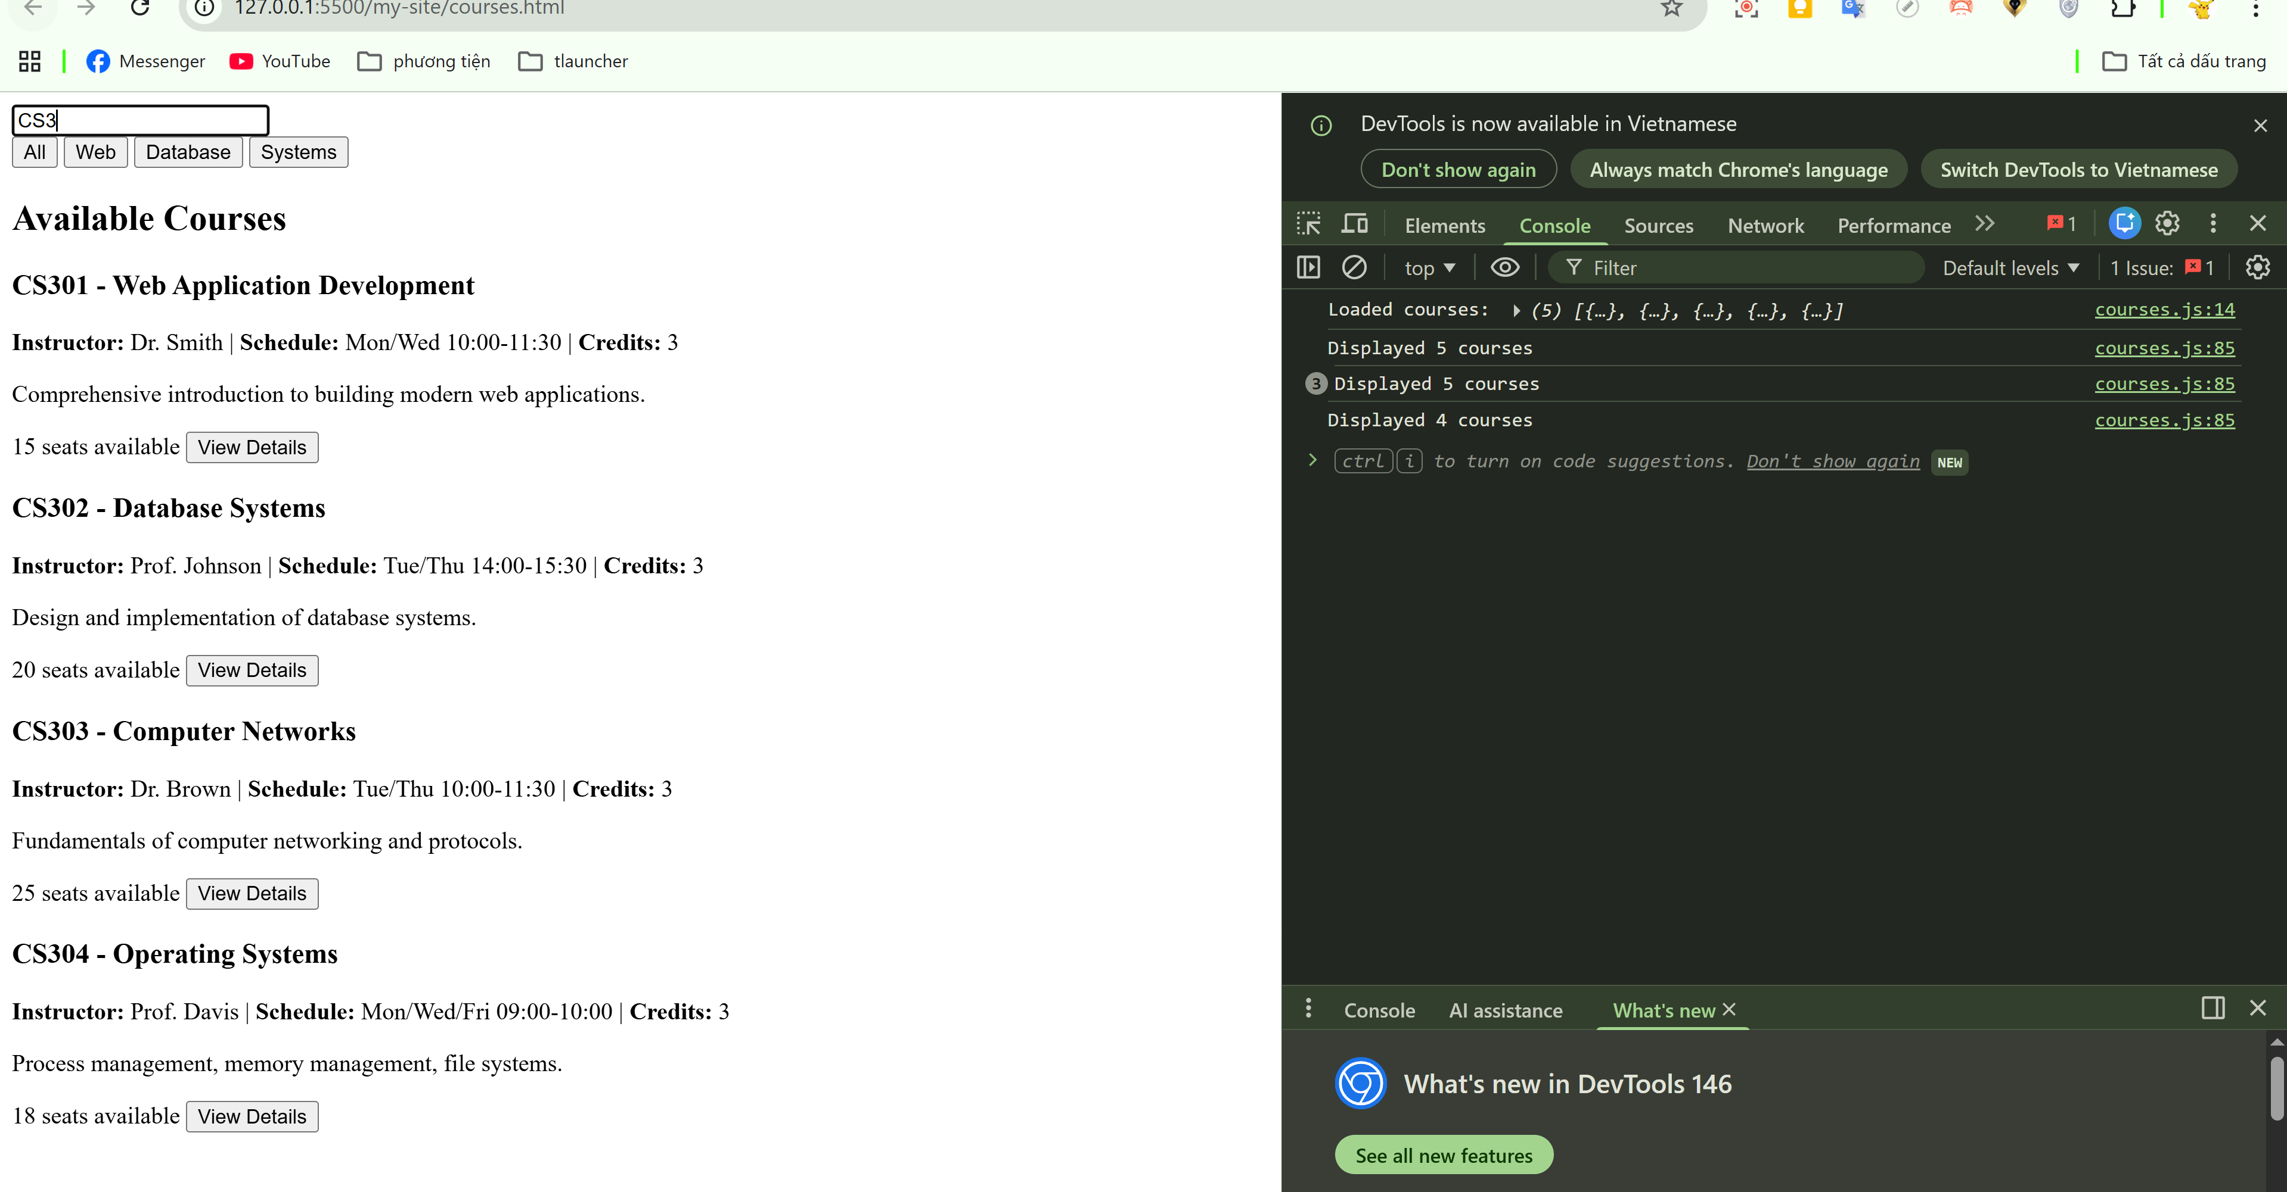
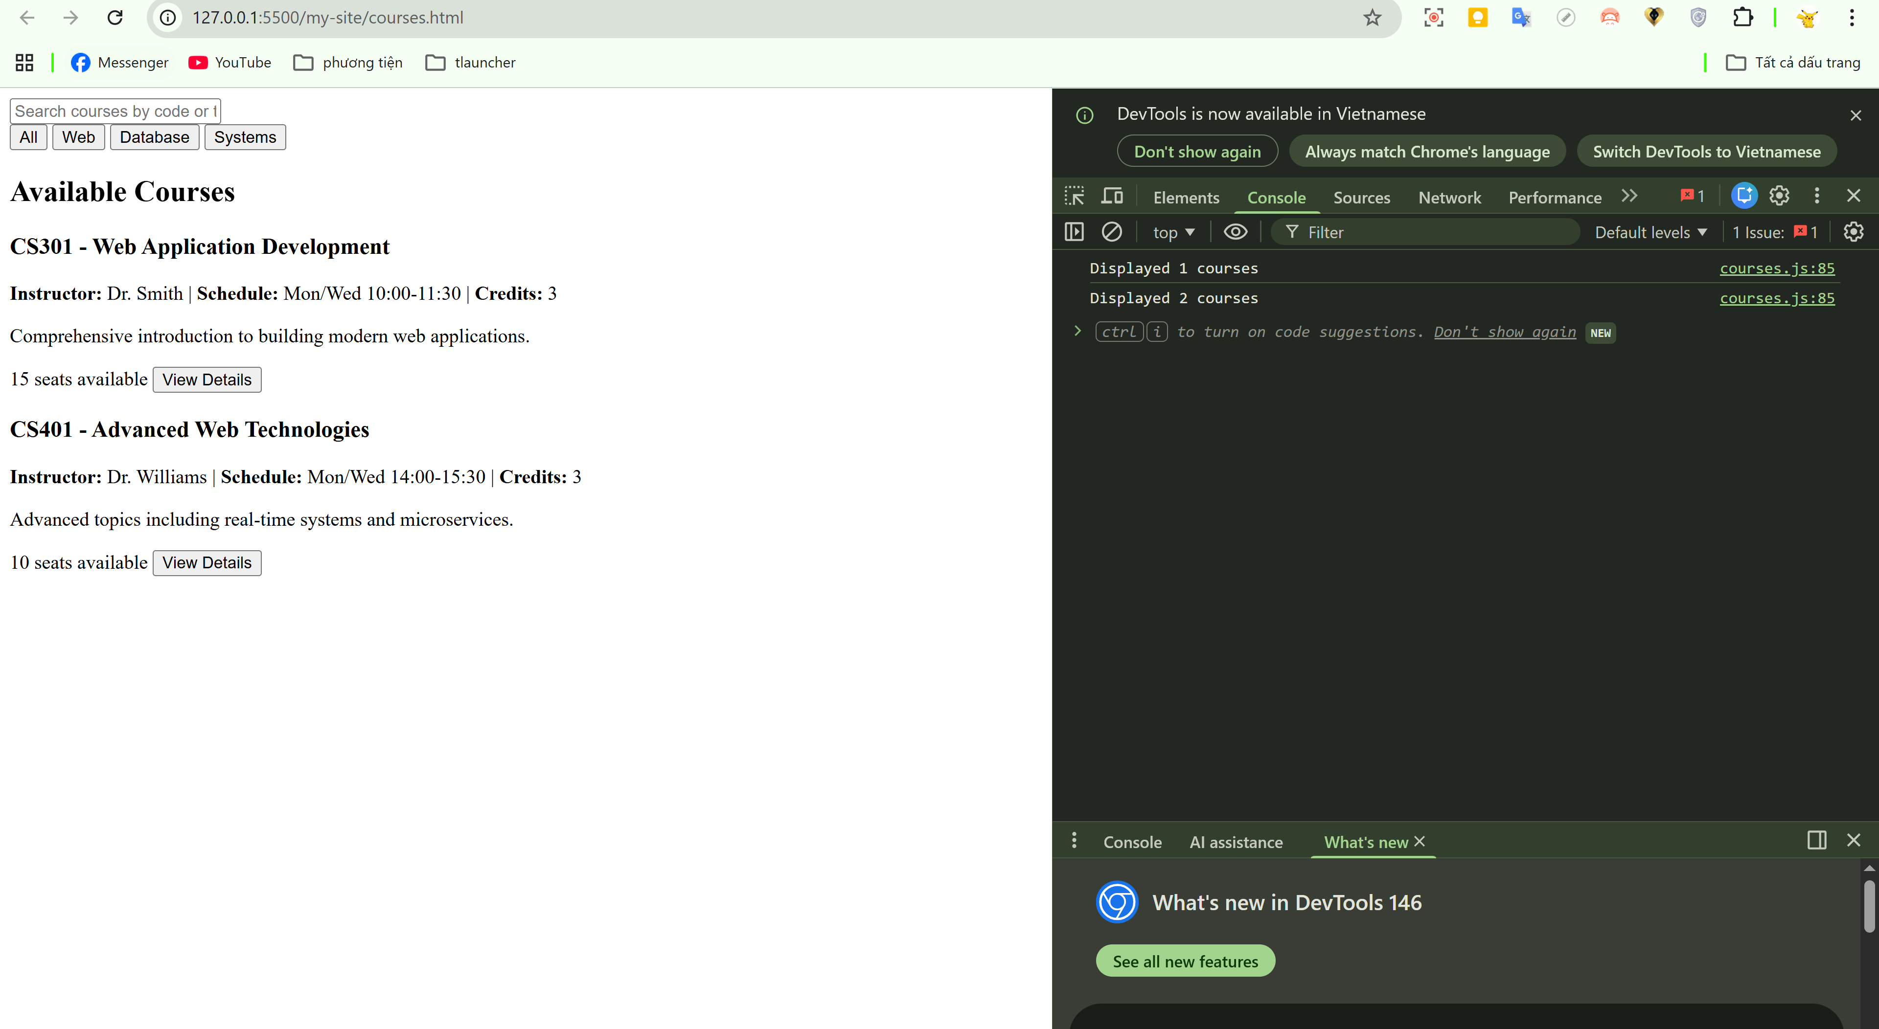

Excercise 1:
1. Test Error Handling
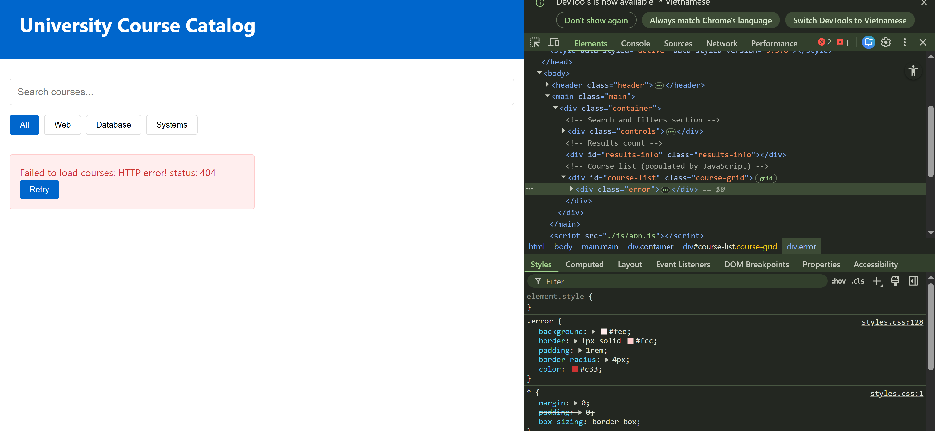
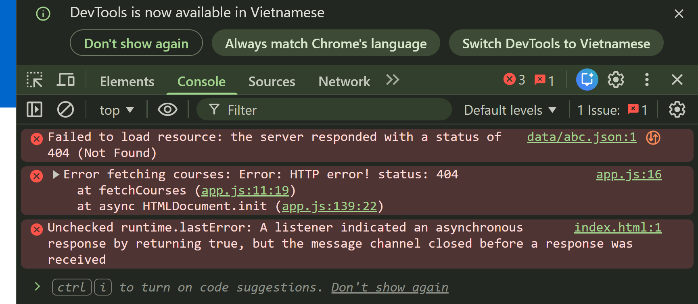
2. Test Event Delegation
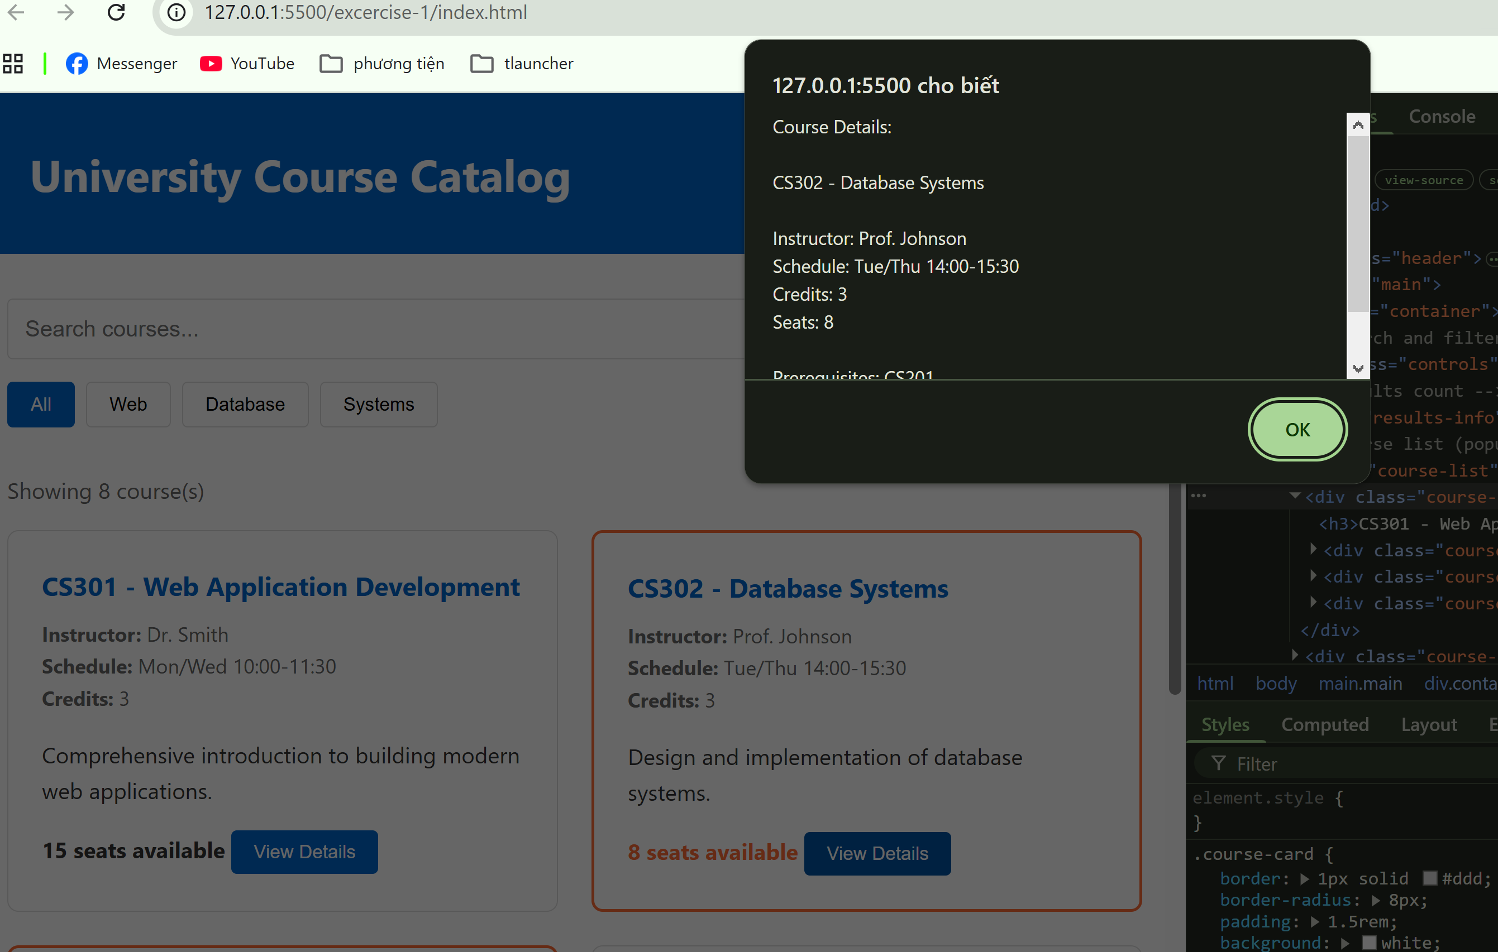
3. Test Async
- in app.js, add this line into fetchCourses():
await new Promise(resolve => setTimeout(resolve, 2000));
- we see that loading delay is 2s

1. Async vs Sync (150 words)
In this project, fetchCourses() is implemented using async/await to handle asynchronous data fetching from a JSON file. If the function were synchronous, the browser would be blocked while waiting for the data to load. This means the entire webpage would freeze until the request is completed, resulting in a poor user experience.
JavaScript uses async/await to allow non-blocking operations. While waiting for the data, the browser can continue rendering the UI, handle user interactions, and display loading indicators. This makes the application more responsive.
Without async behavior, users would not see any feedback during loading. The page might appear broken or unresponsive, especially if the network is slow. With async/await, we can show a loading message, handle errors gracefully, and update the UI once data is ready. This significantly improves usability and performance.

2. Event Delegation (150 words)
Event delegation is used in this project to handle click events on dynamically generated course cards. Instead of attaching a separate event listener to each "View Details" button, a single event listener is attached to the parent container (#course-list).
The main problem with adding listeners to each card is scalability. If there are many courses, attaching individual listeners increases memory usage and reduces performance. Additionally, when new courses are dynamically added, those new elements would not have event listeners unless manually assigned again.
With event delegation, events bubble up from child elements to the parent. The parent listener can detect which button was clicked using event.target. This approach ensures that all current and future course cards are handled automatically without additional code. It simplifies maintenance and improves performance, especially in dynamic applications.

3. Client-Side Filtering (150 words)
In this project, filtering is performed on the client side using JavaScript. All course data is loaded once and stored in memory, then filtered based on user input. While this approach is simple and fast for small datasets, it has limitations.
If the dataset becomes large, such as 10,000 courses or more, performance can degrade. Filtering large arrays repeatedly can cause slow response times and increased memory usage. It may also impact browser performance on lower-end devices.
In such cases, server-side filtering is preferred. Instead of loading all data at once, the client sends a request to the server with search parameters. The server processes the query and returns only relevant results. This reduces data transfer and improves efficiency.
Client-side filtering is suitable for small to medium datasets, while server-side filtering is necessary for large-scale applications.

4. Error Handling (100 words)
Error handling is implemented using try/catch in the async fetchCourses() function. To test this, I intentionally changed the JSON file path to an invalid one. This caused the fetch request to fail, triggering the error message displayed on the screen.
Error handling is important because it prevents the application from crashing and provides feedback to the user. Instead of showing a blank page or broken interface, users see a clear message and can retry the action. This improves user experience and makes the application more robust and reliable in real-world scenarios.
8. THINKING & DISCUSSION QUESTIONS
Question 1: Client vs Server Execution
Scenario: You're building a course enrollment system.
Which operations should run on client vs server?
Operation A: Validate email format
Operation B: Check if student has prerequisites
Operation C: Highlight search results
Operation D: Deduct seats from database
Operation E: Calculate total credits
Operation F: Authenticate user login
Questions:
a) Which should run on client? Which on server? Which on both?
b) For each operation, explain your reasoning.
c) What happens if you ONLY validate on client?
d) What are the trade-offs of doing more on client vs server?
a)
- Client: A, C, E
- Server: B, D, F
- Both: A, E
b)
- A (Email validation): Client for instant feedback; server for security.
- B (Prerequisites): Server → requires trusted data.
- C (Highlight search): Client → UI only.
- D (Deduct seats): Server → avoid race conditions.
- E (Total credits): Client for UX; server for final validation.
- F (Authentication): Server → sensitive logic.
c)
Only client validation → easily bypassed → security risks, invalid data.
d)
- Client-heavy: faster UX, less server load, but insecure.
- Server-heavy: secure, consistent, but slower and more load.

Question 2: Async Execution Flow
Given this code:
console.log('A');

setTimeout(() => {
console.log('B');
}, 0);

Promise.resolve().then(() => {
console.log('C');
});

console.log('D');
Questions:
a) What order do these log? Why?
b) Why doesn't setTimeout with 0ms run immediately?
c) What's the difference between setTimeout and Promise?
d) How does the event loop work?
a)
Order: A → D → C → B
- Sync first, then microtask (Promise), then macrotask (setTimeout).
b)
setTimeout(0) is queued in macrotask queue → runs after current stack + microtasks.
c)
- Promise: microtask (higher priority)
- setTimeout: macrotask (lower priority)
d)
Event loop:
- Execute call stack
- Run all microtasks
- Then run one macrotask
- Repeat

Question 3: Event Delegation vs Direct Binding
Scenario: You have 100 course cards, each with a "View Details" button.
Approach A: Direct Binding
document.querySelectorAll('.view-btn').forEach(btn => {
btn.addEventListener('click', handleClick);
});
Approach B: Event Delegation
document.querySelector('#course-list').addEventListener('click', (e) => {
if (e.target.classList.contains('view-btn')) {
handleClick(e);
}
});
Questions:
a) What's the memory difference between these approaches?
b) What happens if you add a new course card dynamically?
c) Are there cases where direct binding is better?
d) How do you debug event delegation issues?
a)
- Direct: 100 listeners → more memory
- Delegation: 1 listener → efficient
b)
- Direct: new elements need manual binding
- Delegation: works automatically
c)
Direct binding is better when:
- Few elements
- Need precise control
d)
- Use console.log(e.target)
- Check bubbling path
- Verify selector conditions

Question 4: State Management Challenge
Scenario: Your app has this state:
- List of courses (from server)
- Search term (from user input)
- Selected category (from filter buttons)
- Shopping cart (courses to enroll in)
- User info (name, ID, etc.)
Questions:
a) Where should each piece of state be stored?
b) What happens to state when user refreshes page?
c) How do you keep UI in sync with state?
d) When would you need a state management library (Redux, MobX)?
e) How would you implement undo/redo?
a)
- Courses → global/store
- Search/filter → local/UI state
- Cart → store + localStorage
- User info → store
b)
State resets unless persisted (e.g., localStorage)
c)
Use reactive updates (setState → re-render UI)
d)
Use Redux/MobX when:
- Large app
- Complex shared state
- Hard-to-track updates
e)
Store history stack:
- push state → undo/redo via pointer

Question 5: Race Condition
Scenario:
let selectedCourse = null;

// User clicks course A
setTimeout(() => {
selectedCourse = 'CS301';
showDetails('CS301');
}, 1000);

// Immediately clicks course B
setTimeout(() => {
selectedCourse = 'CS302';
showDetails('CS302');
}, 500);

// Which course details are shown? Why?
Questions:
a) What's the final value of selectedCourse?
b) What details are shown to the user?
c) How would you fix this race condition?
d) In a real app with API calls, how could this go wrong?
a)
Final value: CS301
b)
User sees:
- CS302 first (500ms)
- Then overwritten by CS301 (1000ms)
c)
Fix:
- Cancel previous request
- Use request ID / latest-only logic
d)
API calls may return out of order → wrong UI shown

Question 6: Error Handling Strategy
Scenario: Your fetchCourses() can fail because:
- Network is down (TypeError)
- Server returns 404 (course data not found)
- Server returns 500 (server error)
- JSON is malformed (SyntaxError)
- Request times out
Questions:
a) How would you handle each error differently?
b) What should users see for each error?
c) Should you retry? If so, how many times?
d) How do you log errors for debugging?
e) What's the difference between recoverable and unrecoverable errors?
a)
- Network → retry
- 404 → show “not found”
- 500 → server error message
- JSON error → fallback UI
- Timeout → retry/abort
b)
- Clear, user-friendly messages
c)
Retry: 2–3 times (with backoff)
d)
Log:
- console (dev)
- remote logging service (prod)
e)
- Recoverable: retry possible
- Unrecoverable: show error, stop

Question 7: Performance Optimization
Scenario: You have a search that filters 1000 courses.
Current implementation:
searchInput.addEventListener('input', (e) => {
const filtered = allCourses.filter(course => {
return course.title.toLowerCase().includes(e.target.value.toLowerCase());
});
displayCourses(filtered);
});
Questions:
a) What performance issues might this have?
b) How would debouncing help? Show code.
c) What if filtering still takes 200ms? (too long)
d) How would you optimize the filter operation itself?
e) When would you need to move search to server-side?
a)
- Runs on every keystroke → lag
- Re-renders too often
b)
function debounce(fn, delay) {
let t;
return (...args) => {
clearTimeout(t);
t = setTimeout(() => fn(...args), delay);
};
}
c)
- Use Web Worker
- Show loading indicator
d)
- Preprocess data
- Use indexing / caching
- Limit results
e)
When:
- Large dataset
- Complex queries
- Need scalability

Question 8: Memory Leaks
Scenario:
function createCourseCard(course) {
const card = document.createElement('div');
const btn = document.createElement('button');

btn.addEventListener('click', () => {
showCourseDetails(course);
});

card.appendChild(btn);
return card;
}

// Called 1000 times
for (let i = 0; i < 1000; i++) {
const card = createCourseCard(courses[i]);
container.appendChild(card);
}

// Later, clear all cards
container.innerHTML = '';

// Memory leak? Why or why not?
Questions:
a) Is there a memory leak here?
b) What happens to the event listeners?
c) How would you fix this?
d) When do you actually need to remove listeners manually?
a)
No major leak (if no external references)
b)
Listeners are garbage collected with DOM nodes
c)
Fix:
- Use event delegation
- Remove listeners if needed
d)
Remove manually when:
- Long-lived apps
- Detached DOM still referenced

Question 9: Optimistic UI
Scenario: User clicks "Enroll" in a course.
Approach A: Wait for Server
async function enroll(courseCode) {
showLoading();
try {
await api.enrollInCourse(courseCode);
updateUI(); // Only update after success
showSuccess();
} catch (error) {
showError();
}
}
Approach B: Optimistic Update
async function enroll(courseCode) {
updateUI(); // Update immediately
try {
await api.enrollInCourse(courseCode);
showSuccess();
} catch (error) {
revertUI(); // Undo changes
showError();
}
}
Questions:
a) What's the user experience difference?
b) What are the risks of optimistic updates?
c) When should you NOT use optimistic UI?
d) How do you handle the "revert" operation?
e) What if multiple operations are in flight?
a)
- Optimistic: fast, smooth UX
- Wait: slower but safe
b)
- Data inconsistency
- Rollback complexity
c)
Avoid when:
- Critical data (payments)
- High failure rate
d)
Store previous state → restore on failure
e)
- Track requests (IDs)
- Queue or lock updates

Question 10: Real-World Architecture
Scenario: You're building a large course management system with:
- 50+ different pages
- Shared components (header, navigation, course cards)
- Complex state (user session, shopping cart, notifications)
- API communication
- Real-time updates
Questions:
a) How would you organize your JavaScript code?
b) At what point does vanilla JavaScript become too complex?
c) What problems would a framework (React/Vue) solve?
d) What new problems would a framework introduce?
e) How would you decide whether to use a framework?
f) If you were building this for production, what would your tech stack be? Why?
a)
- Modular structure (API, services, components, store)
b)
Vanilla JS too complex when:
- Large scale
- Many states & interactions
c)
Framework solves:
- State management
- Component reuse
- UI updates
d)
Introduces:
- Learning curve
- Boilerplate
- Performance overhead
e)
Decision:
- Small app → vanilla
- Large/complex → framework
f)
Tech stack:
- Frontend: React + Redux
- Backend: Node.js (Express)
- Database: MongoDB/PostgreSQL
- Realtime: WebSocket
→ scalable, maintainable, widely supported

