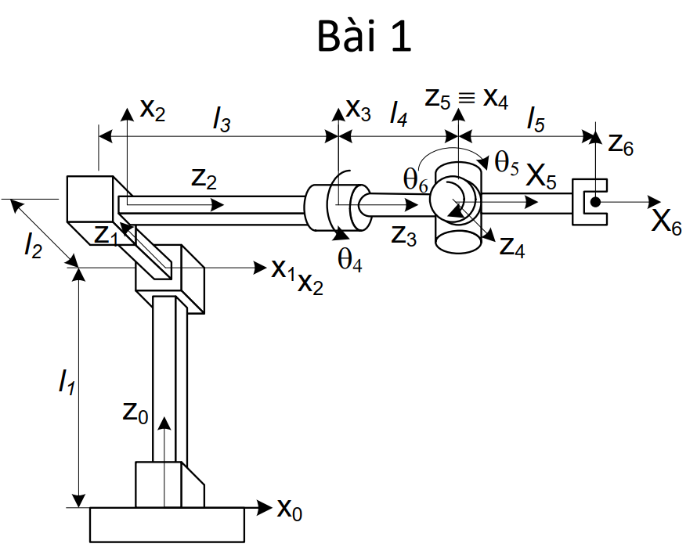

OP= OT7 . 7P

= OT1.1T2.2T3.3T4.4T5.5T6.7P

= T(l3,l2,l1) \* R(x,θ4) \* T(l4,0,0) \* R(z,θ5)\* R(y,θ6) \*T(l5,0,0)\*P

=

=

Vậy

x =

y =

z =

Đồ thị vẽ bằng Mathlab

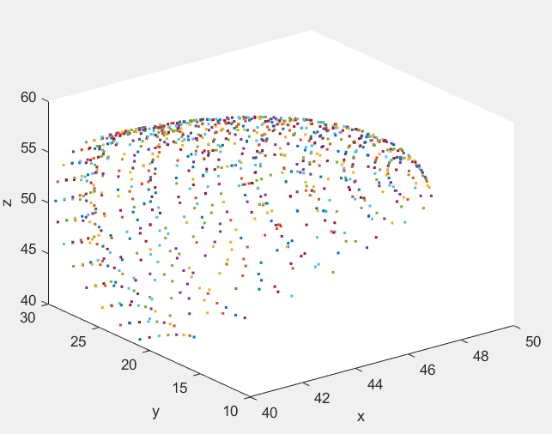

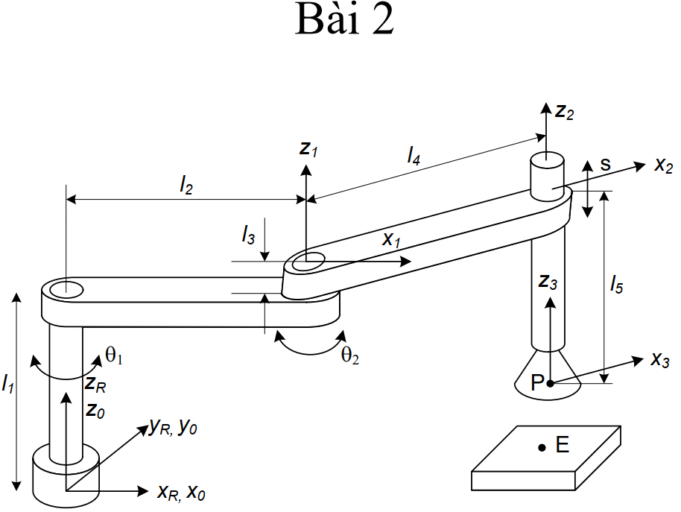

OP= OT4 . 4P

= OT1.1T2.2T3.3T4.4P

= R(z,θ1) \* T(l2,0,l1) \* R(z,θ2)\*T(l4,0,l3 - l5 +s) \* P

=

=

Vậy

x =)

y =

z = l1 + l3 - l5 + s

Đồ thị vẽ bằng Mathlab

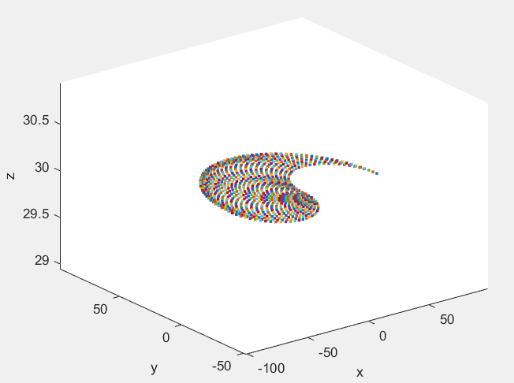

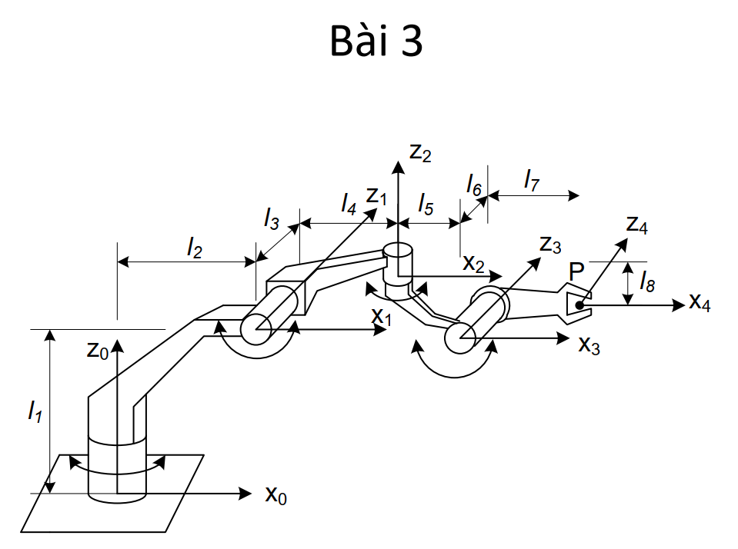

OP= OT8. 8P

= OT1.1T2.2T3.3T4.4T5.5T6.6T7.7T8.8P

= R(z,θ1) \* T(l2,0,l1) \* R(y,θ2)\* T(l4,l3,0) \* R(z,θ3) \*T(l5,0,-l8)

\* R(y,θ4)\* T(l7,l6,0) \*P

=

= [ l2\*cos(t1) - l6\*(cos(t3)\*sin(t1) + cos(t1)\*cos(t2)\*sin(t3)) - l5\*(sin(t1)\*sin(t3) - cos(t1)\*cos(t2)\*cos(t3)) - l3\*sin(t1) - l7\*(cos(t4)\*(sin(t1)\*sin(t3) - cos(t1)\*cos(t2)\*cos(t3)) + cos(t1)\*sin(t2)\*sin(t4)) + l4\*cos(t1)\*cos(t2) - l8\*cos(t1)\*sin(t2)

; l5\*(cos(t1)\*sin(t3) + cos(t2)\*cos(t3)\*sin(t1)) + l6\*(cos(t1)\*cos(t3) - cos(t2)\*sin(t1)\*sin(t3)) + l3\*cos(t1) + l2\*sin(t1) + l7\*(cos(t4)\*(cos(t1)\*sin(t3) + cos(t2)\*cos(t3)\*sin(t1)) - sin(t1)\*sin(t2)\*sin(t4)) + l4\*cos(t2)\*sin(t1) - l8\*sin(t1)\*sin(t2)

; l1 - l7\*(cos(t2)\*sin(t4) + cos(t3)\*cos(t4)\*sin(t2)) - l8\*cos(t2) - l4\*sin(t2) - l5\*cos(t3)\*sin(t2) + l6\*sin(t2)\*sin(t3)

;1]

Vậy

x= l2\*cos(t1) - l6\*(cos(t3)\*sin(t1) + cos(t1)\*cos(t2)\*sin(t3)) - l5\*(sin(t1)\*sin(t3) - cos(t1)\*cos(t2)\*cos(t3)) - l3\*sin(t1) - l7\*(cos(t4)\*(sin(t1)\*sin(t3) - cos(t1)\*cos(t2)\*cos(t3)) + cos(t1)\*sin(t2)\*sin(t4)) + l4\*cos(t1)\*cos(t2) - l8\*cos(t1)\*sin(t2)

y= l5\*(cos(t1)\*sin(t3) + cos(t2)\*cos(t3)\*sin(t1)) + l6\*(cos(t1)\*cos(t3) - cos(t2)\*sin(t1)\*sin(t3)) + l3\*cos(t1) + l2\*sin(t1) + l7\*(cos(t4)\*(cos(t1)\*sin(t3) + cos(t2)\*cos(t3)\*sin(t1)) - sin(t1)\*sin(t2)\*sin(t4)) + l4\*cos(t2)\*sin(t1) - l8\*sin(t1)\*sin(t2)

z= l1 - l7\*(cos(t2)\*sin(t4) + cos(t3)\*cos(t4)\*sin(t2)) - l8\*cos(t2) - l4\*sin(t2) - l5\*cos(t3)\*sin(t2) + l6\*sin(t2)\*sin(t3)

Đồ thị vẽ bằng Mathlab

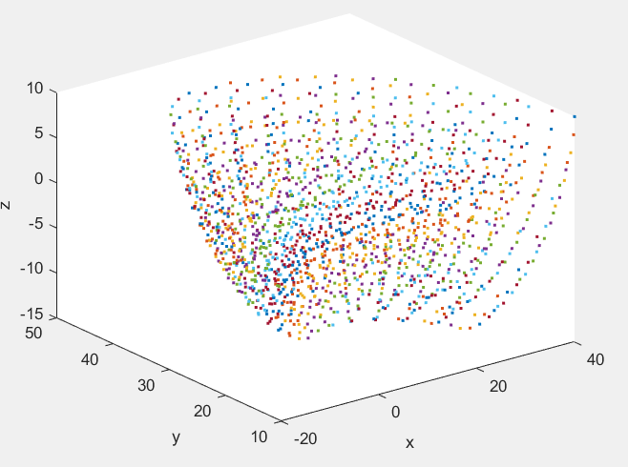

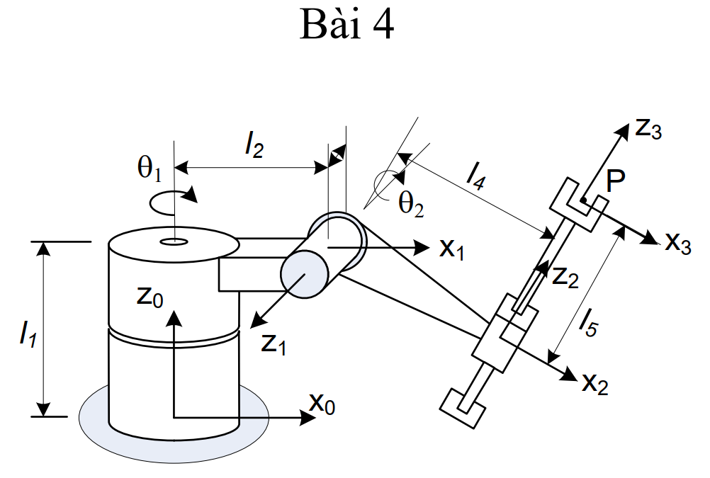

OP= OT4 . 4P

= OT1.1T2.2T3.3T4.4P

= R(z,θ1) \* T(l2,0,l1) \* R(y,θ2)\*T(l4,0,l5)\*P

=

=

Vậy

x= cos(t1)\*(l2 + l4\*cos(t2) + l5\*sin(t2))

y= sin(t1)\*(l2 + l4\*cos(t2) + l5\*sin(t2))

z= l1 + l5\*cos(t2) - l4\*sin(t2)

Đồ thị vẽ bằng Mathlab

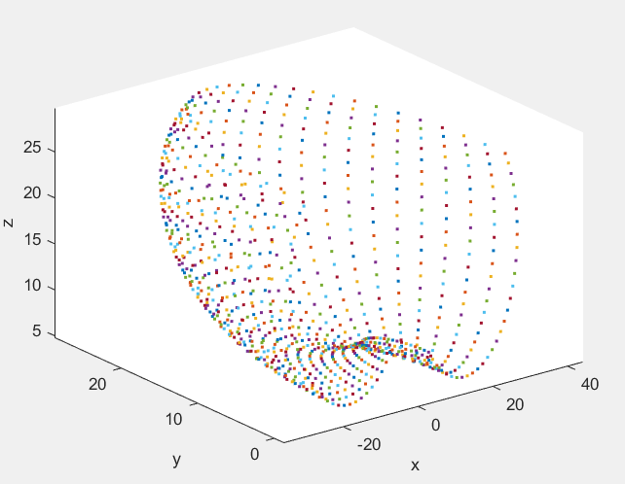

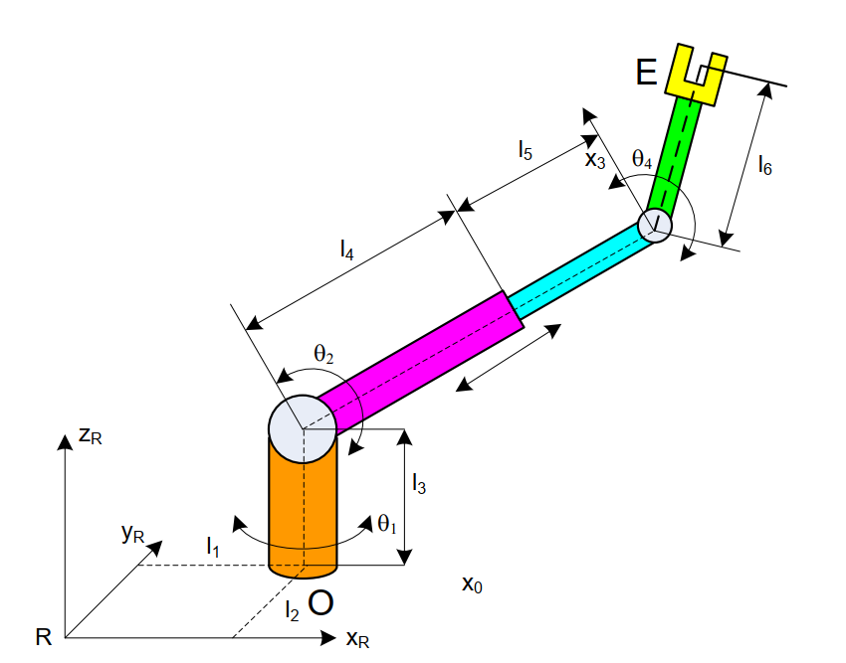

OP= OT7 . 7P

= OT1.1T2.2T3.3T4.4T5.5T6.6T7.7P

= T(l1,l2,0)\*R(z,θ1) \* T(0,0,l3) \* R(y,θ2)\*T(l4+l5,0,0)\*R(y,θ4)

\*T(l6,0,0)\*P

=

=

Vậy

x= l1 + cos(t1)\*cos(t2)\*(l4 + l5) + l6\*cos(t2 + t4)\*cos(t1)

y= l2 + cos(t2)\*sin(t1)\*(l4 + l5) + l6\*cos(t2 + t4)\*sin(t1)

z= l3 - sin(t2)\*(l4 + l5) - l6\*sin(t2 + t4)

Đồ thị vẽ bằng Mathlab

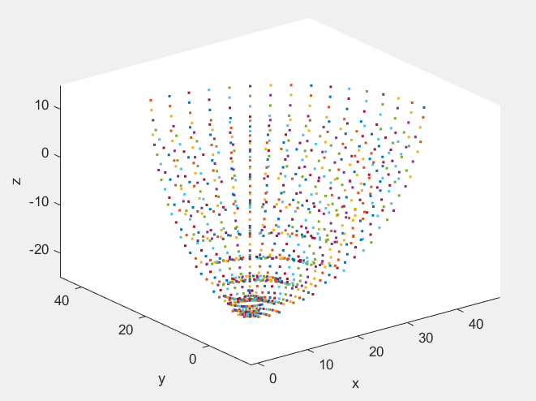

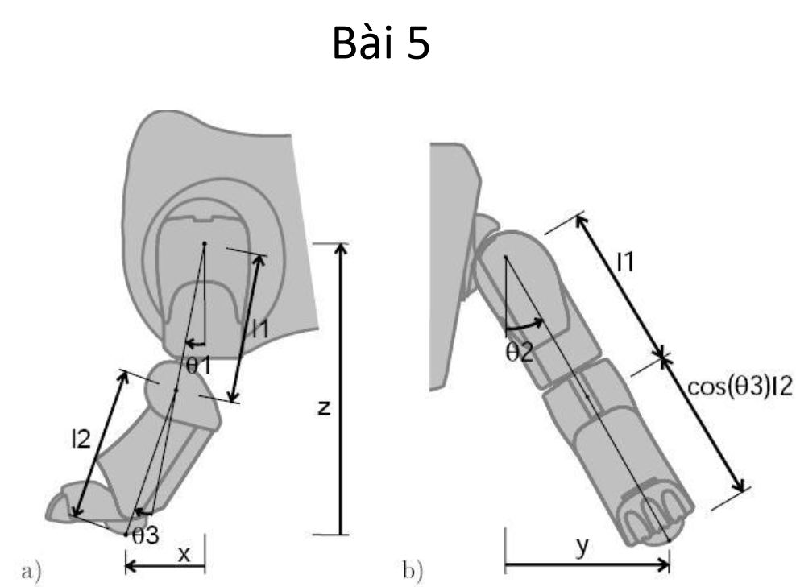

Chọn gốc tọa độ ở tâm xoay góc θ1

OP= OT5 . 5P

= OT1.1T2.2T3.3T4.4T5.5P

= R(y,θ1)\*R(x,θ2) \* T(0,0,l1) \* R(y,θ3)\*T(0,0,l2)\*P

=

=

Vậy

Xx= cos(t2)\*sin(t1)\*(l1 + l2)

Yy= -sin(t2)\*(l1 + l2)

Zz= cos(t1)\*cos(t2)\*(l1 + l2)

Đồ thị vẽ bằng Mathlab

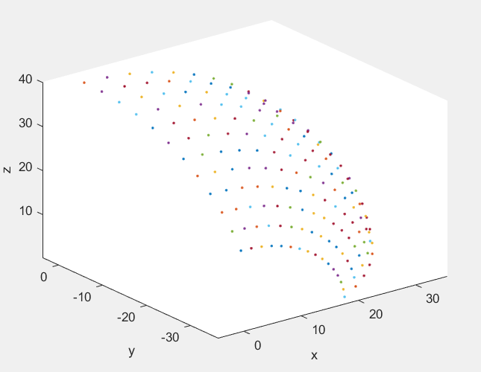

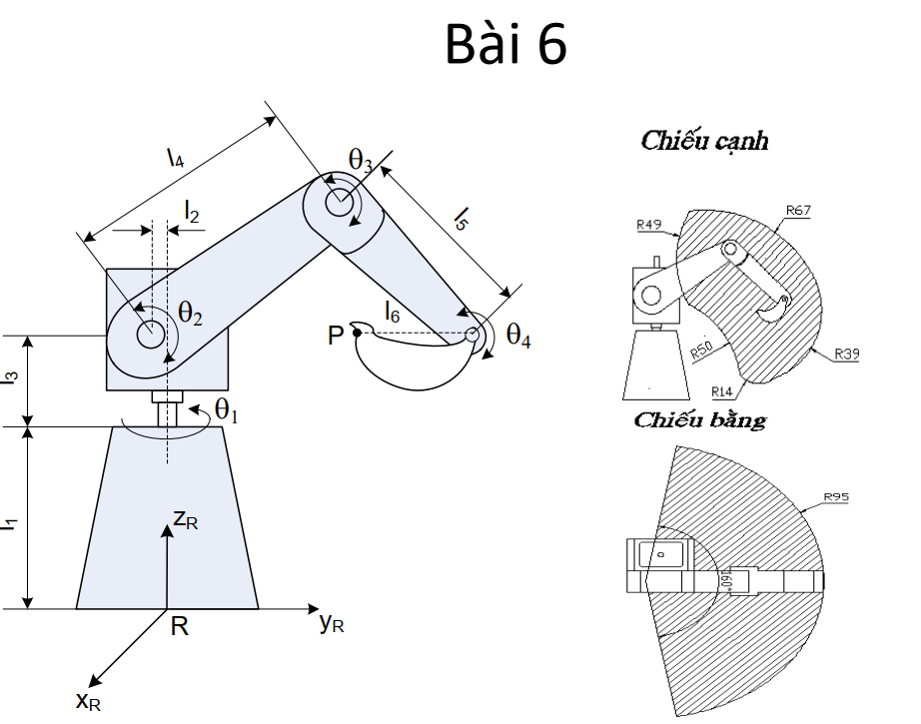

OP= OT7 . 7P

= OT1.1T2.2T3.3T4.4T5.5T6.6T7.7P

= T(0,0,l1)\*R(z,θ1) \* T(0,-l2,l3) \* R(x,θ2)\*T(0,l4,0)\*R(x,θ3)

\*T(0,l5,0)\*R(x,θ4)\*T(0,-l6,0)\*P

=

=

Vậy

x= l2\*sin(t1) + l5\*sin(t2 + t3)\*cos(t1) + l4\*cos(t1)\*sin(t2) - l6\*sin(t2 + t3 + t4)\*cos(t1)

y= l5\*sin(t2 + t3)\*sin(t1) - l2\*cos(t1) + l4\*sin(t1)\*sin(t2) - l6\*sin(t2 + t3 + t4)\*sin(t1)

z= l1 + l3 + l5\*cos(t2 + t3) + l4\*cos(t2) - l6\*cos(t2 + t3 + t4)

Đồ thị vẽ bằng Mathlab

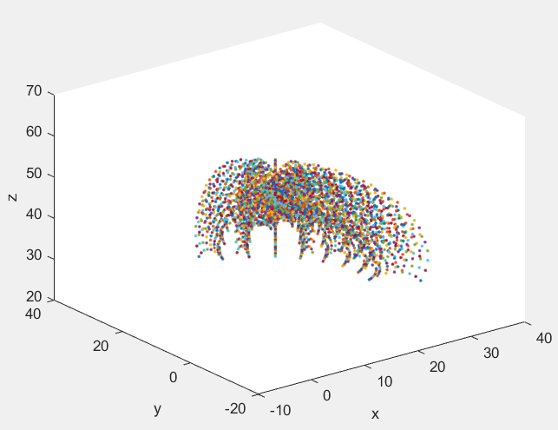

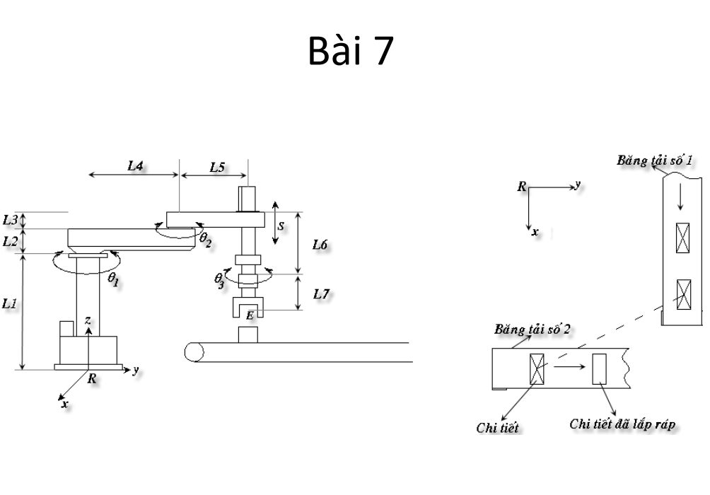

OP= OT7 . 7P

= OT1.1T2.2T3.3T4.4T5.5T6.6T7.7P

= T(0,0,l1)\*R(z,θ1) \* T(0,l4,l2) \* R(z,θ2)\*T(0,l5,l3-l6+s)\*R(z,θ3)

\*T(0,0,-l7)\*P

=

=

Vậy

X= - l5\*sin(t1 + t2) - l4\*sin(t1)

Y= l5\*cos(t1 + t2) + l4\*cos(t1)

Z= l1 + l2 + l3 - l6 - l7 + s

Đồ thị vẽ bằng Mathlab

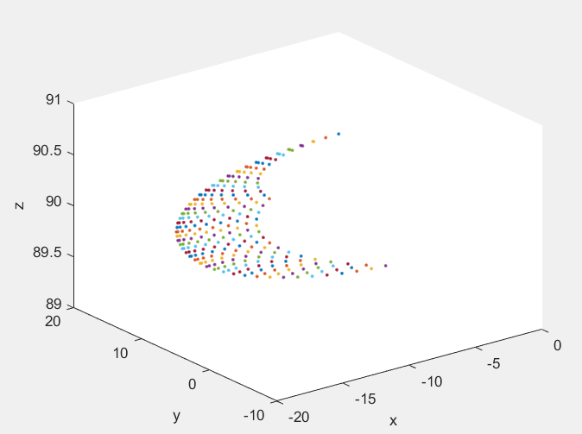

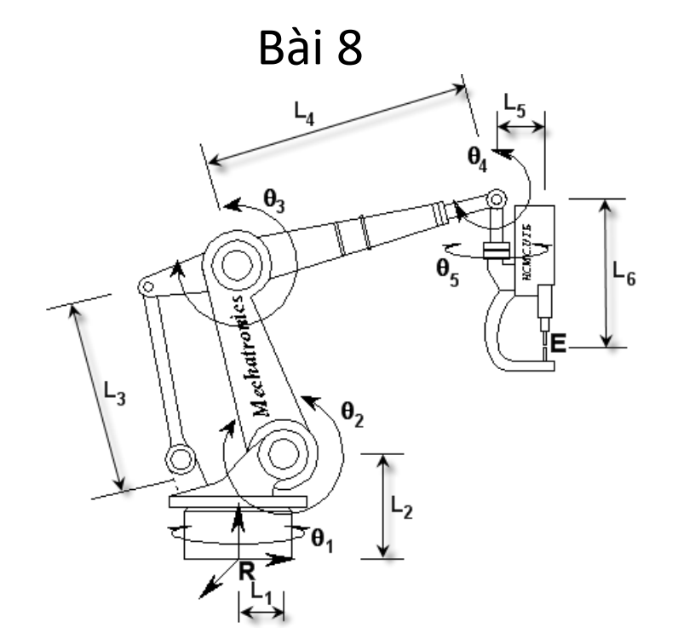

OP= OT9 . 9P

= OT1.1T2.2T3.3T4.4T5.5T6.6T7.7T8.8T9.9P

= R(z,θ1) \* T(l1,0,l2) \* R(y,θ2)\*T(0,0,l3)\*R(y,θ3)

\*T(l4,0,0)\* R(y,θ4)\* \* R(z,θ5)\*T(l5,0,l6)\*P

=

=

Vậy

X= l1 + l6\*sin(t2 + t3)\*cos(t1) + l4\*cos(t1)\*cos(t2) - l6\*sin(t2 + t3 + t4)\*cos(t1)

Y= sin(t1)\*(l6\*sin(t2 + t3) + l4\*cos(t2) - l6\*sin(t2 + t3 + t4))

Z= l2 + l3 + l6\*cos(t2 + t3) - l4\*sin(t2) - l6\*cos(t2 + t3 + t4)

Đồ thị vẽ bằng Mathlab

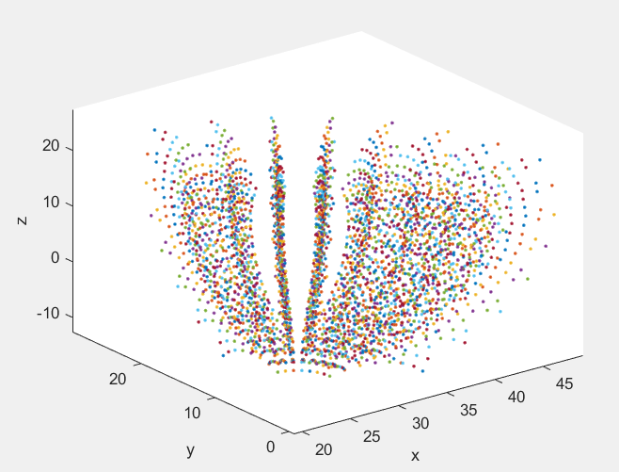

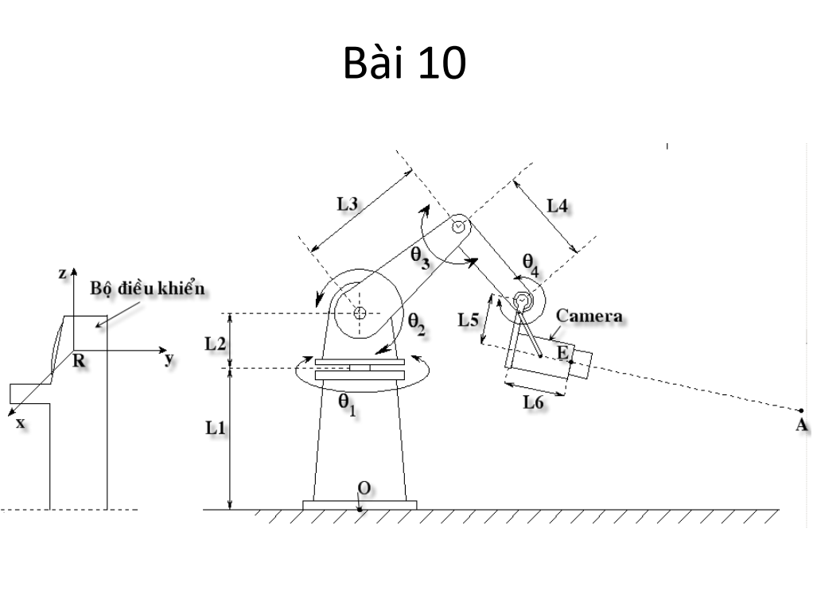

OP= OT9 . 9P

= OT1.1T2.2T3.3T4.4T5.5T6.6T7.7T8.8T9.9P

= T(0,0,l1)\*R(z,θ1) \* T(0,0,l2) \* R(x,θ2)\*T(0,l3,0)\*R(x,θ3)

\*T(0,l4,0)\* R(x,θ4)\* T(0,l6,l5)\*P

=

=

Vậy

X= -sin(t1)\*(l4\*cos(t2 + t3) + l3\*cos(t2) + l6\*cos(t2 + t3 + t4) - l5\*sin(t2 + t3 + t4))

Y= cos(t1)\*(l4\*cos(t2 + t3) + l3\*cos(t2) + l6\*cos(t2 + t3 + t4) - l5\*sin(t2 + t3 + t4))

Z= l1 + l2 + l4\*sin(t2 + t3) + l3\*sin(t2) + l5\*cos(t2 + t3 + t4) + l6\*sin(t2 + t3 + t4)

Đồ thị vẽ bằng Mathlab

