Literature Review Summary:

These articles served to give a background on how electromagnetic characterization is currently being done for absorbing materials. While the NRL arch, bi-static reflection test, is an industry standard to determine reflection/attenuation of microwave radiation spectra, but to determine complex permittivity and permeability, other guided or free space tests are employed. Tests may involve waveguide tests with either partial or full fill with the material present, or fixed free space measurement with focusing lenses.

Articles:

1. Carbon nanostructure based Broadband microwave absorbers
2. Free-Space measurement of magnetic materials – Focusing Horn antenna
3. Paintable microwave absorbing coatings -Measurement and Simulation techniques
4. Explosives detection with wideband millimeter wavelength
5. Carbon nano-powder RAM synthesis and measurement techniques
6. Emerson Cumming Products Sheet

NRL Arch Test – Bi-static reflection test

“The NRL Arch is the industry standard for testing the reflectivity of materials. Originally designed at the Naval Research Laboratory, the NRL Arch allows for quick, repeatable non-destructive testing of microwave absorbent materials over a wide frequency range.” (Emerson 2016)

The arch itself is referenced in most papers without much detail. The important parts for it are the inner radius and the ability to fix the antenna at incremental angles from the center.

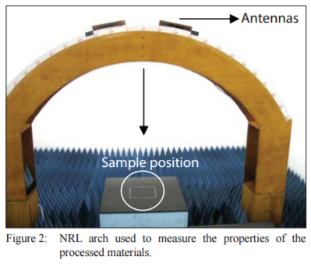

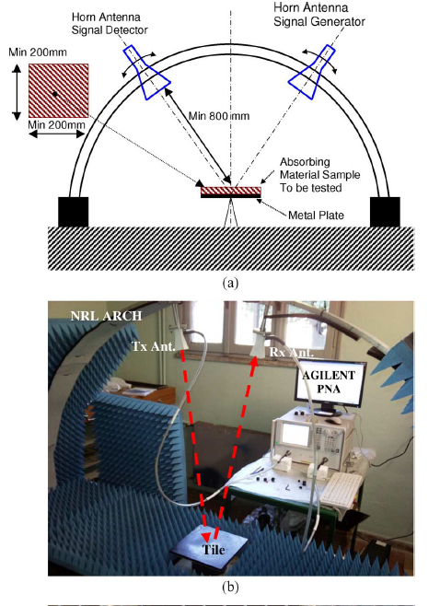

**Waveguide**

Paper 1:

Software: Agilent software 8571E material measurement

Accuracy: 2%

VNA: Agilent PNA-L N5230C

Calibration Kit: X-band waveguide kit

Sample Holder: 20cm^2 x 0.977cm 2port waveguide measurements

VNA power: +5dBm

Number f steps: 512 (8.2MHz resolution per step)

Frequency range: Up to 18GHz

Paper 2:

Spot focusing Horn antenna with (F/D) at unity and D ~ 30.5 cm

Material between quartz plates in between antenna.

Polarization can be easily adjusted.

Ideal measurement range 8.6-13.4 GHz

Paper 3: Transmission line technique and rectangular wave guide:

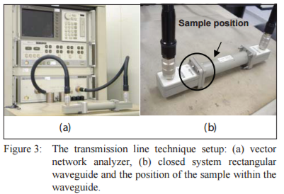

Paper 4: Setup: 18–40-GHz wideband horn (Q-par WBH18–40) Single ended, just outside of nearfield

Example of wideband: <http://schwarzbeck.de/Datenblatt/k9170.pdf>

**Software/Data Modeling:**

Recurring equation: 

Paper 1: Uses Nicholson-Ross Algorithm, NIST Iterative and Non-Iterative

Loss Factor Calculations and derivations to determine characteristics based on Impedance

Paper 2: WPO – Winning Particle Optimization – Computer model for layering optimization

**Citations:**

Folgueras, L. D., Alves, M. A., & Rezende, M. C. (2010). Microwave absorbing paints and sheets based on carbonyl iron and polyaniline: measurement and simulation of their properties. *Journal of Aerospace Technology and Management,2*(1), 63-70. doi:10.5028/jatm.2010.02016370

Ghodgaonkar, D., Varadan, V., & Varadan, V. (1990). Free-space measurement of complex permittivity and complex permeability of magnetic materials at microwave frequencies. *IEEE Transactions on Instrumentation and Measurement,39*(2), 387-394. doi:10.1109/19.52520

Micheli, D., Pastore, R., Apollo, C., Marchetti, M., Gradoni, G., Primiani, V. M., & Moglie, F. (2011). Broadband Electromagnetic Absorbers Using Carbon Nanostructure-Based Composites. *IEEE Transactions on Microwave Theory and Techniques,59*(10), 2633-2646. doi:10.1109/tmtt.2011.2160198

Micheli, D., Vricella, A., Pastore, R., & Marchetti, M. (2014). Synthesis and electromagnetic characterization of frequency selective radar absorbing materials using carbon nanopowders. *Carbon,77*, 756-774. doi:10.1016/j.carbon.2014.05.080

Weatherall, J. C., Barber, J., & Smith, B. T. (2016). Spectral Signatures for Identifying Explosives With Wideband Millimeter-Wave Illumination. *IEEE Transactions on Microwave Theory and Techniques,* 1-7. doi:10.1109/tmtt.2016.2518159

Http://ljournal.ru/wp-content/uploads/2016/08/d-2016-154.pdf. (2016). doi:10.18411/d-2016-154