**EM Characterization for TangiTek LLC Flocked Carbon Composite Material**

*Capstone Project Literary Review for Design Considerations*

Team Members

Jeffrey Brown

Thanh Le

Ha Tran

Advisor

Dr. Branomir Pejcinovic

Winter-Spring 2017



**Content:**

1. **Free Space Measurements**
   1. **NRL Arch Test**
   2. **Focusing Antenna Alternative**
   3. **Characterization Theory**
   4. **Arch Dimension Considerations**
2. **Wave Guide Measurements**
   1. **Partial Filled Waveguide**
   2. **Fully Filled Waveguide**
   3. **Dimensional Considerations**
   4. **Example of Parameters for Test**
3. **Algorithm and Simulation**
   1. **Nicolson-Ross-Weir**
   2. **Matlab extraction**
4. **Summary**
5. **References**

**Abstract**

This document is a summary of three separate review compilations performed by each of us. This meta-document attempts to distill down the information from 15 research papers into an approachable overview for us to formulate a test plan and bill of materials to allow us to begin designing test fixtures and extraction algorithms that will allows us to determine the Loss Factor/reflectivity and complex EM components of the Materials provided to us by TangiTek.

With that data organized and optimized we plan to develop a reproducible model and test case for performance predictions of different iterations.

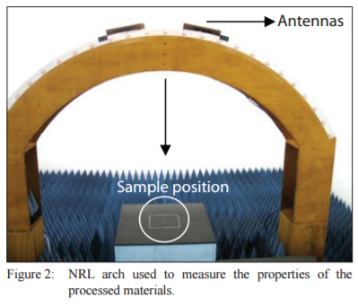**Test 1 - NRL Arch:**

Figure -NRL example (Folgueras 2010)

The arch must be constructed as a rigid body with the ability to attach horn antenna along the inner radius at specific and quantized angles towards the center. Vibration damping should be considered.

This test will deliver a reflection/attenuation characterization at different specific angles with the ability to rotate Horn antenna to adjust polarizations.

The sample table at the center is metal backed to help determine the Loss Factor of the material under test but absorptive material should be used around the table to help isolate antenna cross talk. An anechoic chamber for measurement is recommended.

*Loss Factor Equation:*

;

**Alternative Free Space Test:**

An alternate Free Space measurement is to use 2 focusing horn antenna with the MUT at the focal distance of each to determine reflection and pass through. The availability of focusing horn antennas would be a limiting factor but would allow complex parameter extraction and straight forward setup for the different frequency bands.

**Theory for Free Space Characterization** (Ghodgaonkar 1990):

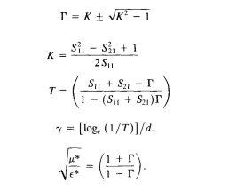Below is an example of the of the derivation described by Ghodgaonkar to extract complex characteristics of the MUT from S-parameters. The start of the derivation is on the left and the near finished product is on the right. See paper for full derivation.

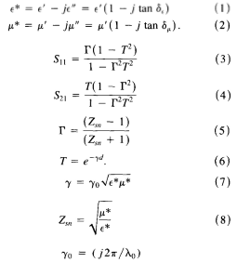

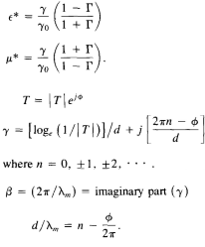

**Dimensionality:**

Inner Arch Radius: 1.83-2.0m (Adjustable antenna mounts?)

Angle Fixtures: Equally spaced 5° increments from normal incidence to near horizon

Sample Size: Frequency band dependent 180mm^2 up to 600mm^2 (lower frequency band requires the larger samples) See Table below.

Sample Table: Table should match dimensions of MUT with precision adjustable height to allow proper distance from antenna.

Table -Dimensions of NRL Test Samples

|  |  |  |  |  |  |  |
| --- | --- | --- | --- | --- | --- | --- |
| Frequency(GHz) | Sample Dimension (mm) | | | Arch radius(m) | Calibration | Control Sample |
| L | W | H |
| 1 – 2.65 | 600 | 600 | 2 | 2 | Measure reflectivity from metal plate to calibrate | No |
| 8 – 12 | 150 | 150 | 1 and 3 | No mention | No |
| 2 – 18and 18 – 40 | 180 | 180 | 2 | No mention | No |

**Test 2 - Waveguide:**

Partially filled and fully filled rectangular wave guide tests will allow us to derive complex characteristics based on S-parameter and impedance measurements through the material.

**Partial Filled Wave Guide:**

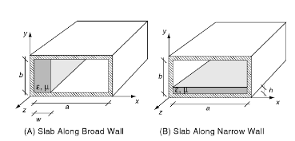The sample will need to be cut/formed to the dimensionality of the wave guide in use. Perhaps one sheet of similar TangiTek material can be used to make the samples for each band tested, or the same sample can be trimmed down and used in each successively smaller wave guide. Thickness control is a potential problem.

Figure 2- Possible Sample placement for Partial Fill Test (Chen 2005)

**Fully Filled Wave Guide**:

In a fully filled waveguide, a thin sample occupies the cross section of the wave guide, fit is important as gaps or sagging sections in the material will drastically alter the characteristic data.

**Dimensionality for Wave Guides:**

The frequency band being tested will determine the thickness of the sample used in the waveguide so that may be a limiting factor in what bands we can test with the waveguide set up.

The tables below show examples of waveguide dimensional considerations of the samples to test for the separate bands.

## Partially filled waveguide setup

|  |  |  |  |  |  |
| --- | --- | --- | --- | --- | --- |
| Frequency(GHz) | Sample Dimension (mm) | | | Calibration Performance | Control Sample |
| L | W | H |
| 8– 12.5 | Smaller than the length of holder | Small dimension of waveguide | 2 | Thru-Reflect-Line | No |
| 6.6 – 12.9 | 9.61 | Thru-Reflect-Line | No |

## Fully filled waveguide setup

|  |  |  |  |  |  |
| --- | --- | --- | --- | --- | --- |
| Frequency(GHz) | Sample Dimension (mm) | | | Calibration Performance | Control Sample |
| L | W | H |
| 1.72 – 2.61 | 109.2 | 54.6 | 2.06 | Thru-Reflect-Line (TRL) | No |
| 6.6 – 12.9 | Smaller than the length of holder | Small dimension of waveguide | 5.11 and 9.61 | TRL | No |

Examples of Dimension restrictions:

[1] 2 to 3 GHz. 2-mm thick. About 90 mm by 45 mm. Waveguide: WR340

[2] 750 to 1120 MHz. 15-cm thick. About 25cm by 12.5cm. Waveguide: WR875

[3] 8 to 12.5 GHz. 5cm thick. About 17 cm by 17 cm.

[4] 50 to 75 GHz. 1mm thick. About 170mm by 25 mm.

Calibration is necessary and will be specific to the waveguides we use but will need an impedance terminator and two short standards 1/8 lambda and 3/8 lambda long, at geometry mean frequency).

Each wave guide used will require specific parameters which will be detailed per test case.

**Example of parameters for a Test Case**:

Software: Agilent software 8571E material measurement

Accuracy: 2%

VNA: Agilent PNA-L N5230C

Calibration Kit: X-band waveguide kit

Sample Holder: 20cm^2 x 0.977cm 2port waveguide measurements

VNA power: +5dBm

Number f steps: 512 (8.2MHz resolution per step)

Frequency range: Up to 18GHz

**Data Analysis Tools and Techniques**:

**NRW Algorithm** – A technique based on the Fresnel-airy equations for describing the normal reflection and transmission co-efficient allowing mathematical extraction of permittivity and permeability of the material under test.

**Matlab** – The data gathered from the tests can apply the NRW algorithm

**Summary:**

Based on these articles we can design test set ups that will allow us to extract reflection/absorption data along with complex EM characteristics of the materials supplied to us from TangiTek LLC. Following examples of the Nicholson-Ross-Weir Algorithm, and cross checking them with the Free Space Theory derivation presented in Ghodgaokar, we will attain meaningful results from our experimental set-ups.

References:

Ghodgaonkar, D., Varadan, V., & Varadan, V. (1990). Free-space measurement of complex permittivity and complex permeability of magnetic materials at microwave frequencies. IEEE Transactions on Instrumentation and Measurement,39(2), 387-394. doi:10.1109/19.52520

Micheli, D., Pastore, R., Apollo, C., Marchetti, M., Gradoni, G., Primiani, V. M., & Moglie, F. (2011). Broadband Electromagnetic Absorbers Using Carbon Nanostructure-Based Composites. IEEE Transactions on Microwave Theory and Techniques,59(10), 2633-2646. doi:10.1109/tmtt.2011.2160198

Micheli, D., Vricella, A., Pastore, R., & Marchetti, M. (2014). Synthesis and electromagnetic characterization of frequency selective radar absorbing materials using carbon nanopowders. Carbon,77, 756-774. doi:10.1016/j.carbon.2014.05.080

Folgueras, L. D., Alves, M. A., & Rezende, M. C. (2010). Microwave absorbing paints and sheets based on carbonyl iron and polyaniline: measurement and simulation of their properties. Journal of Aerospace Technology and Management,2(1), 63-70. doi:10.5028/jatm.2010.02016370

Weatherall, J. C., Barber, J., & Smith, B. T. (2016). Spectral Signatures for Identifying Explosives With Wideband Millimeter-Wave Illumination. IEEE Transactions on Microwave Theory and Techniques, 1-7. doi:10.1109/tmtt.2016.2518159

J. M. Catala-Civera, A. J. Canos, F. L. Penaranda-Foix, and E. de los R. Davo, “Accurate determination of the complex permittivity of materials with transmission reflection measurements in partially filled rectangular waveguides,” *IEEE Trans. Microw. Theory Tech.*, vol. 51, no. 1, pp. 16–24, Jan. 2003.

D. Micheli *et al.*, “Electromagnetic characterization and shielding effectiveness of concrete composite reinforced with carbon nanotubes in the mobile phones frequency band,” *Mater. Sci. Eng. B*, vol. 188, pp. 119–129, Oct. 2014.

F. Sagnard and G. El Zein, “Characterization of building materials for propagation modelling: frequency and time responses,” *Aeu-Int. J. Electron. Commun.*, vol. 59, no. 6, pp. 337–347, 2005.

K. Naito, Y. Kagawa, and K. Kurihara, “Dielectric properties and noncontact damage detection of plain-woven fabric glass fiber reinforced epoxy matrix composites using millimeter wavelength microwave,” *Compos. Struct.*, vol. 94, no. 2, pp. 695–701, Jan. 2012.

H. B. Baskey, M. J. Akhtar, and T. C. Shami, “Investigation and performance evaluation of carbon black- and carbon fibers-based wideband dielectric absorbers for X-band stealth applications,” J. Electromagn. Waves Appl., vol. 28, no. 14, pp. 1703–1715, Sep. 2014.

Tian Zhou*, D. Wel, S. Yang, G. Xu, and C. J. and Z. Zhao</p>, “Measurement and Characterization of Flexible Absorbing Materials for Applications in Wireless Communication,” J. Sci. Ind. Metrol., 2016.

Christos Tsipogiannis, “Microwave materials characterization using waveguides and coaxial probe.” [Online]. <http://lup.lub.lu.se/luur/download?func=downloadFile&recordOId=3359623&fileOId=3359627>. [Accessed: 30-Jan-2017].

R. Faez, I. M. Martin, M. A. de Paoli, and M. C. Rezende, “Microwave properties of EPDM/PAni-DBSA blends,” Synth. Met., vol. 119, no. 1–3, pp. 435–436, Mar. 2001.

T. H. Ting, R. P. Yu, and Y. N. Jau, “Synthesis and microwave absorption characteristics of polyaniline/NiZn ferrite composites in 2–40 GHz,” Mater. Chem. Phys., vol. 126, no. 1–2, pp. 364–368, Mar. 2011.

Chen, W. (2005). *The electrical engineering handbook*. Amsterdam: Elsevier Academic Press.

O. Luukkonen, S. I. Maslovski and S. A. Tretyakov, "A Stepwise Nicolson–Ross–Weir-Based Material Parameter Extraction Method," in *IEEE Antennas and Wireless Propagation Letters*, vol. 10, no. , pp. 1295-1298, 2011. doi: 10.1109/LAWP.2011.2175897