VIETNAMESE NATIONAL UNIVERSITY
INTERNATIONAL UNIVERSITY
SCHOOL OF COMPUTER SCIENCE & ENGINEERING
RMG TECHONOLOGIES VIETNAM (RELIABILITY – MAKING - GOOD)


INTERNSHIP REPORT
by
TRAN GIA KHOI
Dobot Robot MG400 and Xport Application
Submitted to: School of Computer Science and Engineering
International University, VNU-HCM
September 2024
Organization/Company: RMG Technologies Vietnam (1/22A Vo Van Hat Street, Long Truong Ward, Thu Duc City, HCMC)
Duration of the Internship: 8 weeks (08/07/2024 – 08/09/2024)

Supervisor during the Internship: Mr. Dung – Service Manager

Supervisor’s signature: _______________________________

IU’s Internship Coordinator: Mr. Dang Tam Nhan

ACKNOWLEDGEMENT

First of all, I would like to give my appreciation to the School of Computer Science and Engineering for offering me the opportunity to apply for Summer Internship 2023-2024. You have provided me with vital information and guided me through some of the difficulties that I have encountered during the internship. Secondly, I want to thank my internship coordinator, Mr. Dang Tam Nhan. Your advice and guidance helped me adjust the development orientation in my career path to become more significant.
During my time working at RMG Technologies, I want to send my respect and admiration to my supervisor, Mr. Dung. I have been broadening my knowledge and aspect about how this career works in real life thanks to his instructions and sharing through every task that he has given me. Moreover, I would like to thank you Mr. Duyen, Mr. Thanh, and Mr. Huu at the Department of Service for always assisting me with crucial detail during my study and research about the Dobot robot arm. By applying their information, I have understood the behavior of the robot arm as well as developed its movement in the way I want. Finally, my thank you will be sent to Mr. Sach. By working with him in fixing the bug and error of a web application, which inspired me to develop a GUI as well as learnt how to connect a database with that GUI to make it more complete.

TABLE OF CONTENT
List of Figures iii
1. Dobot Robot MG400 with PLC (Programmable Logic Controller) System iii
2. Xport Application vi
List of Tables xi
I. DESCRIPTION OF COMPANY/ORGANIZATION 1
II. SUMMARY OF THE INTERNSHIP 4
III. PLANNING 6
1. Dobot Robot MG400 with PLC (Programmable Logic Controller) System 6
2. Xport Application 7
IV. INTERNSHIP ACTIVITIES & ACHIEVEMENTS 8
1. Dobot Robot MG400 with PLC (Programmable Logic Controller) System 8
2. Xport Application 13
V. INTERNSHIP ASSESSMENT 19
REFERENCE 20

List of Figures
1. Dobot Robot MG400 with PLC (Programmable Logic Controller) System
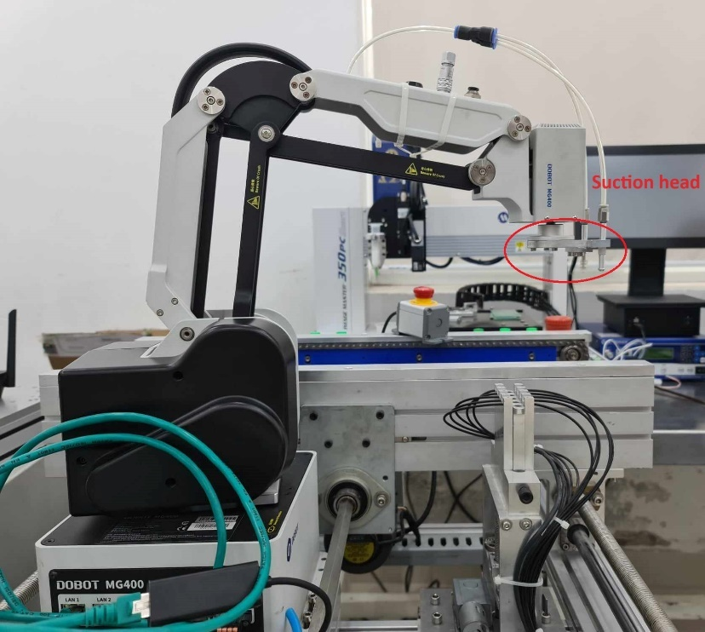
Figure 1.1 – Robot Arm Dobot MG400
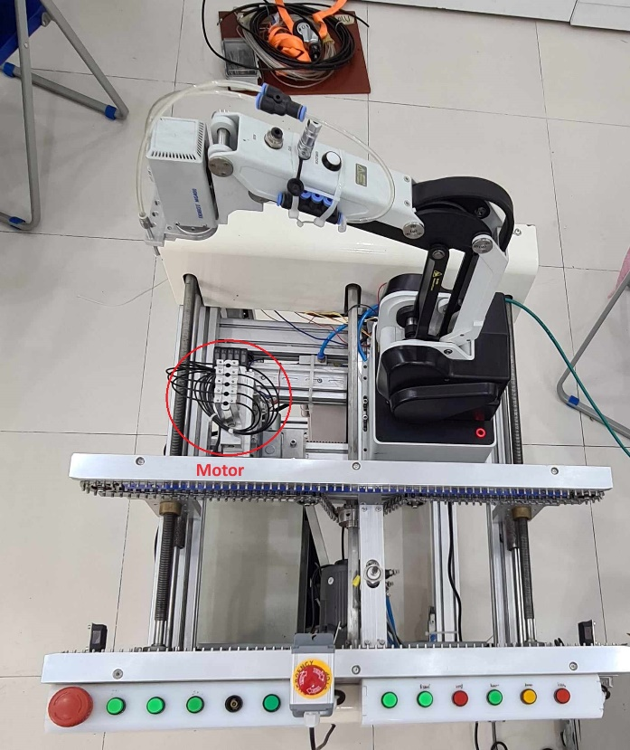
Figure 1.2 – Motor system attached to MG400
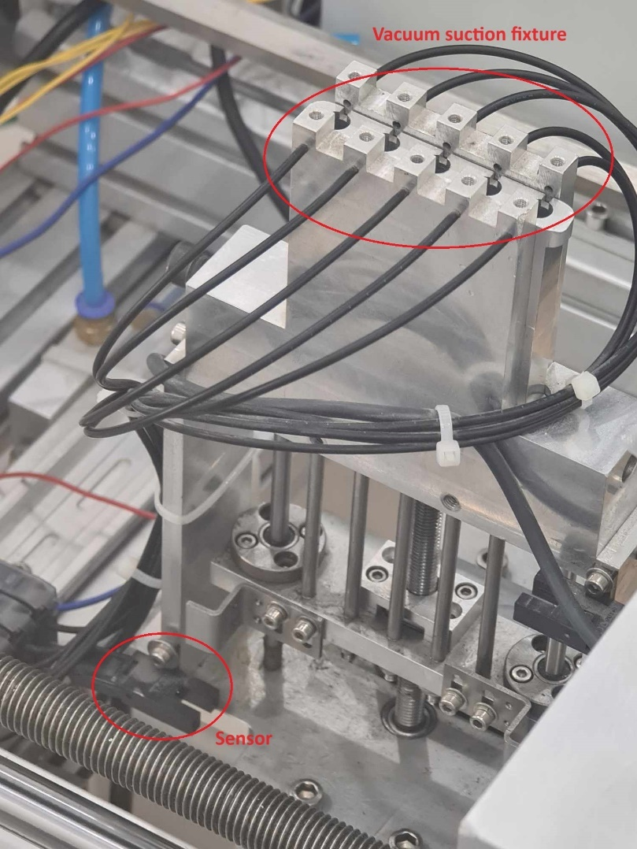
Figure 1.3 – Sensor and vacuum suction fixture in the motor system
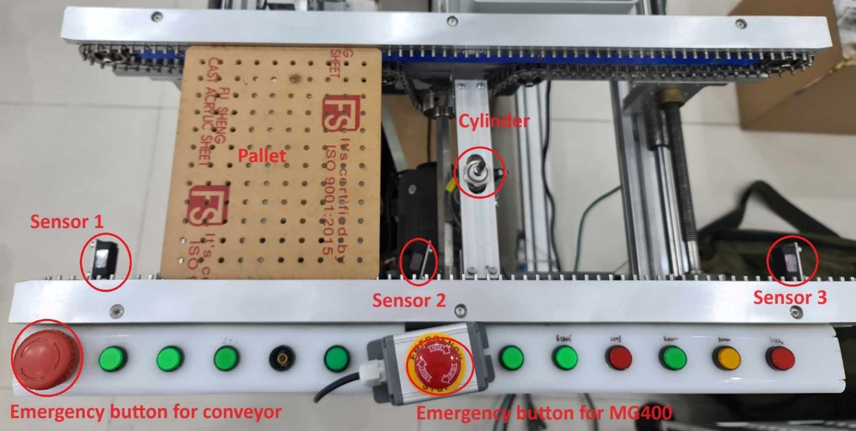
Figure 1.4 – Conveyor belt system with pallet, sensors and cylinder
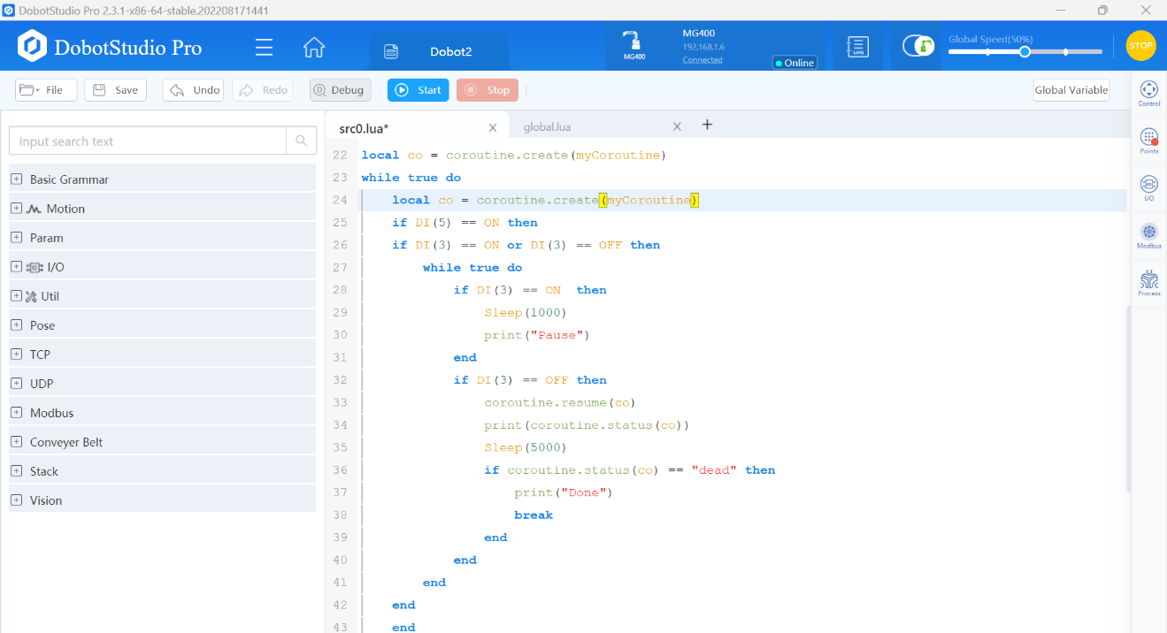
Figure 1.5 – Lua programming to check for signal DI(3) and DI(5)

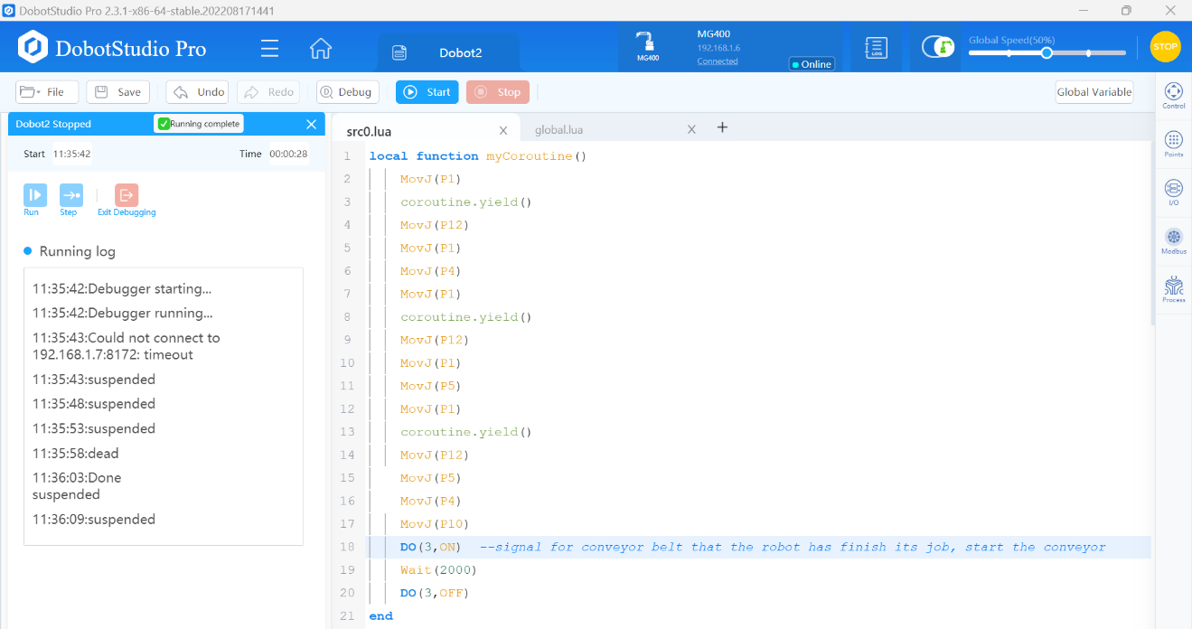
Figure 1.6 – Lua programming to control the movement of MG400 and check for DO(3)

2. Xport Application (export data of MY700 Jet Printer)
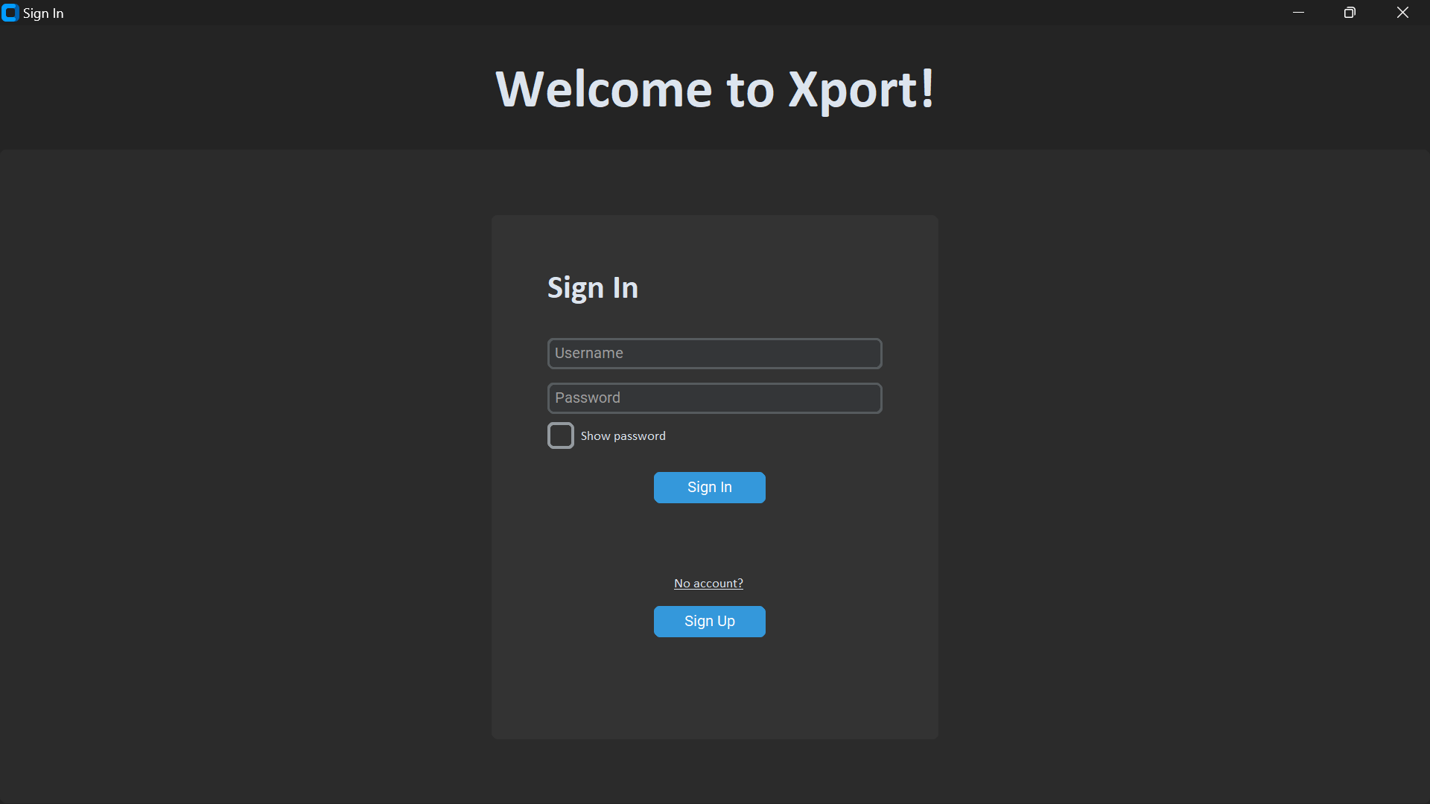
Figure 2.1 – Sign In page
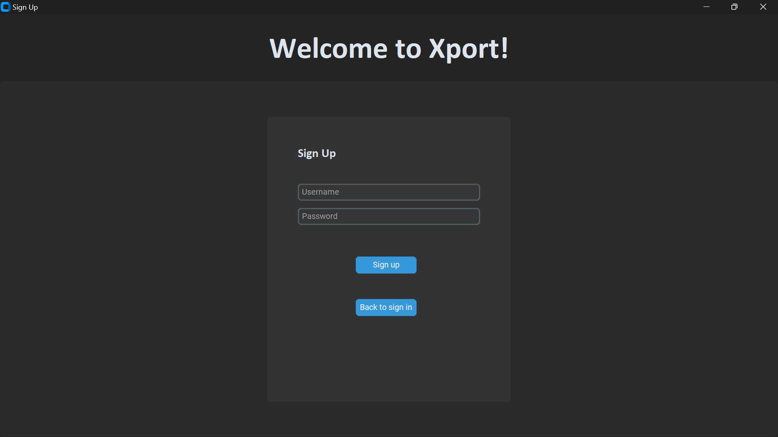
Figure 2.2 – Sign Up page

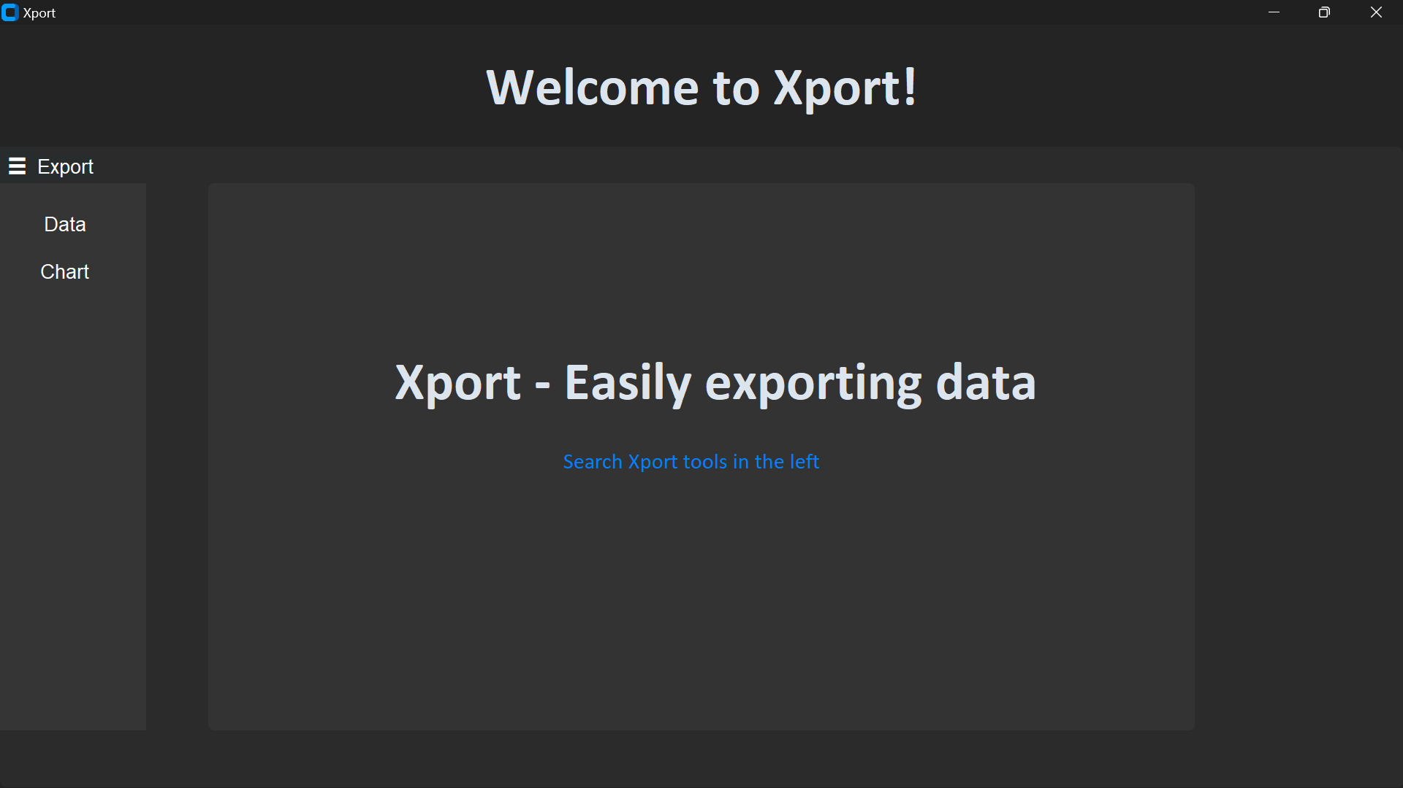
Figure 2.3 – Xport Home page
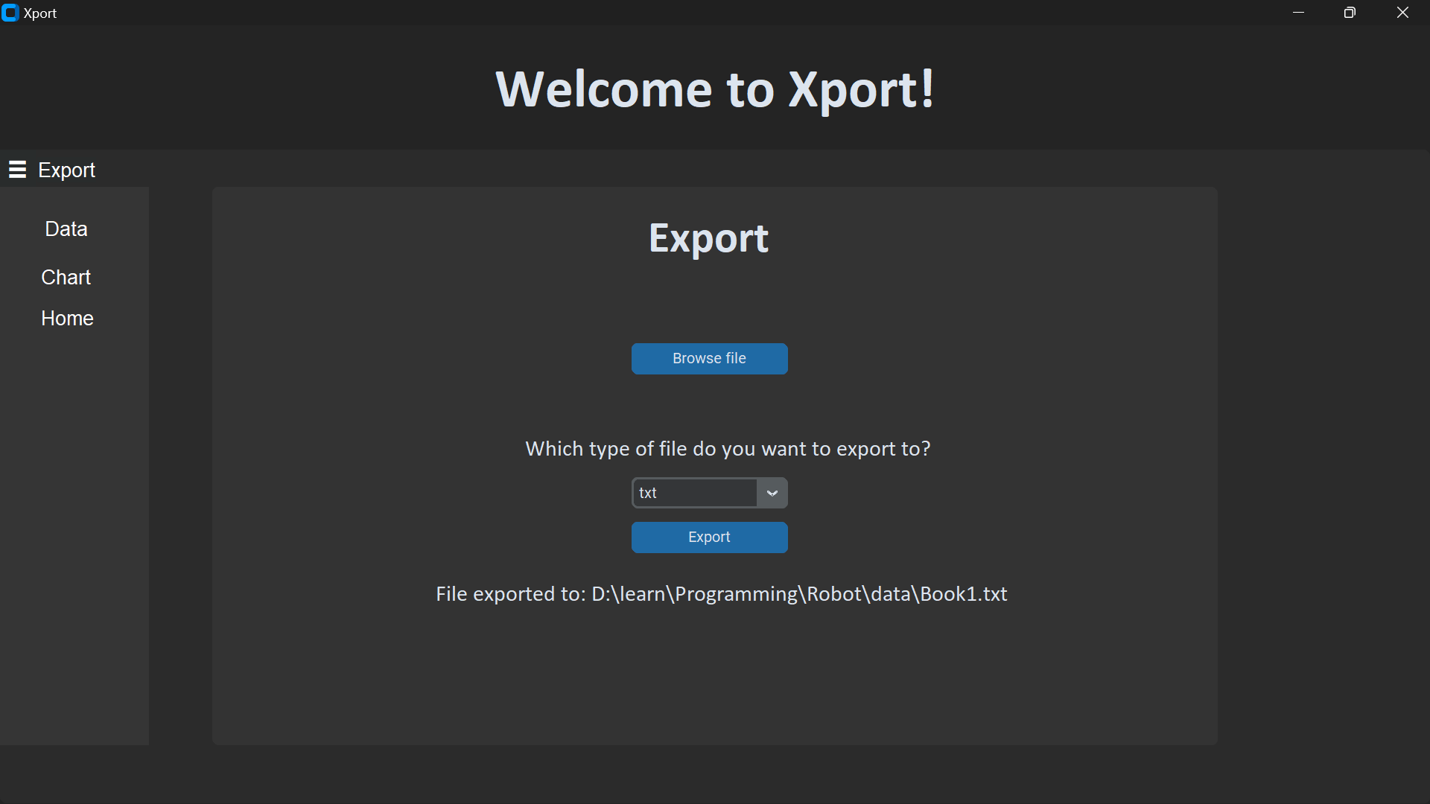
Figure 2.4 – Export Data page

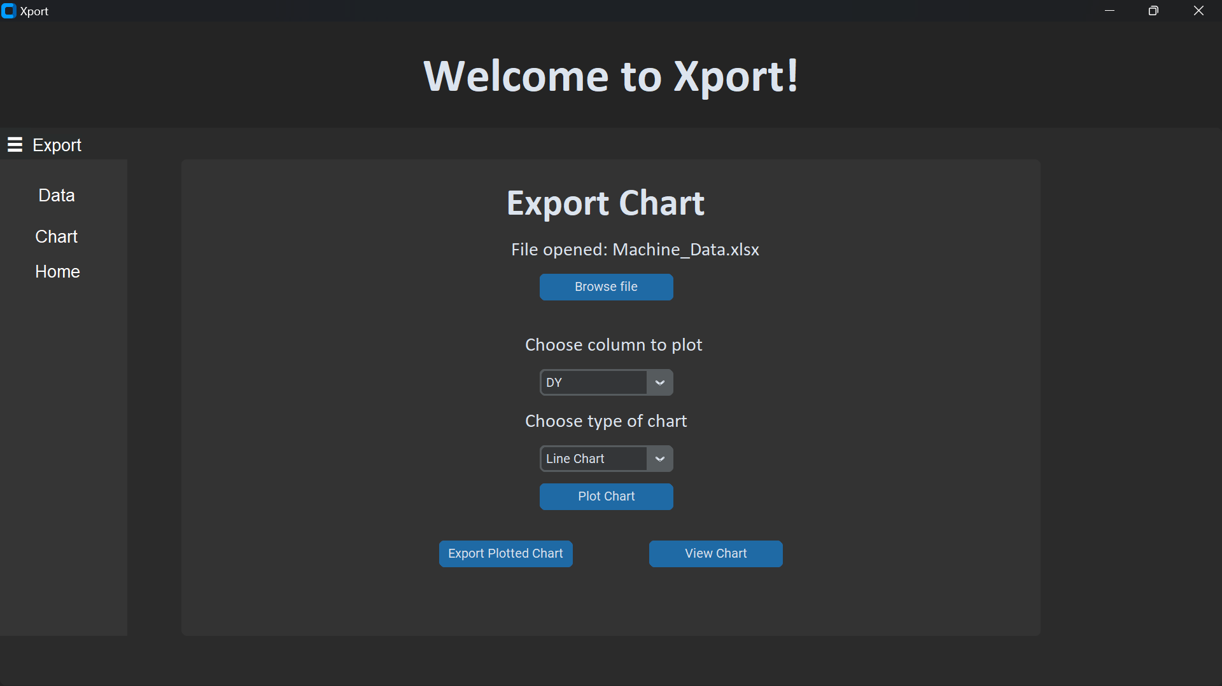
Figure 2.5 - Export Chart page

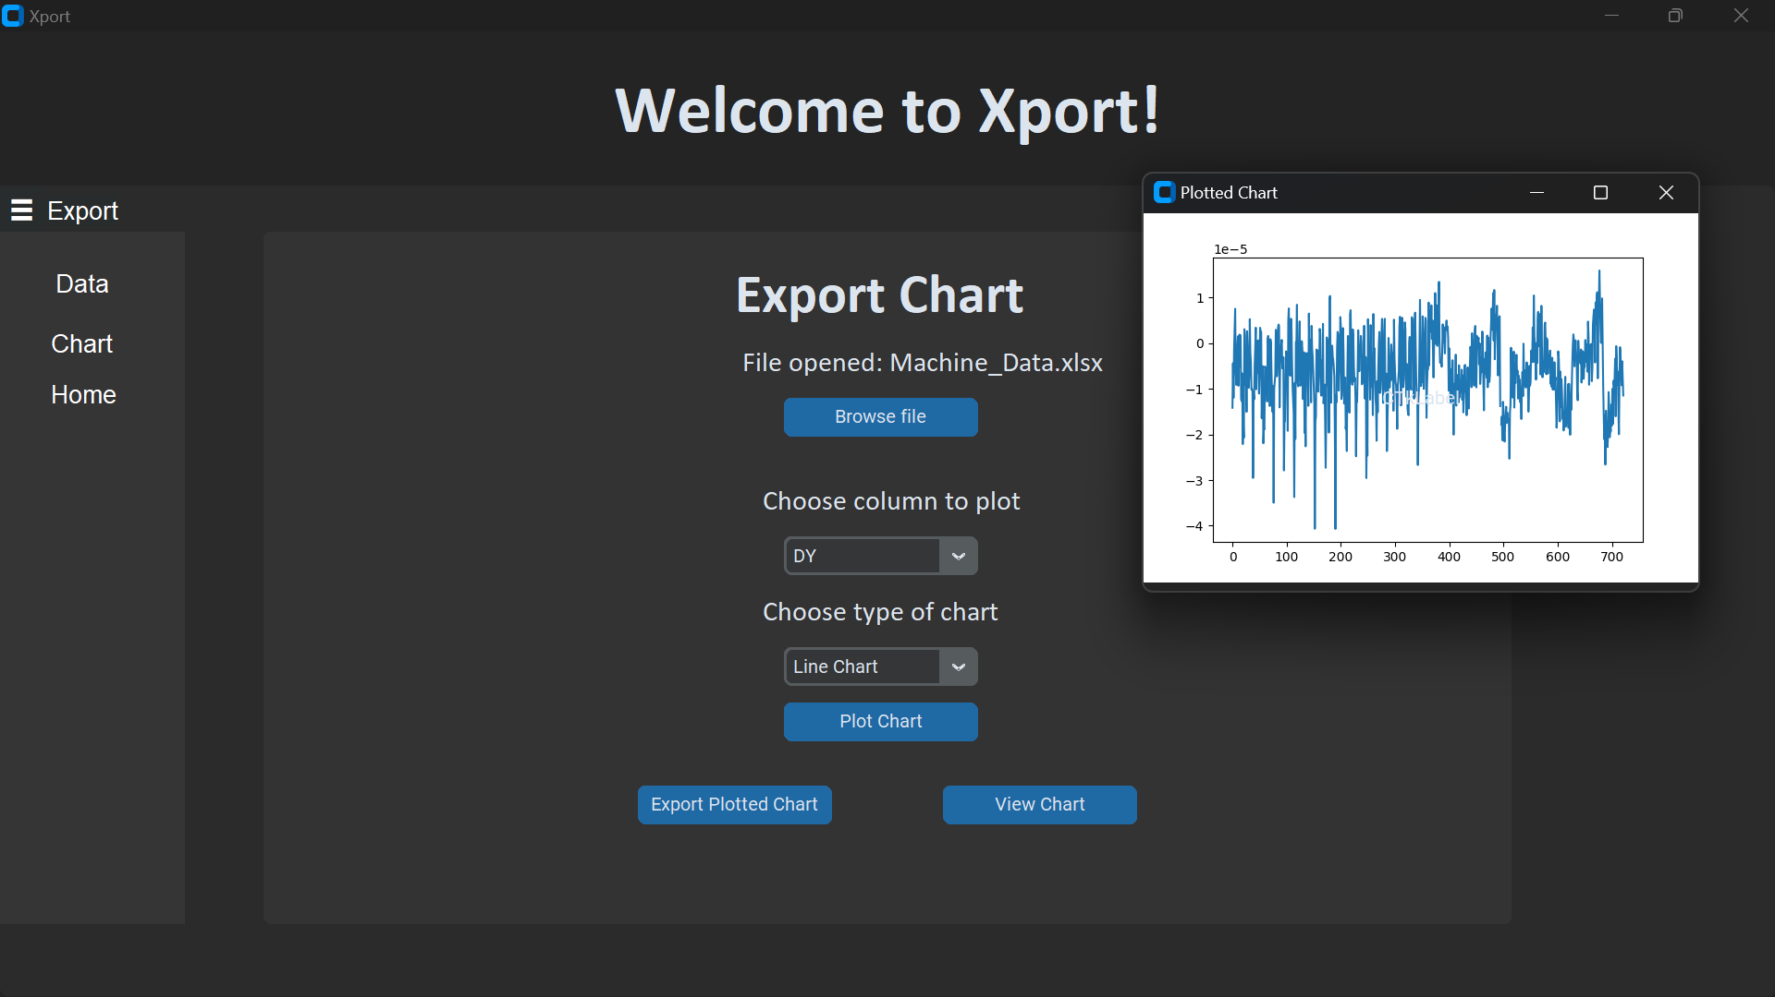
Figure 2.6 – New window pop up when hitting a View Chart button

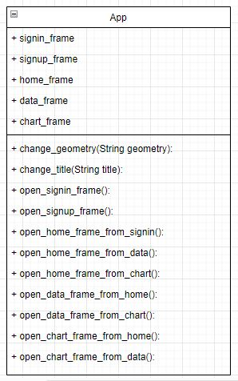
Figure 2.7 – app.py
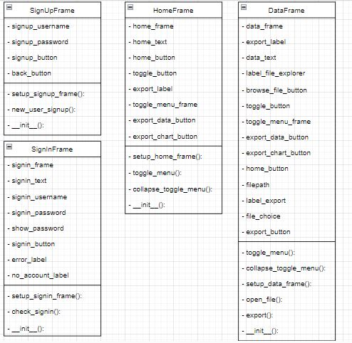
Figure 2.8 – frames.py

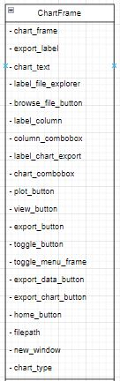
Figure 2.9 – Class ChartFrame in frames.py (attributes)
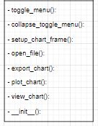
Figure 2.10 – Class ChartFrame in frames.py (function)
Lists of Tables
Data achieve by analyzing and calculating statistics of MY700 Jet Printer

Table 1: X-axis Positioning (DX)
Statistic | Value
Min | -0.0000443
Max | 0.0000157
Range | 0.0000599
Mean | -0.00000749
Median | -0.0000074
Standard Deviation (σ) | 0.000007861
X-axis (3σ) | 0.00002358
Cpk (limit 40μm) | 3390000
Cpk 1.0 limit (x + 3σ) | 0.0000161

Table 2: Y-axis Positioning (DY)
Statistic | Value
Min | -0.0000407
Max | 0.0000159
Range | 0.0000566
Mean | -0.00000601
Median | -0.00000593
Standard Deviation (σ) | 0.000008009
Y-axis (3σ) | 0.00002403
Cpk (limit 40μm) | 3330000
Cpk 1.0 limit (x + 3σ) | 0.000018

Table 3: In-line Positioning (Xt)
Statistic | Value
Min | 0.0999
Max | 0.211
Range | 0.111
Mean | 0.155
Median | 0.155
Standard Deviation (σ) | 0.0329288
In-line (3σ) | 0.987865
Cpk (limit 40μm) | 808
Cpk 1.0 limit (x + 4σ) | 0.287

Table 4: Cross-line Positioning (Yt)
Statistic | Value
Min | 0.171
Max | 0.225
Range | 0.0541
Mean | 0.198
Median | 0.198
Standard Deviation (σ) | 0.0164471
Cross-line (3σ) | 0.0493414
Cpk (limit 40μm) | 1620
Cpk 1.0 limit (x + 4σ) | 0.263

I. DESCRIPTION OF COMPANY/ORGANIZATION
RMG Technologies Vietnam (Reliability-Making-Good) was established in August 2008 with a determination that provide and supply services products in SMT aspect for FDI business in Vietnam.
After 12 years of working and developing, RMG Technologies Vietnam has been advanced and built up with three factories and office system locate at:
- District 9, HCM City
- Quang Phu Industrial Zone, Quang Ngai Province
- Tien Son Industrial Zone, Bac Ninh Province
- Bui Vien Street, Nam Hai, Hai An, Hai Phong
RMG has been successful in becoming a top supplier in Vietnam that supports for FDI business increasing operating productivity, as well as saving a great amount of shipping cost and more.
With manufacturing facilities spread over the North, Central, and South areas of Vietnam, RMG is likewise expanding quickly in size. RMG's primary goal is to provide competitive pricing, high-quality products, and services. They take great pride in being one of the top providers of SMT materials and equipment to Vietnamese electronics manufacturing enterprises that attract foreign direct investment.
RMG concentrate on business and manufacture a wide range of materials and equipment that support printed circuit board assembly industries such as SMT Machines, Wave Soldering Machines, Selective Soldering Machines, Conveyors, Soldering Machines, ESD materials, …
To ensure the interest of the customer, RMG has four main policies to improve the service quality:
Policy 1: Customer information security policy
- RMG may request essential personal data from its clients, such as complete name, address, email address, phone number, bank account, etc. To give its clients the best service possible, RMG will receive and utilize this information in accordance with its nature.
Policy 2: Warranty and Maintenance policy
- Despite having a sophisticated and rigorous production process, RMG's main priority is always minimizing faults.
- Products such as pallets and conveyor belts have a one-year warranty period. RMG guarantees that every mistake in safety, method, material, or processing that affects product quality will be corrected as quickly and effectively as possible to provide the greatest possible experience for consumers.
- When a product's warranty expires, RMG is always prepared to offer the best fixes to help clients with any issues that may come up.
Policy 3: Shipping and Installation policy
- The entire Ho Chi Minh City district is eligible for free shipping; the exact time of delivery will be specified prior to your purchase and will be contingent upon the quantity and value of the order.
- During shipment, unloading, and installation, RMG oversees product packaging and preservation.
Policy 4: Conflict minerals policy
- During manufacturing, RMG strives for a “friction-free” supply chain, including a commitment to overall corporate social responsibility and supply chain initiatives as well as sustainability efforts.
- The policy includes requiring manufacturing suppliers to provide written evidence regarding the use of any conflict minerals in products manufactured by RMG.
- RMG does not source minerals directly from smelters. They rely on feedback from manufacturing suppliers to source information related to conflict minerals.
The following email is the email contact for RMG Technologies Vietnam: contact@rmg.com.vn

II. SUMMARY OF THE INTERNSHIP
My role at RMG Technologies Vietnam (Reliability-Making-Good) was an embedded software programmer. Particularly, this position is responsible for collaborating the behavior of hardware and software by programming to yield and control a specific action of the system. Throughout the time of nearly two months (July 8th – September 8th) internship at RMG, my insight into industry in general as well as programming in detail has been broadened. Since I have a great opportunity to approach industrial systems like robot arm supplied by Dobot Robotics – the creator of the world’s first desktop grade collaborative robot as well as conveyor belt. Furthermore, by analyzing and calculating the wet dispense accuracy data of a jet printer produced by Mycronic, I have implemented an application that will read the data in an excel file and then export to multiple type of files.
For the robot arm system, I have cooperated with two friends, who studying at Ho Chi Minh University of Technology, since this robot have a complicated behavior and problem to understand. Through studying on a movement of the robot arm alongside the behavior of the conveyor belt, I have a realistic insight of how these two devices can connect with each other to generate complete action. The core of how they can communicate with each other depends on how they input and output the signal.
After having a great insight into the robot arm, I started to consult for the export data application. For this application, exporting data of the jet printer is not only the case I concentrated on, but I mainly focus on how to export all data that is saved on excel file to multiple types of files, i.e., txt, csv, json... Due to that, the first thing I came up with this approach was creating a UI (User Interface). This is the first impression for all applications and designing and constructing UI will make the application more significant. After generating UI, I started to research the main issue, which is exporting data.
Finishing these two activities, I have a clear vision into how the industrial system performs in real life, as well as the interaction between hardware and software through signal and how to optimize the behavior between them by means of programming. Besides that, I also achieved the knowledge of how different frames in one application can merge and collaborate to make the application optimal.

III. PLANNING
1. Dobot Robot MG400 with PLC (Programmable Logic Controller) System

Monday | Tuesday | Wednesday | Thursday
08/07  Start of the internship | 09/07  Study about Modula Warehouse System | 10/07  Research on basic operation of Modula Warehouse | 11/07  Self-study
15/07  Setup and install Dobot Studio Pro software for Dobot MG400 | 16/07  Study on Lua programming language | 17/07  Review user manual of MG400 and use guide of Dobot Studio Pro | 18/07  Explore movement of Dobot MG400 through its syntax
22/07  Test some basic movement of MG400 | 23/07  - Code basic operation of MG400  - Reading manual about I/O signal | 24/07  - Research about PLC I/O signal  - Probe into sensor | 25/07  Analyze into MG400 I/O signal
26/07  Collab I/O signal of both PLC and MG400 | 30/07  Implement and code for new operation of MG400 | 31/07  Complete the operation | 01/08  Review and record the results of MG400 project

2. Xport Application (export data of MY700 Jet Printer)
Monday | Tuesday | Wednesday | Thursday
05/08  Study on data of MY700 Jet Printer | 06/08  Research on formula and calculate Cpk as well as basic data (Max and Min Deviation, Mean, Median…) | 07/08  - Statisticize calculated data in Excel file | 08/08  - Review some Python libraries that support reading and writing data to file
12/08  Test those libraries to read calculated data and export data to the console | 13/08  Explore Python Tkinter and Custom Tkinter to implement a UI for the application | 14/08  Plan and design sign in as well as sign up page for the application | 15/08  Study on SQLite and setup a database for user sign-up information
19/08  Code the sign in and sign-up page | 20/08  Analyze and implement an export page | 21/08  Improve the export mechanism to achieve an exceeding format for the file | 22/08  Advance a UI with more functionality (show password checkbox, side navigation bar, home page)
26/08  Study Python Matplotlib | 27/08  Use Matplotlib to read data and plot a chart | 28/08  Apply the plotting mechanism and find a way to export a plotted chart | 29/08  - Integrate export plotted chart mechanism to the UI  - Review the UI project

IV. INTERNSHIP ACTIVITIES & ACHIEVEMENTS
1. Dobot Robot MG400 with PLC (Programmable Logic Controller) System
This is the first project that I came up with during my internship at RMG Technologies Vietnam. By the time I worked and experienced the Dobot MG400, I have achieved a stable knowledge of how embedded systems communicate through every device. Also, to control the robot MG400, I have learnt a new concept, which is I/O programming. This is a core key knowledge, that every embedded system must have to communicate through devices.
The MG400 (see in Figure 1.1) is an ultra-compact desktop grade robotic arm with footprint smaller than a piece of A4 size paper. It is safe for human collaboration, easy to use, and quick to deploy, making it perfect to automate small batch flexible productions. With 750 g maximum payload, 440 mm maximum reach, drag-to-teach and collision detection features, MG400 is a cost-effective option for smart automation tasks.
Firstly, to get in touch with Dobot MG400, Dobot Studio Pro must be installed – this is an exclusive software that can control not only Dobot MG400, but also all the Dobot series products. Dobot Studio Pro uses Lua programming language to program and control the movement as well as operation of MG400. Thus, in the first step, I must study syntax and structure of Lua programming language. Moreover, for Robot products, Dobot has created and implemented unique motion commands for users to control the Robot. For having a great insight of these commands, I have review and research through Dobot Lua Syntax Guide provided by Dobot. Some basic commands for control Dobot Robot series are as follows:
- MovJ(P): Point to point motion, the target point (P) is the Cartesian point (non-linear movement)
- MovL(P): Point to point motion, the target point (P) is the Cartesian point (linear movement)
- DI(Index): Get the status of the digital input port (Index: Digital input port, value range 1-18)
- DO(Index): Get the status of the digital output port (Index: Digital output port, value range 1-18)
- Wait(time): Set the delay time for robot motion commands (time: delay time, unit: ms)
- Sleep(time): Set the delay time for all commands (time: delay time, unit: ms)
After processing through some basic commands to run the MG400 as well as coding fundamental operation like drag and drop small objects, I collaborated with my two friends, who studying at Ho Chi Minh University of Technology, to probe into PLC (Programmable Logic Controller). In this progress, I have examined input and output ports of the PLC in addition with I/O signal that the PLC received and sent through the system. Moreover, I also delve into a sensor, since in conveyor belt system (see Figure 1.4), it plays a vital role in starting and stopping the pallet as well as transmitting the I/O signal for the Robot Arm MG400. The I/O signal of MG400 was researched in this process as well.
Basically, in this step, my two friends, programming on how to start the conveyor belt with the help of the sensor. For this system, we have total 36 digital signal, 18 for each input and output. The signal to manage the conveyor belt is digital input signal 5 (in Dobot Lua Syntax, illustrated by DI(5)). The sensors (see Figure 1.4) will detect the presence of objects above it, specifically in this case the pallet. If the pallet is above sensor 1, then it turns DI(5) to OFF to force the conveyor belt to start and move the pallet to sensor 2. When the pallet arrives at sensor 2, it will signal for the cylinder to pop up and stop the pallet in the middle of the conveyor belt. Then sensor 2 will turn DI(5) to ON and forward this signal to trigger the robot to start the operation. The ON signal of DI(5) indicates that the conveyor has finished half of the job, and it needs to wait until the operation of the MG400 ended, then the conveyor will start the remaining progress, move the pallet to end.
After the conveyor belt sent the ON signal from DI(5), my role was to help MG400 receive that signal to operate by coding in Lua. The digital signal to run Robot Arm MG400 is digital output signal 3 (in Dobot Lua Syntax, illustrated by DO(3)). Knowing that the conveyor has sent the ON signal of DI(5), DO(3) will be turned OFF to start the robot. Succeeding in working, the robot will turn ON DO(3) to communicate with the conveyor that it has finished its journey, then the conveyor will be set off by turning OFF the DI(5) to complete remaining process.
Subsequently understanding the I/O signal of both PLC and MG400 as well as their procedure, we start to implement a new activity for this system. This new operation will aim for the fundamental of the robot arm, which is drag and drop objects to a pallet in a conveyor belt. Hence, as in Figure 1.2 and Figure 1.3, we have another system called motor. This system has two main components, which are sensor and vacuum suction fixture. These two components served as a detector and placement of small components like nails, screws...
The idea for this new functioning was to control MG400 to detect whether components are placed in vacuum suction fixture or not. As in Figure 1.3, we have a total of 5 positions, if the components fill all these positions, means there are enough items, thus MG400 will start its journey. MG400 will suck up those pieces using its suction head, then place them on the pallet on the conveyor belt. However, if there are not enough portions, MG400 will wait until components were filled all 5 positions, then it will operate.
Due to that behavior, the first thing we start to analyze is the digital signal that the sensor transmits to MG400, which is DI(3). With that information, I start to program the new activity as in Figure 1.5 and Figure 1.6.
Figure 1.5 displays the logic to check for the DI(5) – signal of the conveyor belt, and signal of vacuum suction fixture, which is DI(3). On the first line I created a variable called co, then assigned it with a special feature in Lua, which is coroutine. In Lua, coroutine is a powerful feature that allows us to write functions that can yield and resume execution, enabling cooperative multitasking within a program. Due to that, I have generated a function namely myCoroutine (see in Figure 1.6) by using coroutine.create(). This function will represent the movement of MG400 that we can pause or resume when we want.
Next, I implemented a while loop to check for the desired digital signal. The co variable that has been assigned the myCoroutine function will be used to jump into the myCoroutine function to start the operation. This infinite loop continuously checks the state of the input signal (DI(5) and DI(3)) to determine when to start or resume the robot’s operation. The logic in this loop will be explain as follows:
- if DI(5) == ON: This line checks if the conveyor belt has delivered the pallet to the correct position. If DI(5) is ON, it means the pallet is in place, and the robot can start working
- if DI(3) == ON or DI(3) == OFF: This condition will check the state of DI(3). If DI(3) is ON, it means that there are not enough components on the vacuum suction fixture, then the robot will wait (using Sleep(1000)) until components are loaded. If DI(3) is OFF, the fixture has been filled, then the coroutine is resumed using coroutine.resume(co) to continue executing the myCoroutine function.
- coroutine.status(co): After resuming the coroutine, the code checks its status so that MG400 can stop when it finished its journey.
In Figure 1.6, I defined the myCoroutine function to manage the action of MG400 during its cycle. We start at position P1 then pause the action using coroutine.yield() to check for signal DI(3) in the infinite while loop as we seen in Figure 1.5. If DI(3) is ON then it will wait (using Sleep(1000)), however, if it is OFF then we resume the action by execute coroutine.resume(co) to jump right back where we pause in the myCoroutine function. The cycle continues like that until MG400 completes the job, then it will sign the conveyor belt by triggering the signal DO(3) to ON so that the conveyor belt will accomplish its remaining journey. I also put a delay time by using Wait(2000), means wait 2 seconds, to ensure action from MG400 does not continuously behave when the conveyor belt process. Finally, by setting DO(3) to OFF, the operation has finished, unless the new pallet comes up, the whole system will process the cycle again.

2. Xport Application (exporting data of MY700 Jet Printer)
After finishing the Dobot Robot MG400, I came up with this application. For this project, I was given the wet dispense accuracy data of MY700 Jet Printer supply by Mycronic to analyze the behavior as well as Cpk specification of the device.
The MY700 Jet Printer makes it possible to handle the most challenging boards and components with micrometer accuracy, maximum speed and perfect quality solder joints. The smallest and largest dots are now possible to combine with higher throughput than ever before, thanks to dual heads for continuous jetting of nanoliter and large deposits.
As boards and components become smaller, smarter and more complex, jet printing stands out as the most efficient solution for the modern electronics industry. Fully software-driven and with complete solder paste volume control, the MY700 is the optimal way to ensure perfect quality solder joints at high speed – even in the industry’s most challenging applications. The MY700 Jet Printer ensures excellent volume repeatability and solder joint quality to reduce rework.
As in the list of table index, there are 4 tables, in which they are related to each other. As in Table 1 and Table 2, the statistics express the testing value of MY700 Jet Printer in x and y-axis. Following that, Table 3 and Table 4 is the value of Jet Printer illustrated by in-line and cross-line position respectively. Data in those tables reflect the behavior as well as some fundamental specifications of MY700 Jet Printer. Moreover, the data is partly used for calculating the Cpk (Process capability index). This specification is used to measure the ability of a process to produce output within the specification limits defined by the customer. In other words, this tool is used to measure the ability to produce a product within a customer's defined tolerance range. Due to that the formula for computing the Cpk given in the tables are as follows:
Cpk = x + 3σ (X-axis and Y-axis Positioning)
Cpk = x + 4σ (In-line and Cross-line Positioning)
By applying the two formulas above, the value of Cpk is below 1.0 limit, means that MY700 Jet Printer is satisfied with the standard specification. Through analyzing fundamental statistics of MY700 Jet Printer as well as calculating the Cpk, I have achieved and understand how meaningful of Cpk specification can be used in industrial management to control and evaluate the efficiency of specific process or system.
The next step on this project is to research how to export data to multiple types of files. For this purpose, firstly, I statistically express calculated data as well as computed Cpk into an excel file. Next, for the main objective, I researched and studied Python libraries that support export data from file to file. Since basically Python has many libraries that provide multiple of features like NumPy (used for high-level mathematical functions), pandas (for data manipulation and analysis), or Tkinter (standard Python interface to the Tk GUI toolkit)… With various options, I came up with pandas. This library is built around data structures called Series and DataFrames. Data for these collections can be imported from various file formats such as JSON, comma-separated values (csv), and Microsoft Excel. Hence this library is suitable for the given objective.
Subsequently, for the real application, it is reasonable to have a name and UI (User Interface), which expresses specific information as well as interacts with users. Moreover, I came up with the name Xport for this application, which is a wordplay of letter ‘X’ with the prefix ‘ex’ as well as the objective of this application is export data. Considering Tkinter and CustomTkinter (a modern and customizable Python UI-library based on Tkinter), I arise with the idea that creating fundamental pages as in Figure 2.1 to 2.6. The Xport application was implemented with 4 files. The name and purpose of each file are as follows:
- app.py: This file aims for transitioning from frame to frame (page to page)
- frame.py: In this file, the definition as well as function of each frame (page) was implemented by categorized them as class, for example like Sign In, Sign Up, DataFrame, ChartFrame, HomeFrame.
- functions.py: This file will be responsible for some fundamental functions that checking the account for sign in (check_signin function) or creating an account (signup_user function) by using SQLite database with the support of open-source tool called DB Browser for SQLite.
- main.py: This file contains the main function for simply running the Xport application.
The first approach for Xport application was researching databases through essential syntax as well as embedded its syntax to Python code. The databases are crucial since this is the key for creating and storing user accounts.
In Figure 2.7, I created a class called App. This class aims for switching from one frame to another frame. So, firstly in this class, I have defined some variables (or attributes) to specify necessary frames in Xport applications, which are signin_frame, signup_frame, home_frame, data_frame, chart_frame. The App class is inherited from CTk class, which is the class from module CustomTkinter, hence the App class can use functions from the CTk class, specifically the destroy() function. The destroy() function is the critical factor to change the frame apparently, for example, if we want to jump from signin_frame to signup_frame, we must call the destroy() function to terminate the signin_frame completely then we open signup_frame. Classes have been defined in frames.py, hence we can create the object (frame) of the respective class after we destroy() the old frame to make the transition apparently. For more convenience, we can simply change the size of the frame by using change_geometry() function or we can modify the title of the frame through change_title() function.
Next, we come to Figure 2.8, 2.9 and 2.10 or frames.py, this file defines all the frames in Xport application as well as main behavior, which is exporting data and chart. The Xport application will start with the Sign In page (Figure 2.1), hence the implementation of this page is SignInFrame class (Figure 2.8). The main objective of this page is logging in the user account to Xport application by calling the check_signin() from functions.py with username and password as parameter, means that it will check whether the user information has been registered or not. If the account has been registered then we can sign in to Xport, however, if the account does not exist, hence the no_account_label (in SignInFrame class) will notify the user to sign up the account. One more condition to check is when the account has been registered, but the user type the wrong username (signin_username) or password (signin_password), the error_label will warn the user with the message to check the information again. Moreover, if user has no account, then they simply hit the Sign Up button to register the account, which responsible by Sign Up page (implementation by SignUpFrame class).
The SignUpFrame class will acquire the username and password so that it can save this information to the table of SQLite database by using signup_user() function from functions.py. Moreover, there is a ‘Back to sign in’ button (Figure 2.2) to jump to Sign In page to log in the account. After logging in to Xport, we start with the Home page (Figure 2.3), implemented by HomeFrame class. With the message ‘Xport – Easily exporting data’ at the center, we also have the side navigation bar (toggle menu) on the left to handle some other operation (tools) like export data or export chart. If the user wants to export data, they will choose the Data on the toggle menu, then the Xport will guide them to the Export Data page (Figure 2.4), which is achieved by DataFrame class. Thus, if the user demands a chart exported, then the Chart on the toggle menu will direct them to the Export Chart page (Figure 2.5), completed by ChartFrame class (Figure 2.9 and 2.10).
The Export Data page first requires the user to choose the file by hitting the browse_file_button (in DataFrame). After the file is successfully chosen, the combobox (input widget that has an associated popup) shows up with three different choices, which are txt, csv, and json. These are three different types of files that are often used to store data, and the user will choose among three types to export data from the excel file to the selected type. Note that the path of the chosen file was stored in the filepath (in DataFrame) variable then label_file_explorer (in DataFrame) will yield a label that the file has chosen. Moreover, the option that the user chooses in combobox will be stored in file_choice (in DataFrame) for later use. Thus, after choosing the file as well as desire type to export into, the user can clearly export the data by hitting the ‘Export’ button. This button will read the value of filepath as well as file_choice to export data into the following selected type of file.
Considering the Export Chart page is like the Export Data page, however, there are some variations. Since the chart in the Excel file can be drawn from different columns, this page gives us the authority to choose which column we want to plot the chart. Thus, we can choose the type of chart to be drawn from the preferred column, but
For simplicity I just implemented three types, which are line chart, bar chart and pie chart. Note that the value for selected column will be stored in column_combobox (Figure 2.9) and the choice of the chart is set in chart_combobox variable (Figure 2.9). Following with the column and type of chart, the ‘Plot Chart’ button (plot_chart function in Figure 2.10) will take the chosen value from column_combobox and chart_combobox to graph the chart respectively. Moreover, there is ‘View Chart’ button (view_chart function in Figure 2.10) to help the user to view the plotted chart so that they can decide whether to export the chart or not. For convenience, when the user hits ‘View Chart’ button, a new window will popup to help the user analyze the chart clearly. Finally, the ‘Export Plotted Chart’ button will be used to export the chart that user has been plotted by calling the export_chart function (Figure 2.10)

V. INTERNSHIP ASSESSMENT
This Summer Internship 2024 is a critical opportunity for me to bridge the gap between academic learning and practical experience. By taking advantage of this occasion at RMG Technologies Vietnam, I have achieved for myself a fundamental as well as necessary knowledge in embedded system. Also, through researching on operation of Modula Warehouse System and working with Dobot Robot MG400, I experienced and applied theory of embedded system to fully control and manage those system by I/O programming. Moreover, along with studying the data of MY700 Jet Printer, I can apparently understand about how significant of Cpk statistic can affect the industrial management process. Thus, statisticize the data and export it to multiple types of files by using Xport application is a great experience. Since I have gained a stable knowledge in Python and using its libraries to generate UI and export data as well as chart.
In this occasion, I have a chance to work with my two friends from HCMC University of Technology, whose major is mechatronics. We have collaborated on research on Dobot Robot MG400 behavior, also by applying our understanding of embedded systems, we start to create the new operation and fully manage its procedure. During the experience in RMG Technologies Vietnam, the knowledge of industrial management and embedded system can support my career greatly, since these knowledges can give insight into tendency of industry and technologies. Also, this knowledge can be employed to work on software and hardware altogether. Thus, this internship period is great likelihood to practice on correlate theory and lab experience in university like creating UI in OOP course, digital signal in Digital Logic Design course as well as analyzing and graph a chart from a following data by employing methods from Theoretical Model in Computing course. These courses are crucial and corresponds to what I have experienced in different tasks in RMG Technologies Vietnam.

REFERENCE
[1] Yuejiang Technology CO., Ltd | China, Dobot MG400 User Guide. Shenzhen (2023).
[2] Yuejiang Technology CO., Ltd | China, MG400 Training System Standard Conveyor Demo Guide. Shenzhen (2023).
[3] Yuejiang Technology CO., Ltd | China, Dobot Lua Syntax Guide. Shenzhen, unpublished.
[4] Yuejiang Technology CO., Ltd | China, The MG400 Training Course. Shenzhen, unpublished.
[5] Yuejiang Technology CO., Ltd | China, DobotStudio Pro User Guide (MG400 & M1 Pro). Shenzhen (2020).
[6] Alan D. Moore, Python GUI Programming with Tkinter. Birmingham: Packt Publishing Ltd (2018).
[7] Van Rossum, G. The Python Standard Library – Graphical User Interface with Tk, release 3.12.5. Python Software Foundation. 2024
[8] Tom Schimansky. CustomTkinter Documentation. 2024
[9] The pandas development team, pandas-dev/pandas: Pandas, 2024 (v2.2.2)
[10] J. D. Hunter, Matplotlib: A 2D Graphics Environment, Computing in Science & Engineering, vol 9, no.3, pp. 90-95, 2007.

