Lab 4
ID: ITITIU21231
Name: Tran Gia Khoi

Ex1: Setup and Display
Task 1.1: Project Setup
Project name: StudentManagement
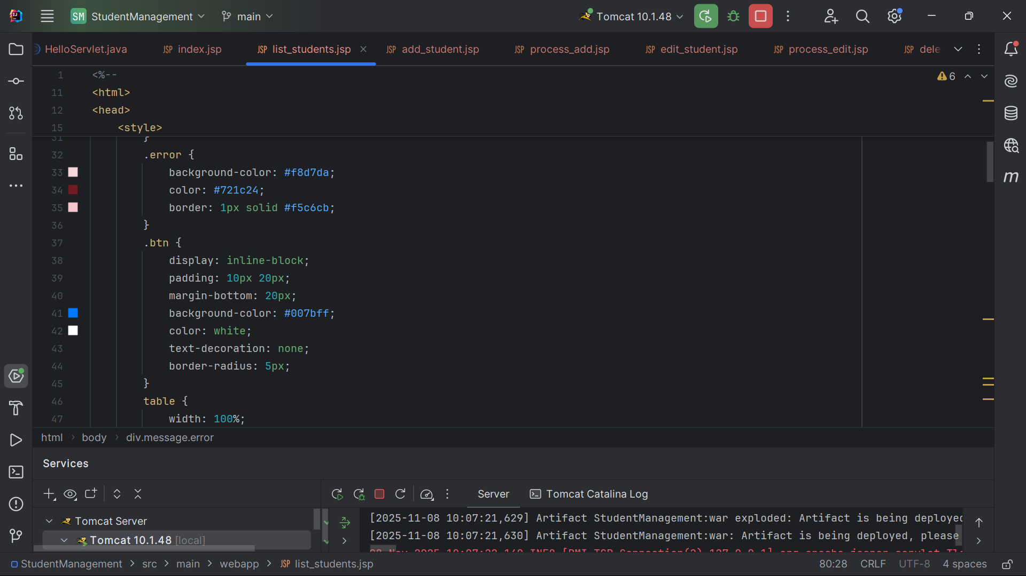
Add MySQL Connector/J Library
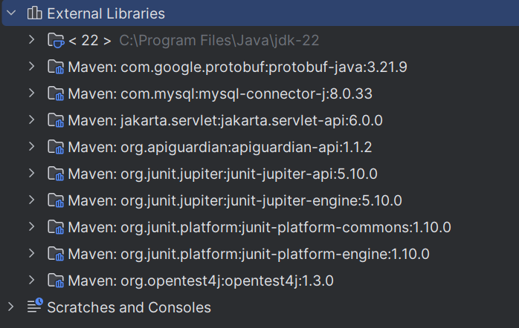
Configure Tomcat Server
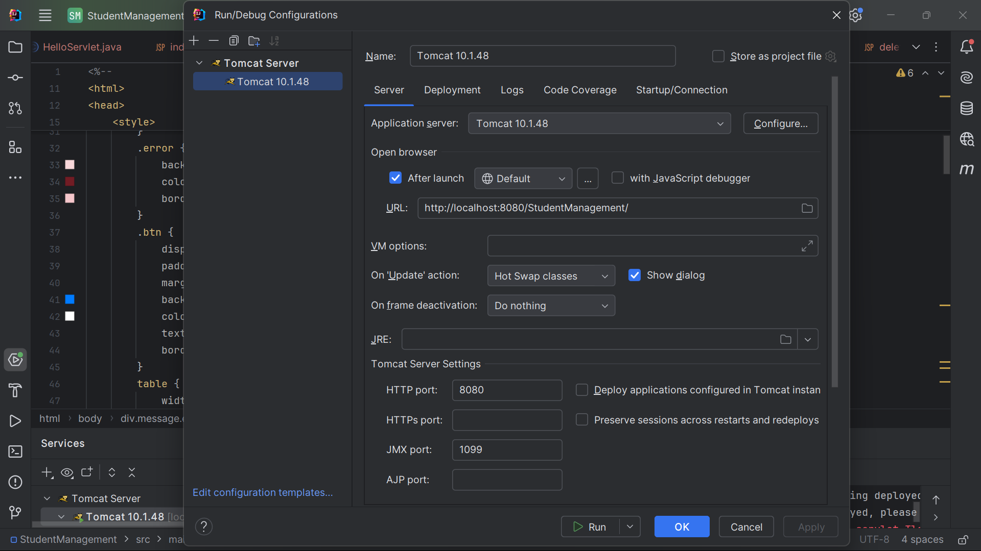

Project run successfully
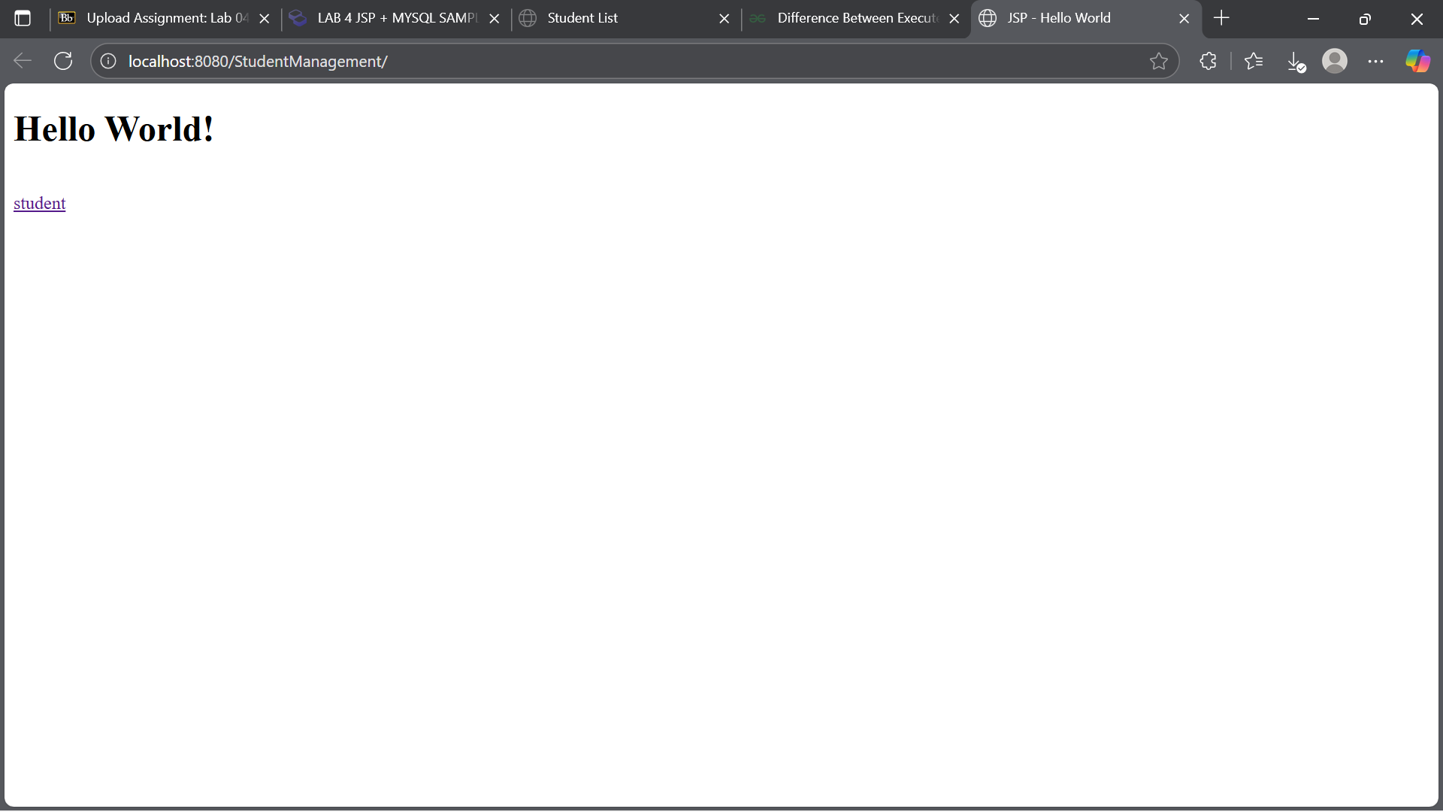

Task 1.2: Display Student List
Database connection successfully
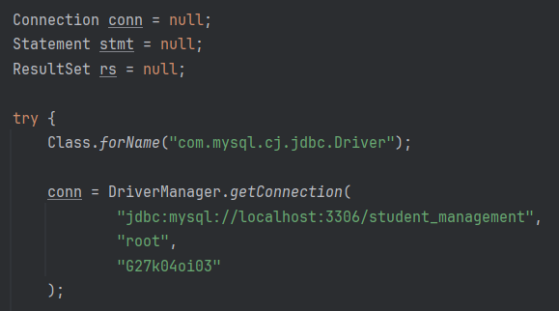
Query executes correctly
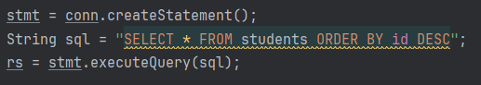
Data display in table
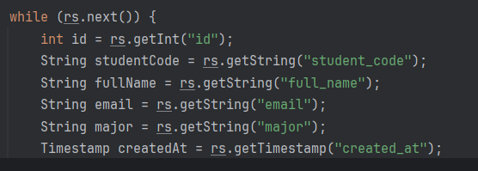

Error handling and resource closed
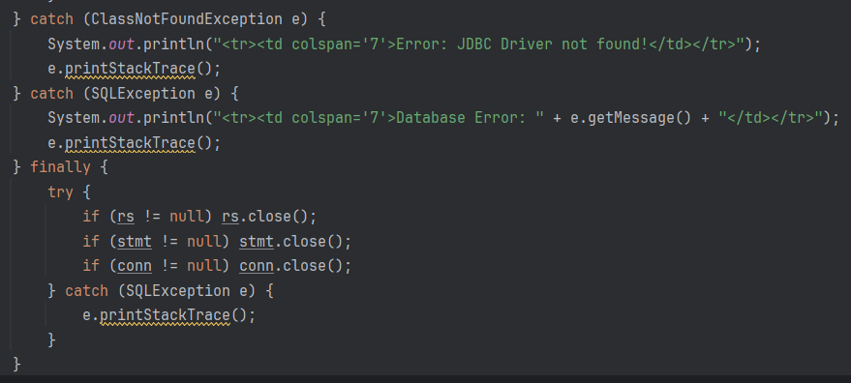
Page:
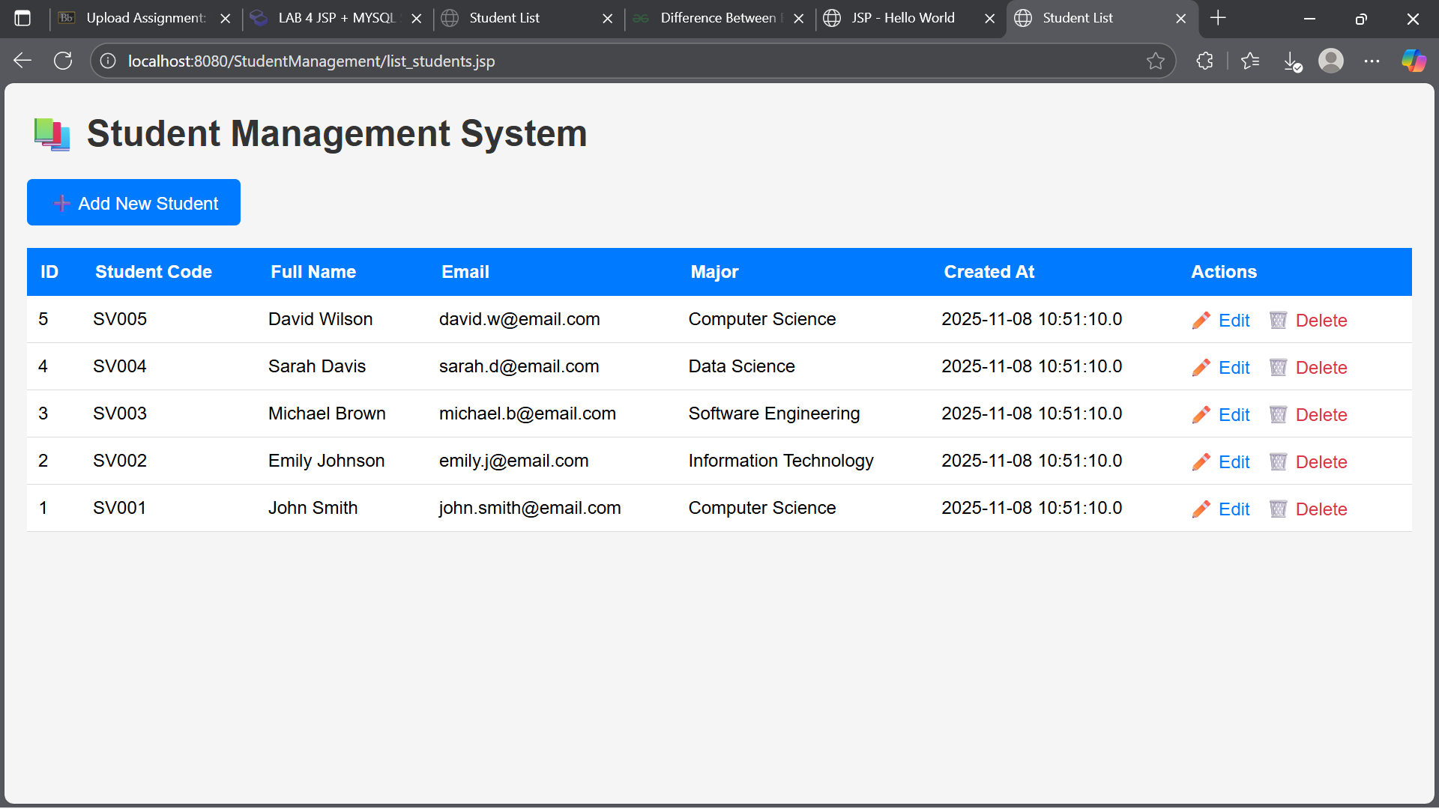

Ex2: Create operation
Task 2.1: Create add student form

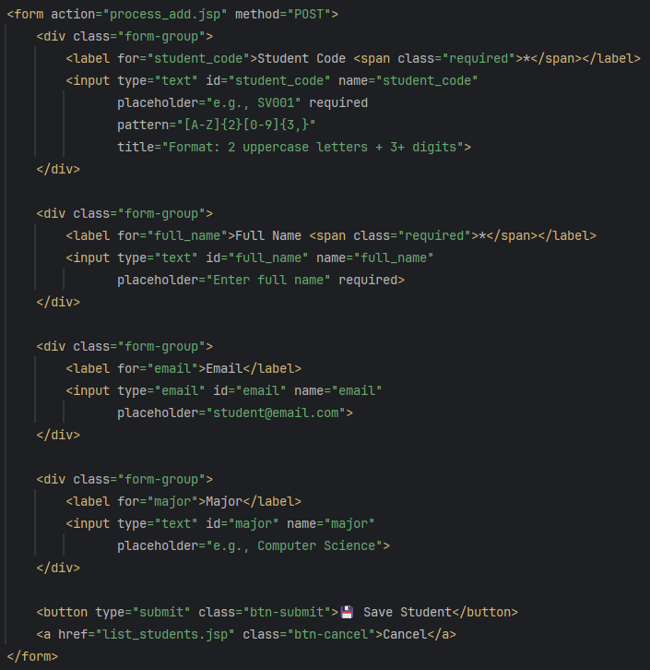
Task 2.2: Process add student
Retrieve parameters
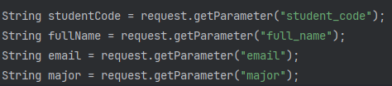

Server-side validation
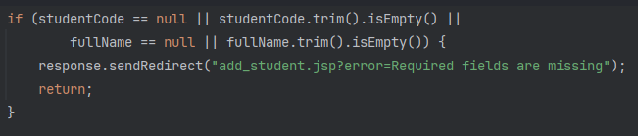
PreparedStatement
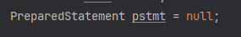
Insert redirect with message
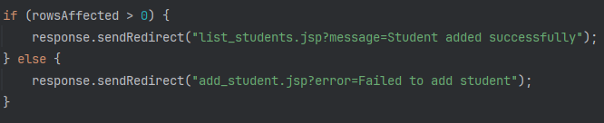
Error handling
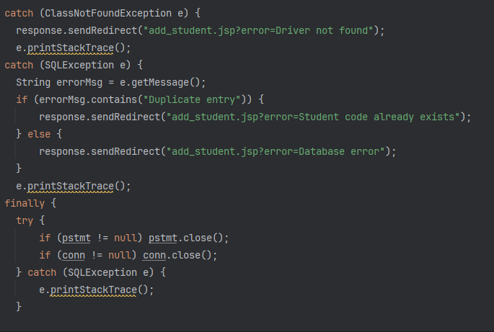

Ex3: Update operation
Task 3.1: Create edit form
ID parameter retrieved and validate
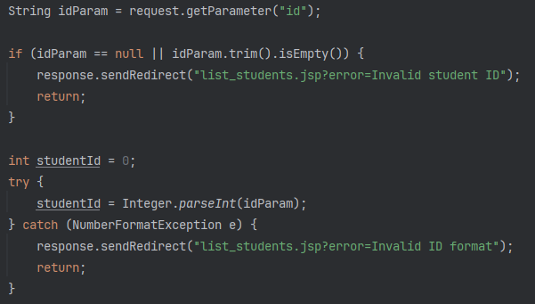
Student data queried
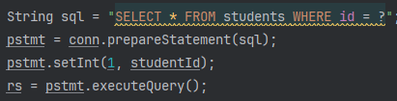
Form pre-filled
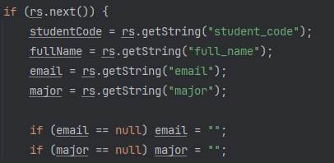
Student code is readonly
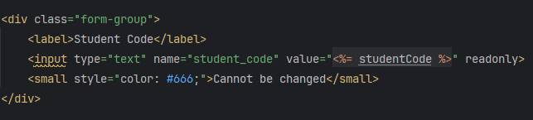
Task 3.2: Process Update
Parameters retrieved
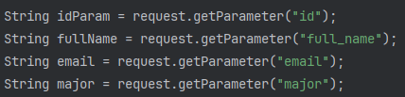
UPDATE query with WHERE clause
PreparedStatement used correctly
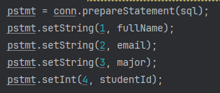
Redirect with message
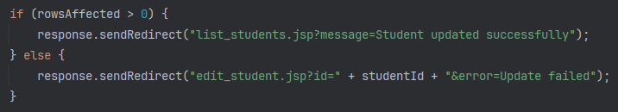
Error handling
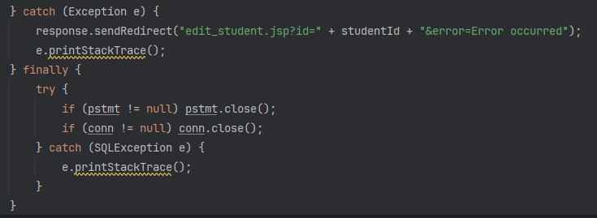

Ex4: Delete operation
Task 4.1: Implement Delete
ID parameter validated
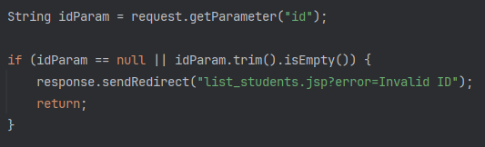
DELETE query executed
PreparedStatement used
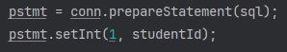
Redirect with message
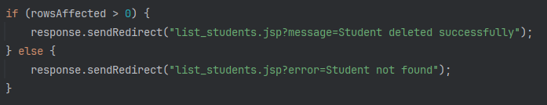
Error handling
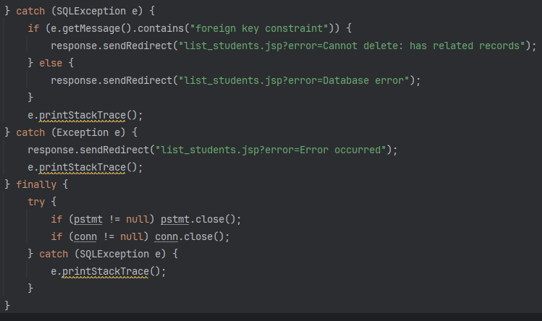
Task 4.2: Add Delete Links and Confirmation

