Lab 8
Name: Trần Gia Khôi
ID: ITITIU21231
Exercise 5: Search & Filter Endpoints
Task 5.1: Search Customers
Custom method in CustomerRepository
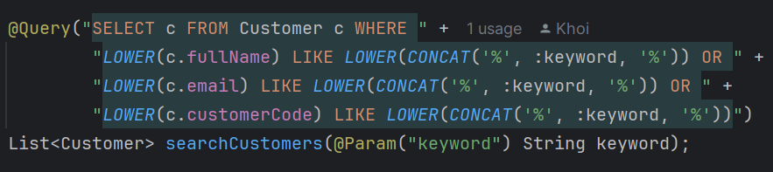
Define method in CustomerService
Implementation of searchCustomers() in CustomerServiceImpl
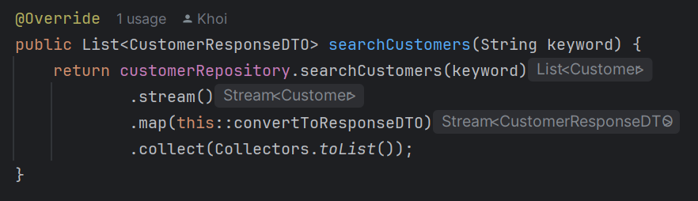
Add to Controller
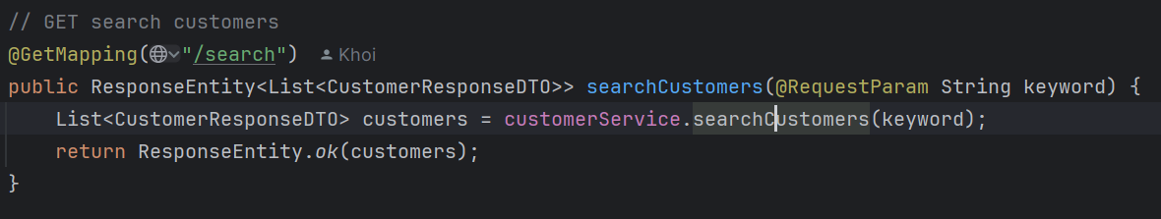
Test:
GET /api/customers/search?keyword=john
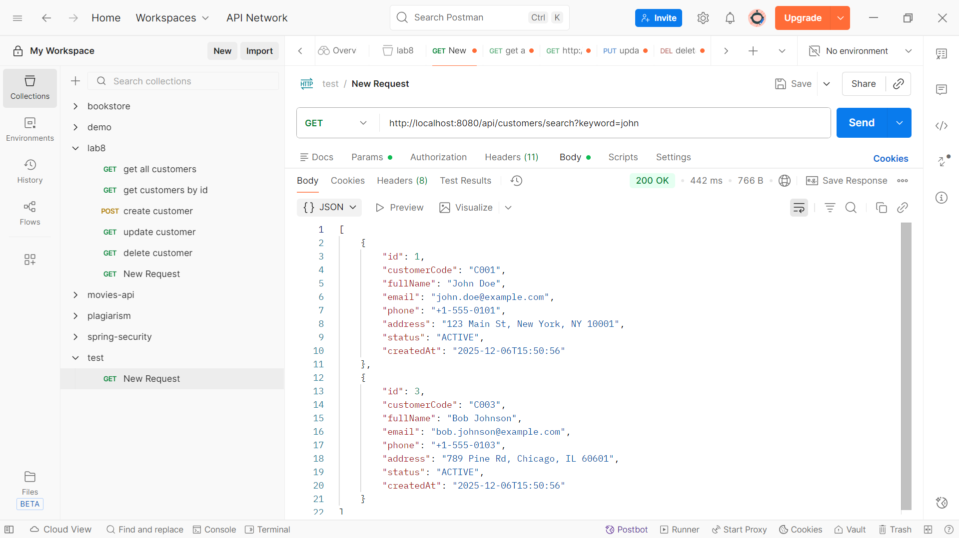
Task 5.2: Filter by Status
Add to Controller
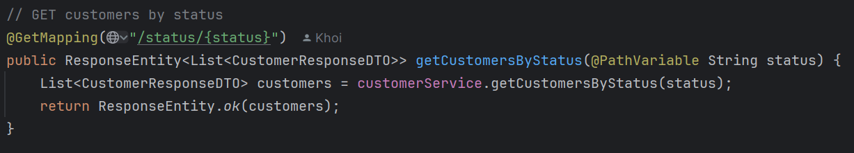
Test:
GET /api/customers/status/ACTIVE
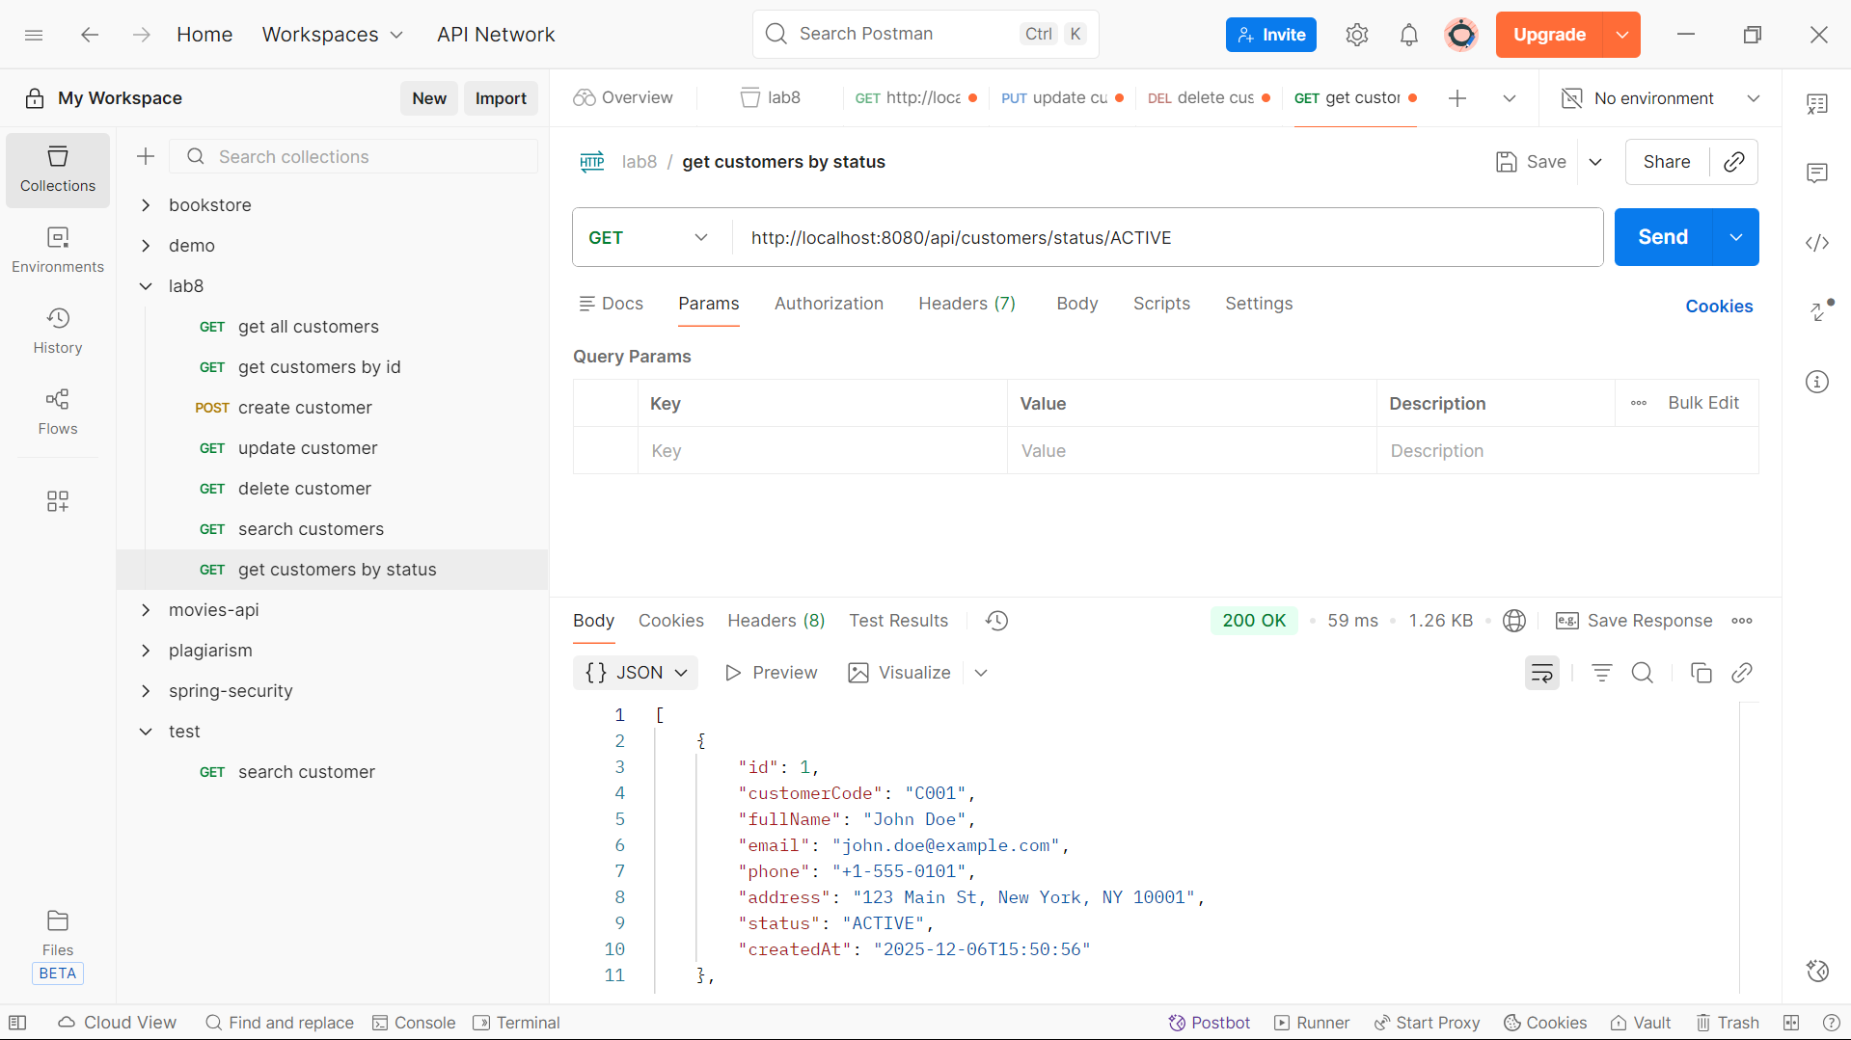
GET /api/customers/status/INACTIVE
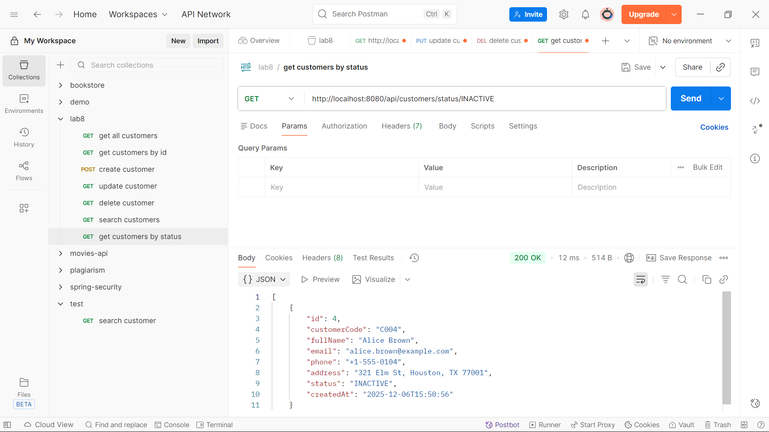

Task 5.3: Advanced Search with Multiple Criteria
Custom method in CustomerRepository
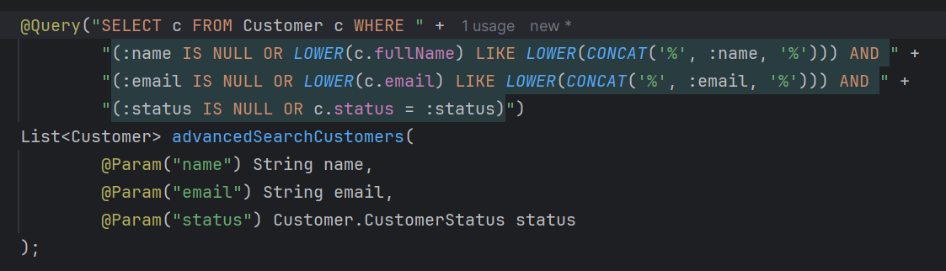
Define method in CustomerService
Implementation in CustomerServiceImpl
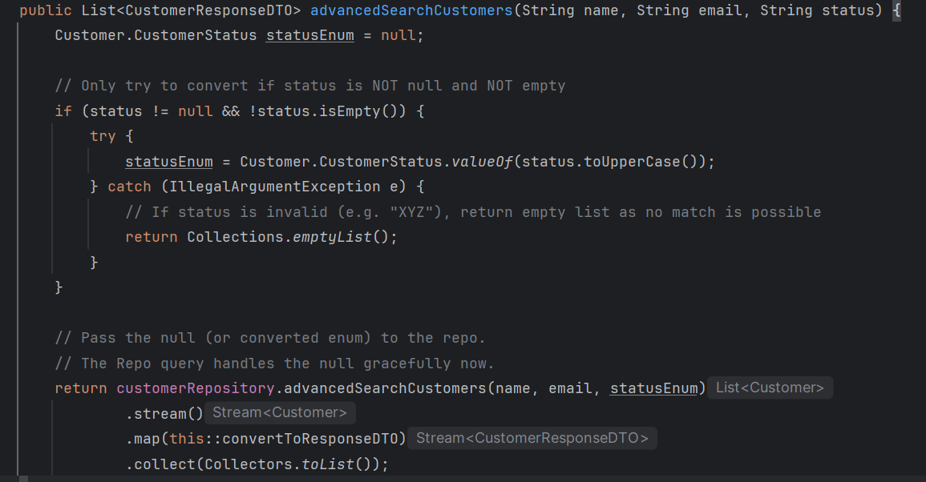

Add to Controller
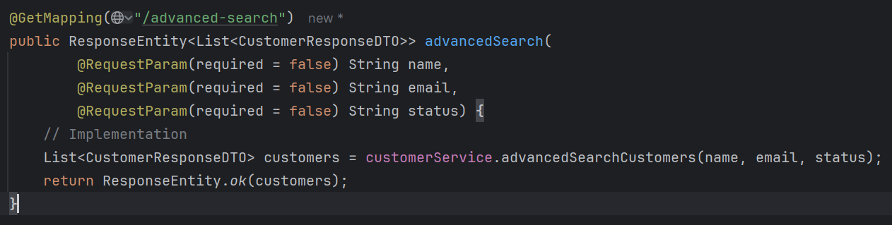

Test:
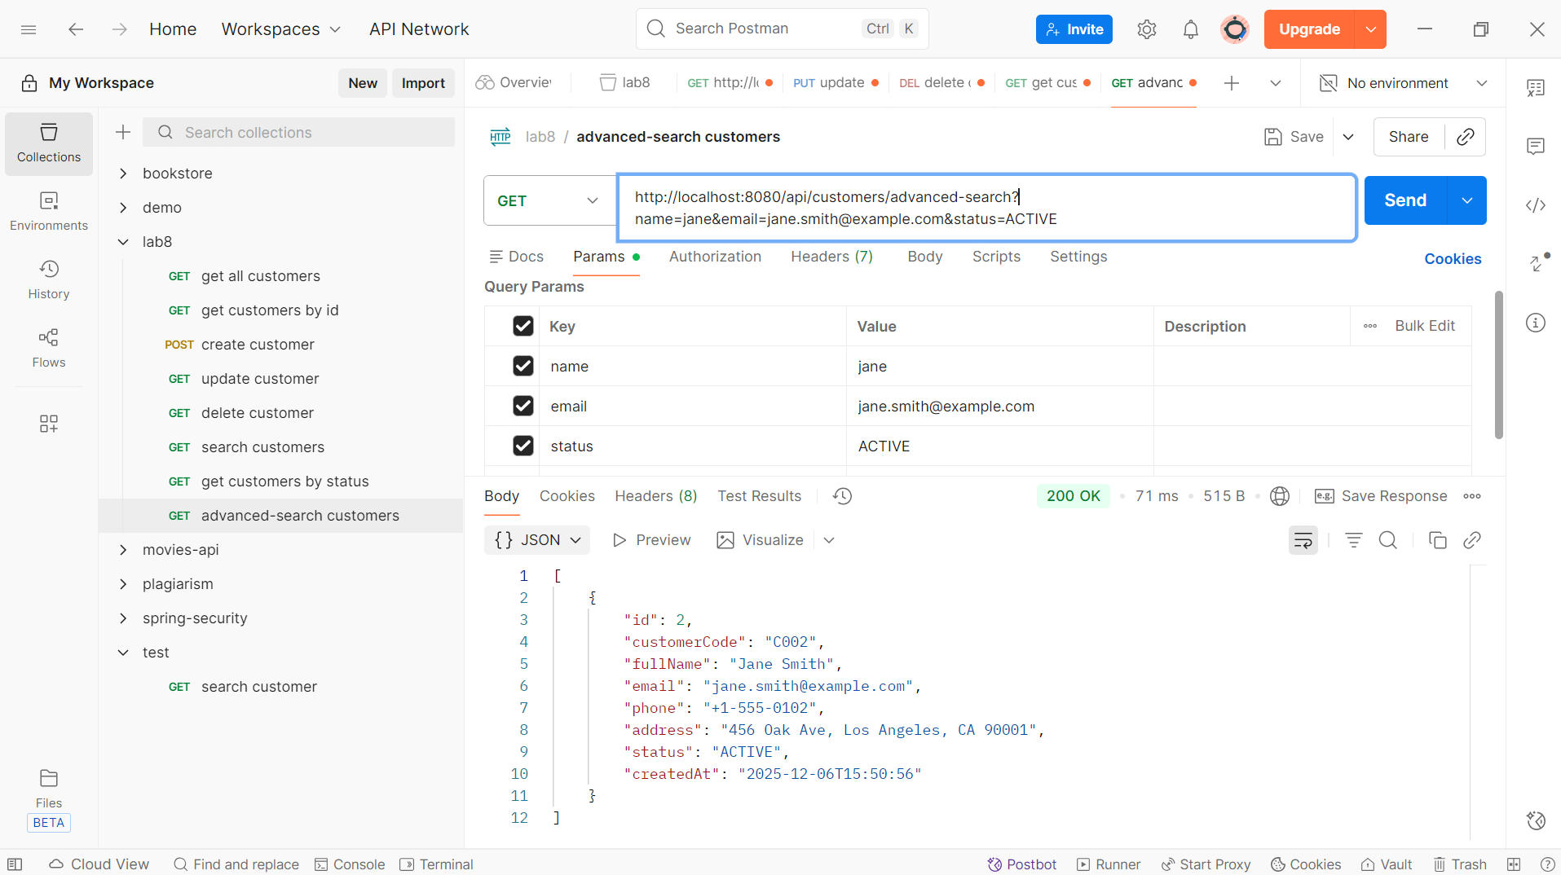

Exercise 6: Pagination & Sorting
Task 6.1: Add Pagination
Update in CustomerService

Implementation in CustomerServiceImpl
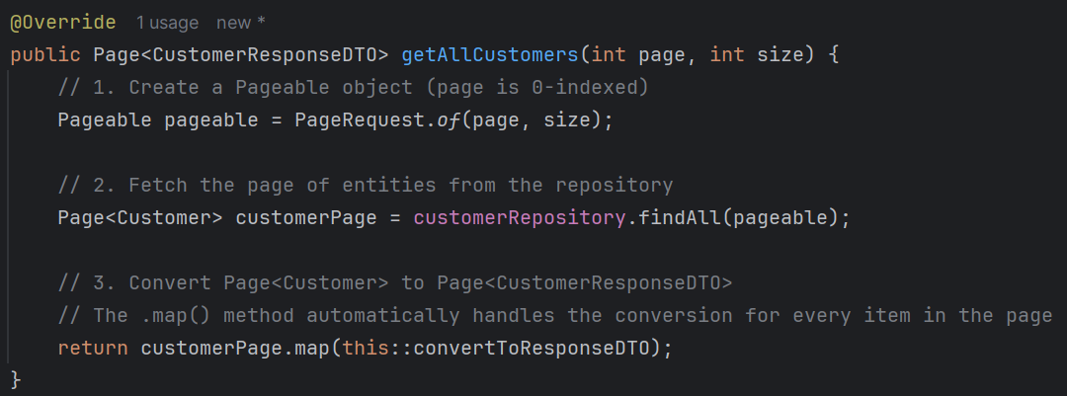
Update in Controller
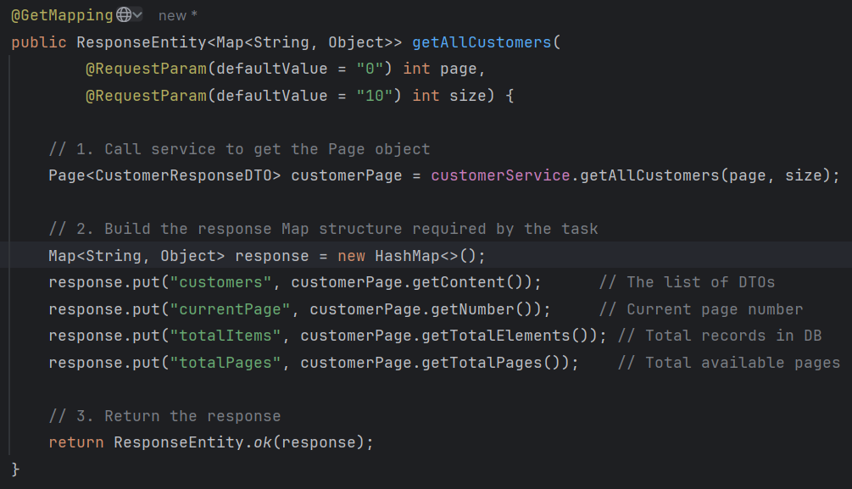

Test:
GET /api/customers?page=0&size=5
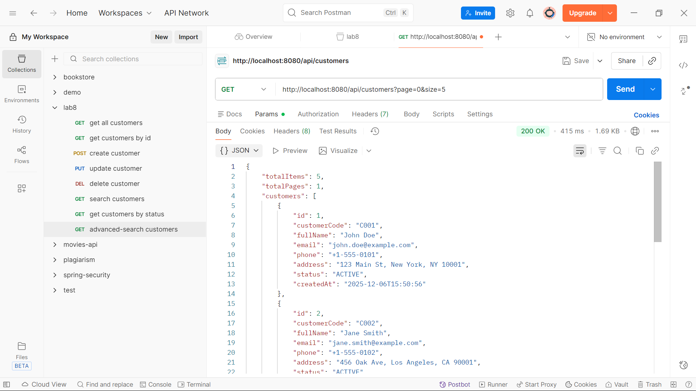
GET /api/customers?page=1&size=10
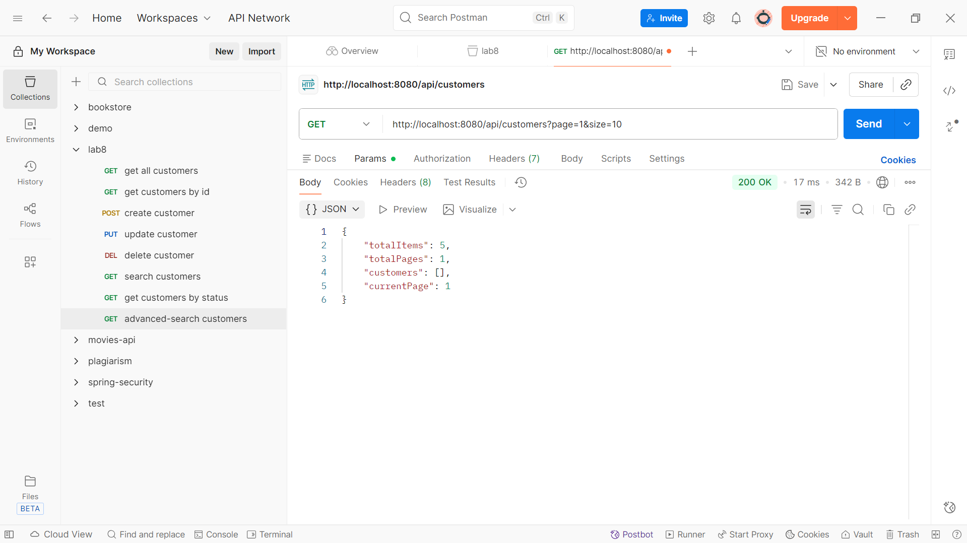

Task 6.2: Sorting
Update in CustomerService
Implementation in CustomerServiceImpl
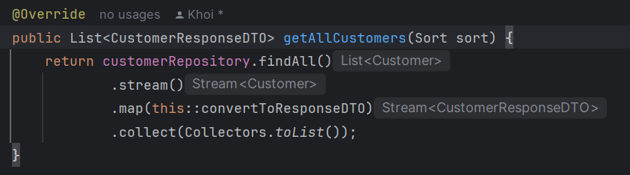
Update in Controller
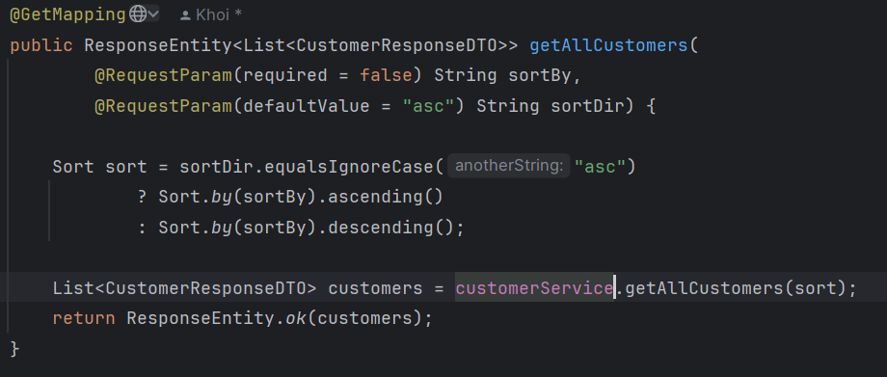

Test
GET /api/customers?sortBy=fullName&sortDir=asc
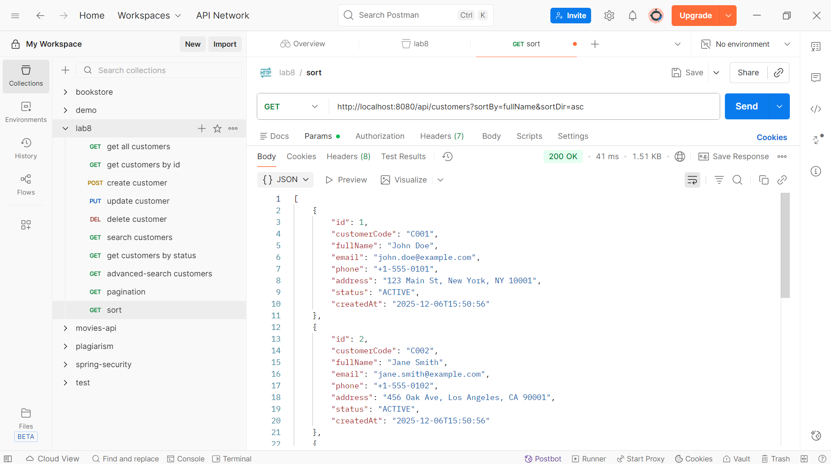
GET /api/customers?sortBy=createdAt&sortDir=desc
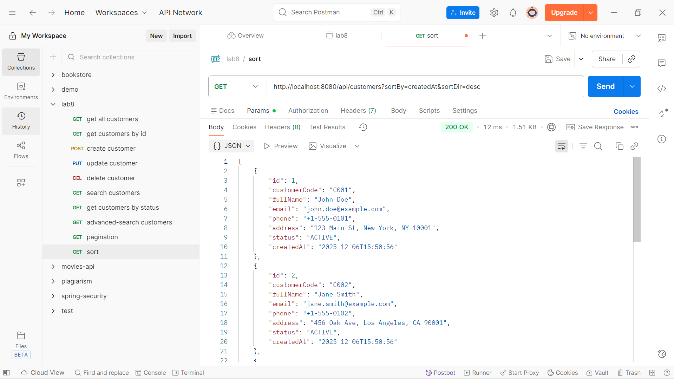

Exercise 7: Partial update with patch
Task 7.1: Create Update DTO
Create CustomerUpdateDTO
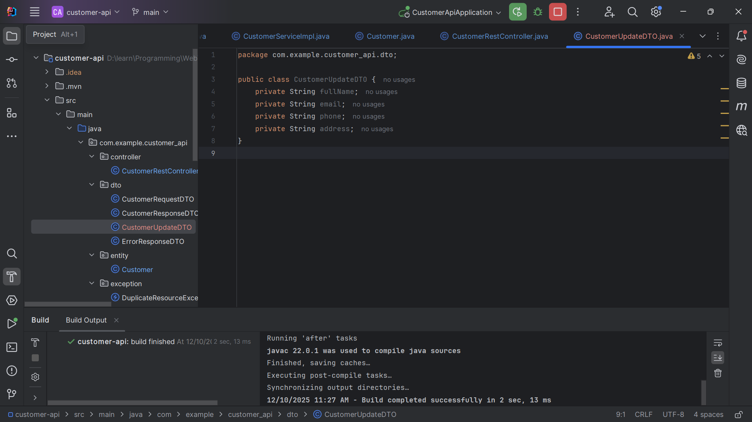
Task 7.2: Implement PATCH Endpoint
Define method in CustomerService
Implementation in CustomerServiceImpl
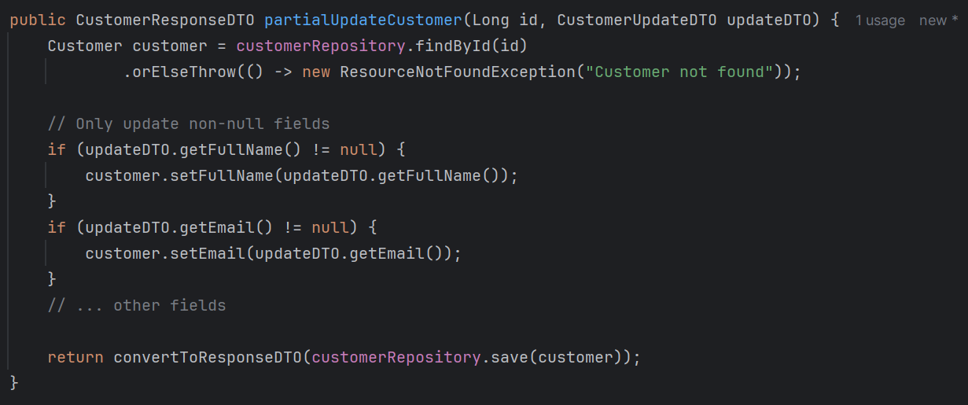
Add in Controller
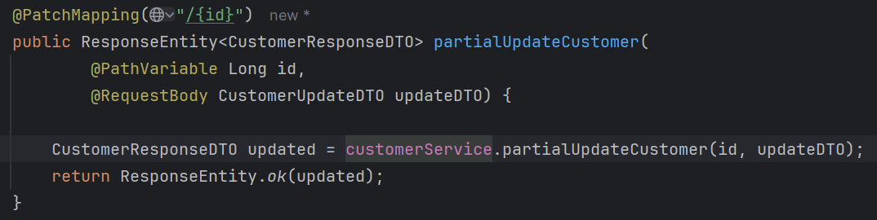
Task 7.3: Test PATCH vs PUT
Test cases:
PUT /api/customers/1
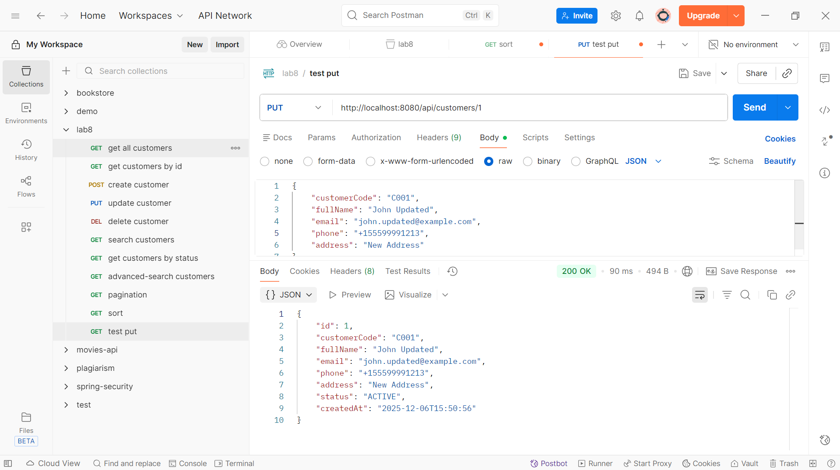

PATCH /api/customers/1
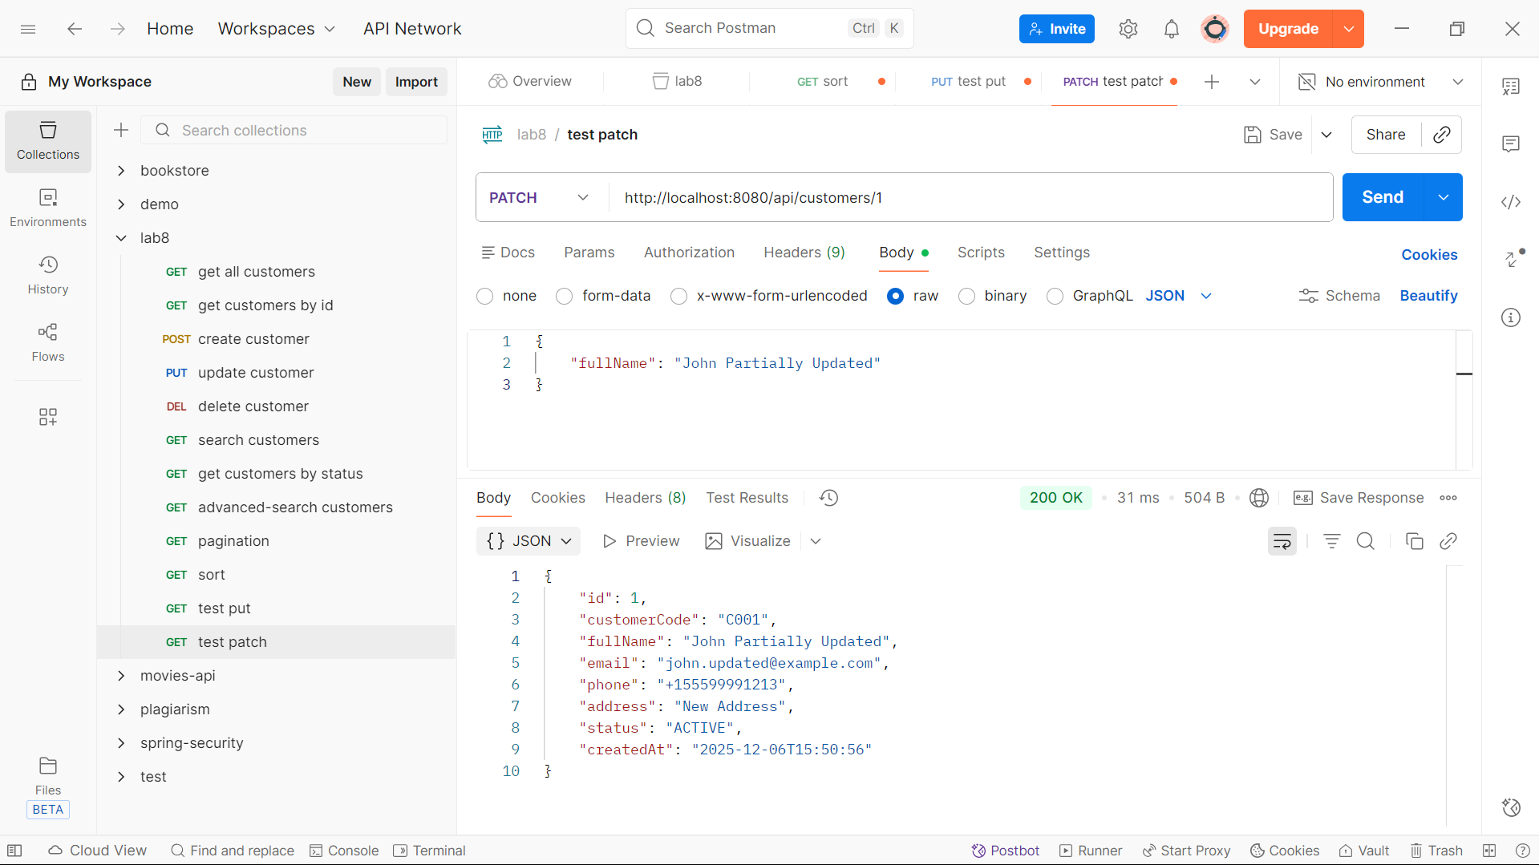
Exercise 8: API Documentation
Task 8.1: Create Postman Collection
Postman collection with all endpoints:
- GET all customers
- GET customer by ID
- POST create customer
- PUT update customer
- PATCH partial update
- DELETE customer
- Search customers
- Filter by status
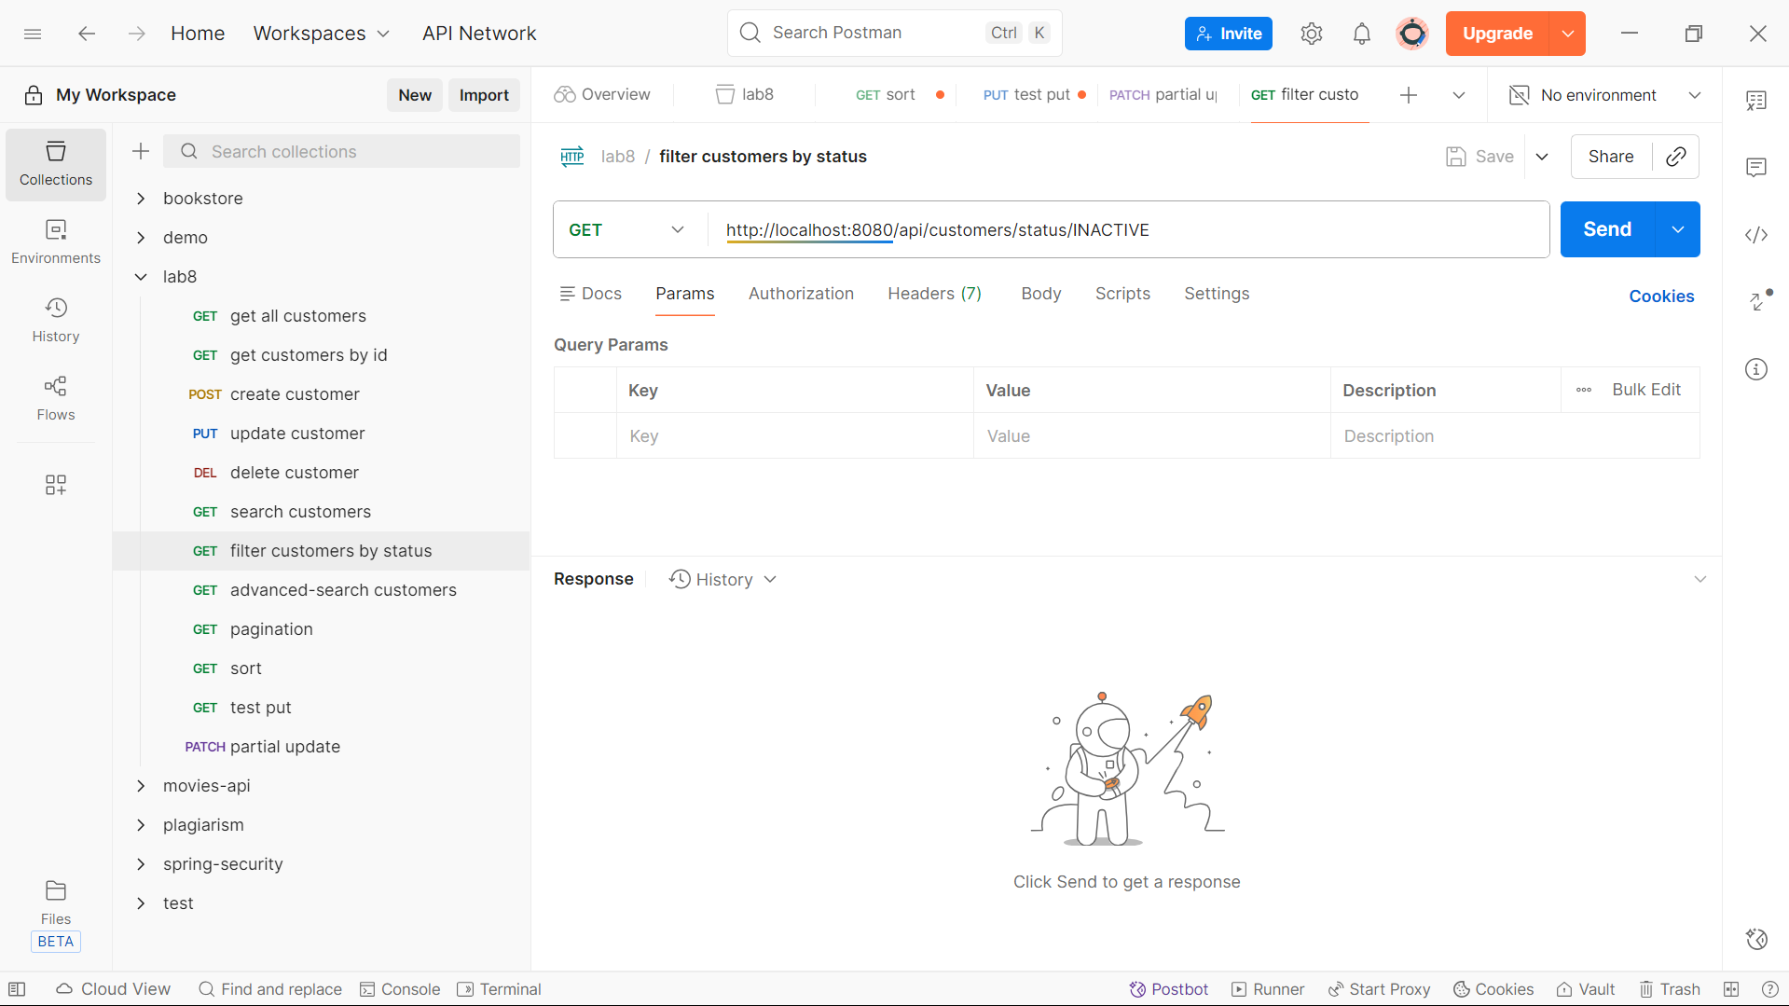
Workflow:
Search customer
1. Browser GET /api/customers/search?keyword
2. CustomerRestController receives request (@GetMapping)
3. Controller calls customerService.searchCustomers()
4. Service calls customerRepository.searchCustomers()
5. JPA automatically queries database
6. Repository returns List<Customer>
7. Service will convert each Customer to CustomerResponseDTO
8. Then put each object (CustomerResponseDTO) to a List and return to Controller
9. Controller response with a list of CustomerResponseDTO
Filter by status
1. Browser GET /api/customers/status/{status}
2. CustomerRestController receives request (@GetMapping)
3. Controller calls customerService.getCustomersByStatus()
4. Service calls customerRepository.findByStatus()
5. JPA automatically queries database
6. Repository returns List<Customer>
7. Service will convert each Customer to CustomerResponseDTO
8. Then put each object (CustomerResponseDTO) to a List and return to Controller
9. Controller response with a list of CustomerResponseDTO
Partial update
1. Browser PATCH /api/customers/{id}
2. CustomerRestController receives request (@PatchMapping)
3. Controller calls customerService. partialUpdateCustomer()
4. Service calls customerRepository.findById()
5. JPA automatically queries database
6. Repository returns Customer
7. Service will convert Customer to CustomerResponseDTO and return to Controller
8. Controller response with a CustomerResponseDTO

