Introduction to DMS

BAWACO Co., LTD

HCMC, December 2016

Revision history

|  |  |  |  |
| --- | --- | --- | --- |
| Revision Number | Revision Date | Changes | Author |
| 1.0 | December 2016 | Create document | Vu Tran |
| 1.1 | December 05, 2016 | Add notes | Vu Tran |
|  |  |  |  |
|  |  |  |  |
|  |  |  |  |

1. Introduction to DMS

DMS consist of the following modules:

* Sale-CRM
* Service (After Sale)
* Inventory
* Finance

DMS integrates strictly with existing systems at VOLKSWAGEN. DMS database is created based on the parts of data structures from these ones such as ELSA, SASA… So it is very easy for your staffs when using DMS. In addition, DMS can import data from other systems easily. Also, it can export data to other ones based on pre-defined structures (at any formats or any file styles such as text, CVS, Excel…)

In another, DMS brings a simple, easy, visual GUI to end users. It is very important. Because it makes users feel comfortable and increase productivity in business.

1. Tools and technologies

DMS is designed and developed by tools and technology bellow:

* IDE: Microsoft Visual Studio 2015, Android Studio
* Programming Language: C#, Java
* Framework: .Net framework 4.5
* OS Support: Windows 7 or higher, Windows 10 mobile, Android
* DBMS: SQL Server 2012, Azure SQL

1. System architecture:

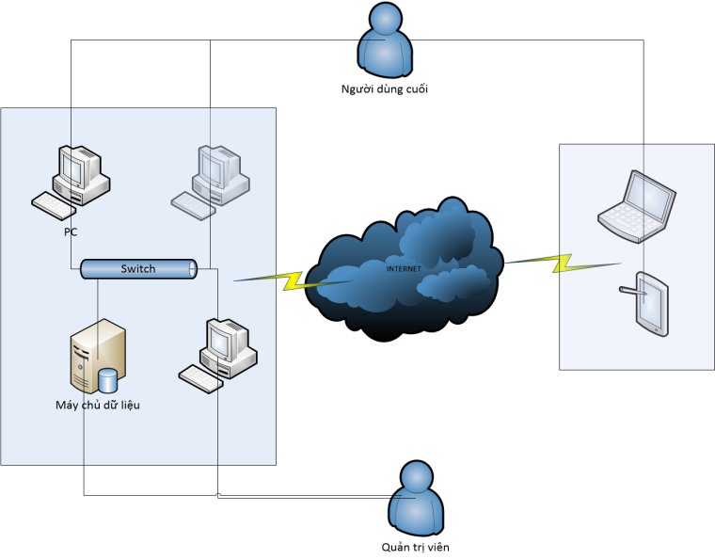

VOLKSWAGEN Existing Systems

Data: Text, Excel…

V

DMS

1. Sale-CRM module:

When running a marketing campaign, the system generates leads. Then the system will qualify them. If they are opportunities, it saves contacts and accounts. Also, it is ready for creating order, contract and delivery.

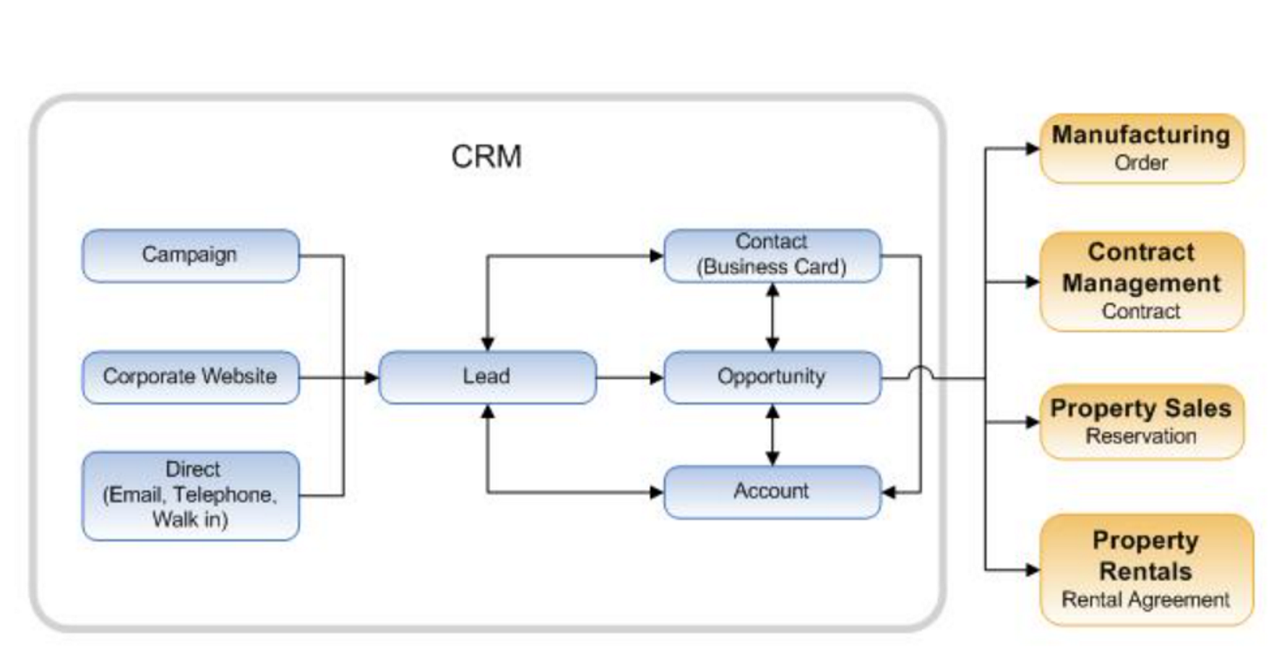

1. Service module: based on requirement from VOLKSWAGEN
2. Inventory module: Normal
3. Finance and Accounting module: Normal (in Vietnam)
4. Cost:
   1. Sale-CRM: 100.000.000 VNĐ
   2. Service: 85.000.000 VNĐ
   3. Inventory: 85.000.000
   4. Finance and Accounting: 80.000.000 VNĐ
5. Timeline: total time: 3 months
   1. Get requirements: (1)
      1. Time: 7 days
      2. Stakeholders: VOLKSWAGEN and Bawaco
      3. Results: file DMS_Requirement.pdf
   2. System analysis and Design: (2a, 2b)
      1. Time: 28 days
      2. Stakeholders: VOLKSWAGEN and Bawaco
      3. Results: file DMS_AnalysisAndDesign.pdf
   3. Coding: (3)
      1. Time: 28 days
      2. Stakeholders: Bawaco
      3. Results: Execution files DMS_PC.exe, DMS_Mobile.apk,…
   4. Local testing: (4)
      1. Time: 7 days
      2. Stakeholders: Bawaco
      3. Results: DMS_Testcase_Result.xls
   5. Setting up, system integration, training: (5)
      1. Time: 7 days
      2. Stakeholders: VOLKSWAGEN, Bawaco
      3. Results: DMS_Integration.pdf
   6. Finishing: Refresh system, create initial data, go live (6)
      1. Time: 7 days
      2. Stakeholders: VOLKSWAGEN, Bawaco
6. Manpower: 5 developers/project/3months
7. Support: warranty time is 12 months