Eyeconic – Glasses Shop Management System

Use-case Realization Specification:

Comment on product (Show comments)

Version 1.0

Revision History

|  |  |  |  |
| --- | --- | --- | --- |
| **Date** | **Version** | **Description** | **Author** |
| 18/10/2019 | 1.0 | Final Draft. | Trần Thị Mai Hương |
|  |  |  |  |
|  |  |  |  |
|  |  |  |  |

Table of Contents

1. Introduction 3

1.1 Purpose 3

1.2 Scope 3

1.3 Definitions, Acronyms, and Abbreviations 3

1.4 References 3

1.5 Overview 3

2. Flow of Events—Design 4

3. Derived Requirements 5

# Introduction

## Purpose

This document describes how the Comment on product Use-Case is realized within the design model, in terms of collaborating objects.

## Scope

This document applies to the Eyeconic – Glasses Shop Management System.

## Definitions, Acronyms, and Abbreviations

User – a person who use the system, can be admin or customer.

## References

None

## Overview

In the following section, Use-Case Realization Specification of the Comment on product Use-Case of the Eyeconic – Glasses Shop Management System is provided in detail. The first section is a textual description of the Use-Case specification. The following section contains diagrams (sequence and collaboration diagrams) describing how the use case is realized in terms of collaborating objects. The third section includes class diagrams with relationships that participate in the realization of the use case. The last section is an analysis of all requirements, such as non-functional requirements, on the use-case realization that are not considered in the design model, but that need to be taken care of during implementation.

# Flow of Events—Design

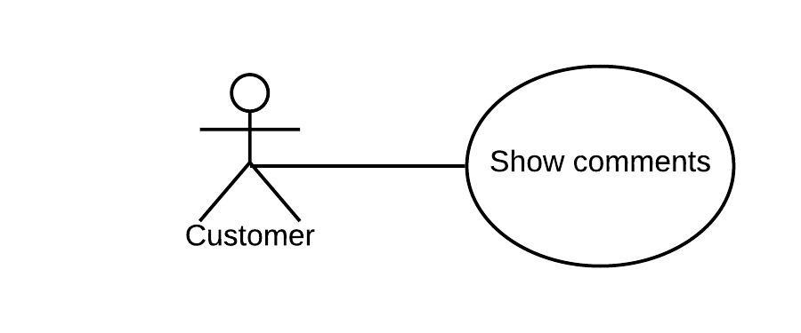

|  |  |
| --- | --- |
| **Name** | Show comments |
| **Description** | The customer see all comments on product |
| **Actor(s)** | Customer |
| **Flows of even**t |  |
| **Basic flow** | |
| 1. The customer selects a product. 2. The system shows all comments of that product. | |
| **Alternative Flows** | |
| None. | |
| **Pre-conditions** | |
|  | |
| **Post-conditions** | |
| All comments are shown | |
| **Extension Points** | |
| None | |

**Sequence Diagram**

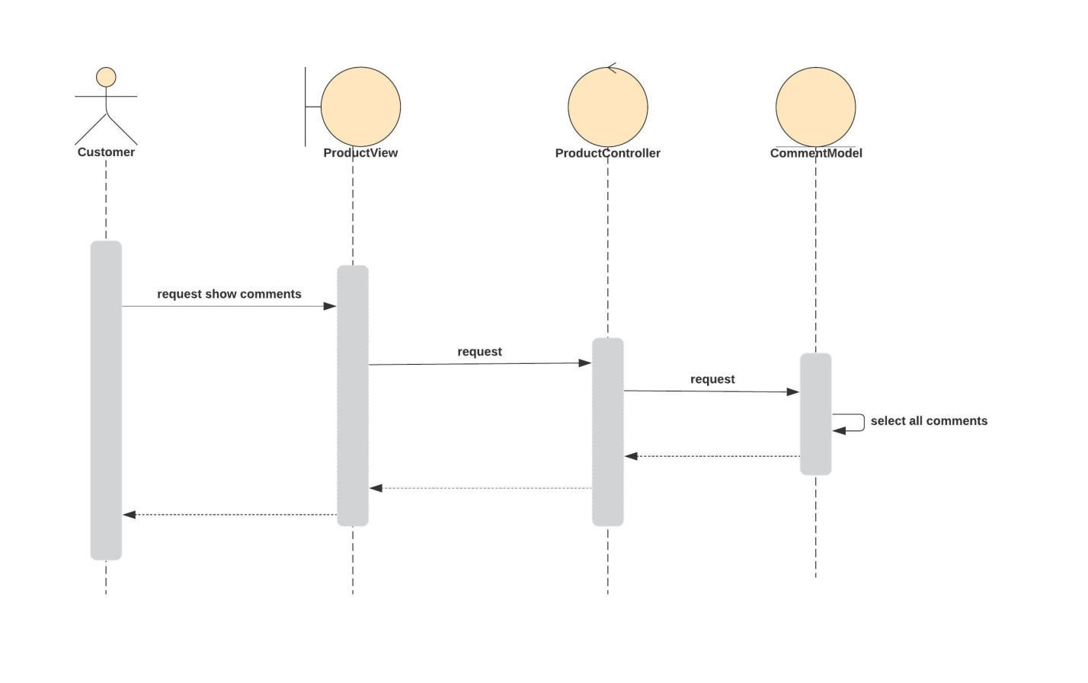

**Class Diagram**

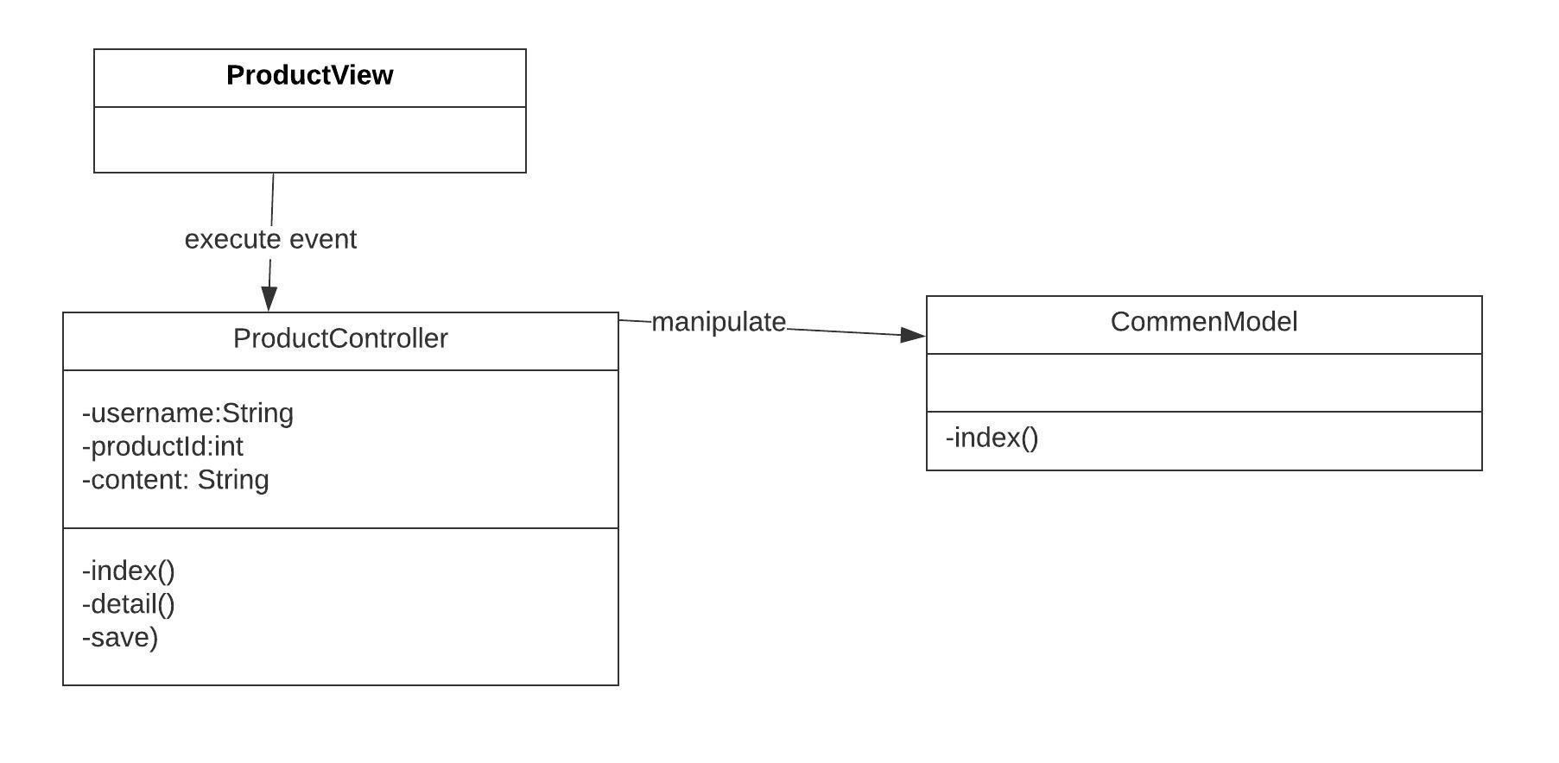

# Derived Requirements

None