Eyeconic - Glasses Shop Management System

Use-case Realization Specification: F02

Messages box - Customer care

Version 1.0

Revision History

| **Date** | **Version** | **Description** | **Author** |
| --- | --- | --- | --- |
| 14/Nov/19 | 1.0 | Init | TungPD |
|  |  |  |  |
|  |  |  |  |
|  |  |  |  |

Table of Contents

1. Introduction 4

1.1 Purpose 4

1.2 Scope 4

1.3 Definitions, Acronyms, and Abbreviations 4

1.4 References 4

1.5 Overview 4

2. Flow of Events—Design 4

3. Derived Requirements 5

# Introduction

## Purpose

This document describes how the Messages box (customer care) use-case is realized within the design model, in terms of collaborating objects.

## Scope

This document applies to the Eyeconic – Glasses Shop Management System.

## Definitions, Acronyms, and Abbreviations

None

## References

None

## Overview

In the following section, Use-Case Realization Specification of the Messages box (customer care) is provided in detail. The first section is a textual description of the Use-Case specification. The following section contains sequence diagrams describing how the use case is realized in terms of collaborating objects. The third section includes class diagrams with relationships that participate in the realization of the use case. The last section is an analysis of all requirements, such as non-functional requirements, on the use-case realization that are not considered in the design model, but that need to be taken care of during implementation.

# Flow of Events—Design

| **Name** | | Read & reply customer messages |
| --- | --- | --- |
| **Description** | | Admin and customer chat interactively, in realtime |
| **Flows of event** | | |
| **Basic flow** | | |
| Admin:   * Go to Messages Box page * Views all messages * Reply or create new   Client:   * Go to Messages Box page * View the message from admin * Reply or create new | | |
| **Alternative Flows** | | |
| If message is presented | | Admin/Customer can click on it and chat something to reply |
| If conversation never been made | | Admin/Customer can create a new one |
| **Pre-conditions** | | |
| Admin logged in  Customer logged in | | |
| **Post-conditions** | | |
| Success | | New message is sent  Message content saved to database |
| Failure | | Message will not be sent  Database persists |
| **Extension Points** | | |
|  |  | |

**Sequence Diagram**

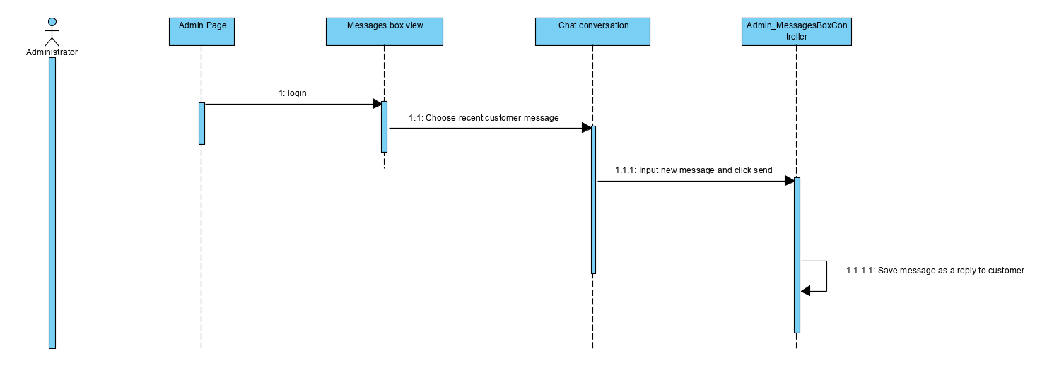

**Class Diagram**

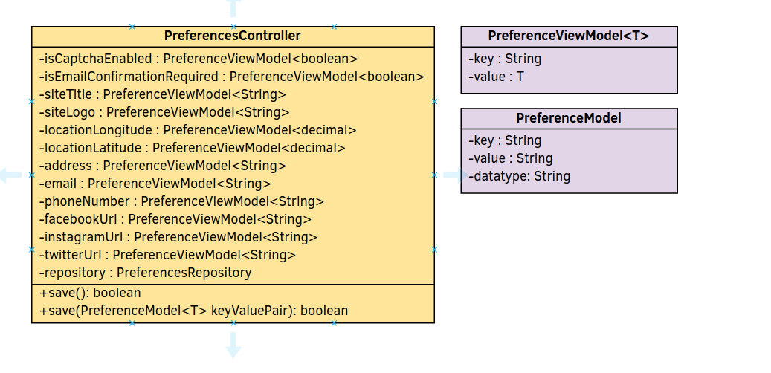

# Derived Requirements