Eyeconic - Glasses Shop Management System

Use-case Realization Specification: M03

Orders Management - Admin

Version 1.0

Revision History

| **Date** | **Version** | **Description** | **Author** |
| --- | --- | --- | --- |
| 14/Nov/19 | 1.0 | Init | TungPD |
|  |  |  |  |
|  |  |  |  |
|  |  |  |  |

Table of Contents

1. Introduction 4

1.1 Purpose 4

1.2 Scope 4

1.3 Definitions, Acronyms, and Abbreviations 4

1.4 References 4

1.5 Overview 4

2. Flow of Events—Design 4

3. Derived Requirements 6

# Introduction

## Purpose

This document describes how the Orders Management - Admin use-case is realized within the design model, in terms of collaborating objects.

## Scope

This document applies to the Eyeconic – Glasses Shop Management System.

## Definitions, Acronyms, and Abbreviations

None

## References

None

## Overview

In the following section, Use-Case Realization Specification of the Orders Management for administrator is provided in detail. The first section is a textual description of the Use-Case specification. The following section contains sequence diagrams describing how the use case is realized in terms of collaborating objects. The third section includes class diagrams with relationships that participate in the realization of the use case. The last section is an analysis of all requirements, such as non-functional requirements, on the use-case realization that are not considered in the design model, but that need to be taken care of during implementation.

# Flow of Events—Design

| **Name** | Manage orders |
| --- | --- |
| **Description** | Administrator views, update status for orders |
| **Flows of event** | |
| **Basic flow** | |
| * Admin goes to Orders page * Views all orders * Update orders as needed | |
| **Alternative Flows** | |
| Order is submitted but not reviewed (Pending) | Prepare products and change to Shipping |
| Order is failed to ship | Change to Failed |
| Order is shipped successfully, but customer rescind | Change to Rescinded |
| **Pre-conditions** | |
| Admin logged in | |
| **Post-conditions** | |
| Order’s LastModifiedDate updates  An email sent to notify customer | |
| Success | Toast message  Database updates |
| Failure | Toast message  Nothing changes |
| **Extension Points** | |
| None | |

**Sequence Diagram**

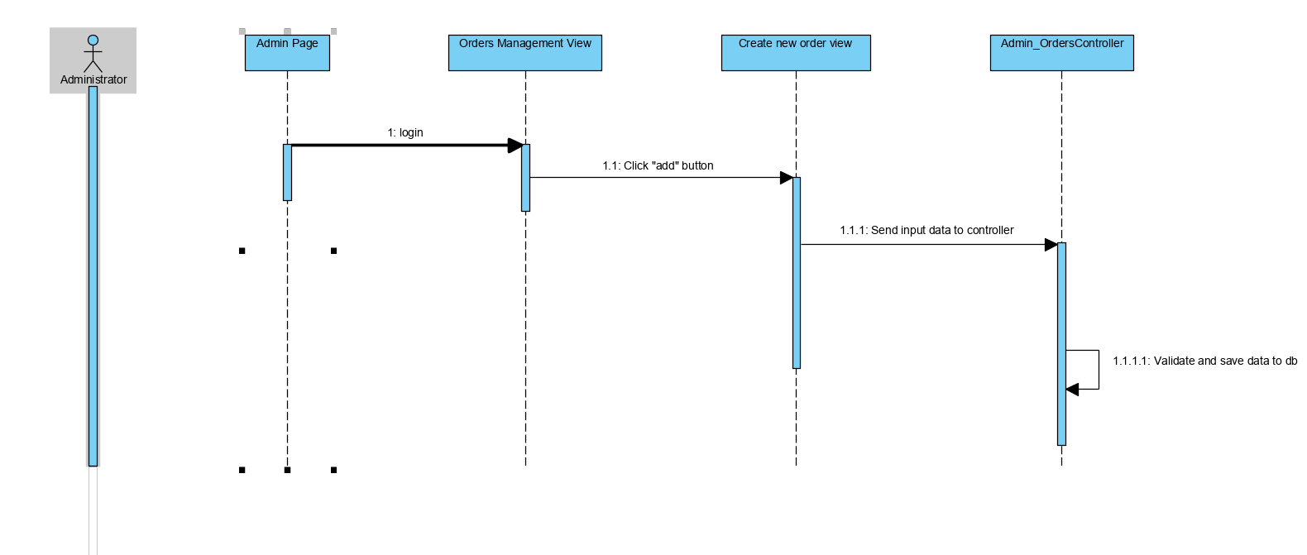

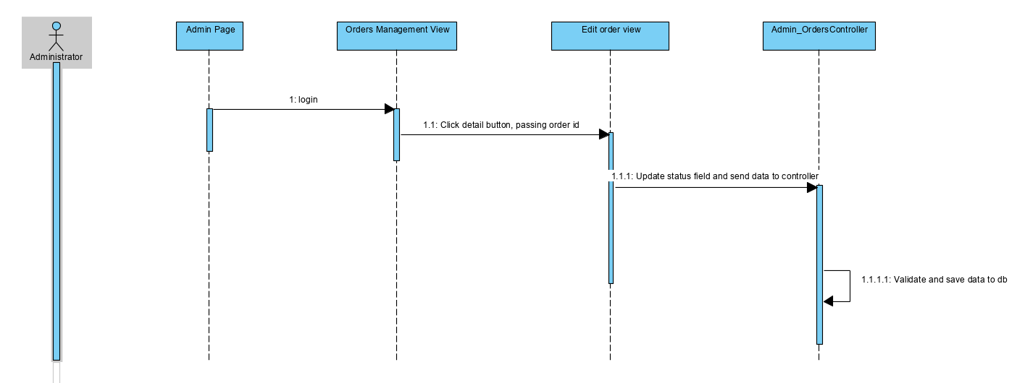

**Class Diagram**

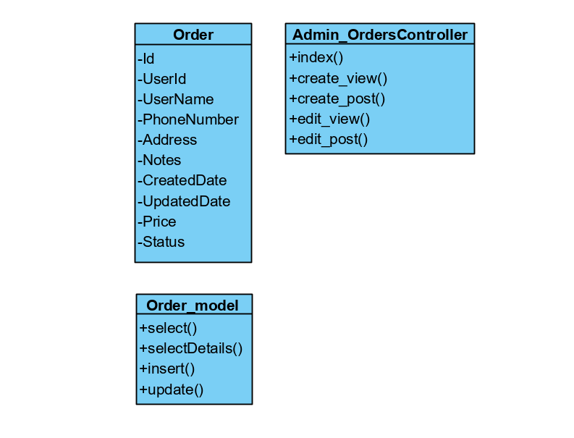

# Derived Requirements