Eyeconic - Glasses Shop Management System

Use-case Realization Specification: M14

**Add Contact lens**

Version 1.0

Revision History

|  |  |  |  |
| --- | --- | --- | --- |
| **Date** | **Version** | **Description** | **Author** |
| 18/Nov/19 | 1.0 | First version of add contact lens | Hoàng Ân |

Table of Contents

1. Introduction 4

1.1 Purpose 4

1.2 Scope 4

1.3 Definitions, Acronyms, and Abbreviations 4

1.4 References 4

1.5 Overview 4

2. Flow of Events—Design 4

3. Derived Requirements 6

Use-Case-Realization Specification: <Add Contact lens>

# Introduction

## Purpose

This document describes how the Add Lens Use-case is realized within the design model, in terms of collaborating objects.

## Scope

This document applies to the Glasses Shop Management System.

## Definitions, Acronyms, and Abbreviations

User – a person who use the system, can be customer or employee

Employee – a person who work for the computer shop

Guest – a user who is not logged in the system

Admin - Administrator

## References

None.

## Overview

In the following section, Use-Case Realization Specification of the Web Preferences is provided in detail. The first section is a textual description of the Use-Case specification. The following section contains sequence diagrams describing how the use case is realized in terms of collaborating objects. The third section includes class diagrams with relationships that participate in the realization of the use case. The last section is an analysis of all requirements, such as non-functional requirements, on the use-case realization that are not considered in the design model, but that need to be taken care of during implementation.

# Flow of Events—Design

**2.1. Use-Case Specification**

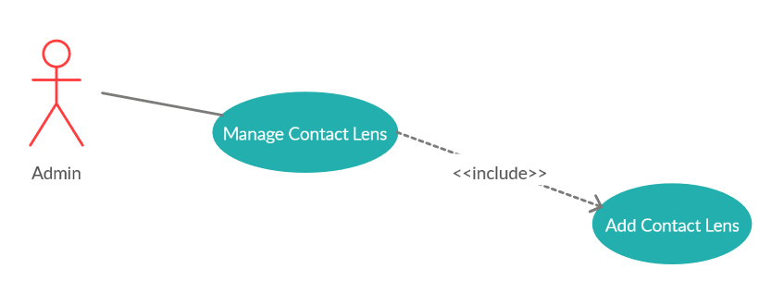

|  |  |  |  |
| --- | --- | --- | --- |
| **Name** | | | Add Contact lens |
| **Brief Description** | | | Administrator adds new contact lens to the database |
| **Actors** | | | Administrator |
| **Flow of Events** | | | |
| **Basic Flow** | | | |
| Step 1: Click add button.  Step 2: Enter new contact lens’s information.  Step 3: Confirming adding the contact lens by clicking the “Save” button  Step 4: Successful added contact lens is added to the screen. | | | |
| **Alternative Flows** | | | |
| **Title** | | **Description** | |
| Invalid information entered | | 1. Administrator enters invalid information.  2. System displays information with appropriate message to correct invalid information. | |
| **Pre-Conditions** | | | |
| The added contact lens had not existed in the database before. | | | |
| **Post-Condition**  Administrator checks the database and the website to ensure that the new contact lens are added successfully. | | | |
| **Title** | **Description** | | |
| Success | Success message is prompted and the contact lens are added to database. | | |
| Failure | The admin is unable to add new contact lens to database for one or more reasons and an error is prompt. | | |
| **Extension Points** | None | | |

**2.2. Sequence Diagram**

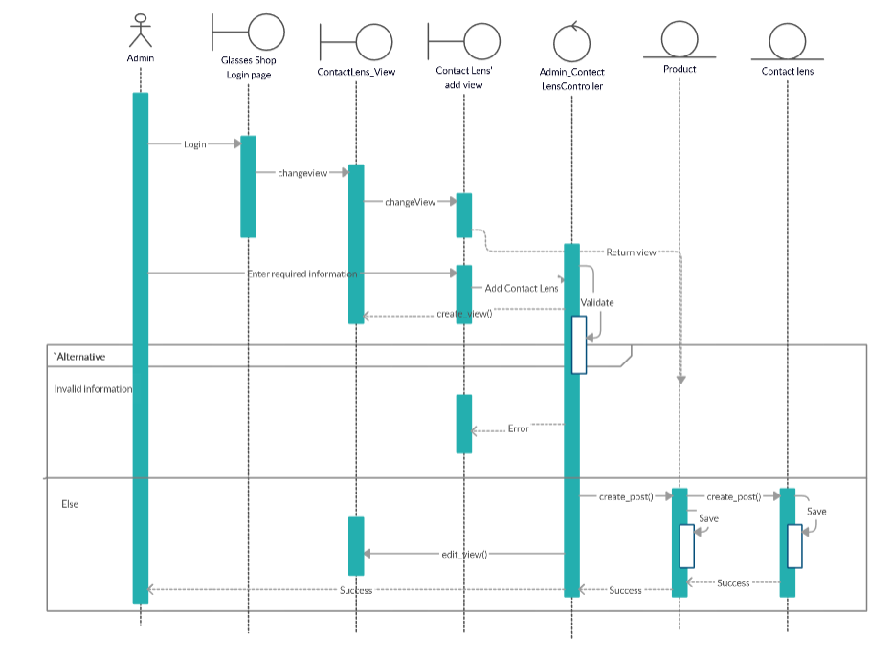

**2.3. Class Diagram**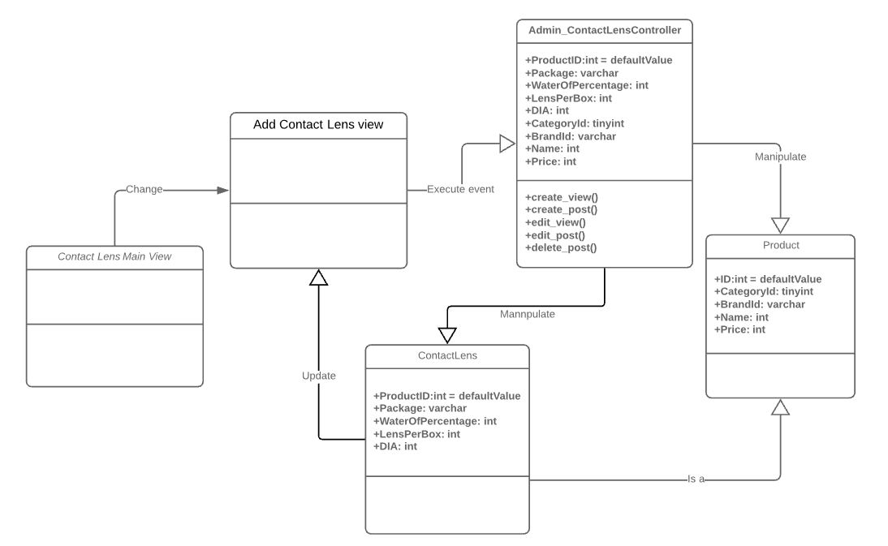

# Derived Requirements

None.