Eyeconic - Glasses Shop Management System

Use-case Realization Specification: M20

**Remove Brands**

Version 1.0

Revision History

|  |  |  |  |
| --- | --- | --- | --- |
| **Date** | **Version** | **Description** | **Author** |
| 18/Nov/19 | 1.0 | First version of remove brands | Hoàng Ân |

Table of Contents

**Introduction** **4**

Purpose 4

Scope 4

Definitions, Acronyms, and Abbreviations 4

References 4

Overview 4

**Flow of Events—Design** **4**

**Derived Requirements** **7**

Use-Case-Realization Specification: Remove Brands

# Introduction

## Purpose

This document describes how the Remove Brands Use-case is realized within the design model, in terms of collaborating objects.

## Scope

This document applies to the Glasses Shop Management System.

## Definitions, Acronyms, and Abbreviations

User – a person who use the system, can be customer or employee

Employee – a person who work for the computer shop

Guest – a user who is not logged in the system

Admin - Administrator

## References

None.

## Overview

In the following section, Use-Case Realization Specification of the Web Preferences is provided in detail. The first section is a textual description of the Use-Case specification. The following section contains sequence diagrams describing how the use case is realized in terms of collaborating objects. The third section includes class diagrams with relationships that participate in the realization of the use case. The last section is an analysis of all requirements, such as non-functional requirements, on the use-case realization that are not considered in the design model, but that need to be taken care of during implementation.

# Flow of Events—Design

**2.1. Use-Case Specification**

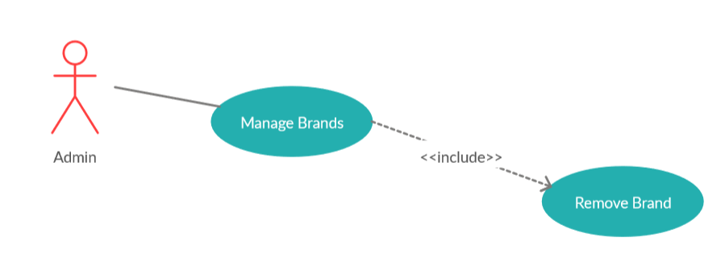

|  |  |  |
| --- | --- | --- |
| **Name** | | Remove Brands |
| **Brief Description** | | Admin removes brands from the database. |
| **Actors** | | Administrator |
| **Flow of Events** | | |
| **Basic Flow** | | |
| Step 1: Choose the brands you want to remove  Step 2: Click Delete button  Step 3: Confirming removing the brands by clicking the “Yes” button.  Step 4: Brands are removed from database and no longer appeared on the screen. | | |
| **Alternative Flows: None** | | |
| **Pre-Conditions** | | |
| Administrator has been logged in. Removed brands had been existed in the database. | | |
| **Post-Condition**  Administrator checks the website and the system to ensure that the brands is completely removed. | | |
| **Title** | **Description** | |
| Success | Success message is prompted and selected brands are deleted from database | |
| Failure | The admin is unable to delete brands information .  An error is prompted. | |
| **Extension Points** | None | |

**2.2. Sequence Diagram**

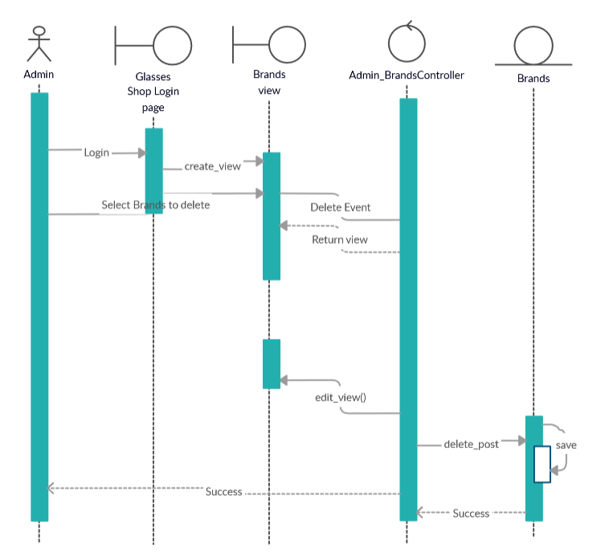

**2.3. Class Diagram**

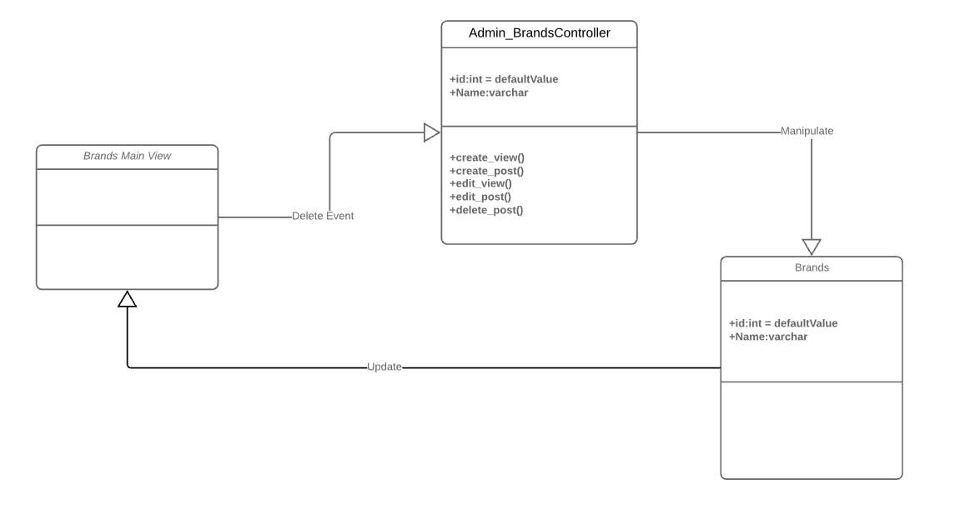

# Derived Requirements

None.