Eyeconic - Glasses Shop Management System

Use-case Realization Specification: P00

Website Preferences

Version 1.0

Revision History

| **Date** | **Version** | **Description** | **Author** |
| --- | --- | --- | --- |
| 14/Nov/19 | 1.0 | Init | tungpd |
|  |  |  |  |
|  |  |  |  |
|  |  |  |  |

Table of Contents

1. Introduction 3

1.1 Purpose 3

1.2 Scope 3

1.3 Definitions, Acronyms, and Abbreviations 3

1.4 References 3

1.5 Overview 3

2. Flow of Events—Design 4

3. Derived Requirements 5

# Introduction

## Purpose

This document describes how the Website Preferences use-case is realized within the design model, in terms of collaborating objects.

## Scope

This document applies to the Eyeconic – Glasses Shop Management System.

## Definitions, Acronyms, and Abbreviations

None

## References

None

## Overview

In the following section, Use-Case Realization Specification of the Web Preferences is provided in detail. The first section is a textual description of the Use-Case specification. The following section contains sequence diagrams describing how the use case is realized in terms of collaborating objects. The third section includes class diagrams with relationships that participate in the realization of the use case. The last section is an analysis of all requirements, such as non-functional requirements, on the use-case realization that are not considered in the design model, but that need to be taken care of during implementation.

# Flow of Events—Design

| **Name** | | Save website preferences |
| --- | --- | --- |
| **Description** | | Administrator configure website and save those settings to database |
| **Flows of event** | | |
| **Basic flow** | | |
| * Admin goes to preference page * Change settings as needed * Click save to send system the new settings * System updates | | |
| **Alternative Flows** | | |
|  | |  |
| **Pre-conditions** | | |
| Admin logged in | | |
| **Post-conditions** | | |
| Success | | Success message prompted  Settings saved to database |
| Failure | | Failure message prompted  Nothing changes |
| **Extension Points** | | |
| email is not correct  siteTitle is empty  locationLongitude or locationLatitude is empty  address is empty  phoneNumber is empty | Display appropriate messages | |

**Sequence Diagram**

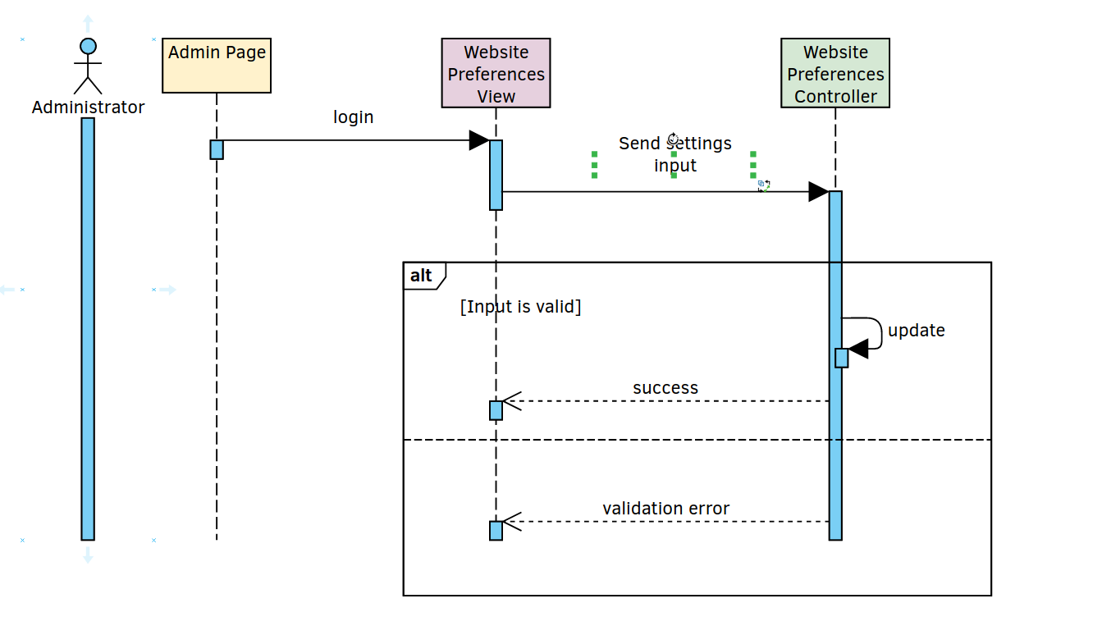

**Class Diagram**

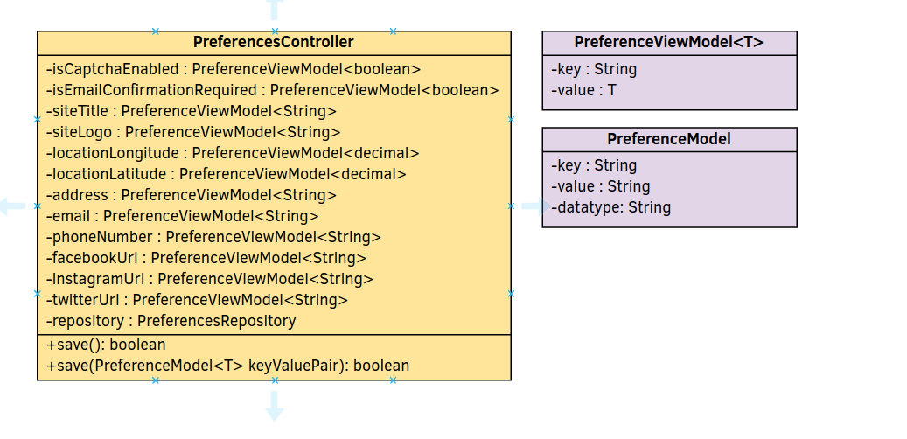

# Derived Requirements