Eyeconic – Glasses Shop Management System

Use-case Realization Specification: Authentication

Log-in

Version 1.0

Revision History

|  |  |  |  |
| --- | --- | --- | --- |
| **Date** | **Version** | **Description** | **Author** |
| 18/10/2019 | 1.0 | Final Draft. | Trần Thị Mai Hương |
|  |  |  |  |
|  |  |  |  |
|  |  |  |  |

Table of Contents

1. Introduction 4

1.1 Purpose 4

1.2 Scope 4

1.3 Definitions, Acronyms, and Abbreviations 4

1.4 References 4

1.5 Overview 4

2. Flow of Events—Design 4

3. Derived Requirements 7

# Introduction

## Purpose

This document describes how the Sign-in Use-Case is realized within the design model, in terms of

collaborating objects.

## Scope

This document applies to the Eyeconic – Glasses Shop Management System.

## Definitions, Acronyms, and Abbreviations

User – a person who use the system, can be admin or customer.  
Admin – a person who work for the computer shop.  
Guest – a user who is not logged in the system.

## References

None

## Overview

In the following section, Use-Case Realization Specification of the Sign-in Use-Case of the Eyeconic – Glasses Shop Management System is provided in detail. The first section is a textual description of the Use-Case specification. The following section contains diagrams (sequence and collaboration diagrams) describing how the use case is realized in terms of collaborating objects. The third section includes class diagrams with relationships that participate in the realization of the use case. The last section is an analysis of all requirements, such as non-functional requirements, on the use-case realization that are not considered in the design model, but that need to be taken care of during implementation.

# Flow of Events—Design

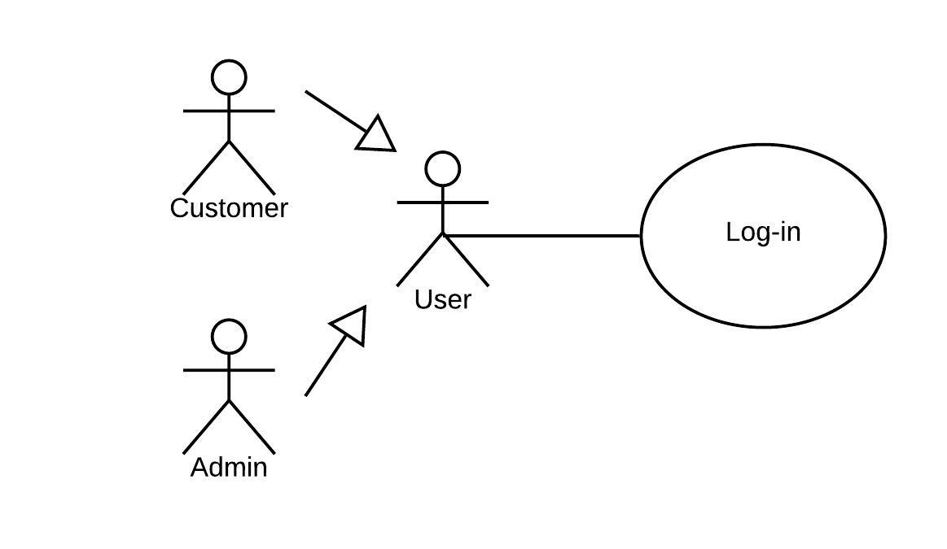

|  |  |
| --- | --- |
| **Name** | Log-in |
| **Description** | A user logging in to the system |
| **Actor(s)** | User |
| **Flows of even**t |  |
| **Basic flow** | |
| 1. The users visit login page. 2. The user enters username/ email and password value in corresponding fields. 3. The user clicks on login button. 4. If credential is correct, then user/admin successfully login to the system. | |
| **Alternative Flows** | |
| Authentication fail | 1. User enter invalid username or password.  2. System displays information with appropriate message to correct invalid username or password. |
| **Pre-conditions** | |
| The user is not logged in the system (guest). | |
| **Post-conditions** | |
| None | |
| Success | Success message is prompted and user is returned to the homepage as a logged in user. |
| Failure | The user is unable to log in for one or more reasons and an error is prompted. |
| **Extension Points** | |
| None | |

**Sequence Diagram**

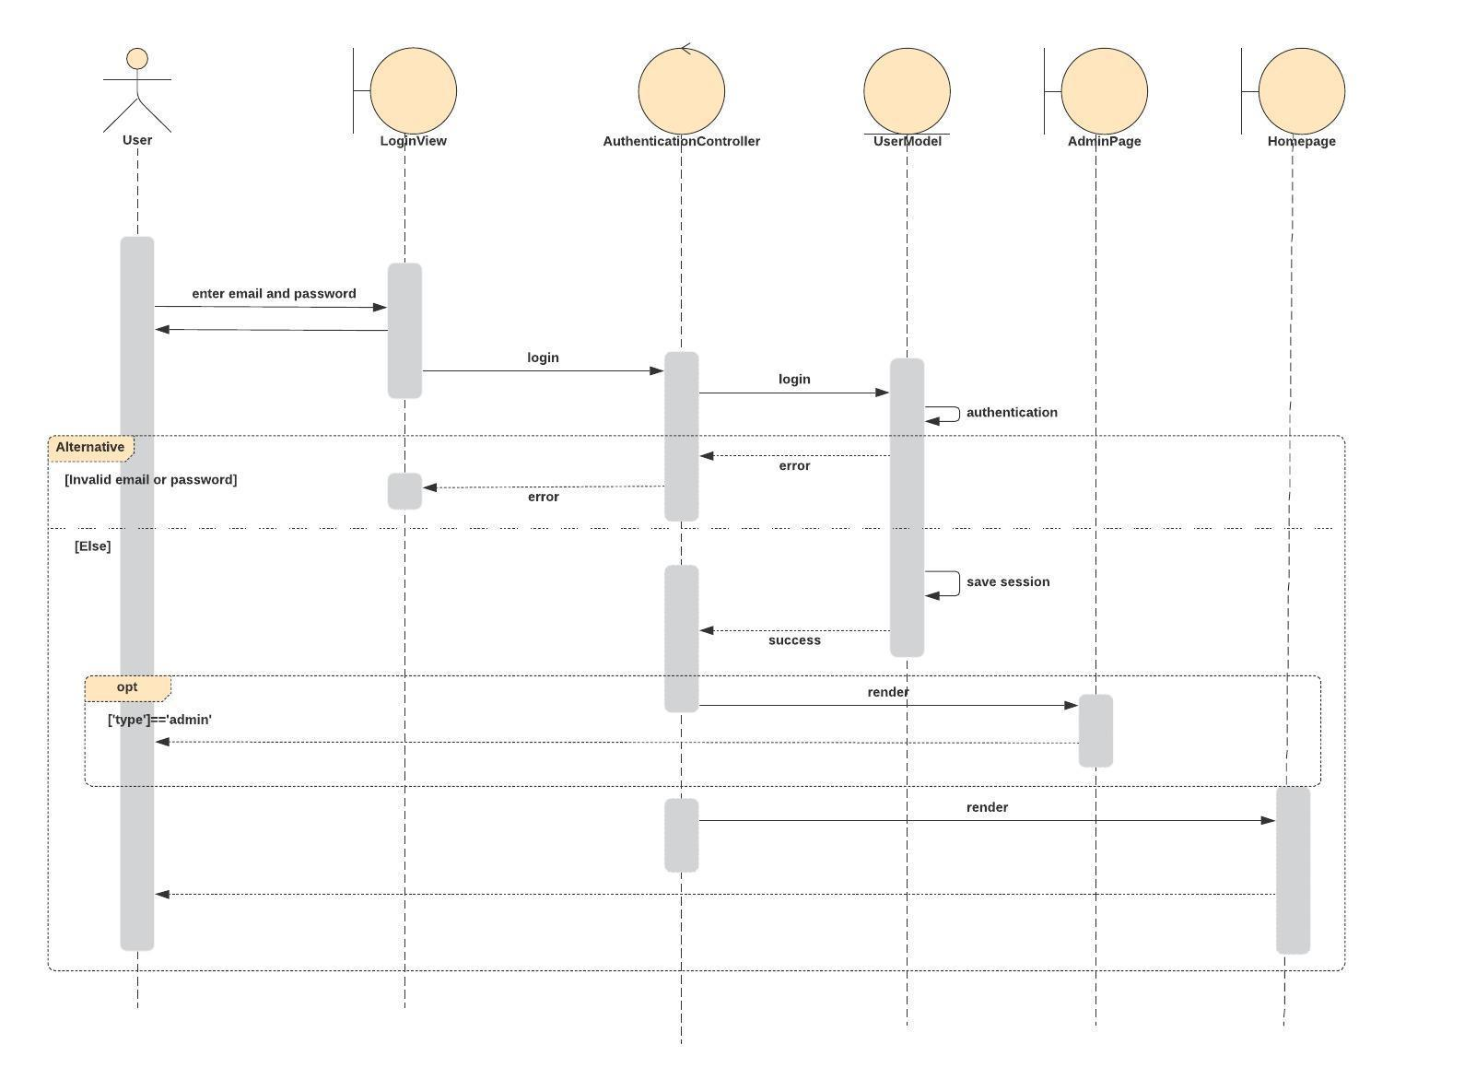

**Class Diagram**

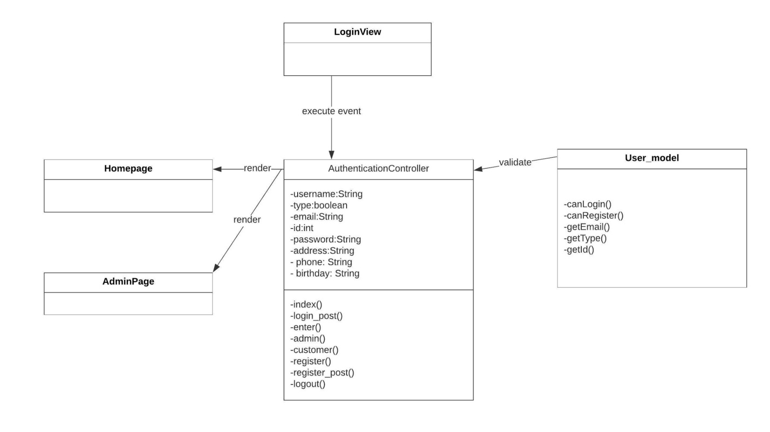

# Derived Requirements

None