Eyeconic – Glasses Shop Management System

Use-case Realization Specification: Authentication

Sign-up

Version 1.0

Revision History

|  |  |  |  |
| --- | --- | --- | --- |
| **Date** | **Version** | **Description** | **Author** |
| 18/10/2019 | 1.0 | Final Draft. | Trần Thị Mai Hương |
|  |  |  |  |
|  |  |  |  |
|  |  |  |  |

Table of Contents

1. Introduction 3

1.1 Purpose 3

1.2 Scope 3

1.3 Definitions, Acronyms, and Abbreviations 3

1.4 References 3

1.5 Overview 3

2. Flow of Events—Design 4

3. Derived Requirements 5

# Introduction

## Purpose

This document describes how the Sign-up Use-Case is realized within the design model, in terms of collaborating objects.

## Scope

This document applies to the Eyeconic – Glasses Shop Management System.

## Definitions, Acronyms, and Abbreviations

User – a person who use the system, can be admin or customer.

Admin – a person who work for the computer shop.

Guest – a user who is not logged in the system.

Customer – a customer who logged in the system.

## References

None

## Overview

In the following section, Use-Case Realization Specification of the Sign-up Use-Case of the Eyeconic – Glasses Shop Management System is provided in detail. The first section is a textual description of the Use-Case specification. The following section contains diagrams (sequence and collaboration diagrams) describing how the use case is realized in terms of collaborating objects. The third section includes class diagrams with relationships that participate in the realization of the use case. The last section is an analysis of all requirements, such as non-functional requirements, on the use-case realization that are not considered in the design model, but that need to be taken care of during implementation.

# Flow of Events—Design

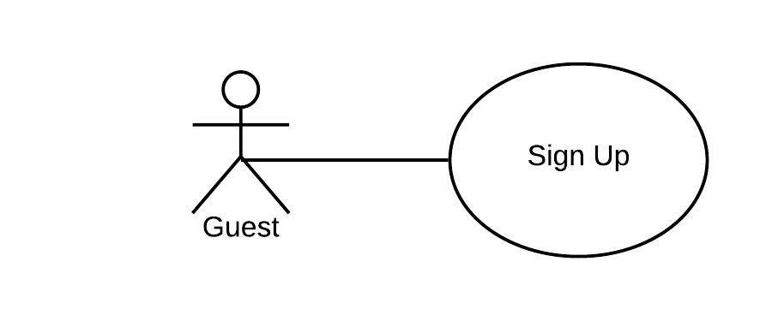

|  |  |
| --- | --- |
| **Name** | Sign-up |
| **Description** | A guest creates a new account |
| **Actor(s)** | Guest |
| **Flows of even**t |  |
| **Basic flow** | |
| 1. The guest select registration button on login page.  2. The system prompts guest for registration information: username, password, etc.  3. The guest enters their information.  4. The system validates guest information.  5. The system creates a new user base on entered information  6. The system saves the new user to database. | |
| **Alternative Flows** | |
| Duplicate username | 1. Guest enter existed username  2. System displays information with appropriate message to correct invalid information. |
| **Pre-conditions** | |
| The user is not logged in the system (guest). | |
| **Post-conditions** | |
| None | |
| Success | Success message is prompted and user is redirected to home page. |
| Failure | The guest is unable to register for one or more reasons and an error is prompted |
| **Extension Points** | |
| None | |

**Sequence Diagram**

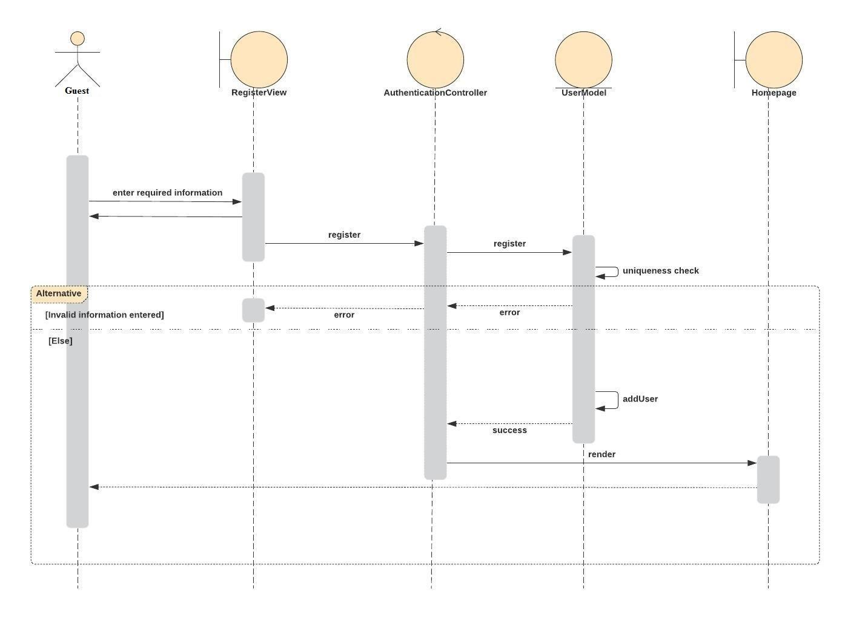

**Class Diagram**

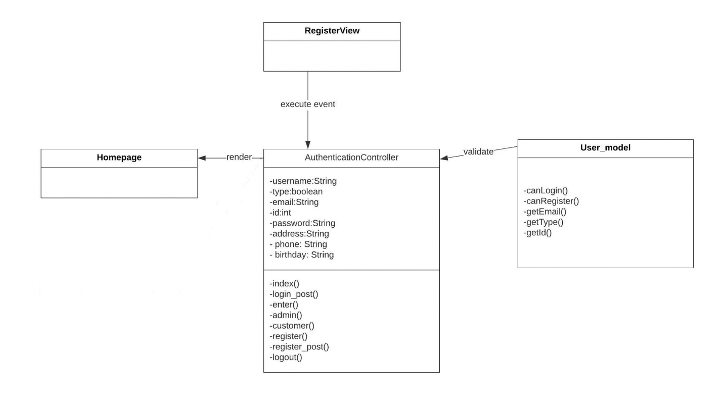

# Derived Requirements

None