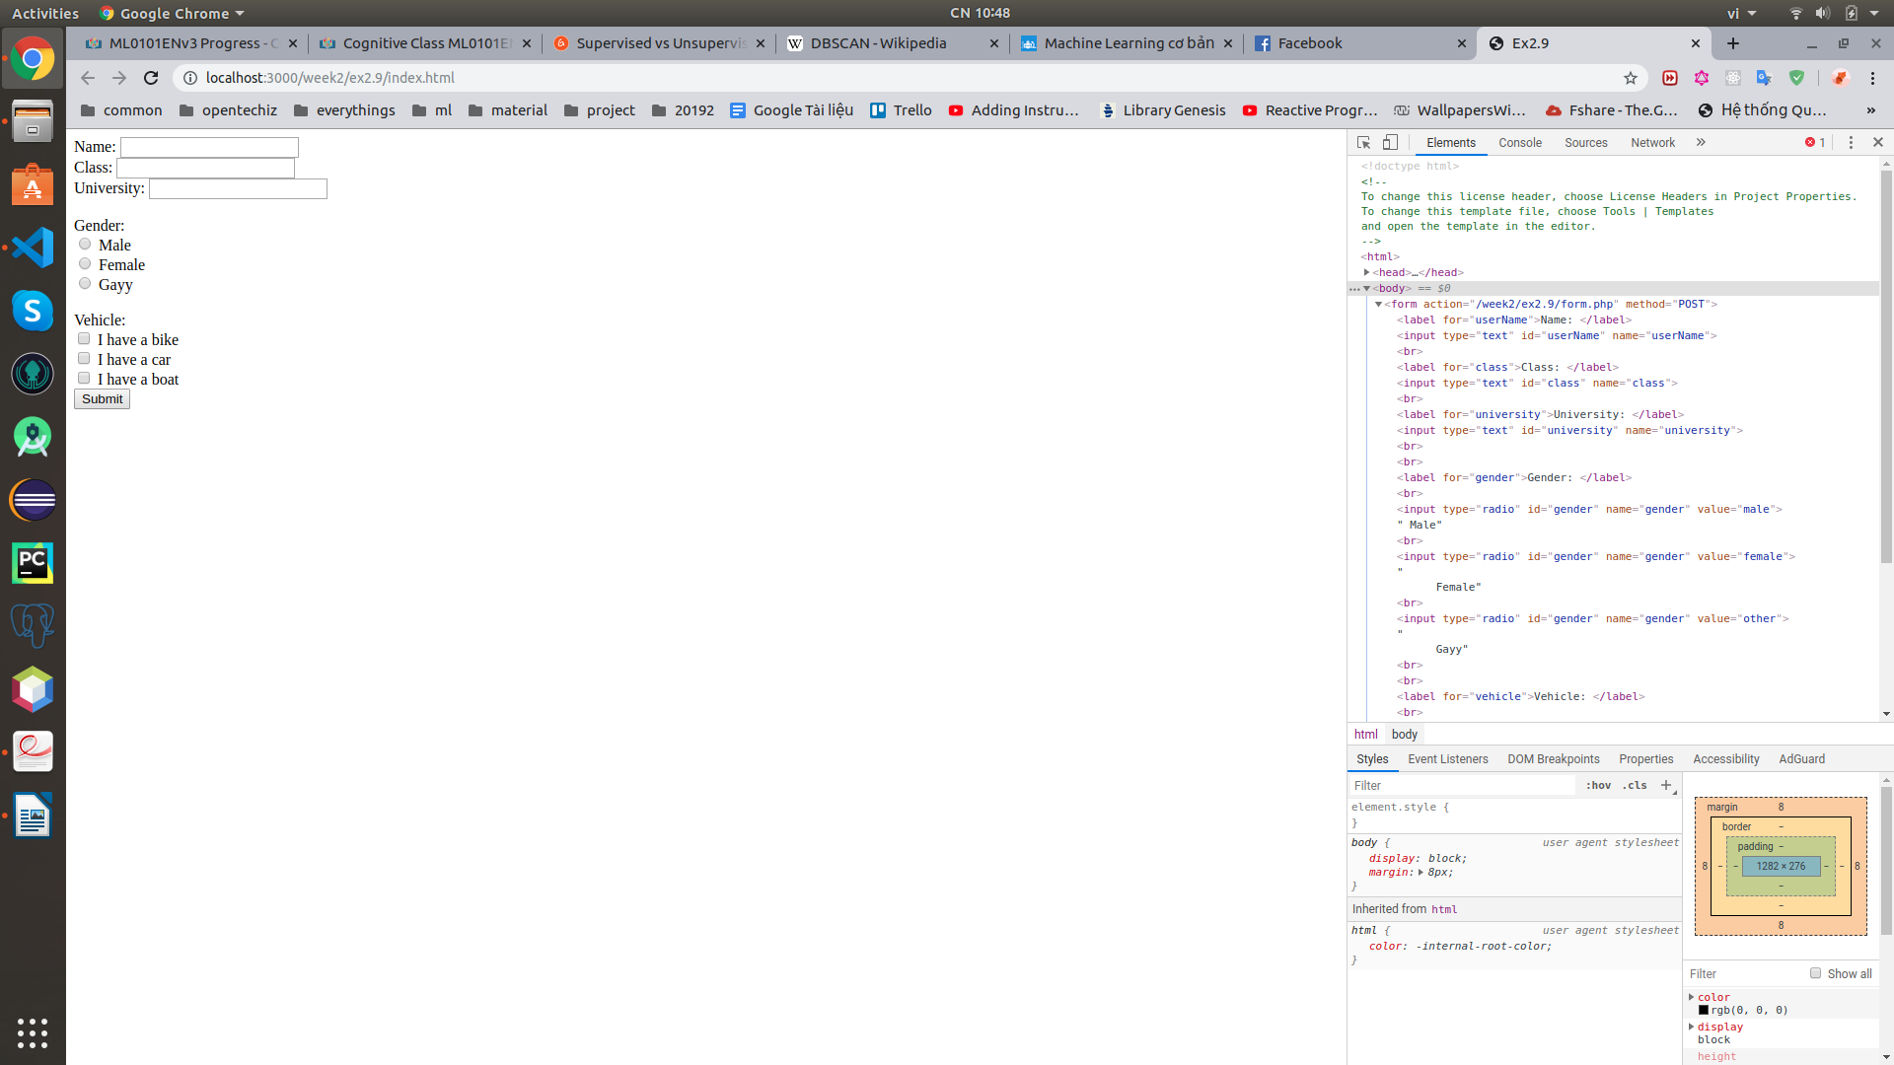

index.html screen: requests the users to fill their name, class, university, vehicle.

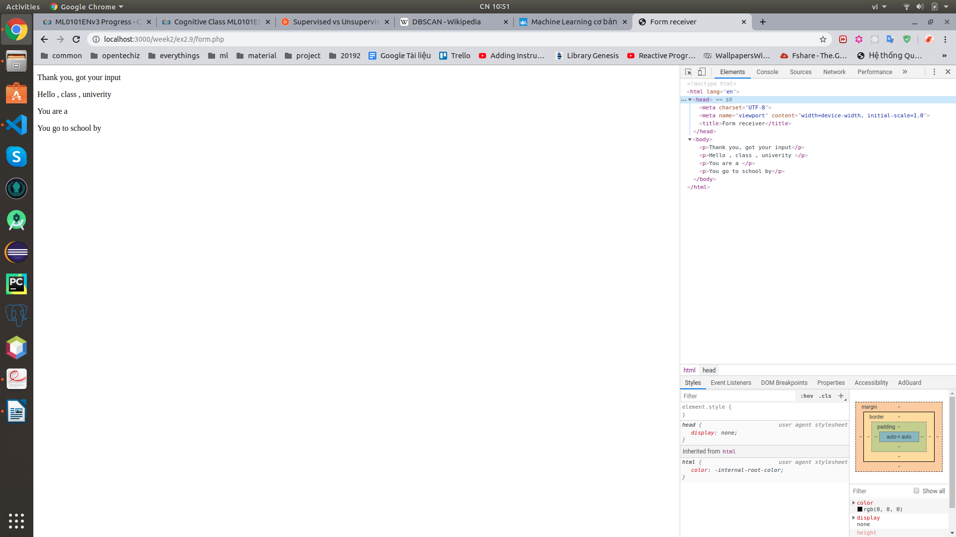

form.php screen: display all the information that users entered.