Tên: Võ Bùi Hoài Sang

Mssv: 2100362

**Các file code**

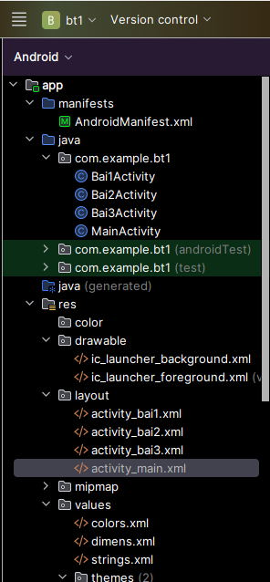

**Giao diện chính**

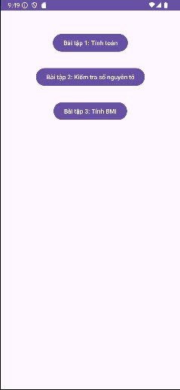

Activity_main.xml

<RelativeLayout xmlns:android="http://schemas.android.com/apk/res/android"  
 android:layout_width="match_parent"  
 android:layout_height="match_parent" >  
  
 <Button  
 android:id="@+id/button_bai1"  
 android:layout_width="wrap_content"  
 android:layout_height="wrap_content"  
 android:text="Bài tập 1: Tính toán"  
 android:layout_centerHorizontal="true"  
 android:layout_marginTop="50dp"/>  
  
 <Button  
 android:id="@+id/button_bai2"  
 android:layout_width="wrap_content"  
 android:layout_height="wrap_content"  
 android:text="Bài tập 2: Kiểm tra số nguyên tố"  
 android:layout_below="@id/button_bai1"  
 android:layout_centerHorizontal="true"  
 android:layout_marginTop="30dp"/>  
  
 <Button  
 android:id="@+id/button_bai3"  
 android:layout_width="wrap_content"  
 android:layout_height="wrap_content"  
 android:text="Bài tập 3: Tính BMI"  
 android:layout_below="@id/button_bai2"  
 android:layout_centerHorizontal="true"  
 android:layout_marginTop="30dp"/>  
</RelativeLayout>

MainActivity.java

package com.example.bt1**;**import android.content.Intent**;**import android.os.Bundle**;**import android.view.View**;**import android.widget.Button**;**import androidx.appcompat.app.AppCompatActivity**;**public class MainActivity extends AppCompatActivity {  
  
 @Override  
 protected void onCreate(Bundle savedInstanceState) {  
 super.onCreate(savedInstanceState)**;** setContentView(R.layout.*activity_main*)**;** Button buttonBai1 = findViewById(R.id.*button_bai1*)**;** Button buttonBai2 = findViewById(R.id.*button_bai2*)**;** Button buttonBai3 = findViewById(R.id.*button_bai3*)**;** buttonBai1.setOnClickListener(new View.OnClickListener() {  
 @Override  
 public void onClick(View v) {  
 Intent intent = new Intent(MainActivity.this**,** Bai1Activity.class)**;** startActivity(intent)**;** }  
 })**;** buttonBai2.setOnClickListener(new View.OnClickListener() {  
 @Override  
 public void onClick(View v) {  
 Intent intent = new Intent(MainActivity.this**,** Bai2Activity.class)**;** startActivity(intent)**;** }  
 })**;** buttonBai3.setOnClickListener(new View.OnClickListener() {  
 @Override  
 public void onClick(View v) {  
 Intent intent = new Intent(MainActivity.this**,** Bai3Activity.class)**;** startActivity(intent)**;** }  
 })**;** }  
}

**Giao diện bài 1**

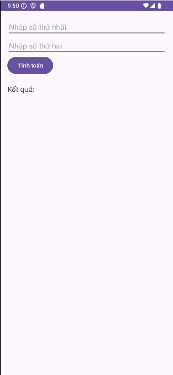

activity_bai1.xml

<?xml version="1.0" encoding="utf-8"?>  
<LinearLayout xmlns:android="http://schemas.android.com/apk/res/android"  
 android:layout_width="match_parent"  
 android:layout_height="match_parent"  
 android:orientation="vertical"  
 android:padding="16dp">  
  
 <EditText  
 android:id="@+id/edtNumber1"  
 android:layout_width="match_parent"  
 android:layout_height="wrap_content"  
 android:hint="Nhập số thứ nhất"  
 android:inputType="number" />  
  
 <EditText  
 android:id="@+id/edtNumber2"  
 android:layout_width="match_parent"  
 android:layout_height="wrap_content"  
 android:hint="Nhập số thứ hai"  
 android:inputType="number" />  
  
 <Button  
 android:id="@+id/btnCalculate"  
 android:layout_width="wrap_content"  
 android:layout_height="wrap_content"  
 android:text="Tính toán" />  
  
 <TextView  
 android:id="@+id/tvResult"  
 android:layout_width="match_parent"  
 android:layout_height="wrap_content"  
 android:paddingTop="20dp"  
 android:text="Kết quả:"  
 android:textSize="18sp" />  
</LinearLayout>

Bai1Activity.java

package com.example.bt1**;**import android.os.Bundle**;**import android.view.View**;**import android.widget.Button**;**import android.widget.EditText**;**import android.widget.TextView**;**import androidx.appcompat.app.AppCompatActivity**;**public class Bai1Activity extends AppCompatActivity {  
  
 EditText edtNumber1**,** edtNumber2**;** Button btnCalculate**;** TextView tvResult**;** @Override  
 protected void onCreate(Bundle savedInstanceState) {  
 super.onCreate(savedInstanceState)**;** setContentView(R.layout.*activity_bai1*)**;** edtNumber1 = findViewById(R.id.*edtNumber1*)**;** edtNumber2 = findViewById(R.id.*edtNumber2*)**;** btnCalculate = findViewById(R.id.*btnCalculate*)**;** tvResult = findViewById(R.id.*tvResult*)**;** btnCalculate.setOnClickListener(new View.OnClickListener() {  
 @Override  
 public void onClick(View v) {  
 int number1 = Integer.*parseInt*(edtNumber1.getText().toString())**;** int number2 = Integer.*parseInt*(edtNumber2.getText().toString())**;** int sum = number1 + number2**;** int difference = number1 - number2**;** int product = number1 * number2**;** double quotient = (double) number1 / number2**;** String result = "Tổng: " + sum + "\n" +  
 "Hiệu: " + difference + "\n" +  
 "Tích: " + product + "\n" +  
 "Thương: " + quotient**;** tvResult.setText(result)**;** }  
 })**;** }  
}

**Giao diện bài 2**

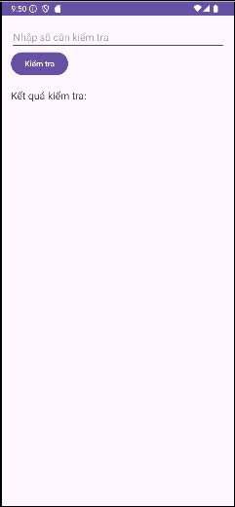

activity_bai2.xml

<?xml version="1.0" encoding="utf-8"?>  
<LinearLayout xmlns:android="http://schemas.android.com/apk/res/android"  
 android:layout_width="match_parent"  
 android:layout_height="match_parent"  
 android:orientation="vertical"  
 android:padding="16dp">  
  
 <EditText  
 android:id="@+id/edtPrimeCheck"  
 android:layout_width="match_parent"  
 android:layout_height="wrap_content"  
 android:hint="Nhập số cần kiểm tra"  
 android:inputType="number" />  
  
 <Button  
 android:id="@+id/btnCheckPrime"  
 android:layout_width="wrap_content"  
 android:layout_height="wrap_content"  
 android:text="Kiểm tra" />  
  
 <TextView  
 android:id="@+id/tvPrimeResult"  
 android:layout_width="match_parent"  
 android:layout_height="wrap_content"  
 android:paddingTop="20dp"  
 android:text="Kết quả kiểm tra:"  
 android:textSize="18sp" />  
</LinearLayout>

Bai2Activity.java

package com.example.bt1**;**import android.os.Bundle**;**import android.view.View**;**import android.widget.Button**;**import android.widget.EditText**;**import android.widget.TextView**;**import androidx.appcompat.app.AppCompatActivity**;**public class Bai2Activity extends AppCompatActivity {  
  
 EditText edtPrimeCheck**;** Button btnCheckPrime**;** TextView tvPrimeResult**;** @Override  
 protected void onCreate(Bundle savedInstanceState) {  
 super.onCreate(savedInstanceState)**;** setContentView(R.layout.*activity_bai2*)**;** edtPrimeCheck = findViewById(R.id.*edtPrimeCheck*)**;** btnCheckPrime = findViewById(R.id.*btnCheckPrime*)**;** tvPrimeResult = findViewById(R.id.*tvPrimeResult*)**;** btnCheckPrime.setOnClickListener(new View.OnClickListener() {  
 @Override  
 public void onClick(View v) {  
 int number = Integer.*parseInt*(edtPrimeCheck.getText().toString())**;** boolean isPrime = checkPrime(number)**;** if (isPrime) {  
 tvPrimeResult.setText(number + " là số nguyên tố.")**;** } else {  
 tvPrimeResult.setText(number + " không phải là số nguyên tố.")**;** }  
 }  
 })**;** }   
  
 private boolean checkPrime(int number) {  
 if (number < **2**) return false**;** for (int i = **2;** i <= Math.*sqrt*(number)**;** i++) {  
 if (number % i == **0**) {  
 return false**;** }  
 }  
 return true**;** }  
}

**Giao diện bài 3**

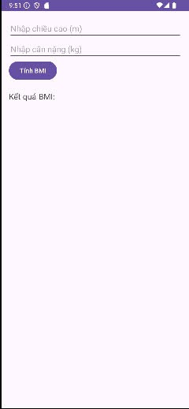

activity_bai3.xml

<?xml version="1.0" encoding="utf-8"?>  
<LinearLayout xmlns:android="http://schemas.android.com/apk/res/android"  
 android:layout_width="match_parent"  
 android:layout_height="match_parent"  
 android:orientation="vertical"  
 android:padding="16dp">  
  
 <EditText  
 android:id="@+id/edtHeight"  
 android:layout_width="match_parent"  
 android:layout_height="wrap_content"  
 android:hint="Nhập chiều cao (m)"  
 android:inputType="numberDecimal" />  
  
 <EditText  
 android:id="@+id/edtWeight"  
 android:layout_width="match_parent"  
 android:layout_height="wrap_content"  
 android:hint="Nhập cân nặng (kg)"  
 android:inputType="numberDecimal" />  
  
 <Button  
 android:id="@+id/btnCalculateBMI"  
 android:layout_width="wrap_content"  
 android:layout_height="wrap_content"  
 android:text="Tính BMI" />  
  
 <TextView  
 android:id="@+id/tvBMIResult"  
 android:layout_width="match_parent"  
 android:layout_height="wrap_content"  
 android:paddingTop="20dp"  
 android:text="Kết quả BMI:"  
 android:textSize="18sp" />  
</LinearLayout>

Bai3Activity.java

package com.example.bt1**;**import android.os.Bundle**;**import android.view.View**;**import android.widget.Button**;**import android.widget.EditText**;**import android.widget.TextView**;**import androidx.appcompat.app.AppCompatActivity**;**public class Bai3Activity extends AppCompatActivity {  
  
 EditText edtHeight**,** edtWeight**;** Button btnCalculateBMI**;** TextView tvBMIResult**;** @Override  
 protected void onCreate(Bundle savedInstanceState) {  
 super.onCreate(savedInstanceState)**;** setContentView(R.layout.*activity_bai3*)**;** edtHeight = findViewById(R.id.*edtHeight*)**;** edtWeight = findViewById(R.id.*edtWeight*)**;** btnCalculateBMI = findViewById(R.id.*btnCalculateBMI*)**;** tvBMIResult = findViewById(R.id.*tvBMIResult*)**;** btnCalculateBMI.setOnClickListener(new View.OnClickListener() {  
 @Override  
 public void onClick(View v) {  
 double height = Double.*parseDouble*(edtHeight.getText().toString())**;** double weight = Double.*parseDouble*(edtWeight.getText().toString())**;** double bmi = weight / (height * height)**;** String result = "Chỉ số BMI: " + bmi**;** if (bmi < **18.5**) {  
 result += "\nBạn gầy."**;** } else if (bmi >= **18.5** && bmi < **24.9**) {  
 result += "\nBạn bình thường."**;** } else if (bmi >= **25** && bmi < **29.9**) {  
 result += "\nBạn thừa cân."**;** } else {  
 result += "\nBạn béo phì."**;** }  
  
 tvBMIResult.setText(result)**;** }  
 })**;** }  
}

**Kết quả thực hiện:**

Bài 1

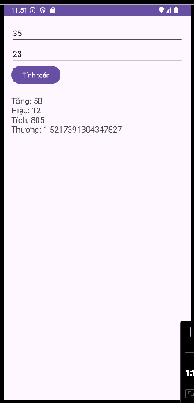

Bài 2

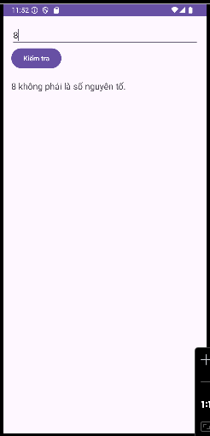

Bài 3

