Tên: Võ Bùi Hoài Sang

MSSV: 2100362

**Giao diện chính bài tập 1 2 3**

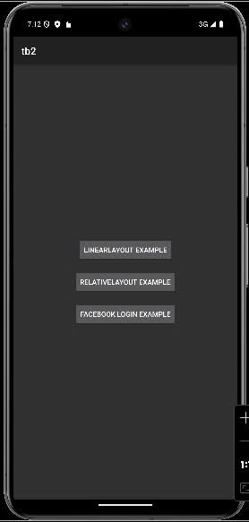

**File activity_main.xml**

<?xml version="1.0" encoding="utf-8"?>  
<LinearLayout xmlns:android="http://schemas.android.com/apk/res/android"  
 android:layout_width="match_parent"  
 android:layout_height="match_parent"  
 android:orientation="vertical"  
 android:gravity="center"  
 android:padding="16dp">  
  
 <Button  
 android:id="@+id/btnLinearLayout"  
 android:layout_width="wrap_content"  
 android:layout_height="wrap_content"  
 android:text="LinearLayout Example" />  
  
 <Button  
 android:id="@+id/btnRelativeLayout"  
 android:layout_width="wrap_content"  
 android:layout_height="wrap_content"  
 android:text="RelativeLayout Example"  
 android:layout_marginTop="16dp" />  
  
 <Button  
 android:id="@+id/btnLogin"  
 android:layout_width="wrap_content"  
 android:layout_height="wrap_content"  
 android:text="Facebook Login Example"  
 android:layout_marginTop="16dp" />  
</LinearLayout>

**File MainActivity.java**

package com.example.tb2**;**import android.content.Intent**;**import android.os.Bundle**;**import android.view.View**;**import android.widget.Button**;**import androidx.appcompat.app.AppCompatActivity**;**public class MainActivity extends AppCompatActivity {  
  
 @Override  
 protected void onCreate(Bundle savedInstanceState) {  
 super.onCreate(savedInstanceState)**;** setContentView(R.layout.*activity_main*)**;** Button btnLinearLayout = findViewById(R.id.*btnLinearLayout*)**;** Button btnRelativeLayout = findViewById(R.id.*btnRelativeLayout*)**;** Button btnLogin = findViewById(R.id.*btnLogin*)**;** // Chuyển sang Activity LinearLayout  
 btnLinearLayout.setOnClickListener(new View.OnClickListener() {  
 @Override  
 public void onClick(View v) {  
 Intent intent = new Intent(MainActivity.this**,** LinearLayoutActivity.class)**;** startActivity(intent)**;** }  
 })**;** // Chuyển sang Activity RelativeLayout  
 btnRelativeLayout.setOnClickListener(new View.OnClickListener() {  
 @Override  
 public void onClick(View v) {  
 Intent intent = new Intent(MainActivity.this**,** RelativeLayoutActivity.class)**;** startActivity(intent)**;** }  
 })**;** // Chuyển sang Activity Facebook Login  
 btnLogin.setOnClickListener(new View.OnClickListener() {  
 @Override  
 public void onClick(View v) {  
 Intent intent = new Intent(MainActivity.this**,** LoginActivity.class)**;** startActivity(intent)**;** }  
 })**;** }  
}

**File AndroidManifest.xml**

<?xml version="1.0" encoding="utf-8"?>  
<manifest xmlns:android="http://schemas.android.com/apk/res/android"  
 xmlns:tools="http://schemas.android.com/tools">  
  
 <application  
 android:allowBackup="true"  
 android:icon="@mipmap/ic_launcher"  
 android:label="@string/app_name"  
 android:roundIcon="@mipmap/ic_launcher_round"  
 android:supportsRtl="true"  
 android:theme="@style/Theme.AppCompat">  
  
 <activity android:name=".MainActivity"  
 android:exported="true">  
 <intent-filter>  
 <action android:name="android.intent.action.MAIN" />  
 <category android:name="android.intent.category.LAUNCHER" />  
 </intent-filter>  
 </activity>  
  
 <activity android:name=".LinearLayoutActivity" />  
 <activity android:name=".RelativeLayoutActivity" />  
 <activity android:name=".LoginActivity" />  
  
 </application>  
  
  
</manifest>

**Giao diện bài 1**

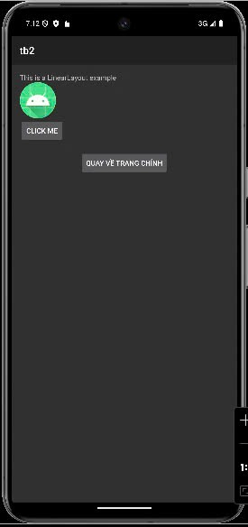

**File activity_linear_layout.xml**

<?xml version="1.0" encoding="utf-8"?>  
<LinearLayout xmlns:android="http://schemas.android.com/apk/res/android"  
 android:layout_width="match_parent"  
 android:layout_height="match_parent"  
 android:orientation="vertical"  
 android:padding="16dp">  
  
 <TextView  
 android:layout_width="wrap_content"  
 android:layout_height="wrap_content"  
 android:text="This is a LinearLayout example" />  
  
 <ImageView  
 android:layout_width="wrap_content"  
 android:layout_height="wrap_content"  
 android:src="@mipmap/ic_launcher" />  
  
 <!-- Nút quay về trang chính -->  
 <Button  
 android:layout_width="wrap_content"  
 android:layout_height="wrap_content"  
 android:text="Click me" />  
  
 <Button  
 android:id="@+id/btnBackToMain"  
 android:layout_width="wrap_content"  
 android:layout_height="wrap_content"  
 android:text="Quay về trang chính"  
 android:layout_gravity="center"  
 android:layout_marginTop="16dp"/>  
</LinearLayout>

**File LinearLayoutActivity.java**

package com.example.tb2**;**import android.content.Intent**;**import android.os.Bundle**;**import android.view.View**;**import android.widget.Button**;**import androidx.appcompat.app.AppCompatActivity**;**public class LinearLayoutActivity extends AppCompatActivity {  
 @Override  
 protected void onCreate(Bundle savedInstanceState) {  
 super.onCreate(savedInstanceState)**;** setContentView(R.layout.*activity_linear_layout*)**;** // Nút quay về trang chính  
 Button btnBackToMain = findViewById(R.id.*btnBackToMain*)**;** btnBackToMain.setOnClickListener(new View.OnClickListener() {  
 @Override  
 public void onClick(View v) {  
 Intent intent = new Intent(LinearLayoutActivity.this**,** MainActivity.class)**;** startActivity(intent)**;** }  
 })**;** }  
}

**Giao diện bài 2**

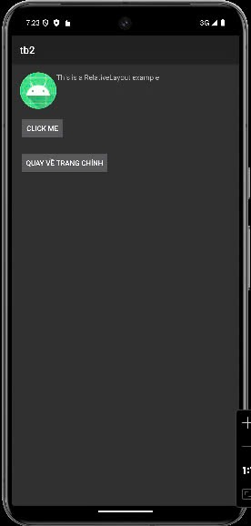

**File activity_relative_layout.xml**

<?xml version="1.0" encoding="utf-8"?>  
<RelativeLayout xmlns:android="http://schemas.android.com/apk/res/android"  
 android:layout_width="match_parent"  
 android:layout_height="match_parent"  
 android:padding="16dp">  
  
 <ImageView  
 android:id="@+id/image"  
 android:layout_width="wrap_content"  
 android:layout_height="wrap_content"  
 android:src="@mipmap/ic_launcher" />  
  
 <TextView  
 android:id="@+id/text"  
 android:layout_width="wrap_content"  
 android:layout_height="wrap_content"  
 android:layout_toRightOf="@id/image"  
 android:text="This is a RelativeLayout example" />  
  
 <!-- Nút quay về trang chính -->  
  
 <Button  
 android:layout_width="wrap_content"  
 android:layout_height="wrap_content"  
 android:layout_below="@id/text"  
 android:layout_marginTop="67dp"  
 android:text="Click me" />  
  
 <Button  
 android:id="@+id/btnBackToMain"  
 android:layout_width="wrap_content"  
 android:layout_height="wrap_content"  
 android:layout_below="@id/text"  
 android:layout_marginTop="135dp"  
 android:text="Quay về trang chính" />  
</RelativeLayout>

**File RelativeLayoutActivity.java**

package com.example.tb2**;**import android.content.Intent**;**import android.os.Bundle**;**import android.view.View**;**import android.widget.Button**;**import androidx.appcompat.app.AppCompatActivity**;**public class RelativeLayoutActivity extends AppCompatActivity {  
 @Override  
 protected void onCreate(Bundle savedInstanceState) {  
 super.onCreate(savedInstanceState)**;** setContentView(R.layout.*activity_relative_layout*)**;** // Nút quay về trang chính  
 Button btnBackToMain = findViewById(R.id.*btnBackToMain*)**;** btnBackToMain.setOnClickListener(new View.OnClickListener() {  
 @Override  
 public void onClick(View v) {  
 Intent intent = new Intent(RelativeLayoutActivity.this**,** MainActivity.class)**;** startActivity(intent)**;** }  
 })**;** }  
}

**Giao diện bài 3**

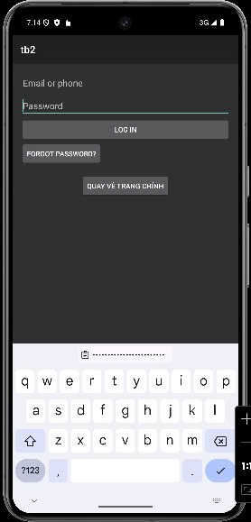

**File activity_login.xml**

<?xml version="1.0" encoding="utf-8"?>  
<LinearLayout xmlns:android="http://schemas.android.com/apk/res/android"  
 android:layout_width="match_parent"  
 android:layout_height="match_parent"  
 android:orientation="vertical"  
 android:padding="16dp">  
  
 <EditText  
 android:layout_width="match_parent"  
 android:layout_height="wrap_content"  
 android:hint="Email or phone" />  
  
 <EditText  
 android:layout_width="match_parent"  
 android:layout_height="wrap_content"  
 android:hint="Password"  
 android:inputType="textPassword" />  
  
 <Button  
 android:layout_width="match_parent"  
 android:layout_height="wrap_content"  
 android:text="Log in" />  
  
 <Button  
 android:layout_width="wrap_content"  
 android:layout_height="wrap_content"  
 android:text="Forgot password?" />  
  
 <!-- Nút quay về trang chính -->  
 <Button  
 android:id="@+id/btnBackToMain"  
 android:layout_width="wrap_content"  
 android:layout_height="wrap_content"  
 android:text="Quay về trang chính"  
 android:layout_gravity="center"  
 android:layout_marginTop="16dp"/>  
</LinearLayout>

**File LoginActivity.java**

package com.example.tb2**;**import android.content.Intent**;**import android.os.Bundle**;**import android.view.View**;**import android.widget.Button**;**import androidx.appcompat.app.AppCompatActivity**;**public class LoginActivity extends AppCompatActivity {  
 @Override  
 protected void onCreate(Bundle savedInstanceState) {  
 super.onCreate(savedInstanceState)**;** setContentView(R.layout.*activity_login*)**;** // Nút quay về trang chính  
 Button btnBackToMain = findViewById(R.id.*btnBackToMain*)**;** btnBackToMain.setOnClickListener(new View.OnClickListener() {  
 @Override  
 public void onClick(View v) {  
 Intent intent = new Intent(LoginActivity.this**,** MainActivity.class)**;** startActivity(intent)**;** }  
 })**;** }  
}

**Giao diện bài tập 4**

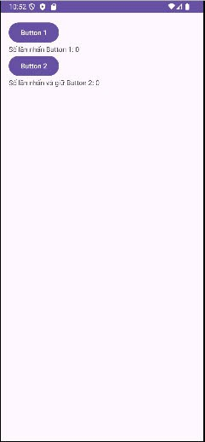

**File MainActivity.java**

package com.example.bt2_1**;**import android.os.Bundle**;**import android.view.View**;**import android.widget.Button**;**import android.widget.TextView**;**import androidx.appcompat.app.AppCompatActivity**;**public class MainActivity extends AppCompatActivity {  
  
 private Button btn1**,** btn2**;** private TextView txt1**,** txt2**;** private int countBtn1 = **0;** private int countBtn2 = **0;** @Override  
 protected void onCreate(Bundle savedInstanceState) {  
 super.onCreate(savedInstanceState)**;** setContentView(R.layout.*activity_main*)**;** // Khởi tạo các View  
 btn1 = findViewById(R.id.*btn1*)**;** txt1 = findViewById(R.id.*txt1*)**;** btn2 = findViewById(R.id.*btn2*)**;** txt2 = findViewById(R.id.*txt2*)**;** // Bắt sự kiện click cho btn1  
 btn1.setOnClickListener(new View.OnClickListener() {  
 @Override  
 public void onClick(View v) {  
 countBtn1++**;** txt1.setText("Số lần nhấn Button 1: " + countBtn1)**;** }  
 })**;** // Bắt sự kiện LongClick cho btn2  
 btn2.setOnLongClickListener(new View.OnLongClickListener() {  
 @Override  
 public boolean onLongClick(View v) {  
 countBtn2++**;** txt2.setText("Số lần nhấn và giữ Button 2: " + countBtn2)**;** return true**;** }  
 })**;** }  
}

**File activity_main.xml**

<LinearLayout  
 xmlns:android="http://schemas.android.com/apk/res/android"  
 android:layout_width="match_parent"  
 android:layout_height="match_parent"  
 android:orientation="vertical"  
 android:padding="16dp">  
  
 <Button  
 android:id="@+id/btn1"  
 android:layout_width="wrap_content"  
 android:layout_height="wrap_content"  
 android:text="Button 1" />  
  
 <TextView  
 android:id="@+id/txt1"  
 android:layout_width="wrap_content"  
 android:layout_height="wrap_content"  
 android:text="Số lần nhấn Button 1: 0" />  
  
 <Button  
 android:id="@+id/btn2"  
 android:layout_width="wrap_content"  
 android:layout_height="wrap_content"  
 android:text="Button 2" />  
  
 <TextView  
 android:id="@+id/txt2"  
 android:layout_width="wrap_content"  
 android:layout_height="wrap_content"  
 android:text="Số lần nhấn và giữ Button 2: 0" />  
</LinearLayout>

**Kết quả bài tập 4**

