**Bài 1**

**Giao diện bài 1**

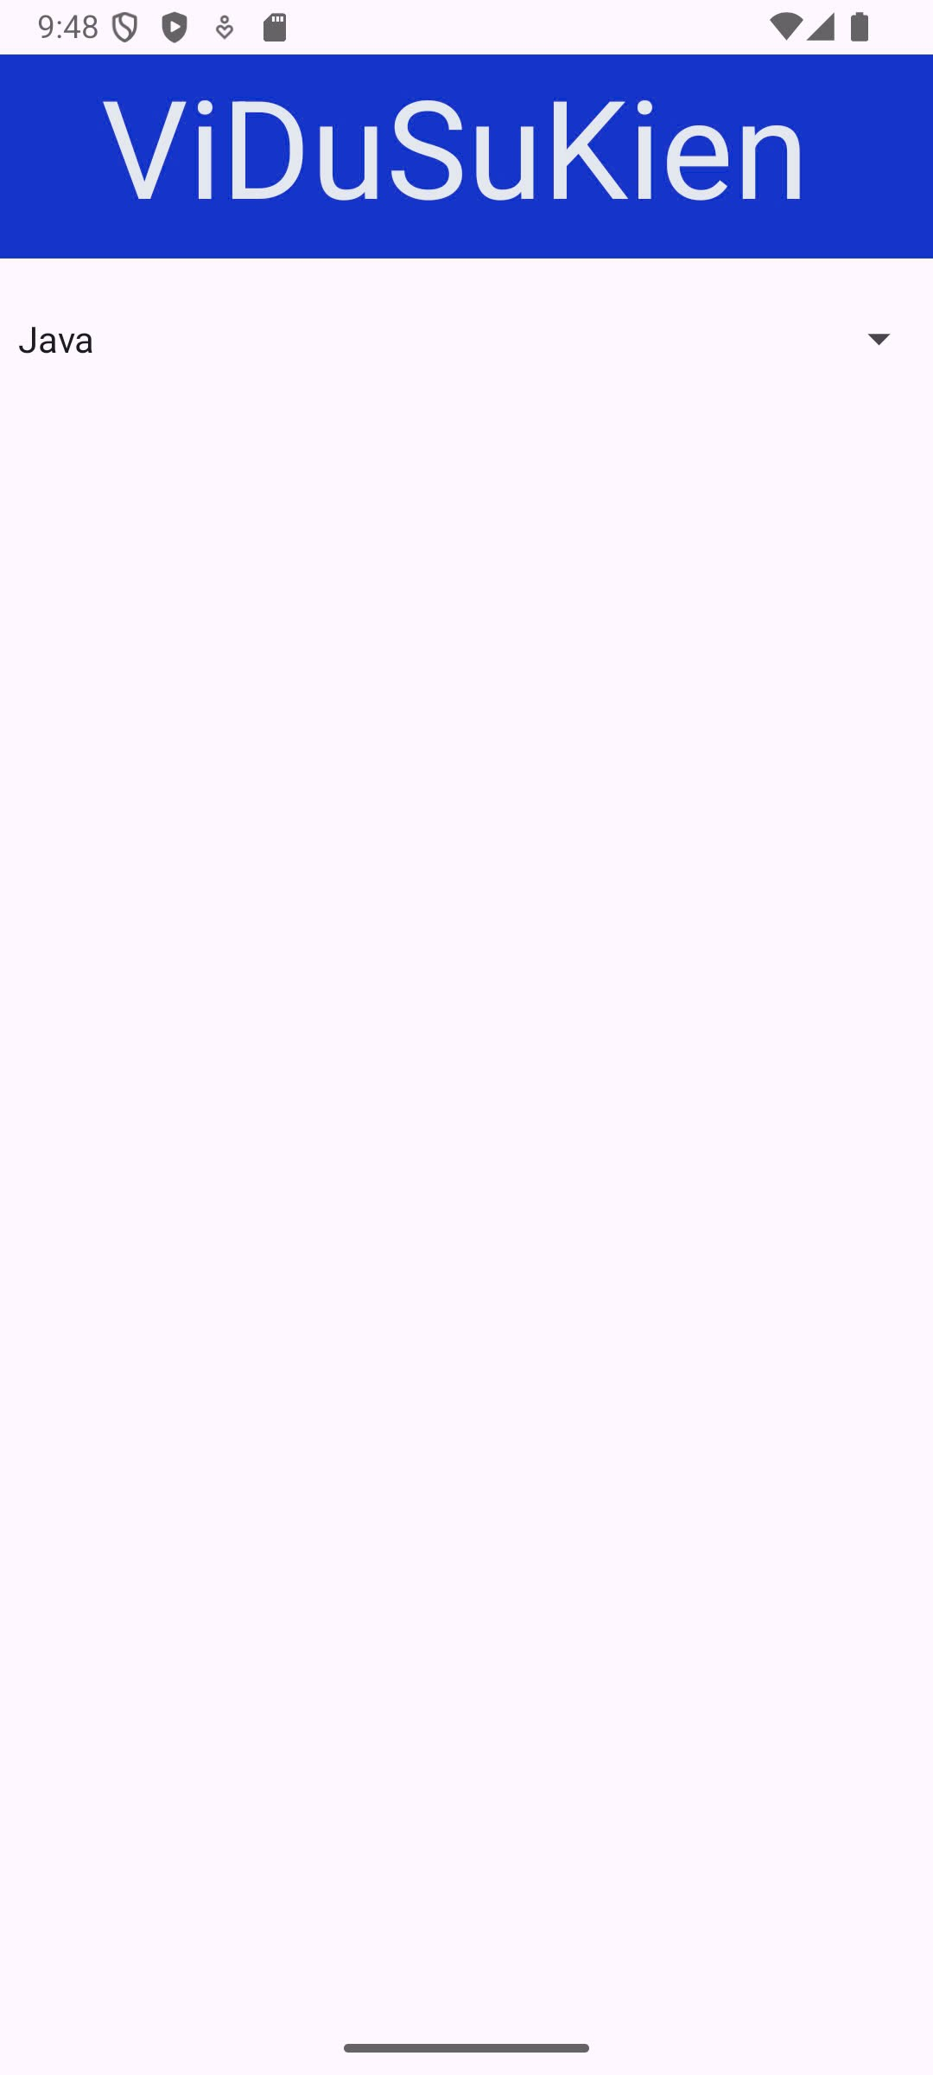

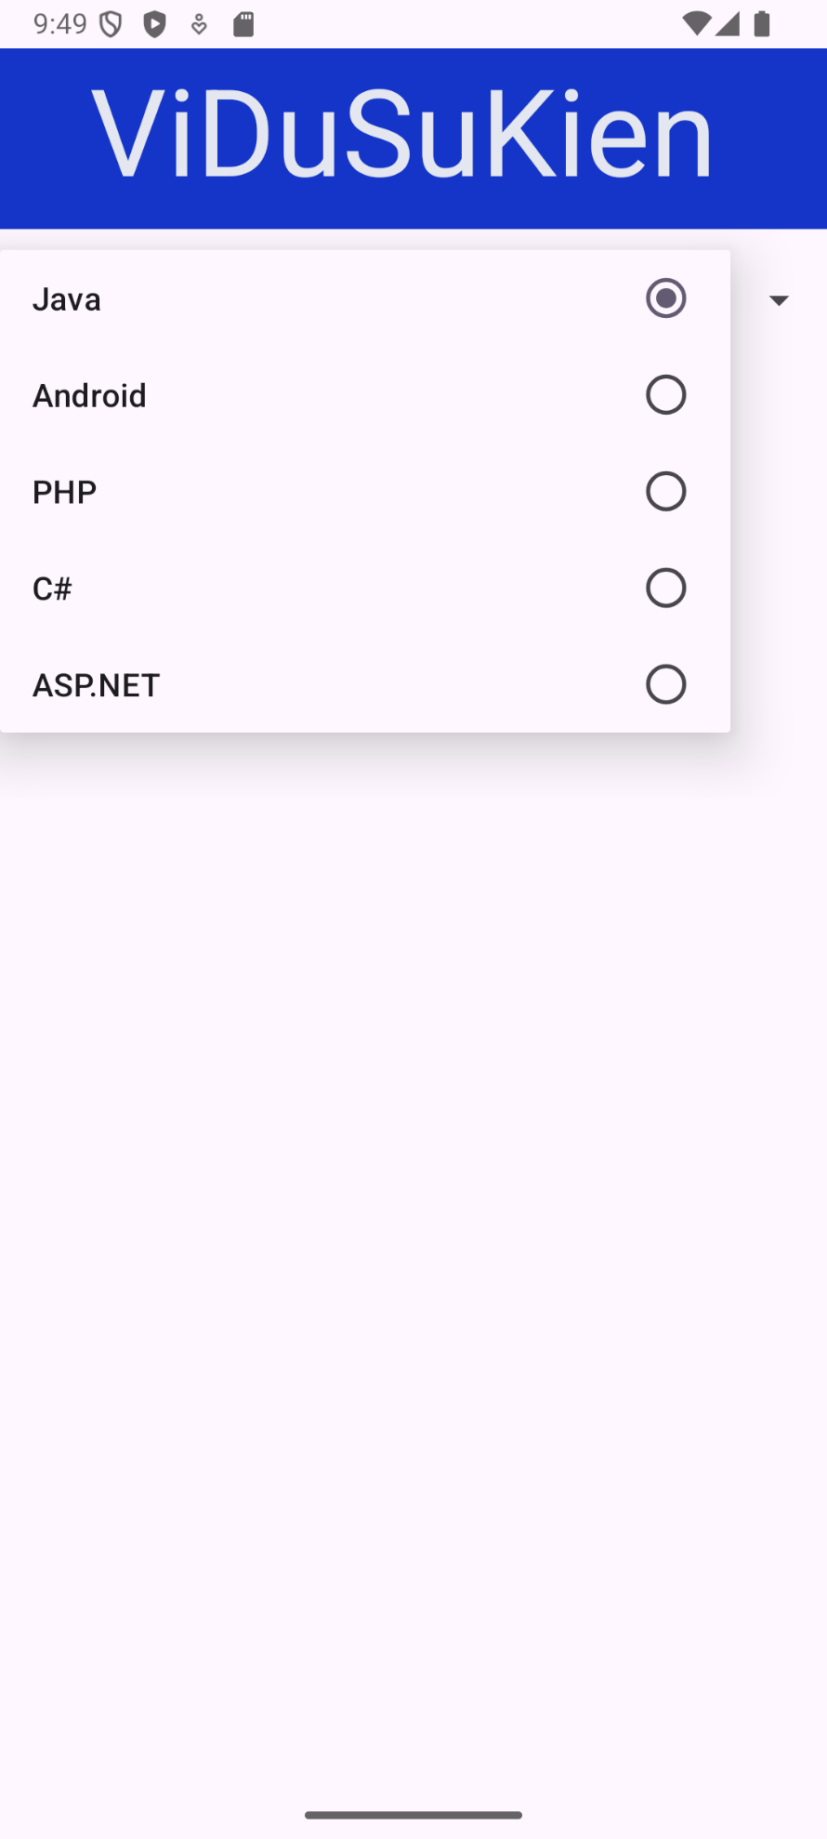

**File activity_main.xml**

<?xml version="1.0" encoding="utf-8"?>  
<androidx.constraintlayout.widget.ConstraintLayout xmlns:android="http://schemas.android.com/apk/res/android"  
 xmlns:app="http://schemas.android.com/apk/res-auto"  
 xmlns:tools="http://schemas.android.com/tools"  
 android:id="@+id/main"  
 android:layout_width="match_parent"  
 android:layout_height="match_parent"  
 tools:context=".MainActivity">  
  
 <Spinner  
 android:id="@+id/spnCategory"  
 android:layout_width="0dp"  
 android:layout_height="50dp"  
 android:layout_marginTop="100dp"  
 app:layout_constraintEnd_toEndOf="parent"  
 app:layout_constraintHorizontal_bias="0.0"  
 app:layout_constraintStart_toStartOf="parent"  
 app:layout_constraintTop_toTopOf="parent" />  
  
 <TextView  
 android:id="@+id/textView"  
 android:layout_width="567dp"  
 android:layout_height="90dp"  
 android:background="#1535C9"  
 android:text=" ViDuSuKien"  
 android:textColor="#E4E7EF"  
 android:textSize="60sp"  
 tools:layout_editor_absoluteX="0dp"  
 tools:layout_editor_absoluteY="4dp" />  
   
  
</androidx.constraintlayout.widget.ConstraintLayout>

**File MainActivity.java**

package com.example.th3**;**import android.os.Bundle**;**import android.widget.AdapterView**;**import android.widget.ArrayAdapter**;**import android.widget.Spinner**;**import android.widget.Toast**;**import androidx.activity.EdgeToEdge**;**import androidx.appcompat.app.AppCompatActivity**;**import androidx.core.graphics.Insets**;**import androidx.core.view.ViewCompat**;**import androidx.core.view.WindowInsetsCompat**;**import java.util.ArrayList**;**import java.util.List**;**public class MainActivity extends AppCompatActivity {  
  
 private Spinner spnCategory**;** @Override  
 protected void onCreate(Bundle savedInstanceState) {  
 super.onCreate(savedInstanceState)**;** EdgeToEdge.*enable*(this)**;** setContentView(R.layout.*activity_main*)**;** // Set window insets  
 ViewCompat.*setOnApplyWindowInsetsListener*(findViewById(R.id.*main*)**,** (v**,** insets) -> {  
 Insets systemBars = insets.getInsets(WindowInsetsCompat.Type.*systemBars*())**;** v.setPadding(systemBars.left**,** systemBars.top**,** systemBars.right**,** systemBars.bottom)**;** return insets**;** })**;** // Initialize the Spinner  
 spnCategory = findViewById(R.id.*spnCategory*)**;** // Create a list of items for the Spinner  
 List<String> categories = new ArrayList<>()**;** categories.add("Java")**;** categories.add("Android")**;** categories.add("PHP")**;** categories.add("C#")**;** categories.add("ASP.NET")**;** // Set up the ArrayAdapter for the Spinner  
 ArrayAdapter<String> adapter = new ArrayAdapter<>(this**,** android.R.layout.*simple_spinner_item***,** categories)**;** adapter.setDropDownViewResource(android.R.layout.*simple_list_item_single_choice*)**;** spnCategory.setAdapter(adapter)**;** // Set the Spinner item selection listener  
 spnCategory.setOnItemSelectedListener(new AdapterView.OnItemSelectedListener() {  
 @Override  
 public void onItemSelected(AdapterView<?> parent**,** android.view.View view**,** int position**,** long id) {  
 // Display a Toast with the selected item  
 String selectedItem = parent.getItemAtPosition(position).toString()**;** Toast.*makeText*(MainActivity.this**,** selectedItem**,** Toast.*LENGTH_SHORT*).show()**;** }  
  
 @Override  
 public void onNothingSelected(AdapterView<?> parent) {  
 // Do nothing if no item is selected  
 }  
 })**;** }  
}

**Bài 2**

**Giao diện bài 2**

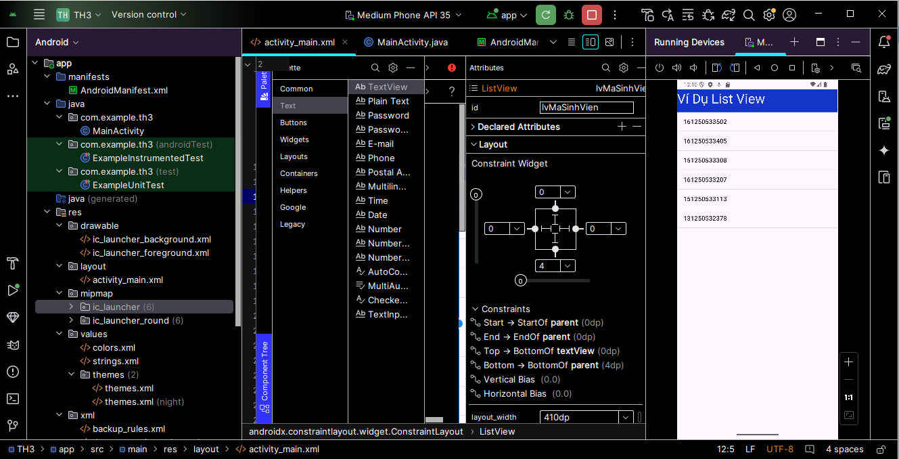

**File activity_main.xml**

<?xml version="1.0" encoding="utf-8"?>  
<androidx.constraintlayout.widget.ConstraintLayout xmlns:android="http://schemas.android.com/apk/res/android"  
 xmlns:app="http://schemas.android.com/apk/res-auto"  
 xmlns:tools="http://schemas.android.com/tools"  
 android:id="@+id/main"  
 android:layout_width="match_parent"  
 android:layout_height="match_parent"  
 tools:context=".MainActivity">  
  
 <!-- ListView to display the list of items -->  
  
 <ListView  
 android:id="@+id/lvMaSinhVien"  
 android:layout_width="410dp"  
 android:layout_height="633dp"  
 android:layout_marginBottom="4dp"  
 app:layout_constraintBottom_toBottomOf="parent"  
 app:layout_constraintEnd_toEndOf="parent"  
 app:layout_constraintHorizontal_bias="0.0"  
 app:layout_constraintStart_toStartOf="parent"  
 app:layout_constraintTop_toBottomOf="@+id/textView"  
 app:layout_constraintVertical_bias="0.0" />  
  
 <TextView  
 android:id="@+id/textView"  
 android:layout_width="410dp"  
 android:layout_height="58dp"  
 android:background="#1535C9"  
 android:text="Ví Dụ List View"  
 android:textColor="#E4E7EF"  
 android:textSize="34sp"  
 app:layout_constraintTop_toTopOf="parent"  
 tools:layout_editor_absoluteX="0dp" />  
  
  
</androidx.constraintlayout.widget.ConstraintLayout>

**File MainActivity.java**

package com.example.th3**;**import android.os.Bundle**;**import android.widget.ArrayAdapter**;**import android.widget.ListView**;**import androidx.activity.EdgeToEdge**;**import androidx.appcompat.app.AppCompatActivity**;**import androidx.core.graphics.Insets**;**import androidx.core.view.ViewCompat**;**import androidx.core.view.WindowInsetsCompat**;**public class MainActivity extends AppCompatActivity {  
  
 private ListView lvMaSinhVien**;** @Override  
 protected void onCreate(Bundle savedInstanceState) {  
 super.onCreate(savedInstanceState)**;** EdgeToEdge.*enable*(this)**;** setContentView(R.layout.*activity_main*)**;** // Set window insets  
 ViewCompat.*setOnApplyWindowInsetsListener*(findViewById(R.id.*main*)**,** (v**,** insets) -> {  
 Insets systemBars = insets.getInsets(WindowInsetsCompat.Type.*systemBars*())**;** v.setPadding(systemBars.left**,** systemBars.top**,** systemBars.right**,** systemBars.bottom)**;** return insets**;** })**;** // Initialize the ListView  
 lvMaSinhVien = findViewById(R.id.*lvMaSinhVien*)**;** // Create a list of student IDs  
 String[] studentIDs = {  
 "161250533502"**,** "161250533405"**,** "151250533308"**,** "161250533207"**,** "151250533113"**,** "131250532378"  
 }**;** // Set up an ArrayAdapter to bind the data to the ListView  
 ArrayAdapter<String> adapter = new ArrayAdapter<>(this**,** android.R.layout.*simple_list_item_1***,** studentIDs)**;** lvMaSinhVien.setAdapter(adapter)**;** }  
}

**Bài 3**

**Giao diện bài 3**

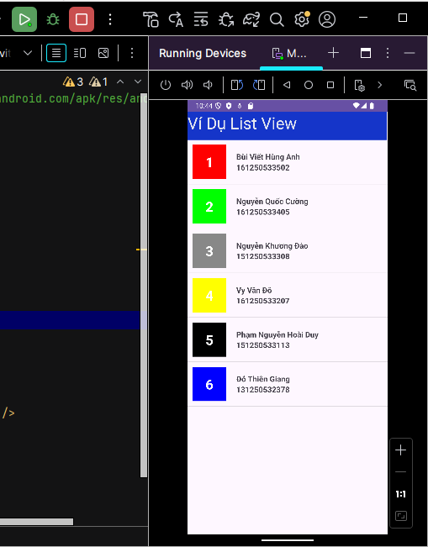

**File activity_main.xml**

<?xml version="1.0" encoding="utf-8"?>  
<LinearLayout xmlns:android="http://schemas.android.com/apk/res/android"  
 android:layout_width="match_parent"  
 android:layout_height="match_parent"  
 android:orientation="vertical">  
 <TextView  
 android:id="@+id/textView"  
 android:layout_width="410dp"  
 android:layout_height="58dp"  
 android:background="#1535C9"  
 android:text="Ví Dụ List View"  
 android:textColor="#E4E7EF"  
 android:textSize="34sp"  
 />  
  
 <ListView  
 android:id="@+id/lvContacts"  
 android:layout_width="match_parent"  
 android:layout_height="match_parent" />  
  
</LinearLayout>

**File row_listview.xml**

<?xml version="1.0" encoding="utf-8"?>  
<LinearLayout xmlns:android="http://schemas.android.com/apk/res/android"  
 android:layout_width="match_parent"  
 android:layout_height="wrap_content"  
 android:orientation="horizontal"  
 android:padding="10dp">  
  
 <!-- Avatar -->  
 <TextView  
 android:id="@+id/tvAvatar"  
 android:layout_width="70dp"  
 android:layout_height="70dp"  
 android:background="#18ade4"  
 android:gravity="center"  
 android:text="1"  
 android:textColor="#ffffff"  
 android:textSize="28sp"  
 android:textStyle="bold" />  
  
 <!-- Thông tin sinh viên -->  
 <LinearLayout  
 android:layout_width="wrap_content"  
 android:layout_height="wrap_content"  
 android:layout_gravity="center"  
 android:layout_marginLeft="20dp"  
 android:orientation="vertical">  
  
 <TextView  
 android:id="@+id/tvName"  
 android:layout_width="wrap_content"  
 android:layout_height="wrap_content"  
 android:text="Tên sinh viên"  
 android:textSize="16sp"  
 android:textStyle="bold" />  
  
 <TextView  
 android:id="@+id/tvMaSinhVien"  
 android:layout_width="wrap_content"  
 android:layout_height="wrap_content"  
 android:text="Mã sinh viên"  
 android:textSize="16sp"  
 android:textStyle="bold" />  
 </LinearLayout>  
</LinearLayout>

**File MainActivity.java**

package com.example.th3**;**import android.graphics.Color**;**import android.os.Bundle**;**import android.widget.ListView**;**import androidx.appcompat.app.AppCompatActivity**;**import java.util.ArrayList**;**public class MainActivity extends AppCompatActivity {  
  
 private ListView lvContacts**;** @Override  
 protected void onCreate(Bundle savedInstanceState) {  
 super.onCreate(savedInstanceState)**;** setContentView(R.layout.*activity_main*)**;** lvContacts = findViewById(R.id.*lvContacts*)**;** ArrayList<Contact> contactList = new ArrayList<>()**;** contactList.add(new Contact("Bùi Viết Hùng Anh"**,** "161250533502"**,** Color.*RED*))**;** contactList.add(new Contact("Nguyễn Quốc Cường"**,** "161250533405"**,** Color.*GREEN*))**;** contactList.add(new Contact("Nguyễn Khương Đào"**,** "151250533308"**,** Color.*GRAY*))**;** contactList.add(new Contact("Vy Văn Đô"**,** "161250533207"**,** Color.*YELLOW*))**;** contactList.add(new Contact("Phạm Nguyễn Hoài Duy"**,** "151250533113"**,** Color.*BLACK*))**;** contactList.add(new Contact("Đỗ Thiên Giang"**,** "131250532378"**,** Color.*BLUE*))**;** CustomAdapter adapter = new CustomAdapter(this**,** R.layout.*row_listview***,** contactList)**;** lvContacts.setAdapter(adapter)**;** }  
}

**File Contact.java**

package com.example.th3**;**public class Contact {  
 private String name**;** private String idStudent**;** private int color**;** public Contact(String name**,** String idStudent**,** int color) {  
 this.name = name**;** this.idStudent = idStudent**;** this.color = color**;** }  
  
 // Getters và Setters  
 public String getName() {  
 return name**;** }  
  
 public String getIdStudent() {  
 return idStudent**;** }  
  
 public int getColor() {  
 return color**;** }  
}

**File CustomAdapter.java**

package com.example.th3**;**import android.content.Context**;**import android.view.LayoutInflater**;**import android.view.View**;**import android.view.ViewGroup**;**import android.widget.ArrayAdapter**;**import android.widget.TextView**;**import java.util.List**;**public class CustomAdapter extends ArrayAdapter<Contact> {  
 private Context context**;** private int resource**;** private List<Contact> contactList**;** public CustomAdapter(Context context**,** int resource**,** List<Contact> contactList) {  
 super(context**,** resource**,** contactList)**;** this.context = context**;** this.resource = resource**;** this.contactList = contactList**;** }  
  
 @Override  
 public View getView(int position**,** View convertView**,** ViewGroup parent) {  
 ViewHolder viewHolder**;** if (convertView == null) {  
 LayoutInflater inflater = LayoutInflater.*from*(context)**;** convertView = inflater.inflate(R.layout.*row_listview***,** parent**,** false)**;** viewHolder = new ViewHolder()**;** viewHolder.tvName = convertView.findViewById(R.id.*tvName*)**;** viewHolder.tvIdStudent = convertView.findViewById(R.id.*tvMaSinhVien*)**;** viewHolder.tvAvatar = convertView.findViewById(R.id.*tvAvatar*)**;** convertView.setTag(viewHolder)**;** } else {  
 viewHolder = (ViewHolder) convertView.getTag()**;** }  
  
 Contact contact = contactList.get(position)**;** viewHolder.tvAvatar.setBackgroundColor(contact.getColor())**;** viewHolder.tvAvatar.setText(String.*valueOf*(position + **1**))**;** // Hiển thị vị trí như avatar  
 viewHolder.tvName.setText(contact.getName())**;** viewHolder.tvIdStudent.setText(contact.getIdStudent())**;** return convertView**;** }  
  
 private static class ViewHolder {  
 TextView tvName**;** TextView tvIdStudent**;** TextView tvAvatar**;** }  
}

**Bài 4 và 5**

**Giao diện bài 4 và 5**

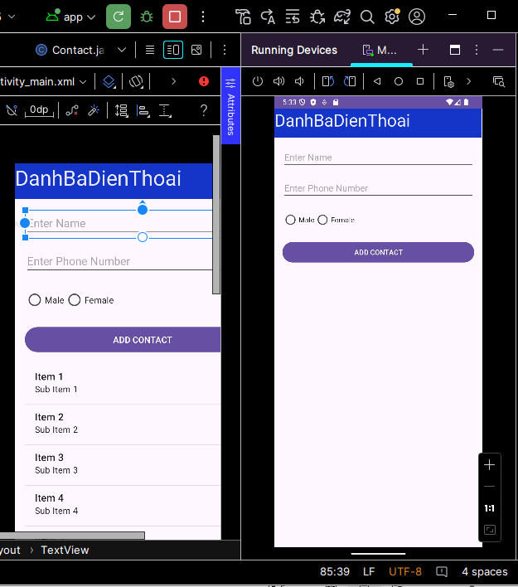

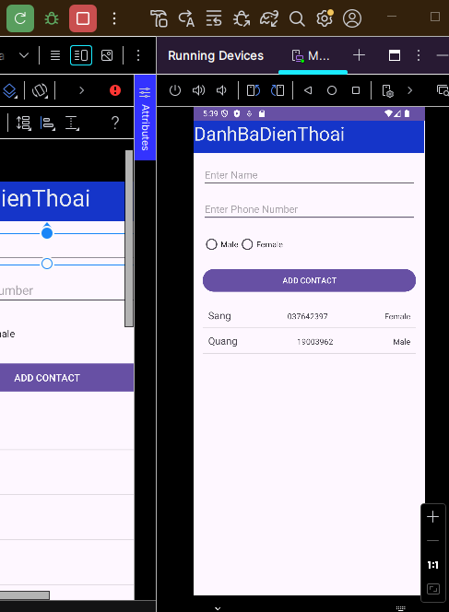

**File activity_main.xml**

<?xml version="1.0" encoding="utf-8"?>  
<androidx.constraintlayout.widget.ConstraintLayout xmlns:android="http://schemas.android.com/apk/res/android"  
 xmlns:app="http://schemas.android.com/apk/res-auto"  
 xmlns:tools="http://schemas.android.com/tools"  
 android:layout_width="match_parent"  
 android:layout_height="match_parent"  
 tools:context=".MainActivity">  
  
 <!-- EditText for Name -->  
  
 <!-- EditText for Phone Number -->  
  
 <EditText  
 android:id="@+id/etName"  
 android:layout_width="0dp"  
 android:layout_height="wrap_content"  
 android:layout_margin="16dp"  
 android:hint="Enter Name"  
 app:layout_constraintEnd_toEndOf="parent"  
 app:layout_constraintStart_toStartOf="parent"  
 app:layout_constraintTop_toBottomOf="@+id/textView" />  
  
 <EditText  
 android:id="@+id/etPhone"  
 android:layout_width="0dp"  
 android:layout_height="wrap_content"  
 android:hint="Enter Phone Number"  
 android:inputType="phone"  
 app:layout_constraintTop_toBottomOf="@+id/etName"  
 app:layout_constraintStart_toStartOf="parent"  
 app:layout_constraintEnd_toEndOf="parent"  
 android:layout_margin="16dp" />  
  
 <!-- RadioGroup for Gender Selection -->  
 <RadioGroup  
 android:id="@+id/rgGender"  
 android:layout_width="0dp"  
 android:layout_height="wrap_content"  
 app:layout_constraintTop_toBottomOf="@+id/etPhone"  
 app:layout_constraintStart_toStartOf="parent"  
 app:layout_constraintEnd_toEndOf="parent"  
 android:layout_margin="16dp"  
 android:orientation="horizontal">  
  
 <RadioButton  
 android:id="@+id/rbMale"  
 android:layout_width="wrap_content"  
 android:layout_height="wrap_content"  
 android:text="Male" />  
  
 <RadioButton  
 android:id="@+id/rbFemale"  
 android:layout_width="wrap_content"  
 android:layout_height="wrap_content"  
 android:text="Female" />  
 </RadioGroup>  
  
 <!-- Button to Add Contact -->  
 <Button  
 android:id="@+id/btnAdd"  
 android:layout_width="0dp"  
 android:layout_height="wrap_content"  
 android:text="ADD CONTACT"  
 app:layout_constraintTop_toBottomOf="@+id/rgGender"  
 app:layout_constraintStart_toStartOf="parent"  
 app:layout_constraintEnd_toEndOf="parent"  
 android:layout_margin="16dp" />  
  
 <!-- ListView for displaying contacts -->  
 <ListView  
 android:id="@+id/lvContacts"  
 android:layout_width="0dp"  
 android:layout_height="0dp"  
 app:layout_constraintTop_toBottomOf="@+id/btnAdd"  
 app:layout_constraintBottom_toBottomOf="parent"  
 app:layout_constraintStart_toStartOf="parent"  
 app:layout_constraintEnd_toEndOf="parent"  
 android:layout_margin="16dp" />  
  
 <TextView  
 android:id="@+id/textView"  
 android:layout_width="410dp"  
 android:layout_height="58dp"  
 android:background="#1535C9"  
 android:text="DanhBaDienThoai"  
 android:textColor="#E4E7EF"  
 android:textSize="34sp"  
 />  
  
  
</androidx.constraintlayout.widget.ConstraintLayout>

**File row_contact.xml**

<?xml version="1.0" encoding="utf-8"?>  
<LinearLayout xmlns:android="http://schemas.android.com/apk/res/android"  
 android:layout_width="match_parent"  
 android:layout_height="wrap_content"  
 android:orientation="horizontal"  
 android:padding="10dp">  
  
 <!-- TextView for Contact Name -->  
 <TextView  
 android:id="@+id/tvName"  
 android:layout_width="wrap_content"  
 android:layout_height="wrap_content"  
 android:text="Name"  
 android:textSize="18sp"  
 android:layout_weight="1" />  
  
 <!-- TextView for Phone Number -->  
 <TextView  
 android:id="@+id/tvPhone"  
 android:layout_width="wrap_content"  
 android:layout_height="wrap_content"  
 android:text="Phone"  
 android:layout_weight="1" />  
  
 <!-- TextView for Gender -->  
 <TextView  
 android:id="@+id/tvGender"  
 android:layout_width="wrap_content"  
 android:layout_height="wrap_content"  
 android:text="Gender" />  
</LinearLayout>

**MainActivity.java**

package com.example.th345**;**import android.os.Bundle**;**import android.view.View**;**import android.widget.ArrayAdapter**;**import android.widget.Button**;**import android.widget.EditText**;**import android.widget.ListView**;**import android.widget.RadioButton**;**import android.widget.RadioGroup**;**import androidx.appcompat.app.AppCompatActivity**;**import java.util.ArrayList**;**public class MainActivity extends AppCompatActivity {  
  
 private EditText etName**,** etPhone**;** private RadioGroup rgGender**;** private Button btnAdd**;** private ListView lvContacts**;** private ArrayList<Contact> contactList**;** private ContactAdapter contactAdapter**;** @Override  
 protected void onCreate(Bundle savedInstanceState) {  
 super.onCreate(savedInstanceState)**;** setContentView(R.layout.*activity_main*)**;** // Initialize views  
 etName = findViewById(R.id.*etName*)**;** etPhone = findViewById(R.id.*etPhone*)**;** rgGender = findViewById(R.id.*rgGender*)**;** btnAdd = findViewById(R.id.*btnAdd*)**;** lvContacts = findViewById(R.id.*lvContacts*)**;** // Initialize the list and adapter  
 contactList = new ArrayList<>()**;** contactAdapter = new ContactAdapter(this**,** contactList)**;** lvContacts.setAdapter(contactAdapter)**;** // Set button click listener to add a contact  
 btnAdd.setOnClickListener(new View.OnClickListener() {  
 @Override  
 public void onClick(View v) {  
 String name = etName.getText().toString()**;** String phone = etPhone.getText().toString()**;** int selectedGenderId = rgGender.getCheckedRadioButtonId()**;** RadioButton selectedRadioButton = findViewById(selectedGenderId)**;** String gender = selectedRadioButton.getText().toString()**;** // Create new contact and add to the list  
 Contact newContact = new Contact(name**,** phone**,** gender)**;** contactList.add(newContact)**;** // Notify the adapter to refresh the ListView  
 contactAdapter.notifyDataSetChanged()**;** // Clear input fields  
 etName.setText("")**;** etPhone.setText("")**;** rgGender.clearCheck()**;** }  
 })**;** }  
}

**Contact.java**

package com.example.th345**;**public class Contact {  
 private String name**;** private String phoneNumber**;** private String gender**;** public Contact(String name**,** String phoneNumber**,** String gender) {  
 this.name = name**;** this.phoneNumber = phoneNumber**;** this.gender = gender**;** }  
  
 public String getName() {  
 return name**;** }  
  
 public String getPhoneNumber() {  
 return phoneNumber**;** }  
  
 public String getGender() {  
 return gender**;** }  
}

**ContactAdapter.java**

package com.example.th345**;**import android.content.Context**;**import android.view.LayoutInflater**;**import android.view.View**;**import android.view.ViewGroup**;**import android.widget.ArrayAdapter**;**import android.widget.TextView**;**import java.util.ArrayList**;**public class ContactAdapter extends ArrayAdapter<Contact> {  
  
 public ContactAdapter(Context context**,** ArrayList<Contact> contacts) {  
 super(context**, 0,** contacts)**;** }  
  
 @Override  
 public View getView(int position**,** View convertView**,** ViewGroup parent) {  
 Contact contact = getItem(position)**;** if (convertView == null) {  
 convertView = LayoutInflater.*from*(getContext()).inflate(R.layout.*row_contact***,** parent**,** false)**;** }  
  
 TextView tvName = convertView.findViewById(R.id.*tvName*)**;** TextView tvPhone = convertView.findViewById(R.id.*tvPhone*)**;** TextView tvGender = convertView.findViewById(R.id.*tvGender*)**;** tvName.setText(contact.getName())**;** tvPhone.setText(contact.getPhoneNumber())**;** tvGender.setText(contact.getGender())**;** return convertView**;** }  
}