Tên: Trần Thị Na

MSSV:2151053040

**CHƯƠNG V: ĐỒ THỊ**

**1. Thực hiện đếm bậc các đỉnh tại ví dụ 5.1, 5.2, 5.3, 5.6**

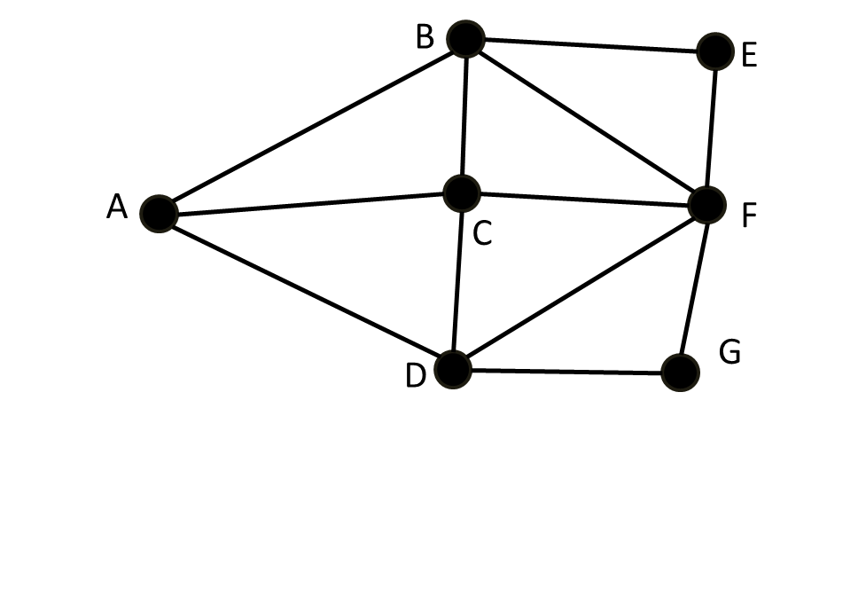

d(A)=3

d(B)=4

d(C)=4

d(D)=4

d(E)=2

d(F)=5

d(G)=2

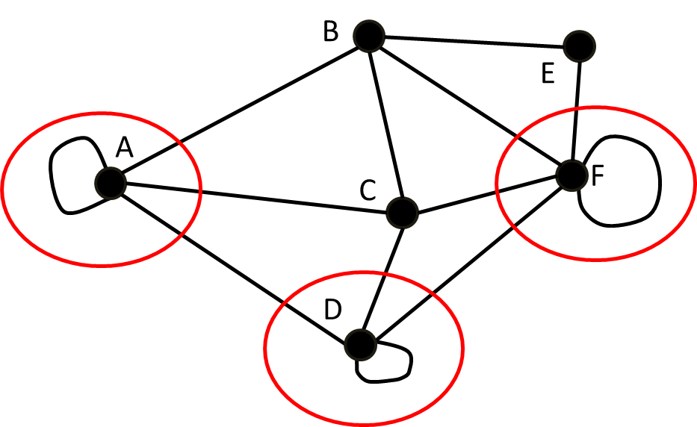

d(A)=5

d(B)=4

d(C)=4

d(D)=5

d(E)=2

d(F)=6

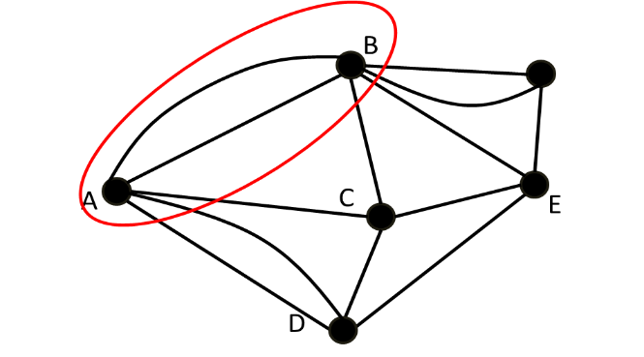

d(A)=5

d(B)=6

d(C)=4

d(D)=4

d(E)=4

d(F)=3

**2. Cho biết ma trận kề của đồ thị tại ví dụ 5.1, 5.6, 5.7, 5.11**



|  |  |  |  |  |  |  |  |
| --- | --- | --- | --- | --- | --- | --- | --- |
|  | **A** | **B** | **C** | **D** | **E** | **F** | **G** |
| **A** | **0** | **1** | **1** | **1** | **0** | **0** | **0** |
| **B** | **1** | **0** | **1** | **0** | **1** | **1** | **0** |
| **C** | **1** | **1** | **0** | **1** | **0** | **1** | **0** |
| **D** | **1** | **0** | **1** | **0** | **0** | **1** | **1** |
| **E** | **0** | **1** | **0** | **0** | **0** | **1** | **0** |
| **F** | **0** | **1** | **1** | **1** | **1** | **0** | **1** |
| **G** | **0** | **0** | **0** | **1** | **0** | **1** | **0** |

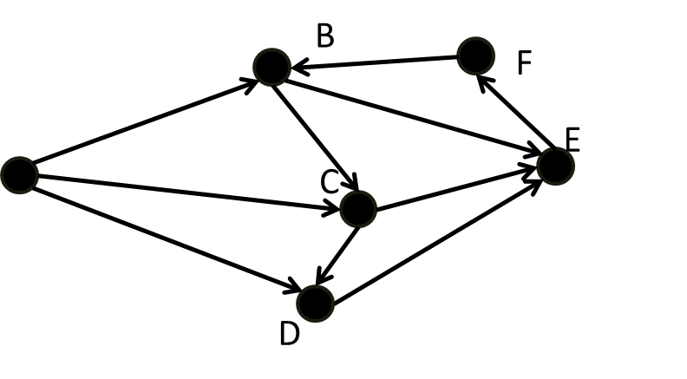

|  |  |  |  |  |  |  |
| --- | --- | --- | --- | --- | --- | --- |
|  | **A** | **B** | **C** | **D** | **E** | **F** |
| **A** | **0** | **1** | **1** | **1** | **0** | **0** |
| **B** | **0** | **0** | **1** | **0** | **1** | **0** |
| **C** | **0** | **0** | **0** | **1** | **1** | **0** |
| **D** | **0** | **0** | **0** | **0** | **1** | **0** |
| **E** | **0** | **0** | **0** | **0** | **0** | **1** |
| **F** | **0** | **1** | **0** | **0** | **0** | **0** |

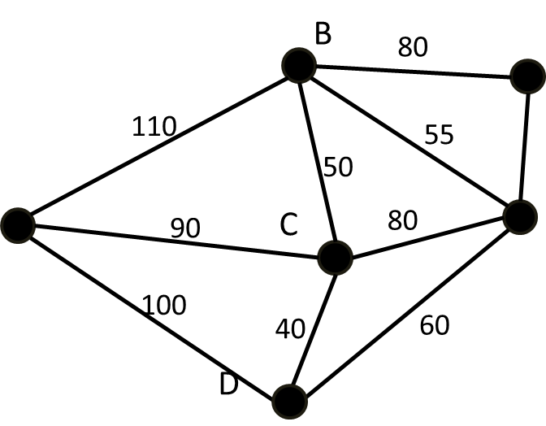

|  |  |  |  |  |  |  |
| --- | --- | --- | --- | --- | --- | --- |
|  | **A** | **B** | **C** | **D** | **E** | **F** |
| **A** | **0** | **1** | **1** | **1** | **0** | **0** |
| **B** | **1** | **0** | **1** | **0** | **1** | **1** |
| **C** | **1** | **1** | **0** | **1** | **1** | **0** |
| **D** | **0** | **0** | **0** | **0** | **0** | **0** |
| **E** | **1** | **0** | **1** | **0** | **1** | **0** |
| **F** | **0** | **1** | **0** | **0** | **1** | **0** |

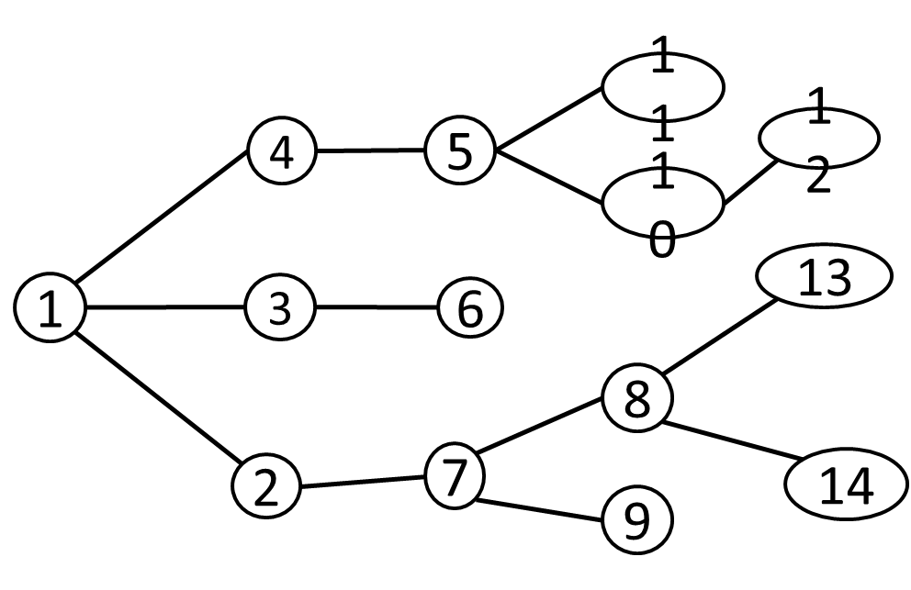

|  |  |  |  |  |  |  |  |  |  |  |  |  |  |  |
| --- | --- | --- | --- | --- | --- | --- | --- | --- | --- | --- | --- | --- | --- | --- |
|  | **1** | **2** | **3** | **4** | **5** | **6** | **7** | **8** | **9** | **10** | **11** | **12** | **13** | **14** |
| **1** | **0** | **1** | **1** | **1** | **0** | **0** | **0** | **0** | **0** | **0** | **0** | **0** | **0** | **0** |
| **2** | **0** | **0** | **0** | **0** | **0** | **0** | **1** | **0** | **0** | **0** | **0** | **0** | **0** | **0** |
| **3** | **0** | **0** | **0** | **0** | **0** | **1** | **0** | **0** | **0** | **0** | **0** | **0** | **0** | **0** |
| **4** | **0** | **0** | **0** | **0** | **1** | **0** | **0** | **0** | **0** | **0** | **0** | **0** | **0** | **0** |
| **5** | **0** | **0** | **0** | **0** | **0** | **0** | **0** | **0** | **0** | **1** | **1** | **0** | **0** | **0** |
| **6** | **0** | **0** | **0** | **0** | **0** | **0** | **0** | **0** | **0** | **0** | **0** | **0** | **0** | **0** |
| **7** | **0** | **0** | **0** | **0** | **0** | **0** | **0** | **1** | **1** | **0** | **0** | **0** | **0** | **0** |
| **8** | **0** | **0** | **0** | **0** | **0** | **0** | **0** | **0** | **0** | **0** | **0** | **0** | **1** | **1** |
| **9** | **0** | **0** | **0** | **0** | **0** | **0** | **0** | **0** | **0** | **0** | **0** | **1** | **0** | **0** |
| **10** | **0** | **0** | **0** | **0** | **0** | **0** | **0** | **0** | **0** | **0** | **0** | **0** | **0** | **0** |
| **11** | **0** | **0** | **0** | **0** | **0** | **0** | **0** | **0** | **0** | **0** | **0** | **0** | **0** | **0** |
| **12** | **0** | **0** | **0** | **0** | **0** | **0** | **0** | **0** | **0** | **0** | **0** | **0** | **0** | **0** |
| **13** | **0** | **0** | **0** | **0** | **0** | **0** | **0** | **0** | **0** | **0** | **0** | **0** | **0** | **0** |
| **14** | **0** | **0** | **0** | **0** | **0** | **0** | **0** | **0** | **0** | **0** | **0** | **0** | **0** | **0** |

**3. Cho biết danh sách kề của đồ thị tại ví dụ 5.1, 5.7, 5.8, 5.11**

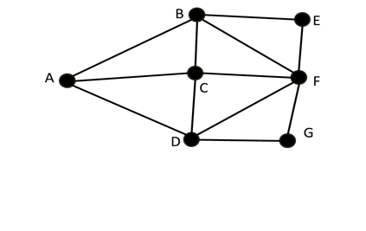

**First[0] A->B->C->D->NULL**

**First[1] B->A->C->E->F->NULL**

**First[2] C->A->B->D->F->NULL**

**First[3] D->A->C->F->G->NULL**

**First[4] E->B->F->NULL**

**First[5] F->B->C->D->E->G->NULL**

**First[6] G->D->F->NULL**



**E**

**A**

**F**

**First[0] A->B->C->D->NULL**

**First[1] B->A->C->E->F->NULL**

**First[2] C->A->B->D->E->NULL**

**First[3] D->A->C->E ->NULL**

**First[4] E->C->D->F->NULL**

**First[5] F->B->E ->NULL**

