

International School
Capstone Project 2

CMU-SE 451 – C2SE.12

User Interface Design
Version 1.1 Date: 20/1/2026

EXCESS PRODUCT MANAGEMENT SYSTEM

Submitted by Nam Khanh
Bao Huy
Nhat Quang
Quang Kiet
Quang Sang

Approved by
MSc Huy, Truong Dinh

Proposal Review Panel Representative:

Name Signature Date

Capstone Project 2- Mentor:

Name Signature Date

PROJECT INFORMATION

Project acronym | LET
Project Title | EXCESS PRODUCT MANAGEMENT SYSTEM
Start Date |  | End Date | 08 Jun 2021
Lead Institution | International School, Duy Tan University
Project Mentor | MSc Huy, Truong Dinh
Scrum master / Project Leader & contact details | Ha, Le Thanh  Email: lethanhhadtu@gmail.com Tel: 0334002818
Partner Organization | Duy Tan University
Project Web URL
Team members | Name | Email | Tel
 | Nam Khanh | namkhanhtran10@gmail.com
 | Quang Kiet | ngqkiet121205@gmail.com
 | Bao Huy | hymail90299029@gmail.com
 | Quang Sang | sangtran486@gmail.com
 | Nhat Quang | quangquang04022005@gmai.com

The following signatures are required for approval of this document.

Tran Nam Khanh  Scrum Master | Signature | Date
Dang Nguyen Nhat  Team Member | Signature | Date
Tran Quang Sang  Team Member | Signature | Date
Nguyen Bao Huy  Team Member | Signature | Date
Nguyen Quang Kiet
Team Member

REVISION HISTORY

Version | Date | Comments | Author
1.0 | 20/1/2026 | Initial Release

- Introduction 5
  - Purpose 5
  - Scope 5
- Interface Design 5
  - Home page 5
  - Navbar 6
  - Footer 6
  - Group 7
    - Topic 7
    - Group of topic 8
    - Detail group 9
  - Profile 10
  - Live stream 11
  - Chat 12

Introduction

Purpose
This specification covers following:
- Documentation helps to better understand the user interface of the website, the detailed description and functionality of the website.
- With this documentation, the development team can understand the structure and composition details to create a consistent and complete system.

Scope
- Overview of the stages and modules of the software.
- Create a complete interface and describe them clearly.

Interface Design

Home page
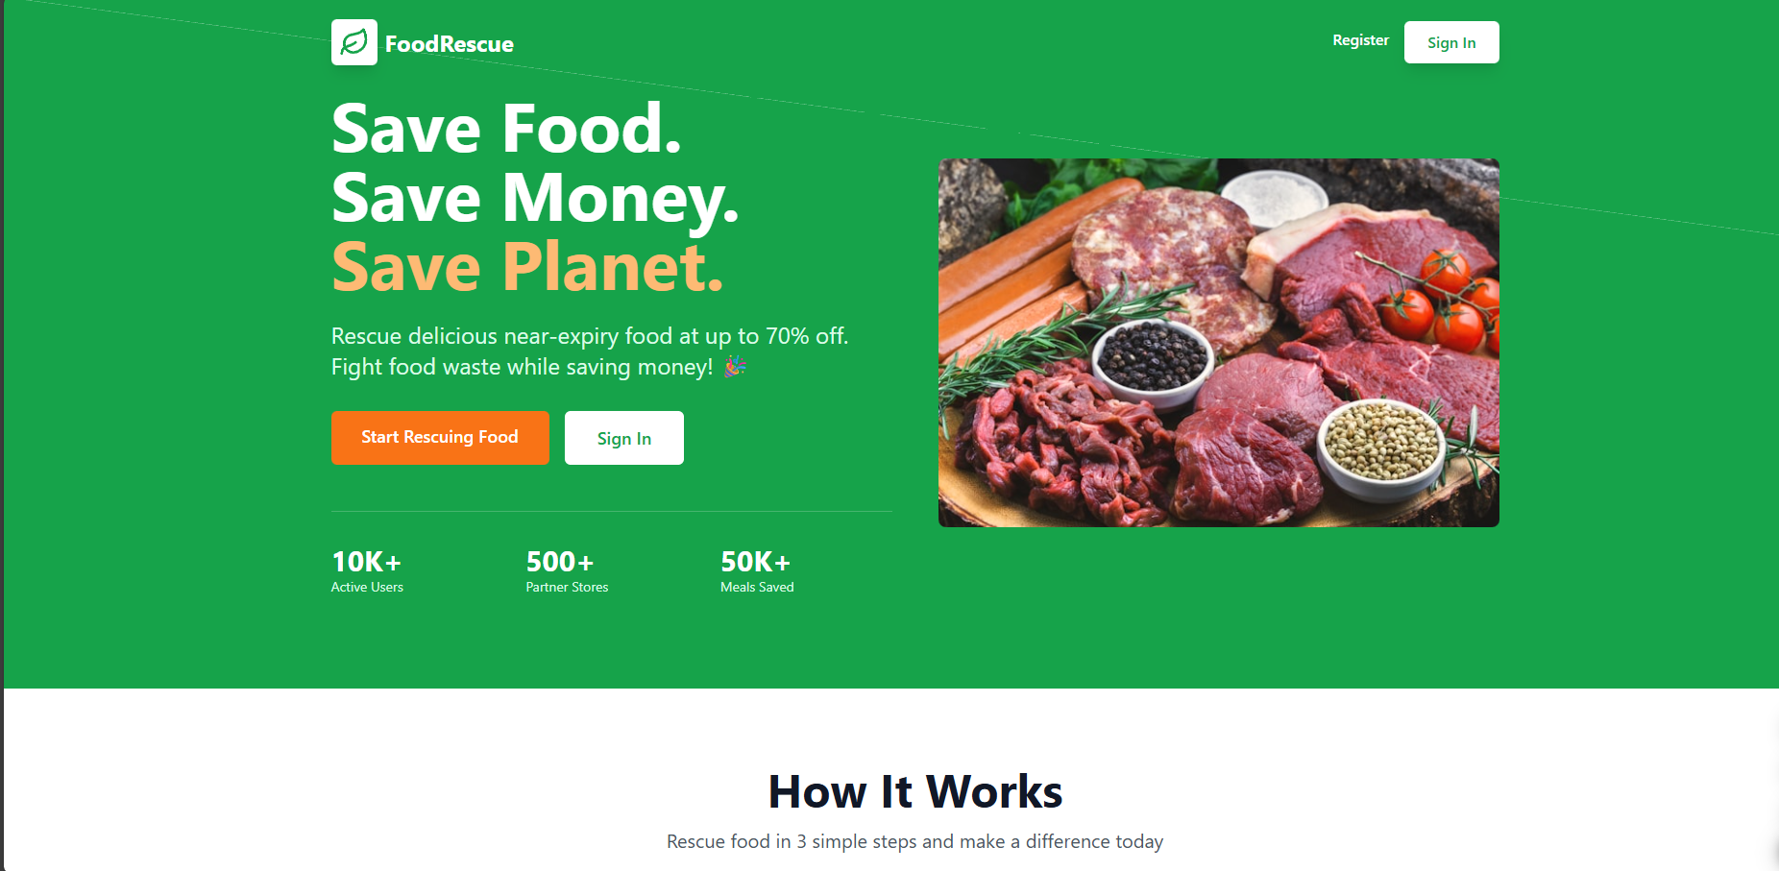

Homepage
No. | Field name | Type | Require | Target
1 | Background |  | Background: #10b981 | Full page background
2 | Hero Section | Grid Layout | Heading: h1 tag; Font-size: 5xl-7xl; Color: white | Display main value proposition

3 | Navigation Bar | Flex Container | Logo + Text; Background: transparent; Buttons: Register, Sign In | Navigation menu
4 | Stats Section | Grid View | Font-size: 3xl; Color: white; Padding-top: 8 | Show: Active Users, Partner Stores, Meals Saved
5 | Call-to-Action | Button Group | Background: accent-500, white; Font-size: lg; Padding: px-8 py-3 | "Start Rescuing Food", "Sign In"
6 | Features Section | Grid Layout | Icons: ShoppingBag, Store, TrendingDown; Padding: 20 | How it works section
7 | Hero Image | Image | Position: right; Border-radius: 8px | Display food image
8 | Benefits Cards | Card Grid | Border: 2px gray-200; Hover: border-primary-600 | Platform benefits

Login Page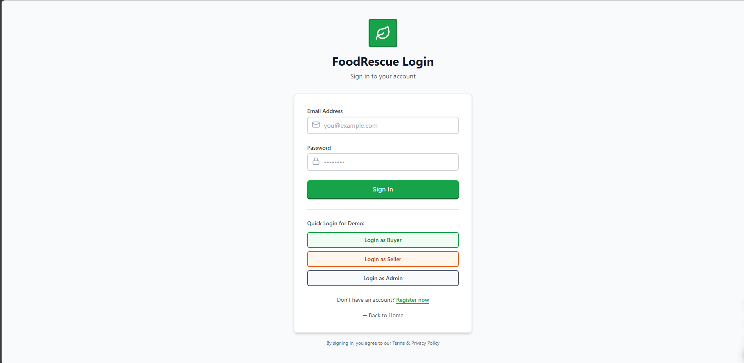

Login Page
No. | Field name | Type | Require | Target
1 | Background | Color | Background: #f9fafb | Full page background
2 | Form Container | Card | Background: white; Border: 2px gray-200; Shadow: md; Padding: 8 | Login form wrapper
3 | Email Input | Text Field | Type: email; Border: 2px gray-300; Icon: Mail; Padding-left: 10 | User email input
4 | Password Input | Password Field | Type: password; Icon: Lock; Toggle visibility button | User password input
5 | Login Button | Submit Button | Background: primary-600; Color: white; Hover: primary-700 | Submit login form
6 | Quick Login | Button Grid | Background: gray-50; Border: 2px gray-200; Text: center | Demo account login
7 | Error Message | Flex | Background: primary-600; Padding: 12px; Border: 4px | Display logo
8 | Logo Container | Alert | Background: red-50; Border-left: 4px red-500 | Error messages

Register Page

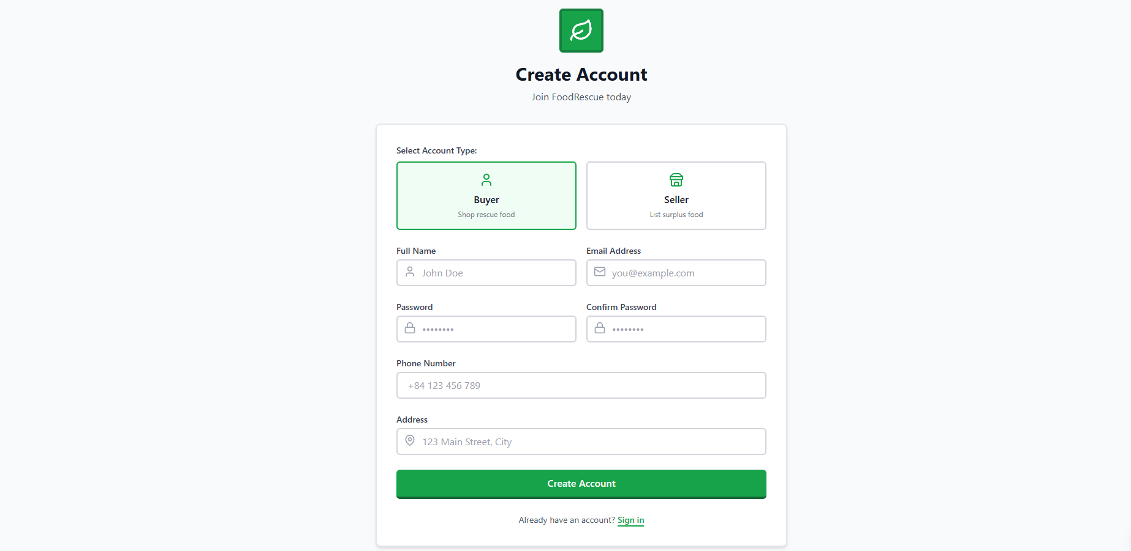

Register Page
No. | Field name | Type | Require | Target
1 | Background | Color | Background: gray-50 | Full page background
2 | Name Input | Text Field | Type: text; Border: 2px gray-300; Icon: User; Required: true | User full name
3 | Role Selection | Radio Group | Options: Buyer, Seller; Background: gray-50; Selected: primary-600 | Select user role
4 | Register Button | Submit Button | Background: primary-600; Color: white; Font-weight: semibold | Submit registration
5 | Password Input | Password | Min-length: 6; Icon: Lock; Required: true | User password
6 | Form Container | Card | Max-width: 448px; Padding: 32px; Border: 2px | Registration wrapper

Marketplace Page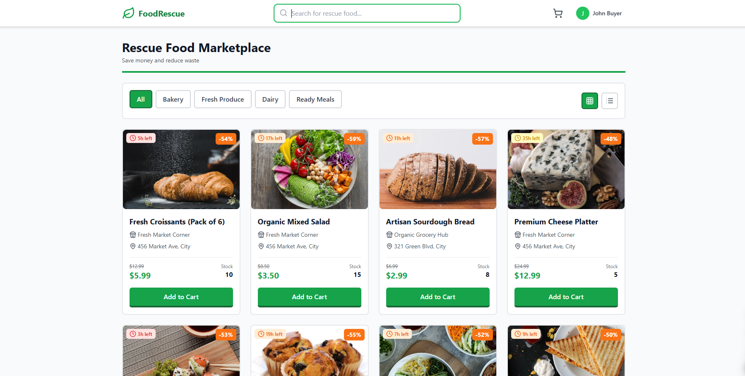

Topic
No. | Field name | Type | Require | Target
1 | Search Bar | Input Field | Type: text; Border: 2px gray-300; Placeholder: "Search products..." | Search products
2 | Product Card | Card Component | Background: white; Border: 2px gray-200; Border-radius: lg | Display product info
3 | Discount Badge | Label | Background: accent-500; Color: white; Position: absolute top-right | Show discount %
4 | Expiry Timer | Label | Background: dynamic (red/orange/yellow-100); Icon: Clock | Show time left
5 | Price Display | Text Group | Original: line-through gray-400; Rescue price: text-2xl primary-600 | Display pricing
6 | Category Filter | Button | Background: gray-100; Radius: 6px; Font-size: 14px +2 | Filter by category
7 | Product Image | Image | Height: 192px; Object-fit: cover; Radius: 8px +3 | Product photo
8 | Add to Cart | Button | Background: primary-600; Icon: Plus; Hover: primary-700 | Add to cart

Cart Page
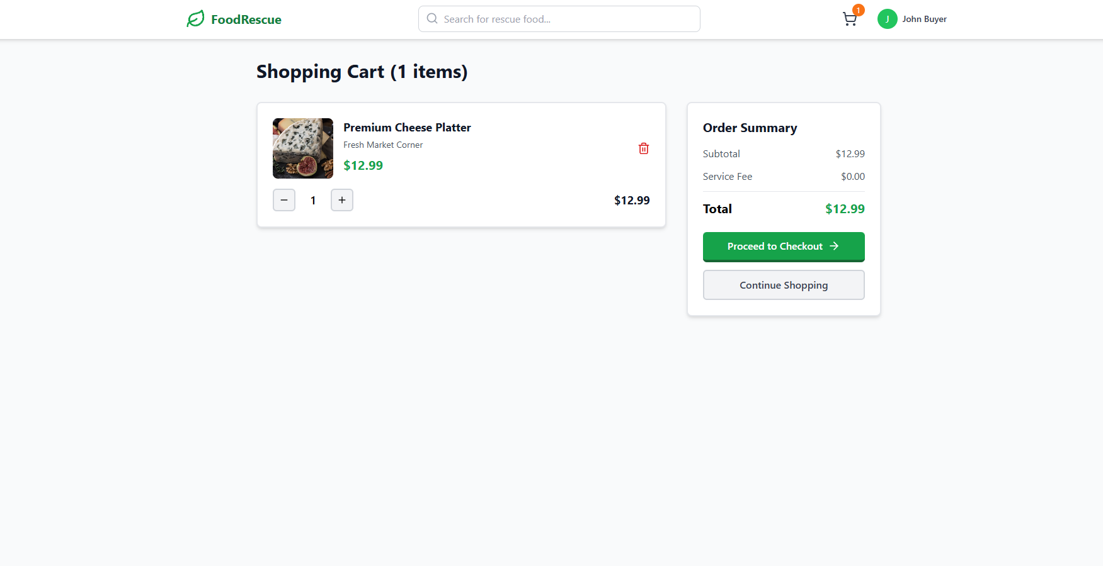
Profile
No. | Field name | Type | Require | Target
1 | Cart Item Card | Card | Background: white; Border: 2px gray-200; Flex layout | Display cart item
2 | Quantity Control | Button Group | Buttons: Minus, Plus; Border: 2px gray-300; Icons: Minus, Plus | Adjust quantity
3 | Summary Card | Card | Background: gray-50; Border: 2px gray-200; Position: sticky | Order summary
4 | Checkout Button | Submit Button | Background: primary-600; Color: white; Width: full | Proceed to checkout
5 | Cart Header | Heading | Font-size: 24px; Bold; Color: gray-900; Margin-bottom: 24px +4 | Page title
6 | Item Image | Image | Width & Height: 96px; Radius: 8px; Object-fit: cover +3 | Product thumbnail

Seller Dashboard

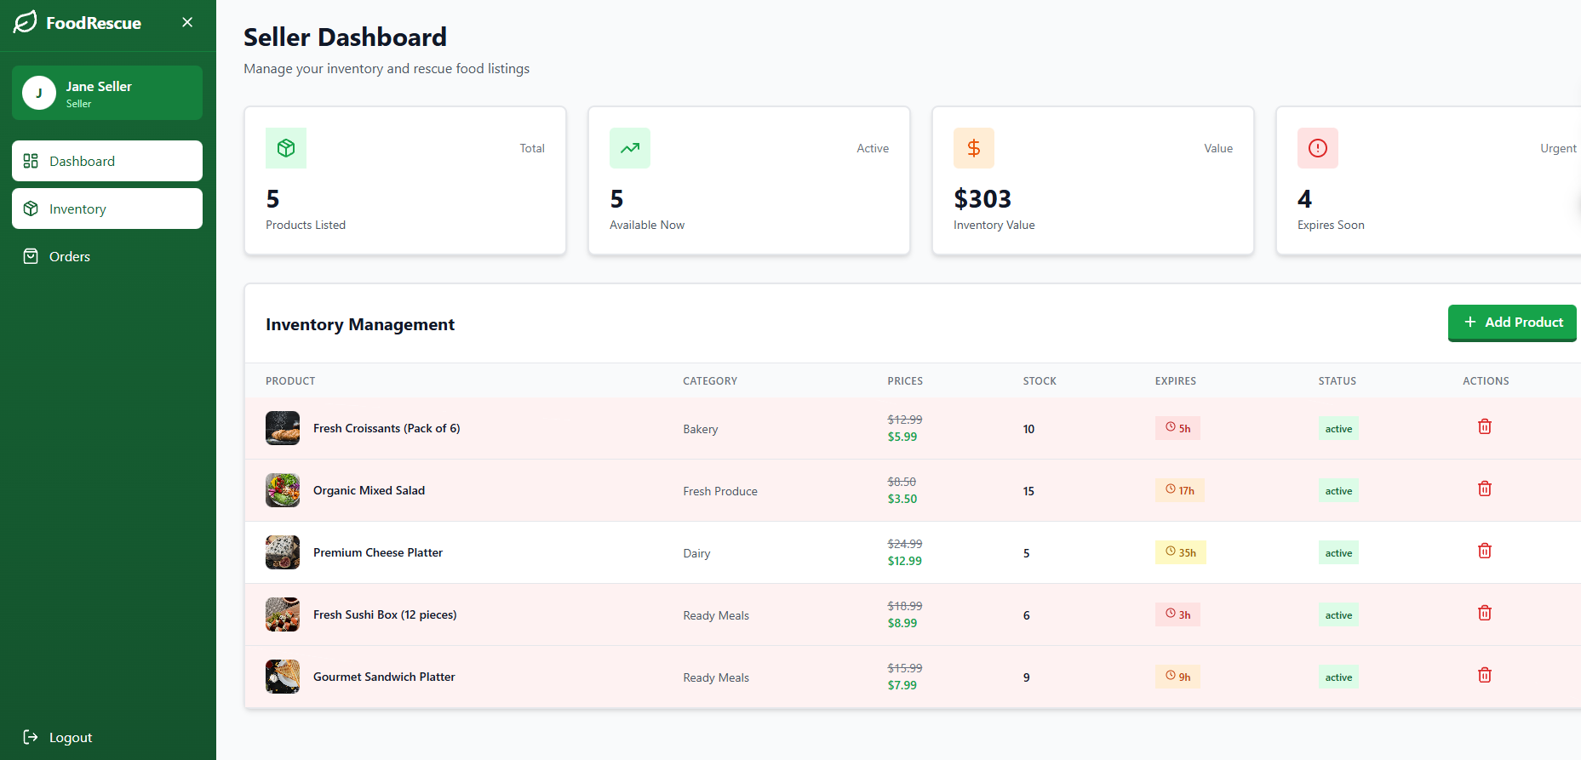
Profile
No. | Field name | Type | Require | Target
1 | Stats Grid | Grid Layout | Background: gradient primary; Padding: 6; Shadow: lg | Display key metrics
2 | Product List | Table/Grid | Background: white; Border: 2px gray-200; Padding: 6 | Display products

3 | User Table | Table Component | Headers: Name, Email, Role, Status; Border: 2px gray-200 | When others click, my screen will share
4 | Role/Status Badge | Label | Background: blue/green/red-100; Font-size: xs; Padding: 1 2 | back to the front of the computer screen

Admin Dashboard
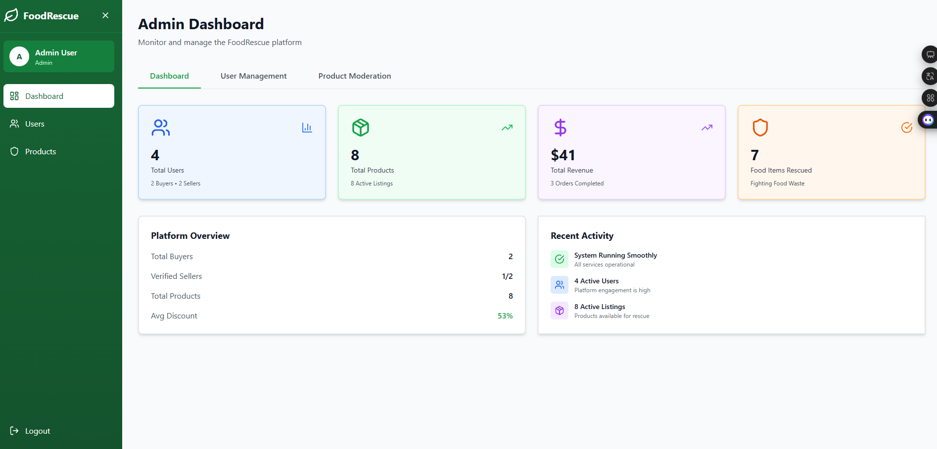
Profile
No. | Field name | Type | Require | Target
1 | Stats Grid | Grid | 4 columns; Padding: 24px; Radius: 8px | Key metrics
2 | Stat Number | Text | Font-size: 30px; Color: white; Bold | Show counts/revenue
3 | Product Table | Table | Border: 2px gray-200; Background: white; Padding: 24px | Display items/users
4 | Action Buttons | Button | Edit: blue-600; Delete: red-600; Toggle: green-600 | Product actions

5 | Role/Status Badge | Label | Font-size: 12px; Padding: 4px 8px | Show status

