FlowChart

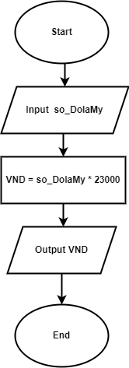

Pseudo-code

Begin

Input so_DolaMy

VND=so_DolaMy*23000

Output VND

End