SWE80005 – Enterprise Development

Learning Summary Report

Nguyen Tran Nguyen (6586880)

**Portfolio Submission Due**

Pass / Credit Portfolio: 6 June 2016 (Monday) 9:00 am

Distinction / High Distinction Portfolio: 13 June 2016 (Monday) 9:00 am

**Portfolio Interview Dates**

Distinction / High Distinction: 14 – 17 June 2016 (1 hour per student)

**[Optional, but Recommended] Timing for Tutor Feedback**

Pass / Credit Portfolio:

Your submission: 30th May 2016 (Monday) 9:00am

Tutor Feedback: 1st June 2016 (Wed) 5:00pm

Your revision and final submission: 6th June 2016 (Monday) 09:00am

Distinction / High Distinction: 14 – 17 June 2016 (1 hour per student)

Your submission: 6th June 2016 (Monday) 9:00am

Tutor Feedback: 8th June 2016 (Wed) 5:00pm

Your revision and final submission: 13th June 2016 (Monday) 9:00am

Self-Assessment Details

The following checklists provide an overview of my self-assessment for this unit.

Table 1 Self-assessment Statement

|  |  |  |  |  |
| --- | --- | --- | --- | --- |
|  | Pass (P) | Credit (C) | Distinction (D) | High Distinction (HD) |
| Self-Assessment (please tick) |  |  |  | X |

Table 2 Minimum Pass Checklist

|  |  |
| --- | --- |
|  | Included (please tick) |
| Learning Summary Report | X |
| All Pass Tasks are “Complete” on Doubtfire | X |

Table 3 Minimum Credit Checklist, in addition to Pass Checklist

|  |  |
| --- | --- |
|  | Included (please tick) |
| All Credit Tasks are “Complete” on Doubtfire | X |

Table 4 Minimum Distinction Checklist, in addition to Credit Checklist

|  |  |
| --- | --- |
|  | Included (please tick) |
| Interview booked | X |
| Distinction tasks (other than Custom Program; e.g. Software Proposal; Software Requirements Doc; Software Design Doc) are “Complete” on Doubtfire |  |
| Your custom-built Enterprise application software of your own design meets Distinction standards | X |
| Supporting documents for your design and implementation (e.g. Software Design doc, Software Test report) meet Distinction criteria | X |

Table 5 Minimum High Distinction Checklist, in addition to Distinction Checklist

|  |  |
| --- | --- |
|  | Included (please tick) |
| HD Proposal is “Complete” on Doubtfire |  |
| A research report and associated pieces (e.g. source code, if any) that meet HD standards |  |

# Declaration

I declare that this portfolio is my individual work. I have not copied from any other student’s work or from any other source except where due acknowledgment is made explicitly in the text, nor has any part of this submission been written for me by another person.

Signature:

# Introduction

This report summarises what I learnt in SWE80005 Enterprise Development. It includes a self-assessment against the criteria described in the unit outline, a justification of the pieces included, details of the coverage of the unit’s intended learning outcomes, and a reflection on my learning.

# Overview of Pieces Included

This section outlines the pieces that I have included in my portfolio…

1. Pass Task 1.1 Enterprise development glossary
2. Pass Task 1.2 Database Connectivity (C#) – program design and implementation
3. Pass Task 2.1 Enterprise development glossary (continue)
4. Pass Task 2.2 Entity Persistence and ORM – program design and implementation
5. Pass Task 3.1 Enterprise development glossary (continue)
6. Pass Task 3.2 Business logic layer – program design and implementation
7. Pass Task 4.1 Enterprise development glossary (Presentation Layer)
8. Pass Task 4.2 Web UI – program design and implementation
9. Pass Task 5.1 Enterprise development glossary (Business logics 2 – Stateful behaviour)
10. Pass Task 5.2 Stateful business logic – program design and implementation
11. Pass Task 6.1 Enterprise development glossary (Messaging)
12. Pass Task 6.2 Messaging – program design and implementation
13. Pass Task 8.1 Enterprise development glossary (Security concerns in Enterprise Application)
14. Pass Task 8.2 Security concerns in Enterprise Application – program design and implementation
15. Credit Task 4.3 Enterprise development glossary (WebUI + Ajax)
16. Credit Task 4.4 Web UI + Ajax – program design and implementation
17. Credit Task 5.3 Enterprise development glossary (Stateful behaviour retention)
18. Credit Task 8.3 Enterprise development glossary (SqlRoleProvider)
19. Credit Task 8.4 Securing your enterprise application – program design and implementation
20. …

# Coverage of the Intended Learning Outcomes

Change the grade. Then delete this box.

This section outlines how the pieces I have included demonstrate the depth of my understanding in relation to each of the unit’s intended learning outcomes. In particular, it includes work that demonstrates that I have achieved all Unit Learning Outcomes for SWE80005 Enterprise Development to a **Pass** level.

## ILO 1:

*Use a range of APIs and technologies to build enterprise applications and explain why the APIs and technologies were selected to develop the applications*

The following pieces demonstrate my ability in relation to this ILO:

For each ILO, describe the work you have included in your portfolio that demonstrates your ability in relation to the required outcomes. Then delete this box.

* Pass Task # …
* …

## ILO 2:

*Design (with justifications) and describe an enterprise architecture for a software solution to a given business scenario. The justification should ideally include at least the following topics:*

*a. the choice of any APIs and technologies*

*b. the selection of architectural patterns and the use of any best practices*

*c. any security issues and concerns and how to mitigate the potential threats*

…

## ILO 3:

*Develop end-to-end features of enterprise applications to given business scenarios. Ideally, you should demonstrate your understanding of at least the following topics*

*a. The choice of any APIs and technologies*

*b. The selection of architectural patterns and the use of any best practices*

*c. The choice of enterprise technologies to mitigate any potential threat raised by security issues and concerns*

…

## ILO 4:

*Perform independently research into a range of APIs and technologies so as to select appropriate technologies (with justification) to build enterprise applications; during the research process you should be able to present your findings and reasoning why such decisions are made*

…

# Reflection

Reflect on your learning and discuss these areas. Read the suggestions in [ ] for each question. Write your reflections then delete the text in the [ ] and delete this box.

## The most important things I learnt:

[ Think about topics covered, but also other general things you may have learnt. Think about what you have learnt in this subject, and reflect on what you think were key learning points, or incidents. Did you learn what you wanted/expected to learn? ]

## The things that helped me most were:

[ List and explain ]

## I found the following topics particularly challenging:

[ List and explain – if none explain why ]

## I found the following topics particularly interesting:

[ List and explain – remove if none ]

## I feel I learnt these topics, concepts, and/or tools really well:

[ List and explain – if none explain why, refer to your pieces for evidence to support your claims ]

## I still need to work on the following areas:

[ List and explain – if none explain why, refer to your pieces ]

## My progress in this unit was …:

[ Include a screenshot of your **progress graph** from **DoubtFire**, and comment on what happened from your perspective… what does the graph say about how you approached the unit? (Login to Doubtfire to get your graph <https://doubtfire.ict.swin.edu.au>)]

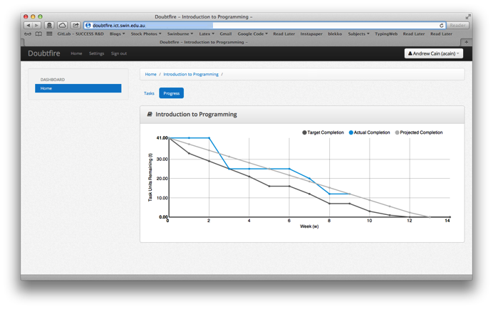

## This unit will help me in the future:

[ How will the things you learnt relate to the rest of your studies, and career. What have you learnt that will be valuable for you in the future? ]

## If I did this unit again I would do the following things differently:

[ List and explain, how will you approach learning in the future? What things worked well, but what could you change to make sure you did better next time?]

## Other…:

[ Add any other reflections you think help you demonstrate your learning ]