**TRƯỜNG ĐẠI HỌC KINH TẾ TP.HỒ CHÍ MINH**

**KHOA CÔNG NGHỆ THÔNG TIN KINH DOANH**

**KHÓA LUẬN TỐT NGHIỆP**

**ĐỀ TÀI:**

**XÂY DỰNG WEBSITE QUẢN LÍ PHÒNG KHÁM**

GVHD :

Sinh viên thực hiện :

Võ Đỗ Tiến Khâm

MSSV :

TP. Hồ Chí Minh , T8/2021

**NHẬN XÉT CỦA GIẢNG VIÊN**

………………………………………………………………………………………………………………………………………………………………………………………………………………………………………………………………………………………………………………………………………………………………………………………………………………………………………………………………………………………………………………………………………………………………………………………………………………………………………………………………………………………………………………………………………………………………………………………………………………………………………………………………………………………………………………………………………………………………………………………………………………………………………………………………………………………………………………………………………………………………………………………………………………………………………………………………………………………………………………………………………………………………………………………………………………………………………………………………………………………………………………………………………………………………………………………………………………………………………………………………………………………………

Ngày… Tháng … Năm …

**NHẬN XÉT CỦA GIẢNG VIÊN PHẢN BIỆN**

………………………………………………………………………………………………………………………………………………………………………………………………………………………………………………………………………………………………………………………………………………………………………………………………………………………………………………………………………………………………………………………………………………………………………………………………………………………………………………………………………………………………………………………………………………………………………………………………………………………………………………………………………………………………………………………………………………………………………………………………………………………………………………………………………………………………………………………………………………………………………………………………………………………………………………………………………………………………………………………………………………………………………………………………………………………………………………………………………………………………………………………………………………………………………………………………………………………………………………………………………………………………………………………………………………………………………………………………………………………………………………………………………………………………………………………………………………………………………………………………………………………………………………………………………………………………………………………………………………………………

Ngày… Tháng … Năm …

# Introduce

Online clinic management systems are facilities that meet the needs of patient examination and treatment management in clinics operated using information technology. The clinic management system also provides managers with control over the level, as well as the medical examination and treatment process of each patient seeking medical treatment at the clinic. The process of organizing and managing medical examination and treatment records of patients currently in some private clinics is still very primitive, taking a lot of time and energy of clinic managers. Along with the development of science and technology, the application of information technology to serve the management process well is an essential need. Therefore, I implemented the project "Clinic Management System" to solve this urgent need.

However, the main reason for choosing this project is that I want to write a program that is really simple, easy to use and effective in managing work effectively. This type of project has been implemented a lot with small and medium clinics and hospitals. But different characteristics for different clinics promote the analysis, evaluation and implementation of this project with the above objectives.

In addition, a challenge of the "Clinic Management System" project is how to effectively manipulate the number of patients, the medical examination and treatment process quickly and effectively. As well as the medical team in the clinic is increasing. This is the characteristic of the Online Clinic Management System, although initially the number of work and staff salaries is not much, but after a period of time, one thing is certain that the number will affect the number of employees, management, administration of drugs, prescriptions ... in the clinic system.

**Table of contents**

1. Introduce 4

1. Overview 1

1. Reasons for choosing a topic 1

1.1. Objectives, Scope And Objects Of Study 2

1.1.1. Research objectives 2

1.1.2. Scope of research 3

1.1.3. Subjects of study 3

1.2. Research approaches and methods 3

1.3. Research approaches and methods 4

2. SYSTEM ANALYSIS 5

2.1 The professional process of the hospital is generally described as follows 5

2.1.1 Medical Examination Process 5

2.1.2 Disease treatment process 5

2.1.3 Case Management Process 6

2.2 System User case 6

2.2.1 Use case system specification 8

2.2.2 Management of pathology lists 9

2.2.3 Visitation management 9

2.2.4 Staff management (medics, doctors, receptionists, accountants ...) 9

2.2.5 Clinic management 10

2.3 Sequential scheme in the clinic system 10

2.3.1 Service function sequential chart 10

2.3.2 Visitation management function 11

2.3.3 Appointment management function 11

2.3.4 Medical examination records 12

2.3.5 Drug administration 13

2.3.6 Material management 13

2.4 System design 14

2.4.1 Layout Login 14

2.4.2 Layout hơmpage 15

2.4.3 Class Chart 15

2.4.4 Moving the ERD model to the relational model 19

2.5 DATABASES 19

2.5.1 Data tables 19

3 LEARN ABOUT THE WATERFALL MODEL 24

CLINIC MANAGEMENT SYSTEM 28

Clinic login interface 28

4 GOLIVE PHASE AND SOFTWARE TESTING 39

4.1 Golive 39

4.2 Results obtained 39

4.3 Restrict 40

4.4 Development direction of the topic 40

5. BIBLIOGRAPHY 40

Bibliography

*Figure 1: System 7 decay diagram* 7

*Figure 2: System specification use-case* *9*

*Figure 3: Managing the pathology list* *10*

*Figure 4: Session 10 management* 10

*Figure 5: Management of staff, doctors, receptionists, accountants ...)*  *10*

*Figure 6: Medical record management* *11*

*Figure 7: Service Function Sequential Chart* *12*

*Figure 8:Clinic* *management chart 12*

*Figure 9: Chart of appointment management* *function 13*

*Figure 10: Medical examination records* *13*

*Figure 11: Medication administration* *14*

*Figure 12: Materials Management* *15*

*Figure 13: System login layout* *16*

*Figure 14: Layout of clinic management page* *17*

*Figure 15: Class chart of system* *18*

*Figure 16: ERD model to relational model* *21*

*Figure 17: The interface of the system login page* *31*

*Figure 18: Clinic management interface* *31*

*Figure 19: Employee management page*  *32*

*Figure 20: The interface for creating new employees interface* *33*

*Figure 21: Employee update interface* *33*

*Figure 22: Employee deletion interface* *34*

*Figure 23: Disease type* management interface *34*

*Figure 24: Interface for creating new disease type* *35*

*Figure 25: Disease type* update interface *35*

*Figure 26: Disease category 36 deletion interface* 35

*Figure 27: Drug administration interface* *36*

*Figure 28: The interface for creating new drugs* *37*

*Figure 29: Drug update interface* *37*

*Figure 30: Drug removal interface* *38*

*Figure 31: Examination slip management interface* *38*

*Figure 32: The interface for creating a new examination slip* *39*

*Figure 33: The interface of adding an appointment slip for a consultation slip* *39*

*Figure 34: Prescription Management Interface* *40*

*Figure 35: The interface for creating a new prescription* *40*

*Figure 36: Prescription update interface* *41*

*Figure 37: Prescription removal interface* *41*

**List of tables**

*Table 1: Actor System* *8*

*Table 2: Use - Main case of system* *8*

*Table 3: Disease categories* *19*

*Table 4: Medicines 19*

*Table 5: Patient class* *20*

*Table 6: User Table* *22*

*Table 7: Disease category* *23*

*Table 8: Detailed table of prescriptions* *24*

*Table 9: Prescription table* *24*

*Table 10: Examination slip table* *25*

*Table 11: Patient Table* *26*

*Table 12: Medicine table* *26*

# Overview

## Reasons for choosing a topic

1. In the health system in countries today, hospitals occupy an important position in the care and protection of people's health. And a website is really necessary for any hospital to meet the information search needs of all people easily: medical information, information about common diseases or registration for medical examination and treatment ... The application of information technology in hospital management in general and patients in particular has been fully utilized by many hospitals in the world as well as in Vietnam. Such as many applications in patient management, medical records, data retrieval and other operations. And go gradually to electronic storage in the future (if there is a possibility to build and develop systems).
2. With the strong development of Technology 4.0, hospitals need to improve their IT management systems more perfectly. Within the scope of research of this graduation thesis, I hope to build an optimal management system that is easy to use and has the following outstanding advantages:

* The system has been streamlined to reduce complicated operations, the patient's information is saved on the system after each medical visit, so the doctor does not need to enter full information anymore.

* The system is absolutely confidential of patient information, patient's documents are arranged by code, so it is easy to search and not confused.

* The system is accessible on any platform and media (smart phone, tablet,..) as long as there is an internet connection.

* In addition, in the current COVID 19 epidemic situation, the system also records patient information and status when visiting the hospital to facilitate quick monitoring, screening and tracing when something goes wrong (I hope to do this function in the future if possible).

Therefore, I chose the topic "Building a clinic **management website"** as the research content for my KLN.

## Objectives**,** **Scope** **And** **Objects** **Of** **Study**

### Research objectives

- Analyze the patient management process to propose new reasonable solutions to build 1 website to solve the medical examination and treatment process, manage staff and patient information faster and more effectively than before.

- With the functions of the System in medical examination and treatment management such as:

1. Make a medical examination registration form: The system allows recording administrative information of patients (patient code, full name, age, address, occupation, date of examination, symptoms, name of the examining doctor ...).
2. Manage doctor information (BS code, full name, address, gender, date of birth, SDT, position).
3. Manage patient information (BN code, full name, address, date of birth, gender, subject, room, type of disease...).
4. Manage disease information.
5. Manage drug receipt information (date of prescription, name of prescribing doctor, name of patient, number of drug vouchers, name of drug, quantity).
6. Manage information of the service BN is using (BN name, number of vouchers, date of use, service name, quantity).
7. Manage information of hospital services (service name, unit price).
8. Manage receipts for hospital fees of patients (BN name, employee name, payment date, expense name, expense amount...).
9. Manage medical record information (BN name, start date, end of treatment, treatment doctor, department, treatment cost).
10. Consultation management (patient name, voucher number, date of use)
11. Appointment management (Patient name, appointment date, appointment time, doctor, disease name, type of disease)
12. Service Manager (Name of service booker. service, service date, service hours, desired doctor)

### Scope of research

1. Space range: clinic.
2. Time range: from 1/8/2021 to 24/10/2021.
3. Content Range:
4. Develop the main functions and a few other functions (mentioned in section 1.2.1).
5. Manage employee information (staff, medics, doctors).
6. Registration and reception of patients for medical examination.
7. Disease type management
8. Medication management
9. Prescription management.
10. Manage examination slips, appointment slips.
11. Track patient medical records.

### Subjects of study

1. Information about staff working (mainly medics, doctors) at the clinic: full name, address, SDT (if any).
2. Some other information: medications, expertise, position, medications, prescriptions, examination slips, patient appointment slips.

* Information and data on the examination and treatment of patients at the hospital.

## Research approaches and methods

1. Find out the website interface, process, examination and treatment and functions in any hospital.
2. Result: basic grasp of the above requirements to dive into system design analysis.
3. System design analysis (using power desinger software combined with SQL server).
4. The result: draw context diagrams, function diagrams, data flow charts, E-R charts, and relational diagrams.
5. Use known programming languages like C#, html, CSS, javascript.
6. Achievements: Design the main interface of the website, the basic functions are in Section 1.2.1.

## Research approaches and methods

1. System design analysis: 1/8/2021 to 28/8/2021 (4 weeks).
2. Website development: 28/8/2021 to 14/10/2021(7 weeks).
3. Testing, writing complete reports: 14/10/2021 to 24/10/2021(1 week).

# 2. SYSTEM ANALYSIS

## 2.1 The professional process of the hospital is generally described as follows

### Medical Examination Process

1. Check-in:
2. Patients (who will later be abbreviated as BN for convenience) come to the clinic lobby to get their order number.
3. Go to the clinic's application counter to complete the examination registration procedure. Staff will write examination slips, take patient information and save it to the management system.
4. BN will be given a medical examination slip and called to the clinic for examination. Here, the doctor will ask the patient for symptoms of the disease and ask him to go for laboratory and scan procedures.
5. Then the Laboratory department will return the results to the clinic. After the doctor relies on the test results, he will conclude and notify the patient (and accompanying family members if any) of the condition to continue with further treatment.

+ If the disease ismild, the doctor can immediately conclude the disease and prescribe drugs, patients buy drugs at the pharmacy counter of the clinic to go home for treatment and return to the clinic by appointment.

+ If the disease is serious, the doctor will suggest referral at major hospitals and hospitalization procedures.

1. Periodic follow-up visits:

BN brings the previous medical examination book and submits it directly to the application receipt counter (because BN's previous information has been saved on the website system).

### Disease treatment process

BN comes to the clinic and checks for treatment:

1. At the clinic, patients are re-examined by specialists or given additional relevant tests to make sure the disease is correct. From there, patients will be examined periodically by doctors (depending on the type of patient), prescribing daily care orders until the end of the treatment course.
2. For patients examined when. When recovering, the doctor will give the patient a home health care route.

### Case Management Process

BS is responsible for monitoring and updating BN's HSBA live.

At the end of the examination at the clinic, based on the examination information in the systematized HSBA, the staff *tabulates* the patient's examination costs and sends them to the clinic's cashier.

From the statistics of the service used by the patient, the staff will calculate the aggregate and then *tabulate*  the patient's treatment costs and send them to the clinic's cashier.

After paying the examination fee, the patient goes to the counter to receive the medicine and is advised by the doctor on how to use the medicine and after the health care diet at the hospital.

Scheme of functional decay of the clinic:

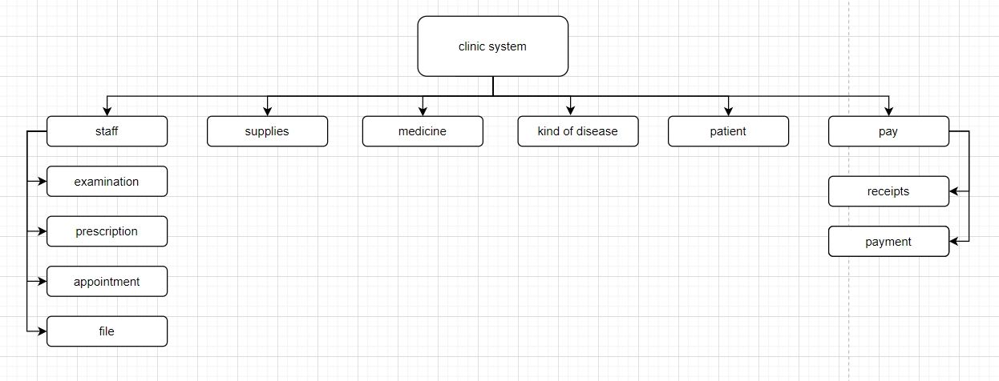

*Figure 1: System decay diagram*

## System User case

Information Actor

|  |  |  |
| --- | --- | --- |
| No. | **Name Actor** | **Explain** |
| 1 |  | A person who has the right to access the whole admin page system. When manipulating on optical administration, they can edit module information. View all information in the system. The manager can see all the information of the system. Manage and monitor, evaluate and give comments in each stage of the patient's medical examination and treatment. |
| 2 |  | Staff role when logged into the patient's medical record management system, patient information is in the system. Manipulating the issuance of prescriptions, examination slips, appointment slips (if any). And prescribe medications to patients. |

*Table 1: System Actor*

List of Main Uses – Cases of the system :

|  |  |  |
| --- | --- | --- |
| **No.** | **Name UseCase** | **Meaning** |
| 1 | Use case overview | Functional overview in the clinic system |
| 2 | Use cases for the list of pathologies | The process of adding, deleting, using pathology in the clinic system |
| 3 | Use visit management case | The process of adding, deleting, and using visits in the clinic system |
| 4 | Use case management of staff (medics, doctors, patients) | The process of adding, deleting, and using doctors and patients in the clinic system |
| 5 | Use case to manage the patient's examination book | The process of adding, deleting, and using the patient's medical examination book in the clinic system |

*Table 2: Use - Main cases of the system*

### 2.2.1 Use case system specification

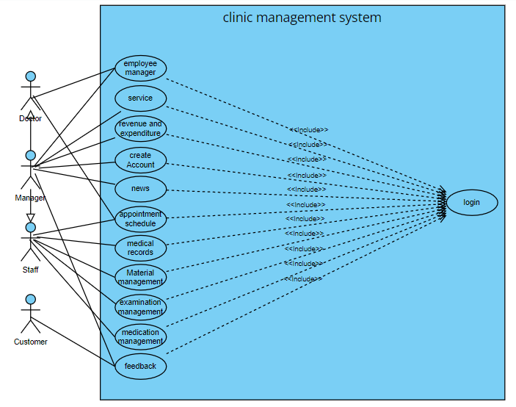

*Figure 2: Use-case system specification*

### 2.2.2 Management of pathology lists

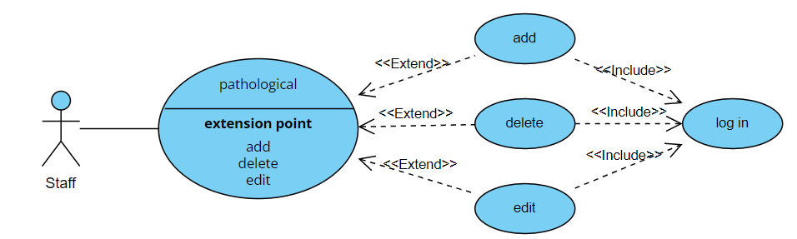

*Figure 3: Pathology list management*

### 2.2.3 Visitation management

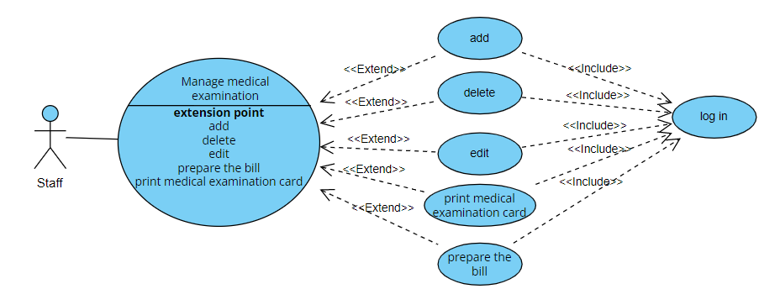

*Figure 4: Consultation management*

### 2.2.4 Staff management (medics, doctors, receptionists, accountants ...)

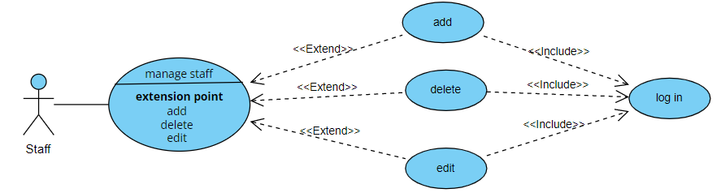

*Figure 5: Management of staff, doctors, receptionists, accountants ...)*

### 2.2.5 Clinic management

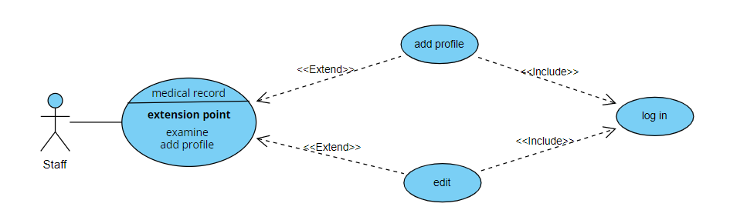

*Hình 6: Quản lý hồ sơ khám bệnh*

## Sequential scheme in the clinic system

### 2.3.1 Service function sequential chart

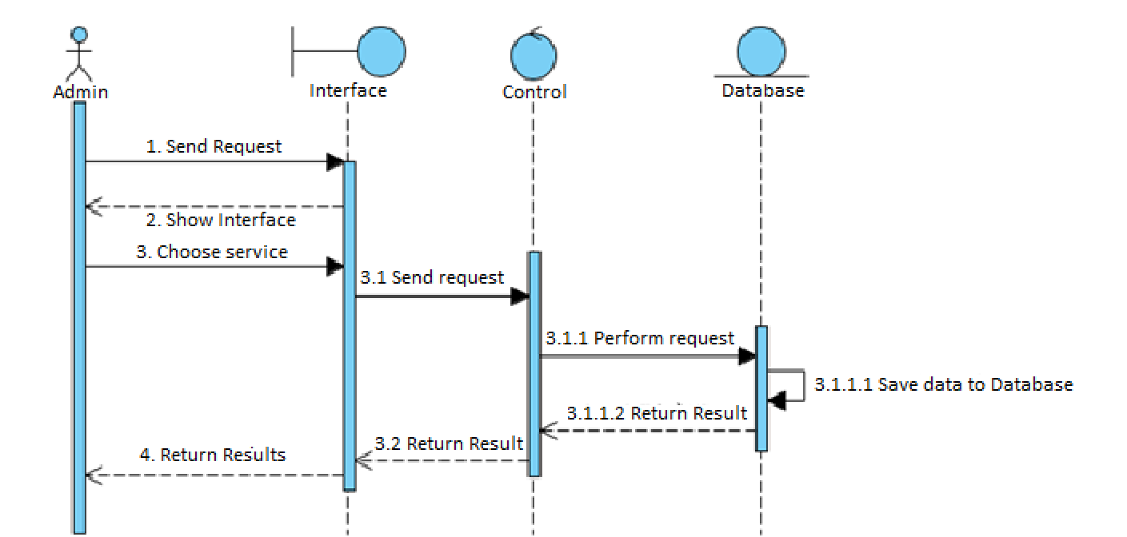

*Figure 7: Service function sequential chart*

### 2.3.2 Visitation management function

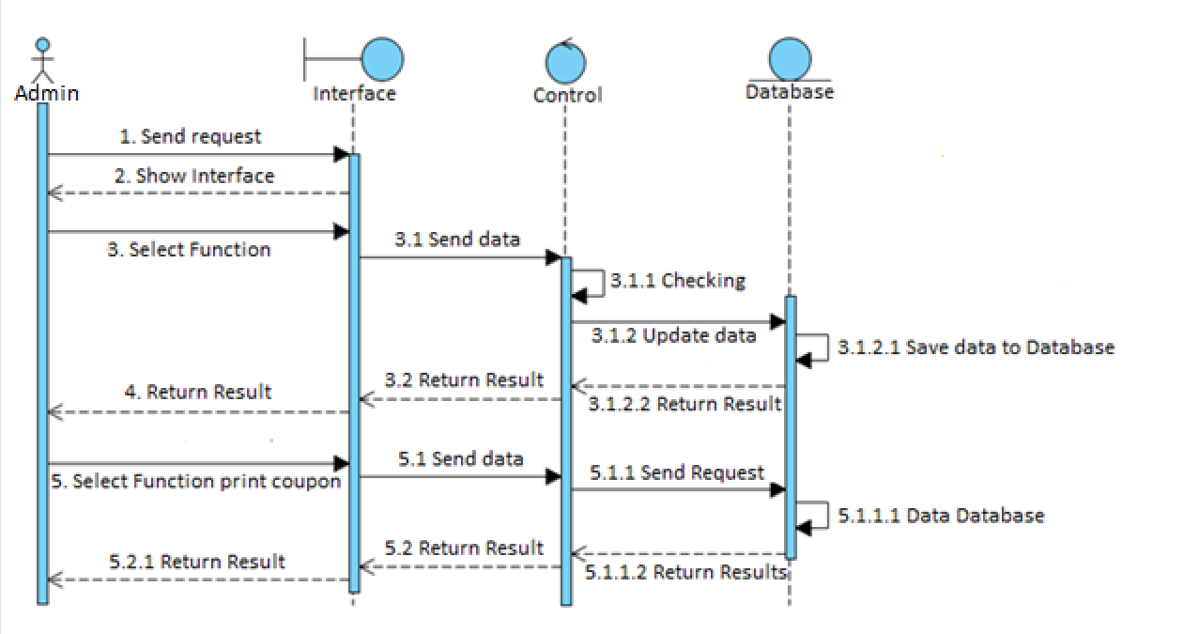

*Figure 8:* Visitmanagement chart

### 2.3.3 Appointment management function

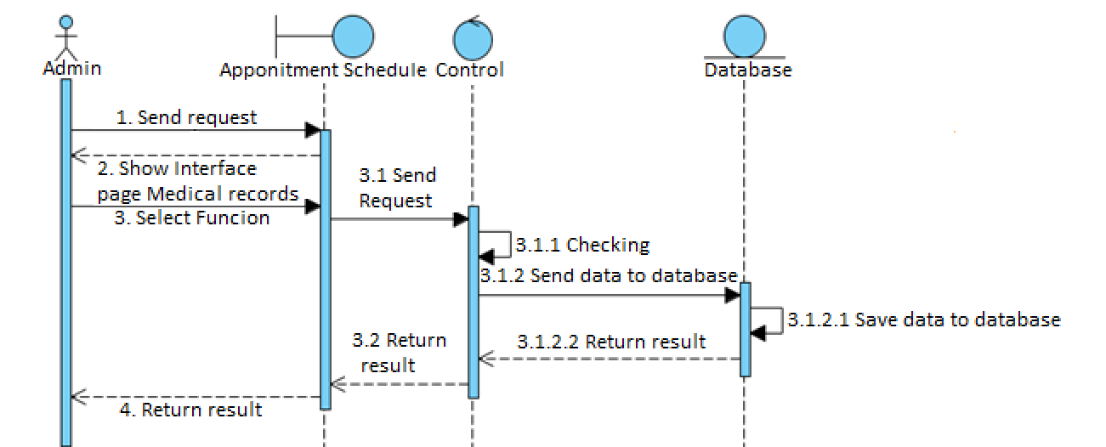

*Figure 9:* Chart of appointment management function

### 2.3.4 Medical examination records

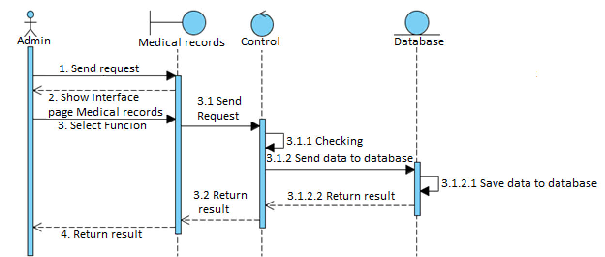

*Figure 10: Medical examination records*

### 2.3.5 Drug administration

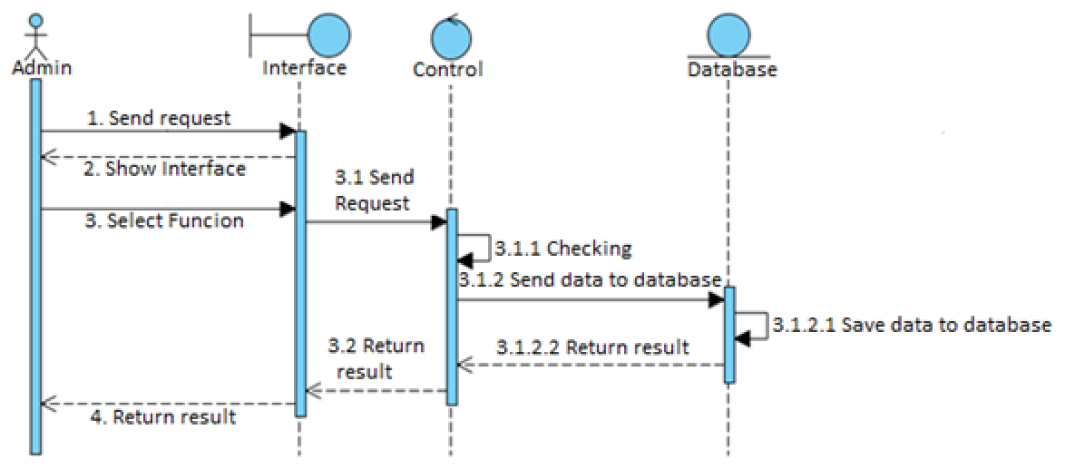

*Figure 11: Medication administration*

### 2.3.6 Material management



*Figure 12: Materials management*

## System design

### Layout Login

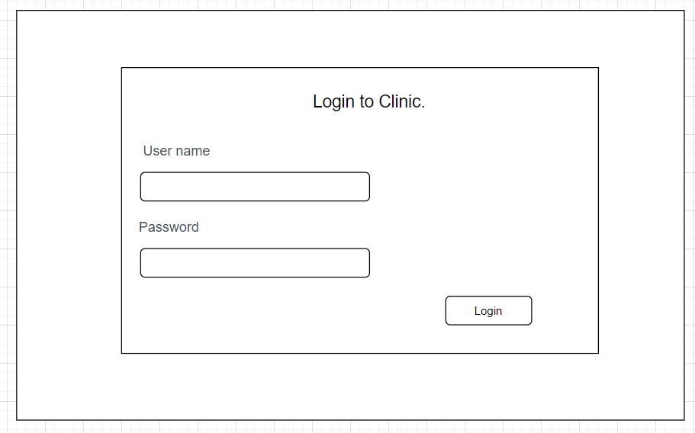

*Figure 13: System login layout*

### Layout hơmpage

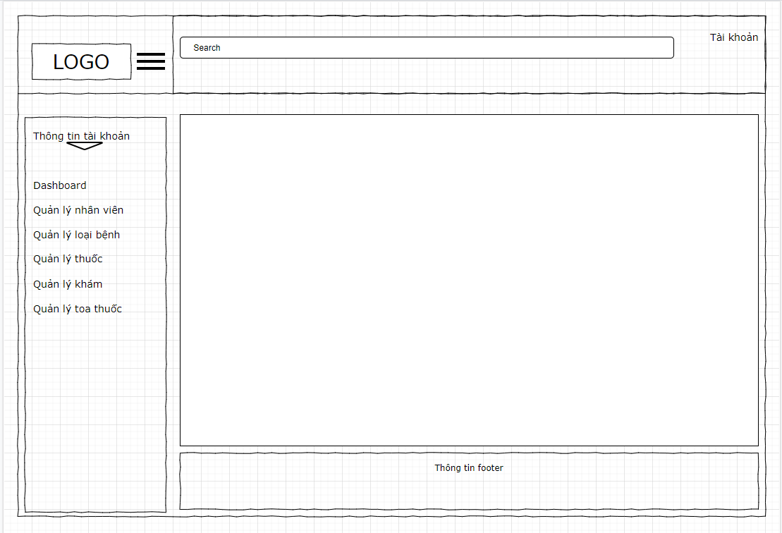

*Figure 14: Layout of the clinic management page*

### Class Chart

Class charts depict the classes of entities present in the system and their relationships to each other.

1. Class diagram for the system:

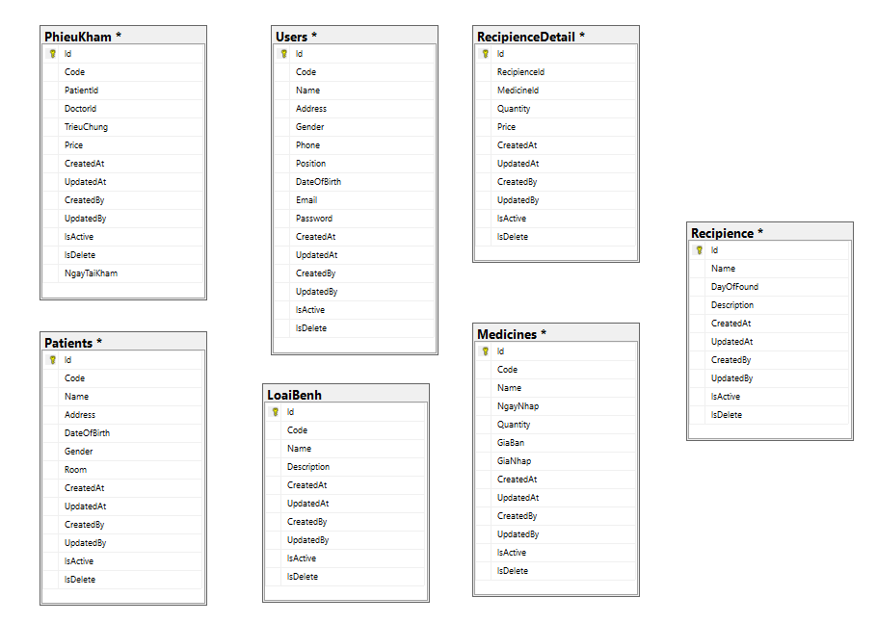

*Figure 15: Class diagram of the system*

* ***Danh sách các lớp :***

**2.4.3.1 Class TypeDisease**

Danh sách các thuộc tính

|  |  |  |
| --- | --- | --- |
| **STT** | **Tên thuộc tính** | **Ý nghĩa** |
| 1 | Id | Type code of the disease |
| 2 | Code | Disease type code |
| 3 | Name | Type name of the disease |
| 4 | DoctorId | Id Doctor |
| 5 | TrieuChung | Symptom |
| 6 | Price | Price |
| 7 | NgayTaiKham | Follow-up date |
| 8 | CreateAt | Creation date |
| 9 | UpdateAt | Creator |
| 10 | IsActive | Activity status |

*Table 3: Type of disease*

**2.4.3.2 Medicines** **Class**

List of attributes

|  |  |  |
| --- | --- | --- |
| **No.** | **Property name** | **Ý nghĩa** |
| 1 | Id | Id Number |
| 2 | Code | Drug code |
| 3 | Name | Drug name |
| 4 | NgayNhap | Date of entry |
| 5 | Quantity | Amount |
| 6 | GiaBan | Price |
| 7 | GiaNhap | Entry price |
| 8 | CreateAt | Creation date |
| 9 | UpdateAt | Creator |

*Table 4: Medicines class*

**2.4.3.3 Patients Class**

List of attributes

|  |  |  |
| --- | --- | --- |
| **No.** | **Property name** | **Meaning** |
| 1 | Id | Codes Job |
| 2 | Name | Name |
| 3 | Address | Address |
| 4 | DateOfBirth | Day of birth |
| 5 | Gender | Gender |
| 6 | Room | Room |
| 7 | CreateAt | Creation date |
| 8 | UpdateAt | Creator |
| 9 | CreateAt | Creation date |

*Table 5: Patient classes*

... Similarly, there are classes: PhieuKham, Recipience, RecipienceDetail, Users.

### Moving the ERD model to the relational model

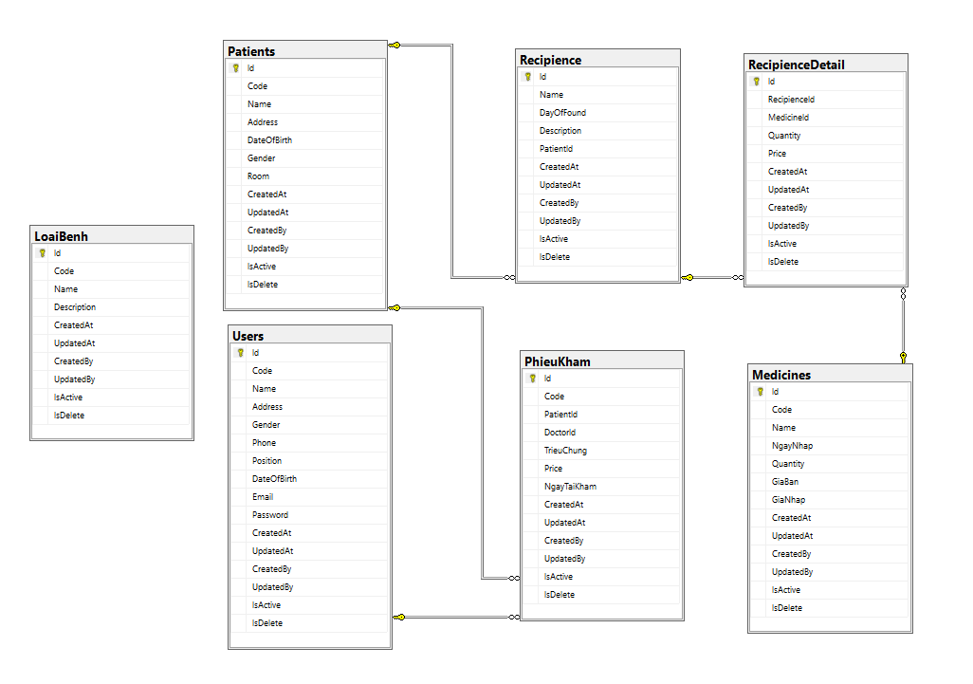

*Figure 16: ERD model to relational model*

# DATABASES

## Data tables

1. Table Users

|  |  |  |  |  |
| --- | --- | --- | --- | --- |
| **No.** | **Variable name** | **Data type** | **Bind** | **Meaning** |
| 1 | Id | Nvarchar | Primary key, not null | id |
| 2 | Code | Nvarchar | Null | Id user |
| 3 | Name | Nvarchar | Null | Username |
| 4 | Gender | Nvarchar | Null | Gender |
| 5 | Phone | Nvarchar | Null | Phone number |
| 6 | Position | DateTime | Null | Location |
| 7 | DateOfBirth | DateTime | Null | Email |
| 8 | Email | Nvarchar | Null | Email |
| 9 | Password | Nvarchar | Null | Pass word |
| 10 | IsActive | Bit | Null | Condition |
| 11 | IsDelete | Bit | Null | Deletion status |
| 12 | CreatedBy | Nvarchar | Null | Creator |
| 13 | UpdatedBy | Nvarchar | Null | Updater |
| 14 | CreatedAt | Datetime | Null | Creation date |
| 15 | UpdatedAt | Datetime | Null | Updated date |

*Table 6: Users table*

1. Table LoaiBenh

|  |  |  |  |  |
| --- | --- | --- | --- | --- |
| **STT** | **Variable name** | **Data type** | **Bind** | **Meaning** |
| 1 | Id | Nvarchar | Primary key, not null | Id |
| 2 | Code | Nvarchar | Null | Id Type of disease |
| 3 | Name | Nvarchar | Null | Type name of the disease |
| 4 | Description | Nvarchar | Null | Describe |
| 5 | CreatedBy | Nvarchar | Null | Người tạo |
| 6 | UpdatedBy | Nvarchar | Null | Updater |
| 7 | CreatedAt | Datetime | Null | Creation date |
| 8 | UpdatedAt | Datetime | Null | Updated date |

*Table 7: Disease categories* table

1. Table RecipienceDetail

|  |  |  |  |  |
| --- | --- | --- | --- | --- |
| **No.** | **Variable name** | **Data type** | **Bind** | **Meaning** |
| 1 | ID | Nvarchar | Primary key, not null | Id |
| 2 | RecipienceId | Int Foreign key | Null | Id prescription |
| 3 | MedicineId | Int Foreign key | Null | Id medicine |
| 2 | Quantity | Nvarchar | Null | Amount |
| 3 | Price | Nvarchar | Null | Price |
| 4 | Description | Nvarchar | Null | Describe |
| 5 | CreatedBy | Nvarchar | Null | Creator |
| 6 | UpdatedBy | Nvarchar | Null | Updater |
| 7 | CreatedAt | Datetime | Null | Creation date |
| 8 | UpdatedAt | Datetime | Null | Ngày cập nhật |

*Table 8: Detailed prescription table*

1. Table Recipience

|  |  |  |  |  |
| --- | --- | --- | --- | --- |
| **No.** | **Variable name** | **Data type** | **Bind** | **Meaning** |
| 1 | ID | Nvarchar | Primary key, not null | Id |
| 2 | Name | Nvarchar | Null | Prescription Name |
| 3 | DayOfFound | DateTime | Null | Date of establishment |
| 4 | Description | Nvarchar | Null | Describe |
| 5 | PatientId | Int Foreign key | Null | Activity status |
| 6 | CreatedBy | Nvarchar | Null | Creator |
| 7 | UpdatedBy | Nvarchar | Null | Updater |
| 8 | CreatedAt | Datetime | Null | Creation date |
| 9 | UpdatedAt | Datetime | Null | Updated date |
| 10 | … | … | … | … |

*Table 9: prescription table*

1. Table PhieuKham

|  |  |  |  |  |
| --- | --- | --- | --- | --- |
| **No.** | **Variable name** | **Data type** | **Bind** | **Meaning** |
| 1 | ID | Nvarchar | Primary key, not null | Id |
| 2 | PatientId | Nvarchar | Null | Controller |
| 3 | DoctorId | Nvarchar | Null | Action |
| 4 | TrieuChung | Nvarchar | Null | Page |
| 5 | Price | Nvarchar | Null | Page name |
| 6 | NgayTaiKham | Nvarchar | Null | Action |
| 6 | CreatedBy | Nvarchar | Null | Creator |
| 7 | UpdatedBy | Nvarchar | Null | Updater |
| 8 | CreatedAt | Datetime | Null | Creation date |
| 9 | UpdatedAt | Datetime | Null | Updated date |

*Table 10: Examination slip table*

1. Table Patients

|  |  |  |  |  |
| --- | --- | --- | --- | --- |
| **No** | **Variable name** | **Data type** | **Bind** | **Meaning** |
| 1 | Id | Nvarchar | Primary key, not null | Id |
| 2 | Code | Nvarchar | Null | Id patient |
| 3 | Name | Nvarchar | Null | Patient Name |
| 4 | IsActive | Nvarchar | Null | Condition |
| 5 | IsDelete | Bit | Null | Deletion status |
| 6 | CreatedBy | Nvarchar | Null | Creator |
| 7 | UpdatedBy | Nvarchar | Null | Updater |
| 8 | CreatedAt | Datetime | Null | Creation date |
| 9 | UpdatedAt | Datetime | Null | Updated date |

*Table 11: Patient table*

1. Table Medicines

|  |  |  |  |  |
| --- | --- | --- | --- | --- |
| **STT** | **Variable name** | **Data type** | **Bind** | **Meaning** |
| 1 | ID | Nvarchar | Primary key, not null | Id |
| 2 | Code | Nvarchar | Null | Id medicine |
| 3 | Name | Nvarchar | Null | Drug name |
| 4 | IsActive | Nvarchar | Null | Condition |
| 5 | IsDelete | Bit | Null | Deletion status |
| 6 | CreatedBy | Nvarchar | Null | Creator |
| 7 | UpdatedBy | Nvarchar | Null | Updater |
| 8 | CreatedAt | Datetime | Null | Creation date |
| 9 | UpdatedAt | Datetime | Null | Updated date |
| 10 | NgayNhap | Datetime | Null | Date of entry |
| 11 | Quantity | int | Null | Amount |
| 12 | GiaNhap | Decimal | Null | Entry price |
| 13 | GiaBan | Decimal | Null | Price |

*Table 12: Medicine table*

# LEARN ABOUT THE WATERFALL MODEL

**Waterfall model definition**

Waterfall model, also known as Waterfall model. The Waterfall model is one of the easiest project management models to understand today. The Waterfall model is a project management methodology based on a sequential and continuous design process.

In the Waterfall model, the phases of the project are carried out one after the other. The new phase is only started when the previous phase has been completed.

**Stages of the Waterfall model**

A simple waterfall model has 6 stages: requirements, design, implementation (construction), verification, deployment and maintenance.

**Requirement Analysis**

The team performs a search for requirements related to the project. Examples include identifying which business needs the project will address, user requirements for the product developed by the project, constraints and associated risks.

**Design phase**

The team creates designs for the product to address every requirement, constraint, and design goal. A typical design will be completed in as specific a way as possible. It will describe exactly how the logic of the system mentioned in the analysis will be executed.

**Implementation phase or construction phase (Development)**

The product is built to aid in the design. Sometimes, the product is built in units used for testing and integration in the next stage.

**Verification phase (Test)**

Parts of the product are inspected. If necessary, it will be integrated together for testing. The entire system is tested to find faults and ensure design objectives.

**Deployment phase**

The tested product actually goes into operation. For projects in the field of information technology, the product is deployed into the environment so that users can start using it. For a construction project, the implementation phase is when the building is completely ready for occupancy.

**Maintenance phase**

It is a short period of monitoring. In which the project team solves customer problems. For software projects, this usually means releasing patches and updates to fix the problem. In other projects, environmental adjustments are made to solve the problem. Such as optimizing air conditioning in a new building.

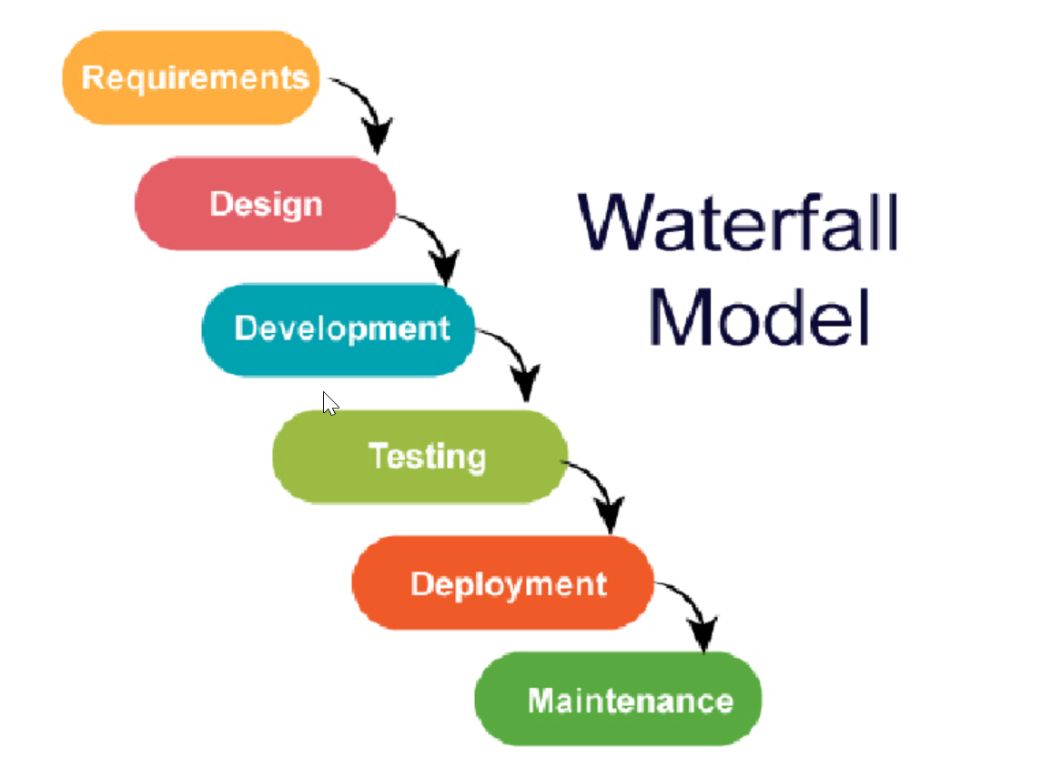

**Advantages of the Waterfall model**

Although the waterfall model has gradually disappeared over the past few years, giving way to more agile models. But it still has some benefits, especially in large projects and organizations that need stages and deadlines of work.

1. Adapts well to flexible teams

Although this is not merely the only model with this advantage. This application has helped the whole project to be maintained in the right development direction. Have overarching goals and design. Get structured by sketching and automating documents from the very first stage.

This is perfectly suited for large teams, which often have members coming in and out frequently, not fixed but still have the core design of the project.

1. Impose a tightly structured organization

This is the advantage and to maintain this Waterfall model. It is necessary to have an organization that builds the project rigorously, accurately, in accordance with the design and construction of the product. In particular, large projects will need many specific processes to help manage all aspects of the project, from conceptualization, design, development, implementation and testing.

1. Allow for early design changes

As we all know, in the later stages changing the design will be very difficult. But with the Waterfall method, it is quite easy to deploy changes at an early stage of the application. This change is more advantageous because there is no code or implementation at this stage.

1. Suitable for milestone-driven projects

When applying the sequential structure of the Waterfall model, there are projects that are very suitable for organizations and teams that perform well based on specific timeline factors. With clear and specific time frames, team members can easily understand and follow the timeline correctly.

**Disadvantages of the Waterfall model**

It is not an ideal model for a large size project.

If the requirement is not clear from the start, it is a less effective method.

It is very difficult to move back to the previous stage to change.

The testing process begins when development is finished. Therefore, it has a high risk of bugs being found after the development phase, and it is very expensive to fix bugs.

**When to apply the Waterfall model**

The application of Waterfall model is encouraged when the implementer knows the requirements of the project best, requiring high clarity and stability such as:

1. Master the development of technology.
2. Eliminate vague, unclear requests.
3. There are abundant development resources and a high level of expertise and technology.
4. May be suitable for small, short-term projects.
5. Through the article, PMA provided the basic concepts of the Waterfall model. The important thing about this model is to follow the outlined stages. At the same time, the Waterfall model is still very well applied in small-scale and short-term projects.

# CLINIC MANAGEMENT SYSTEM

## Clinic login interface

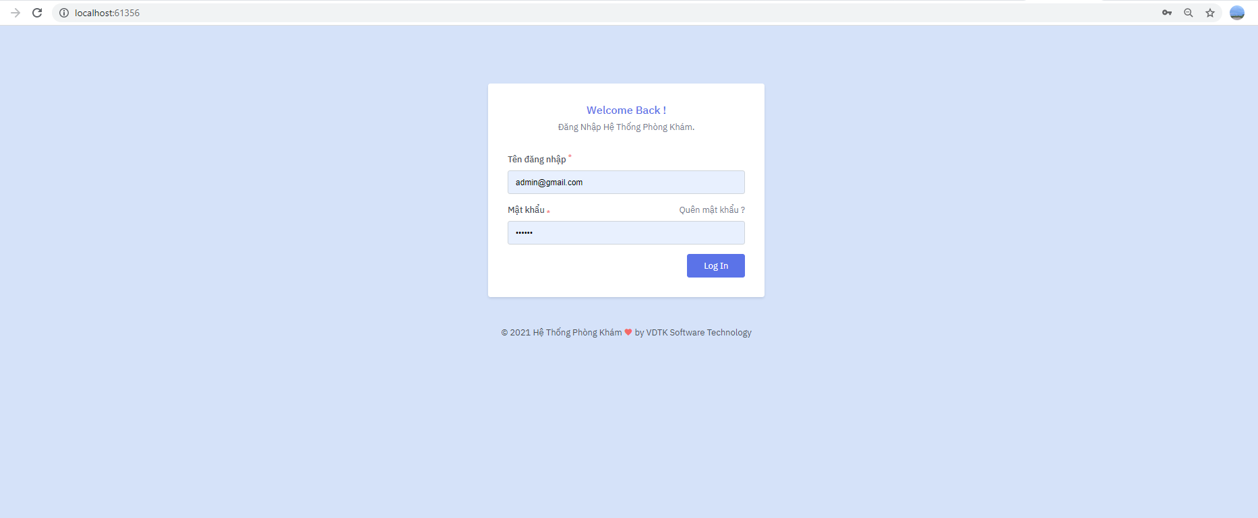

*Figure 17: The interface of the system login page*

Source "*index.* *cshtml*". Clinic management system login interface. The user enters the username and password information of the login form.

**Task management page interface**

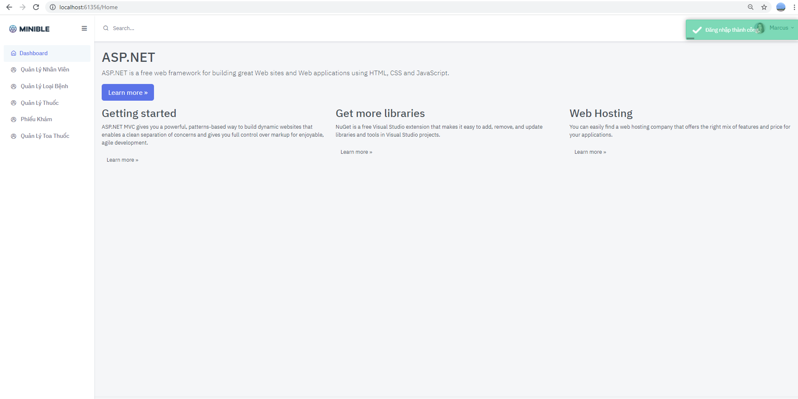

*Figure 18: Clinic management interface*

1. Managers or employees have the right to create employees, drugs, prescriptions ... Adjust the information you just created.
2. The newly created information can be edited.
3. It is possible to delete the generated information.

Employee management interface

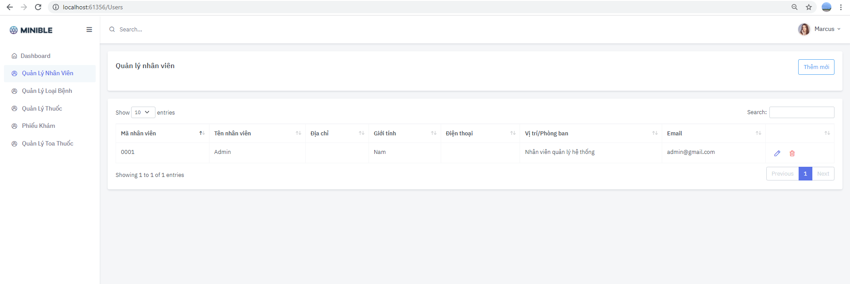

*Figure 19: The interface of the employee management page*

At this interface, users can see all employees of the system.

And can edit and delete employees if desired.

**New employee creation interface**

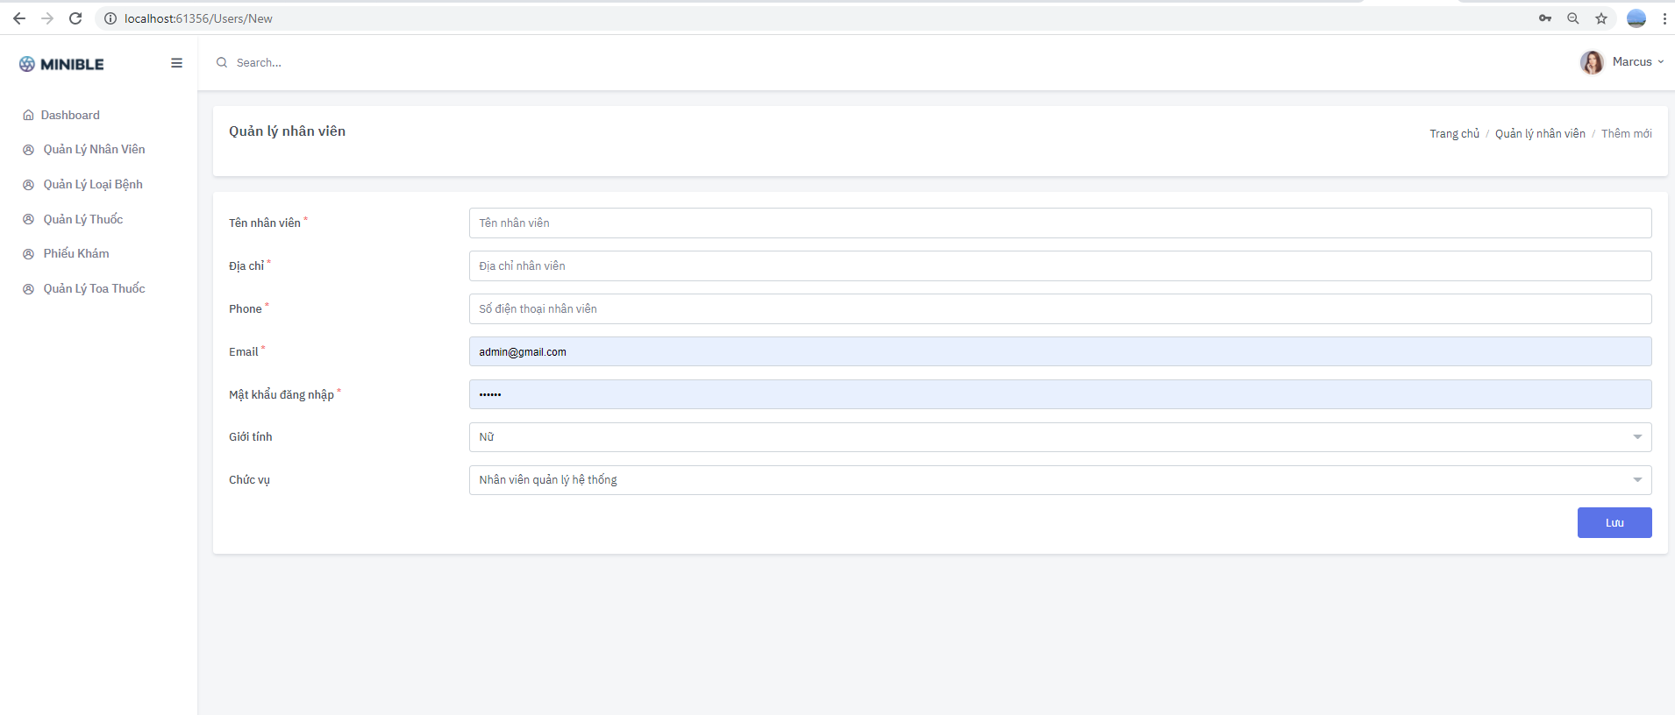

*Figure 20: The agent creation interface*

At this screen, users enter the employee's name and related information and click save information. Information will be saved to the system and displayed again on the employee list interface.

**Employee update interface**

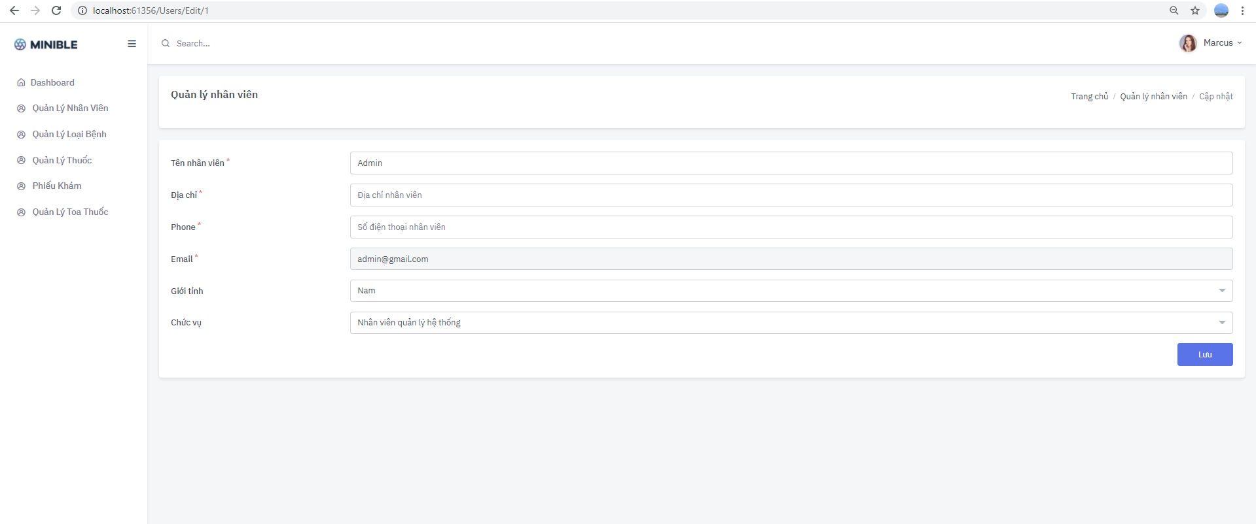

*Figure 21: The employee update interface*

At this interface, users edit employee name information and click save. The information will be updated again in the database.

**Employee removal interface**

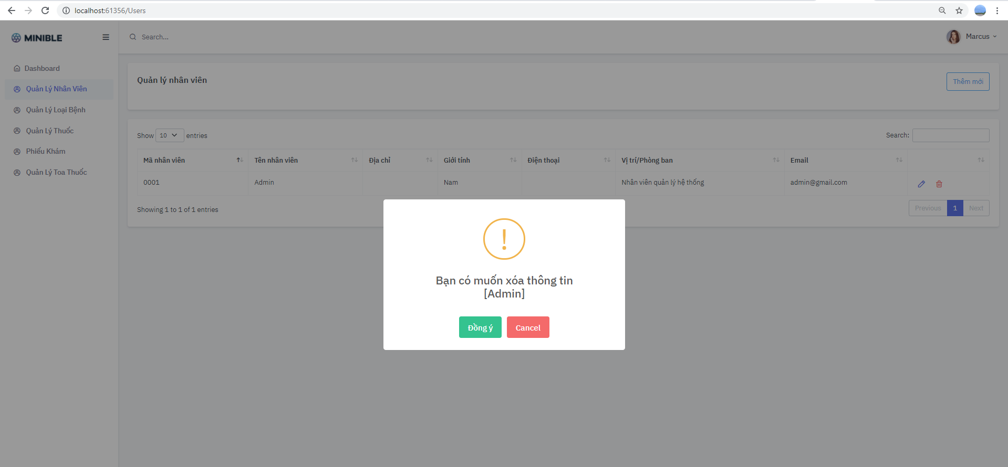

*Figure 22: The employee deletion interface*

At this interface, users confirm whether they want to delete employee information or not. If so, click OK and the system will delete this employee information. Otherwise, the system will cancel the user's request to remove this employee.

**Disease type management interface**

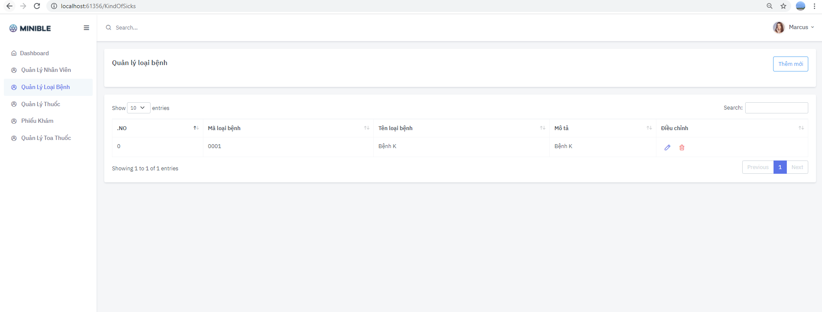

*Figure 23: Disease type management interface*

At this interface, users can see all kinds of diseases of the system.

And you can edit and delete the type of disease if you want.

**Interface to create new disease types**

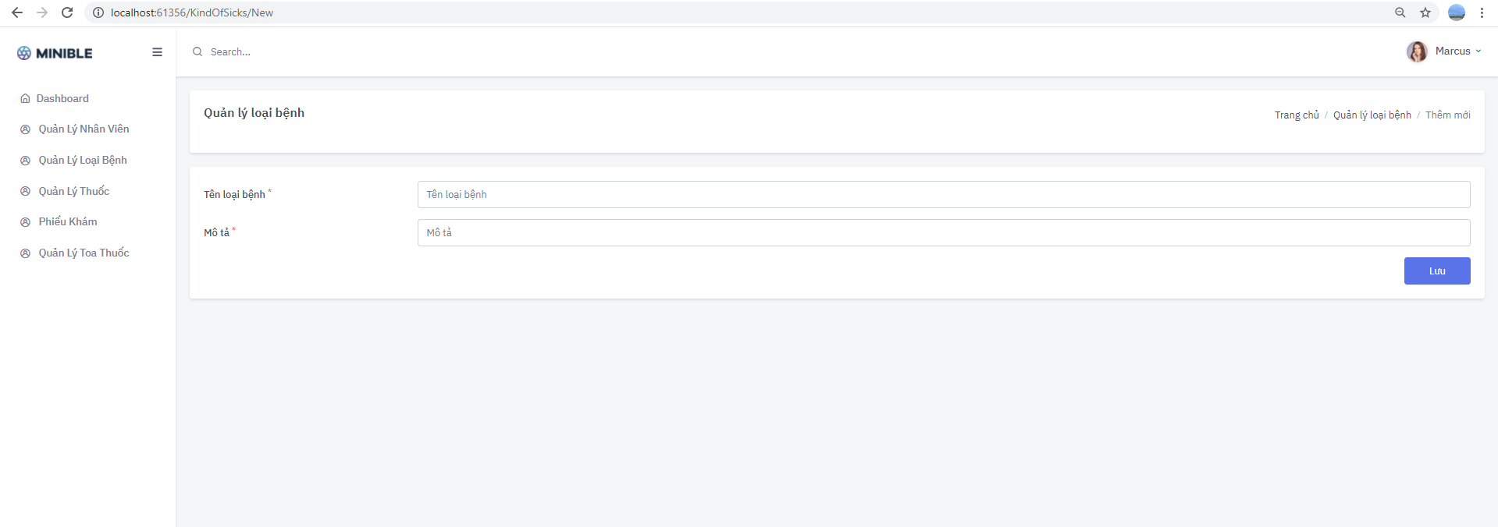

*Figure 24: The interface for creating a new type of disease*

At this screen, the user enters the name of the disease and clicks save information. Information will be saved to the system and displayed again on the disease list interface.

**Disease type update interface**

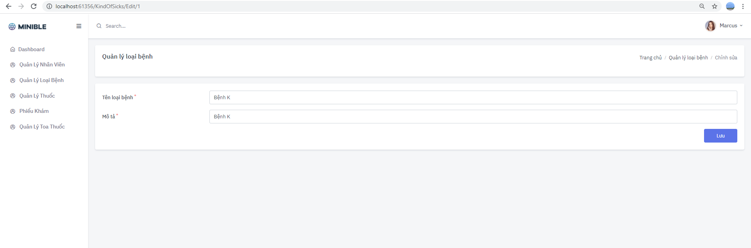

*Figure 25: Disease type update interface*

At this interface, users edit the information of the name of the disease and click save. The information will be updated again in the database.

**Disease type removal interface**

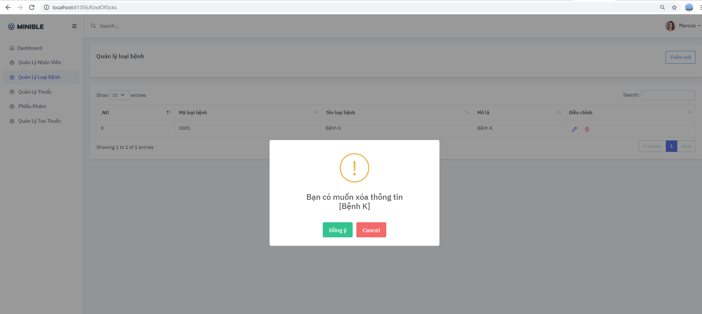

*Figure 26: Disease type deletion interface*

At this interface, users confirm whether they want to delete disease type information or not. If so, click OK and the system will delete this disease type information. If not, then the system will cancel the user's request to remove this disease.

**Medication management interface**

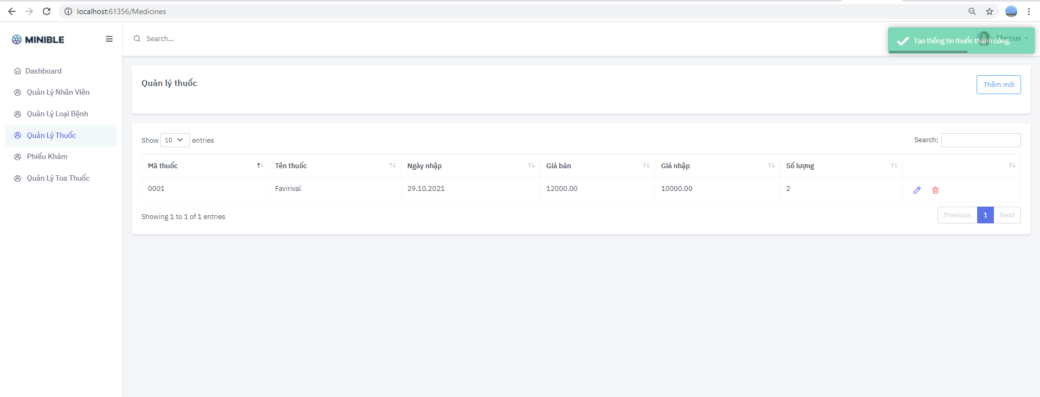

*Figure 27: Drug management interface*

At this interface, users can see all drugs of the system.

And the drug can be edited and deleted if desired.

**New drug creation interface**

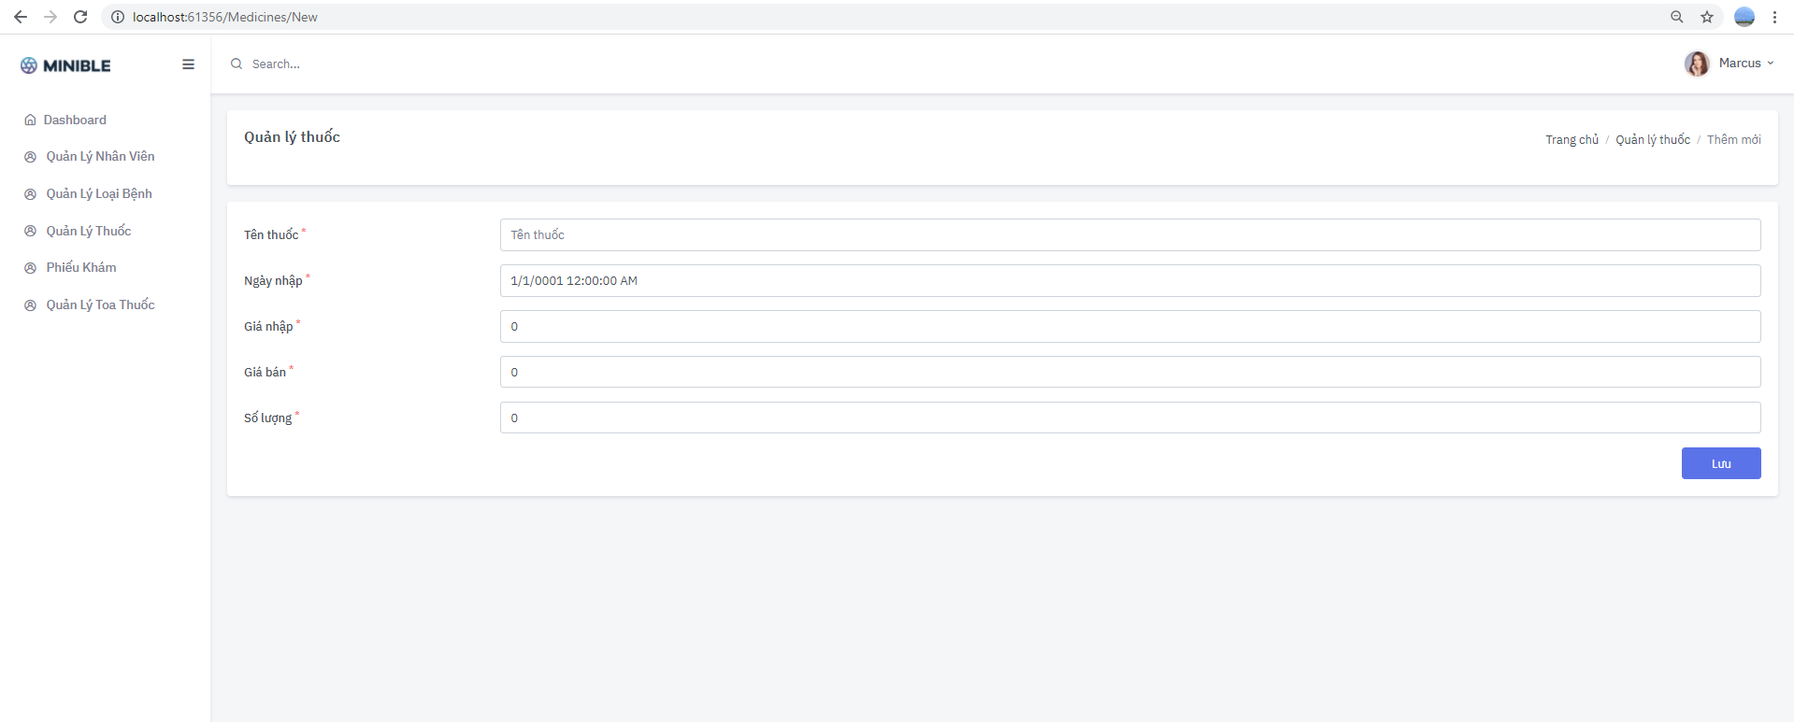

*Figure 28: The interface for creating new drugs*

At this screen, the user enters the drug name and clicks save information. Information will be saved to the system and displayed again on the drug list interface.

**Drug update interface**

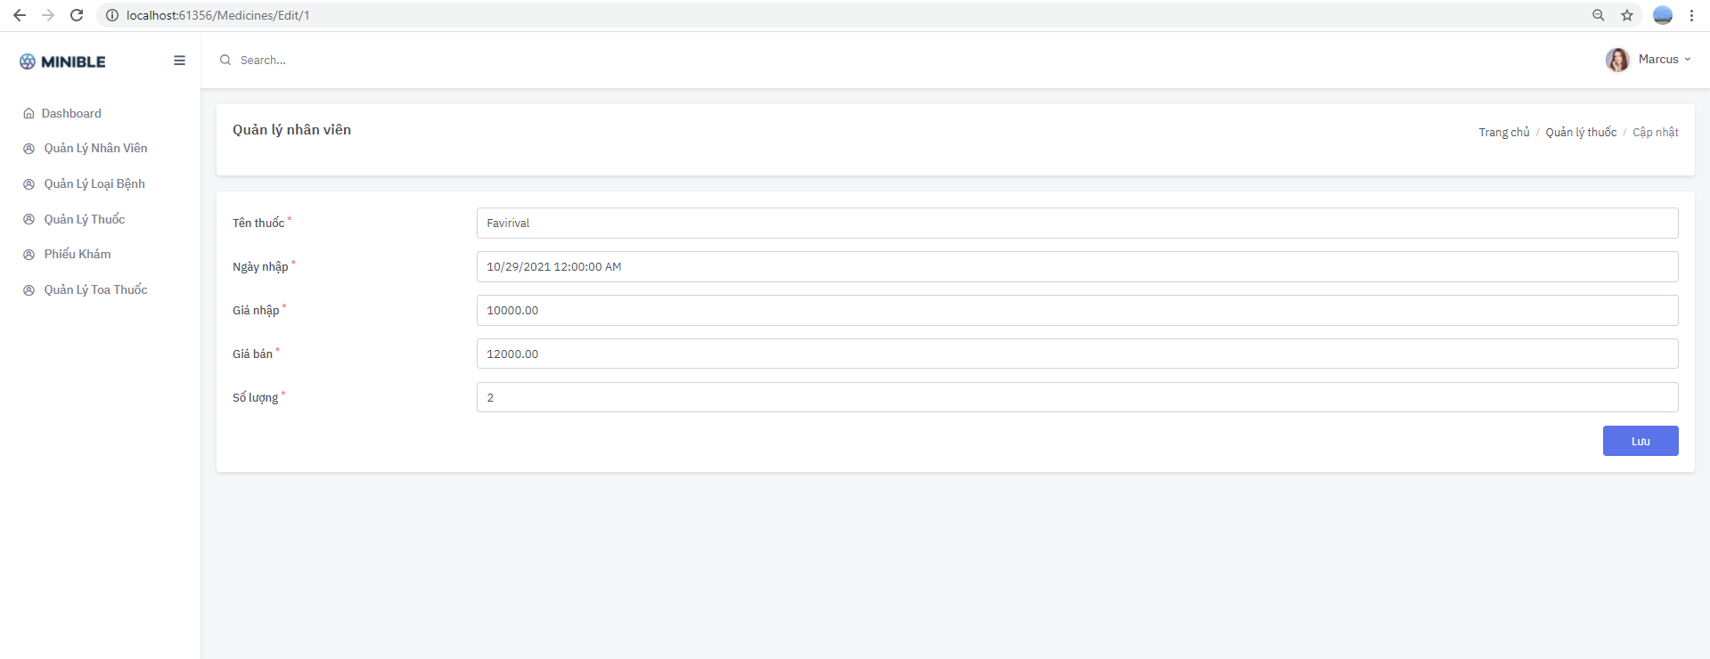

*Figure 29: Drug update interface*

At this interface, users edit drug information and click save. The information will be updated again in the database.

Drug removal interface

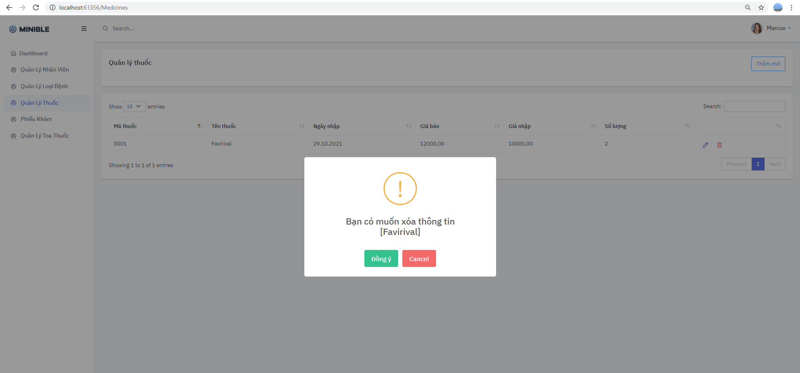

*Figure 30: The drug removal interface*

At this interface, users confirm whether they want to delete drug information or not. If so, click OK and the system will delete this drug information. If not, then the system will cancel the user's request to remove this drug.

**Examination slip management interface**

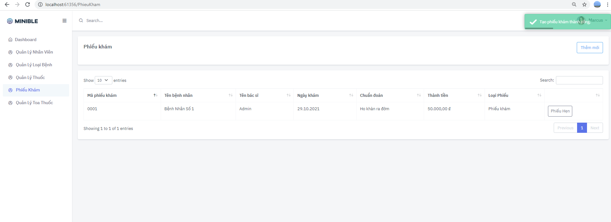

*Figure 31: Examination slip management interface*

At this interface, users can see all examination slips and vouchers of patients in the system.

**Interface to create new examination slips**

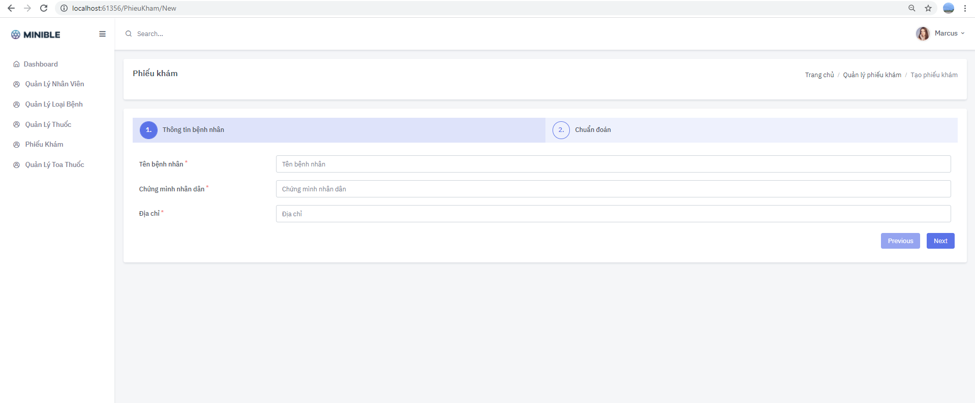

*Figure 32: The interface for creating a new examination slip*

At this screen, the user enters the patient's name and clicks save information. The information will be saved to the system and displayed again on the examination list interface

**Interface for adding appointment slips for examination slips**

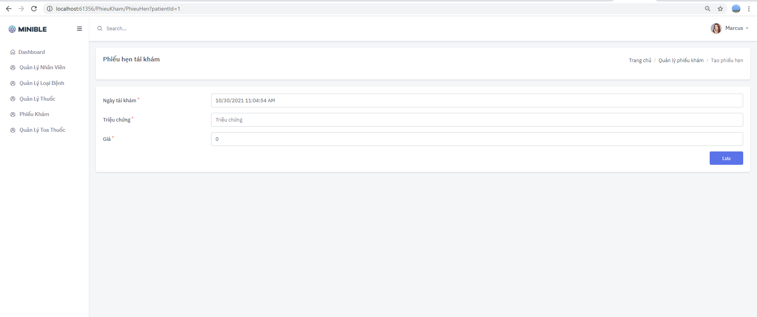

*Figure 33: The interface of adding an appointment slip to the examination slip*

At this interface, users enter appointment information and click save. The information will be updated again in the database.

**Prescription management interface**

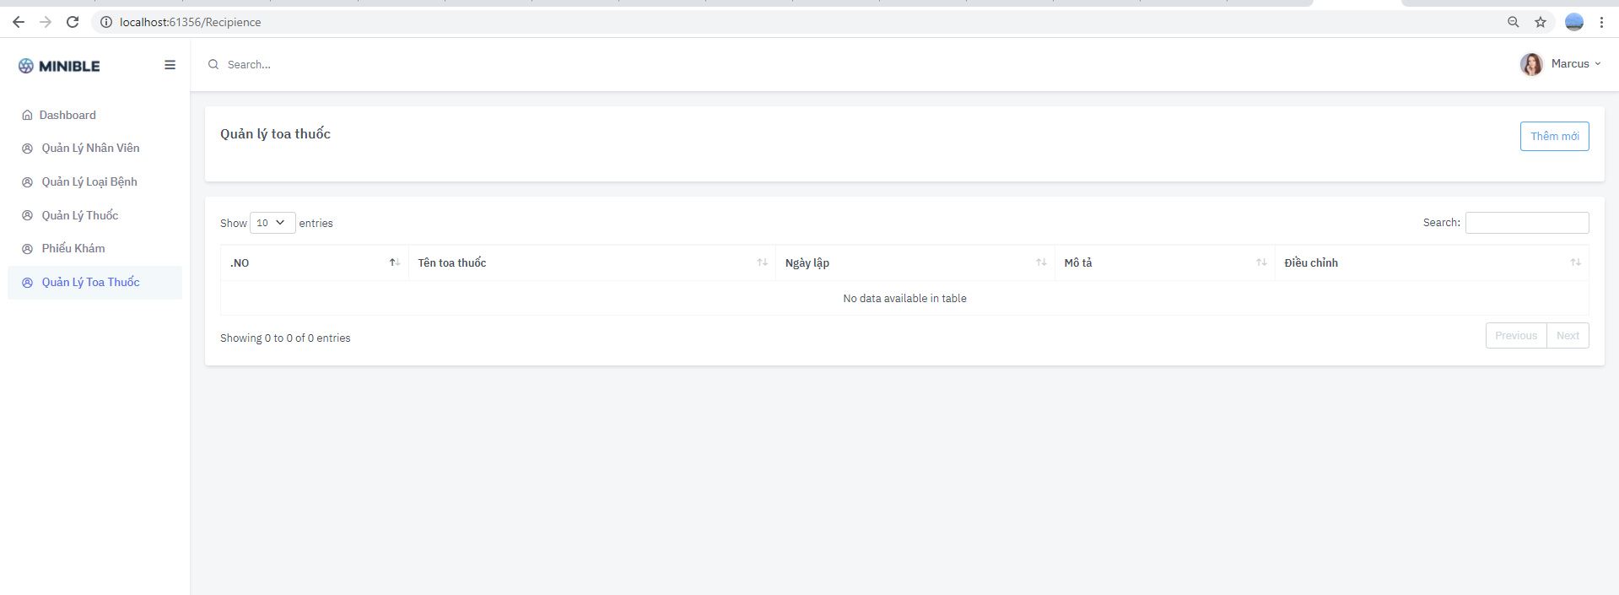

*Figure 34: The prescription management interface*

At this interface, users can see all the drugs of the system.

And you can edit and remove prescriptions if you want.

**New prescription creation interface**

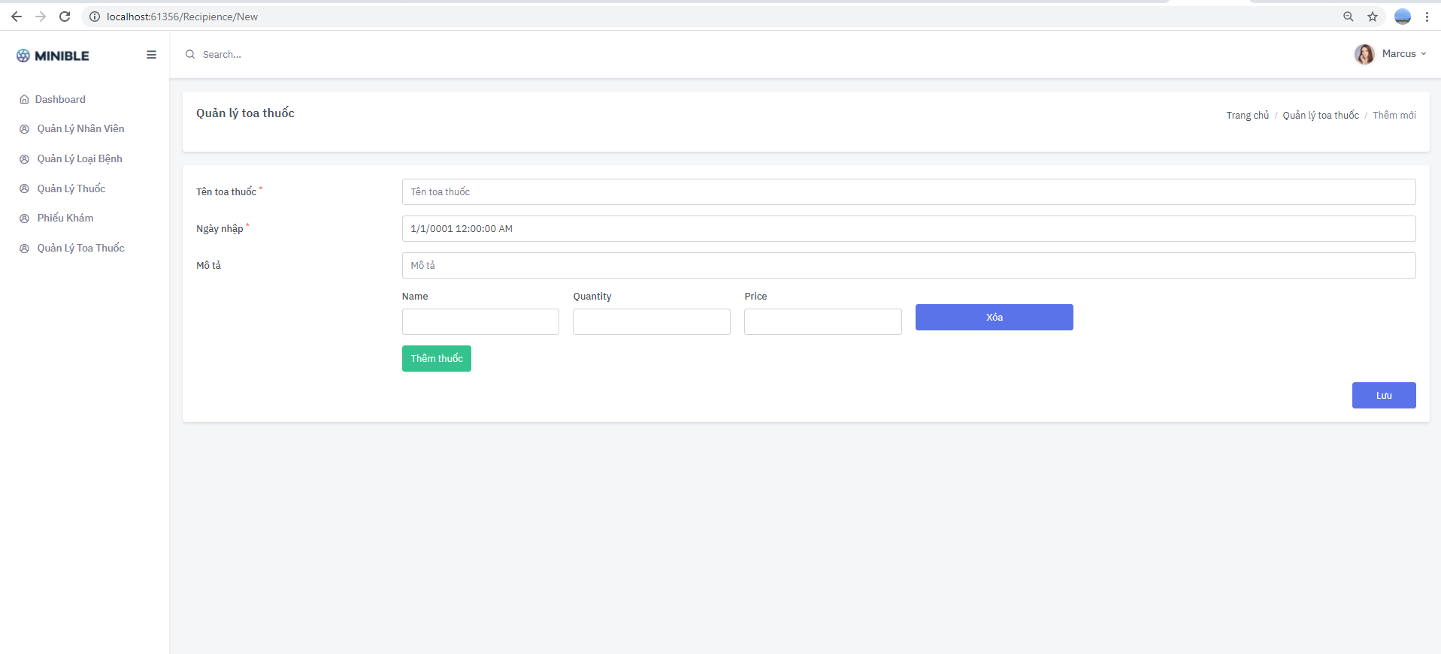

*Figure 35: The prescription creation interface*

At this screen, users enter the name of the prescription and the patient's and drug information and click save information. The information will be saved to the system and displayed back on the prescription list interface.

**Prescription update interface**



*Figure 36: The prescription update interface*

At this interface, users edit prescription information and click save. The information will be updated again in the database.

**Prescription removal interface**



*Figure 37: The prescription removal interface*

At this interface, users confirm whether they want to delete prescription information or not. If so, click OK and the system will delete this prescription information. Otherwise, the system will cancel the user's request to remove this prescription.

# GOLIVE PHASE AND SOFTWARE TESTING

## Golive

1. The software runs stably during the testing phase.
2. Will develop and improve web features during development and collect feedback from customers. Gradually finalize the project.

## Results obtained

1. Meet a basic online task management system.
2. Simple, user-friendly interface.
3. Not complicated in terms of functionality as well as business of the website.
4. Through working on the project, it helped me personally a lot in terms of studying, researching as well as my skills.

## Restrict

1. The system is not yet complicated. Being at a basic level.
2. A few new framewords haven't been used today.
3. A few interfaces need to be improved. Dynamic features attract users.
4. Apply customer incentives, customer gratitude ...

## Development direction of the topic

1. Apply system change to become a more scale system.
2. Run ads to let more users know about the system.
3. Collect comments from users.
4. Clinic links now.

# BIBLIOGRAPHY

Bibliography:

[1] Microsoft .NET – Architecting Applications for the Enterprise

[2] Writing High-Performance .Net Code

[3] Patterns of Enterprise Application Architecture