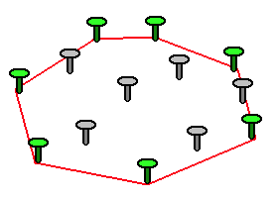
2021
Thany Trann
Southern Institute of Technology
11/22/2021
Convex Hull

USER’s Manual
Mobile Application Interface
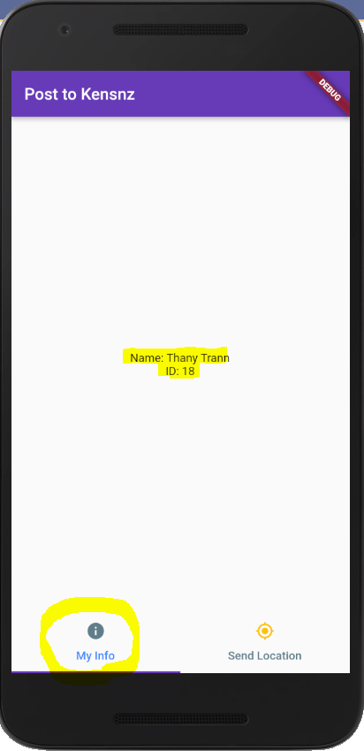  Figure 1: My Info page. | 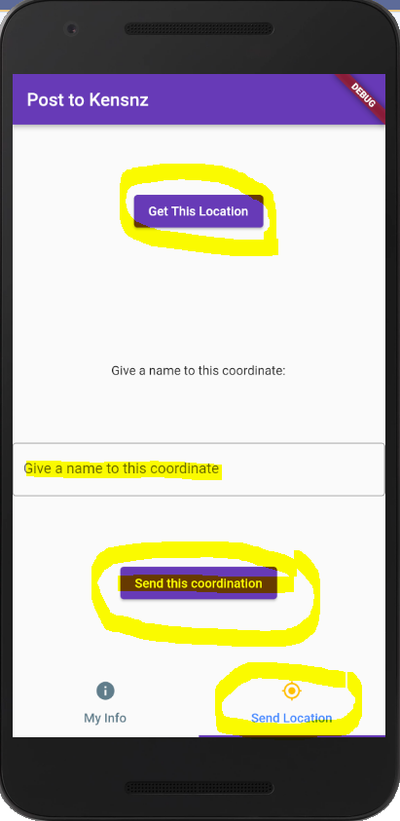  Figure 2: Send Location page.

Figure 1: Mobile front page.
My Info page has the information of the app developer.
Set Location page has 3 functions. Function 1 is Get This Location, which will record the current GPS of the mobile device. Function 2 is to give a descriptive name to the recorded GPS location. Finally, function 3 is to send JSON object to http://developer.kensnz.com/api/addlocdata server.

Desktop Application Interface
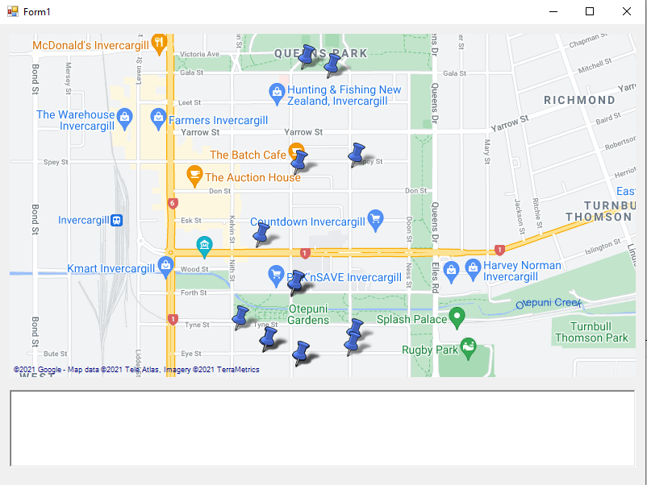
These are map marker pins.
This is text box controller
Figure 3: When the application is loaded.
The map marker pins mark the recorded GPS locations.
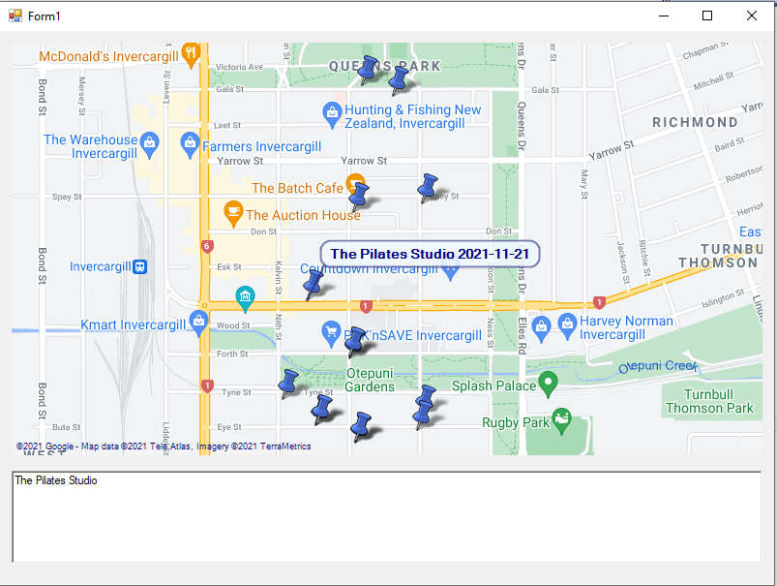
Figure 4: When hover on a marker.
When we hover on a marker, the tooltip will show the name description of the recorded GSP locations. Moreover, if we click on the marker its name description will display in the text box controller.
We drag the map by holding left click and then drag.
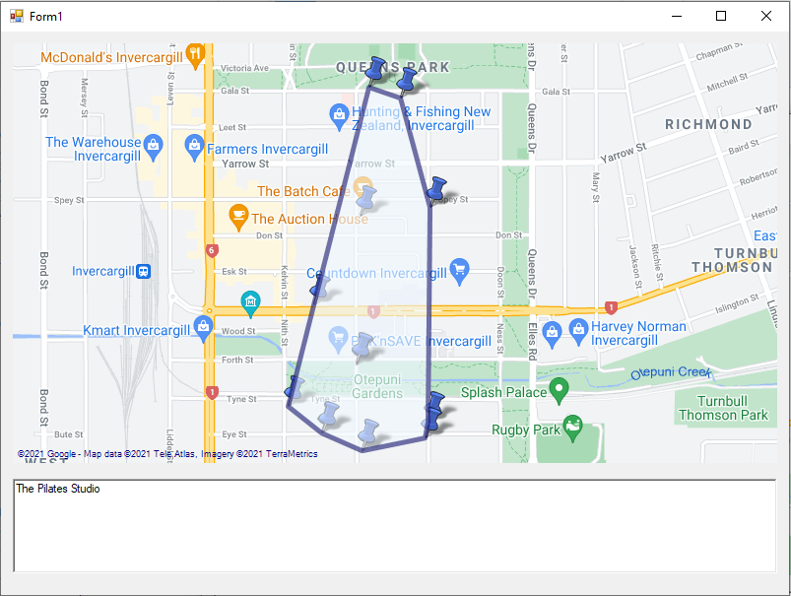
Figure 5: Covex Hull operation.
When we press h key it will perform Covex Hull operation and if we press h key again the Covex Hull drawing will be removed.

