CHEATSHEET

1. BASIC
2. Only use code to build UI.
3. Everything is a Widget.
4. App’s UI is a Widget tree.
5. How is Flutter/ Dart “transformed” to a Native App?
   1. Flutter compile through Flutter SDK

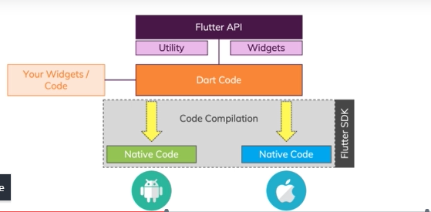

* 1. Flutter Doesn’t use Platform Primitives, control each pixel on phone.

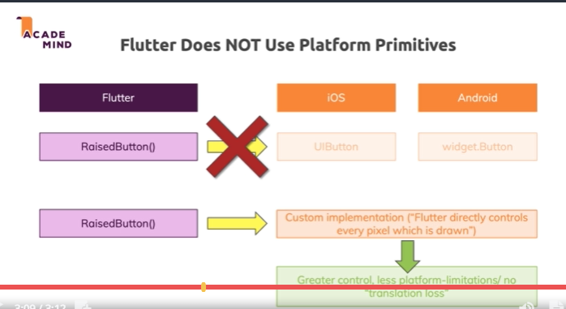

1. Performance is a huge advantage of Flutter.
2. So sánh statelessWidget và statefullWidget:

|  |  |
| --- | --- |
| StatelessWidget | StatefullWidget |
| Chỉ có 1 lớp StatelessWidget | Có 2 lớp là StatefullWidget và lớp State (generic) (Quản lý state của widget khi Widget recreated thì state vẫn không được tạo lại mà dùng cái đã có. Và phần render giao diện (build) sẽ do state quản lý).   * Cần dùng setState để notify cho ứng dụng render lại giao diện. |
| Không chấp nhận sự thay đổi bên trong. Chỉ thụ động thay đổi theo bên ngoài. |  |
|  |  |
|  |  |

1. All widgets (i.e. both Stateless and Stateful) can receive data via their constructors. But only StatefulWidgets can have class properties where they can update values + re-run build().
2. setState() is a "trigger" that informs Flutter that it needs to re-run build() of the Widget. Without setState(), the Widget still change its property value but it will not re-run the build() method. Hence updates aren’t reflected on the screen.
3. This is correct! The leading "_" marks a class, property or method as private, which means that you can only use it in the same library. Typically, a file is treated as a separate library.
4. An enum is a value where you can choose from multiple possible choices. You choose by selecting a human-readable label, behind the scenes, the labels are mapped to integers (0, 1).
5. Maps are basically like Lists without number indexes but custom indexes (keys).
6. Final: At runtime, an initial, dynamic value can be assigned, thereafter, the property / variable can't be changed again.