

ASSIGNMENT 1

Vietnam Multimedia Corporation

Nguyễn thanh thế vinh - 16943768 - IT Service management

July 12th, 2017

Table of Contents

My Video Presentation Link 2

VTC Introduction 3

Existing IT Services Scoping 4

Current IT Services 4

IT Services 6

VTC Game 6

**Resources** 6

**Provider** 6

**Customers** 6

**Benefits** 6

**Time** 6

VTC Pay 6

**Resources** 6

**Provider** 7

**Customers** 7

**Benefits** 7

**Time** 7

Customer Services Encounters 7

VTC Game 7

**Physical** 7

**Virtual** 7

**Direct/Indirect** 8

**Service Encounters Diagram** 8

VTC Pay 8

**Physical** 8

**Virtual** 8

**Direct/Indirect** 8

**Service Encounters Diagram** 9

Service Priorities 9

Value creation 9

Value co-creation 9

Value In-use 10

Rationale 10

IT Service Changes 10

References 11

Introduction 11

Existing IT Services Scoping 11

Customer Services Encounters 11

Service Priorities 11

Rationale 11

# **My Video Presentation Link**

<https://www.youtube.com/watch?v=yUPkNdmfe4E>

# **VTC Introduction**

* Vietnam Multimedia Corporation or Vietnam Television Corporation (VTC)) was founded in February 1988 for the purpose of building television stations. In July 2003, the Vietnam Ministry of Post and Telematics purchased VTC.
* VTC has several Subsidiary companies that include:
* VTC Mobile
* VTC Digicom
* Digital Television
* VTC Technology and Digital Content Company - VTC Intecom
* Trading Corporation VTC (communications equipment)
* Service Corporation (international cooperation)
* Communications Corporation Friendship
* VTC School of Communication
* VTC Studio (established February 2010)
* VTC has five main business sectors:

|  |  |  |  |
| --- | --- | --- | --- |
| Order | Business career | Field/Content | Note |
| 1 | Television | HD channel, SD channel, Radio Channel | 72 channels of VTC is broadcasted on VINASAT 1 |
| 2 | Publish online games | Audition Online, CrossFire, FIFA Online 2, Atlantica Online, BoomSpeed |  |
| 3 | Producing online games | Squad, Generation 3, Showbiz, Tour247 |  |
| 4 | Online payment | Electronic wallet VTC Pay |  |
| 5 | Others | News, newspaper, mobile, eBank, mobile TV, iTV | In Feb 2010, VTC Studio was established |

* Disadvantages and negatives of VTC:
* Copyright: World Cup 2006, FPT bought exclusively this tournament and firstly sell it for VTV and HTV. VTC negotiated consecutively with FPT and VTV to buy World Cup 2006 copyright and that’s successful with the price was equivalent 300.000 USD. In October 2006, VTV warned to litigate VTC because of copyright infringement of Miss World. VTC gave an apology to VTV and compensated to TVplus.
* VTC-Digital: old versions such as T5, T9, T10, T11, T12, T13. VTC said that they will increase channels for version T13 but channels VTC3, VTC6 had been released and locked Irdeto. This showed that VTC didn’t support old digital receiver and made customers didn’t satisfy because they couldn’t watch channels that they wanted.

# **Existing IT Services Scoping**

## **Current IT Services**

VTC has several IT services which serve human’s needs and make plenty of profits for itself. The below is 5 prime IT services of VTC:

* VTC Game:
* VTC Game is the common name for game field at VTC Intecom. After a long period of research, VTC Game has introduced new brand identity standards, which are applied since 01/01/2017 for all parts of VTC Game and communication department of VTC Intecom.
* VTC Game was awarded “The publisher has a quality 5 stars customer care”
* VTC Publisher has many games now include:

+ Client games: CrossFire with 8years at top 1 FPS game in Vietnam, Audition with 10 years at top 1 of music games in Vietnam

+ Mobile games: Phục Kích, Tam Quốc Moba, Võ Lâm, KingDay, AU Stars

+ Global games: Bomber Heroes, Captain Galaxy

In those games, CrossFire and Audition are two games which bring giant profits for VTC Game in particular and VTC in general.

* VTC News:
* With 9 years since establishing at 7th July 2008, VTC News has been one of the most popular newspaper in Vietnam.
* From an inside news site, VTC News, like a brave ship stretching out to sea, is ready to face all difficulties and challenges to raise the desire to become one of the leading newspapers for supplying news inside and outside country 24/7. Besides that, official VTC News page has reached over 800.000 likes on Facebook with a lot of exclusive reporting news.
* VTC Digital Television (VTC for abbreviation):
* VTC is founded in 19th August 2004, is one of the three television networks covering the entire territory of Vietnam. Over the course of its history, VTC has been hailed as a phenomenon of television by pioneering the digital broadcasting of the DVB-T standard.
* VTC owns a variety of channels with 15 unique channels. Besides, VTC is also the governing body of VTC News.
* VTC Pay:
* VTC Pay e-wallet is an electronic account opened at https://vtcpay.vn/ which is used as a non-cash payment medium, allowing customers to keep money in their account of equivalent value with the money at the bank account.
* Besides 3 main functions: recharge, payment and transfer, VTC Pay also has function withdrawal. Withdrawal is made through 4 easy steps and just take about 3 minutes to finish the process. In addition, VTC Pay just apply transaction fee is 1.000 VND for 1 cash withdrawal transactions regardless of transaction value. Moreover, VTC Pay e-wallet supports withdrawals through 29 connected banks and also Paypal so wherever you are at home, at work or even on the bus, with one mobile device with internet connection, you can make withdrawals from your VTC Pay Wallet easily.
* VTC eBank:
* It is an account management, billing system for VTC's online services and provides an online payment solution for services of partners.
* VTC eBank was established in 2006 under the name Paygate (https://paygate.vtc.vn). In 2012, VTC eBank has more than 60 million registered accounts, of which more than 8 million payment accounts. Through the trust of customers and trust of partners, VTC eBank is currently the largest online community and also the number one provider of online payment solutions in Vietnam.
* The payment unit in the VTC eBank system is Vcoin, with the current conversion rate of 1.000 VND = 1 Vcoin. VTC eBank is currently issuing Vcoin cards with distribution network in 64 provinces. Customers easily load Vcoin into the account, recharge the phone and use many other services of partners with Vcoin card.

# **IT Services**

## **VTC Game**

### **Resources**

Web applications, client applications, mobile applications, network servers, development team, maintenance team, moderator team, essential facilities

### **Provider**

VTC institution includes: Ministry of Information and Communication, membership council, board of directors, surveyors, VTC Intecom and relevant employees.

### **Customers**

The targeted customers are people who register game accounts of VTC Game Publisher and want to play game for relaxing and entertainment.

### **Benefits**

* VTC Game’s benefits: reducing HR, collecting data of customers and classify them into kinds of games, making a lot of profits for the company, increasing brand awareness and game quality of VTC Game and also game producer who cooperate with VTC Game.
* Customer’s benefits: play game for relaxing after work days, earn lots of money through part-time jobs such as streamer or gamer of tournaments which are held by VTC Game .

### **Time**

Since 2006, continuous updating, developing and extending games on mobiles, PC and global.

## **VTC Pay**

### **Resources**

A high-tech web application, a mobile application, cards, administration team, maintenance team, network servers and essential facilities.

### **Provider**

VTC institution includes: Ministry of Information and Communication, membership council, board of directors, surveyors, VTC Intecom and relevant employees.

### **Customers**

The targeted customers are people who register VTC Pay accounts and want to payout without any cash when shopping or anything which support online payment.

### **Benefits**

* VTC Pay’s benefits: reducing HR, collecting data of customers, making a lot of profits for the company, simplify the transaction process, saving so much money for system enhancement.
* Customer’s benefits: making payments easily with just a smartphone whenever they want at anywhere with internet connection in only minutes. Customers will be more comfortable when they need to payout something with one time swipe QR code on VTC Pay app or VTC Pay card.

### **Time**

Since 2010, consecutive updates to complete the application to bring the cutting-edge payment experience to the customers.

# **Customer Services Encounters**

## **VTC Game**

### **Physical**

In case customers lost the account of online games because of hackers or forgot password that they couldn’t take it back, they need to go to VTC Game branch and see employees at the counter and they will support customers to take the account back.

### **Virtual**

Customers create VTC Game account through the web application <https://vtcgame.vn/> to play all of games which published by VTC Game. Right after that, they can edit the information, recharge Vcoin, view news or promotion to take giftcode to use in games. In addition, they can download games that they like to play to relax and have fun time with their friends.

### **Direct/Indirect**

Direct: Customers can play the webgame which is published by VTC Games with any device that support Internet connection at anywhere.

Indirect: Customers want to play online games such as CrossFire or Audition must download the client application on laptop or PC to play

### **Service Encounters Diagram**

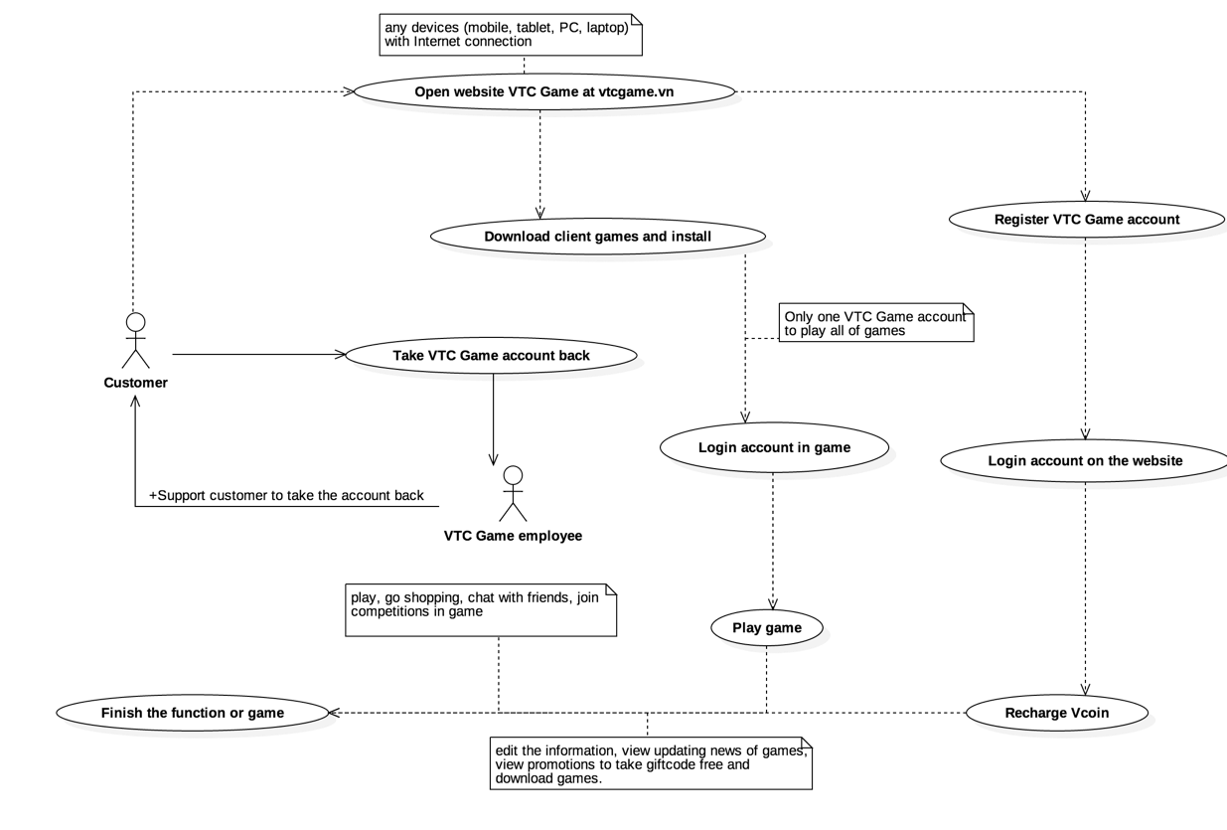

## **VTC Pay**

### **Physical**

After creating VTC Pay account on website of VTC Pay, customers need to take VTC Pay cards at VTC Pay counter with employee.

### **Virtual**

Customers create VTC pay account through the web application <https://vtcpay.vn/>. After that, they can edit the information, view all transactions, view available balance, add Visa/Mastercard/Bank cards and do 4 main functions include recharge, payment and transfer and withdrawal.

### **Direct/Indirect**

Customers use the VTC Pay web or the mobile application with any devices with Internet connection to make transactions and any functions the app supports at anywhere.

### **Service Encounters Diagram**

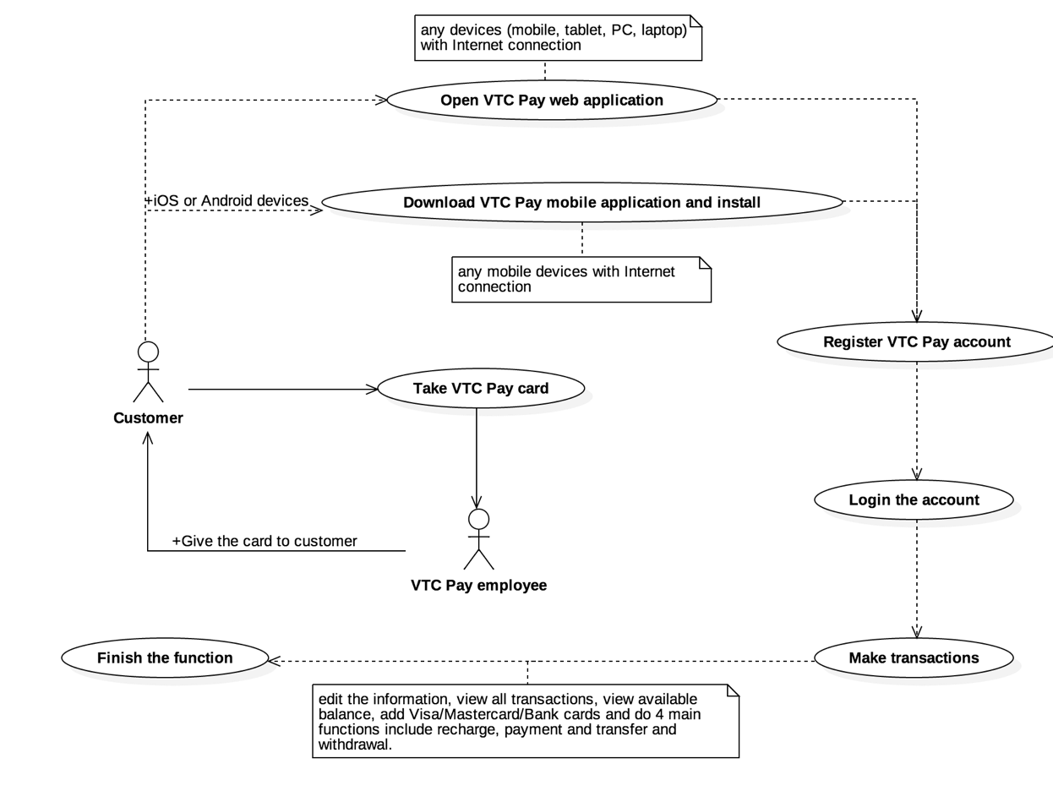

# **Service Priorities**

## **Value creation**

VTC has been focusing on 3 most important IT business sectors include: digital content service, television service and telecommunication service. The value creation is created with each business sector correspondingly. With the overwhelming digital content service such as online games and newspaper, VTC will expand some new directions such as multi-purpose payment, step by step forming content production studios towards the international market and that will bring brands of agencies throughout the world. In television service, customers just need to pay once and have 3 benefits consist of watching HD television, TV on mobile and TV channels as required. For telecommunication service, customers/clients will have storage service and information security.

## **Value co-creation**

Value co-creation is created consecutively between customers/agencies and each of VTC services everyday. For VTC Game, when customers play online games, customers will have fun time with their friends and VTC will have money when you recharge and agencies (game producers) also earn the amount of money with percentage profits was engaged earlier. For another example, VTC Pay, you create a VTC Pay account, you can make payments when you go shopping at anytime and VTC Pay will have profit whenever you make a transaction. The same for other IT services, VTC and customers/agencies always are in a mutual relationship, both are beneficial.

## **Value In-use**

I’ve been a customer of VTC Game until now and CrossFire is my favorite online FPS game. I remembered there’s a time hackers released full features patch for CrossFire, VTC Game moderator team tried hard to interrupted the patch right after the patch just 2 days. For other services of VTC, the customers always feel safe when using VTC Pay or VTC eBank because their privacy issues as well as information security ability are guaranteed 24/7 by supervision team. Besides, customers feel trustful when reading VTC News because all of news are checked carefully before they’re posted on website, therefore, VTC News is one of top 10 electronic newspapers of Vietnam. In conclusion, almost customers appreciate VTC IT services.

# **Rationale**

## **IT Service Changes**

With increasing competition in the field of gaming, VTC Game has been lost a large number of gamers because they switch from FPS or MMORPG or Music games to MOBA games such as Dota and especially League of Legends in Vietnam. In 2014, VTC really wanted to buy Dota 2 but going through a long time for negotiating, Valve didn’t approve to sell it and just co-operate with VTC to issue Steam Wallet and souvenirs of Dota 2. Because of this, VTC lost a big chance to compete with Vietnam Esports which is the publisher of League of Legends in Vietnam. Moreover, in CrossFire, more and more gamers using hack when playing so a lot of fair players leaved the game then the number of gamers reduce significantly. Although moderator team often supervise channels in game, that don’t really improve the situation. I suggested that VTC Game need to update new versions for prime games consists of CrossFire and Audition, and upgrade the anti-hack software of games continuously as well as expand mobile game market contemporarily. That will bring more gamers and maintain the progress of game development of VTC Intecom and VTC Game in particular and VTC in general. For other IT services, VTC is doing well because of business statistics. In 3 most recent years 2014, 2015, 2016, the revenue of VTC has grown consecutively as follows:

* Total revenue in 2015 of VTC Corporation reached 3,500 billion, exceeding over 6% the plan and 9% growth compared to 2014; profit reached 123 billion VND, exceeding over 20% the plan and over 60% growth compared to 2014.
* In 2016, VTC Corporation achieved high growth rate in all three targets: revenue, profit and paying national budget. In which, the revenue reached 5,209 billion, increase 39%, the profit reached 180 billion VND, over 46% growth compared to 2015.

# **References**

## **Introduction**

[Vietnam Television Corporation - VTC (English Wiki)](https://en.wikipedia.org/wiki/Vietnam_Multimedia_Corporation)

[Vietnam Television Corporation - VTC (Vietnamese Wiki)](https://vi.wikipedia.org/wiki/T%E1%BB%95ng_C%C3%B4ng_ty_Truy%E1%BB%81n_th%C3%B4ng_%C4%90a_ph%C6%B0%C6%A1ng_ti%E1%BB%87n_Vi%E1%BB%87t_Nam)

## **Existing IT Services Scoping**

[VTC Game Homepage](https://vtcgame.vn/)

[VTC News was 8 years old in 2016](http://vtc.vn/bao-dien-tu-vtc-news-tron-8-tuoi-d265303.html)

[VTC Digital Television](https://vi.wikipedia.org/wiki/%C4%90%C3%A0i_Truy%E1%BB%81n_h%C3%ACnh_K%E1%BB%B9_thu%E1%BA%ADt_s%E1%BB%91_VTC)

[VTC Pay Introduction](https://vtcpay.vn/huong-dan-472/gioi-thieu-156/gioi-thieu-vi-dien-tu-vtc-pay-649)

[VTC Digital TV Introduction](http://vtc.gov.vn/gioithieu)

## **Customer Services Encounters**

[VTC Game Recharge Vcoin](https://vtcgame.vn/nap-vcoin/)

[VTC Pay Homepage](https://vtcpay.vn/)

[VTC Pay E-wallet for Android](https://play.google.com/store/apps/details?id=com.vtc.paygate.main)

[VTC Pay E-wallter for iOS](https://itunes.apple.com/vn/app/vtc365/id404108605?l=vi&mt=8)

## **Service Priorities**

[Three most important IT business sectors (Vietnamnet news)](http://vietnamnet.vn/vn/cong-nghe/tong-cong-ty-vtc-dat-muc-tieu-doanh-thu-tren-10-000-ty-dong-255696.html)

## **Rationale**

[VTC couldn't buy Dota 2 of Valve](http://infogame.vn/esports/qua-kho-de-vtc-game-so-huu-dota-2-2321.html)

[Revenue of VTC in 2015 compared to 2014](http://ictnews.vn/kinh-doanh/doanh-nghiep/nam-2015-tong-cong-ty-vtc-dat-loi-nhuan-tang-60-so-voi-2014-133823.ict)

[Revenue of VTC in 2016 compared to 2015](http://ictnews.vn/kinh-doanh/doanh-nghiep/vtc-can-moc-doanh-thu-5-209-ty-dong-nam-2016-147038.ict)