# dt_dev_tools_color_white.png

Table of Contents

|  |  |
| --- | --- |
| Section One: Pool Boss Overview | 2 |
| Section Two: Spawning From Code | 6 |
| Section Three: Miscellaneous Other Scripts | 8 |
| Section Four: Other Plugin Integration | 8 |
| Section Five: Using JavaScript (UnityScript) | 8 |
| Conclusion | 8 |

# Pool Boss - Getting Started

Congratulations on your purchase of Dark Tonic’s Pool Boss! You now have a very flexible yet easy to use object pooling system. Pool Boss is part of the popular [Core GameKit](https://www.assetstore.unity3d.com/en/#!/content/6640) plugin by Dark Tonic, which also includes a full combat system, spawners and level setup tools! Check it out if you need any of those features.

To start, find the PoolBoss prefab in Project View under DarkTonic/PoolBoss/Prefabs and select it. Then drag it into your Scene to create one. Make sure to create your own prefab elsewhere immediately so that you won’t lose your changes when updating PoolBoss later on.

**Note:** It's important that you never drag out a copy into your Scene because if you do, the next time you update the plugin you will lose all your pool items. This is a Unity prefab problem. When you drag a prefab into a Scene, the Scene copy is connected to the one in the plugin folder. The button we have provided disconnects your Scene's Pool Boss copy from the source.

# Section One: Pool Boss Overview

Pool Boss is a prefab pre-loader / recycler similar to Pool Manager. If you're familiar with Pool Manager, you will have no trouble using Pool Boss. Here's a screen shot.

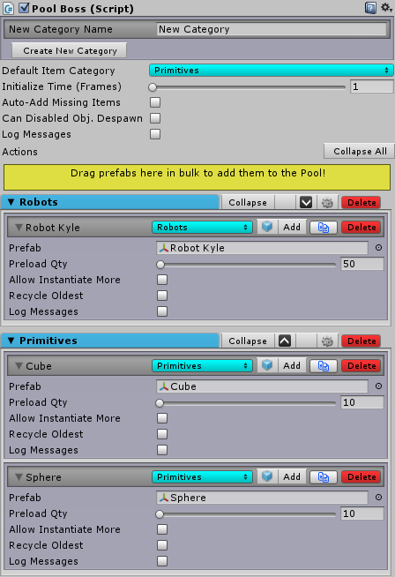

If you are unfamiliar with the reasons for using a pooling solution, here are the basics. Instantiate and Destroy calls (which are what normally happen if you don't use pooling) can cause stuttering when complex objects are created (and destroyed) during game play, especially on mobile devices. A pooling solution will create everything up front when the Scene starts, and everything not needed at start will begin in a despawned (inactive) state initially.

To set this up, you simply specify which game objects you want in that pool, and how many of each. At runtime, the pool items are disabled GameObjects when despawned and are enabled when you spawn them. Performance is massively affected and more predictable by a system such as this. The settings are as follows:

1. Top-level controls
   1. Create Category section: Pool Boss begins with one category: “Uncategorized”. You can create as far categories as you wish and organize your game objects into them. For instance you may want the following categories: Players, Enemies, Enemy Projectiles, Particles, etc. Use the Create Category section to add as many categories as you like. Just type the name and click “Create New Category”.
   2. Default Item Category – any items you create by dragging a prefab into the yellow drag area will be added to the category you have selected here.
   3. Initialize Time (Frames) - defaults to 1. This controls how long it takes Pool Boss to create all the clones for all pool items, for spawning. You can set it between 1 and the number of different prefabs you have set up in Pool Boss. In the highest setting, Pool Boss will only initialize the clones of 1 prefab per frame, so the game won't lock up while Pool Boss initializes everything.
   4. Auto-Add Missing Items - checking this box will actually allow you to "half-pool", meaning that you can check the box and hit play without adding any Pool Items. What will happen is that nothing will be created up front, but Pool Items will be created (Instantiated - bad for performance) as you need them, and can be reused. Also, any prefab that is in the Hierarchy (already in the Scene at startup and doesn't need to spawn) will get despawned in to the pool when it goes away so you can re-use it later in that Scene. If you do not check this box, any prefabs you try to spawn that don't have a matching Pool Item will instead log an error and nothing will be able to spawn without setting up the Pool Items. This mode is normally only used for the prototyping phase, and later when you know how many of what you want to pool, you can set up the pool items correctly.
   5. Can Disabled Obj. Despawn - off by default. If you need to be able to despawn a game object you have disabled, you must check this box. It is worse on performance because it doesn't only check "is the object enabled" so only use it if you must have the ability.
   6. Log Messages - checking this box will tell you when each prefab spawns, despawns, or if Pool Boss needs to Instantiate an extra copy because you are already using all copies of the prefab.
   7. Collapse All / Expand All – this button changes text and function depending on whether everything is already collapsed or not. This will expand or collapse all categories and pool items.
   8. Despawn All – this appears only at runtime and will despawn all active Game Objects that are set up in Pool Boss.
   9. Yellow Drag Area – it says “drag prefabs here”. Dragging a prefab (or multiple prefabs if you lock the Inspector) into this area will create new pool items.
2. Per Category Controls
   1. Arrow on left is used to collapse or expand the category only. When collapsed it will show the number of pool items in it.
   2. Collapse / Expand button – clicking this will collapse / expand the category and all pool items in it.
   3. Up / Down arrows – use these to change the display order of your categories.
   4. Edit (gear) icon – click this to change the name of the category. When editing, the edit icon is replaced with a save (disk) and cancel (red X) icon and the category name is editable. When done, either save the change or cancel to go back to the old name.
   5. Delete (Del) – click this to delete the category. You cannot delete a category containing pool items though. You must delete or move the items first.
3. Per Item Settings
   1. Title bar
      1. Arrow on left is used to collapse or expand the pool item only.
      2. Item Category (blue dropdown) – change this to move an item to another category.
      3. Prefab icon (cube) – click this to select the prefab in Project View.
      4. Click the Add button to add a new blank item, then drag the prefab into that new item’s Prefab field from Project view.
      5. Clone (copy / paste) icon – click this to create a copy of the pool item below the original. Good when you want identical (or almost) settings. Just change the prefab afterward.
      6. Click the Del button to delete a pool item.
   2. Prefab - drag a prefab here to specify which prefab you want to pool.
   3. Preload Qty - here you specify the amount of copies of the prefab to create when the Scene starts. They will all begin despawned (inactive in the Hierarchy) and will appear as a child of the PoolBoss game object
   4. Allow Instantiate More - this defaults to off. If you check this box, and there are no remaining copies of the prefab despawned, another copy will Instantiate (not good for performance). Leave this checkbox on if you aren't sure how many you need. Later you can adjust the Preload Qty and turn this off.
   5. Item Limit - this is only visible and used when Allow Instantiate More is checked. This is used to put a limit on the amount of items that can be Instantiated after the Scene begins. This number will default to your Preload Qty.
   6. Recycle Oldest – check this if you wish Pool Boss to automatically take the oldest spawned pool item and re-spawn it when you don’t have any despawned copies available in the pool.
   7. Enable NavMeshAgent - defaults to off. Only visible if you have a NavMeshAgent component on your pool item. If you do not disable your NavMeshAgent, then you will get errors in the Console as each one awakens prior to spawn (since they will be disabled). This checkbox will auto-enable the component as it spawns.
   8. Log Messages - checking this box lets you log messages for only the Pool Items you check instead of all Pool Items. Good for troubleshooting.
4. Runtime: at runtime, Pool Boss shows you more information about the pool items.

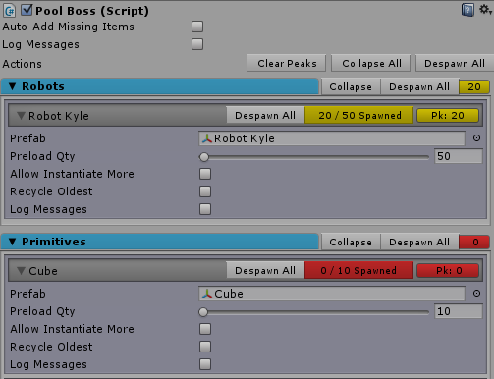

Notice the yellow text "20/50 spawned" in the screen shot above. That appears to let you know how many are spawned and what the total number of all copies of the Pool Item is (spawned + despawned). This is also great when you have turned on Auto-Add Missing Items. You can play the busiest section of your game, and just before pressing stop, pause the game and click on PoolBoss to take note of the totals so you can create or modify your Pool Items with those numbers in mind so you don't need to count them. Good time-saver! You can also click on this text to select all the spawned items in the Hierarchy.

Of similar use is the Peak Indicator for each pool item, which shows as "Pk: 20". This will always show the highest number of the pool item that have been used since you hit play. You can click that button to reset the peak to the current number spawned. There's also a Clear Peaks button up top that will do the same for all pool items.

Categories also have a similar roll-up yellow or red number (shown 10 above) that you can click on to select all spawned pool items in the category.

Also during runtime, more buttons will appear on each item row. These are the same as the same-named buttons in the top-level section, but apply only to the single prefab configured in that pool item.

* 1. Despawn All

1. Spawning Events - there are events broadcast whenever a prefab is spawned or despawned. Any script on any prefab (or sub-prefab) can perform actions in these event handlers. Just to keep things easier for people migrating from Pool Manager, I have named the events the same as they did.
   1. OnSpawned - this code fires immediately after the prefab has spawned. Note that when not using pooling solutions, you put a lot of initialization code in the Awake or Start event. However, you will want to move some or all of that code into the OnSpawned event so that it fires each time the prefab is respawned. This is because the Awake and Start events will not fire again when the prefab is respawned.
   2. OnDespawned - this code fires immediately before the prefab despawns. This should be cleanup code only, and it should not take longer than one frame to execute (starting a CoRoutine is not advised as it will probably not finish). When despawn occurs, the prefab will be re-parented as a child of the PoolBoss game object automatically.

Code would look like this (C#):

void OnSpawned() {

// initialization code.

}

void OnDespawned() {

// cleanup code.

}

**Note:** If you are using a pooling solution, never call Instantiate or Destroy! If you destroy a cloned prefab in the pool by code, it will no longer be available the next time Pool Boss needs it. Pool Boss will log an error if this happens so you can find your code that did it.

**Note:** If you want to spawn Particles or audio items, make sure to attach the Timed Despawner script to those prefabs and set the Life Seconds to the amount of time the audio should play or the amount of time the particle takes to disappear. Then these prefabs will return to the Pool. However, if you need a more complete audio solution, we do recommend that you check out our flagship product [Master Audio](https://www.assetstore.unity3d.com/#/content/5607).

# Section Two: Spawning From Code

To use Pool Boss without Playmaker, you will need to use one line of code to spawn and to despawn. The complete API can be [found here](http://www.dtdevtools.com/API/poolboss/index.html). These look identical to GameObject.Instantiate calls except that you pass and get back a Transform instead of a GameObject.

Note that all scripts that use the API will need the following line at the top:

using DarkTonic.PoolBoss;

Here are the basics in C#:

PoolBoss.SpawnInPool(Transform transToSpawn, Vector3 position, Quaternion rotation);

This will spawn the prefab you pass in at the position and rotation you provide, with the Pool Boss prefab as its parent.

PoolBoss.SpawnOutsidePool(Transform transToSpawn, Vector3 position, Quaternion rotation);

This will spawn the prefab you pass in at the position and rotation you provide, with no parent.

PoolBoss.Despawn(Transform transToDespawn);

This will despawn the prefab you pass in. There are also variants where you use a string instead of a Transform for the name of the item. Consult the [Pool Boss API website](http://www.dtdevtools.com/API/poolboss/index.html) for more details.

# Section Three: Miscellaneous Other Scripts

1. Timed Despawned - found under Dark Tonic -> Pool Boss -> Timed Despawner. This script can be used to automatically despawn a prefab after X seconds. This is useful for despawning prefabs with particle systems without writing any code.

# Section Four: Other Plugin Integration

We have included an optional Playmaker package in the 3rd Party Plugin Integration folder.

1. [Playmaker](https://assetstore.unity.com/packages/tools/visual-scripting/playmaker-368) - there are several custom actions included in the Playmaker\_CustomActions package. These show up under the Script Control category in Playmaker.
   * Pool Boss Despawn
   * Pool Boss Despawn All Prefabs
   * Pool Boss Despawn Prefabs Of Type
   * Pool Boss Item Despawned Count
   * Pool Boss Item Is In Pool
   * Pool Boss Item Spawned Count
   * Pool Boss Item Total Count
   * Pool Boss Prefab Count
   * Pool Boss Spawn
2. There's also a packages for [ORK Framework](https://assetstore.unity.com/packages/templates/systems/ork-framework-rpg-engine-14419) and [Makinom](https://assetstore.unity.com/packages/templates/systems/makinom-pro-game-toolkit-37431) to use Pool Boss.

# Section Five: Using JavaScript (UnityScript)

You will need to move the Assets/DarkTonic/PoolBoss/Scripts folder into the Assets/Plugins folder so that it will compile in the right order and be accessible from other scripting languages. It's wise to also rename the "Scripts" folder to "PoolBoss" so you know what they are after moving. Note that the Editor folder will need to be moved into Assets/Plugins/Editor/DarkTonic/PoolBoss folder, which changes its folder hierarchy.

# Conclusion

That’s it for now! We hope your enjoy this plugin as much as we have. Now get making awesome games with this! Dark Tonic will also help you promote your games made with Pool Boss. Email us for details!

Thank you,

-All at Dark Tonic

Pool Boss is part of the complete game system [Core GameKit](https://www.assetstore.unity3d.com/en/#!/content/6640) which includes simple combat, spawners, level setup tools and much more. Check it out if you'd like the entire integrated system!

Make sure to check out our other plugins such as the top-selling Master Audio at <http://u3d.as/content/dark-tonic-inc-/master-audio/3PY>. Support is available by emailing [info@darktonic.com](mailto:info@darktonic.com). You can also post on the Unity Forum Pool Boss thread [linked here](http://forum.unity3d.com/threads/coming-soon-pool-boss-the-new-super-simple-pooling-solution.274956/). Or use the official Dark Tonic forums here for help: <http://darktonic.freeforums.net>

Tutorial videos of our plugins can be [found here](https://www.youtube.com/watch?v=AOo6qfNSEww&index=1&list=PLW6fMWQDKB24osBmTuJd0IG8R5tOim6eV).