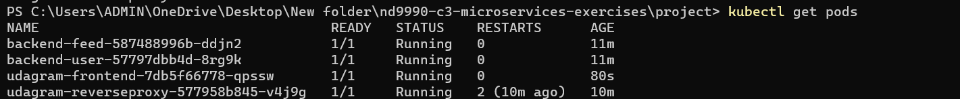

HPA

END HPA

