PLEASE NOTE: These drives arrive unformatted. They will need to be initialised and formatted before they are able to be used. They will NOT show up in Explorer/Finder until this process is completed. This is standard practice for used drives and helps to ensure the drives are best suited for your use-case and helps to reduce unnecessary writes on the disks.
Instructions for windows are attached - For MacOS: Open Disk Utility, Ensure the correct drive is selected, then click Erase and follow the prompts. Apple suggests using the APFS file system, which should be selected by default. However, you should use ExFAT if you are planning to use the disk between devices. WARNING: Ensure the correct disk is selected as this will erase any data on the selected disk and will not be recoverable.
If you run into issues, contact us at support@transcendbinary.co.uk and we will walk you through the process for your system.
Note: you may need to be logged into an administrator account to perform this process
INSTRUCTIONS FOR WINDOWS:
- Right-click the start menu button and select ‘Disk Management’
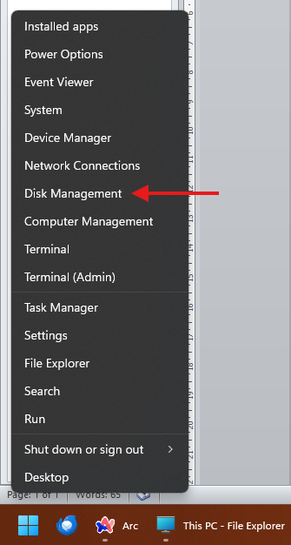
NOTE FOR STEP 2: If windows does not prompt you automatically, find your disk in the list and look for the red X shown in the image below. Right click that left-hand-side box and select ‘Initialise disk’ and continue following instructions.
- Windows should detect the disks as uninitialized and automatically prompt you to initialise them. Ensure your disk(s) are checked and that GPT is the selected partition style (choose MBR if you need support for older windows versions), then click Okay.
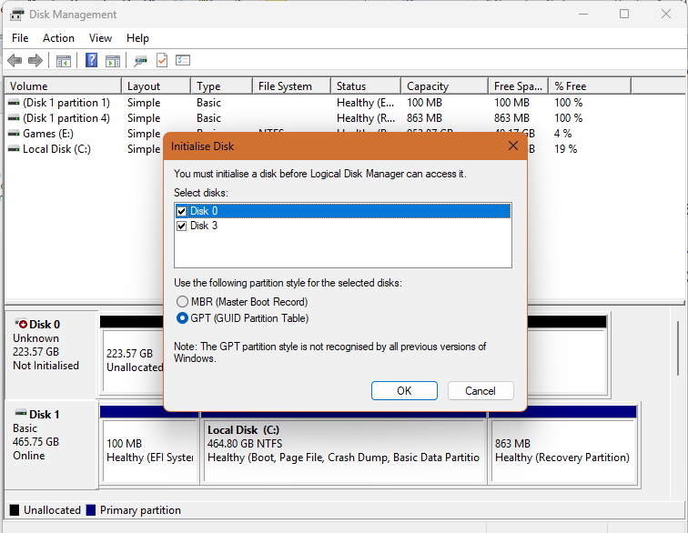
(please flip page)
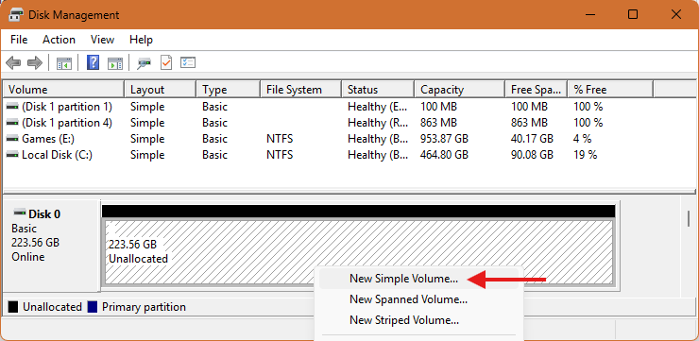
- Follow through the Wizard as follows
  - Select volume size, default is the full disk – choose a smaller size to create multiple partitions for organisation, these show up as separate “drives” in Explorer. Note: This size is in MB. for a capacity in GB, times by 1024, i.e. 64GB = 65536MB
  - Ensure ‘Assign the following drive letter’ is selected, then choose a drive letter which isn’t in-use by your system or any external drives you regularly use. Windows will try to use a safe drive letter but its best to double check as duplicate drive letters will cause problems.
  - Ensure “format this volume with the following settings” is selected. The filesystem should be NTFS if you are planning to use this drive exclusively with windows, or ExFAT if you plan to use it across devices (some older devices may not support ExFAT, in such cases use FAT32). Also ensure ‘perform a quick format’ is selected as this will speed up the process significantly and reduce wear on the drive.
  - Ensure your settings are correct and click Finish – repeat for any other drives or partitions
- Check your disks are accessible in windows explorer

