33333333333333333AGWASURI: AN IOT-DRIVEN PLATFORM FOR MONITORING WATER QUALITY WITH PREDICTIVE ANALYTICS USING DECISION TREE ALGORITHM

An Undergraduate Thesis Proposal
Submitted to the Faculty of
Information Technology Department
Cavite State University Naic
Naic, Cavite

In Partial Fulfillment
of the Requirements for the Degree
Bachelor of Science in Computer Science

MENDOZA, JAZREL P.
MIRANTE, REYMAR V.
PACHICO, JOHN MARK A.
December 2025

BIOGRAPHICAL DATA
Jazrel Dennis P. Mendoza, born on September 27, 2002, was a native of Bucal 2 Maragondon, Cavite. His life has been spent entirely within the territory. As the eldest of his two siblings, Jazrel has always been the brotherly pillar that sustains them. He is the child of Mrs. Aime P. Mendoza and Mr. Dennis P. Mendoza, who acted as instrumental figures in molding his aspirations and moral values.
Jazrel attended Bucal National Integrated School for his formal education and graduated from junior high school in 2017. His tenacity of purpose was evident throughout his years in this institution, leading him to graduate at the top of his class from Western Colleges after senior high school. This was one of his outstanding academic achievements, serving as a steppingstone for the rest of his pursuits. It well portrayed his intelligence and expertise in it.
He was studying at Cavite State University-Naic Campus, earning a bachelor's degree in computer science. Through his choice of this course, he has started to express a deep interest in technology and wants to bridge the gap between theoretical thought and practical implementation. Jazrel believes that his educational experience presents real-world problems and wants to make a difference in discipline.
Jazrel is interested in web development, UI, artificial intelligence, and graphic design. Integrating technical ability with creative approaches toward beautifying user experience and visual communication.
His research on emerging trends in technology helps hone his skills, in addition to completing his academic research. With commitment, an uncompromising push for academic pursuits, and innovation, such a pointed intent to influence change through the technological sphere usually results.

BIOGRAPHICAL DATA
Reymar V. Mirante was born on September 27, 2002, in Timalan Balsahan, Naic, Cavite, where he has lived his entire life. He is the eldest among two siblings and is the son of Mrs. Rosemarie V. Victoriano and Mr. Reynante A. Mirante, who have played significant roles in shaping his values, character, and aspirations.
Reymar completed his junior high school education at Centro de Naic National High School, where he graduated with honors. He then pursued his senior high school education at Western Colleges and likewise graduated with honors, demonstrating his consistent dedication to academic excellence.
Currently, Reymar is pursuing a Bachelor of Science in Computer Science at Cavite State University - Naic Campus. His interest in technology motivated him to choose this program, through which he aims to develop strong technical knowledge and practical skills relevant to the rapidly evolving field of information technology.
Reymar academic interests include web development, UI/UX, graphic design, and artificial intelligence. Through his coursework and projects, he continues to develop problem-solving skills and a passion for creating innovative and effective technological solutions.

BIOGRAPHICAL DATA
John Mark A. Pachico was born in Pilar, Sorsogon, on December 12, 2002, but grew up in Villa Apolonia, Naic, Cavite, and now resides in Hillsview Royale Subdivision, Timalan Balsahan, Naic, Cavite. He is the firstborn child of Mrs. Leonida A. Pachico and Mr. Michael A. Pachico.
John Mark is successful in academics. He is a student with a passion for software engineering, especially AI and web development. An excellent student at Cavite State University taking a bachelor’s degree in computer science, showing his excellent academic ability and dedication to his craft. He religiously applies academic and web development excellence to cutting-edge technologies. Skills include AI, data analytics, mobile app development, and web development, with current expertise going deep in Laravel.
John Mark is an independent AI software developer with a proven track record of successful projects. His expertise involves thorough practical work in computer vision and natural language processing. His portfolios are full of impressive initiatives, including the Gemini Chat Bot, a conversational AI, and PeraNatin, a proposed financial management tool.
With his skills in all the above fields, including Python, PHP, Flutter, and SQL, John Mark has been working hard to develop his skills in Laravel to attain mastery over the modern web.
Accredited in data analytics and leadership, John Mark aims to create innovative user-centric solutions bridging intelligence and technology that will give a solid foundation for a bright career in software engineering.

ACKNOWLEDGMENTS
It involves an exhausting but fulfilling effort, and we are assisted throughout by the goodwill and encouragement of many people and institutions whom we thank. Firstly, we thank our adviser, Mr. Ricky Jay Riel, and our technical critic, Mrs. Rossian Perea. Their technical guidance, wise critiques, and essential input strongly influenced the course and quality of our investigation.
We sincerely appreciate the fishpond owners who participated in this study. Their willingness to share some of their precious time, experience, and practical knowledge greatly helped facilitate the critical data that was the basis for this research. Their cooperation and contributions would have made it considerably more problematic to successfully achieve the aims of this project, and for this, we extend our sincere thanks.
Therefore, we are pleased to take the step of pride that culminates in this masterpiece. To our friends, families, and classmates, we acknowledge those indispensable guides without whom this journey would have been meaningless, especially acknowledging and showing appreciation for their relentless belief in us, along with their love, motivation, and support. To our fellow classmates, whose friendship made our burdens lighter and who helped ease our loads for us, and to our families and friends, our foundation of strength. It would not have been possible without each of you.
THE AUTHORS

TABLE OF CONTENTS
BIOGRAPHICAL DATA 3
BIOGRAPHICAL DATA 5
BIOGRAPHICAL DATA 5
ACKNOWLEDGMENTS 6
TABLE OF CONTENTS 7
LIST OF TABLES 8
LIST OF FIGURES 9
LIST OF APPENDICES 10
INTRODUCTION 1
Project Context 2
Objectives of the Study 3
Purpose and Description 5
Time and Place of the Study 6
Scope and Limitations 7
Conceptual Framework of the Study 8
Definition of Terms 9
REVIEW OF RELATED LITERATURE 11
Related Studies 11
System Technical Background 17
Synthesis 20
METHODOLOGY 22
Design of Software, Systems Products, and Processes 22
System Development 25
System Testing 31
System Evaluation 32
Data analysis plan 37
Implementation Plan (Infrastructure/Deployment) 37
RESULTS AND DISCUSSION 39
System Design 39
System Development 40
System Testing 42
System Evaluation 47
SUMMARY, CONCLUSION, AND RECOMMENDATIONS 51
Summary 51
Conclusion 52
Recommendations 53
APPENDICES 39

LIST OF TABLES
Tables
Pages

1 Comparative Analysis of Related Theses 16
2 Prior Art Matrix 17
3 Quality Characteristics 31
4 List of Participants (N=86) 31
5 Descriptive interpretation of the mean 35

LIST OF FIGURES
Figures
Pages

1 Input-Process-Output (IPO) Model 9
2 Use Case Diagram 22
3 Entity Relationship Diagram 23
4 Prototyping Model 25
5 Prototype Design of Agwasuri 26
6 Presentation of Sensor and Controller and its Major Components 27

LIST OF APPENDICES
Figures
Pages

1 Budgetary Requirements 39
2 Water Quality Test Time Comparison 40

INTRODUCTION
Aquaculture plays a crucial role in the Philippines, contributing significantly to food security and economic stability. It supports the livelihoods of many, particularly in rural areas, by providing sustainable income sources. As global demand for seafood grows, aquaculture production has surged from 19 million tons in 1950 to 122 million tons by 2020 (Noor & Harun, 2022). Despite this growth, the industry faces numerous challenges, especially in fishpond management.
Aquaculture productivity is critically constrained by the complex interplay of water quality parameters, with environmental monitoring emerging as a pivotal challenge in sustainable fisheries management. In San Juan I, Ternate, Cavite, local aquaculture operators frequently encounter significant operational challenges arising from inadequate water quality assessment.
The Agwasuri system aligns with Sustainable Development Goal (SDG) 14: Life Below Water by empowering fishpond operators to adopt sustainable practices, reduce fish mortality, and protect marine ecosystems, directly supporting the UN’s objectives of reducing marine pollution and promoting sustainable aquaculture. Moreover, Agwasuri contributes to SDG 9: Industry, Innovation, and Infrastructure. It uses technology to improve aquaculture efficiency and sustainability, hence fostering technological progress in the sector. Its system exemplifies SDG 17: Partnerships for the Goals. The system is a collaboration between the Municipal Agricultural Office and the farmers in the community. The system guarantees a community-driven approach that precisely matches the local needs and desires of the people involved, promoting the action of many towards sustainable development. Agwasuri tackles very critical challenges in marine resource management. It not only conserves these marine areas but also manages them in a way that advances multiple SDGs.

Project Context
The Agwasuri system is a technological innovation meant to revolutionize the management of aquaculture through integrated IoT technologies and advanced decision tree algorithms. With the view of creating a holistic solution that enhances operational efficiency, reduces mortality rates, and promotes sustainable aquaculture practices, this research is conceptualized to develop a real-time water quality monitoring system with added data-driven species selection recommendations.
Water quality parameters are critical in determining the productivity of aquaculture, where pH, dissolved oxygen, salinity, and temperature are some of the pivotal determinants of health in an aquatic ecosystem. The physicochemical characteristics have a direct influence on modulating physiological processes, metabolic efficiency, and survival mechanisms of the cultivated aquatic species. Accurate environmental monitoring and strategic management of these parameters are important for optimizing fish production, maintaining ecosystem resilience, and mitigating possible biological stress responses in aquaculture systems. As Sir Samuel Hermogino from the Research Development and Extension Services Office of Cavite State University pointed out during an interview, the most important things for the survival of fish are dissolved oxygen (DO), pH, and temperature. If not properly monitored, poor water quality can lead to high mortality of fish, reduced growth, and financial loss for operators. In San Juan I, Ternate, Cavite, traditional trial-and-error methods of species selection are usually employed by fishpond operators without considering the real-time water conditions.
Interviews with local operators disclose that sometimes fish species such as bangus (milkfish), sugpo (prawn), tilapia (chicken fish), and alimango (mudcrab) are mixed without considering critical water parameters. These yields recurring problems, including the death of the fish during the summer months from high salinity or in rainy seasons when too much freshwater becomes destructive to the condition. Such problems trigger financial losses that put the operators' livelihoods at risk.
Without data-driven tools, these problems persist, and the operators are never able to monitor water conditions or to select appropriate fish species. In view of this, Agwasuri, a system using IoT and a decision tree algorithm, provides real-time water quality monitoring and actionable species selection recommendations for the operators. The Agwasuri project thus aims at increasing sustainable aquaculture practices in Ternate by reducing mortalities and increasing the productivity of the systems.
The Agwasuri system is developed using the Prototyping model, emphasizing prototype and iterative development, adaptability, and collaboration. It places a strong emphasis on iterative refinement through continuous feedback to achieve a user-centric design. Involves feature development with respect to sensor integration and algorithm refinement while incorporating feedback into the system to enhance its functionality.
Its evaluation is based on the ISO/IEC 25010 standard, which includes key attributes of functionality, usability, reliability, efficiency, maintainability, and portability. This will ensure that the Agwasuri system meets high technical and operational standards for sustainable and efficient aquaculture practices.

Objectives of the Study
To develop a solar-powered IoT-driven system that can monitor real-time water quality and provide predictive analysis for the best fish species selection in fishponds. The following specific objectives will guide this effort:
- To design and develop the Agwasuri system with the following features;
  - A solar-powered system aimed at maximizing sustainability and economic efficiency,
  - A prediction module for optimal fish selection,
  - An IoT enabled microcontroller for integrating sensors, providing flexibility, scalability, and cost-effectiveness,
  - Non-volatile flash storage for data backup and support offline access,
  - Cloud connectivity for data transfer,
  - A web platform for data repository and visualization, and
  - Municipal Agriculture Office module.
- To identify and assess the software and tools used for the development of Agwasuri and their relevance to the project;
  - Figma for software wireframing and design,
  - Tailwind CSS for front-end interface design,
  - Blender for 3D modeling of visual components,
  - Laravel and Python as programming languages,
  - Visual Studio Code for software programming interface,
  - Thonny for microcontroller programming interface,
  - MicroPython for microcontroller programming language,
  - MySQL for database management,
  - Fritzing for prototype designing.
- To identify and assess the hardware and tools used for the development of Agwasuri and their relevance to the project;
  - ESP32 for microcontroller,
  - pH probe sensor for measuring acidity of water,
  - Electric Conductivity probe sensor for measuring water salinity,
  - Temperature probe sensor for measuring water temperature,
  - Dissolved Oxygen probe sensor for measuring dissolved oxygen levels,
  - SD Card module for reading/writing MicroSD data,
  - Breadboard for circuit assembly,
  - LED Display for visual output,
  - Jumper Wires for connecting components,
  - Switch for controlling the power supply,
  - MicroSD for data storage,
  - Solar Panel for renewable energy supply, and
  - Battery for backup power.
- To test the Agwasuri system in terms of alpha testing.
- To integrate a classification algorithm into the system.
- Evaluate the Agwasuri system for compliance with the ISO 25010 Software Evaluation Tool
- To formulate an implementation plan for the deployment of Agwasuri on the target beneficiaries

Purpose and Description
The Agwasuri system will provide fishpond managers with real-time information and actionable advice on best practices. It is expected to get aquaculture production off the cycle of dependence on labor-based, trial-and-error practices while arriving at a scalable, data-driven framework for enhancing fish farming practices. The key benefits of the study include:
For Fishpond Operators. Provides accurate quality water data and predictive fish species recommendations, which result in lower fish mortality and higher productivity.
The Municipal Agriculture Office of Ternate, Cavite. Mobilizes itself to strengthen its capability to support the local fishpond operators through more efficient monitoring tools.
To the aquaculture industry. Sustainable and effective farming will strengthen food security and preserve the environment.
Combining IoT-driven application with complex algorithms, the research ensures sustainability in the aquaculture sector with high benefits toward economic profits for the stakeholders.

Time and Place of the Study
The study will be conducted in San Juan I, Ternate, Cavite, focusing on the fishponds under the Municipal Agriculture Office (MAO). The MAO is very instrumental in helping the local fishpond operations with their technical assistance and guidance on the use of appropriate practices that ensure the sustainability of aquaculture activities within the area under its jurisdiction. This includes monitoring water quality and training fishpond operators on better practices for sustainable management of fishpond resources.
Information concerning water quality and the way aquaculture is practiced shall be gathered from the interviewed local fishpond owners, besides making direct observations in fishpond operations. This research will also coordinate closely with MAO to make sure that the data reflects reality on the ground and is attuned to the local fishery laws.
The Municipal Agriculture Office is located at the Ternate Municipal Hall with an address of 7PMC+P27, H. Ventura, Ternate, Cavite, Philippines. It serves as the central office where aquaculture practices are promoted and advanced throughout the region to establish a sustainable fish farming operation. To support the local fishpond operators, this office provides them with technical assistance and water quality monitoring, while implementing a host of productivity-enhancing programs coupled with environmental sustainability.

Scope and Limitations
This study works on the monitoring of important water quality parameters for pH, DO, salinity, and temperature in fishponds established in San Juan I, Ternate, Cavite. These parameters are critical for the assessment of health and productivity of fish; hence monitoring is important to determine effective decision-making on which species of fish should be produced. As informed by Sir Samuel Hermogino, the head of the Research Development and Extension Services Office of Cavite State University, optimal DO, pH, and temperature levels in water are very critical to the survival and productivity of fishes. Thus, this study could, on the one hand, give real-time water quality analysis with predictive recommendations based on the data collected. Specifically, the Agwasuri system would monitor these parameters, guiding the fishpond operators to identify the appropriate fish species to further enhance the sustainability and productivity level of the fishpond.
The geographical scope of this study is therefore put within the fishponds of San Juan I, Ternate, Cavite, because of considerations related to accessibility and practicality. These local operators in fishpond operations are knowledgeable about the region; besides, it is suited to execute the system to be tested for monitoring. This makes data and other resources needed for the said monitoring available to ensure its accuracy.
This study is just limited to the parameters of pH, dissolved oxygen (DO), salinity, and temperature, not including other water quality parameters such as turbidity, ammonia, alkalinity, TDS, TSS, level of algae (NPK), nitrite, and nitrate. These were not included because of resource constraints and issues, but further studies could also consider other parameters should technology and resources permit. As gleaned from the interview with Sir Samuel Hermogino, the fundamental parameters in maintaining the health of the fish are pH, DO, and temperature. Their absence shall not hinder the main objective of this study in improving fish species selection based on the critical chosen factors, though their non-inclusion may affect the comprehensiveness of the monitoring.
Furthermore, the calibration of the sensors presents a limitation attributed to financial constraints. The procurement of commercial-grade standard solutions and buffers for frequent, professional calibration is restricted by the project's budget. To mitigate this, the researchers will employ alternative "Do-It-Yourself" (DIY) calibration methods to baseline the sensors. While this approach is adopted to ensure the functionality and reasonable accuracy of the system, it is acknowledged that the precision of the data may be subject to minor variances when compared to readings derived from industrial-grade calibration standards.
The study does not include other types of ponds or aquaculture systems. This will make data collection easier and will make it practicable to work with local fishpond operators. Moreover, the system may need adaptations for use in other locations or pond types in the future.

Conceptual Framework of the Study
The conceptual framework of Agwasuri is based on the IPO model. It develops a solar-powered IoT platform for monitoring and analyzing the quality of water in ponds using a Decision Tree algorithm. Starting with knowledge and technical requirements integration, including aquaculture and IoT sensors, as well as related software tools, it focuses on system design, hardware, database development, and user interface development, and then rigorous testing. An evaluation phase is still available to assess the feasibility of such a design while the output phase results in an operable real-time water quality analysis platform.
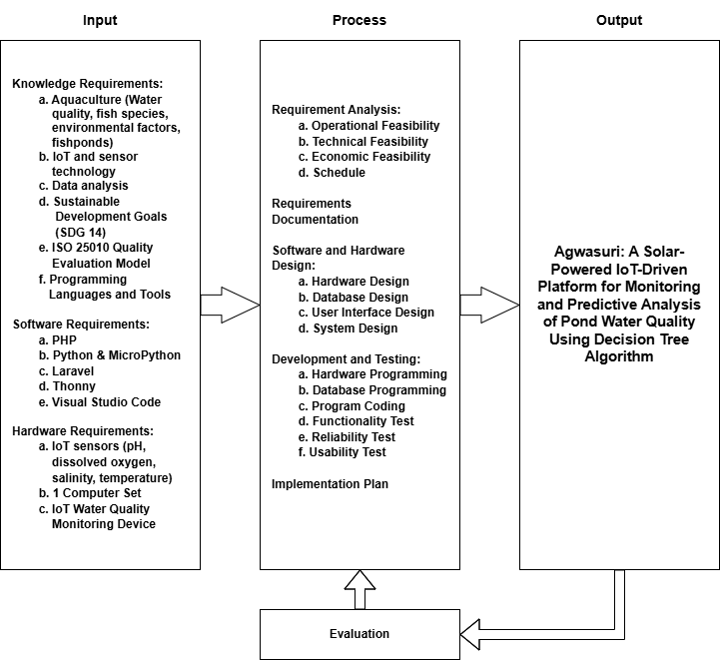
Figure 1. Input-Process-Output (IPO) Model

Definition of Terms
The following terms are operationally defined in the study:
Brackish Water is a mixture of freshwater and seawater.
Decision Tree Algorithm is a machine learning technique that examines data and provides forecasts, like choosing suitable fish species.
Dissolved Oxygen (DO) is the amount of oxygen in water, without which fish cannot breathe and survive.
IoT (Internet of Things) describes a system of interconnected devices that collect and transmit real-time data, including water quality parameters.
pH measures the acidity or alkalinity of water, which significantly affects fish health and growth.
Predictive Analysis involves using statistical methods and machine learning algorithms to analyze data and forecast outcomes, such as suitable fish species.
Salinity indicates the concentration of dissolved salt in water, determining the suitability of various fish species.
Temperature refers to the degree of heat in water, which influences fish metabolism and growth.

REVIEW OF RELATED LITERATURE
This chapter discusses the related literature and studies of the Agwasuri system, which is a solar-powered IoT-driven platform for monitoring and predictive analysis of pond water quality using a decision tree algorithm.

Related Studies
Integrating sensor technology in aquaculture provides a wide array of benefits that highly increase the effectiveness and sustainability of farming methods. These sensors are used in monitoring basic environmental conditions such as pH, DO, salinity, and temperature that are crucial in maintaining optimal conditions necessary for the survival and growth of fish. Aquaculture producers are aided in making informed, timely decisions by data acquisition that is done constantly and the transmission thereof, enabling the avoidance of a negative impact, such as fishes' mortality during changes in environment (Su et al., 2020). Further, because of the greater operational performance provided by the sensor systems, these directly take over a lot of the process in data acquisition while reducing the necessity for extensive hand monitoring that tends to be error-prone and laborious. This automation should not only save costs on labor but also increase precision and reliability with maximum retention of water quality always.
The application of real-time monitoring through WSNs can appreciably improve fish welfare and productivity. These systems help in the instant detection of problems such as oxygen deficiency or detrimental pH levels, hence promoting timely interventions that may prevent some stress or disease incidences in the fish populations (Kang, 2022). In addition, sensor technology has become economically viable, as it provides real-time streams of data without requiring laboratory-based costly analyses, which implies that advanced environmental monitoring is now achievable even for small-scale aquaculture industries (Su et al., 2020). The use of sensors in aquaculture broadens, increases, and intensifies farming, seeing, regulation, and maintenance of the seawater ecosystem as a likely course of action in a totally holistic and integrated way.
Data acquisition and analysis have become efficient and precise due to the dramatic change that IoT technology brought about in water quality monitoring. In this regard, Sugiharto et al. (2023) developed an IoT and cloud computing-based real-time system of water quality monitoring during the assessment of parameters such as pH, TDS, turbidity, and temperature in a continuous mode. In this regard, the use of the Internet of Things (IoT) to monitor the environment is shining bright with the increased sense of availability of commercially accessible sensors that are recognized for their superior accuracy. In the same line, J. Y. Lin et al. (2021) used the IoT platforms to assist in real-time data transfer among the deployed sensors that monitor temperature, pH levels, dissolved oxygen (DO), and electrical conductivity (EC). With these systems, IoT has the greatest impact, and its real-time visualization and management features greatly enhance data accuracy and significantly reduce response times (J. Y. Lin et al., 2021).
The choice and integration of sensors are critical elements for the performance and reliability of water quality monitoring systems. Sugiharto et al. (2023) emphasize the requirement of sensor accuracy within their framework that is designed to monitor real-time parameters such as temperature, pH, and TDS with an accuracy of the order of hundredths. In another research study, Ya'acob et al. (2021) have monitored several water quality parameters and fish presence in a fishpond by using IoT technology through a combination of temperature, pH, and ultrasonic sensors and NodeMCU ESP8266 microcontroller. While these advances have occurred, sensor accuracy and data transmission reliability remain. Chen et al. (2022) tackled these issues by using a robotic arm for measurement in automation; this ensures continuous working and overcomes the weakness, mainly the pH sensor, of its durability. The implementations above highlight the necessity of choosing robust and precise sensors to ensure dependable water quality monitoring.
Effective data transmission and processing are vital for achieving the best possible system performance in modern water quality monitoring systems. Lin et al. (2021) utilized an ESP32 Wi-Fi module to communicate real-time data quickly from their apparatus, which carries a multi-sensor to allow for quick analysis and visualization of critical parameters. Sugiharto et al. (2023) emphasized that reliable data transmission protocols are necessary to maintain data integrity, especially during network disruption. The real-time data transmission of their system to a cloud platform enables immediate analysis, which is essential for prompt decision-making and efficient environmental management. Such capabilities are critical for sustaining optimal conditions within aquaculture settings.
Maintaining and calibrating the water quality monitoring systems are integral parts that ensure long-term accuracy and reliability. According to Lin et al. (2021), pre-calibration and adaptive flexibility allow for adjustments in response to environmental changes and provide data integrity. Recurrent maintenance and calibration operations are necessary for any sensor to be functional and ensure that the information collected will be credible. (Chen et al., 2022) explored challenges more fully when they took on the robotic arm, designed for regular measurement and maintenance measurements that are completely free from humans and, therefore, their labor vulnerabilities. (Mohamed et al., 2023) thus ensured that a prototype placed much emphasis on sensor calibration, meaning that accuracy and reliability had better be preserved with their Arduino-based system. This aspect remains a key feature of the correct working principles of water quality monitoring systems.
For the Agwasuri System, which predicts fish species based on water quality parameters such as pH, salinity, temperature, and dissolved oxygen, the decision tree algorithm is an ideal choice due to its interpretability, efficiency, and ability to handle both continuous and discrete attributes. This clarity of a decision tree, through its hierarchical structure, eases the visualization of the decision process and thus is especially applicable to environmental science applications that require transparency in the model results (Wakiya et al., 2021). In fact, interpretability allows stakeholders to understand, in a fast way, the importance of certain water quality parameters on the predicted species, trust the model, and engage with it. It is also computationally efficient and doesn't need as much processing power as more complex ensemble methods, which may not show big differences in smaller datasets with fewer features (Christianti et al., 2020). Ensemble methods such as Random Forests and gradient-boosted Decision Trees can produce better performance, but such improvement in performance usually occurs at the expense of higher complexity and greater vulnerability to overfitting when applied to simple data sets (Lin et al., 2022). Therefore, the decision tree algorithm is balanced in terms of performance and interpretability, and hence it best suits the task of predicting the fish species in the Agwasuri System.
The Prototyping Model used in the development of the Agwasuri water quality monitoring system has several significant advantages. This is a methodology within the Software Development Life Cycle that focuses on creating initial prototypes and subjecting them to iterative development alongside ongoing feedback from users. This iterative process is important to ascertain that the system meets the needs of the users, as Daud et al. (2023) put it, since such models improve product quality through continuous refinement based on practical testing and user feedback. This particularly manifests in systems such as Agwasuri, wherein the interrelation between hardware and software requires holistic testing and validation of the different constituents. Further, the Prototyping Model is one way towards achieving economic feasibility. In Pasika & Gandla (2020), it has been stated that with basic, inexpensive sensors and microcontrollers, the developers can design step by step without investing much financially. Furthermore, the model has enabled a collaborative development environment in which users are more directly engaged in making the final product. Such a procedure for developing the model would be extremely critical for ensuring that the Agwasuri system is bound to meet the true needs of the people responsible for managing water quality. According to Rezaee et al. (2023), such involvement would eventually lead to the development of a system that is not only functional but also very user-friendly. Ultimately, the importance of the Prototyping Model in the field of system development, especially in the development of engaging and reliable systems, lies in its emphasis on seeking continuous feedback, detecting errors at an early stage, and reducing costs.
The stratified random sampling technique through disproportionate selection is very appropriate for the Agwasuri System since it enables the collection of representative and meaningful data from different participant groups. This method classifies the population into clear strata according to relevant characteristics and uses random selection to ensure that each subgroup is adequately represented irrespective of differences in their population sizes (Cobblah et al., 2022; Long et al., 2022). This technique allows for the collection of substantial amounts of data that are more representative of the diversity of the system, as it ensures proportional or augmented representation of the minority or smaller subgroups, and subgroup analyses can present different perspectives (Cobblah et al., 2022). It also enhances statistical power and reduces sampling bias as compared to non-probability methods such as quota sampling, which may rely on participant availability and can introduce bias (Iliyasu & Etikan, 2021). In summary, through stratified random sampling, disproportionate selection will be helpful in providing a basis through which varied characteristics and standpoints are necessary for thorough and proper examination and utilization of results within the Agwasuri System.
Table 1 is a comparative analysis of water quality monitoring systems that depicts that only Agwasuri implements all the nine critical features. Present solutions mainly have only focused on implementation of IoT and sensor-related capabilities, whereas Agwasuri has encompassed all those aspects.
Table 1. Comparative Analysis of Related Theses
Article Name | IoT enabled micro  controller | Wi-Fi connectivity | Water quality sensors | Cloud support | Respon  sive  web UI | Solar panel system | Offline data backup | Com  pact design | ML capabi  lities
Agwasuri | Y | Y | Y | Y | Y | Y | Y | Y | Y
Real-Time Water Quality Assessment via IoT: Monitoring pH, TDS, Temperature, and Turbidity (Sugiharto et al., 2023) | Y | Y | Y | Y | Y | N | N | N | N
An Integrated Wireless Multi-Sensor System for Monitoring the Water Quality of Aquaculture (J. Y. Lin et al., 2021) | Y | Y | Y | Y | Y | N | N | N | N
Water Quality Monitoring System for Fisheries using Internet of Things (IoT) (Ya’acob et al., 2021) | Y | Y | Y | Y | N | N | N | N | N
IoT-Based Fish Farm Water Quality Monitoring System (Chen et al., 2022) | Y | Y | Y | Y | Y | N | N | N | N
An Arduino-based Water Quality Monitoring System using pH, Temperature, Turbidity, and TDS Sensors (Mohamed et al., 2023) | Y | N | Y | N | N | N | N | N | N

Table 2 shows Agwasuri's technological advantages compared to existing solutions (D1-D4), highlighting its unique features in aquaculture monitoring. While sharing basic IoT capabilities and solar power systems with prior art, Agwasuri introduces three distinctive features: compact portable design, offline data backup, and ML-based predictive analysis for fish species selection. The prior art includes D1 (Intelligent oxygenation device, Utility Model, 2021), D2 (Distributed monitoring device, Utility Model, 2017), D3 (Water quality analysis device, Utility Model, 2024), and D4 (IoT-based monitoring system, Utility Model, 2017), which established the foundation but lack Agwasuri's advanced capabilities.
Table 2. Prior Art Matrix
Disclosed Features | Invention | Prior Art
Disclosed Features | Invention | D1 | D2 | D3 | D4
Internet of Things (IoT) enabled microcontroller | Y | Y | Y | Y | Y
Solar panel system integrated with power storage | Y | Y | Y | Y | Y
Water quality sensors (temperature, salinity, dissolved oxygen, pH) | Y | Y | Y | Y | Y
Responsive web UI for multi-platform access | Y | N | N | Y | Y
Cloud support for scalable data storage | Y | Y | N | N | Y
Real-time Wi-Fi connectivity for cloud-based data transfers | Y | Y | N | Y | Y
Compact design for portability | Y | N | N | N | N
Offline data backup capability | Y | N | N | N | N
ML for predictive analysis of fish species selection | Y | N | N | N | N

System Technical Background
In aquaculture, the most important environmental parameters affecting fish health and productivity include pH, dissolved oxygen, salinity, and temperature. Changes in these factors can significantly impact several fish species. Changes may indeed alter their metabolic rates and stress characteristics. Dissolved oxygen levels below a certain threshold can cause asphyxiation in fish, and changes in salinity may also disrupt the conventional osmoregulatory mechanisms that operate during normal conditions. Other influencing environmental factors include temperature changes, which affect growth rates and immune functions. Aquaculture professionals face challenges in efficiently monitoring these parameters because establishing accurate real-time information is also costly and requires additional demands of maintaining such sophisticated sensor technology (Sharma & Kumar, 2021).
A microcontroller is the heart of Arduino and ESP32. It contains IoT applications, support for real-time decisions, and even automation through acquisition, processing, and communication. Microcontrollers have been used in agriculture and aquaculture to monitor environmental setups in fields and water bodies. Sensors monitor important variables like water quality, temperature, and moisture levels in the soil. Aquaculture Application Aquaculture applies ESP32 microcontrollers to monitor the real-time pH, turbidity, and temperature and promises corrective measures that range from change of circumstances around water to adjustment of feeding programs according to Olanubi et al. (2024). Some advantages of applying microcontrollers in aquaculture have been cost-effectiveness, reduced energy consumption, and even the ability to automate, which entails labor cutback and productivity increase. Microcontrollers-based IoT platforms offer more timely and accurate data than traditional methods, allowing farmers to make better-informed decisions, thereby upping the ante for productivity and sustainability in agricultural and aquacultural systems (Kang, 2022). These systems are far more technological than manual gathering techniques that are quite labor-intensive and time-consuming; thus, microcontrollers have emerged as a necessity for data-driven farming today.
The ESP32 microcontroller is especially useful for IoT projects requiring real-time observation and data communications, thanks to built-in Wi-Fi, Bluetooth, and comprehensive input/output options. One crucial feature applicable to aquaculture is its two 12-bit Analog-to-Digital Converters (ADC) with a maximum number of up to 18 channels. This feature allows for exact measurements using several sensors, among them those measuring water quality parameters, such as pH and turbidity. Temperature, undoubtedly, is one of the key parameters in aquaculture operations (CircuitSchools Staff, 2022). This digital output from the sensors is thus transmitted in real-time to web or cloud-based dashboards through ESP32. It makes remote monitoring and control of the aqua parameters possible. In aquaculture, the ESP32 is mostly used for environmental variable observation and carries out automatic responses such as water aeration and filtration. Additionally, using HTTP and MQTT protocols gives ESP32 more advantages in including web applications that allow proper visualization and management of data presented (ESP32 - HTTP Request | ESP32 Tutorial, n.d.).
Aquaculture consists of monitoring the environmental parameters of water to ensure the safe quality of water and fish. Many critical sensors are applied to obtain information relevant to aquaculture: each of them is targeted at measuring different aspects of water quality. Of course, one sensor is very notable: the pH sensor estimates the water's acidity or alkalinity. It is of great importance in fish metabolism and the general chemical mix of water. The sensors generally have an accuracy of ±0.1 pH and a response time below one minute, thus showing great efficiency in real-time monitoring (PH Meter (SKU_SEN0161) DFRobot, n.d.).
Dissolved oxygen in water is sensed through DO sensors, which are the main requirement for fish survival. Low dissolved oxygen in water causes hypoxia, which leads to stress or even death in fish. The modern galvanic DO sensors have a detection range of 0-20 mg/L, and respond in about 90 seconds. They require regular maintenance for their foolproof long-term use (Gravity Analog Dissolved Oxygen Sensor (SKU_SEN0237) DFRobot, n.d.).
The DS18B20 is often used to measure water temperature since it tremendously influences metabolic activity, feeding behavior, and overall health of fish. Sensors are accurate within ±0.5°C over a broad range so that water temperature will always be above positive thresholds that are suitable for all species (Waterproof DS18B20 Digital Temperature Sensor (SKU_DFR0198) DFRobot, n.d.). A salinity sensor measures the concentration of salt in the aquatic environment, an important factor for both freshwater and marine aquaculture. High-precision salinity sensors provide measurement accuracy of ±5% full scale, guaranteeing that aquatic conditions are appropriate for a range of fish species (Gravity Analog Electrical Conductivity Sensor Meter V2 K=1 (SKU_DFR0300) DFRobot, n.d.).
The reliability of these sensors in real-time monitoring has been confirmed, with many units being able to continually collect and send data to the cloud platform for instant analysis. This allows aquaculture operators to rapidly adjust by implementing required alterations whenever the water quality changes from satisfactory levels (Vo et al., 2021). In conclusion, the functionality of these sensor devices has led to the design of contemporary IoT-driven aquaculture systems founded on their functionality. Productivity and sustainability have been improved with these systems since they facilitate monitoring and automatic reaction to environmental changes.

Synthesis
The Agwasuri system represents a major advance in the field of aquaculture monitoring; it is the technology that can eliminate the drawbacks from traditional systems. In contrast to the earlier model, which centered mainly on basic operations of IoT and sensors, Agwasuri is different for its solar-powered, compact design, and machine learning techniques applied to predictive analysis of fish species relative to indicators of water quality, such as pH, salinity, temperature, and dissolved oxygen levels. Grounded on a decision tree algorithm, the system manages to balance the interpretability aspect with computational efficiency, thus well-suited for a dataset with only a few features. Unlike some ensemble methods which can result in overfitting, the decision tree allows clear and actionable decisions to be communicated to stakeholders involved in aquaculture (Christianti et al., 2020; Wakiya et al., 2021). Furthermore, the implementation of stratified random sampling with a disproportionate selection methodology guarantees the acquisition of representative data, thereby improving the dependability of the results by encompassing a range of characteristics from various subgroups, which concurrently minimizes sampling bias (Cobblah et al., 2022; Iliyasu & Etikan, 2021).
Another proof of innovation in the design of Agwasuri is the approach used. This is because the Prototyping Model in the SDLC allowed for iterative improvements based on user feedback, which ensured that it met the needs of the users and combined both hardware and software components in an efficient manner (Daud et al., 2023). Similarly, the use of accurate sensors and microcontrollers enabled the implementation of sophisticated functionality at every stage without significant financial exposure. Due to its ability to be used offline, along with its offline backup, Agwasuri is recommended as a whole monitoring system for aquaculture. The introduction of recent predictive features in the machine learning field, combined with robust design options, overcomes the shortcomings raised by previous research and promotes the development of management in aquaculture based on the principles of sustainability goals (Chen et al., 2022; Mohamed et al., 2023).

METHODOLOGY
This chapter includes the design of software, systems, products, or processes, system development, system testing and evaluation, data analysis and implementation plan of the study.

Design of Software, Systems Products, and Processes
- Use Case Diagram
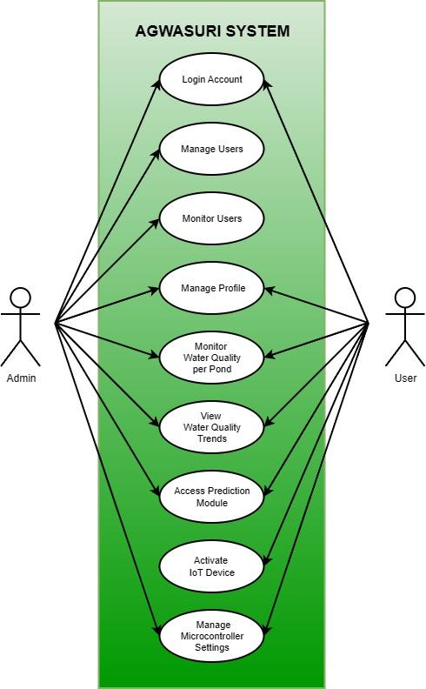
Figure 2. Use Case Diagram
- Entity Relationship Diagram
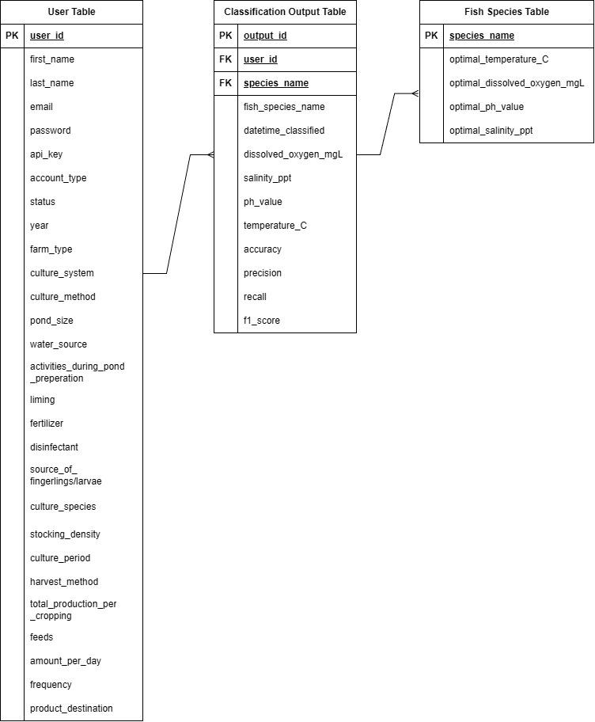
Figure 3. Entity Relationship Diagram
Requirements Analysis. The requirement analysis stage of the Agwasuri system involved gathering detailed information on what was needed and the specific specifications required to develop a sustainable, data-oriented aquaculture management solution. To this end, it involved an interview with the main stakeholders, which are fishpond managers and owners, based on experience in fishpond management and awareness of water quality assessment technologies.
During the interviews, stakeholders were emphatic about a system that would be able to offer predictive analysis for optimal fish selection based on real-time water conditions. It is through their inputs that the technical and functional specifications of the system are established, in terms of installing IoT-enabled sensors, decision tree algorithms, and solar-powered features to promote sustainability in off-grid environments. The significance attached to their inputs portrayed the notion that their inputs are respected and appreciated.
Another issue highlighted by the participants in the discussion was the challenge of not having enough tools and technology to determine the quality of water in their aquaculture businesses. The participants gave examples, such as financial losses that are directly associated with fish mortalities, to explain the need for a reliable system to help in solving the issues. Secure cloud-oriented online data storage, enabled by synchronization and microSD-based offline storage, has become a remedy for connectivity issues, especially in remote areas. A collaborative approach ensured that the Agwasuri system would ultimately meet what the users and industry would expect and provided a sound foundation to its design and development.
Requirements Documentation. Agwasuri is an aquaculture management system that handles the challenges of real-time monitoring of water quality and appropriate fish species selection. The system utilizes IoT-enabled sensors integrated with solar power functionality and advanced algorithms for a fully reliable and sustainable solution in managing fishponds.
The system features critical water quality parameters measured by IoT sensors, such as pH, dissolved oxygen, salinity, and temperature. The data obtained is processed by a decision tree algorithm that makes predictive recommendations on the fish species best suited for the current environmental conditions. This feature ensures the best possible health and growth of the fish, which in turn will support productivity in aquaculture.
The system is sustainable because the integration of solar panels allows the system to go beyond a mere grid connection. Coming to the data handling, Agwasuri has microSD storage to manage functionalities offline with Wi-Fi connectivity to upload into the cloud, allowing access and being reliable in areas with remote or very limited connectivity. The development of the user interface ensures that it will be cross-platform responsive, making no problem whatsoever with its continuous access on desktop or mobile. The display is also provided through an LCD display on site for real-time monitoring.

System Development
Agwasuri followed a Prototyping Model of development wherein the approach is iterative to converge on the solution through continuous feedback. Requirements gathering from the fishpond owners identified IoT-enabled sensors, solar power, and decision tree algorithms. A rapid prototype was developed with functionalities that emerged upon evaluation by stakeholders with feedback guiding successive iterations. Improvements were seen in usability, the algorithm's accuracy, and functionalities in offline conditions until it resulted in a solution that was dependable and user-friendly for sustainable aquaculture management.
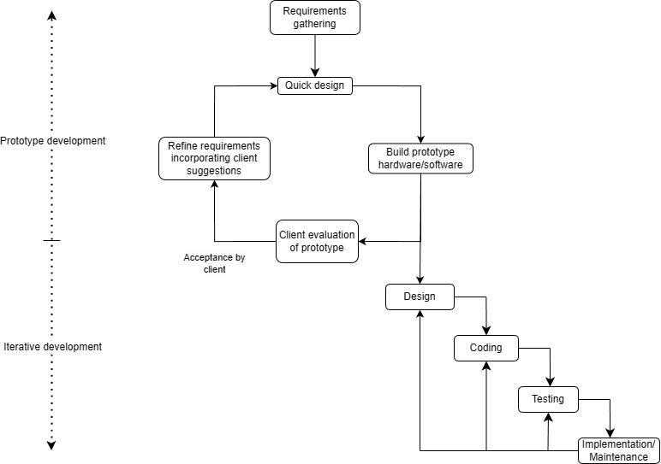
Figure 4. Prototyping Model
Requirement Gathering. It is within this requirements-gathering phase that the identification of needs which the Agwasuri system is to address was done. Among the features identified from the interviews conducted with the managers/owners of fishponds are IoT-enabled sensors for water quality parameters, solar-powered functionality for its running, and predictive recommendations with a decision tree algorithm. Such inputs would go a long way in ensuring the system addresses most of the major challenges faced within aquaculture management.
Quick Design. During the rapid design phase, a preliminary Agwasuri model was created to map out the functionalities of the system and their interrelation. Primarily, this phase is concerned with incorporating IoT sensors and decision tree algorithms with a simple, user-centered interface to ensure smooth data collection, processing, and general usability. The design should provide an adequate foundation for making improvements from iterative feedback provided by users.
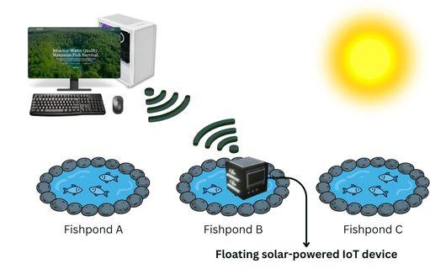
Figure 5. Prototype Design of Agwasuri
Build Prototype Hardware/Software. This prototype phase emphasizes assembling and configuring the hardware and software constituents of the Agwasuri system. The integrated IoT sensors and ESP32 microcontroller allowed real-time monitoring of key water quality parameters such as pH, dissolved oxygen, salinity, and temperature. To ensure continuous running even at off-grid sites, solar panels were installed; for offline data retention, the system was configured with microSD storage. The functionalities, sustainability, and adaptability of the system for aquaculture management were thus collectively ensured.
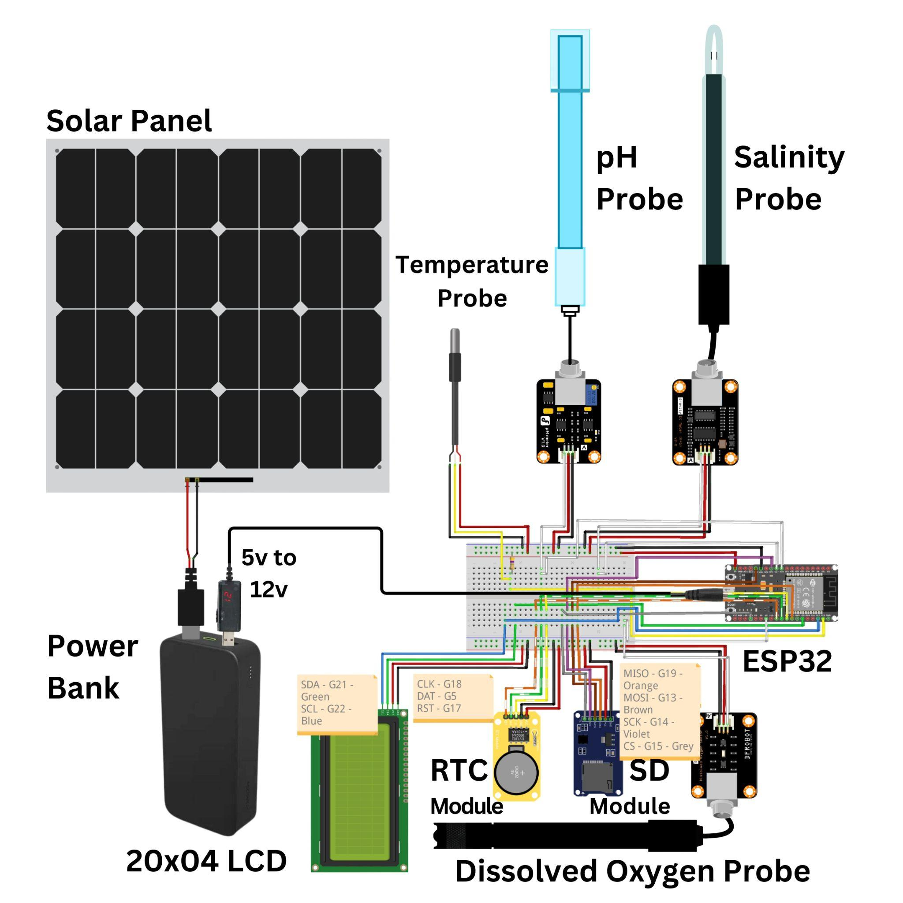
Figure 6. Presentation of Sensor and Controller and its Major Components
Table 4. Technical Specifications
Device Name | Model | Brief Description | Technical Specification
Gravity EC Sensor Kit | DFRobot Analog EC/Electrical Conductivity Sensor (K=1) | Lab-grade analog electrical conductivity sensor for water quality monitoring, ideal for hydroponics systems | - Measurement Range: 0-20 mS/cm  - Recommended Range: 1-15 mS/cm  - Operating Voltage: 3.0-5.0V  - Output Voltage: 0-3.4V analog  - Measurement Accuracy: ±5% F.S.  - Probe Type: Laboratory grade  - Cell Constant (K): 1.0  - Temperature Range: 0-40°C  - Response Time: <1 second  - Probe Connector: BNC  - Signal Interface: PH2.0-3Pin Gravity connector  - Board Size: 42 x 32mm  - Cable Length: 100cm  - Probe Life: >0.5 year (frequency dependent)  - Includes: Calibration buffer solutions (1413μs/cm, 12.88ms/cm)
Dissolved Oxygen Sensor Kit | DFRobot Analog DO Sensor/Meter | Galvanic dissolved oxygen sensor for measuring DO in water, used in aquaculture and environmental monitoring | - Measurement Range: 0-20 mg/L (ppm)  - Operating Voltage: 3.3-5.5V  - Output Signal: 0-3.0V analog  - Probe Type: Galvanic (no polarization time)  - Interface: Gravity plug-and-play  - Response Time: <60 seconds  - Maintenance: Replaceable membrane cap and filling solution
Redmi Power Bank | 20000mAh Redmi Fast Charge Power Bank | High-capacity portable battery with fast charging capability for smartphones and tablets | - Capacity: 20,000mAh (74Wh)  - Input: USB-C & Micro-USB (18W max each)  - Output: Dual USB-A (18W max each, 5.1V/3.6A combined)  - Battery Type: Lithium-ion polymer  - Fast Charging: Two-way 18W  - Protection: Over-current, over-voltage, over-temperature, short-circuit
32GB Micro SD Card | 32GB MicroSDHC | High-capacity memory card for data logging and storage applications | - Capacity: 32GB  - Type: MicroSDHC  - Speed Class: Class 10, UHS-I U1/U3  - Read Speed: Up to 100 MB/s  - Write Speed: Up to 90 MB/s  - Operating Voltage: 3.3V  - Operating Temperature: -25°C to +85°C  - Dimensions: 15 x 11 x 1mm  - File System: FAT32
Micro SD Card Module | Micro SD Card Module | Interface module for reading/writing SD cards with voltage level conversion, uses SPI interface | - Power Supply: 4.5-5.5V  - Logic Level: 3.3V or 5V compatible  - Interface: SPI (Serial Peripheral Interface)  - Module Dimensions: 4.1 x 2.4cm  - Supports: Micro SD and Micro SDHC cards
LCD Display Module | 20x4 LCD Display White on Blue | Character LCD display based on HD44780 chipset, displaying white text on blue background | - Display Size: 20 characters × 4 lines  - Controller: HD44780 compatible  - Interface: Parallel (8-bit or 4-bit mode)  - Operating Voltage: 5V  - Backlight: Blue with white text  - Character Size: 5×8 dots
Real Time Clock Module | DS1302 RTC Module | Real-time clock module for accurate timekeeping with battery backup capability | - IC Chip: DS1302  - Operating Voltage: 2.0-5.5V  - Current Consumption: <300nA at 2.0V (battery mode)  - Interface: 3-wire serial communication  - Time Tracking: Seconds, minutes, hours, day, date, month, year  - Calendar: Leap year compensation to 2100  - RAM: 31 bytes static  - Operating Temperature: 0-70°C  - Backup Battery: CR2032 (included with most modules)
ESP32 Development Board | ESP32-WROOM-32 | Wi-Fi and Bluetooth enabled microcontroller development board with dual-core processor | - SoC: ESP32-WROOM-32  - Processor: Dual-core 32-bit LX6 CPU  - Clock Speed: 80/160/240MHz (adjustable)  - SRAM: 520KB  - Flash Memory: 4MB  - Operating Voltage: 3.3V (I/O), 5V (USB input)  - Wi-Fi: 802.11 b/g/n (up to 150Mbps)  - Bluetooth: v4.2 BR/EDR and BLE  - GPIO: 34 programmable pins  - ADC: 12-bit (18 channels)  - DAC: 8-bit (2 channels)  - Interfaces: SPI, I2C, I2S, UART, SD card, PWM  - Operating Temperature: -40°C to 85°C
Client Evaluation of Prototype. An evaluation by the client was carried out to test the performance and usability of the implemented Agwasuri system. Through a structured evaluation form aligned with the ISO 25010 framework, fishpond owners gave their ratings on functional suitability, reliability, and usability of the system. The system was highly rated regarding the monitoring of water quality parameters such as pH, dissolved oxygen, salinity, and temperature; the users found the predictive recommendations very accurate and pragmatic in improving aquaculture operations.
Participants praised the system's solar-powered functionality for ensuring a stable performance in off-grid locations and noted the user-friendly interface on web and mobile platforms. The training sessions and manuals were effective in preparing clients to operate the system independently. In conclusion, the evaluation showed high satisfaction with the reliability and usability of Agwasuri, with valuable insights gathered to guide future enhancements.
Refine Requirement Incorporating Client Suggestion. Input from the clients allowed re-specification of the system to make improvements to the decision tree algorithm, simplify the user interface, and increase offline capabilities. These changes will ensure that the system becomes more accurate, usable, and useful for aquaculture management by considering the unique needs of its users.
Design. All the enhancements that the client accepted are also included in Agwasuri's final design, strong offline storage, real time cloud syncing and good web and mobile interfaces. In this way, the system was designed to be modular and scalable for future enhancements, such as integrating additional sensors.
Coding. The coding phase prioritized the decision tree algorithm's implementation and firmware development of the system. That assured seamless processing of data flowing in from the IoT sensors, effective storage solutions, and a responsive interface to be used by people to gain real-time insight and recommendations from.
Testing. The system’s reliability, usability, and accuracy have been tested comprehensively. In alpha testing, the functionality of individual components is validated, but in beta testing, it proves stability under real-world conditions as applied in real fishponds. Incorporation of feedback has been helpful in solving most bugs and enhancing performance.
Implementation/Maintenance. The Agwasuri system was installed in operational aquaculture settings with accompanying training for fishpond owners. The manuals and technical support were provided to ensure the users could operate the system independently. Regular maintenance plans were put in place to ensure long-term functionality and reliability.

System Testing
System testing was performed for the Agwasuri system to guarantee hardware, software, and user interface functionalities integrated together in a manner that is dependable and user-friendly. Puspaningrum et al. (2024) explain that the work involves both alpha and beta testing of the systematic nature on both controlled and real world environment. The process also followed the ISO/IEC 25010:2023 for the quality characteristics of the product such as functionality, reliability and usability.
Alpha testing was done on the site to identify and correct the bugs. Each module which is equipped with integrated sensors, decision tree algorithm processing and real time data visualization, was subjected to unit and integration testing. Simulated inputs were employed to verify the accuracy of pH, dissolved oxygen, salinity and temperature levels that the system is supposed to monitor. Integration testing of the hardware and software components ensured that they were working in harmony, i.e., they were able to communicate properly (International Organization for Standardization, 2023; Puspaningrum et al., 2024).
Beta testing of Agwasuri was carried out in real life aquaculture environments with help of selected fish farmers during the beta testing stage. This stage examined how well the system worked, especially when the power source was off-grid solar power. Interface of the system was refined based on the users’ feedback to ensure that the decision tree algorithm gave accurate and understandable results. All these rigorous tests revealed that Agwasuri is a simple and effective tool for the management of aquaculture (International Organization for Standardization, 2023; Puspaningrum et al., 2024).

System Evaluation
Evaluation of Agwasuri system performance delineates how the checking of the performance, usability, reliability, and maintainability shall be performed on the IoT-driven aquaculture management system. To this end, evaluation of the system was made about its objective of real-time environmental monitoring and prediction analysis of the selection of fish species in relation to water quality parameters like dissolved oxygen, pH, salinity, and temperature. The quality framework ISO/IEC 25010:2023 applied gave essential characteristics, including functionality, usability, and reliability, to facilitate a thorough and uniform system evaluation (International Organization for Standardization, 2023).
Table 3 shows the ISO/IEC 25010 framework provided a structured approach to evaluate Agwasuri’s eight core qualities: functionality, performance efficiency, compatibility, usability, reliability, security, maintainability, and portability. This comprehensive assessment confirmed that Agwasuri aligns with its objectives and is flexible, efficient, and capable of accommodating future enhancements.
Table 3. Quality Characteristics
Quality Characteristic | Sub-characteristics
Functionality | Functional completeness, functional correctness, functional appropriateness
Performance Efficiency | Time behavior, resource utilization, capacity
Compatibility | Co-existence, interoperability
Usability | Appropriateness recognizability, learnability, operability, accessibility
Reliability | Maturity, availability, fault tolerance, recoverability
Security | Confidentiality, integrity, non-repudiation, accountability, authenticity
Maintainability | Modularity, reusability, analyzability, modifiability, testability
Portability | Adaptability, installability, replaceability
Participants of the Study
Table 4 reveals the composition of the study's participant sample, comprising 70 individuals systematically selected through convenience sampling. The participants were grouped into four categories 2 Marine Sciences Experts, 2 Fishpond Operators from San Juan I, Ternate, Cavite, 3 IT Experts, and 2 MAO Officers. According to Adams et al. (2023), traditional usability practice requires developers to recruit three to five expert evaluators with domain content knowledge and experience or training in usability for system evaluation, which aligns with the expert composition utilized in this study.
Table 5. List of Participants (N=10)
PARTICIPANTS | Frequency (%) | Quantity | Total
Fishpond Operators of San Juan I, Ternate, Cavite | 5.00% | 2 | 40
Marine Sciences Experts | 18.18% | 2 | 11
IT Experts | 21.43% | 3 | 14
MAO Officers | 60.00% | 3 | 5
Total | 14.29% | 10 | 70
Data Gathering Procedure
This methodology entailed structured interviews, user surveys, and empirical system evaluations. The participants were selected based on relevant experience with fishpond management; thus, they provided insight into the usability and effectiveness of the Agwasuri system. Information collected throughout the evaluation process includes system performance, user engagement, and environmental parameters.
Sampling Technique
The research employed convenient sampling to identify participants with specific knowledge of fishpond management and aquaculture. This methodology involved selecting participants based on their accessibility and availability, allowing for the systematic gathering of input and information from people whose experiences would give insight into the Agwasuri system. This approach facilitated a more nuanced and targeted data collection process that ensured critical perspectives were adequately represented while maintaining practical efficiency in participant recruitment. A similar convenience sampling procedure was successfully utilized by Olaoye et al. (2014) in their comparative evaluation of economic benefits of earthen fishponds and concrete tanks in aquaculture enterprises in Oyo State, Nigeria, where researchers used a combination of purposive and convenience sampling to select 100 fish farmers with relevant aquaculture experience.
Data Analysis
Quantitative was applied for data aggregation to examine the effectiveness and performance of the Agwasuri system. This considered quantitative information produced by testing the system with regards to response time, precision, or interaction by users and subjected these to statistical procedures to measure performance. This assembled precious qualitative feedback based on expert judgments from the surveys and interviews conducted regarding the user experience and usability of the system. All in all, the integrative assessment led to the comprehensive appraisal of the performance of the system, its reliability, and readiness for application to the practical management of sustainable fishponds.
Statistical Treatment of Data
The study used descriptive statistics to analyze the system performance metrics and the user's feedback to keep an all-inclusive assessment of the Agwasuri system. The weighted mean was used to summarize the participants' evaluation of the system, accounting for the relative importance of each criterion.
The formula for the weighted mean is:
$X= \frac{\left(X_{1}+W_{1}\right)+\left(X_{2}+W_{2}\right)+…+\left(X_{n}+W_{n}\right)}{n}$
Where:
- X : Weighted mean
- X₁ to X_{n}​ : Individual scores for each criterion
- W₁​ to W_{n}​ : Corresponding weights assigned to each criterion
- n : Total number of criteria

The standard deviation was calculated to determine the system's reliability and consistency on those performance metrics that included pH levels, temperature, salinity, and dissolved oxygen. The formula for standard deviation is:
$σ= \sqrt{\frac{\sum{}{(x-\underline{x})}^{2}}{N}}$
Where:
- σ : Standard deviation
- x : Value of each data set
- x̄ : Weighted mean
- N : Total number of observations
Research Instrument
The research instrument in this study is a systematically designed questionnaire. It measures the functionality, usability, reliability, security, maintainability, and portability of the Agwasuri system. In the process of creating the questionnaire, the ISO 25010 quality model was adopted, and the survey was carried out in such a way to comprehensively assess the system characteristics.
The questionnaire contains metrics in the form of seven critical criteria: functional adequacy, performance efficiency, compatibility, usability, reliability, security, maintainability, and portability. For every metric, the respondents must evaluate using a Likert scale of 5, an "Excellent" rating, and a rating of 1 means "Poor." Some examples of these metrics are functional completeness, time behavior, user-error protection, fault tolerance, and adaptability. Each section is accompanied by a comprehensive explanation to help the respondents judge properly the system's behavior and performance under every criterion.
The questionnaire was administered to fishpond managers, aquaculture practitioners, and technical experts. It primarily contained questions about name, profession, and specialization, followed by performance-related questions that targeted insights into effectiveness, usability, and user satisfaction. Additional remarks and comments solicited qualitative feedback for system refinement purposes. This tool facilitated carrying out an all-around appraisal of Agwasuri, which has international standards and quality criteria to ensure that it is effective and reliable as a management tool in aquaculture.

Data analysis plan
The data analysis plan outlines the approach for evaluating the collected data using a descriptive interpretation of the mean, as shown in Table 1. The data will be assessed based on a numerical scale ranging from 1.00 to 5.00, where scores are categorized into five distinct levels that will be interpreted from Poor to Excellent. This method will allow for a clear and structured understanding of the system's performance, providing insights into its effectiveness and areas for improvement based on user feedback and system testing.
The following table provides the descriptive interpretation of the mean scores used to assess the responses in the questionnaire.
Table 6. Descriptive interpretation of the mean
NUMERICAL SCALE | INTERPRETATION
4.51 – 5.00 | Excellent
3.51 – 4.50 | Very Good
2.51 – 3.50 | Good
1.51 – 2.50 | Fair
1.50 – below | Poor

Implementation Plan (Infrastructure/Deployment)
The faculty of Information Technology Department is responsible for the release phase through the implementation plan. After the model evaluation, the deployment process to implement the model target activity. This phase is a baseline study for applying the modified model to be used in assessing the level of understanding.

RESULTS AND DISCUSSION

This chapter presents the presentation, analysis, interpretation, and discussion of the results of the study.

System Design
The Agwasuri system was developed for fishpond operators in San Juan I, Ternate, Cavite, in collaboration with the Municipal Agriculture Office (MAO), to reduce the burden of manual water quality monitoring and trial-and-error fish species selection. It provides a centralized platform where operators and MAO personnel can view real-time pond conditions, review stored readings, and receive fish species recommendations based on current water parameters. With an interactive and user-friendly interface, the system makes water quality information accessible anytime and anywhere, supporting faster decisions that help reduce fish mortality and improve productivity. Agwasuri includes user-based access control for roles such as fishpond operator and MAO officer. Data collection is automated through IoT sensors that measure pH, dissolved oxygen (DO), salinity, and temperature, while a decision tree-based prediction module generates data-driven recommendations. It also supports offline data backup via microSD storage to handle unstable connectivity.
Agwasuri follows a robust architecture combining hardware and web technologies. An ESP32 microcontroller integrates the sensors and transmits data through Wi-Fi, supported by a solar-powered setup with battery backup for off-grid operation. Sensor readings are stored in a MySQL database and displayed through a responsive web platform built using HTML, CSS, JavaScript, Tailwind CSS, and Laravel for backend processing and system modules. Python supports the implementation of the classification logic. The system is accessible across desktops and mobile devices and includes an LCD display for on-site viewing. These design choices ensure Agwasuri is efficient, reliable, and practical for sustainable fishpond management and MAO monitoring.
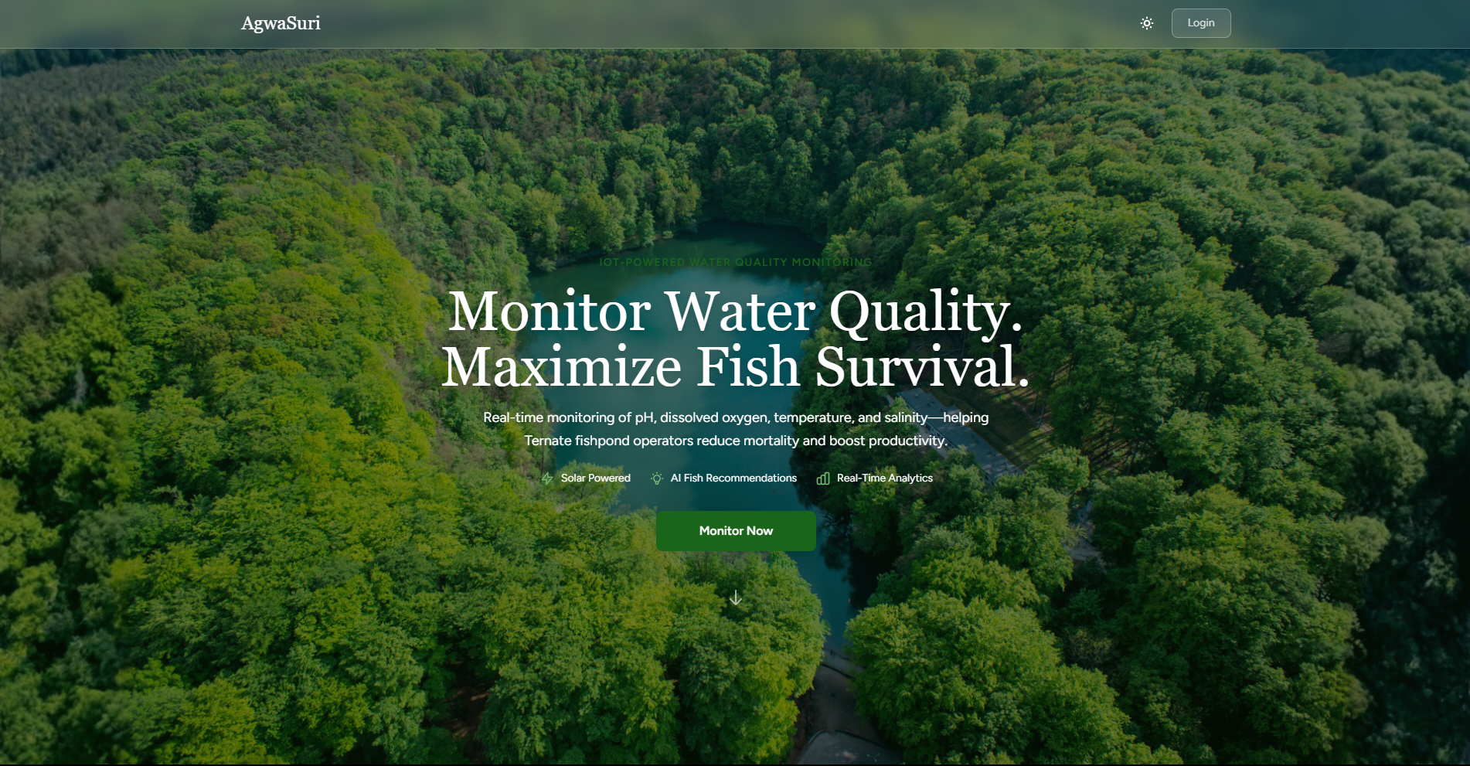
Figure 6 shows the Agwasuri home page with the main system overview and the primary button to start monitoring.
Figure 6. Agwasuri Home Page
Figure 7 shows the Agwasuri login page where users enter their email and password to access the system.
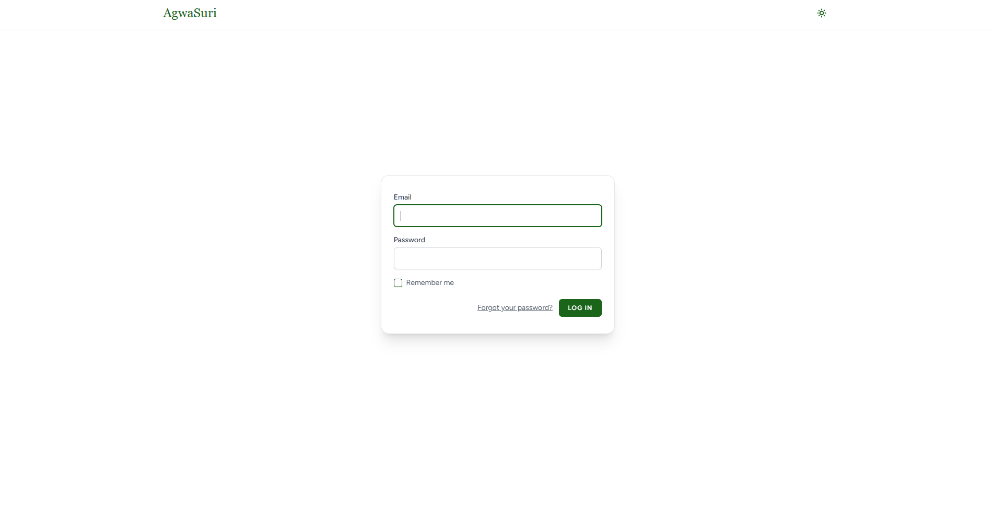
Figure 7. Agwasuri Login Page
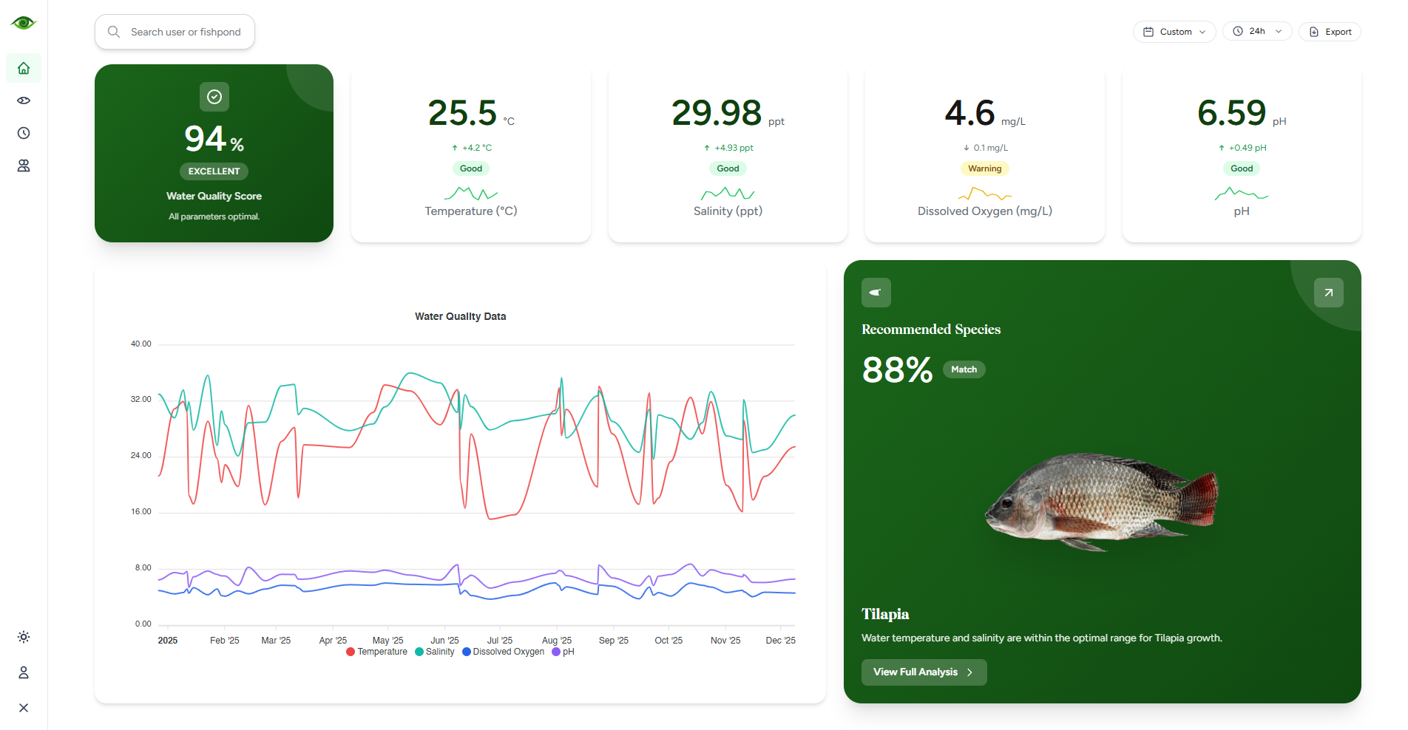
Figure 8 shows the Agwasuri dashboard displaying the overall Water Quality Score, real-time readings for temperature, salinity, dissolved oxygen, and pH, a historical trend chart, and the recommended fish species with its match percentage.
Figure 8. Agwasuri Dashboard Page
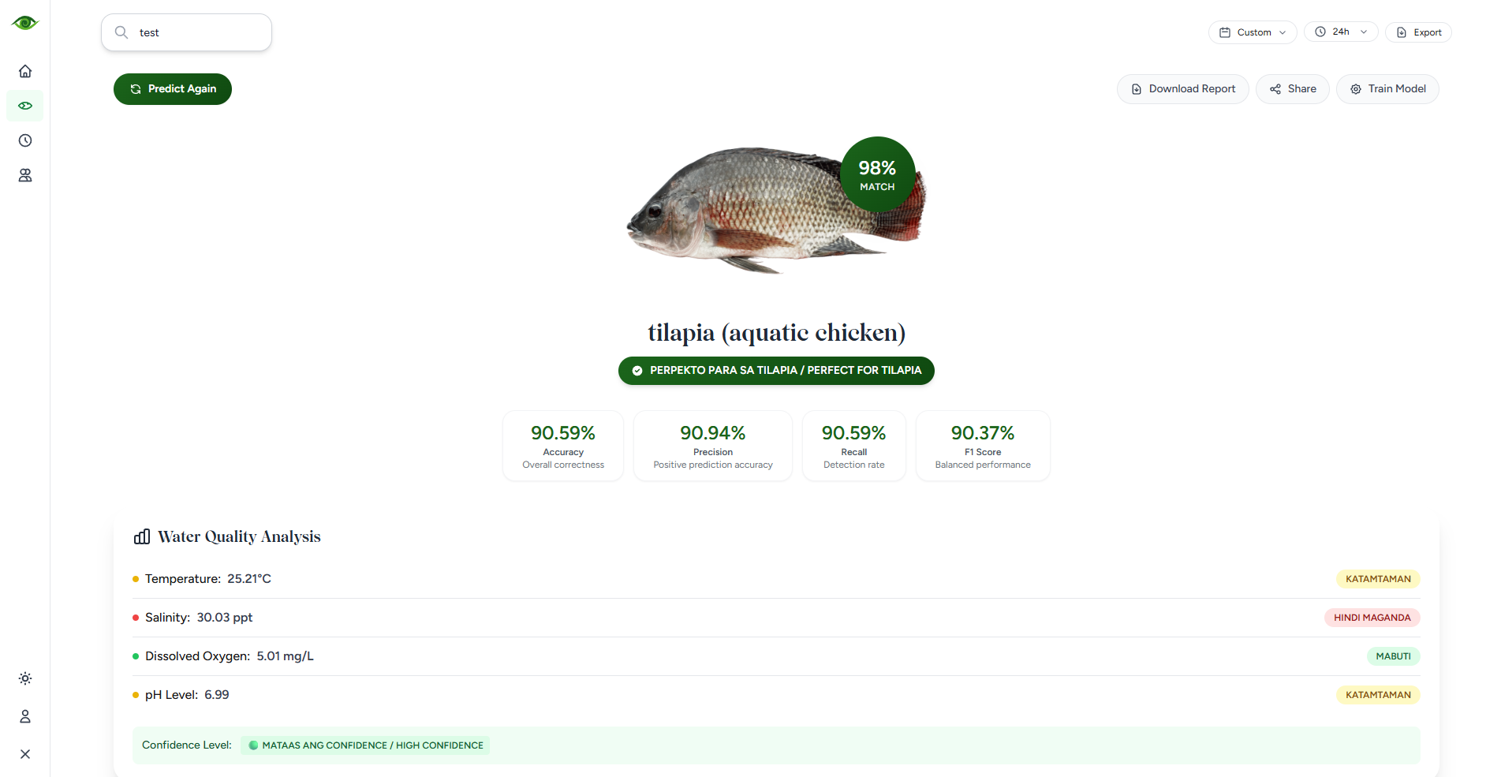
Figure 9 shows the Agwasuri Fish Prediction page where users can generate an AI-based optimal fish species recommendation using the decision tree algorithm based on current water quality data
Figure 9. Agwasuri Fish Prediction Page

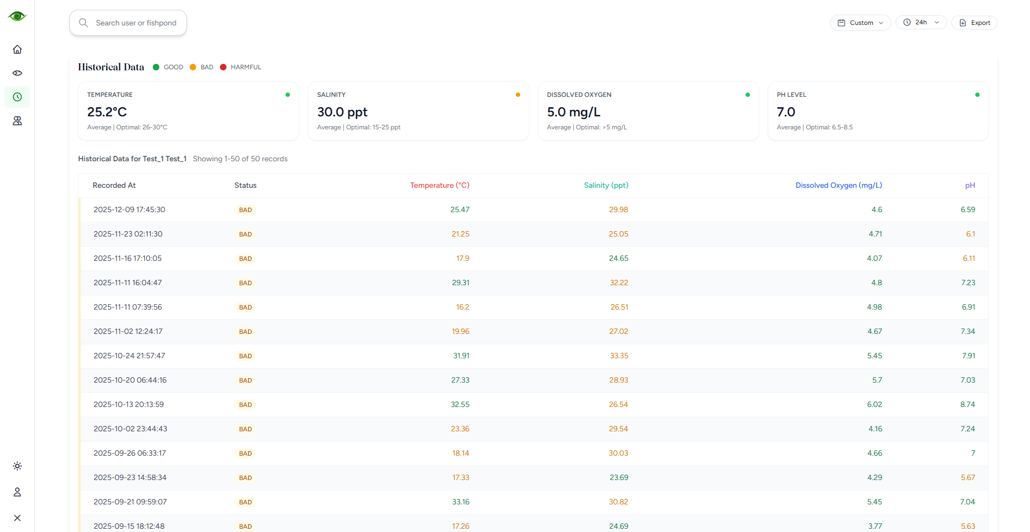
Figure 10 shows the Agwasuri Historical Data page, which displays past water quality readings in a timestamped table with status classifications for temperature, salinity, dissolved oxygen, and pH.
Figure 10. Agwasuri Historical Data Page
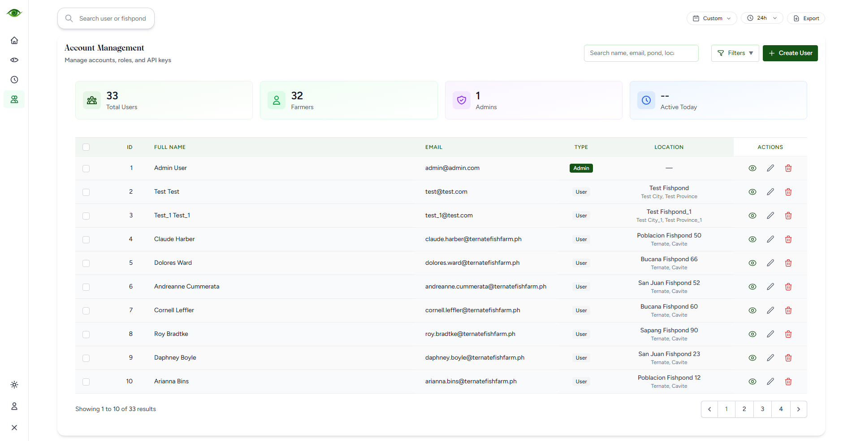
Figure 11 shows the Agwasuri Account Management page, where administrators can view user statistics and manage accounts through a searchable table with options to create, edit, or deactivate users.
Figure 11. Agwasuri Account Management Page

System Development
The researchers developed Agwasuri using an iterative prototyping approach to combine an ESP32-based monitoring device with a responsive web dashboard. The web system was built using Laravel and PHP for backend processing, HTML, CSS, JavaScript, and Tailwind CSS for the interface, and MySQL for data storage. The ESP32 was programmed in MicroPython using Thonny to collect pH, dissolved oxygen (DO), salinity, and temperature readings, with Wi-Fi for data transmission and microSD for offline backup. Python supported the decision tree logic for fish species recommendations, while Figma and Fritzing were used for UI planning and circuit prototyping.
Figure 12 shows the Agwasuri device prototype deployed in an actual fishpond environment, floating on a platform with a solar panel-powered enclosure and on-site display.
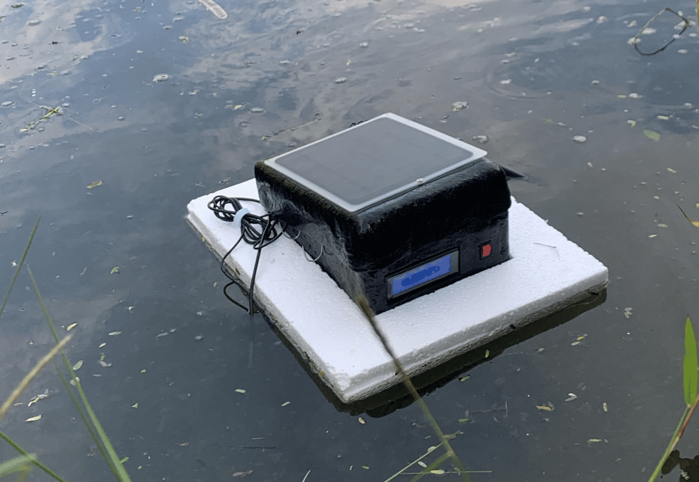
Figure 12. Agwasuri Device Prototype Actual Environment

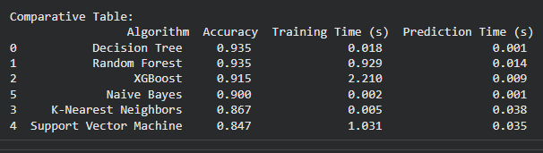
Figure 13 shows the comparative results of multiple machine learning algorithms for fish species recommendation, summarizing each model’s accuracy along with its training and prediction time, where the Decision Tree matches the top accuracy while remaining faster to run than heavier models like Random Forest and XGBoost.
Figure 13. Algorithm Comparison Results for Fish Species Recommendation Model Selection`
As part of the system development phase, an algorithm comparison was conducted to determine the most suitable classification model for the fish species recommendation module. Using the optimal_fish_species_data.csv dataset containing 5,000 optimal fish species records, multiple machine learning algorithms were trained and evaluated, including Decision Tree, Random Forest, XGBoost, Naive Bayes, K-Nearest Neighbors, and Support Vector Machine. The comparison focused on classification accuracy as well as computational efficiency in terms of training time and prediction time.
Results showed that the Decision Tree and Random Forest achieved the highest accuracy at 93.5%. However, the Decision Tree significantly outperformed the other models in terms of efficiency, with a training time of 0.018 seconds and a prediction time of 0.001 seconds. In contrast, models such as XGBoost and Support Vector Machine required substantially longer training and prediction times. Based on these results, the Decision Tree algorithm was selected for implementation due to its high accuracy, fast computation, and rule-based interpretability, making it suitable for real-time recommendations and easier understanding by fishpond operators and MAO personnel.

System Testing
After the system development, Agwasuri was subjected to alpha testing for both software and hardware to ensure the system is stable and ready for field use. The results of the testing served as the basis for improve ments done through the prototyping model. The researchers highlighted the main features during testing, including real-time sensor monitoring (pH, DO, salinity, temperature), data logging (cloud and offline microSD), dashboard visualization, fish species recommendation (decision tree output), and role-based access (Fishpond Operator and MAO Officer). The researchers ensured that these core features were fully working to maintain the integrity and reliability of the system.

Table 7A. Software Test Environment Results under Functional Criteria (Alpha Testing)
Test Case ID | Test Scenario | Test Description | Input Data | Expected Result | Actual Result | Pass  /Fail | Remarks
TC-SW001 | User Login | Test login with valid Fishpond Operator credentials | Username: operator1, Password: validpass | Redirect to Operator Dashboard | Redirected to Operator Dashboard as expected | Passed | No issues.
TC-SW002 | User Login | Test login with invalid credentials | Username: operator1, Password: wrongpass | Display “Invalid credentials” message | “Invalid credentials” message displayed | Passed | No issues.
TC-SW003 | Role-Based Access | Test MAO page restriction for Fishpond Operator | Role: Operator | Access denied to MAO module | Access denied as expected | Passed | No issues.
TC-SW004 | Role-Based Access | Test MAO Officer access to monitoring module | Role: MAO Officer | MAO module loads correctly | MAO module loaded correctly | Passed | No issues.
TC-SW005 | Live Readings Display | Verify latest readings display | pH 7.2, DO 6.5, Sal 12 ppt, Temp 29°C | Values show correctly with timestamp | Values displayed correctly with timestamp | Passed | No issues.
TC-SW006 | Data Visualization | Verify charts update after new record | Submit 1 new sensor record | Graph adds new point | Graph updated and added new point | Passed | No issues.
TC-SW007 | Data Filtering | Test date-range filter | Date: Dec 1–Dec 7 | Show only records within range | Filter returned correct records | Passed | No issues.
TC-SW008 | Recommendation Module | Validate decision tree recommendation output | Current pH/DO/Sal/Temp input | Recommendation is generated and shown | Recommendation generated and displayed clearly | Passed | No issues.
TC-SW009 | Data Validation | Test handling of missing sensor field | Payload missing DO | Reject/flag record; no crash | Record rejected/flagged successfully; system stable | Passed | No issues.
TC-SW010 | Security (SQL Injection) | Test login injection attempt | Username: ' OR 1=1 -- | Block attempt and show error | Injection attempt blocked successfully | Passed | No issues.
The system testing for the Agwasuri web platform (alpha testing) confirmed that the major software functions worked correctly and consistently. A total of 10 test cases were executed and all test cases passed, resulting in a 100% passing rate. This indicates that the system is stable for core operations such as authentication, access control, data handling, dashboard visualization, and basic security checks.
User login was tested using both valid and invalid credentials (TC-SW001 and TC-SW002). Valid credentials redirected users to the correct dashboard, while invalid credentials displayed the proper error message, confirming that authentication and input checking are functioning properly. Role-based access was also verified (TC-SW003 and TC-SW004), ensuring that Fishpond Operators could not access MAO-only pages, while MAO Officers were able to view the monitoring module without restrictions.
Live monitoring and visualization features were validated through dashboard display and chart updating tests (TC-SW005 and TC-SW006). Sensor records were shown with correct values and timestamps, and graphs updated properly after new readings were stored. Data filtering by date range (TC-SW007) also worked correctly, ensuring that users can retrieve historical readings reliably for monitoring and reporting purposes.
The decision tree recommendation module (TC-SW008) generated readable fish species recommendations based on the submitted water quality parameters, confirming that the predictive component is integrated and functional. Data validation (TC-SW009) verified that the system can reject or flag incomplete payloads without system failure, improving reliability. Lastly, a basic SQL injection attempt (TC-SW010) was blocked successfully, indicating that the system has protection against common input-based attacks.

Table 7B. Hardware Test Environment Results under Operational and Accuracy Criteria (Alpha Testing)
Test Case ID | Test Scenario | Test Description | Input Data | Expected Result | Actual Result | Passed  /Failed | Remarks
TC-HW001 | Solar-to-Battery Operation | Verify device runs while solar charges the battery | Solar panel + battery connected; device running | Device continues running normally and battery is charging | Device ran normally and battery was charging | Passed | No issues.
TC-HW002 | Sensor Initialization | Verify sensors are detected and start reading | Connected probes | pH/DO/EC/Temp sensors initialize with stable readings | All sensors initialized and readings were stable | Passed | No issues.
TC-HW003 | LCD Display | Verify on-site LCD updates correctly | Live sensor readings | LCD shows latest readings clearly | LCD displayed latest values correctly | Passed | No issues.
TC-HW004 | Data Transmission (Wi-Fi + Upload) | Verify device uploads readings to server | 1 sensor record upload | Record transmitted and stored successfully | Record uploaded and stored successfully | Passed | No issues.
TC-HW005 | Offline Backup (microSD) | Verify data logging during no internet/Wi-Fi | Wi-Fi OFF (10 mins) | Records saved to microSD without corruption | Records saved to microSD successfully | Passed | No issues.
TC-HW006 | Actual Environment Test | Capture and display readings no system error |  | Displayed readings with correct labels | Temp 30.44 (BEST)  pH 18.73 (HARM)  DO 5.06 (BEST)  Sal 8.21 (GOOD) | Passed | No issues.
TC-HW007 | Actual Environment Test | Capture and display readings no system error |  | Displayed readings with correct labels | Temp 30.44 (BEST)  pH 18.71 (HARM)  DO 5.18 (BEST)  Sal 8.09 (GOOD) | Passed | No issues.
TC-HW008 | Actual Environment Test | Capture and display readings no system error |  | Displayed readings with correct labels | Temp 30.44 (BEST)  pH 18.65 (HARM)  DO 5.20 (BEST)  Sal 8.21 (GOOD) | Passed | No issues.
TC-HW009 | Actual Environment Test | Capture and display readings no system error |  | Displayed readings with correct labels | Temp 30.50 (BEST)  pH 18.60 (HARM)  DO 5.21 (BEST)  Sal 8.06 (GOOD) | Passed | No issues.
TC-HW010 | Actual Environment Test | Capture and display readings no system error |  | Displayed readings with correct labels | Temp 30.50 (BEST)  pH 18.56 (HARM)  DO 5.33 (BEST)  Sal 8.18 (GOOD) | Passed | No issues.
TC-HW011 | Actual Environment Test | Capture and display readings no system error |  | Displayed readings with correct labels | Temp 30.50 (BEST)  pH 18.51 (HARM)  DO 5.21 (BEST)  Sal 8.22 (GOOD) | Passed | No issues.
TC-HW012 | Actual Environment Test | Capture and display readings no system error |  | Displayed readings with correct labels | Temp 30.50 (BEST)  pH 18.41 (HARM)  DO 5.27 (BEST)  Sal 8.06 (GOOD) | Passed | No issues.
The system testing for the Agwasuri device (alpha testing) confirmed that the core hardware functions operated reliably under normal and field conditions. The test cases covered power operation (solar-to-battery charging while running), sensor initialization and stability, LCD display updates, Wi-Fi data transmission and server storage, and offline microSD logging during loss of connectivity. Actual environment runs further verified that live readings were captured and displayed with the correct parameter labels and classifications without system errors. Overall, the results indicate that the system is stable in terms of power operation, sensor initialization, display output, data logging, data transmission, and measurement performance.
Actual environment testing produced multiple consecutive live samples with no system errors, confirming that the device can capture and display real-time water quality values with the correct parameter labels and classification tags. The classifications (harm, bad, good, best) were anchored on DENR AO Class SC (2016) regulatory limits and the comparative/observed ranges reported by Baldoza et al. (2020), which served as the basis for the system’s classification bands.
To make the classifications easier to interpret, the system uses four labels (harm, bad, good, best) based on the adopted parameter scales below. In general, harm indicates readings that are extremely outside the acceptable range and may pose immediate risk, bad indicates outside the acceptable range that requires corrective action, good indicates acceptable but not within the typical operating band, and best indicates the typical or optimal operating band for stable culture conditions.
The pH classification table defines the acceptable and typical operating ranges used by the system when labeling measured pH values during monitoring. I

Table 8. pH Scale and Classification
pH Range | Classification | Description
< 6.00 or  > 9.00 | HARM | extremely outside the acceptable range and may pose high risk to fish health and survival
6.00–6.49  or 8.51–9.00 | BAD | outside the acceptable range; indicates undesirable conditions requiring corrective action
6.50–7.88  or 8.32–8.50 | GOOD | within the acceptable range but outside the typical operating range observed in the study
7.89–8.31 | BEST | typical operating range observed and within the acceptable standard
The dissolved oxygen (DO) classification table specifies the thresholds used to determine if oxygen conditions are critical, below recommended levels, acceptable, or optimal for fish production.
Table 9. Dissolved Oxygen Scale and Classification
DO (mg/L) | Classification | Description
< 3.75 | HARM | below the minimum observed range; indicates critically low oxygen conditions requiring immediate action
3.75  - 4.99 | BAD | below the recommended minimum; may result in stress and reduced growth performance
5.00  - 6.12 | GOOD | meets the recommended minimum and remains within the observed range
≥ 5.00 | BEST | satisfies the minimum guideline for fish production
The temperature classification table presents the ranges used to assess whether pond temperature is within safe limits, slightly outside the recommended band, or already at levels that can impair fish survival.

Table 10. Temperature Scale And Classification
Temperature (°C) | Classification | Description
< 20.00  or > 35.00 | HARM | sub-lethal or lethal range that may impair survival, consistent with thresholds cited in the study
20.00 - 24.99  or 31.01 - 35.00 | BAD | outside the recommended range and may reduce fish performance and stability
25.00 - 29.83 | GOOD | within the recommended range but below the typical upper operating range observed in the study
29.84 - 31.00 | BEST | upper operating range aligned with observed values while remaining within the recommended limit
The salinity classification table outlines how the system categorizes salinity conditions from very low to excessively high, reflecting brackish-water culture suitability.
Table 11. Salinity Scale And Classification
Salinity (ppt) | Classification | Description
< 5.00 | HARM | very low salinity condition that may increase stress risk and reduce survival for cultured species requiring brackish conditions
5.00  to < 7.00 | BAD | low range that may be unsuitable for stable culture conditions without careful management
7.00  to < 10.00 | GOOD | light range that supports more stable conditions than lower ranges
10.00  to 17.33 | BEST | optimal operating range aligned with the observed peak range reported in the study
> 17.33  to 25.00 | GOOD | acceptable upper range; requires monitoring to prevent spikes due to evaporation and concentration
> 25.00 | HARM | excessively high salinity that may increase stress risk and reduce survival if sustained

System Evaluation
The performance of Agwasuri was evaluated using the ISO/IEC 25010 quality model for the software (web platform and modules) and a System Usability Scale (SUS) questionnaire for the hardware device. The evaluation involved 10 purposively selected respondents (fishpond operators, MAO officers, marine science experts, and IT experts) because they are the intended users and domain evaluators of the system. Weighted mean and standard deviation were computed to summarize the results using the study’s interpretation scale.
Table 8 summarizes the respondents’ software evaluation results for Agwasuri based on ISO/IEC 25010. The results indicate that the system achieved an overall average mean of 4.84 (Excellent) with an average standard deviation of 0.34, showing that the major quality characteristics met the standards of the majority of evaluators. Among the quality characteristics, Compatibility obtained the highest average mean (4.90, SD = 0.30; Excellent), which suggests that most participants relatively liked how the software can co-exist in a shared environment without negatively affecting other systems and can support interoperability by exchanging and using information with other components or platforms.
In contrast, Reliability recorded the lowest average mean (4.78, SD = 0.41; Excellent), indicating that while still rated Excellent, participants were comparatively more cautious about reliability-related aspects such as maturity under normal operation, availability when required, fault tolerance despite possible hardware or software faults, and recoverability in re-establishing the desired state after interruptions or failures. Overall, the consistently low standard deviations across criteria indicate generally aligned evaluations, with slightly higher variability in Reliability reflecting differing user experiences on continuity and recovery during disruptions.
Table 8. Summary of Software Evaluation (ISO/IEC 25010)
EVALUATION | AVERAGE MEAN | AVERAGE STANDARD DEVIATION | INTERPRETATION
Functional Suitability | 4.87 | 0.33 | Excellent
Performance Efficiency | 4.80 | 0.39 | Excellent
Compatibility` | 4.90 | 0.30 | Excellent
Usability | 4.82 | 0.34 | Excellent
Reliability | 4.78 | 0.41 | Excellent
Security | 4.84 | 0.31 | Excellent
Maintainability | 4.88 | 0.28 | Excellent
Portability | 4.83 | 0.35 | Excellent
Highest | 4.90 (Compatibility) | 0.30 | Excellent
Lowest | 4.78 (Reliability) | 0.41 | Excellent
Table 9 presents the SUS-based hardware usability results of the Agwasuri device. The overall average mean of 4.85 (Excellent) with an average standard deviation of 0.33 indicates that the device is easy to use, learnable, and acceptable for field operation. Among the usability indicators, Functional Integration obtained the highest average mean (5.00, SD = 0.00; Excellent), suggesting that most participants relatively liked that the device’s components and functions are effectively integrated and work together as one system during actual use.
In contrast, Support Dependence recorded the lowest average mean (4.70, SD = 0.46; Excellent), indicating that while still rated Excellent, participants were comparatively more reserved on the degree to which technical personnel support may be required to facilitate system usage, especially during setup, troubleshooting, or field adjustments. Overall, the results show consistently Excellent ratings across indicators, with the slightly higher variability in Support Dependence reflecting differences in user familiarity and confidence when operating the device without assistance.
Table 9. Hardware Usability Results (System Usability Scale (SUS))
EVALUATION | AVERAGE MEAN | AVERAGE STANDARD DEVIATION | INTERPRETATION
Usage Frequency | 4.90 | 0.30 | Excellent
System Complexity | 4.80 | 0.40 | Excellent
Ease of Use | 4.80 | 0.40 | Excellent
Support Dependence | 4.70 | 0.46 | Excellent
Functional Integration | 5.00 | 0.00 | Excellent
System Inconsistency | 4.90 | 0.30 | Excellent
Learnability Speed | 4.90 | 0.30 | Excellent
Operational Cumbersomeness | 4.80 | 0.40 | Excellent
User Confidence | 4.90 | 0.30 | Excellent
Prerequisite Knowledge | 4.80 | 0.40 | Excellent
Highest | 5.00 (Functional Integration) | 0.00 | Excellent
Lowest | 4.70 (Support Dependence) | 0.46 | Excellent

Table 10. Summary of Implementation Plan Results (Agwasuri)
STRATEGY | ACTIVITIES | PERSONS INVOLVED | DURATION | REMARKS
Approval for Evaluation | Requesting approval and endorsement letter for the system evaluation of Agwasuri | Research Coordinator, Technical Critic & Adviser, Department Chairperson | 1 day | Approved
Testing | Demonstration of the Agwasuri device and web platform; validation of sensor readings, dashboard display, and data logging | Researchers, Fishpond Operators, IT Experts, Marine Science Experts, MAO Officers | 3 days | Passed
System Evaluation | Distribution and collection of ISO/IEC 25010 evaluation forms (software) and SUS-based usability forms (hardware) | Researchers, Fishpond Operators, IT Experts, Marine Science Experts, MAO Officers | 5 days | Accomplished
User Training | Hands-on orientation on operating the device, viewing data on the dashboard, and interpreting species recommendations | Researchers, Fishpond Operators, IT Experts, Marine Science Experts, MAO Officers | 1 day | Finished

SUMMARY, CONCLUSION, AND RECOMMENDATIONS
This chapter provides a summary of the key findings from the study, draws conclusions based on the analysis of the results, and offers recommendations for future research or practical application. It aims to encapsulate the main contributions of the study while suggesting areas for further exploration or improvement.

Summary
The development of Agwasuri: an IoT-driven aquaculture monitoring and fish species recommendation system followed the Prototyping Model, allowing continuous refinement through iterative testing and stakeholder feedback. The researchers used tools such as Visual Studio Code, Laravel/PHP, HTML, CSS, JavaScript, Tailwind CSS, and MySQL for the web platform, while the device firmware was implemented on an ESP32 using MicroPython through Thonny. Supporting tools such as Figma and Fritzing were utilized for interface planning and hardware prototyping, while Python supported the decision tree logic used in generating fish species recommendations based on water quality conditions.
After development and revisions, Agwasuri was evaluated by selected respondents from the target beneficiaries and experts, including fishpond operators, MAO officers, marine science experts, and IT experts, using ISO/IEC 25010 for the software and a SUS-based usability evaluation for the hardware device. The results show Excellent performance across the ISO/IEC 25010 quality characteristics, with an overall average mean of 4.84 and an average standard deviation of 0.34, indicating strong system quality and consistent evaluator responses. The hardware device also achieved an Excellent usability result with an overall average mean of 4.85 and an average standard deviation of 0.33, reflecting that the device is easy to operate, learnable, and acceptable for fishpond deployment.
The successful implementation of Agwasuri in San Juan I, Ternate, Cavite supports real-time monitoring of pH, dissolved oxygen, salinity, and temperature, enables cloud-based storage with offline microSD backup, and provides data-driven fish species selection recommendations to reduce mortality and improve aquaculture productivity. The excellent evaluation outcomes confirm that Agwasuri is a reliable and practical solution that strengthens sustainable fishpond management and supports the monitoring capability of the Municipal Agriculture Office.

Conclusion
The Agwasuri system successfully met the objectives of the study by delivering a solar-powered, IoT-driven solution that supports real-time monitoring of critical water quality parameters and provides fish species recommendations based on current pond conditions. The evaluation results indicate that the system performed at an “Excellent” level, confirming that Agwasuri is effective in addressing the needs of fishpond operators and the Municipal Agriculture Office (MAO) for timely monitoring, improved decision-making, and sustainable aquaculture management.
Key challenges in fishpond operations, such as the lack of consistent water quality assessment, delayed responses to poor water conditions, and reliance on trial-and-error species selection, were addressed through Agwasuri’s integrated design. The system’s real-time monitoring of pH, dissolved oxygen, salinity, and temperature, combined with decision tree-based recommendations, supports proactive actions that can reduce fish mortality and prevent avoidable financial loss. The addition of cloud storage with microSD offline backup also strengthened system reliability, especially in areas with unstable connectivity.
Agwasuri’s technical foundation, which integrates an ESP32 microcontroller, MicroPython firmware, and a web platform developed using Laravel, MySQL, and responsive web technologies, ensured scalability, flexibility, and practical deployment in field conditions. Alpha testing confirmed that the major software and hardware functions worked as intended, including sensor acquisition, data transmission, data logging, dashboard visualization, and role-based access for operators and MAO personnel.
In conclusion, Agwasuri proved to be a reliable and practical tool for modernizing fishpond water quality monitoring and supporting data-driven aquaculture decisions in San Juan I, Ternate, Cavite. Its successful implementation demonstrates strong potential for wider adoption and future enhancements, such as expanding to additional water quality parameters, improving calibration methods, and extending deployment to other aquaculture sites while maintaining its sustainability and usability benefits.

Recommendations
The following is hereby recommended to further enhance the study:
1. Upgrade the data visualization. Add more features including the separation of yearly results in charts giving users more detailed grapes and data visualization.
2. Future versions of the Agwasuri system may enhance portability by reducing the size and weight of the hardware and optimizing internal component layout. This improvement will allow easier deployment, relocation, and maintenance across multiple fishpond locations.
3. The web platform may incorporate color-coded visual alerts for each water quality parameter to indicate safe, warning, and critical levels. This feature will enable users to quickly identify unsafe conditions and respond promptly without relying solely on numerical data.
4. A detailed user manual may be integrated into the website along with a printed, foldable quick guide included with the hardware device. These materials will help users properly operate the system, interpret results, and perform basic troubleshooting.
5. Future studies may include testing water quality at varying depths and distances within the fishpond. This approach will provide a more accurate representation of water condition variations across different pond layers.
6. Further evaluation may be conducted under varying weather conditions such as rainy, dry, and extreme temperature scenarios. This will help assess the system’s reliability and accuracy under real-world environmental changes.

REFERENCES
Baldoza, B. J. S., Montojo, U. M., Perelonia, K. B., Benitez, K. C. D., Cambia, F. D., & Garcia, L. C. (2020). Status of Water Quality in Fishponds Surrounding Manila Bay. The Philippine Journal of Fisheries, 27(2), 111–118. https://doi.org/10.31398/tpjf/27.2.2020A0006
Cecchi, T., Poletto, D., Berbecaru, A. C., Cârstea, E. M., & Râpă, M. (2024, April 11). Assessing Microplastics and Nanoparticles in the Surface Seawater of Venice Lagoon—Part I: Methodology of Research. Materials, 17(8), 1759. https://doi.org/10.3390/ma17081759
Chen, C. H., Wu, Y. C., Zhang, J. X., & Chen, Y. H. (2022). IoT-Based Fish Farm Water Quality Monitoring System. Sensors, 22(17). https://doi.org/10.3390/s22176700
Christianti, D., Abdullah, S., & Nurrohmah, S. (2020, January 21). Bayes Risk Post-Pruning in Decision Tree to Overcome Overfitting Problem on Customer Churn Classification. https://doi.org/10.4108/eai.2-8-2019.2290487
CircuitSchools Staff. (2022, January 10). What is ESP32, how it works and what you can do with ESP32? – Circuit Schools. https://www.circuitschools.com/what-is-esp32-how-it-works-and-what-you-can-do-with-esp32/
Cobblah, M. A., Afful-Arthur, P., Filson, C. K., Tachie-Donkor, G., Martin-Yeboah, E., Atuase, D., Amoah, G. B., Imoro, O., Armah, N. Y. A. A., & Nunekpeku, P. (2022). Connecting industries to research outputs: The role of academic libraries. Information Development, 38(4), 510–521. https://doi.org/10.1177/02666669211010204
Daud, M. H., Yusoff, F. H., Abdul-Razak, S., Baharudin, N., Mohamed-Yassin, M. S., Badlishah-Sham, S. F., Nikmat, A. W., Isa, M. R., Jamil, N., Nawawi, H., & Ramli, A. S. (2023). Design, development, utility and usability testing of the EMPOWER-SUSTAIN Self-Management Mobile App© among primary care physicians and patients with metabolic syndrome. Digital Health, 9. https://doi.org/10.1177/20552076231176645
Department of Environment and Natural Resources (DENR). (2016, May 24). DENR Administrative Order No. 2016-08: Water Quality Guidelines and General Effluent Standards of 2016. Republic of the Philippines, Department of Environment and Natural Resources. http://www.denr.gov.ph
ESP32 - HTTP Request | ESP32 Tutorial. (n.d.). Retrieved December 6, 2024, from https://esp32io.com/tutorials/esp32-http-request
Gravity Analog Dissolved Oxygen Sensor (SKU_SEN0237) DFRobot. (n.d.). Retrieved December 6, 2024, from https://wiki.dfrobot.com/Gravity__Analog_Dissolved_Oxygen_Sensor_SKU_SEN0237
Gravity Analog Electrical Conductivity Sensor Meter V2 K=1 (SKU_DFR0300) DFRobot. (n.d.). Retrieved December 6, 2024, from https://wiki.dfrobot.com/Gravity__Analog_Electrical_Conductivity_Sensor___Meter_V2__K%3D1__SKU_DFR0300
Iliyasu, R., & Etikan, I. (2021). Comparison of quota sampling and stratified random sampling. Biometrics & Biostatistics International Journal, 10(1), 24–27. https://doi.org/10.15406/bbij.2021.10.00326
International Organization for Standardization. (2023). Systems and software engineering — Systems and software Quality Requirements and Evaluation (SQuaRE) — Product quality model (ISO/IEC 25010:2023).
Kang, K. D. (2022). A Review of Efficient Real-Time Decision Making in the Internet of Things. In Technologies (Vol. 10, Issue 1). MDPI. https://doi.org/10.3390/technologies10010012
Lin, J. Y., Tsai, H. L., & Lyu, W. H. (2021). An integrated wireless multi-sensor system for monitoring the water quality of aquaculture. Sensors, 21(24). https://doi.org/10.3390/s21248179
Lin, L., Guo, H., Lv, Y., Liu, J., Tong, C., & Yang, S. (2022). A machine learning method for soil conditioning automated decision-making of EPBM: hybrid GBDT and Random Forest Algorithm. Eksploatacja i Niezawodnosc, 24(2), 237–247. https://doi.org/10.17531/ein.2022.2.5
Long, X., Wan, R., Li, Z., Wang, D., Song, P., & Zhang, F. (2022). Sampling Designs for Monitoring Ichthyoplankton in the Estuary Area: A Case Study on Coilia mystus in the Yangtze Estuary. Frontiers in Marine Science, 8. https://doi.org/10.3389/fmars.2021.767273
Mohamed, C., Cheniti, M., Abdesslam, B., & Ramdane, K. (2023). An Arduino-based Water Quality Monitoring System using pH, Temperature, Turbidity, and TDS Sensors. https://www.researchgate.net/publication/371608557
Olanubi, O. O., Akano, T. T., & Asaolu, O. S. (2024). Design and development of an IoT-based intelligent water quality management system for aquaculture. Journal of Electrical Systems and Information Technology, 11(1). https://doi.org/10.1186/s43067-024-00139-z
Pasika, S., & Gandla, S. T. (2020). Smart water quality monitoring system with cost-effective using IoT. Heliyon, 6(7). https://doi.org/10.1016/j.heliyon.2020.e04096
PH meter (SKU_SEN0161) DFRobot. (n.d.). Retrieved December 6, 2024, from https://wiki.dfrobot.com/PH_meter_SKU__SEN0161_
Puspaningrum, E. Y., Yudha, D. S. K., Utami, H. W., Via, Y. V., Mandyartha, E. P., & Maulana, H. (2024). SIMAPA System Testing Using Alpha and Beta Tests. 8 th International Seminar of Research Month 2023. NST Proceedings. 212–218. https://doi.org/10.11594/nstp.2024.4133
Rezaee, R., Parsa, Z., Ahmadzadeh, L., Ahmadian, L., Avazzadeh, S., & Marzaleh, M. A. (2023). Self-help application for obsessive-compulsive disorder based on exposure and response prevention technique with prototype design and usability evaluation: A cross-sectional study. Health Science Reports, 6(9). https://doi.org/10.1002/hsr2.1577
Sharma, D., & Kumar, R. (2021). Smart Aquaculture: Integration of Sensors, Biosensors, and Artificial Intelligence. 455–464. https://doi.org/10.1007/978-3-030-66165-6_21
Su, X., Sutarlie, L., & Loh, X. J. (2020). Sensors, Biosensors, and Analytical Technologies for Aquaculture Water Quality. Research, 2020. https://doi.org/10.34133/2020/8272705
Sugiharto, W. H., Susanto, H., & Prasetijo, A. B. (2023). Real-Time Water Quality Assessment via IoT: Monitoring pH, TDS, Temperature, and Turbidity. Ingenierie Des Systemes d’Information, 28(4), 823–831. https://doi.org/10.18280/isi.280403
Vo, T. T. E., Ko, H., Huh, J. H., & Kim, Y. (2021). Overview of smart aquaculture system: Focusing on applications of machine learning and computer vision. In Electronics (Switzerland) (Vol. 10, Issue 22). MDPI. https://doi.org/10.3390/electronics10222882
Wakiya, T., Ishido, K., Kimura, N., Nagase, H., Kubota, S., Fujita, H., Hagiwara, Y., Kanda, T., Matsuzaka, M., Sasaki, Y., & Hakamada, K. (2021). Prediction of massive bleeding in pancreatic surgery based on preoperative patient characteristics using a decision tree. PLoS ONE, 16(11 November). https://doi.org/10.1371/journal.pone.0259682
Waterproof DS18B20 Digital Temperature Sensor (SKU_DFR0198) DFRobot. (n.d.). Retrieved December 6, 2024, from https://wiki.dfrobot.com/Waterproof_DS18B20_Digital_Temperature_Sensor__SKU_DFR0198_
Xu, Q., & Khan, S. (2023, March 5). How Do R&D and Renewable Energy Consumption Lead to Carbon Neutrality? Evidence from G-7 Economies. International Journal of Environmental Research and Public Health, 20(5), 4604. https://doi.org/10.3390/ijerph20054604
Ya’acob, N., Dzulkefli, N. N. S. N., Yusof, A. L., Kassim, M. M., Naim, N. F., & Aris, S. S. M. (2021). Water Quality Monitoring System for Fisheries using Internet of Things (IoT). IOP Conference Series: Materials Science and Engineering, 1176(1), 012016. https://doi.org/10.1088/1757-899X/1176/1/012016

APPENDICES
Appendices 1. Budgetary Requirements
Item | Unit Price (PHP) | Quantity | Total Cost (PHP)
Gravity: Electrical Conductivity Probe Sensor | 4,000 | 1 | 4,000
Gravity: Temperature Probe Sensor | 450 | 1 | 450
Gravity: Dissolved Oxygen Probe Sensor | 9,500 | 1 | 9,500
Gravity: pH Probe Sensor | 3,200 | 1 | 3,200
ESP32 WROVER | 350 | 1 | 350
Logic Level Shifter | 350 | 5 | 350
SD Card Module | 75 | 1 | 75
LED Display | 200 | 1 | 200
Breadboard Power Supply | 50 | 1 | 50
Resistors | 100 | 1 set | 100
Breadboard | 100 | 1 | 100
Capacitors | 100 | 1 set | 100
Jumper Wires | 100 | 5 | 100
Switch | 100 | 1 | 100
Micro SD | 300 | 1 | 300
Solar Panel | 2, 000 | 1 | 2, 000
Battery | 1,500 | 1 | 1,500
TOTAL |  |  | 23,070

Appendices 2. Water Quality Test Time Comparison
Water Qualities | Test Kits | Sensors
pH | 2 mins | 2 secs
Dissolved Oxygen | 30 mins | 2 secs
Salinity | 5 mins | 2 secs
Temperature | 2 mins | 2 secs

